ITopiaLogo

**Functional design**

*Project Virtualisation  
Team 2*

|  |  |  |  |
| --- | --- | --- | --- |
| **Client: Arjen Jansen** |  | **Filename:** | FD_v1.0.docx |
| **Project Virtualisation** |  | **Version:** | 1.0 |
| **Author:**  **Rami Haddad, Kasper van Brakel, Reinier van Rooij, Tim Dijkhuizen,  Rakis Bipat & Ingwar Verbeek** |  | **Date:** | 29-09-2014 |

# Document management

## History

| **Version** | **Date** | **Changes (draft/final)** | **Client** | **Author(s)** |
| --- | --- | --- | --- | --- |
| 1.0 | 29-09-2014 | Draft | Arjen Jansen | Rami Haddad, Kasper van Brakel, Reinier van Rooij, Tim Dijkhuizen, Rakis Bipat & Ingwar Verbeek |
|  |  |  |  |  |

## Approval

This document needs the following approvals.

Signed approval forms are stored in the Management section of the project archive.

|  |  |  |  |  |
| --- | --- | --- | --- | --- |
| **Name** | **Role** | **Signature** | **Date document** | **Version** |
|  |  |  |  |  |

# Table of contents

Document management 1

History 1

Approval 1

Table of contents 2

1. Introduction 3

2. Use case 1: Rent a server 4

3. Use case 2: Registration customer 5

4. Use case 3: Login 6

5. Use case 4: Use a server 7

6. Use case 5: Maintain a server 8

7. Use case 6: System reporting Plaintech 9

8. Activity diagrams 10

8.1 Rent a server 10

8.2 Registration customer 11

8.3 Login 12

8.4 Use a server 13

8.5 Maintain a server 14

8.6 System reporting Plaintech 15

# Introduction

This document contains the functional description of the virtualization platform for Plaintech. Schematics and diagrams will show the communication between users, the system and Plaintech.

The document is based on the agreements made with Plaintech and the content described in the PID and TD. ITopia tried to fulfil the functional demands of the system made by Plaintech as good as possible.

The functional design contains use cases, activity diagrams and scenarios. Renting, registration, login in, use, maintain and reporting of the system procedures are discussed in this document.

# Use case 1: Rent a server

|  |  |
| --- | --- |
| Use Case Name | Rent a server |
| Primary Actor | Client and Plaintech |
| Preconditions | Client is logged in on his account. |
| Description | 1. Client selects the preferred vps   -Hardware  -Operating system  -Service level agreement   1. Client selects preferred payment method 2. Plaintech will configure server 3. Client will get the server from Plaintech |
| Exceptions | 1a. Client cant select preferred vps  1b. Client cannot find a vps  1c. Operating system is not available  1d. Service level agreement isn’t available  2a. Payment method isn’t available  2b. Payment goes wrong  3a. Server can’t be configured  4a. Server won’t get delivered in time by Plaintech  4b. Vps doesn’t get delivered by Plaintech |
| Result | Client has selected his preferred vps and has received it from Plaintech. |

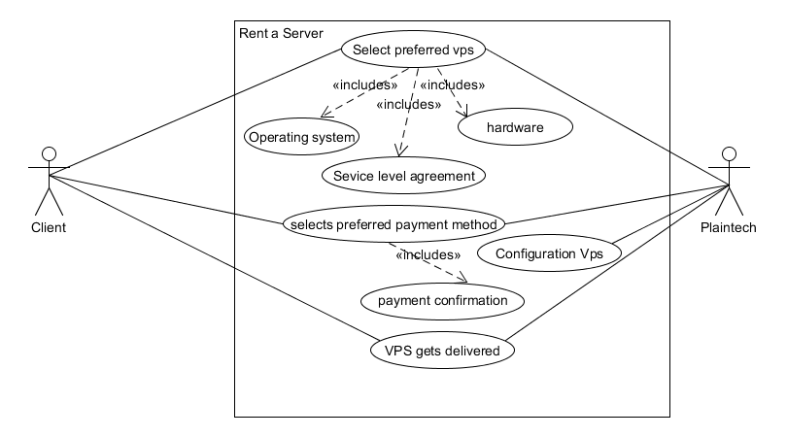

# Use case 2: Registration customer

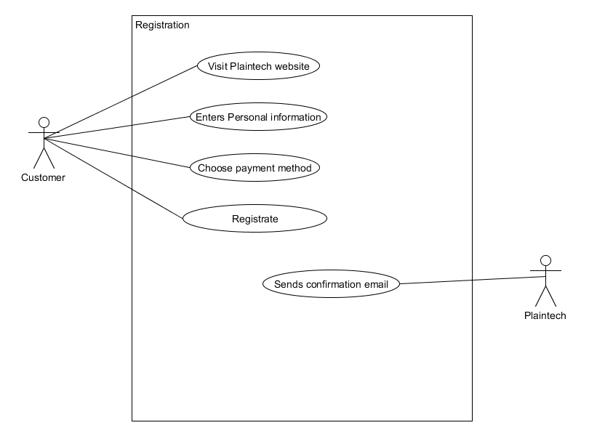

|  |  |
| --- | --- |
| Name | Registration customer |
| Actors | Customer, Plaintech account manager |
| Assumption | Plaintech website is online, Customer has internet |
| Description | 1. Customer visit Plaintech website 2. Customer goes to registration page 3. Customer enters Personal information  * Name * Last name * Address * Company name (optional) * Company address(optional) * phone number * e-mail address * account password * choose payment Method  1. Customer accepts terms of service 2. Customer registrate account 3. Account manager sends e-mail to customer, to confirm registration |
| Exceptions | 3.1 customer doesn’t fill in personal information  4.1 customer doesn’t accept terms of service |
| Result | Customer has a registrated account |

# Use case 3: Login

|  |  |
| --- | --- |
| Name | Login |
| Actors | Customer |
| Assumption | Customer has valid account information, the Plaintech website is online and the customer has a working internet connection. |
| Description | 1. The customer enters his account information at the Plaintech website. 2. Presses the submit button 3. If the account information is valid the customers successfully logs in. |
| Exceptions | 1. If the account information isn’t valid the customer goes back to step one. |
| Result | The customer is successfully logged in. |

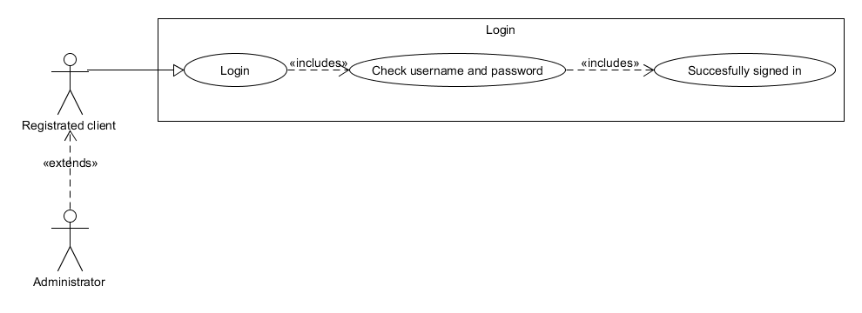

# Use case 4: Use a server

|  |  |
| --- | --- |
| Name | Use a Server |
| Actors | Client, PlainTech |
| Assumption | Client, PlainTech manage the servers |
| Description | 1. Actors can login through ssh 2. Actors manage VM 3. Actors manage Logs |
| Exceptions | Server cannot have access through firewall or ports  Actors must have correct information data to access the server |
| Result | Actors can have access through ssh settings.  Actors can have full manage the VM,  Actors can configure and control the VM. |

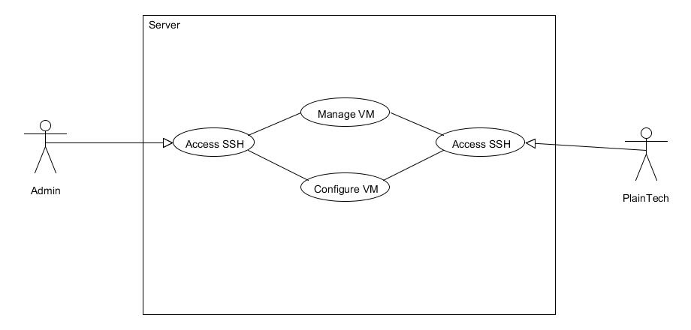

# Use case 5: Maintain a server

|  |  |
| --- | --- |
| Name | Maintain a server |
| Actors | Customer, Plaintech Administrator |
| Aannamen Assumption | Customer & Plaintech administrator are logged on the system and have the user rights to maintain a server. |
| Description | 1. The customers uses his account name and password to log on the system. 2. The customer is logged on the system. 3. The customer can configure the virtual machine on the following subjects.  * Delete the virtual machine * Shut down or restart the virtual machine * Configure the virtual machine * View user/system statistics * Configure back-up and restore the virtual machine |
| Exceptions | When log in information is invalid, system will give error. |
| Result | The customer and Plaintech administrators are capable to configure and maintain the virtual machine. |

# Use case 6: System reporting Plaintech

|  |  |
| --- | --- |
| Name | System reporting Plaintech |
| Actors | Plaintech administrator, Plaintech Management |
| Assumption | Plaintech administrator or Plaintech Management are logged in to the management page |
| Description | 1. Plaintech Administrator or Management can view reports  2. Plaintech Administrator or Management can view log files |
| Exceptions | The system does not create reports |
| Result | Plaintech administrator or Management have an overview of the whole system |

Use case diagram: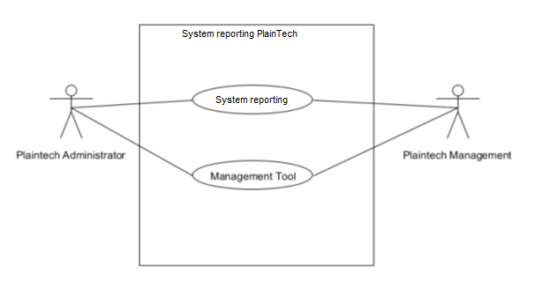

# Activity diagrams

## Rent a server

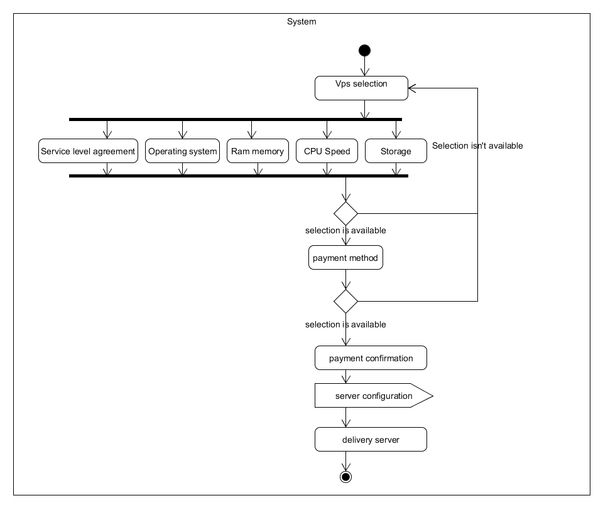

## Registration customer

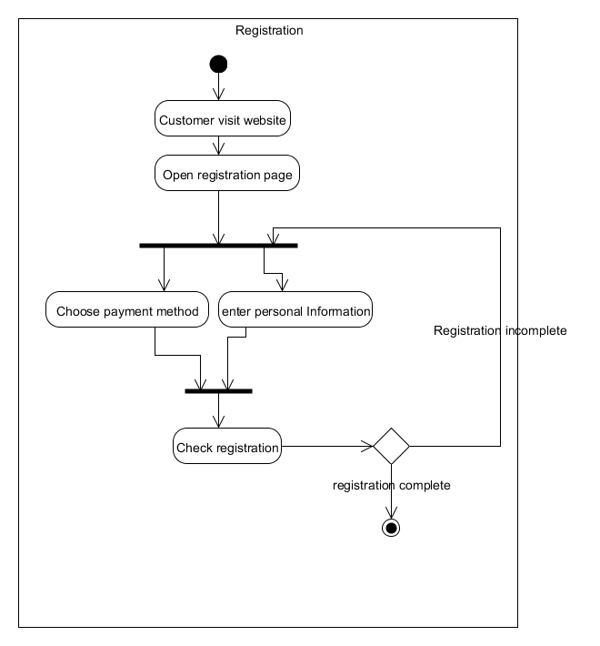

## Login

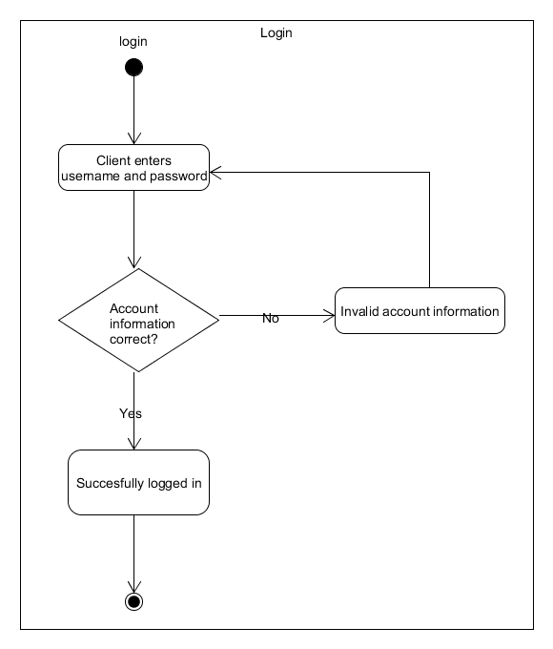

## Use a server

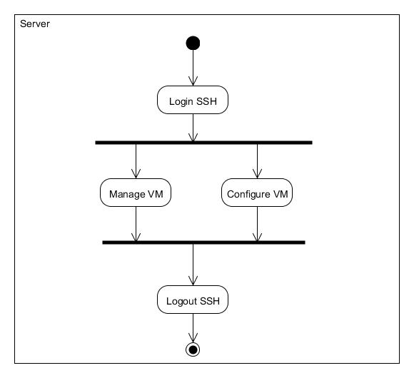

## Maintain a server

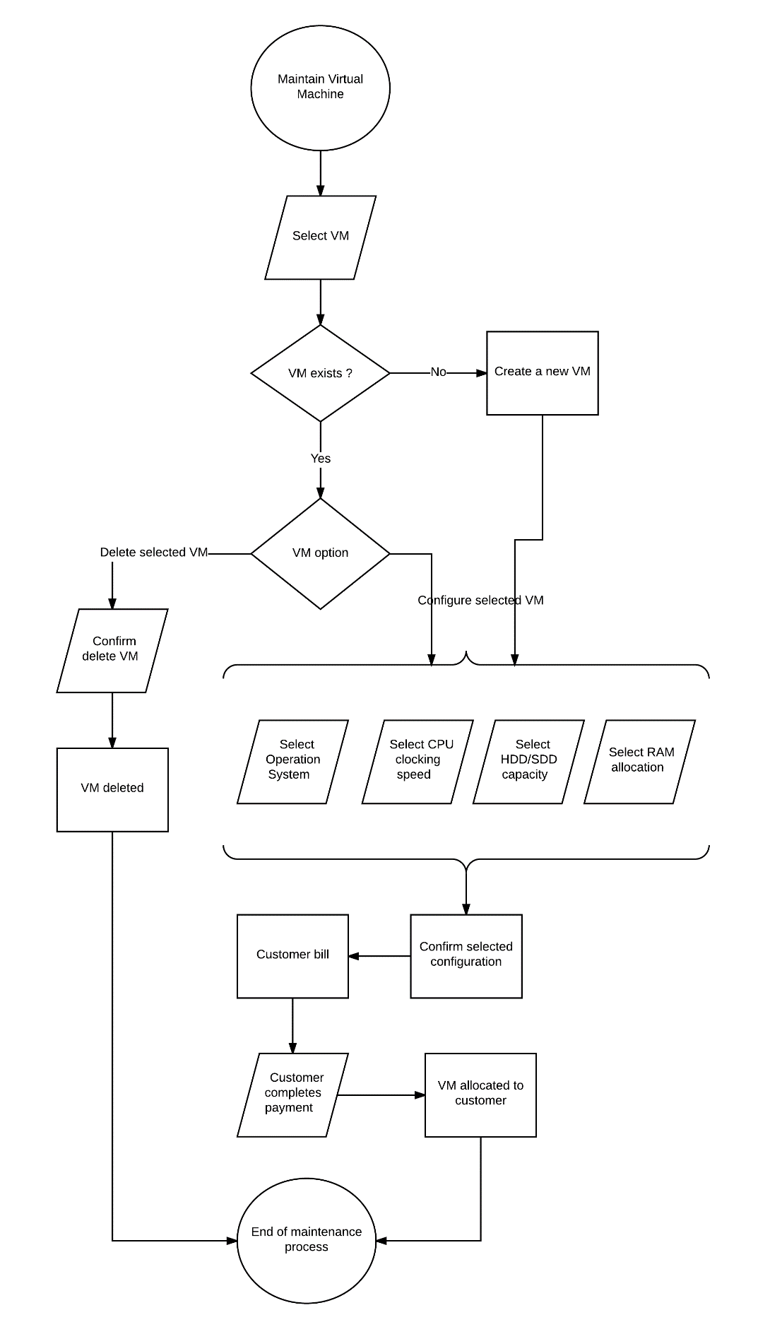

## System reporting Plaintech

