ITopiaLogo

**Project initiation document**

*Project Virtualisation  
Team 2*

|  |  |  |  |
| --- | --- | --- | --- |
| **Client: Arjen Jansen** |  | **Filename:** |  |
| **Project Virtualisation** |  | **Version:** | 1.1 |
| **Author:**  **Rami Haddad, Kasper van Brakel, Reinier van Rooij, Tim Dijkhuizen,  Rakis Bipat & Ingwar Verbeek** |  | **Date:** | 26-10-2014 |

# Document management

## History

| **Version** | **Date** | **Changes (draft/final)** | **Client** | **Author(s)** |
| --- | --- | --- | --- | --- |
| 1.0 | 19-09-2014 | Draft | Arjen Jansen | Rami Haddad, Kasper van Brakel, Reinier van Rooij , Tim Dijkhuizen, Rakis Bipat & Ingwar Verbeek |
| 1.1 | 26-10-2014 | Draft | Arjen Jansen | Rami Haddad, Kasper van Brakel, Reinier van Rooij , Tim Dijkhuizen, Rakis Bipat & Ingwar Verbeek |

## Approval

This document needs the following approvals.

Signed approval forms are stored in the Management section of the project archive.

|  |  |  |  |  |
| --- | --- | --- | --- | --- |
| **Name** | **Role** | **Signature** | **Date document** | **Version** |
|  |  |  |  |  |

# Table of contents

Document management 3

History 3

Approval 3

Table of contents 4

1. Introduction 5

2. Current situation 6

3. Desired situation 7

4. MoSCoW-method 8

5. Project organization 9

6. Roles & responsibilities 10

7. ROI 11

8. Conclusion 15

9. Enclosure 1 team contract 16

Contactmiddelen 16

Contact gegevens 16

Urenverantwoording 17

# Introduction

Plaintech UK is an internationally operating organization with its main headquarters in Birmingham (UK). One division of Plaintech is based in the Netherlands to address the Dutch market and Scandinavia. Plaintech has decades of experience in the hosting business, however, the company has so far only provided services in physical server hosting, which has lately developed into a business disadvantage. The disadvantage being that the majority of the hosting business is moving on to virtualised platforms in order to be more cost effective and to improve our time to market.

The project initiation document will lay the base for this project. The stakeholders of this project are ITopia and Plaintech. The assignment given by Plaintech, is to realize a new system, where customer can rent a virtual server.

Plaintech has demanded, in the request of proposal, a low, mid and high level product. Our ITopia specialists have done research about the cost-benefits, project costs, project schedule, MoSCoW, current situation and desired situation to analyze the results and present the most suitable option to Plaintech.

The end result of the project is to deliver a new virtualized system which will offer many benefits in several fields.

# Current situation

Plaintech UK is an international organization with its headquarters in Birmingham. The organization has a customer database which contain around 50,000 customers. Plaintech delivers physical server hosting services to their customers. Every customer gets one server each, these servers aren’t easy to adapt. This means that Plaintech now has 50,000 servers.

Plaintech has decades of experience with physical server hosting services. These services are getting more old fashioned and competitors are using new methods. Plaintech is getting in a disadvantageous situation on the market, compared to their competitors. They want to use a new method of server hosting services, with different operating systems and more adjustable servers to get back in the market. The organization desires a situation where servers are hosted virtually and with different operating systems.

In the current situation the customers can only choose from Microsoft operating systems. With these operating systems they can discuss what kind of extra software packets they desire. These extra software packages will be installed by the Plaintech administrator.

In the image, shown below, there is schematic design of the current network/system of Plaintech.

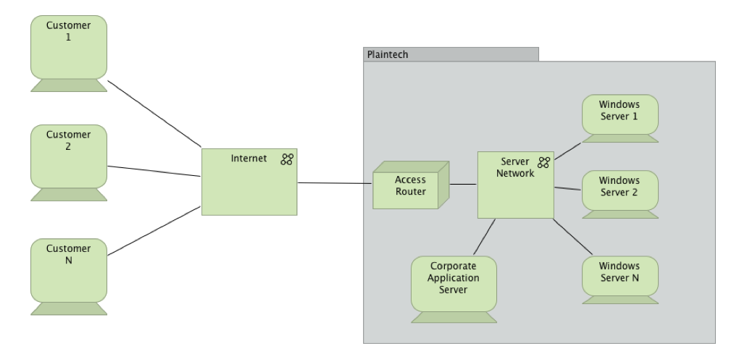

# Desired situation

The desired situation of Plaintech is to have a virtualized hosting environment running on 250 servers with each performing the tasks of 200 users. Each server will run 3 virtual operating systems, Windows Server 2012, Debian and Ubuntu. have been chosen by Plaintech for the desired situation, those Linux distributions are lighter and well suited for a server running several virtual operating systems.

The desired situation in the sales platform is to have the customers of Plaintech be able to order a virtual platform specifying their technical requirements choosing between 3 different service levels based on a low, medium and high end contract. The customers should be able to manager their own server by logging in to their server as an administrator with the ability to configure and install additional products within their virtual environment. The customers should also be able to configure his desired system without intervention from a Plaintech operator, this requires an update of the ordering system which needs several new tools to make the usage of the systems easier for both the employees and customers of Plaintech. Plaintech has mentioned a desired tool in particular that makes it possible to retrieve a management report with an overview of all ordered virtual servers together with basic customer company information and the order date.

This picture describes the desired situation adapted to a virtualized environment, as you can see 1 server runs 3 virtual operating systems, Windows Server 2012, Debian and Ubuntu.

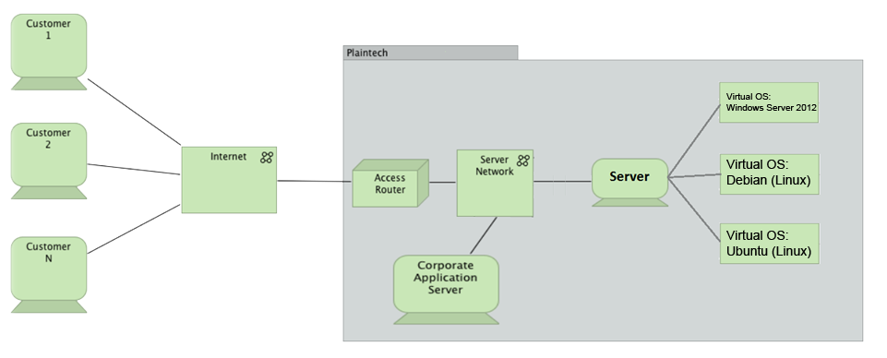

# MoSCoW-method

In an project it is vital to understand the relative importance of things to make progress and keep to deadlines. Prioritization can be applied to requirements, tasks, products, use cases, user stories, acceptance criteria and tests. MoSCoW is a technique for helping to understand priorities.

Must:

* **Virtual platform:** Customers of Plaintech should be able to install Pre-Installed OS’s.
* **Different hosting packages:** Customers of Plaintech should be able to choose between different hosting packages, including operating systems, virtual hardware specifications and software packages.
* **Documentation:** All agreements and plans must be documented in the form of project initiation document, functional design, technical design and manuals.
* **Reseller:** Plaintech uses resellers to make more profit each year.
* **Open Source:** The Pre-Installed OS and Applications that are installed through the virtual platform must be open source. This is mainly to save in the licensing costs.
* **Backup:** There should be a backup available for the whole system, if something goes wrong.
* **Web interface:** Customers of Plaintech should be able to select their desired package via a web interface.
* **No Windows-Only software:** The software should be available for the different operating systems.

Should:

* **Pre-Installed LAMP Server:** Customers of Plaintech should be able to choose a package where a standard LAMP server is presented. This allows customers to host a website, setting up a database and create dynamic content.
* **Bottom boundary:** There should be a bottom boundary or default values of system specification to all of the server packages. This gives Plain Tech a clear picture of what they will lose in performance at least per customer.

Could:

* **Use existing infrastructure:** ITopia can use the existing infrastructure of Plaintech in the elaborated solution, with an eye for energy saving and hardware reuse.
* **Resellers:** Plaintech can choose to take less/more resellers, to save costs/let go faster into profit.

Wont:

* **Nothing beyond the platform itself:** ITopia won’t provide a mobile website, app for external customers or any other form of functionality beyond the platform itself. ITopia only supplies a system to Plaintech that makes it possible to communicate via protocols.
* **Not responsible for customers clients:** Plaintech customers are responsible for their own clients. Plaintech may also choose to outsource to another company to create customized clients.

# Project organization

In this organization you will see which who is involved in this project. The organization has project Plaintech UK, iTopia resources and a development team. Here you can see how the organization is build. There is also an organogram to see who is where connected which each other.

In this Plaintech virtualization project there are several actors who’s a role in this organization. Here are the role’s each member haves. There are 4 Chief Technical Officers, 1 Chief Executive Officer, 1 Plain tech UK representatives. They are determine if the product has all the requirements for this project. This is for to complete the final finished product.

Organigram Plaintech UK:

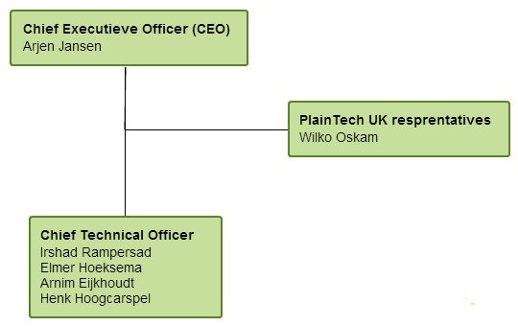

ITopia has also resources to help on this project organization. Here there is also 2 coaches, consultants, technical consultancy, process assessments and one project leader. We as development team needs this ITopia resources for this project. If the development team might come with any problems of technical or non-technical nature, that cannot be unsolvable.

Organigram ITopia: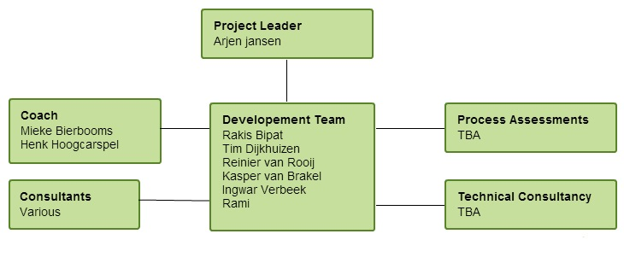

# Roles & responsibilities

In the project virtualization Plaintech is our client. In this project we communicate with the CTO Irshad Rampersad, CFO Wilko Oskam and the CEO Arjen Jansen from the company Plaintech. We will deliver all our products to these three people. They will also judge if our delivered products meet their requirements.

In this project Plaintech hired us to create a new virtual hosting system for their company. We are employed by ITopia who divided all their employees into groups of six persons. In total there are ten groups. In this project all project members are equal. There is not a specific project leader everyone has the same responsibility’s.

All tasks that must be done will be distributed to all team members so that everyone does the same amount of work. All tasks will be written in the planning so that everyone can keep track for when their work has to be finished. In this project it is required that every team members has the same knowledge about the technical aspects of our delivered product. Because of this most tasks will be done in group form so that everyone has the same technical knowledge of our product.

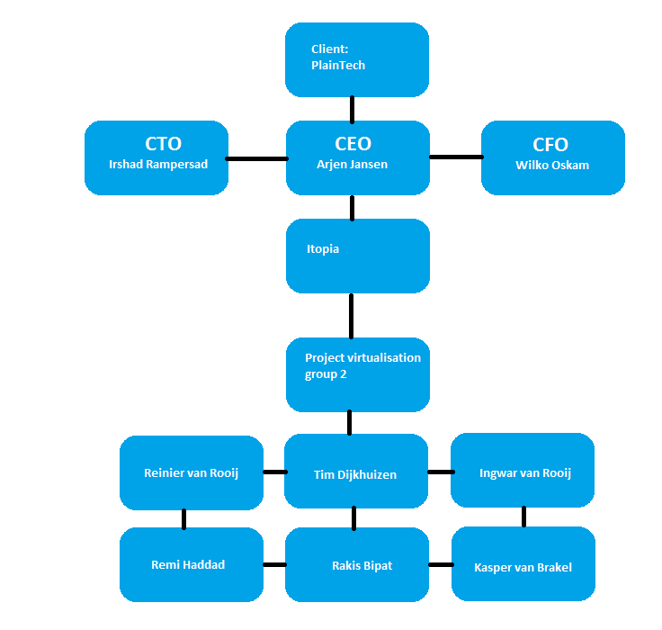

# ROI

As ITopia we have to present Plaintech a plan how to we think is the best plan to start up a virtual hosting company that can be competitive with the competition

We selected one server we think is good for starting a VPS hosting company:

* A Dell PowerEdge R820
* 2x Intel® Xeon® E5-4657L v2 2.4GHz, 30M Cache, 8.0GT/s QPI, Turbo, 12C
* (48) 16 gb ram

Price for one : *€* 37,014.00

We have chosen this server because it’s fast and has allot of ram memory. Thanks to this we can serve allot of customers with one server and stay at a competitive price compared with the competition.

We also selected a San for storage solutions:

* Dell PowerVault MD3660f
* (60) 3TB, 7.2K, NLSAS 6GB Self-Encrypting, 3.5 HDD

Price for one: *€ 66,703.00*

|  |  |  |  |  |
| --- | --- | --- | --- | --- |
|  | Quantity | Cost per unit |  | total |
|  |  |  |  |  |
| Cost servers | 400 | € 37,014.00 |  | € 14,805,600.00 |
| Cost San | 35 | € 66,703.00 | + | € 3,641,860.00 |
|  |  |  | Total costs | € 17,140,205.00 |

Licensing cost:  
Thanks to ITopia we will have zero to none licensing costs. This is a big advantage for Plaintech and saves them allot of money. We can do this by using almost only open source software based in a Linux environment. The only real licensing cost will be the costs for hosting the Windows VPS as demanded in the request for proposal.

**Returning costs**

*Estimated cost utilities:*

|  |  |  |  |  |  |  |
| --- | --- | --- | --- | --- | --- | --- |
|  | KhW server | Price per kwh (18/9/2014) | Quantity of servers | Hours in a year | Quarterly | Year |
| Cost power | 2.2 | € 0.23 | 435 | 8,760.00 | € 482,040.90 | € 1,928,163.60 |

***Serviceplans***

*Service plan 1:*

|  |  |  |  |  |  |
| --- | --- | --- | --- | --- | --- |
| Service plan 1 | Customers | Cost for service plan | Monthly | Quarterly | Yearly |
|  |  |  |  |  |  |
| Year 1 | 24500 | € 25.00 | € 612,500.00 | € 2,450,000.00 | € 7,350,000.00 |
| Year 2 | 29000 | € 25.00 | € 725,000.00 | € 2,900,000.00 | € 8,700,000.00 |
| Year 3 | 38000 | € 25.00 | € 950,000.00 | € 3,800,000.00 | € 11,400,000.00 |
| Year 4 | 53000 | € 25.00 | € 1,325,000.00 | € 5,300,000.00 | € 15,900,000.00 |
| Year 5 | 75000 | € 25.00 | € 1,875,000.00 | € 7,500,000.00 | € 22,500,000.00 |

*Service plan 2:*

|  |  |  |  |  |  |
| --- | --- | --- | --- | --- | --- |
| Service plan 2 | Customers | Cost for service plan | Monthly | Quarterly | Yearly |
|  |  |  |  |  |  |
| Year 1 | 25000 | € 49.00 | € 1,225,000.00 | € 4,900,000.00 | € 14,700,000.00 |
| Year 2 | 35000 | € 49.00 | € 1,715,000.00 | € 6,860,000.00 | € 20,580,000.00 |
| Year 3 | 45000 | € 49.00 | € 2,205,000.00 | € 8,820,000.00 | € 26,460,000.00 |
| Year 4 | 55000 | € 49.00 | € 2,695,000.00 | € 10,780,000.00 | € 32,340,000.00 |
| Year 5 | 65000 | € 49.00 | € 3,185,000.00 | € 12,740,000.00 | € 38,220,000.00 |

*Service plan 3:*

|  |  |  |  |  |  |
| --- | --- | --- | --- | --- | --- |
| Service plan 1 | Customers | Cost for service plan | Monthly | Quarterly | Yearly |
|  |  |  |  |  |  |
| Year 1 | 5000 | € 79.00 | € 395,000.00 | € 1,580,000.00 | € 4,740,000.00 |
| Year 2 | 5500 | € 79.00 | € 434,500.00 | € 1,738,000.00 | € 5,214,000.00 |
| Year 3 | 6000 | € 79.00 | € 474,000.00 | € 1,896,000.00 | € 5,688,000.00 |
| Year 4 | 6500 | € 79.00 | € 513,500.00 | € 2,054,000.00 | € 6,162,000.00 |
| Year 5 | 7000 | € 79.00 | € 553,000.00 | € 2,212,000.00 | € 6,636,000.00 |

***Estimated revenu:***

|  |  |  |  |
| --- | --- | --- | --- |
| Revenue | Monthly | Quarterly | Yearly |
|  |  |  |  |
| Year 1 | € 2,232,500.00 | € 6,697,500.00 | € 26,790,000.00 |
| Year 2 | € 2,874,500.00 | € 8,623,500.00 | € 34,494,000.00 |
| Year 3 | € 3,629,000.00 | € 10,887,000.00 | € 43,548,000.00 |
| Year 4 | € 4,533,500.00 | € 13,600,500.00 | € 54,402,000.00 |
| Year 5 | € 5,613,000.00 | € 16,839,000.00 | € 67,356,000.00 |

***Estimated profit:***

|  |  |  |  |
| --- | --- | --- | --- |
| Profit | Monthly | Quarterly | Yearly |
|  |  |  |  |
| year 1 | € 643,469.28 | € 1,930,407.85 | € 7,721,631.40 |
| year 2 | € 2,713,819.70 | € 8,141,459.10 | € 32,565,836.40 |
| year 3 | € 3,468,319.70 | € 10,404,959.10 | € 41,619,836.40 |
| year 4 | € 4,372,819.70 | € 13,118,459.10 | € 52,473,836.40 |
| year 5 | € 5,452,319.70 | € 16,356,959.10 | € 65,427,836.40 |
|  |  |  |  |
| ROI |  | 746% | |
| Simple annualized ROI |  | 149% | |
|  |  |  | |
| Return on investment |  | 234 days | |

# Conclusion

Plaintech has to update it’s technological infrastructure to keep up with the competitive market as a large market share holder in the hosting business. As you have read our project initiation is well planned and prepared, our professional team has the know-how and skills to realize this project to the full extent of Plaintech requirements and beyond. ITopia offers flexibility in options and professional service. Our next phase is the functional design, the early version of our functional design will establish a concept of functionalities and abilities of our desired environment. ITopia will present Plaintech with the situation every 2 weeks, this will give Plaintech a good idea about our progress. We hope to have informed you sufficiently and look forward to continuing our cooperation.

# Enclosure 1 team contract

**Inleiding**In dit contract zullen de regels en werkwijzen worden omschreven die wij als projectgroep zullen na leven na ondertekening van dit document. Ook zal de verwachtingen van deze groep worden toegelicht in grove lijnen, om misverstanden te voorkomen.

**Contact**

Contactmiddelen

Het houden van contact met de projectgroepsleden en de leiding zal voornamelijk plaatsvinden doormiddel van vergaderingen en werkmomenten.

Ook zal er veelvuldig gebruik gemaakt worden van e-mail en telefoon.

Contact gegevens

|  |  |
| --- | --- |
| Kasper van Brakel  06 36514454  Kaspervanbrakel94@gmail.com | Rami Haddad  06 81016588  r.haddad@hva.nl |
| Reinier van Rooij  06 15192267  Reinier.van.rooij@hva.nl | Tim Dijkhuizen  06 39795352  Tim.dijkhuizen2@hva.nl |
| Ingwar Verbeek  06 43571588  Ingwar.verbeek@hva.nl | Rakis Bipat  06 20239613  Rakis.Bipat@hva.nl |

**Proces-/Inhoudelijke regels en werkoverleg**

**Bekendmaking**

De datum, het tijdstip en de locatie van het geplande overleg dient minimaal 24 uur voor aanvang bekend en goedgekeurd te zijn door de uitgenodigde.

**Aanwezigheid**

Het is verplicht tijdens inhoudelijke begeleiding, procesbegeleiding & projectvergadering aanwezig te zijn.

**Afwezigheid met kennisgeving**

Mocht een persoon een geldige reden hebben om niet aanwezig te zijn bij een gepland overleg wordt dit gemarkeerd als ‘Afwezigheid met kennisgeving’. Denk hierbij aan:

* Ziekte
* Familieomstandigheden
* Overmacht

Afwezigheid met kennisgeving wordt getolereerd binnen de projectgroep.

Bij afwezigheid dient men zich van te voren afgemeld te moeten hebben bij de sub-teamleider en de projectgroepsleden.

**Afwezigheid zonder kennisgeving**

Afwezigheid zonder kennisgeving wordt niet getolereerd. Het wegblijven zonder gegronde reden in de momenten waarop de projectgroep samenkomt wordt middels de volgende procedure behandeld:

* Bij een eenmalige overtreding van de regels zal er een gesprek gevoerd worden met de projectleider, inhoudelijke begeleider en de projectgroep.
* Wordt de overtreding 2 maal begaan dan betekend dit het einde van de samenwerking.

**Agenda**

De agenda dient 1 werkdag voor de vergadering op Drop box te worden gezet, en naar alle betrokkenen verstuurd te worden.

**Notulen**

De notulen dienen 1 werkdag na plaats vinding van de vergadering op Drop box beschikbaar te zijn, voor de overige projectleden. De uitgenodigde ontvangen de notulen maximaal 2 werkdagen na plaats vinding van de vergadering.

Urenverantwoording

Ieder projectlid is verantwoordelijk voor zijn eigen urenverantwoording. Wel is het projectlid verplicht deze bij te houden en op basis van aanvraag aan te tonen bij zowel de docenten als (Sub-)teamleiders.

**Cultuur**

**Openheid en Respect**

In de projectgroep wordt het door allen geaccepteerd dat ieder zijn mening kan geven. Ieder mag kenbaar maken dat hij het eens/oneens is, dit dient te gebeuren op een respectvolle manier.

De voorzitter van het betreffende overleg ziet hierop toe en grijpt in waar nodig.

**Inzet en Stiptheid**

De projectgroep verwacht van iedereen een volle inzet in het project. Hierbij geldt dat de gevraagde producten volgens planning en volgens de eisen & wensen van de opdrachtgever worden ingeleverd.

Bij een maal niet nakomen van afspraken, krijgt degene een waarschuwing, bij 2 maal overtreding, betekent het einde van de samenwerking.

**Dreigende conflicten**

Bij een dreigend conflict zal er een gesprek volgen met de gehele projectgroep. Mocht hier geen uitsluitsel uit volgen, wordt er actie ondernomen in samenwerking met de begeleiders. In de eerste instantie zal er worden uitgezocht waar het conflict vandaan komt alvorens we dit proberen op te lossen. Mocht het zover komen dat hierbij geen passende maatregel wordt bedacht, dan is de begeleider verantwoordelijk voor het vinden van een passende oplossing voor het probleem.

**Verwachtingen**

**Begeleiders**

* Begeleiders dienen voldoende sturing te bieden aan de projectmedewerkers waar dit nodig is, en in te grijpen bij dreigende conflicten wanneer dit niet door de medewerkers zelf op te lossen is.
* Begeleiders dienen de medewerkers te voorzien van voldoende informatie zodat zij hun werk volgens opdracht kunnen uitvoeren.
* Mochten medewerkers via Telefoon of e-mail contact proberen te zoeken met de begeleiders, zijn zij verplicht om binnen twee werkdagen te antwoorden.

**Opdrachtgever**

* Van de opdrachtgever wordt verwacht dat hij/zij duidelijk is in zijn/haar standpunten zodat de medewerkers hier een goede probleemstelling & opdracht uit kunnen formuleren.
* Ook voor de opdrachtgever geldt dat hij/zij binnen twee werkdagen antwoord geeft wanneer medewerkers proberen om contact te leggen.

**Projectgroep**

* Van de medewerkers wordt verwacht dat zij punctueel zijn en de afgesproken deadlines niet overschrijden.
* Daarnaast wordt er van de medewerkers een duidelijke beschrijving van de producten verwacht, eventueel een bijbehorende woordenlijst waarin moeilijke termen uitgelegd staan.
* Medewerkers dienen gestructureerd te werk te gaan; op deze manier is de kans op verwarring het kleinst en weet iedereen wat er op een bepaald punt van hem/haar verwacht wordt.
* Als laatste dienen medewerkers correct werk op te leveren, zij zijn immers uitgekozen om hun specialisme.

**Handtekeningen**

|  |  |
| --- | --- |
| *Naam: Kasper van Brakel* | *Naam:Tim Dijkhuizen* |
| *____________________________* | *____________________________* |
| *Naam: Ingwar Verbeek* | *Naam: Reinier van Rooij* |
| *____________________________* | *___________________________* |
| *Naam: Rakis Bipat* | *Naam: Rami Haddad* |
| *________________________________* | *____________________________* |