What are Opinions? Integrating Theory and Methods for Automatically Analyzing Opinionated Communication (OPINION)

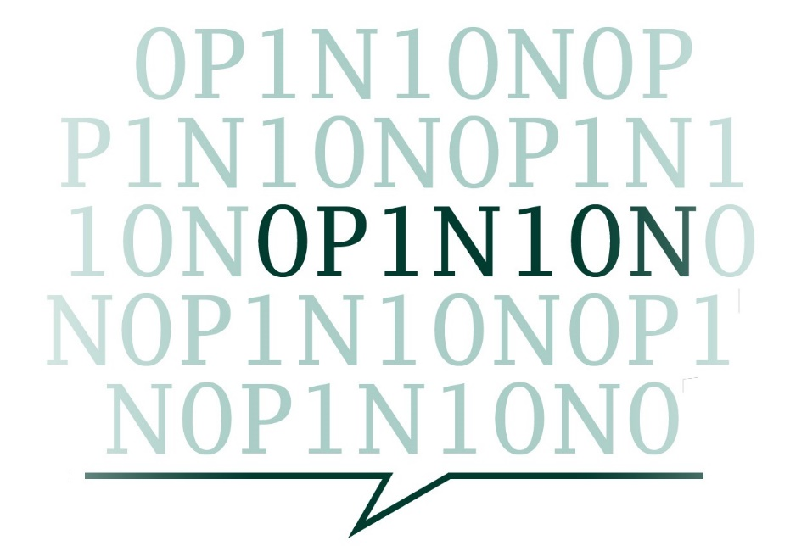

**STAKEHOLDER ANALYSIS & ENGAGEMENT STRATEGY**

COST ACTION CA21129 OPINION

Prepared by Elena Negrea-Busuioc (Stakeholder Liaison Officer)

in collaboration with WG4

**STAKEHOLDER ANALYSIS & ENGAGEMENT STRATEGY**

COST ACTION CA21129 OPINION

Prepared by Elena Negrea-Busuioc (Stakeholder Liaison Officer)

in collaboration with WG4

CONTENTS

1. Summary
2. Stakeholder identification
3. Stakeholder analysis and mapping
4. Stakeholder engagement plan
5. **Summary**

OPINION network seeks to bring together scholars and researchers from different disciplines and countries who are interested in the study of the public expression of opinions in the digital era. The Action aims to build a shared understanding of the multifaceted concept of *opinions* by bringing together insights from various fields such as journalism studies, media studies, political communication, computational linguistics, discourse studies, information science. Furthermore, the Action aims to advance and extend opinion-oriented research beyond academia by strengthening the collaboration with relevant stakeholders (e.g., media industry, policy makers, regulatory authorities) who might contribute to the Action as well as benefit from its outcomes. OPINION will ensure that the theoretical advances and the measurement tools developed during implementation are easily usable by and available to external users who seek to better understand, monitor, and track opinion formation in digital environments.

As stipulated in the Action’s Memorandum of Understanding, OPINION has two main objectives: **a) to ensure research coordination** (to advance theoretical and methodological knowledge of opinions and opinionated communication across disciplines), **b) to enhance capacity-building** (to foster knowledge transfer and exchange across disciplines and relevant industry sectors). In line with these objectives, OPINION will engage **four main stakeholder groups** to ensure the success of the Action by supporting communication, maintaining inclusion, mitigating risks and maximizing impact. These main stakeholder groups are: 1) **the research community**, 2) **policy makers**, 3) **media industries** and 4) **the general public**. The management of stakeholders will be carried out by OPINION’s Stakeholder Liaison Officer who is responsible for overseeing the **Stakeholder Analysis & Engagement Strategy**, in collaboration with WG4. The purpose of the Strategy is twofold: first, it **identifies and maps relevant stakeholders** based on their potential interest in the Action and power to influence it. Secondly, the Strategy **formulates a coherent and robust stakeholder relationship management plan** to maximize stakeholder engagement and enable them to positively impact and be impacted by the Action. Stakeholder involvement is key to the success of the Action (as stipulated in the MoU and the Science Communication Plan) given OPINION’s goal to develop theoretical knowledge and computational tools for textual opinion research that are validated and used by a wider industry and community interested in the analysis and measurement of opinions expressed online.

The Stakeholder Analysis & Engagement Strategy is subject to Core Group and MC review and approval and will be updated every 6 months at WG/ MC meetings. Relevant stakeholders will be identified and mapped on an ongoing basis and the engagement plan will be updated accordingly.

1. **Stakeholder identification**

To achieve its research coordination and capacity-building objectives described in the MoU, OPINION will reach out to scholars interested in opinion research across disciplines, languages and geographical contexts, career stages, ages or genders. At the same time, the Action will engage stakeholders from politics, media, social media companies, regulatory authorities to ensure the transferability and dissemination of results (knowledge and computational tools for the study of opinion) beyond academia and to foster partnerships between relevant industries and the OPINION research network.

Four main stakeholder groups have been identified as key to ensure the success of the Action in terms of impact and dissemination. These groups are:

1. **The research community**: includes researchers from Europe and beyond, primarily those working in the areas of journalism, communication studies, media studies, computational linguistics and information science, social sciences, digital sociology and political communication.
2. **Media industry**: comprises public and private companies, including SMEs, in the fields of social media, journalism, publishing, market research and tech sector (e.g., media and journalism organizations, digital media start-ups, media analytics and consultancy companies).
3. **Policy makers**: includes regulatory authorities at the EU, national and local levels (e.g., DG on Communication Networks, Content and Technology, European Education and Culture Executive Agency (EACEA), European Broadcasting Union (EBU), European Regulators Group for Audiovisual Media Services (ERGA), the European Platform of Regulatory Authorities (EPRA). Given the power of regulatory authorities to oversee policy making, evaluation and recommendation, OPINION will create a designated role of Action Policy Liaison who will be responsible of building a close relationship with relevant stakeholders in that group. The Policy Liaison will consult with regulatory authorities in order to identify opportunities for issuing policy documents and for informing media policies in Action countries and at the EU level. The Policy Liaison will work closely with the Stakeholder Liaison Officer and will correlate efforts to disseminate the Action outcomes and to reach out to policy makers and interest groups.
4. **The general public**: all individuals and institutions interested in the study and measurement of opinions expressed online, including students and professors in the fields of journalism, communications sciences, political science, media studies, computational linguistics and information science. Stakeholders in opinion-related education and research will benefit from the open access materials and tools developed by the Computational Communication Lab (D3.3., Month 48) designed and build by WG3 based on input from WG1 and WG2. This stakeholder group also includes representatives of civil society who will be invited to share their perspective on opinion formation and dissemination (Year 3 and 4).

This general description of the stakeholders relevant to the successful implementation and the efficient dissemination of OPINION outcomes (as stipulated in the MoU) has enabled the Action Core Group and the WG4 Dissemination & inclusion to identify specific organizations and institutions that may be interested in and/ or affected by the results of OPINION, in several countries participating in the Action. The identification of national stakeholders is a continuous task in which all Action members are involved. A shared document has been to be filled in with national representatives for each stakeholder category. The active Google Sheet can be accessed here: <https://docs.google.com/spreadsheets/d/1G5t24aWS7AzgBgTJ3BEWk8og2UDrqUvkKSLd62D5w3A/edit?pli=1#gid=0>

The Action comprises 173 members from over 35 European countries, Israel and the US. The following table summarizes the total number of identified stakeholders (including Action members) at the time of the drafting of this Strategy.

|  |  |  |
| --- | --- | --- |
| **Stakeholder group** | **People/ institutions/ organizations** | **Countries** |
| Action members | 173 | Norway, Sweden, Finland, Denmark, Latvia, Lithuania, Estonia, Poland, Germany, the Netherlands, Belgium, Luxembourg, Czechia, Switzerland, Austria, Hungary, Romania, Moldavia, Slovenia, Croatia, Serbia, Bosnia & Herzegovina, Montenegro, Kosovo, North Macedonia, Albania, Greece, Cyprus, Turkey, Italy, France, Spain, Portugal, United Kingdom, Ireland, Israel, United States |
| Media industries | 53 | Norway, Serbia, Romania, Spain, the Netherlands, Lithuania, Hungary, Germany, Portugal, Czechia, Bosnia & Herzegovina |
| Tech sector | 16 | Norway, Serbia, Romania, Spain, the Netherlands, Lithuania, Hungary, Germany, Portugal |
| Policy | 32 | Norway, Serbia, Romania, Spain, the Netherlands, Lithuania, Hungary, Germany, Portugal, Czechia, Bosnia & Herzegovina |
| Civil sector | 42 | Norway, Serbia, Romania, Spain, the Netherlands, Lithuania, Hungary, Germany, Portugal, Czechia, Bosnia & Herzegovina |
| **Total identified stakeholders** | **316** |  |

The Stakeholder Analysis & Engagement Strategy includes measures to efficiently manage the identified stakeholders and to attract new ones whose involvement in OPINION would be beneficial in terms of dissemination and impact. In accordance with the principles of COST Actions, the Strategy will be cross-disciplinary and strongly inclusive, seeking a balanced involvement of stakeholders from COST member countries (particularly ITCs) and from various stakeholder groups indicated above.

1. **Stakeholder analysis and mapping**

Engaging stakeholders is crucial for the success of OPINION; managing the stakeholders’ involvement efficiently will maximize the impact of the Action within the research community and beyond. The identified stakeholder groups were mapped using the **power/interest matrix** which allowed for the **assessment of stakeholder’s level of engagement** and for **the adoption of a suitable approach** to every stakeholder profile.

The power/ interest matrix helped guide the assessment of stakeholder engagement and the response strategies to be employed (i.e., satisfy, engage, inform and monitor). Based on their level of interest and level of influence, the identified stakeholders occupied different positions on the matrix, which led to the emergence of the following categories (see Figure 1 below):

* **High power and low interest stakeholders**: media industry (including the tech sector), policy makers. OPINION will constantly **monitor their satisfaction**, they will be **kept informed** of all Action outcomes, specific action will be taken to **raise their interest** to higher levels. Journalists, social media freelancers, representatives of media outlets and of the tech sector **will be invited to planned Action events** (General Assemblies, WG meetings, stakeholder specialized sessions, etc.) as keynote speakers, trainers or workshop and training participants. In the case of policy makers, a designated Action Policy Liaison will closely monitor their involvement in the Action and will identify opportunities for collaborating to issue policy recommendations relevant to the expression of opinionated communication in digital environments.

Interest

Power

+

SATISFY

Media industry (including tech sector)

Policy makers

ENGAGE

Action members

Early-stage researchers

MONITOR

General public

Students

Teachers

INFORM

Civil society

Research community

-

- +

Figure 1. Stakeholder power/interest matrix

* **High power and high interest stakeholders:** all Action members (internal stakeholders) must **be engaged** in the activities of the WGs for which they have applied. Action members will also **be involved in joint decisions** regarding the implementation of the Action planned activities. Early career researchers, in particular, will **be closely informed and stimulated** to participate in Short-Term Scientific Missions (STSMs) which will be organized continually and administered by the Grant Manager. Furthermore, Action members will be encouraged participate to established academic conferences to promote OPINION and to identify new members whose involvement will be highly beneficial to the Action.
* **Low power and high interest stakeholders:** the wider research community **will be kept informed** about the OPINION outcomes via the Action website, media appearances, public debates and other dissemination events. All ideas, tools, data and standards generated within OPINION, particularly the Computational Communication Lab, will be made available to the interested scholars freely on open-source sharing platforms, such as GitHub and OSF. Additionally, academics and representatives of civic society will **be extended the invitation to participate in dedicated stakeholder sessions** (e.g., keynote addresses, stakeholder round tables), where they will be given the opportunity to share their perspectives on the topic of the Action.
* **Low power and low interest stakeholders:** the general public, students and teachers interested in the expression and measurement of opinionated communication **will have free and easy access** **to information** about the theoretical advancements and methodological tools developed by OPINION via the Action website, media events, social media communication (e.g., X, LinkedIn, Instagram, Facebook), public debates, which will be facilitated by partners in the public library sector.

The Stakeholder Analysis & Engagement Strategy is **a targeted inclusion strategy** which focuses on devising an efficient plan to involve relevant stakeholders in the Action, from different COST member countries (particularly ITCs), from different academic backgrounds, different languages, genders, ages, or career stages. Furthermore, OPINION will facilitate partnership building between action members and between academia and media industry/ representatives of the civic society/ policy makers.

1. **Stakeholder engagement plan**

The Strategy uses the stakeholder analysis and mapping (the power/interest matrix) to devise an efficient stakeholder engagement plan which provides a clear outline of actions aimed at keeping the relevant stakeholders engaged with and informed of the OPINION outcomes. The stakeholder engagement plan is correlated with the OPINION implementation plan, work packages, WG-specific objectives, milestones and deliveries.

The stakeholder engagement plan is also correlated with the approved Action Science Communication Plan which describes OPINION target audiences and communication actions to be taken to keep the public informed about the Action activities and outcomes.

|  |  |  |  |  |  |
| --- | --- | --- | --- | --- | --- |
| **Stakeholder profile** | **Stakeholder type** | **Actions & stakeholder specialized sessions (StS)** | **Number/ Timeframe** | **Deliverables** | **Responsible** |
| SATISFY | Journalists  Media people  Market research people  Social media freelancers  Tech sector people  Publishers  Policy makers | Stakeholder round table (StS) | 2/ year, organized within GAs (day 2) | Recording  Minutes | Stakeholder Liaison Officer (SLO)  Local host  WG4 chairs  Core Group  MC |
| Journalists  Social media people | Keynote addresses | GAs Year 2 thru 4 (Q4) | Recordings  PPTs | SLO  WG4 chairs  Core Group  MC  Local host |
| Policy makers | Consultation (StS) | 4/ year | Recordings  Minutes  Policy briefs (at least 3) | Policy Liaison Officer  Core Group  MC  WG1 |
| ENGAGE | Action members  Early-stage researchers | General Assembly (GA) | 3-day events  2/ year, Year 1 thru 4 (Q2 and Q4) | Minutes  Recordings | Core Group  MC  WGs chairs  SLO  Local host |
| STSMs | 5/ year | Mission reports | Grant Awarding Coordinator  MC  WG4 |
| Training events | 2 (Year 2 & Year 3) | Materials  Tools  Recordings | MC  WG2  SLO |
| Action members  Early-stage researchers | Masterclasses | 4/ year (Q2), organized within GAs (day 3) | Materials  Recordings | MC  WG2  SLO |
| Action members  Early-stage researchers | Workshops | 4/ year (Q2), organized within GAs (day 2) | Materials  Recordings | MC  WG1  WG2  SLO |
| Action members  Early-stage researchers | Academic conferences | ICA, ECREA, ECPR  IPSA  EPSA ACL  (Year 1 thru 4, depending on conference dates) | Presentations  Publications  Panels | Science comm coordinator  MC  Core Group  WGs chairs |
| INFORM | Academics | Stakeholder round table (StS) | GAs Year 2 thru 4 (Q4) | Presentations  Recordings  Minutes | SLO  Core Group  WG1  Local host |
| Keynote addresses | GAs Year 2 thru 4 (Q2) | Recordings  Ppts | SLO  Core Group  WG1  Local host |
| Civic society people | Stakeholder round table (StS) | 2/ year, organized within GAs (day 2) | Recording  Minutes | SLO  Local host  WG4 chairs  Core Group  MC |
| MONITOR | Students  Professors  General public | Action website | Ongoing  Regular updates | Content | Science comm coordinator  Core Group  WGs chairs |
| Social media communication | Ongoing | Posts | Science comm coordinator  Core Group  MC  WGs chairs |
| Public events | At least 15 regional events, Year 1 thru 4 | Minutes  Recordings | Science comm coordinator  Core Group  WGs chairs |

Table 1. Stakeholder engagement plan (September 2023)

The first 2024 Joint Working Group Meeting will be held at the Cyprus University of Technology in Limassol (Cyprus) on Thursday 18 and Friday 19 January. The Stakeholder Liaison Officer together with the Core Group, WG 4 chairs and the local host, Dimitra Milioni, will ensure that the identified stakeholders are informed and engaged in accordance with the stakeholder engagement plan included in the approved Stakeholder Analysis & Engagement Strategy.