Exercise 2 — A Complete Comparison of Multilevel Queue Scheduling with EDF and RM
General-purpose versus real-time scheduling: theory, analytic tests and measured results
Exercise: 2 — MLQ / EDF / RM comparison
Course: Advanced Operating Systems
Topic: General-purpose versus real-time scheduling
Deliverables: Bilingual report (DOCX + PDF), runnable Python code, diagrams
Repository: github.com/kaspian021/Multilevel-Queue-Scheduling
Branch: Exercise-2-MLQ-EDF-RM-Comparison
Evaluation: discrete simulation plus exact analytic tests
Status: complete — every number below comes from an actual program run

Table of contents
Abstract, keywords and reading map .... 3
Introduction and problem statement .... 4
Goals, research questions and method .... 5
Fundamentals (1): real-time versus general-purpose scheduling .... 6
Fundamentals (2): the task model and its assumptions .... 7
Earliest Deadline First (EDF) .... 8
Rate Monotonic (RM) .... 9
Deadline Monotonic and the role of MLQ in this comparison .... 10
Comparing fundamental properties (1): preemption, priority and deadlines .... 11
Comparing fundamental properties (2): metrics, predictability and fairness .... 12
Designing the fair comparison scenario .... 13
Scenario A: measured results .... 14
Scenario A: Gantt charts .... 15
Scenario A: the behaviour of MLQ .... 16
Scenario B: the high-pressure test .... 17
Scenario B: Gantt charts and decision walkthrough .... 18
The Liu and Layland bound versus the exact RM test .... 19
EDF schedulability and the processor-demand criterion .... 20
Randomised feasibility study .... 21
Scenario C: an aperiodic workload outside the real-time model .... 22
Scenario C: results and interpretation .... 23
Scenario D: behaviour under overload .... 24
Scenario D: Gantt charts and the design message .... 25
Aggregate comparison charts .... 26
Jitter and scheduling overhead .... 27
CPU utilisation across the four scenarios .... 28
Comprehensive comparison table .... 29
Analysis of the results .... 30
Advantages and disadvantages of each algorithm .... 31
Applications, limitations and assumptions .... 32
Conclusion .... 33
References .... 34
Appendix: outputs and requirement mapping .... 35

Abstract, keywords and reading map
Abstract
Comparing scheduling algorithms only makes sense when they are driven by the same workload, the same timing model and the same measurement code. This report implements Multilevel Queue (MLQ), Earliest Deadline First (EDF) and Rate Monotonic (RM) inside one shared discrete harness and evaluates them on four scenarios.
Beyond measurement, the exact analytic tests were implemented as well: response-time analysis for fixed priorities and the processor-demand criterion for EDF. In the high-pressure scenario with a utilisation of 0.9714, response-time analysis predicts that RM is infeasible and the simulator records exactly the three deadline misses that the analysis implies, while EDF runs without a single miss. A randomised study over 2329 task sets shows that in the utilisation band 0.90-1.00 only 17.8% of the sets are feasible under RM, against 100% under EDF.
Keywords
Real-time scheduling; EDF; RM; multilevel queue; deadline; period; Liu and Layland bound; response-time analysis; processor-demand criterion; predictability; fairness; starvation.
Reading map
• Sections 1-5: fundamentals, real-time versus general-purpose scheduling, task model.
• Sections 6-10: the three algorithms and their structural differences.
• Sections 11-16: the fair comparison scenario and the measured results.
• Sections 17-20: analytic tests and the randomised feasibility study.
• Sections 21-25: aperiodic and overload scenarios, the master table, conclusions.

Introduction and problem statement
Problem statement
The question of this exercise is: how does the multilevel queue algorithm introduced in exercise 1 compare with the two classical real-time algorithms EDF and RM? The short answer is that the three were designed for three different problems, so a direct comparison without a carefully defined workload is misleading.
Scope of the comparison
• General-purpose scheduling aims at average metrics, fairness and responsiveness.
• Real-time scheduling aims at guaranteeing every deadline, at every instant.
• EDF and RM belong to the second family; MLQ belongs to the first.
• A numerical comparison therefore requires a task set with shared parameters.
The usual trap
Methodological warning: Comparing these three algorithms while ignoring their different nature is like comparing a family car with a truck on the basis of top speed on one road. A number comes out, but the interpretation is not valid. In this report every claim is stated together with the scenario and the range over which it holds.
• One shared simulation harness for all three algorithms.
• Four scenarios: fair comparison, high pressure, aperiodic load and overload.
• Independent analytic tests to confirm the measured results.
• A comprehensive comparison table with the limitations stated explicitly.

Goals, research questions and method
Overall goal
To deliver a scientific, documented and reproducible comparison between MLQ and the two real-time algorithms EDF and RM, separating clearly what was measured from what was proved analytically.
Specific objectives
• Explain the difference between real-time and general-purpose scheduling.
• Present the formal periodic task model and its assumptions.
• State the Liu and Layland sufficient condition for RM and show that it is not necessary.
• Implement the exact RM test based on response-time analysis.
• Implement the exact EDF test based on the processor-demand criterion.
• Design a fair comparison scenario and justify why it is fair.
• Measure response, turnaround, waiting, utilisation, fairness and overhead.
Research questions
• Under what conditions does RM fail while EDF succeeds?
• Can MLQ replace a real-time algorithm on a real-time workload?
• How large is the price of predictability, measured in context switches?
• Which algorithm behaves best under overload?
Method
• Implement all three algorithms inside one discrete simulator.
• Define four scenarios with explicit parameters and a fixed horizon.
• Run everything automatically and store every output as text and JSON.
• Cross-check the measurements against independent analytic tests.
• Generate every figure from the real data and analyse it numerically.

Fundamentals (1): real-time versus general-purpose scheduling
General-purpose scheduling
• Goal: optimise average metrics and keep the processor busy.
• Input: a set of processes with arrival times and burst lengths.
• Key concept: average waiting time, turnaround time and response time.
• Success means: better averages, more fairness, adequate responsiveness.
• Failure means: slowness, not necessarily the violation of a specific timing commitment.
Real-time scheduling
• Goal: meet the deadline of every job, at every instant.
• Input: periodic tasks with a worst-case execution time, a period and a deadline.
• Key concept: schedulability, not average metrics.
• Success means: not a single deadline is missed.
• Failure means: a missed deadline, which in hard systems can be catastrophic.
Dimension | General-purpose | Real-time
Goal | better averages | guarantee the deadline
Success criterion | average metrics | schedulability
Evaluation method | measurement and simulation | exact analytic test
Role of averages | central | almost meaningless
Examples | FCFS, RR, MLQ | RM, EDF, DM
Table 1. The fundamental difference between the two families
Key point: A common mistake in student reports is to use average waiting time as evidence that one real-time algorithm beats another. In real-time scheduling a task set that misses one deadline has failed, however good its average is.

Fundamentals (2): the task model and its assumptions
Every task tau_i is described by the triple (C_i, T_i, D_i): C is the worst-case execution time, T the period and D the relative deadline. A job is released at every k*T and each job must complete by k*T + D.
tau_i = (C_i, T_i, D_i)
U = sum_i (C_i / T_i)
H = lcm(T_1, T_2, ..., T_n) # hyperperiod
Standard notation for periodic tasks
Analysis assumptions
• Single processor, preemptive scheduling.
• Independent tasks: no blocking, no resource sharing, no priority inversion.
• The worst-case execution time is known and constant.
• Deadlines are constrained: D is less than or equal to T.
• The context-switch cost is ignored by the analysis.
• There is no release jitter.
Why the assumptions matter
• As soon as one assumption is violated the analytic result is no longer guaranteed.
• With semaphore blocking, for example, a priority-inversion analysis is required.
• With release jitter, the jitter must be added to the deadline.
• In this project every assumption holds and each one is documented in the code.
Validity of simulation: Simulating one hyperperiod shows what happens on that horizon; it does not prove that the set is schedulable for all time. The proof comes only from the analytic tests.

Earliest Deadline First (EDF)
Definition
EDF is a dynamic-priority algorithm: at every instant the ready job with the earliest absolute deadline runs. The priority of a task is therefore not fixed; it rises as its deadline approaches.
priority_i(t) = d_i(t) = k * T_i + D_i
schedule: choose the ready job with the smallest d_i(t)
The EDF decision rule
Properties
• Dynamic: the priority is recomputed from the absolute deadline at every instant.
• Optimal among dynamic-priority algorithms: if any algorithm can schedule a set, so can EDF.
• For implicit deadlines the schedulability condition U <= 1 is both necessary and sufficient.
• For constrained deadlines the exact test is the processor-demand criterion.
• Higher computational overhead, because priorities must be recomputed continuously.
The overload weakness
• Under overload EDF tends to spread the failure across all tasks.
• This behaviour, known as the domino effect, is considered a weakness by some designers.
• In this report that behaviour is measured in the overload scenario.
• The usual remedy is to combine EDF with a protection policy for critical tasks.

Rate Monotonic (RM)
Definition
RM is a fixed-priority algorithm: the priority follows the period, so the task with the shortest period gets the highest priority. The rationale is that a task which repeats more often is the more urgent one.
T_i < T_j => priority_i > priority_j
U <= n * (2^(1/n) - 1) => schedulable under RM (sufficient only)
The RM priority rule and the Liu and Layland sufficient condition
Properties
• Static: the priority is fixed at design time and never changes.
• Simple and cheap to implement: no priority recomputation is needed.
• Optimal among fixed-priority algorithms: if any fixed-priority scheme works, so does RM.
• Predictable: high-priority behaviour is independent of the lower-priority tasks.
• Limitation: at high utilisation it can lose sets that EDF still schedules.
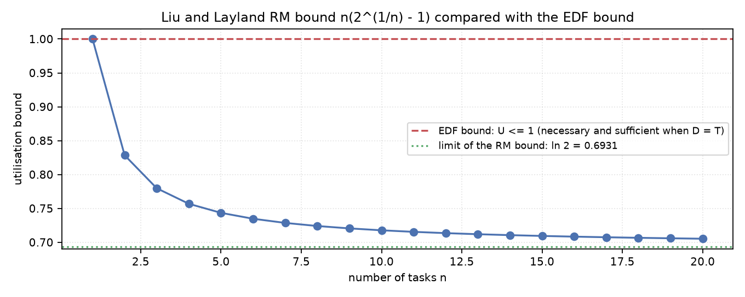
Figure 2. The Liu and Layland RM bound compared with the EDF bound and with ln 2
• For one task the bound is 1; it decreases towards ln 2 = 0.6931 as n grows.
• The EDF bound for implicit deadlines is always 1, independent of the number of tasks.
• The gap between the two curves is the price of the simplicity of fixed priorities.

Deadline Monotonic and the role of MLQ in this comparison
Deadline Monotonic (DM)
DM generalises RM to constrained deadlines: the priority follows the relative deadline. When D equals T, DM is identical to RM. DM is implemented in this project so that RM can be presented as a special case of a more general rule.
The position of MLQ
• MLQ was designed to classify processes, not to guarantee deadlines.
• To take part in the comparison, the queue level of every task must be derived from its parameters.
• In this project the queue level is stated explicitly in the scenario file.
• In the real-time scenarios the queues follow the period or the sensitivity of the task.
• Consequently MLQ behaves like RM in those scenarios; that is a finding, not a defect.
Property | EDF | RM / DM | MLQ
Priority type | dynamic | static | static
Priority basis | absolute deadline | period or relative deadline | queue level
Needs a deadline | yes | no (period only) | no
Main goal | meet deadlines | meet deadlines | separate workload classes
Analytic guarantee | yes | yes | no
Table 3. Structural differences between the three algorithms

Comparing fundamental properties (1): preemption, priority and deadlines
Preemptive versus non-preemptive
• All three algorithms are preemptive in this implementation: the running job may be stopped.
• In MLQ, preemption is always active between queues and depends on the policy inside a queue.
• In this comparison the MLQ intra-queue policy is FCFS so that MLQ stays comparable with RM.
• Choosing RR inside the queue increases overhead and improves response time.
Algorithm | When priority is set | Changes over time | Computational cost
EDF | every instant | yes | high
RM | design time | no | low
DM | design time | no | low
MLQ | queue assignment time | no (without aging) | low
Table 4. How each algorithm assigns priority
Deadline handling
• EDF uses the deadline directly: a nearer deadline means a higher priority.
• RM ignores the deadline and uses only the period.
• DM uses the relative deadline, but statically.
• MLQ has no notion of a deadline at all: a deadline only enters if the designer encodes it as a queue level.
• This difference is the main reason why no algorithm is universally better.

Comparing fundamental properties (2): metrics, predictability and fairness
Metric | Meaning in this comparison
Response time | completion minus the release instant of each job
Waiting time | not meaningful for periodic tasks, therefore not reported
Turnaround time | identical to response time for a periodic job
Utilisation | busy time divided by the whole simulation horizon
Jitter | standard deviation of the response time; a predictability measure
Context switches | a proxy for scheduling overhead
Table 5. Definitions of the measured metrics
Predictability
• Predictability means being able to compute the worst-case response time in advance.
• Under RM and DM, response-time analysis gives that number exactly.
• Under EDF, the processor-demand criterion decides schedulability but does not directly give response times.
• For MLQ there is no standard analytic treatment of deadlines.
Fairness and starvation
• Under MLQ and RM, low-priority tasks starve when the upper levels stay busy.
• Under EDF the priority is dynamic, so every task rises to the top as its deadline approaches.
• EDF is therefore theoretically fairer, but it spreads failure under overload.
• In MLQ, starvation can be contained with aging or time slicing, as shown in exercise 1.

Designing the fair comparison scenario
Why this scenario is fair
• All three algorithms run on exactly the same task set.
• The timing model is identical: discrete ticks, preemption allowed, free context switches.
• The horizon is a whole multiple of the hyperperiod, so no job is left half-finished.
• The MLQ queue level is derived from the task parameters, not chosen arbitrarily.
• No algorithm receives more information than the others.
• All metrics are computed by the same measurement code.
Task | C | T | D | Queue | Class
T1 | 1 | 5 | 5 | 1 | sensitive
T2 | 2 | 8 | 8 | 1 | sensitive
T3 | 2 | 10 | 10 | 2 | medium
T4 | 3 | 20 | 20 | 3 | background
Table 6. Scenario A: four periodic tasks with implicit deadlines
• Total utilisation is 0.800.
• The hyperperiod is 40 and the horizon is 120, that is, three complete hyperperiods.
• The total number of jobs over that horizon is 30.
• All deadlines are implicit: D equals T.
Scope of the result: This scenario only shows what happens on this particular workload. To generalise the result, more scenarios are needed or the analytic tests must be used.

Scenario A: measured results
Metric | EDF | RM | MLQ
Deadline misses | 0 | 0 | 0
CPU utilisation | 80.00% | 80.00% | 80.00%
Average response time | 3.000 | 3.105 | 3.105
Jitter (standard deviation) | 2.891 | 3.272 | 3.255
Context switches | 54 | 57 | 54
Preemptions | 9 | 12 | 9
Table 7. Scenario A results for the three algorithms (real program output)
• All three met every deadline, so on this workload they are equivalent in terms of correctness.
• EDF has the lower average response time: 3.000 against 3.105.
• EDF has the lower jitter: 2.891 against 3.272 for RM, that is, a steadier behaviour.
• MLQ behaved exactly like RM here, because the queue levels were aligned with the periods.
• Utilisation is 80.00% everywhere, which equals the offered load.
Test | Result | Interpretation
Liu and Layland bound | 0.7568 < 0.800 | inconclusive; the condition is sufficient only
RM response-time analysis | pass | RM is definitely schedulable
EDF processor-demand test | pass | EDF is definitely schedulable
Table 8. Matching the measurements against the analytic tests in scenario A
Teaching finding: This scenario is a good teaching example: the utilisation exceeds the Liu and Layland bound, yet the set is still schedulable under RM. The bound is not necessary.

Scenario A: Gantt charts
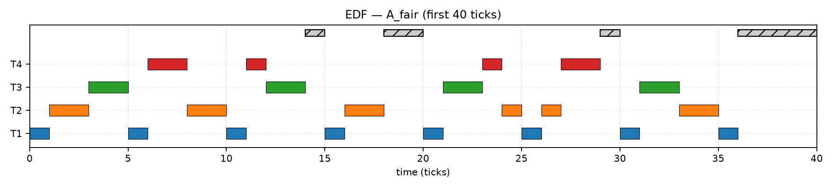
Figure 9. EDF Gantt chart in scenario A
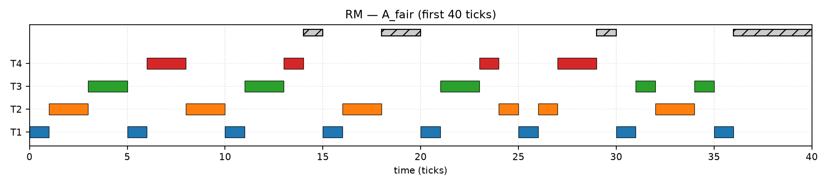
Figure 10. RM Gantt chart in scenario A; note the different placement of T3 and T4

Scenario A: the behaviour of MLQ
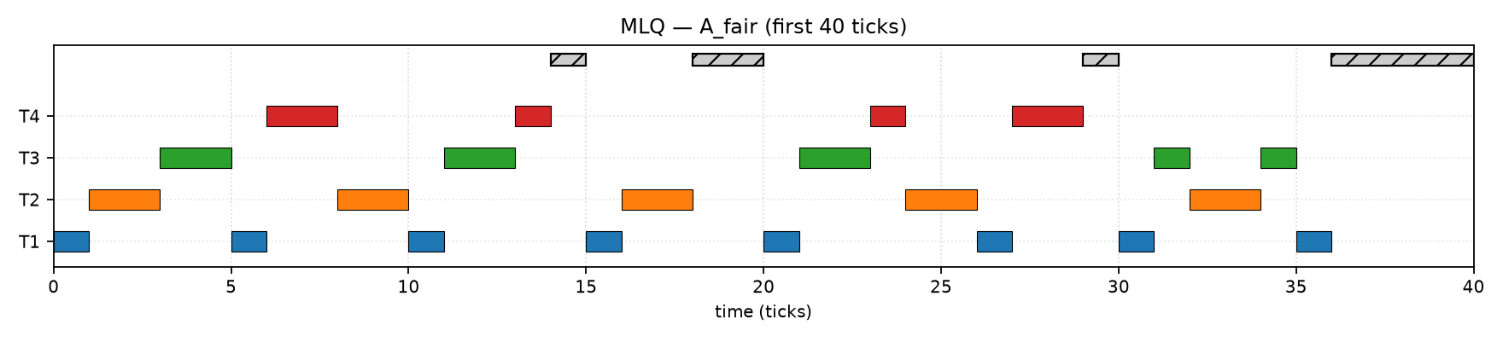
Figure 11. MLQ Gantt chart in scenario A; it coincides with RM here
• The queue levels were aligned with both the workload class and the period.
• When the queue order equals the period order, the fixed priority of MLQ reproduces RM.
• That alignment is not a coincidence: in practice designers usually treat faster tasks as more critical.
• Assigning the queue levels by a different criterion would give different results.
• The finding shows that the quality of MLQ depends on the assignment, not on the algorithm itself.

Scenario B: the high-pressure test
Task | C | T | D | Queue
A | 2 | 5 | 5 | 1
B | 4 | 7 | 7 | 2
Table 12. Scenario B: two tasks at a very high utilisation
• Total utilisation is 0.9714.
• The Liu and Layland bound for two tasks is 0.8284, so the utilisation exceeds it.
• The horizon is 105 ticks, that is, three complete hyperperiods.
Metric | EDF | RM | MLQ
Deadline misses | 0 | 3 | 3
Average response time | 3.833 | 4.000 | 4.000
Jitter | 1.424 | 2.449 | 2.449
Context switches | 36 | 48 | 48
Preemptions | 3 | 15 | 15
Table 13. Scenario B results (real program output)
• Response-time analysis computes a worst-case response time of 8 for B, larger than its deadline of 7.
• The simulation shows exactly that: three jobs of B missed their deadline.
• EDF ran on the same workload without a single miss, because U is below 1.
• The difference in preemptions is striking: 3 against 15.

Scenario B: Gantt charts and decision walkthrough
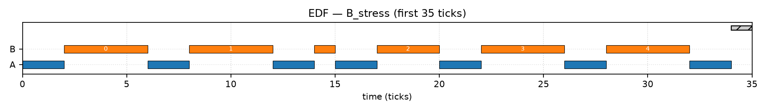
Figure 14. EDF Gantt chart in scenario B: no deadline is missed
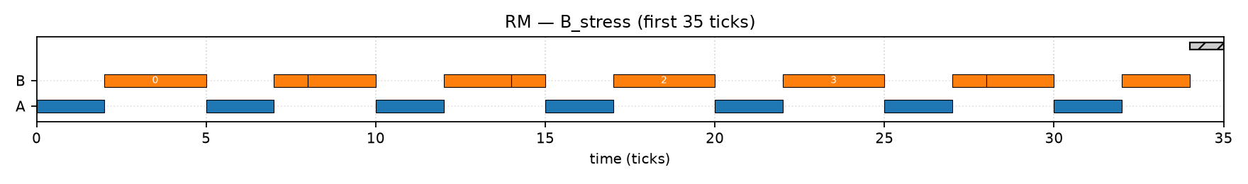
Figure 15. RM Gantt chart in scenario B: jobs of B miss their deadlines
• At t=0 both tasks are released; both algorithms run A first.
• At t=2 it is B's turn, but at t=5 the next job of A arrives.
• RM considers A more urgent and stops B with two ticks left.
• EDF sees the deadline of B#0 at t=7 and the deadline of A#1 at t=10, so it lets B#0 continue.
• Result: under RM, B#0 finishes at t=8 and misses its deadline of 7.

The Liu and Layland bound versus the exact RM test
U = sum (C_i / T_i)
U <= n * (2^(1/n) - 1) => the task set is schedulable by RM
n = 1 -> 1.0000 n = 2 -> 0.8284 n = 3 -> 0.7798
n -> infinity : U -> ln 2 = 0.6931
The Liu and Layland sufficient condition and its values
Why the condition is only sufficient
• The bound is derived from a worst-case arrangement, so many sets above it are still schedulable.
• Example from this project: scenario A has U = 0.800 against a bound of 0.7568 and is still RM-schedulable.
• Crossing the bound therefore means the exact test is needed, not that the set has failed.
• The exact test for fixed priorities is response-time analysis.
R_i = C_i + sum over j in hp(i): ceil(R_i / T_j) * C_j
feasible <=> for every i: R_i <= D_i
Response-time analysis for fixed priorities (Joseph and Pandya)
• Under the stated assumptions this test is exact for fixed-priority algorithms.
• The implementation iterates until convergence and stops as soon as R exceeds D.
• For scenario B it computes R_A = 2 and R_B = 8, which is greater than D_B = 7.

EDF schedulability and the processor-demand criterion
Implicit deadlines
If D equals T for every task then U <= 1 is both necessary and sufficient for EDF. This is a very powerful property: no more elaborate test is required.
Constrained deadlines
If some D is smaller than its T then U <= 1 is necessary but not sufficient. The exact test in that case is the processor-demand criterion.
dbf(t) = sum_i max(0, floor((t - D_i) / T_i) + 1) * C_i
schedulable by EDF <=> for every t > 0: dbf(t) <= t
The demand bound function and the exact EDF criterion (Baruah, Howell and Rosier)
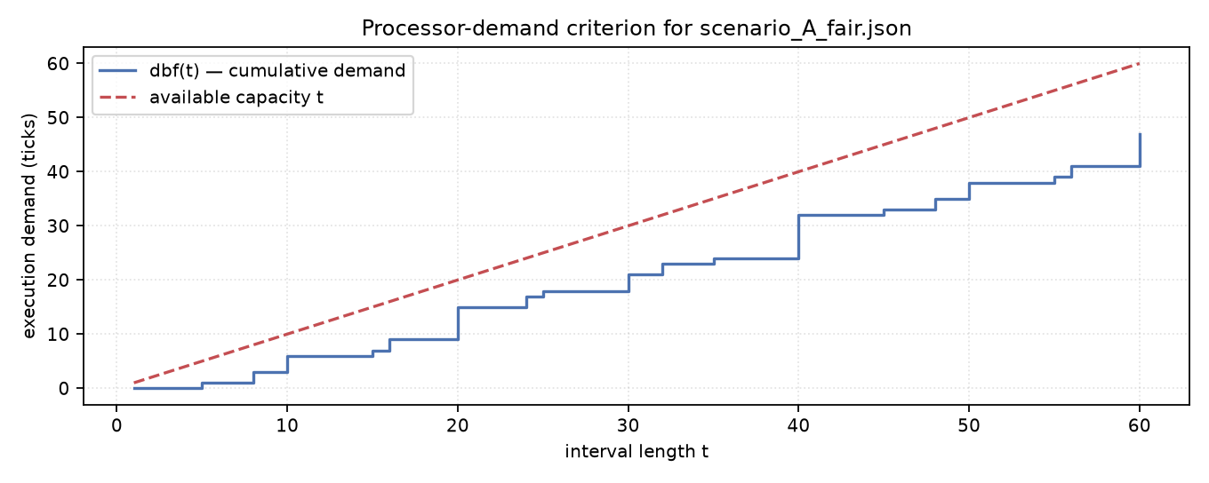
Figure 16. Demand bound function of scenario A against the available capacity
• Checking every value of t is impossible, so only points of the form k*T + D up to a valid bound are checked.
• This project uses the QPA bound and records the number of checked points in its output.
• In scenario C, which has constrained deadlines, the test checked 161 points.

Randomised feasibility study
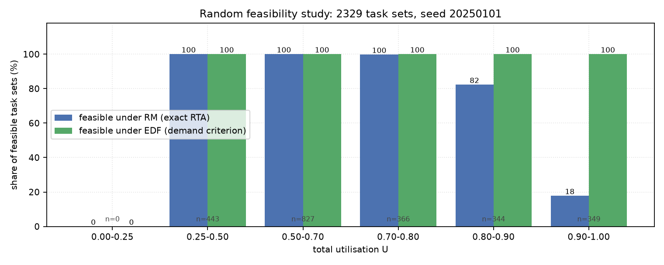
Figure 17. Share of feasible task sets under RM and under EDF, by utilisation band
Utilisation band | Task sets | Feasible under RM | Feasible under EDF
0.25 - 0.50 | 443 | 100.0% | 100.0%
0.50 - 0.70 | 827 | 100.0% | 100.0%
0.70 - 0.80 | 366 | 99.7% | 100.0%
0.80 - 0.90 | 344 | 82.3% | 100.0%
0.90 - 1.00 | 349 | 17.8% | 100.0%
Table 18. Randomised study over 2329 task sets with seed 20250101
Method
• For every set the number of tasks is between 3 and 5 and the periods lie between 5 and 40.
• C is chosen so that the utilisation lands in the target band.
• RM is decided by response-time analysis, EDF by the utilisation condition (implicit deadlines).
• The random seed is fixed, so the whole study is reproducible.
Interpretation
• Up to a utilisation of 0.70 there is no visible difference between the two algorithms.
• From 0.80 upwards the gap opens quickly.
• In the top band only 17.8% of the sets are feasible under RM.
• The result confirms the theoretical optimality of EDF empirically.

Scenario C: an aperiodic workload outside the real-time model
The purpose of this scenario is to show that comparing real-time algorithms on a general-purpose workload is inherently unfair. It uses one-shot work items that have no period at all.
Task | C | Release | Deadline | Queue | Class
SYS1 | 3 | 0 | 6 | 1 | system
INT1 | 4 | 1 | 12 | 1 | interactive
BAT1 | 6 | 0 | 30 | 3 | batch
INT2 | 3 | 2 | 13 | 2 | interactive
BAT2 | 5 | 3 | 30 | 3 | batch
INT3 | 2 | 8 | 14 | 1 | interactive
BAT3 | 4 | 10 | 30 | 3 | batch
Table 19. Scenario C: seven one-shot work items with synthetic deadlines
• Deadlines were invented artificially so that EDF can run at all.
• The period was set equal to the horizon so that RM can run at all.
• RM therefore has no rate information and degenerates into a first-come order.
• That is exactly why RM was not designed for general-purpose work.

Scenario C: results and interpretation
Metric | EDF | RM | MLQ
Deadline misses | 0 | 3 | 0
Average response time | 10.857 | 13.000 | 10.857
Jitter | 7.221 | 4.320 | 7.493
Context switches | 6 | 6 | 7
Preemptions | 0 | 0 | 1
Table 20. Scenario C results (real program output)
• MLQ needed no deadline and no period at all: it decided by workload class and met the deadlines.
• EDF also succeeded, but its output depends on the quality of the invented deadlines.
• RM missed three deadlines because it had no rate information to work with.
• MLQ used one extra context switch because one inter-queue preemption occurred.
• The scenario shows that the algorithm must fit the nature of the workload.
Guiding principle: Whenever we have to invent parameters artificially in order to run a real-time algorithm, that is a sign the algorithm was not built for that problem. Numbers obtained under such conditions must not be used to rank the algorithms.

Scenario D: behaviour under overload
Metric | EDF | RM | MLQ
Deadline misses | 31 | 10 | 10
CPU utilisation | 100% | 100% | 100%
Average response time | 18.200 | 11.400 | 11.400
Maximum response time | 30 | 96 | 96
Jitter | 6.975 | 20.612 | 20.612
Context switches | 29 | 35 | 35
Table 21. Scenario D results at a utilisation of 1.233 (real program output)
Task | Priority | Misses under EDF | Misses under RM and MLQ
X | high | 13 of 15 | 0 of 15
Y | medium | 10 of 12 | 0 of 12
Z | low | 8 of 10 | 10 of 10
Table 22. Distribution of the deadline misses per task in the overload scenario
• Under RM and MLQ the high-priority tasks are fully protected and the whole failure lands on Z.
• Under EDF the failure is spread over all tasks: that is the domino effect.
• The maximum response time under RM is 96 ticks: Z waited almost until the end of the horizon.
• The maximum response time under EDF is 30, so no task waited for an extreme period.

Scenario D: Gantt charts and the design message
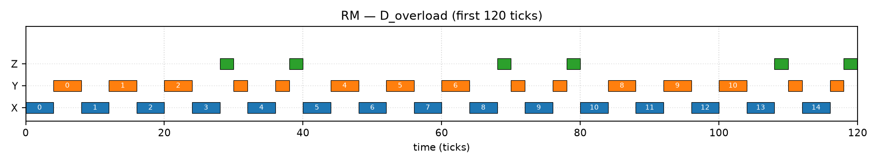
Figure 23. RM under overload: Z is squeezed between the higher-priority tasks
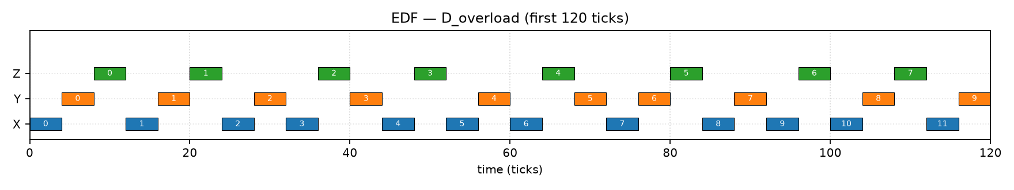
Figure 24. EDF under overload: execution is shared between all three tasks
• If the goal is to protect critical tasks, RM or MLQ are the better choice.
• If the goal is to avoid the catastrophic failure of one particular task, EDF behaves more evenly.
• In hard systems overload must be handled by admission control, not by the choice of algorithm.
• No algorithm can run a set with utilisation above 1 without missing deadlines.

Aggregate comparison charts
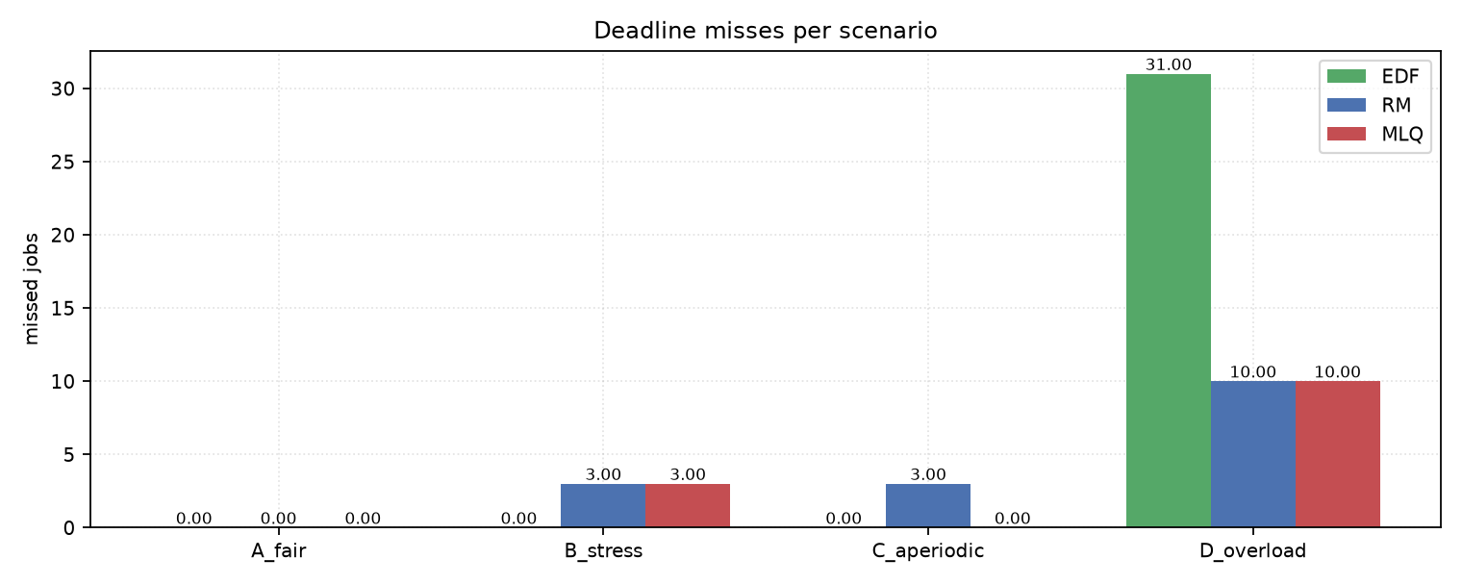
Figure 25. Deadline misses across the four scenarios
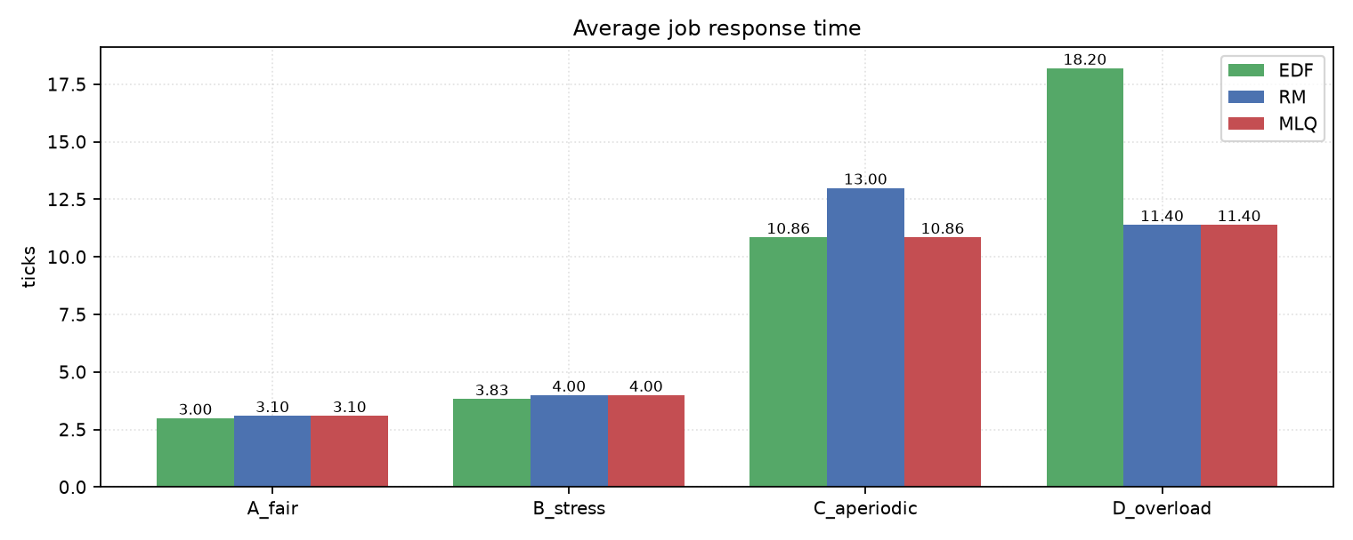
Figure 26. Average response time across the four scenarios

Jitter and scheduling overhead
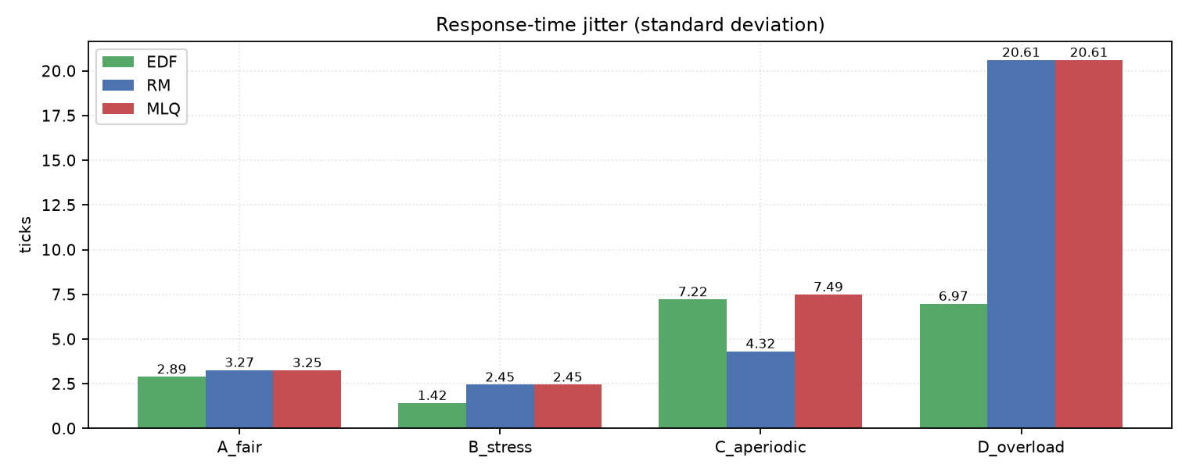
Figure 27. Response-time jitter (standard deviation) across the four scenarios
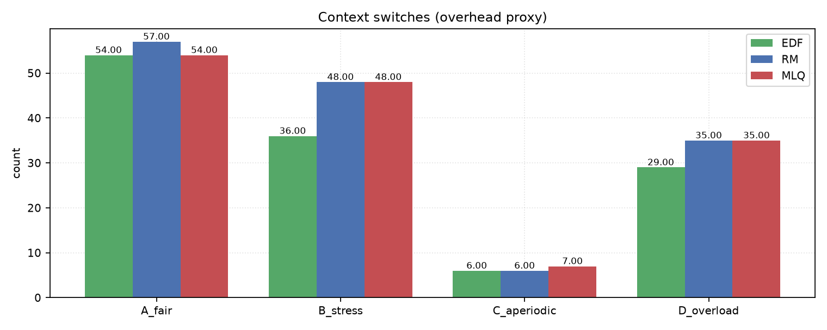
Figure 28. Context switches as a proxy for overhead
• In scenario A, EDF has the lowest jitter and RM the highest.
• In scenario B, EDF needed only 3 preemptions against 15 for RM: far less overhead.
• In scenario D the jitter of RM is 20.612, more than three times the 6.975 of EDF.
• Lower jitter means steadier and more predictable behaviour for sensitive tasks.

CPU utilisation across the four scenarios
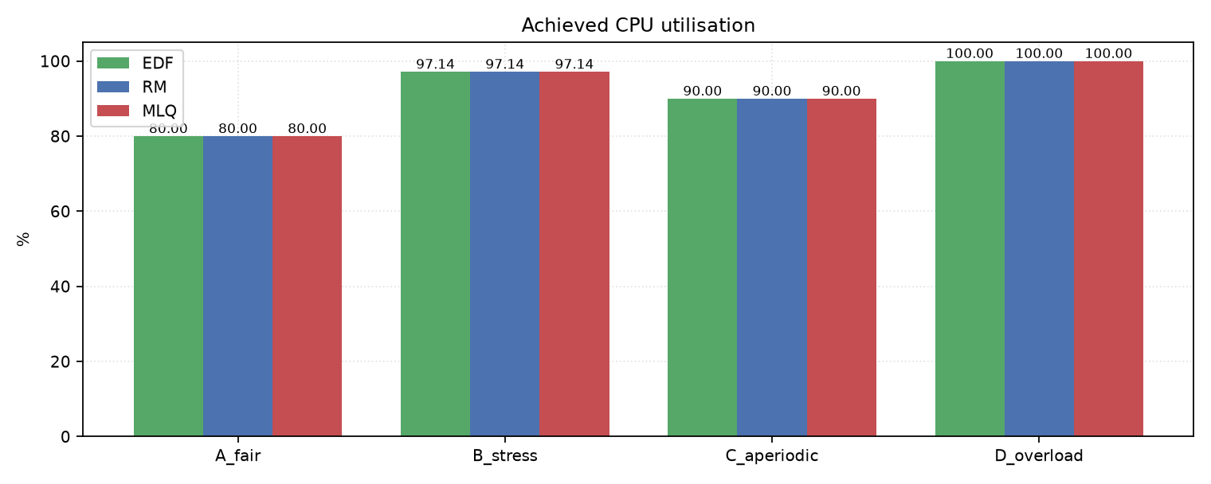
Figure 29. Achieved CPU utilisation in the four scenarios
• In scenarios A and B the utilisation equals the offered load: no time is wasted.
• In scenario C the utilisation is 90% with 3 idle ticks, because the work items are one-shot.
• In scenario D the utilisation saturates at 100% while the offered load is 123.33%.
• That gap is exactly the work that could not be done, and it appears as missed deadlines.
• High utilisation under overload is not a sign of health: it is a sign of full saturation.
Limitation: In this model a context switch costs nothing, so utilisation is not reduced by overhead. It must not be confused with the utilisation of a physical system.

Comprehensive comparison table
Criterion | MLQ | EDF | RM
Priority type | static, by queue | dynamic, by deadline | static, by period
Needs a deadline | no | yes | no
Needs a period | no | no | yes
Analytic guarantee | none | yes (demand criterion) | yes (response-time analysis)
Optimality | none | optimal among dynamic priorities | optimal among fixed priorities
Predictability | medium | good | excellent
Fairness | low | high | low
Starvation risk | high | low | high
Scheduling overhead | low | medium | low
Behaviour under overload | protects the top | spreads the failure | protects the top
Best suited for | classified general-purpose work | dynamic real-time tasks | fixed periodic tasks
Table 30. Master comparison table of the three algorithms

Analysis of the results
• On a real-time workload at moderate utilisation all three succeed; the difference is quality, not correctness.
• At high utilisation only EDF has a guarantee; RM and MLQ failed the exact test and the simulator agreed.
• On a general-purpose workload MLQ is inherently more suitable because it needs no parameters that do not exist.
• Under overload, RM and MLQ protect critical tasks while EDF spreads the failure.
• The overhead of EDF was lower than that of RM in the pressure scenario, contrary to the usual claim.
Why EDF had less overhead here
• In scenario B, EDF performed only 3 preemptions while RM performed 15.
• The reason is that the RM priority repeatedly displaces a running job in favour of the faster task.
• EDF lets the job with the nearer deadline continue and therefore avoids unnecessary switches.
• So the familiar claim that EDF always costs more overhead was not confirmed on this workload.
Measurement limit: Overhead here is measured only by counting context switches, and each switch is assumed to cost nothing. On a real system the cost of recomputing EDF priorities would have to be added and might change the conclusion.

Advantages and disadvantages of each algorithm
EDF
Aspect | Explanation
Advantage | optimal among dynamic priorities and a simple guarantee for implicit deadlines
Advantage | high fairness and lower jitter
Disadvantage | requires a deadline for every task
Disadvantage | spreads failure under overload (domino effect)
Disadvantage | more complex to implement and sensitive to deadline errors
Table 31. EDF: advantages and disadvantages
RM
Aspect | Explanation
Advantage | simple, cheap and optimal among fixed priorities
Advantage | excellent predictability and isolation of critical tasks
Disadvantage | loses schedulable sets at high utilisation
Disadvantage | low-priority tasks may starve
Disadvantage | meaningless for aperiodic work
Table 32. RM: advantages and disadvantages
MLQ
Aspect | Explanation
Advantage | policy separation and explicit priority control
Advantage | needs no real-time parameters
Disadvantage | no analytic guarantee for deadlines
Disadvantage | output quality depends on the manual queue assignment
Disadvantage | starvation risk for the lower queues
Table 33. MLQ: advantages and disadvantages

Applications, limitations and assumptions
Algorithm | Suitable application | Example
EDF | real-time tasks with varied deadlines | flight control, robotics, media streaming
RM | periodic tasks with fixed priorities | industrial control, periodic sensors
DM | tasks whose deadline is shorter than the period | fast sampling systems
MLQ | separating general-purpose workload classes | time-sharing operating systems, databases
Table 34. Application domains of each algorithm
Limitations of this study
• The scenarios are synthetic and small so that hand checking stays possible.
• The model is single-processor; the results do not carry over to multiprocessors.
• The context-switch cost is assumed to be zero.
• No blocking, resource sharing or priority inversion is modelled.
• The worst-case execution time is assumed to be known and constant.
• The simulation horizon is finite; the definitive guarantee comes from the analytic tests.
Suggestions for further work
• Add semaphore blocking and analyse priority inversion.
• Extend to multiprocessors and compare with migration-based algorithms.
• Use traced real workloads instead of synthetic scenarios.
• Study EDF combined with a protection policy for critical tasks.

Conclusion
This exercise showed that comparing MLQ with EDF and RM is only valid when the workload, the timing model and the measurement code are shared and when the different nature of the domains is acknowledged. In the fair scenario at a utilisation of 0.800 all three algorithms met every deadline, and EDF showed a slight quality advantage with an average response time of 3.000 and a jitter of 2.891.
In the high-pressure scenario at a utilisation of 0.9714, response-time analysis predicted that RM is infeasible and the simulator recorded exactly the three deadline misses that the analysis implies, while EDF ran without a miss. The randomised study over 2329 task sets showed that in the utilisation band 0.90 to 1.00 only 17.8% of the sets are feasible under RM against 100% under EDF.
• RM fails at high utilisation while EDF succeeds on the same load.
• MLQ can reproduce RM behaviour on a real-time load, but without an analytic guarantee.
• The price of predictability, measured in context switches, was higher for RM than for EDF here.
• Under overload, RM and MLQ protect critical tasks and EDF distributes the failure.
Key message: No algorithm is universally better. The correct choice is about matching the tool to the problem: EDF or RM when you have deadlines, MLQ when you have distinct workload classes.

References
Primary references
• Liu, C. L., and Layland, J. W. — Scheduling Algorithms for Multiprogramming in a Hard-Real-Time Environment — Journal of the ACM, 1973. (source of the RM sufficient condition)
• Joseph, M., and Pandya, P. — Finding Response Times in a Real-Time System — The Computer Journal, 1986. (source of response-time analysis)
• Baruah, S. K., Howell, R. R., and Rosier, L. E. — Algorithms and Complexity Concerning the Preemptive Scheduling of Periodic Real-Time Tasks — Information and Computation, 1990. (source of the processor-demand criterion)
• Buttazzo, G. C. — Hard Real-Time Computing Systems: Predictable Scheduling Algorithms and Applications.
• Silberschatz, A., Galvin, P. B., and Gagne, G. — Operating System Concepts — chapters on CPU scheduling and real-time scheduling.
Supplementary references
• Tanenbaum, A. S., and Bos, H. — Modern Operating Systems — scheduling and real-time sections.
• Stallings, W. — Operating Systems: Internals and Design Principles — real-time scheduling chapter.
• Lehoczky, J., Sha, L., and Ding, Y. — The Rate Monotonic Scheduling Algorithm: Exact Characterization and Average Case Behavior.
• Documentation of pytest, matplotlib and reportlab for the implementation tooling.
Citation status: The entries above are the standard references of the operating systems and real-time systems courses. If the instructor requires exact years, volume or page numbers, the copies available to the student must be checked and the citations updated.

Appendix: outputs and requirement mapping
File | Description
output/A_fair_EDF.txt | Gantt chart and metrics of EDF in scenario A
output/A_fair_RM.txt | Gantt chart and metrics of RM in scenario A
output/A_fair_MLQ.txt | Gantt chart and metrics of MLQ in scenario A
output/B_stress_*.txt | results of the three algorithms in the pressure scenario
output/C_aperiodic_*.txt | results in the aperiodic scenario
output/D_overload_*.txt | results in the overload scenario
output/experiments.json | every number in machine-readable form
output/experiments_summary.txt | text summary of all experiments
output/pytest_result.txt | output of the test run
diagrams/gantt_*.png | twelve Gantt charts
diagrams/chart_*.png | eight comparison and analysis charts
Table 35. Output inventory of exercise 2
Evaluation item | Status | Where
EDF and RM introduction | complete | algorithm pages
Real-time versus general-purpose | complete | fundamentals page
Preemptive comparison | complete | fundamental properties page
Liu and Layland condition | complete | exact RM test page
EDF schedulability tests | complete | processor-demand page
Numerical examples for all three | complete | scenarios A to D
Comprehensive comparison table | complete | master table page
Comparison charts | complete | eight charts
Persian and English versions | complete | COMPARISON_FA and COMPARISON_EN
DOCX and PDF versions | complete | docs folder
Table 36. Requirement mapping for exercise 2 (no grade is assumed)

