Exercise 3 — EDF and RM Scheduling with Three Inputs: A Complete Hand Solution
Step-by-step printable hand solution of EDF and RM scheduling for a three-task periodic set
Exercise: EDF and RM scheduling with three inputs and a hand solution
Course: Advanced Operating Systems
Topic: Real-time scheduling of periodic tasks
Task set: T1(C=1,T=4,D=4), T2(C=3,T=8,D=8), T3(C=4,T=12,D=12)
Total utilisation: U = 23/24 ≈ 0.9583
Deliverable: Persian and English reports (DOCX and PDF) + runnable code + blank worksheets
Repository: github.com/kaspian021/Multilevel-Queue-Scheduling
Branch: Exercise-3-EDF-RM-Manual-Scheduling

Table of contents
Abstract, keywords and report map .... 3
Introduction, problem statement and goals .... 4
Task-set design and preliminary arithmetic .... 5
RM priority computation and the EDF selection rule .... 6
Analytic tests before scheduling .... 7
The EDF analytic test and the prediction before running .... 8
Release pattern and deadlines .... 9
Hand solution for EDF (part 1): ticks 0 to 11 .... 10
Hand solution for EDF (part 2): ticks 12 to 23 .... 11
Gantt chart and EDF analysis .... 12
Hand solution for RM (part 1): ticks 0 to 11 .... 13
Hand solution for RM (part 2): ticks 12 to 23 .... 14
Gantt chart and the deadline miss under RM .... 15
Comparing the two schedules .... 16
Utilisation, idle time and processor occupancy .... 17
Reconciling the hand solution with the code .... 18
Scope of the results .... 19
Conclusion .... 20
References and reproduction commands .... 21
Blank worksheet 1: rewriting the EDF schedule by hand .... 22
Blank worksheet 2: EDF continued and the RM schedule .... 23
Blank worksheet 3: RM continued and the deadline checklist .... 24

Abstract, keywords and report map
Abstract
This exercise designs a three-task periodic set and solves its scheduling under EDF and RM by hand, step by step. Every calculation was first worked out on paper and then cross-checked against a Python program; the program output and the hand solution agree exactly.
The set is T1(C=1,T=4,D=4), T2(C=3,T=8,D=8) and T3(C=4,T=12,D=12). Total utilisation is 0.9583, i.e. 23/24, and the hyperperiod is 24. The analytic test shows that EDF runs this set without a single deadline miss, while response-time analysis for RM gives R(T3)=14, which exceeds the deadline of 12. Simulation reproduces exactly that one miss at t=12.
Keywords
Real-time scheduling; EDF; RM; absolute deadline; period; hyperperiod; response-time analysis; utilisation; deadline miss; idle time; hand solution.
Report map
• Sections 1-4: task-set design, preliminary arithmetic and priorities.
• Sections 5-8: analytic tests and selection rules.
• Sections 9-15: step-by-step EDF solution and its analysis.
• Sections 16-21: step-by-step RM solution and the deadline miss.
• Sections 22-28: comparison, hand arithmetic and the limits of the claim.
• Sections 29-30: blank worksheets for rewriting the solution by hand.

Introduction, problem statement and goals
Problem statement
Three periodic tasks run on a single preemptive processor. Each task is released at multiples of its period and every job must finish by its relative deadline. The goal is to determine the execution order under EDF and RM, compute the metrics and check for deadline misses.
Goals
• Design a task set with parameters that can be computed by hand.
• Compute the fixed RM priorities from the periods.
• Apply the earliest-deadline-first selection rule.
• Produce a step table for every tick of the hyperperiod.
• Draw the Gantt chart for both algorithms.
• Compute utilisation, idle time and deadline misses.
• Reconcile the hand solution with the Python program.
Model rules
• Single processor, preemptive scheduling.
• Time is discrete; one tick consumes one unit of execution.
• All tasks are released in phase at t=0.
• EDF tie rule: on equal absolute deadlines the smaller task index wins.
• A job that misses its deadline is not aborted; it runs to completion.
• The analysis horizon is one complete hyperperiod.
Scope: This solution shows the behaviour of the set over one hyperperiod. The definitive schedulability verdict for all time comes from the analytic tests presented in the following pages.

Task-set design and preliminary arithmetic
Task parameters
Task | C (execution) | T (period) | D (relative deadline) | Release instants
T1 | 1 | 4 | 4 | 0, 4, 8, 12, 16, 20
T2 | 3 | 8 | 8 | 0, 8, 16
T3 | 4 | 12 | 12 | 0, 12
Table 1. Parameters of the three periodic tasks
Utilisation
U = C1/T1 + C2/T2 + C3/T3
= 1/4 + 3/8 + 4/12
= 6/24 + 9/24 + 8/24 = 23/24 = 0.9583
Hand computation of total utilisation
Hyperperiod
H = lcm(4, 8, 12) = 24
Hand computation of the hyperperiod
Total load in one hyperperiod
• T1 is released 6 times in 24 units and carries 6 x 1 = 6 units of load.
• T2 is released 3 times and carries 3 x 3 = 9 units.
• T3 is released 2 times and carries 2 x 4 = 8 units.
• Total load is 23 units, so in 24 time units there is exactly 1 unit of idle time.
Quantity | Value
Total utilisation U | 0.9583 (23/24)
Hyperperiod H | 24
Total load in the hyperperiod | 23 units
Idle time | 1 unit
Jobs in the hyperperiod | 11 jobs
Table 2. Summary of the preliminary arithmetic

RM priority computation and the EDF selection rule
Fixed priority in RM
In RM the priority is derived from the period: a shorter period means a higher priority. The priority is computed at design time and never changes at run time.
Task | Period | RM priority | Rank
T1 | 4 | highest | 1
T2 | 8 | medium | 2
T3 | 12 | lowest | 3
Table 3. Fixed RM priorities for this task set
The selection rule in EDF
Under EDF, at every instant the job with the earliest absolute deadline is selected. The absolute deadline of job k of task i is k*T + D.
d(k, i) = k * T_i + D_i
choose the ready job with the smallest d(k, i)
tie rule: smaller task index first
Absolute deadline and the EDF selection rule
Absolute deadlines over one hyperperiod
Task | job 0 | job 1 | job 2 | job 3 | job 4 | job 5
T1 | 4 | 8 | 12 | 16 | 20 | 24
T2 | 8 | 16 | 24 | - | - | -
T3 | 12 | 24 | - | - | - | -
Table 4. Absolute deadlines of all jobs in [0,24)
• At t=0 three jobs with deadlines 4, 8 and 12 are ready; EDF picks the nearest, T1.
• At t=12 the deadline of T3_0 arrives, while T1_3 with deadline 16 has just been released.
• EDF continues T3_0 at that instant, but RM preempts it because T1 has higher priority.

Analytic tests before scheduling
The Liu and Layland sufficient bound for RM
U <= n * (2^(1/n) - 1)
n = 3 -> bound = 3 * (2^(1/3) - 1) = 0.7798
U = 0.9583 > 0.7798 => the bound gives no answer
Checking the Liu and Layland sufficient bound
• Utilisation exceeds the bound, but that does not mean failure.
• The condition is only sufficient; many sets above it are still schedulable.
• A definite answer needs response-time analysis.
RM response-time analysis
R_i = C_i + sum over j in hp(i): ceil(R_i / T_j) * C_j
The response-time recurrence
Task | C | iter 1 | iter 2 | iter 3 | final R | D | verdict
T1 | 1 | 1 | - | - | 1 | 4 | ok
T2 | 3 | 4 | 4 | - | 4 | 8 | ok
T3 | 4 | 8 | 13 | 14 | 14 | 12 | MISS
Table 5. Hand execution of response-time analysis for the three tasks
• R(T1) = 1 <= 4, so T1 always finishes in time.
• R(T2) = 3 + ceil(4/4)*1 = 4 <= 8, so T2 is safe.
• R(T3) = 4 + ceil(14/4)*1 + ceil(14/8)*3 = 4 + 4 + 6 = 14 > 12, so T3 misses.
• Analytic verdict: this set is NOT schedulable under RM.

The EDF analytic test and the prediction before running
The utilisation condition for EDF
Because D equals T for every task in this set (implicit deadlines), the condition U <= 1 is both necessary and sufficient for EDF. No more elaborate test is required.
U = 0.9583 <= 1 => EDF can schedule this task set
Necessary and sufficient EDF condition for implicit deadlines
Prediction before running
Test | Result | Prediction
Liu and Layland bound (RM) | inconclusive | a sharper test is needed
Response-time analysis (RM) | R(T3)=14 > 12 | exactly one deadline miss
Utilisation condition (EDF) | satisfied | no deadline miss
Table 6. Summary of the analytic predictions before simulation
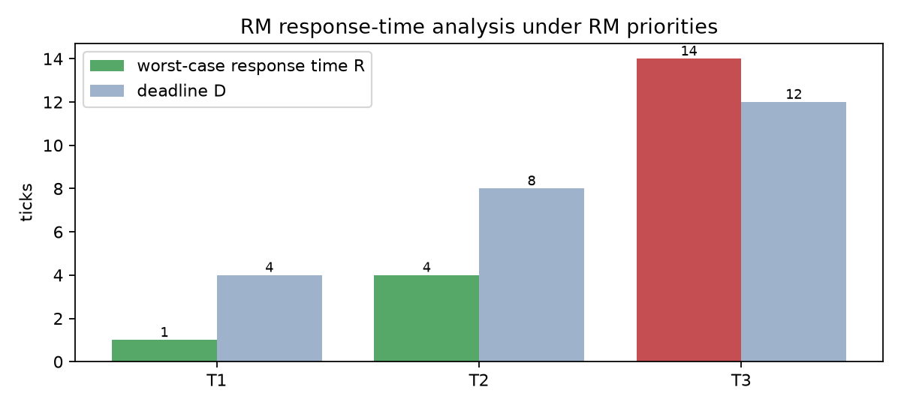
Figure 7. Response-time analysis chart: computed R against the deadline D
• In this chart the T3 bar crosses the deadline line.
• The figure announces the result we are about to see in the RM Gantt chart.
• Agreement between analytic prediction and simulation is the strongest evidence of correctness.

Release pattern and deadlines
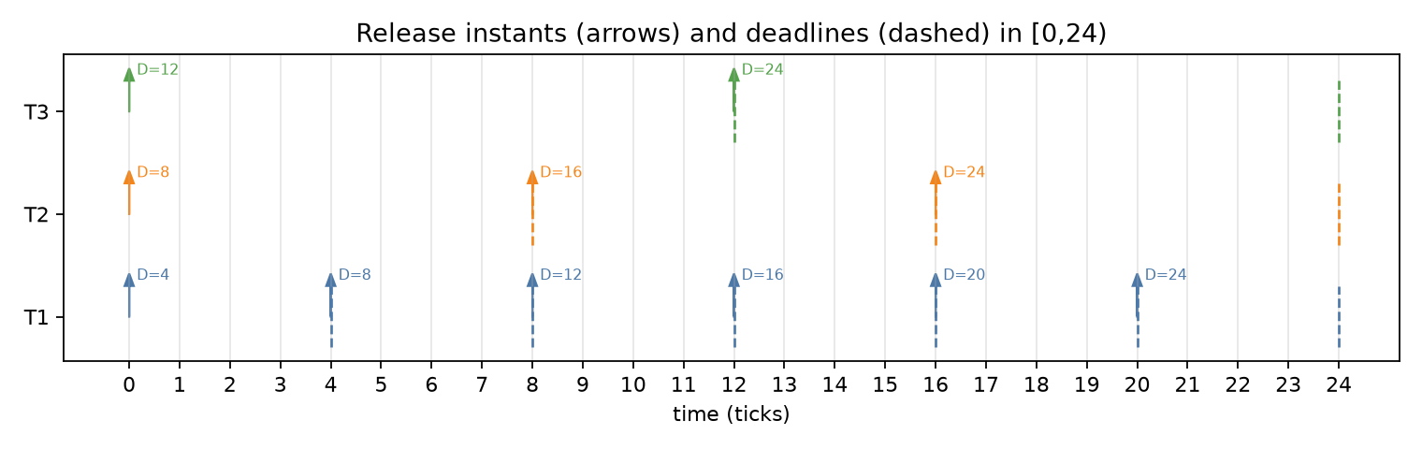
Figure 8. Release instants (arrows) and deadlines (dashed lines) in [0,24)
Reading the figure
• T1 is released at 0, 4, 8, 12, 16 and 20 and has 4 units of deadline each time.
• T2 is released at 0, 8 and 16 and has 8 units of deadline each time.
• T3 is released at 0 and 12 and has 12 units of deadline each time.
• At t=0 all three tasks are released together: the worst-case release pattern.
• At t=24 all tasks are in phase again, so one hyperperiod of analysis suffices.
Why being in phase matters
• Simultaneous release puts the heaviest load on the scheduler.
• In real-time analysis this is normally taken as the worst case.
• If a set is schedulable in this case, it is schedulable in the others.

Hand solution for EDF (part 1): ticks 0 to 11
In every row the ready set is shown with the absolute deadline and the remaining execution time; the job name T1_0 means job zero of task T1.
Interval | Ran | Ready jobs (d=deadline, rem=remaining) | Reason
0-1 | T1_0 | T1_0(d=4,rem=1), T2_0(d=8,rem=3), T3_0(d=12,rem=4) | d=4
1-2 | T2_0 | T2_0(d=8,rem=3), T3_0(d=12,rem=4) | d=8
2-3 | T2_0 | T2_0(d=8,rem=2), T3_0(d=12,rem=4) | d=8
3-4 | T2_0 | T2_0(d=8,rem=1), T3_0(d=12,rem=4) | d=8
4-5 | T1_1 | T1_1(d=8,rem=1), T3_0(d=12,rem=4) | d=8
5-6 | T3_0 | T3_0(d=12,rem=4) | d=12
6-7 | T3_0 | T3_0(d=12,rem=3) | d=12
7-8 | T3_0 | T3_0(d=12,rem=2) | d=12
8-9 | T1_2 | T1_2(d=12,rem=1), T2_1(d=16,rem=3), T3_0(d=12,rem=1) | d=12; tie, lower task index
9-10 | T3_0 | T2_1(d=16,rem=3), T3_0(d=12,rem=1) | d=12
10-11 | T2_1 | T2_1(d=16,rem=3) | d=16
11-12 | T2_1 | T2_1(d=16,rem=2) | d=16
Table 9. Step-by-step EDF table from t=0 to t=11

Hand solution for EDF (part 2): ticks 12 to 23
Interval | Ran | Ready jobs (d=deadline, rem=remaining) | Reason
12-13 | T1_3 | T1_3(d=16,rem=1), T2_1(d=16,rem=1), T3_1(d=24,rem=4) | d=16; tie, lower task index
13-14 | T2_1 | T2_1(d=16,rem=1), T3_1(d=24,rem=4) | d=16
14-15 | T3_1 | T3_1(d=24,rem=4) | d=24
15-16 | T3_1 | T3_1(d=24,rem=3) | d=24
16-17 | T1_4 | T1_4(d=20,rem=1), T2_2(d=24,rem=3), T3_1(d=24,rem=2) | d=20
17-18 | T2_2 | T2_2(d=24,rem=3), T3_1(d=24,rem=2) | d=24; tie, lower task index
18-19 | T2_2 | T2_2(d=24,rem=2), T3_1(d=24,rem=2) | d=24; tie, lower task index
19-20 | T2_2 | T2_2(d=24,rem=1), T3_1(d=24,rem=2) | d=24; tie, lower task index
20-21 | T1_5 | T1_5(d=24,rem=1), T3_1(d=24,rem=2) | d=24; tie, lower task index
21-22 | T3_1 | T3_1(d=24,rem=2) | d=24
22-23 | T3_1 | T3_1(d=24,rem=1) | d=24
23-24 | IDLE |  | no ready job
Table 10. Step-by-step EDF table from t=12 to t=23

Gantt chart and EDF analysis
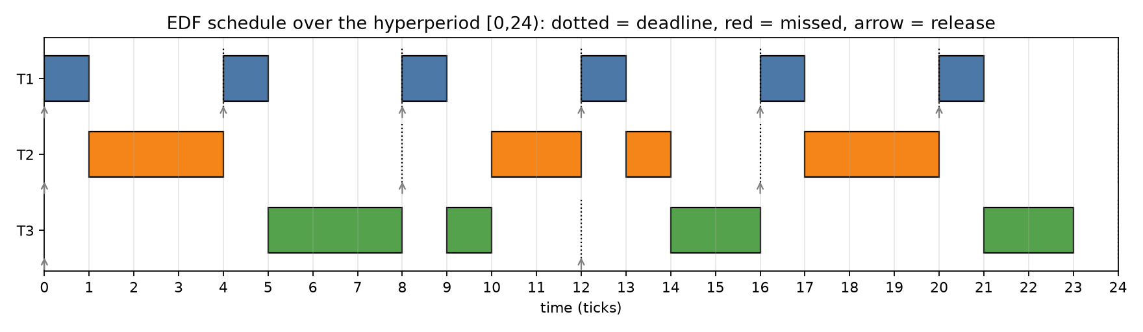
Figure 11. EDF Gantt chart over one hyperperiod; dashed lines are deadlines, arrows releases
Resulting schedule
t : 0 1 2 3 4 5 6 7 8 9 10 11 12 13 14 15 16 17 18 19 20 21 22 23
: T1 T2 T2 T2 T1 T3 T3 T3 T1 T3 T2 T2 T1 T2 T3 T3 T1 T2 T2 T2 T1 T3 T3 -
EDF execution order over 24 ticks (the last tick is idle)
Checking the deadlines
Job | Release | Deadline | Finish | Response | Verdict
T1_0 | 0 | 4 | 1 | 1 | on time
T2_0 | 0 | 8 | 4 | 4 | on time
T3_0 | 0 | 12 | 11 | 11 | on time
T1_1 | 4 | 8 | 5 | 1 | on time
T1_2 | 8 | 12 | 9 | 1 | on time
T2_1 | 8 | 16 | 13 | 5 | on time
T1_3 | 12 | 16 | 13 | 1 | on time
T3_1 | 12 | 24 | 19 | 7 | on time
Table 12. Hand check of EDF deadlines (first eight jobs)
• No job missed its deadline.
• The only idle time is at tick 23, because the total load is 23 units.
• Utilisation is 23/24 = 95.83%.

Hand solution for RM (part 1): ticks 0 to 11
Under RM the priority is fixed, so the reason column always refers to the period of the task, never to its absolute deadline.
Interval | Ran | Ready jobs (d=deadline, rem=remaining) | Reason
0-1 | T1_0 | T1_0(d=4,rem=1), T2_0(d=8,rem=3), T3_0(d=12,rem=4) | T=4; fixed priority
1-2 | T2_0 | T2_0(d=8,rem=3), T3_0(d=12,rem=4) | T=8; fixed priority
2-3 | T2_0 | T2_0(d=8,rem=2), T3_0(d=12,rem=4) | T=8; fixed priority
3-4 | T2_0 | T2_0(d=8,rem=1), T3_0(d=12,rem=4) | T=8; fixed priority
4-5 | T1_1 | T1_1(d=8,rem=1), T3_0(d=12,rem=4) | T=4; fixed priority
5-6 | T3_0 | T3_0(d=12,rem=4) | T=12; fixed priority
6-7 | T3_0 | T3_0(d=12,rem=3) | T=12; fixed priority
7-8 | T3_0 | T3_0(d=12,rem=2) | T=12; fixed priority
8-9 | T1_2 | T1_2(d=12,rem=1), T2_1(d=16,rem=3), T3_0(d=12,rem=1) | T=4; fixed priority
9-10 | T2_1 | T2_1(d=16,rem=3), T3_0(d=12,rem=1) | T=8; fixed priority
10-11 | T2_1 | T2_1(d=16,rem=2), T3_0(d=12,rem=1) | T=8; fixed priority
11-12 | T2_1 | T2_1(d=16,rem=1), T3_0(d=12,rem=1) | T=8; fixed priority
Table 13. Step-by-step RM table from t=0 to t=11

Hand solution for RM (part 2): ticks 12 to 23
Interval | Ran | Ready jobs (d=deadline, rem=remaining) | Reason
12-13 | T1_3 | T1_3(d=16,rem=1), T3_0(d=12,rem=1), T3_1(d=24,rem=4) | T=4; fixed priority
13-14 | T3_0 | T3_0(d=12,rem=1), T3_1(d=24,rem=4) | T=12; fixed priority
14-15 | T3_1 | T3_1(d=24,rem=4) | T=12; fixed priority
15-16 | T3_1 | T3_1(d=24,rem=3) | T=12; fixed priority
16-17 | T1_4 | T1_4(d=20,rem=1), T2_2(d=24,rem=3), T3_1(d=24,rem=2) | T=4; fixed priority
17-18 | T2_2 | T2_2(d=24,rem=3), T3_1(d=24,rem=2) | T=8; fixed priority
18-19 | T2_2 | T2_2(d=24,rem=2), T3_1(d=24,rem=2) | T=8; fixed priority
19-20 | T2_2 | T2_2(d=24,rem=1), T3_1(d=24,rem=2) | T=8; fixed priority
20-21 | T1_5 | T1_5(d=24,rem=1), T3_1(d=24,rem=2) | T=4; fixed priority
21-22 | T3_1 | T3_1(d=24,rem=2) | T=12; fixed priority
22-23 | T3_1 | T3_1(d=24,rem=1) | T=12; fixed priority
23-24 | IDLE |  | no ready job
Table 14. Step-by-step RM table from t=12 to t=23

Gantt chart and the deadline miss under RM
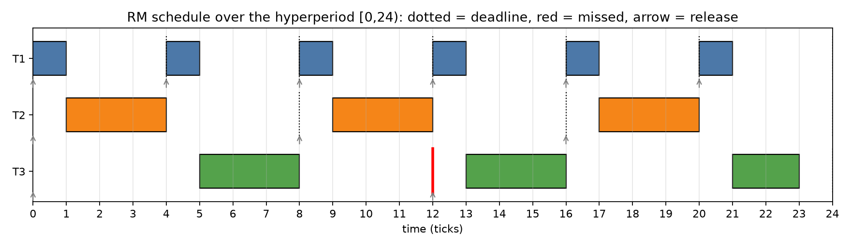
Figure 15. RM Gantt chart; the red line marks the missed deadline of T3_0
Resulting schedule
t : 0 1 2 3 4 5 6 7 8 9 10 11 12 13 14 15 16 17 18 19 20 21 22 23
: T1 T2 T2 T2 T1 T3 T3 T3 T1 T2 T2 T2 T1 T3 T3 T3 T1 T2 T2 T2 T1 T3 T3 -
RM execution order over 24 ticks
The critical instant: t=12
• T3_0 was released at t=0 and ran during ticks 5, 6 and 7; one unit remained.
• At t=8 task T2_1 is released with higher priority and runs for three ticks.
• At t=12 task T1_3 is released and, having a shorter period, runs immediately.
• As a result the last unit of T3_0 runs at tick 13 and its finish time is 14.
• The deadline of T3_0 is 12, so it is 2 units late.
Job | Release | Deadline | Finish | Tardiness | Verdict
T3_0 | 0 | 12 | 14 | 2 | MISS
T3_1 | 12 | 24 | 20 | 0 | on time
Table 16. The T3 jobs under RM and their deadline status

Comparing the two schedules
Metric | EDF | RM
Deadline misses | 0 | 1
Job that missed | - | T3_0 (deadline 12, finish 14)
Idle time | 1 | 1
Utilisation | 95.83% | 95.83%
Context switches | 12 | 11
Average response of T1 | 1.000 | 1.000
Average response of T2 | 4.667 | 4.000
Average response of T3 | 10.500 | 12.500
Maximum response | 11 | 14
Table 17. Measured results of the two algorithms over one hyperperiod
Comparative analysis
• RM gives a better average response for T2: 4.000 against 4.667.
• EDF gives a better average response for T3: 10.500 against 12.500.
• But the primary criterion in real-time scheduling is deadline misses, not averages.
• So despite RM's better average for T2, the overall verdict favours EDF.
• Context-switch counts are close, so overhead is not the deciding factor.
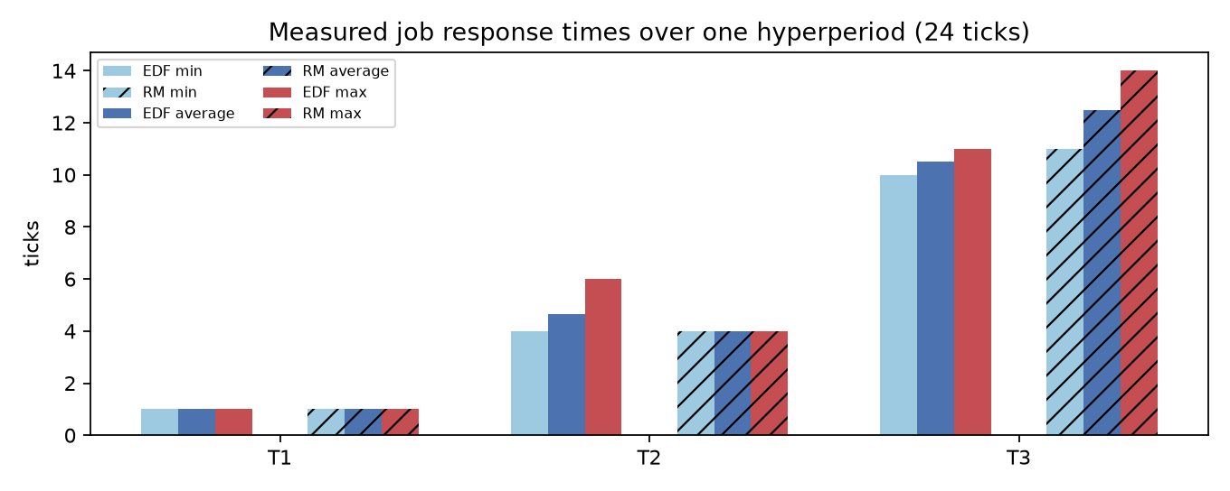
Figure 18. Minimum, average and maximum response per task under both algorithms

Utilisation, idle time and processor occupancy
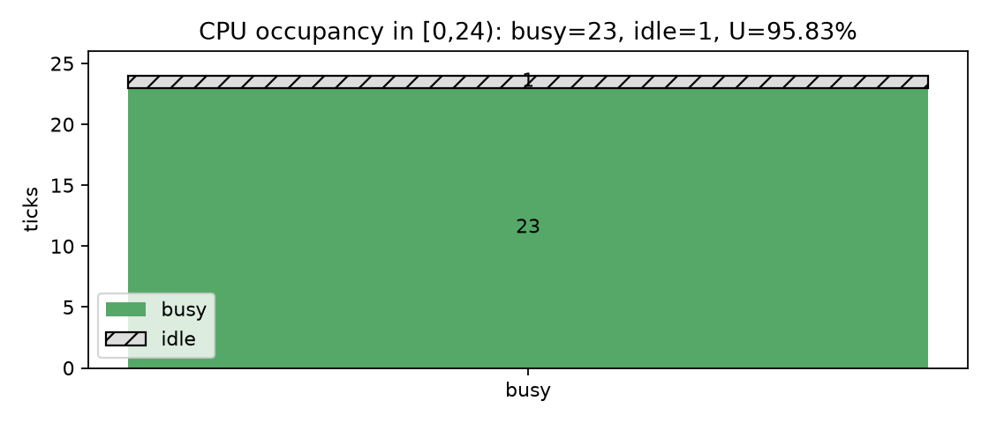
Figure 19. Processor occupancy over one hyperperiod: 23 working units, 1 idle
Hand computation of utilisation
busy = 23 idle = 1 H = 24
CPU utilization = busy / H = 23 / 24 = 0.9583 = 95.83%
offered load = U = 23/24 = 95.83%
Computing utilisation from the execution trace
Why one unit of idle time exists
• The total load in the hyperperiod is 23 units and the hyperperiod is 24 units long.
• So there is exactly one time unit with nothing to do.
• In both algorithms that unit lands at the end of the hyperperiod, at tick 23.
• Idle time is not a defect; it simply means the load is below 100%.
• If the load were exactly 24 units there would be no idle time at all.
Tardiness
• Tardiness is how late a job is relative to its deadline.
• Under EDF the tardiness of every job is zero.
• Under RM the tardiness of T3_0 is 2 units.
• In a hard real-time system any positive tardiness counts as failure.

Reconciling the hand solution with the code
How the check is done
• The execution order computed by hand is stored as a string in the program output.
• The automated tests compare that string against the simulator output.
• The job count and total load are also verified automatically.
• Any disagreement between the hand solution and the code fails the tests.
$ python code/run_experiments.py

algorithm: EDF
horizon=24 jobs=11 busy=23 idle=1
utilization=95.83% (offered 95.83%) demand=23
deadline misses: 0
timeline: T1 T2 T2 T2 T1 T3 T3 T3 T1 T3 T2 T2 T1 T2 T3 T3 T1 T2 T2 T2 T1 T3 T3 -

algorithm: RM
horizon=24 jobs=11 busy=23 idle=1
utilization=95.83% (offered 95.83%) demand=23
deadline misses: 1
miss -> task=T3 job=0 release=0 deadline=12 finish=14
timeline: T1 T2 T2 T2 T1 T3 T3 T3 T1 T2 T2 T2 T1 T3 T3 T3 T1 T2 T2 T2 T1 T3 T3 -
Actual program output, which agrees with the hand solution
Locked tests
• The first test compares the EDF execution order with the hand-worked one.
• The second checks the RM order and exactly one miss.
• The third controls the hyperperiod, utilisation and the Liu and Layland bound.
• Newer tests lock the response-time values and the per-task metrics.

Scope of the results
What has been proved
• Response-time analysis showed this set is not schedulable under RM; that is definitive.
• The condition U <= 1 showed this set is schedulable under EDF; that is also definitive.
• Both results hold for all time, not just for one hyperperiod.
What has not been proved
• Simulating one hyperperiod on its own is not a proof; it is a sample of behaviour.
• If the set were one-shot rather than periodic, the results above would not apply.
• Here the set is periodic, so hyperperiod analysis is valid.
• But if deadlines were constrained (D shorter than T), the EDF condition would no longer be sufficient.
• It is also assumed that there is no blocking, no resource sharing and no release jitter.
Precision of the claim: The claim of this report is not that EDF is always better than RM. The claim is that for this particular task set EDF is schedulable and RM is not, and that this has been confirmed both analytically and by simulation.
Scenarios that would change the result
• If C3 dropped from 4 to 2, utilisation would fall to 0.7917 and RM would probably succeed.
• If T3 rose from 12 to 24, its priority would not change but the load would drop.
• If deadlines became constrained, the processor-demand criterion would be needed.
• All of these can be tested with this same program by changing its arguments.

Conclusion
A three-task periodic set with utilisation 23/24 was designed and scheduled by hand under EDF and RM, step by step. The analytic results and the simulation agree completely.
• EDF met every deadline; the reason is that its priority is dynamic.
• RM missed one deadline: T3_0, whose deadline was 12, finished at 14.
• The cause is repeated preemption by tasks with shorter periods.
• Response-time analysis had already predicted this miss with R(T3)=14.
• Utilisation is 95.83% under both algorithms and idle time is 1 unit.
Answers to the exercise questions
Question | Answer
Which algorithm schedules the set? | EDF
How many deadline misses occur? | zero under EDF, one under RM
What is the utilisation? | 23/24 ≈ 95.83%
How much idle time is there? | 1 unit at the end of the hyperperiod
Is this a definitive proof? | Yes, from the analytic test; not from simulation alone
Table 20. Short answers to the main questions of the exercise
Key message: The difference between EDF and RM in this example comes from a single decision: at t=12, when the deadline of T3_0 has arrived, EDF continues it while RM preempts it in favour of T1_3.

References and reproduction commands
References
• Liu, C. L., & Layland, J. W. — Scheduling Algorithms for Multiprogramming in a Hard-Real-Time Environment — Journal of the ACM, 1973.
• Joseph, M., & Pandya, P. — Finding Response Times in a Real-Time System — The Computer Journal, 1986.
• Buttazzo, G. C. — Hard Real-Time Computing Systems: Predictable Scheduling Algorithms and Applications.
• Silberschatz, A., Galvin, P. B., & Gagne, G. — Operating System Concepts — chapter on Real-Time CPU Scheduling.
Reproduction commands
cd exercise-3
python code/run_experiments.py # every number and table
python code/make_figures.py # Gantt charts and figures
python code/edf_rm.py --tasks T1:1:4:4,T2:3:8:8,T3:4:12:12 \
--json out.json --table table.txt
python -m pytest tests/ -q
Commands for running Exercise 3
Output files
File | Description
output/experiments.json | all numbers in machine-readable form
output/experiments_summary.txt | text summary of the results
output/summary_EDF.txt | full EDF metrics
output/summary_RM.txt | full RM metrics
output/step_table_EDF.txt | step-by-step EDF table
output/step_table_RM.txt | step-by-step RM table
diagrams/gantt_edf.png | EDF Gantt chart
diagrams/gantt_rm.png | RM Gantt chart
diagrams/chart_rta.png | response-time analysis chart
diagrams/chart_response.png | response-time chart
diagrams/chart_utilization.png | processor occupancy chart
diagrams/fig_release_pattern.png | release pattern and deadlines
Table 21. Output files of Exercise 3

Blank worksheet 1: rewriting the EDF schedule by hand
The table below is for practising the EDF schedule by hand. Fill the 'Ran' column with the name of the job executed in each tick and note the remaining execution time of the ready jobs.
Tick | Ran (EDF) | Chosen absolute deadline | Notes
0
1
2
3
4
5
6
7
8
9
10
11
12
13
14
15
16
17
18
19
Table 22. Blank worksheet for the EDF schedule — part one

Blank worksheet 2: EDF continued and the RM schedule
Tick | Ran (EDF) | Notes
20
21
22
23
Table 23. EDF worksheet continued
Now repeat the exercise for RM. Remember that under RM the priority is fixed and the task with the shorter period always wins.
Tick | Ran (RM) | Chosen absolute deadline | Notes
0
1
2
3
4
5
6
7
8
9
10
11
12
13
14
15
Table 24. Blank worksheet for the RM schedule — part one

Blank worksheet 3: RM continued and the deadline checklist
Tick | Ran (RM) | Notes
16
17
18
19
20
21
22
23
Table 25. RM worksheet continued
After completing the schedule, fill in the table below to check the deadline of every job.
Job | Release | Deadline | Finish | Status
T1_0 | 0 | 4
T1_1 | 4 | 8
T1_2 | 8 | 12
T1_3 | 12 | 16
T1_4 | 16 | 20
T1_5 | 20 | 24
T2_0 | 0 | 8
T2_1 | 8 | 16
T2_2 | 16 | 24
T3_0 | 0 | 12
T3_1 | 12 | 24
Table 26. Empty deadline checklist for both algorithms
How to use: The correct answers for these worksheets are given in the earlier pages and in the files under output/. For self-testing, fill the tables by hand first and then compare them with the program output.

