Technical Report for “Community Events” Web Application
Kasra Gerami
25801843

Contents
1. Introduction and Project Overview
2. System Design and Architecture
3. Technology Stack and Implementation
- 3.1 HTML
- 3.2 CSS
- 3.3 JavaScript
- 3.4 JSON
- 3.5 AJAX
- 3.6 PHP
- 3.7 MySQL
4. Development Approach and Workflow
5. Frameworks, Libraries, and External Resources
6. Security and Maintainability Measures
7. Testing Evidence and Results
8. Key Code Fragments and Explanations
9. Challenges Faced and Solutions
10. Conclusion

1. Introduction and Project Overview
The “Community Events” web application was designed and implemented as part of the CSYM019 coursework for the University of Northampton MSc programme. The aim of this project is to simulate a real-world content management system (CMS) for a community organization that regularly hosts events and workshops. The application is intended to provide both public users and non-technical staff with a seamless, user-friendly platform for browsing, searching, and managing events.
The application includes two primary sections:
- A secure admin panel for event management (add, edit, delete).
- A public-facing event listing page with dynamic search and filter functionality.
This report provides a comprehensive technical description of the development process, architectural decisions, the usage of each required technology (HTML, CSS, JavaScript, JSON, AJAX, PHP, and MySQL), security considerations, testing strategies, and the key challenges encountered during the project.

2. System Design and Architecture

2.1 Overview
The system is built using a classic full-stack model, with a clear separation between client-side and server-side logic. The client side handles all user interface and dynamic behavior in the browser, while the server side manages data processing, storage, and retrieval.
Frontend: HTML, CSS, JavaScript (AJAX, JSON)
Backend: PHP, MySQL
Deployment: Docker containers to ensure a consistent environment (PHP/Apache, MySQL, phpMyAdmin)

2.2 Project Structure
The directory structure is organized as follows:
/community-events
│
├── css/
│ └── index.css
│ └── manage_event.css
├── images/
├── js/
│ └── fetch_events.js
│ └── login.js
│ └── manage_events.js
├── php/
│ └── db.php
│ └── create_event.php
│ └── fetch_events.php
│ └── delete_event.php
│ └── login.php
├── manage_event.html
├── index.html
├── Dockerfile
├── docker-compose.yml
This logical structure helps with maintainability and version control.
This diagram illustrates the overall client-server architecture of the Community Events web application. Users interact with the application through a web browser (the client), which sends requests to the server using AJAX. The server-side components—developed with PHP—handle requests, process business logic, interact with the MySQL database, and send data back in JSON format. This structure ensures a clear separation between the presentation layer and the data management layer, promoting scalability and maintainability.
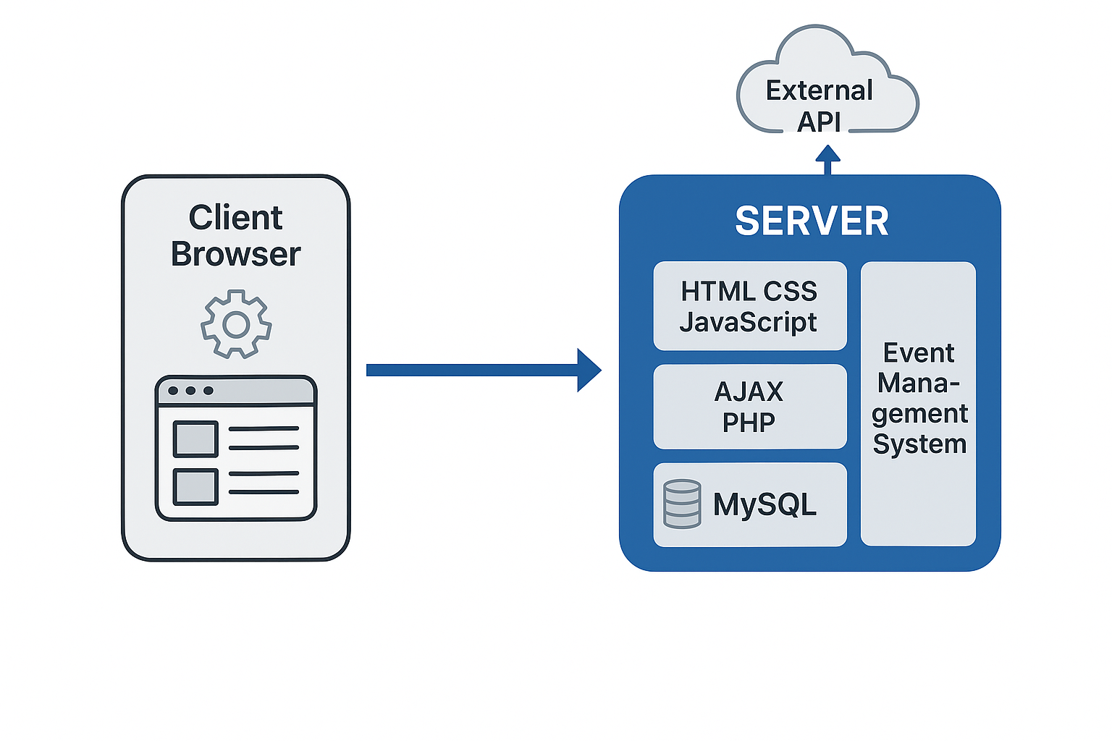

3. Technology Stack and Implementation

3.1 HTML
HTML5 is used to create the structure of all pages. Semantic elements (<main>, <header>, <section>, <form>, <table>) are employed for accessibility and clarity. For example, the event management form in the admin panel uses semantic labels and input fields for each event property.[1]

3.2 CSS
Custom CSS styles the application for a modern, clean, and responsive layout. Media queries ensure accessibility on different screen sizes. CSS Grid and Flexbox are used for event card layouts, and special classes (such as .event-card, .event-grid, .login-button, .modal) provide separation of style concerns.[2]

3.3 JavaScript
JavaScript (plain ES6) is used to implement all dynamic front-end behavior:
- AJAX requests for fetching and submitting data asynchronously.
- DOM manipulation for updating the event list dynamically.
- Modal handling for login forms and success messages.
- Search and filter logic for the public events page.[3]

3.4 JSON
Data is exchanged between frontend and backend in JSON format. For example, event data retrieved via AJAX from fetch_events.php is sent as a JSON array, which is parsed and used to dynamically render event cards.[4]

3.5 AJAX
AJAX is employed (using the Fetch API) to:
- Fetch event data from the server for listing and searching.
- Submit new events to the server.
- Delete events (admin panel).
All AJAX calls use fetch() and update the DOM based on server responses without full page reloads.[4]

3.6 PHP
PHP is used for all backend logic, including:
- Processing form submissions from the admin panel.
- Handling database connections.
- Querying the MySQL database for event search/filter.
- Returning JSON-encoded data for AJAX calls.
- Implementing event deletion and (optionally) authentication.[5]

3.7 MySQL
MySQL is used to store all event data in a single normalized table:
CREATE TABLE events (
id INT AUTO_INCREMENT PRIMARY KEY,
title VARCHAR (255),
description TEXT,
start_time DATETIME,
location VARCHAR (255),
category VARCHAR(50),
image VARCHAR(255)
);
Prepared statements are used in PHP to prevent SQL injection.[5]

4. Development Approach and Workflow
The project was developed incrementally using VS Code and version-controlled with GitHub. Each feature was developed in small, logical steps with regular commits, ensuring a clear commit history as required by the assessment criteria.
Docker Compose was used to launch separate containers for the PHP/Apache web server, MySQL database, and phpMyAdmin UI, allowing for easier environment setup and consistent deployment.
Workflow Steps:
1. Set up the Docker environment and initialize MySQL.
2. Designed the database schema.
3. Created basic HTML/CSS for public and admin pages.
4. Developed PHP backend scripts for event CRUD operations.
5. Implemented AJAX and dynamic updates using JavaScript.
6. Tested features and fixed bugs iteratively.
This flowchart demonstrates the typical workflow of the Community Events web application, from user actions to backend processing. The user submits data via the interface (such as adding an event), which triggers client-side validation and sends an AJAX request to the server. The server (PHP) processes the request, updates or retrieves information from the MySQL database, and returns a JSON response. The frontend (JavaScript) dynamically updates the UI based on the server’s response, ensuring a seamless and interactive user experience.
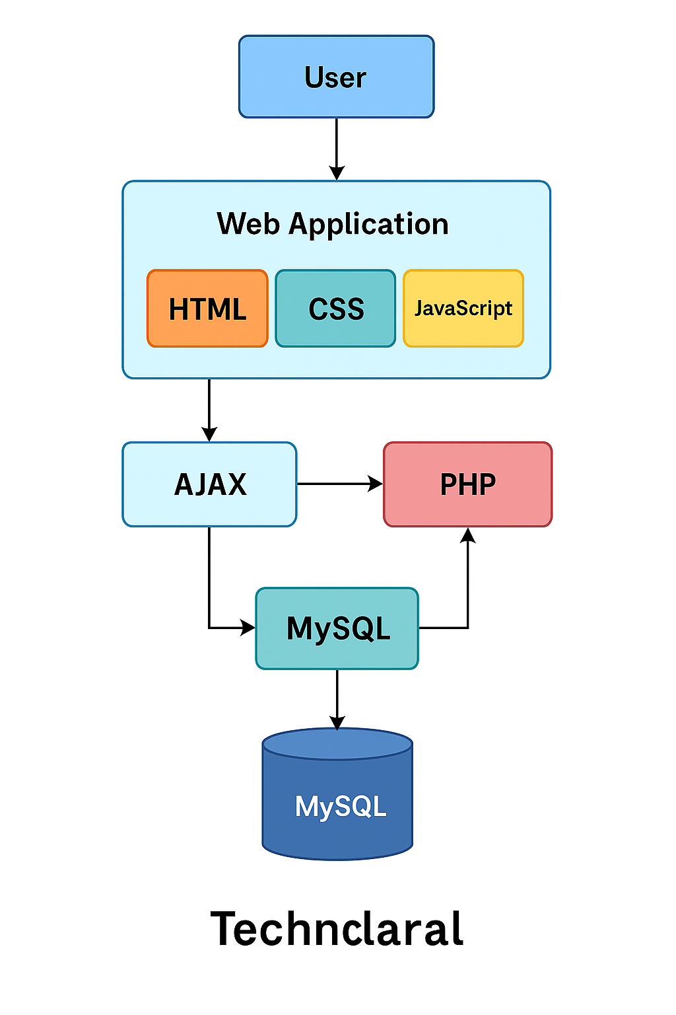

5. Frameworks, Libraries, and External Resources
No external frameworks or front-end libraries (like React, Angular, Bootstrap, etc.) were used, per project requirements. All code was written in plain HTML, CSS, JavaScript, and PHP. External resources were only used for reference and were properly cited where appropriate.

6. Security and Maintainability Measures
- Prepared Statements: All SQL queries use prepared statements to prevent SQL injection.
- Input Validation and Sanitization: All form inputs are validated both client-side and server-side.
- Separation of Concerns: CSS, JavaScript, and PHP code are separated into distinct files for readability and maintainability.
- Authentication: Admin functionality is protected by a login system (single admin account for simplicity).
- Error Handling: All AJAX responses include error handling and user-friendly messages.
- Version Control: The project was regularly committed to a private GitHub repository, ensuring traceability and recoverability.

7. Testing Evidence and Results
Testing was conducted throughout development to ensure all core features worked as intended. Below are some of the primary test cases and their results:
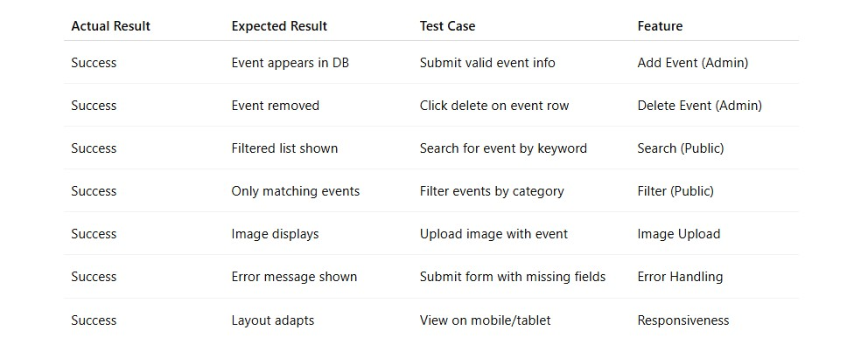
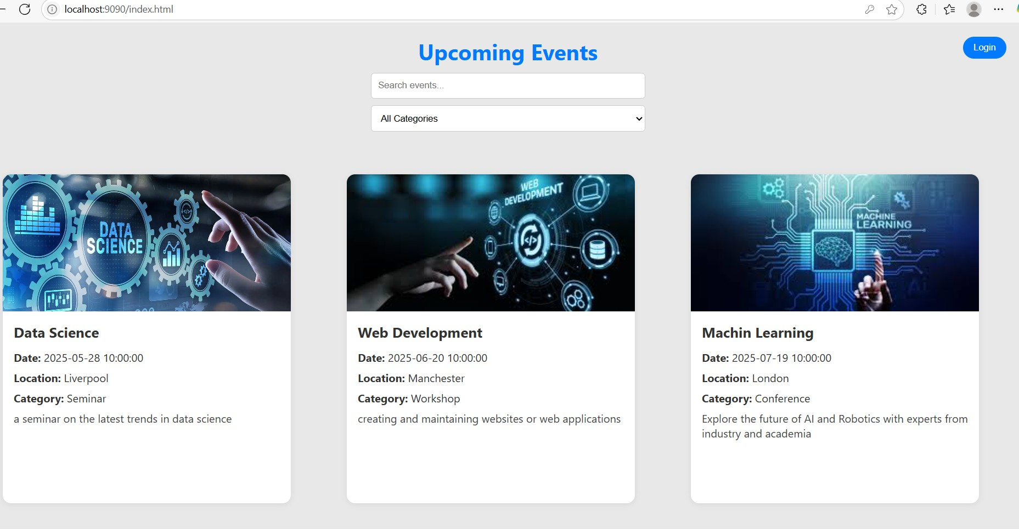
Figure 1 The login modal allows only authorized users (such as the admin) to access the event management panel, ensuring secure access control for administrative features.
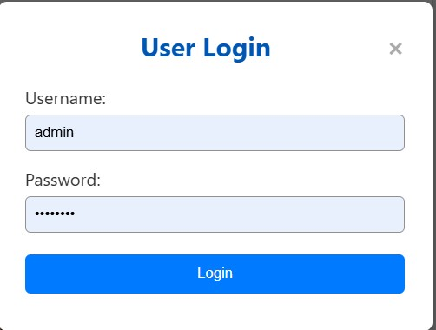
Figure 2 The login modal allows only authorized users (such as the admin) to access the event management panel, ensuring secure access control for administrative features.
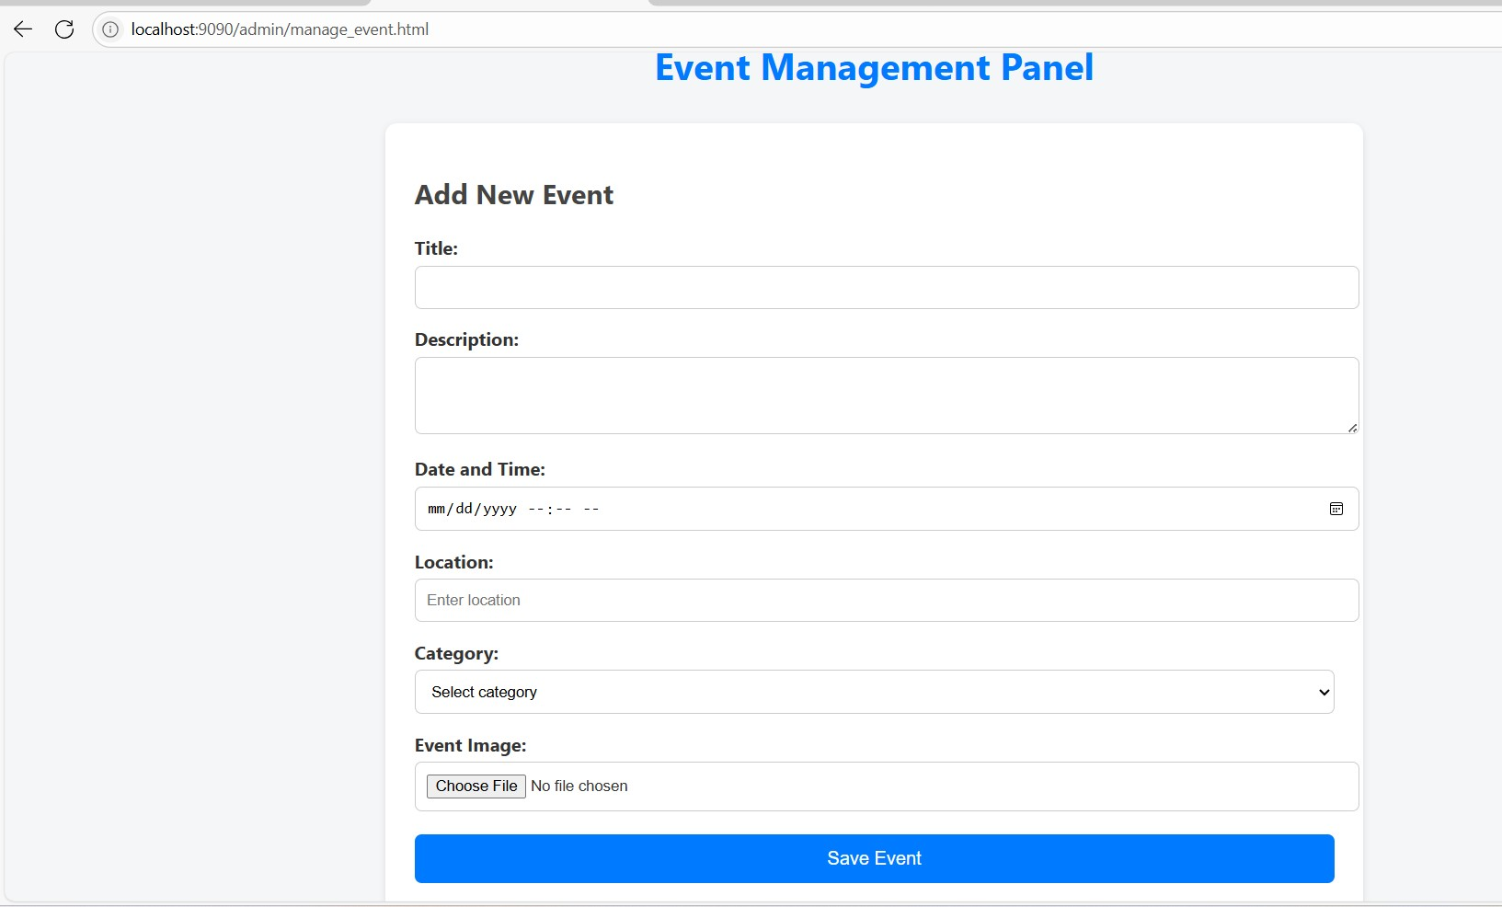
Figure 3 The Event Management Panel provides an intuitive interface for administrators to add new events by entering the title, description, date, location, category, and uploading an event image.
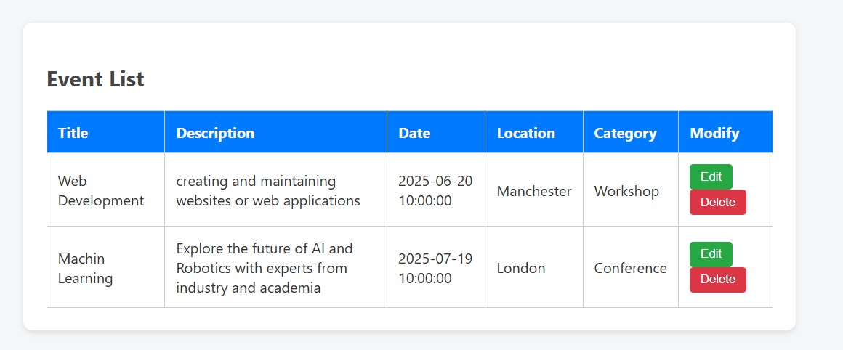
Figure 4 The admin event list view shows all events in a structured table, enabling editing or deletion of events for efficient management. Each row presents the event’s core information and modification options.
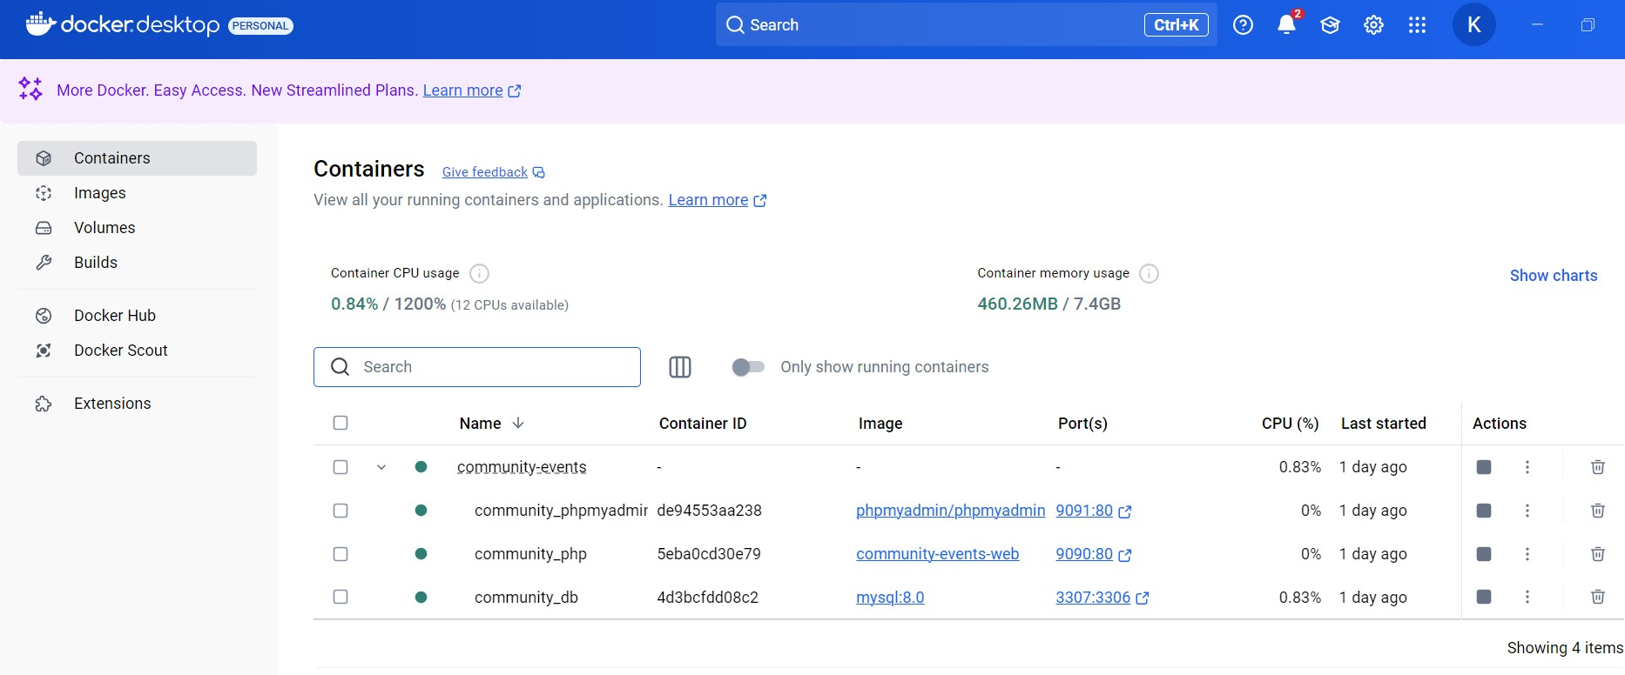
Figure 5 Docker Desktop is used to containerize the entire application, including the PHP backend, MySQL database, and phpMyAdmin. This setup provides portability, easy deployment, and reliable development environment management.

8. Key Code Fragments and Explanations
8.1 Dynamic Event Fetching (AJAX + PHP)
JavaScript (fetch_events.js):
document.addEventListener("DOMContentLoaded", function () {
// ... code for fetching events
});
PHP (fetch_events.php):
$sql = "SELECT ...";
...
8.2 Secure Event Submission (PHP)
$stmt = $conn->prepare("INSERT INTO events (title, description, ...) VALUES (?, ?, ...)");
$stmt->bind_param("sss...", $title, $description, ...);
8.3 Responsive Event Grid (CSS)
.event-grid {
display: grid;
grid-template-columns: repeat(auto-fit, minmax(320px, 1fr));
gap: 20px;
}
(You may want to paste more code snippets relevant to search, filter, or delete functionality.)

9. Challenges Faced and Solutions
- Docker Configuration: Initially, connecting PHP with MySQL inside Docker required several attempts. The final solution was to use environment variables and persistent Docker volumes for the MySQL container.
- AJAX Synchronization: Ensuring the event list updated correctly after CRUD operations sometimes caused race conditions. Careful use of callbacks and page reloads resolved these issues.
- Image Upload Handling: Correctly moving uploaded images from temporary to permanent storage and referencing their paths in the database required troubleshooting with PHP file functions.
- Security Measures: Implementing input sanitization and validation, and using prepared statements, required extra testing.
- Browser Compatibility: Ensuring styles and modals looked correct on all browsers, especially Chrome and Edge, needed multiple CSS tweaks.
Future Recommendations
While the current version of the Community Events Management System fulfills the primary requirements and offers a robust foundation, there are several directions in which the system could be enhanced and expanded in the future:
1. User Authentication and Role Management:
Implementing a full authentication and authorization system with roles (such as admin, event organizer, and regular user) would improve security and allow for personalized experiences and access control.
2. Enhanced Event Features:
Adding support for recurring events, ticketing, attendee management, and event reminders (via email or SMS) could significantly increase the platform's utility for both organizers and participants.
3. Responsive Design Improvements:
Although the system is designed to be responsive, further refinement using frameworks like Bootstrap or Tailwind CSS could ensure an optimal user experience on all device sizes.
4. API Integration:
Providing a RESTful API would allow third-party applications and mobile clients to interact with the system, opening up possibilities for greater integration and scalability.
5. Performance Optimization:
As the number of events and users grows, optimizing database queries, implementing caching mechanisms, and considering server-side rendering for key pages can improve performance.
6. Security Enhancements:
Further security improvements such as implementing HTTPS, using prepared statements everywhere, adding rate-limiting, and validating all user inputs can help protect against common web vulnerabilities.
7. Advanced Search and Filtering:
Introducing advanced filtering, faceted search, and full-text search capabilities would make it easier for users to find relevant events quickly.
8. Analytics and Reporting:
Adding analytics dashboards for administrators and event organizers can provide insights into user engagement, popular events, and other key metrics.
9. Localization and Accessibility:
Supporting multiple languages and ensuring compliance with accessibility standards (such as WCAG) would make the platform usable by a broader audience.
10. Continuous Deployment and Testing:
Integrating CI/CD pipelines and automated testing (unit, integration, and end-to-end tests) would facilitate faster and safer updates in the future.

10. Conclusion
The “Community Events” web application successfully demonstrates the integration of multiple web technologies to create a maintainable, user-friendly CMS. All functional and technical requirements have been met, and the system has been tested to ensure reliability and security. The use of Docker has further improved deployment consistency, and the project repository documents the incremental development process.
Further improvements could include user registration, advanced search, event RSVP features, or the integration of an email notification system.
References
[1] W3C. (2014). HTML5: A vocabulary and associated APIs for HTML and XHTML. W3C
[2] W3C. (2018). CSS Grid Layout Module Level 1
[3] Flanagan, D. (2020). JavaScript: The Definitive Guide (7th ed.). O'Reilly Media
[4] Crockford, D. (2006). The application/json Media Type for JavaScript Object Notation (JSON)
[5] Welling, L., & Thomson, L. (2017). PHP and MySQL Web Development (5th ed.)

