Appendix

**Analysis, Design and Software Architecture-E2012  
Exam Project:  
Slice of Pie**



Kewin Bent Pedersen (kbep@itu.dk)  
Christian Martin Henriksen (cmah@itu.dk)  
Kasra Tahmasebi Shahrebabak (ktah@itu.dk)

Indhold

Appendix 1: Use cases 5

1.0 Revision Table 5

1.1: Create new document 5

1.2: Change the name of a document 5

1.3: Delete a document 6

1.4: Open a document 6

1.5: Save a document 7

1.6: Create a project 7

1.7: Choose a project to work in 7

1.8: Share a project with another user 8

1.9: Insert picture to a document 8

1.10: View a picture attached to a document 8

1.11: Remove picture attached to a document 9

1.12: Rename folder 9

1.13: Move object in explorer 9

1.14: Synchronize local project with server 10

1.15: Add project from server to offline client. 10

Appendix 2: Domain Model 11

2.0 Revision Table 11

Appendix 3: System Sequence Diagrams 12

3.1 OfflineClient-Server SSD 12

3.2 OfflineClient-Server SSD diagram Revision Table 12

3.3 OfflineClient-Storage SSD 13

3.4 OfflineClient-Storage SSD Revision Table 14

3.5 WebClient-Server SSD 14

3.6 Web-Server diagram SSD Revision Table 16

Appendix 4: Scrum Burndown charts 17

4.1 Example from sprint 1 17

4.1 Burndown for entire project 17

Appendix 5: Use case diagram 17

5.1 Use case Model 18

5.2 Use case diagram Revision Table 18

Appendix 6: Class diagram 19

Appendix 6.0: Class diagram 20

Appendix 7: Sprint reviews and retrospectives 20

7.1 Sprint 1 20

7.1.1 Review 20

7.1.2 Retrospective 20

7.2 Sprint 2 21

7.2.1 Review 21

7.2.2Retrospective 21

7.3 Sprint 3 21

7.3.1 Review 21

7.3.2 Retrospective 22

Appendix 8: Sprint documentation 22

8.1 Sprint 1 22

8.1.1 Description of each work day 22

8.1.2 The programs functionality at the end of this sprint 23

8.2 Sprint 2 24

8.2.1 Description of each work day 24

8.2.2 The programs functionality at the end of this sprint 24

8.3 Sprint 3 27

8.3.1 Description of each work day 27

8.3.2 The programs functionality at the end of this sprint 27

# Appendix 1: Use cases

## 1.0 Revision Table

|  |  |  |
| --- | --- | --- |
| Date | Description | Author |
| 04-12-2012 | Initial version | All |
| 04-12-2012 | Details and diagram added for Use case 1 and 2.[1] | Christian |
| 13-12-2012 | Diagrams edited for use case 1 and 2.  Details and diagram added for use cases 2-8. | Kewin |
| 16-12-2012 | Major overhaul of how use cases are written. | Kewin |
| 16-12-2012 | Added use cases 9 to 15, and rewrote others. | Kewin |

## 1.1: Create new document

The user wants to create a new document.

Basic flow

1. The user chooses a place where the document should be and specifies a name for it.
2. The program saves the document to the storage, and updates the list of documents to include the new document.

Preconditions:

* The user must be logged into a client.

## 1.2: Change the name of a document

The user wants to change the name of a document.

Basic flow

1. The user chooses which document he wants to rename, and specifies the new name for it.
2. The program edits the document and saves the change to the storage, while also adding the change to the document’s logs. And then finally updates the list of documents to show the changed name.

Preconditions:

* The user must be logged into a client and be working in a project.
* The user must have access and rights to a document.

## 1.3: Delete a document

The user wants to delete a document.

Basic flow

1. The user specifies which document he wants to delete.
2. The program deletes the document from the storage, and updates the list of documents is show that the document is no longer there.

Preconditions:

* The user must be logged into a client and be working in a project.
* The user must have access and rights to a document.

## 1.4: Open a document

The user wants to open a document he has selected in the explorer.

Basic flow

1. The user chooses which document he wants to open.
2. The program reads all info about the document from the storage, and shows it to the user.

Preconditions:

* The user must be logged into a client and be working in a project.
* The user must have access and rights to a document.

## 1.5: Save a document

The user wants to save a document.

Basic flow

1. The user has changed attached pictures and or changed the documents text.
2. The program saves the document to the storage.

Preconditions:

* The user must be logged into a client and be working in a project.
* The user has opened the document, and made changes to it.

## 1.6: Create a project

The user wants to create a project.

Basic flow

1. The user specifies he title for his new project.
2. The program saves the new project to the storage, and makes sure the user has access to his new project through the explorer.

Preconditions:

* The user must be logged into the web client.

## 1.7: Choose a project to work in

The user wants to choose which project he would like to work in.

Basic flow

1. The user logs in with his username.
2. The program presents the user with a list of projects available to him.
3. The user selects which program he wants to work in.
4. The program gets the information about the project from the storage, and presents the project in the explorer.

Preconditions:

* The user must be logged into a client.
* The user must either own or have projects be shared with him.

## 1.8: Share a project with another user

The user wants to share a project.

Basic flow

1. The user writes the name of the person he wants to share his project with.
2. The program updates the storage to reflect that the project is now shared with the person the user specified.

Preconditions:

* The user must either be the owner of the project, or the project has to be shared with him.
* The user must have opened the project in the web client.

## 1.9: Insert picture to a document

The user wants to attach a picture to a document.

1. The user chooses a picture from his local file system to add to the document.
2. The program saves the picture to the storage, and updates the document to reflect that the picture is attached to it.

Preconditions:

* The user must be logged into a client.
* The user must have opened the document he wants to insert the picture to.

## 1.10: View a picture attached to a document

The user wants to see a picture that is attached to a document.

Basic flow

1. The user selects the picture he wants to view.
2. The program shows the picture to the user in a separate window.

Preconditions:

* The user must be logged into a client and be working in a project.
* The user must have opened a document that has a picture attached to it.

## 1.11: Remove picture attached to a document

The user wants to remove a picture attached to a document.

Basic flow

1. The user chooses which picture in the document he wants to delete.
2. The program will remove the picture from the storage, and update the document view to reflect that the picture is no longer attached to it.

Preconditions:

* The user must be logged into a client and be working in a project.
* The user must have opened a document that has a picture attached to it.

## 1.12: Rename folder

The user wants to rename a folder.

1. The user chooses which document he wants to rename, and specifies the new name for it.
2. The program edits all documents in the folder and underlying folders’ paths and saves the changes to the storage, while also adding the change to all impacted document’s logs. And then finally updates the list of documents to show the changed name.

Preconditions:

* The user must be logged into a client and be working in a project containing a folder.

## 1.13: Move object in explorer

The user wants to move either a document or a folder to another folder in the explorer.

Basic flow

1. The user chooses which folder or document should be moved.
2. The program asks the user where the object should be moved to.
3. The user chooses which folder the object should be moved to.
4. The program changes the single documents path if the object was a document, or all documents the folder contained if the object was a folder. The program then saves the changes to the storage, and updates the explorer to reflect the changes.

Preconditions:

* The user must be logged into a client and be working in a project..

## 1.14: Synchronize local project with server

The user wants to synchronize his local project with the servers version of the project.

Basic flow

1. The user tells the program he wants to synchronize the project he is working in.
2. The program contacts the server and handles all synchronization with the server, and saves the changes made to the local storage, and updates the explorer to reflect changes made to local content.

Preconditions:

* The user must be logged into the offline client and be working in a project.

## 1.15: Add project from server to offline client.

The user wants to add a project that is shared with him on the server to his local client.

1. The user tells the program he would like to add a remote project to his local client.
2. The program contacts the server which supplies it with a list of project titles on the server that the user does not have in his local client, that he either owns or is shared with him.
3. The user chooses which project he wants to add to his local client from the list.
4. The program gets the project and all its content from the server, and saves it to the storage, and then finally updates the list of projects available on the local client to reflect the change.

Preconditions:

* The user must be logged into the offline client.

# Appendix 2: Domain Model

**Document**

Includes text and pictures.

**User**

Owns a

Is shared with

1

0..*

**Folder**

**Project**

1

0..*

1

0..*

Contains

1

Contains

1

Contains

0..*

0..*

## 2.0 Revision Table

|  |  |  |
| --- | --- | --- |
| Date | Description | Author |
| 04-12-2012 | Initial version | Kewin & Kasra |
| 16-12-2012 | Updated model, added folder and project | Kewin |
|  |  |  |

# Appendix 3: System Sequence Diagrams

These diagrams were all created in our visual studio solution, and can also be found there in the project “UML Slice of Pie”.

## 3.1 OfflineClient-Server SSD

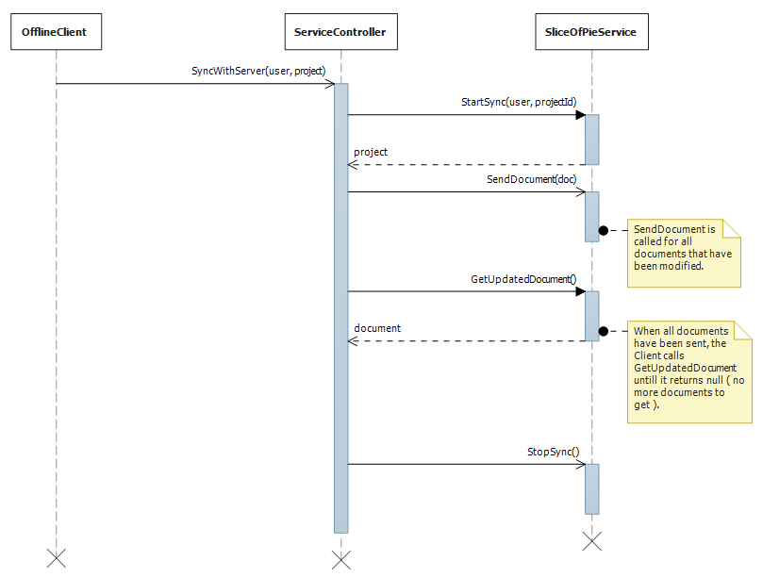

## 3.2 OfflineClient-Server SSD diagram Revision Table

|  |  |  |
| --- | --- | --- |
| Date | Description | Author |
| 16-12-2012 | Initial version | Kewin |
|  |  |  |
|  |  |  |
|  |  |  |

## 3.3 OfflineClient-Storage SSD

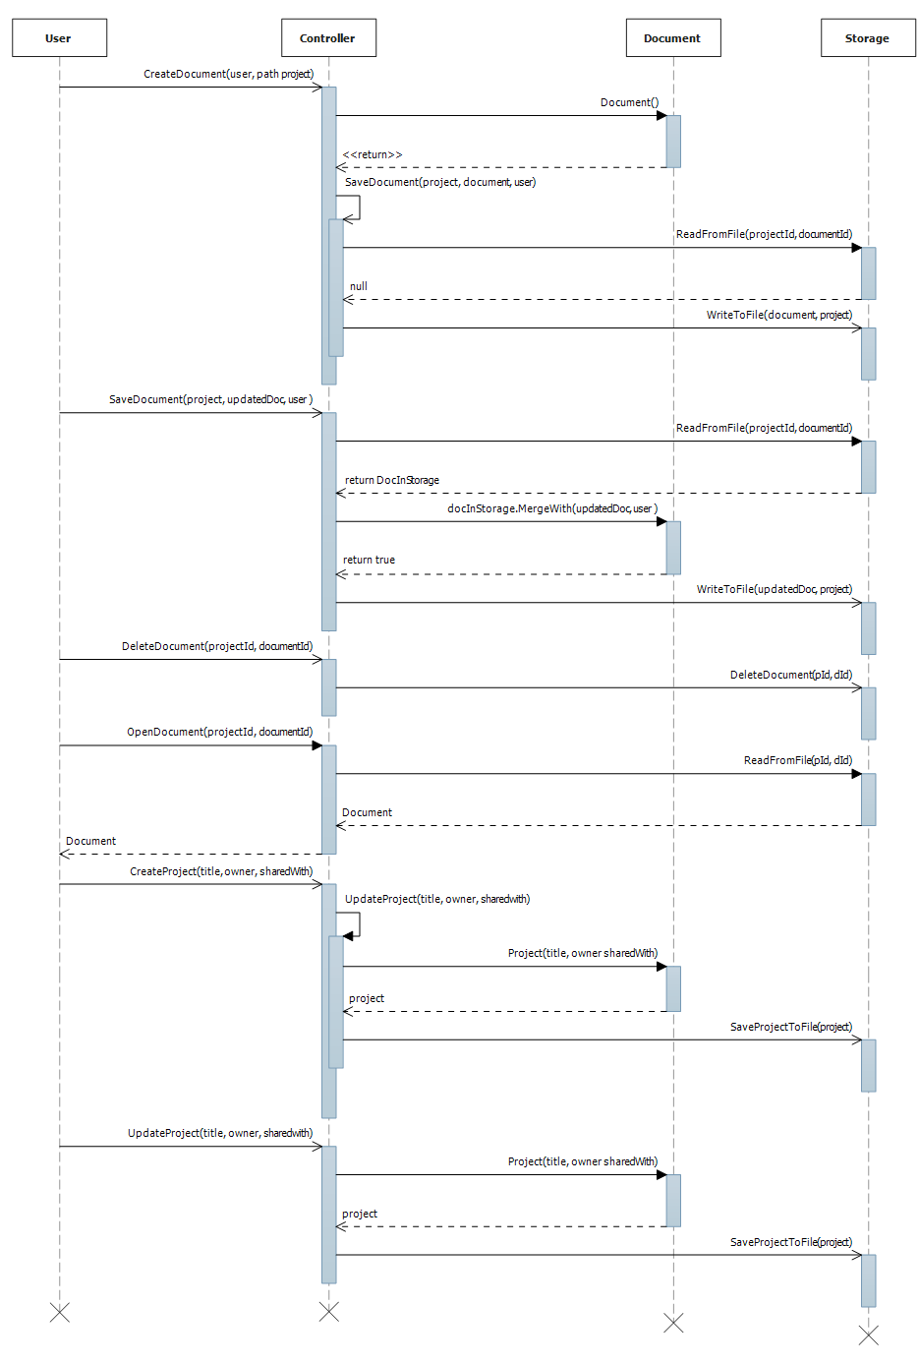

## 3.4 OfflineClient-Storage SSD Revision Table

|  |  |  |
| --- | --- | --- |
| Date | Description | Author |
| 04-12-2012 | Initial version | Christian |
| 14-12-2012 | Changed according to new architechture. | Kewin |
| 16-12-2012 | Small changes | Kewin |
|  |  |  |

## 3.5 WebClient-Server SSD

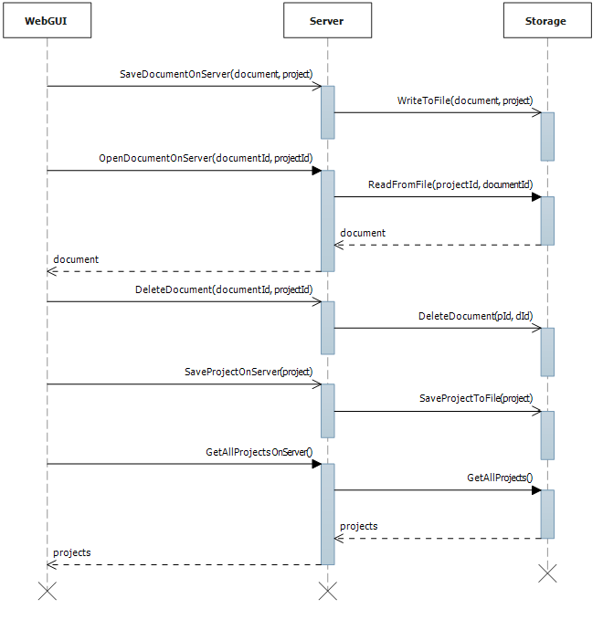

## 3.6 Web-Server diagram SSD Revision Table

|  |  |  |
| --- | --- | --- |
| Date | Description | Author |
| 16-12-2012 | Initial version | Kewin |
|  |  |  |
|  |  |  |

# Appendix 4: Scrum Burndown charts

## 4.1 Example from sprint 1

Example of a burndown-chart from a concluded sprint, in this case we forgot to put the last stories to status: Done before the sprint was done, so that wasn’t calculated properly, resulting in the green field not reaching the top.

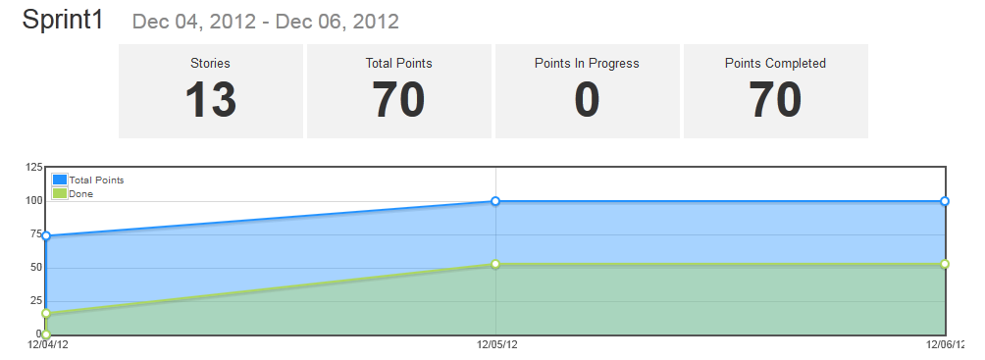

## 4.1 Burndown for entire project

This is our burndown-chart for the entire project duration.

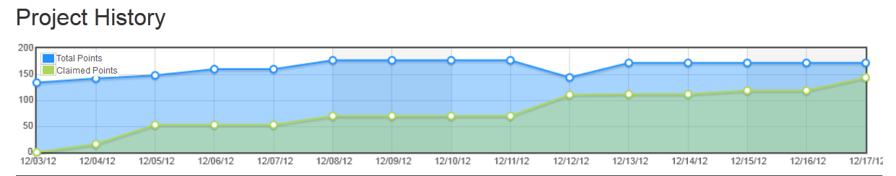

# Appendix 5: Use case diagram

This diagrams was created in our visual studio solution, and can also be found there in the project “UML Slice of Pie”.

## 5.1 Use case Model

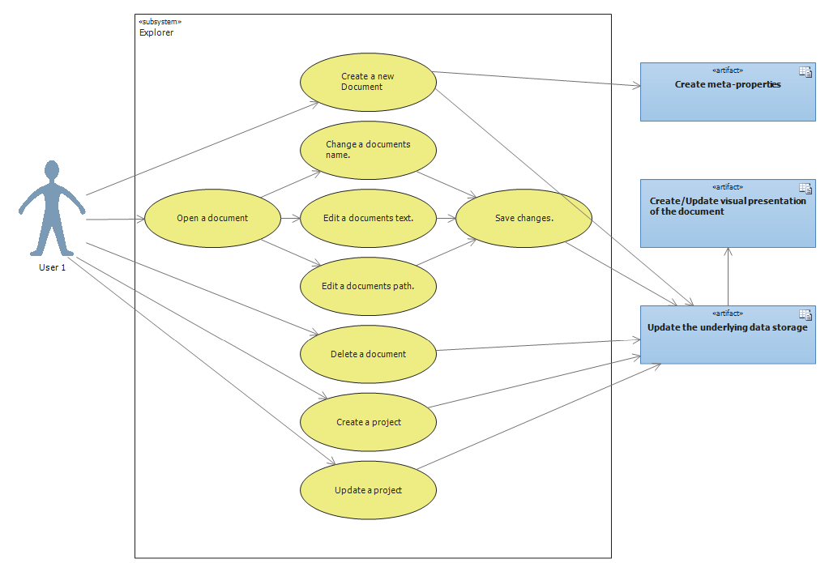

## 5.2 Use case diagram Revision Table

|  |  |  |
| --- | --- | --- |
| Date | Description | Author |
| 04-12-2012 | Initial version | Christian |
| 14-12-2012 | Added many use cases | Kewin |
|  |  |  |
|  |  |  |

# Appendix 6: Class diagram

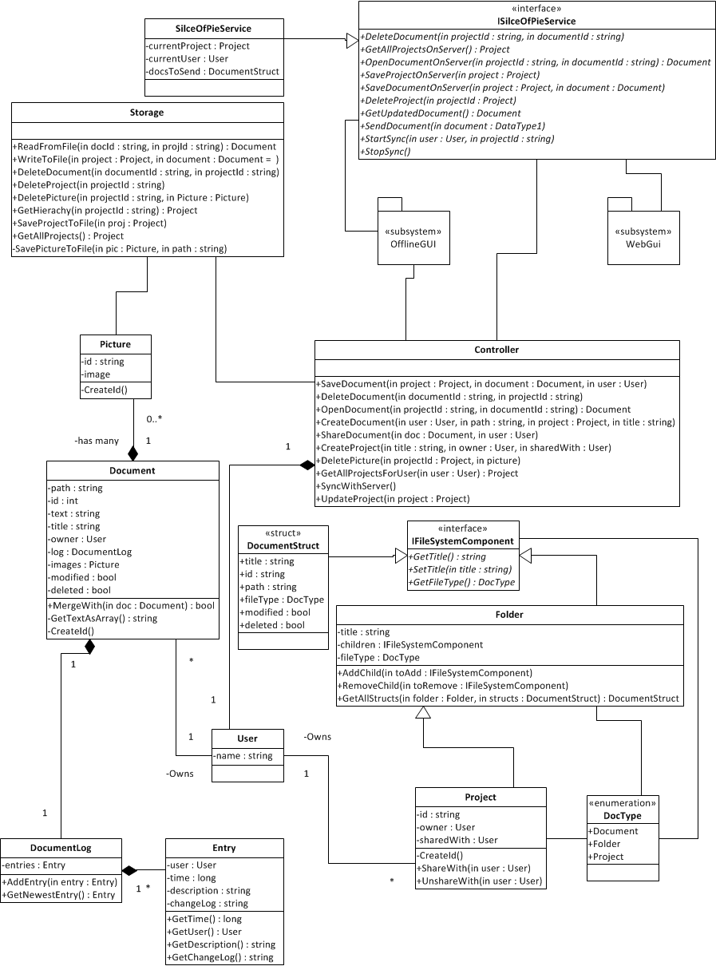

## Appendix 6.0: Class diagram

|  |  |  |
| --- | --- | --- |
| Date | Description | Author |
| 04-12-2012 | Initial version | All |
| 04-12-2012 | Small additions to controller and storage | Kasra |
| 08-12-2012 | Completely reworked class diagram to conform to new decisions. | Kasra & Kewin |
| 11-12-2012 | Reworked class diagram again. | Kewin |
| 16-12-2012 | Reworked again | Kewin |
| 17-12-2012 | Adjusted to fit final implementation | Kasra |

# Appendix 7: Sprint reviews and retrospectives

## 7.1 Sprint 1

### 7.1.1 Review

We have made a first draft of the offline editor for the client.

At this point we can write documents to the hard drive, but we can’t read from it just yet.

### 7.1.2 Retrospective

What went well?

We were quick and efficient.

We were good at working independently.

We were good at creating a manageable overview of what should be done, which eased the development process.

What could have been better?

Very little progress on the last day of the sprint.

We kept adding new stories, making the sprint too heavy for us to complete within the timeframe.

Some stories were too loosely defined.

## 7.2 Sprint 2

### 7.2.1 Review

Our offline client is almost completely done, all that is missing for it to be done is picture support and slightly improved functionality with buttons and interface.

The server is set up and can be run, both with connection and contract. Its behavior needs to be defined for it to be done though.

We have made several changes to our programs design, including adding “Project” and “DocumentStruct”, and editing Document and Storage.

Our stories were not very describing of the work that had to be done, and their velocity did not reflect the amount of work that needed to be put in to them.

### 7.2.2Retrospective

What went well?

We were good at identifying problems and figuring out ways to solve the immediately.

What could have been better?

We were late each day on starting the actual work, and instead put in more hours in the evenings/nights, which made is more tired.

## 7.3 Sprint 3

### 7.3.1 Review

Our offline client is completely done, it has a single bug that we are aware of[2] Our web gui is well underway, but not done at this time, it holds a big majority of functionality needed, but not all just yet.

Our server is correctly set up, and just needs to be implemented into the two different types of clients.

We lack some testing on few parts of the system as well.

All the work that was done in this sprint was VERY poorly documented by stories on ScrumDo, as it was neglected in the wake of immense coding sessions.

### 7.3.2 Retrospective

What went well?

We were very efficient at implementing new features to our program, and very few errors were encountered in this sprint, making it very efficient.

A lot of coding/work was done.

What could have been better?

We worked way more than the time allotted to this sprint, spending nearly 50 % more time working each day than what was planned.

# Appendix 8: Sprint documentation

## 8.1 Sprint 1

### 8.1.1 Description of each work day

Day 1

We spent all working hours on creating various design artifacts, including domain model, SSD’s and more. At the end of the day we had a good idea of how to start the coding the next day.

Day 2

We started the day reviewing our design artifacts with a small meeting, and then sat down individually and coded separate parts of the program.   
At the end of the day a lot of coding had been successfully done, and we a lot of working functionality that had been tested.

Day 3

On day 3 there was not a lot of work done due to other real life activities coming in the way of the work. Some slight coding, documenting and testing was done, but not at a satisfactory level.

## 8.1.2 The programs functionality at the end of this sprint

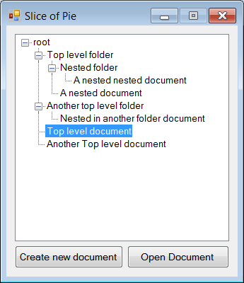GUI

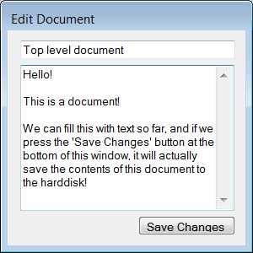The user interface is an initial version with basic functionality. The main window shows a tree hierarchy of the folders and documents created, and the user can open one of the documents and start editing. For now it only reads in a set of test data already defined in code, but it will save to the hard disk when the ‘Save Changes’ button is pressed in the ‘Edit Document’ window. (The ‘Create New Document’ button is currently just a placeholder)

Controller

The controller is used as a gateway to the functionality that lies in the storage class, so it is not directly accessed from the GUI.

Document

The document class is at this stage done unless new requirements for it arise. It holds all information related to a document, including a Log which holds entries on changes made to the document.   
It also holds functionality to merge the document with a newer version of the same document.

Folder

The folder class holds information relevant to a folder in the file system, and functions to add and remove children, as well as getting all children.

IFileSystemComponent

Our interface that covers over both folders and documents, not much to say other than it at this point serves its functionality.

IFileSystemComponentEnum

An enum describing whether a component is a folder or a document.

Storage

The storage at its current stage can perform most functionality needed from it, but still needs further development.  
At this stage it is able to create documents on the file system from a document object without a change log. It can also create folders from folder objects, even if they have a document inside or another folder it will still create a representation of it on the harddrive, but it still needs some optimization before it’s done.  
We can also read from the harddrive and make new documents, but not folders yet.

## 8.2 Sprint 2

### 8.2.1 Description of each work day

Day 1

Day one we started out looking at our diagrams to see what updated had to be made, when that was done, we started coding on our separate parts of the program, extending functionality in all ends.

Day 2

We did a lot of testing on day 2, to make sure everything was working as intended, found several minor issues which were corrected.

We also realized that the structure of our program had to be slightly readjusted to cope with requirements as well as just make more sense in the way data was stored and handled within the program.

Day 3

We did a lot of researching on server functionality, and started implementing it as well as being busy with including new readjustments from day 2, the day was very productive and a lot of work was put into the program, resulting in good progress of the program.

# 8.2.2 The programs functionality at the end of this sprint

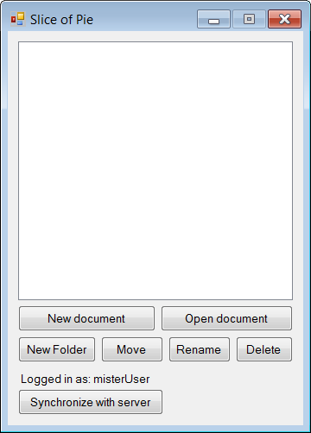GUI

The User interface is nearing a finished state. All the controls the user needs to fully operate the program has been added. Some of these controls are not functional yet, and only serve as placeholders until the back end is ready to be tied up to these buttons.

This version of the User Interface does not include the recent design change our program underwent, that being the introduction of projects.

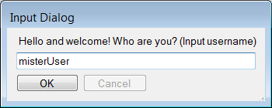

Controller

The Controllers functionality is unchanged since the last sprint, but will be updated to allow interaction with server, as well as the remaining functionality that is required from our readjustment of the structure.

Document

Our Document Class was changed in several ways since last sprint. The biggest change being the MergeWith function, along with several others.  
The MergeWith function now takes all changes in the document into account, and generates a fitting changeLog according to the changes.

A document is no longer “shared”, as that is handled by our new class “Project”.

Folder

The folder class has not been changed since the last sprint.

IFileSystemComponent

The IFileSystemComponent has not been changed since the last sprint.

Doctype

The enum “IFileSystemComponentEnum” was renamed to Doctype, and a new third value was added, which is “Project”.

DocumentStruct

This sprint also included the introduction of the DocumentStruct, which is used to store enough information to create a suitable Gui from, with information taken from the storage, without pulling out and handling large amounts of data, of which very little is needed. The documentStruct also inherits from IFileSystemComponent.

Project

The Project class was added to allow users to shared entire “folders”, which are named projects. Projects function in almost the same manner as folders, being that they can contain children that are IFileSystemComponents, which is why it extends the folder class.   
Projects also include an owner and a list of users it is shared with.

Storage

Our storage class can now save an object of our new Project class on the file system, it creates a folder and some metainformation(a .txt file) which says something about the owner of the project and who it shared with. We can also at this moment, given a project id, create a new project from the files the file system, and return the project object as it should look like for gui representation.

The storage was also updated to read and write documents with their entire log to and from the file system.

Server

A lot of time during this sprint was spent doing reserach and considering the specifics of the implementation of the server. In its current state, the server is runnable and the client application is able to contact the server correctly. The server has no behavior implemented yet. The server is a WCF service hosted in a separate application.

## 8.3 Sprint 3

### 8.3.1 Description of each work day

Day 1

We sat down looking at diagrams and models, checking which should be updated, and which are as they should, we also started looking at our webgui.

Day 2

Almost the entire day was devoted to coding, spending more time than allotted, but spending the time well on implementing many features across the program.

Day 3

Day 3 was very much like day 2, we spent way more time than was allotted to the day, but the time was spent doing hardcore coding implementing new features every single hour.

### 8.3.2 The programs functionality at the end of this sprint

OfflineGui

The “offlineGui” for clients working offline is completely done, all it needs is to be hooked up with the server.

Controller

The controller has been expanded with a lot of functionality to cope with all the new features that were added during the sprint, including pictures, projects and more.

Document

Our document Class has been updated to be able to contain pictures, as well as slight fixes to the way the documents log is written.

Folder

The folder class has not been changed since the last sprint.

IFileSystemComponent

The IFileSystemComponent has not been changed since the last sprint.

Doctype

The enum “IFileSystemComponentEnum” was renamed to Doctype, and a new third value was added, which is “Project”.

DocumentStruct

The folder class not been changed since the last sprint.

Project

The Project class not been changed since the last sprint.

Storage

Our storage has received its final additions, including server functions, improved functionality to functions like reading and writing to files, getting the hierarchy. New functions include adding and deleting pictures.

Picture

The picture class was added to allow documents to hold images as well as their Id.   
The picture Class simply has two properties, an Id and a System.Drawing.Bitmap, being the picture object.

Server

The server has been deployed and is fully operational, all that’s needed is for it to be implemented by our various clients.

WebGui

Our program now also has the online client, being the WebGui. At this stage it holds functionality to open and edit both folders and documents. For it to be completed it still needs picture support and possibly some styling, as well as allowing editing and creation of projects.

# Appendix 9: Package diagram

**Domain**

SliceOfPie

**User Interface**

GUI

WebGUI

**Server**

Server

SliceOfPieServiceLibrary

**Client**

SliceOfPieClient

**ServerLirary**

## 9.0 Revision Table

|  |  |  |
| --- | --- | --- |
| Date | Description | Author |
| 16-12-2012 | Initial version | Kewin |
|  |  |  |

1. Diagram added in visual studio project
2. When deleting pictures attached to a document, if two pictures are removed within the same session, the second picture will not be deleted from the physical storage in 9/10 tests.