## The Scrum Process

For our scrum process we used a very great website called [www.scrumdo.com](http://www.scrumdo.com), in which we started a free trial for the period, it was a great tool to help us manage our scrum segments, it gave a nice overview and we would definitely use a tool like that again.

Scrum roles

Since we are 3 people in our group we decided to have one guy being part-time scrum-master, and another guy being part-time product owner and the last guy being a pig. We mainly used these roles when we planned stories for sprints and decided story points and so on.  
For reference we appointed Kasra to product owner and Christian to Scrum-Master, and we kept these roles throughout the entire project.

Capacity planning

We decided due to our rather late start of the project, due to other hand-ins in the parallel courses, that we would use a lot of time every single day on the project.

|  |  |  |
| --- | --- | --- |
|  | Days to work each week | Time allotted each workday |
| Christian | 6 days | 7-8 hours |
| Kewin | 6 days | 7-8 hours |
| Kasra | 6 days | 7-8 hours |

This rather extreme capacity planning was possible, because we all moved in together in the duration of the project period.

### Iteration planning

We decided that even though we only had two weeks from the time we began working on the project, we wanted to have multiple sprints to really try out the scrum method. Initially we planned on doing a total of 3 sprints, spanning 3 days each, starting on the 4th of December, ending the 13th of December and finally a release sprint spanning to the release date. However we had a one day break after each sprint moving the release sprint a bit.

Backlog story planning

We realized very late in the process that we didn’t quite write the stories exactly as they should have been, we wrote the stories as tasks that had to be implemented or diagrams to be made, where we in fact should have written them in the format like: As a _____ I want to ____ so I can ____ . Then when we put them into the sprintlogs we should create tasks and assign persons to each one. Instead we just created the tasks as stories.

Here’s and example of our backlog:

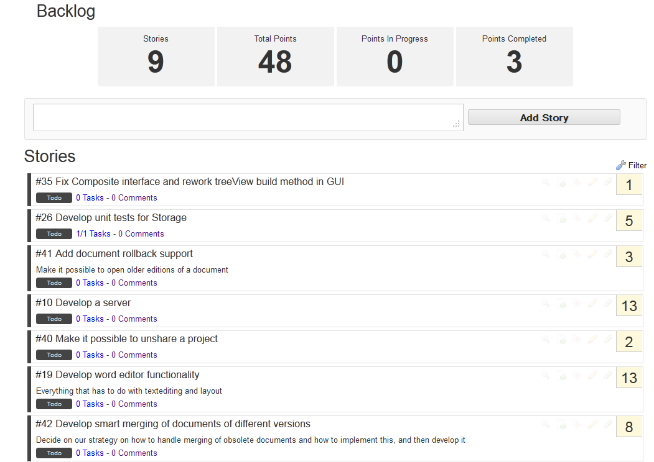

However, we used a feature on scrumDo called PlanningPoker, to decide how many points each story was worth, it worked as following:  
The scrum-master chooses a story and everybody chooses how many points they think it’s worth, then the numbers are revealed, and a discussion of maximum 1 minute is initiated where the story is discussed, finally the scrum-master decides the amount of points the story should have, and next story is voted upon.  
  
Burndown charts

ScrumDo has automatically produced burndown charts reflecting our progress as the time progressed, these can be found in the appendix 4.

As it shows, we actually kept a partly linear progression line. We started by adding every story we could think of, and gave them high amounts of points, which we reevaluated later as we progressed. At times we were not as good at setting the stories status to “Done” as we should be, and it shows in the graph certain places, but we believe it shows how our work effort progressed very well.

Sprint planning meetings and daily scrums

We tried to almost every morning, to start the day off with a standing meeting in several minutes discussing what we accomplished the previous day, and what we have in mind that we should be doing this day, and what might be troubling to these tasks.  
These meetings were always held under our big ScrumBoard as it can be seen in the picture below:

INSERT PICTURE OF SCRUMBOARD AND US TROLO HIIHIHIHIHIHIH

In the start we very good at keeping the meetings very punctual but as we progressed the sharp meeting times got a bit more loose.

In addition to our stand up meetings we also had a meeting dedicated to each sprint the night before the day it should be started, where we planned what to do in the following sprint and played PlanningPoker again to reevaluate the points we gave the stories earlier.

### Definition of Done

Throughout the whole project, whenever we talked about the stories, we ensured that everybody had a consistent meaning of when we thought the story was done, we obtained this by talking the story out thoroughly, of course it’s not possible to get the exact same vision of the definition of done, as we experienced, but we tried to get as close as we could. In retrospective we should probably have written them down on each story, instead of just discussing them orally.

### Sprint retrospectives and reviews

After every sprint before we discussed the next sprint, we discussed how it went and what could have been better, and of course what we accomplished and furthermore what we didn’t. We have included the reviews and retrospectives for each sprint in the appendix 7. We all agreed that was a really nice way to catch up on what actually had been gone

Scrum Review

We all really liked to work in the scrum environment, even though sometimes we felt that scrum wasn’t really the right method to use in our case, because of different reasons:

Deadline-Oriented

Scrum is often not the best idea if you are having a fixed deadline with a strict requirement set, as we have in this case, that would call for a more waterfall-oriented approach.

No contact with stakeholders

Usually you would have a stakeholder representing the firm at the workplace, which we of course could not have, for the same reason we didn’t experience that much big changes to the project, which is one of the aspects that scrum is built for, being good at adapting to changes.

That being said, we liked the way that we reviewed the aspects often and iterated over the diagrams from sprint to sprint to update them. It gave us a nice overview on the direction the project was going, and how far in the progress we were.