**Question4**

**Code**

library ieee;

use ieee.std_logic_1164.all;

entity carry_look_ahead_adder is

port(

input1,input2,carryIn : in bit;

sum,gen,propagate : out bit);

end entity;

architecture struct of carry_look_ahead_adder is

begin

sum <= (input1 xor input2) xor carryIn;

propagate <= input1 xor input2;

gen <= input1 and input2;

end architecture;

**compilation report**

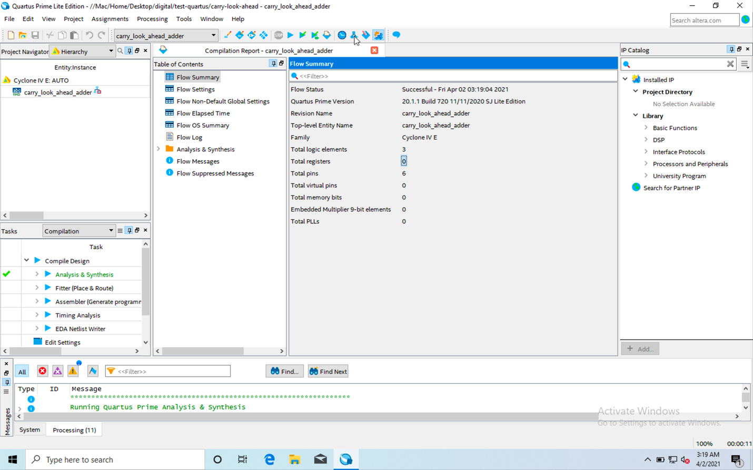

**RTL**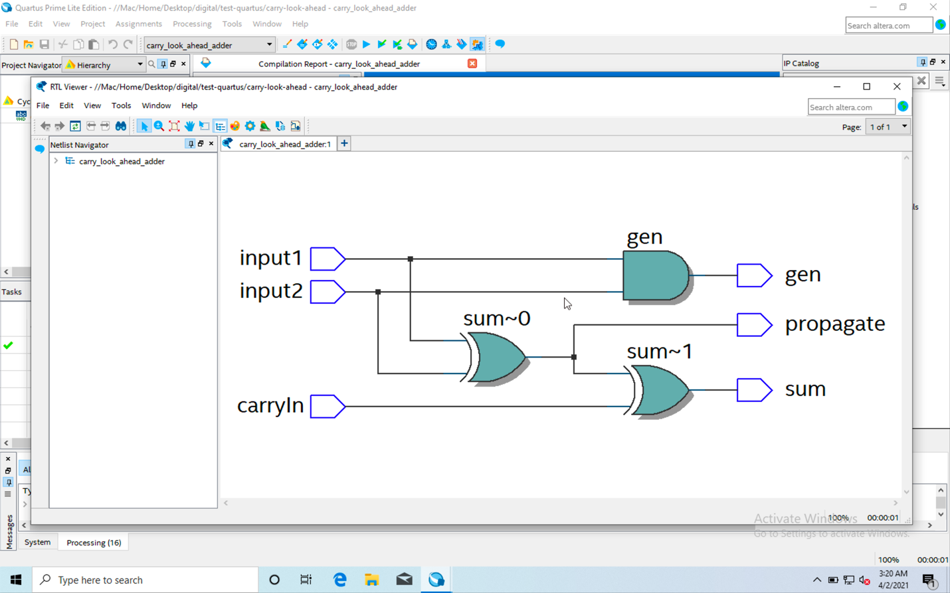

**Post-mapping**

