**طراحی سیستم های دیجیتال**

**تکلیف سوم**

**استاد مروستی**

**علیرضا نعمتی**

**کسری رشیدفر**

Table of Contents

Question1 2

Code 2

Dec_counter 2

N_dec_counter 3

testbench 4

Compilation report 6

RTL 6

Post-Mapping 7

Simulation 8

اسکرین شات 8

توضیح عملکرد 9

Question2 9

Code 9

Fifo controller 9

Fifo buffer 11

Fifo 13

Fifo Test Bench 14

Compilation report 16

RTL 17

Fifo controller 17

Fifo buffer 17

Fifo 18

Post-Mapping 18

Simulation 19

# Question1

## Code

### Dec_counter

library ieee;

use ieee.std_logic_1164.all;

use ieee.numeric_std.all;

entity dec_counter is

port (

clk, reset: in std_logic;

en: in std_logic;

q: out std_logic_vector(3 downto 0);

pulse: out std_logic);

end dec_counter;

architecture arch of dec_counter is

signal r_reg: unsigned(3 downto 0):= (others => '0');

signal r_next: unsigned(3 downto 0):= (others => '0');

constant TEN: integer:= 10;

begin

process(clk, reset)

begin

if(reset = '1') then

r_reg <= (others => '0');

elsif(clk'event and clk = '1') then

r_reg <= r_next;

end if;

end process;

process(en, r_reg)

begin

r_next <= r_reg;

if(en = '1') then

if r_reg = (TEN - 1) then

r_next <= (others => '0');

else

r_next <= r_reg + 1;

end if;

end if;

end process;

q <= std_logic_vector(r_reg);

pulse <= '1' when r_reg = (TEN - 1) else

'0';

end arch;

### N_dec_counter

library ieee;

use ieee.std_logic_1164.all;

use ieee.numeric_std.all;

entity n_dec_counter is

generic (N: natural:= 4);

port (

clk, reset: in std_logic;

en: in std_logic;

q_n: out std_logic_vector(0 to (4*N)-1);

p: out std_logic

);

end n_dec_counter;

architecture counter_arch of n_dec_counter is

component dec_counter

port(

clk, reset: in std_logic;

en: in std_logic;

q: out std_logic_vector(3 downto 0);

pulse: out std_logic);

end component;

signal p_n: std_logic_vector(0 to N):= (0 => '1',others => '0');

signal tmp: std_logic_vector(0 to N);

begin

tmp(0) <= p_n(0);

for_gen: for i in 0 to N-1 generate

gen: dec_counter

port map (clk => clk, reset => reset, en => p_n(i), q => q_n(4*i to 4*i+3), pulse => p_n(i+1));

end generate for_gen;

p_gen: for j in 1 to N-1 generate

tmp(j) <= p_n(j) and tmp(j-1);

end generate p_gen;

p <= tmp(N-1);

end counter_arch;

### testbench

library ieee;

use ieee.std_logic_1164.all;

entity testbench is

end testbench;

architecture arch of testbench is

component n_dec_counter is

generic (N: natural);

port (

clk, reset: in std_logic;

en: in std_logic;

q_n: out std_logic_vector(4*N-1 downto 0);

p: out std_logic);

end component;

constant N: natural:= 4;

signal clk: std_logic:= '0';

signal reset: std_logic:= '0';

signal en: std_logic:= '1';

signal q: std_logic_vector(4*N-1 downto 0);

signal p: std_logic:= '0';

begin

uut: n_dec_counter

generic map (N => N)

port map (

clk => clk,

reset => reset,

en => en,

q_n => q,

p => p);

process

begin

clk <= '1';

wait for 15 ns;

clk <= '0';

wait for 15 ns;

clk <= '1';

wait for 15 ns;

clk <= '0';

wait for 15 ns;

clk <= '1';

wait for 15 ns;

clk <= '0';

wait for 15 ns;

end process;

end arch;

## Compilation report

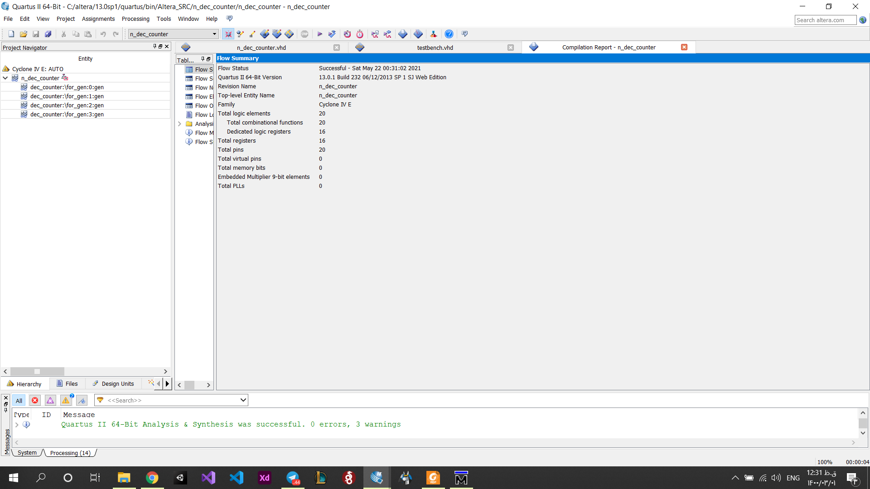

## RTL

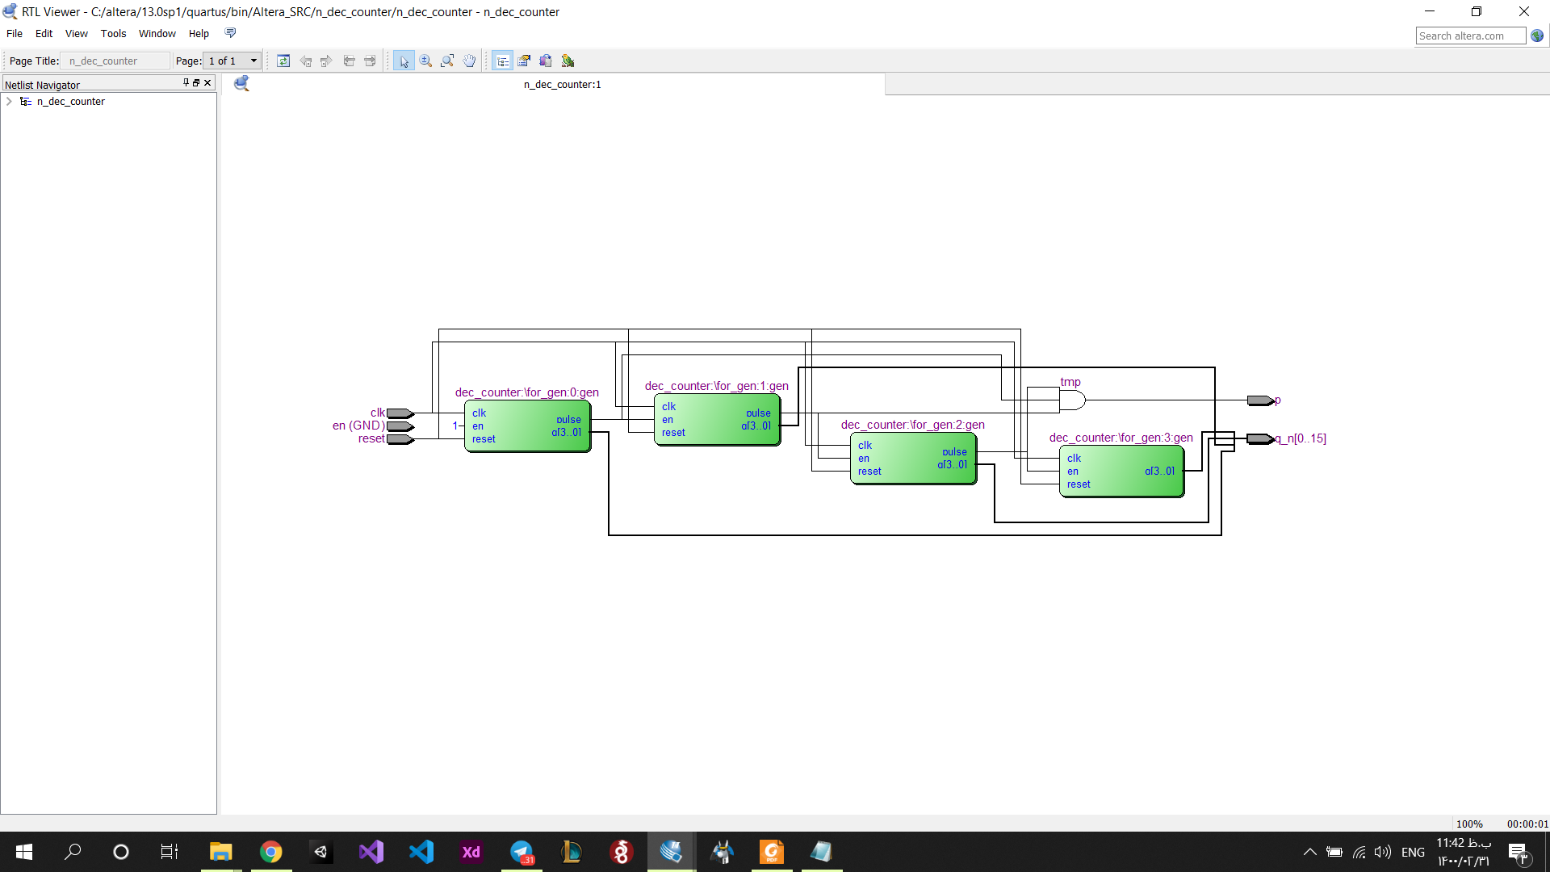

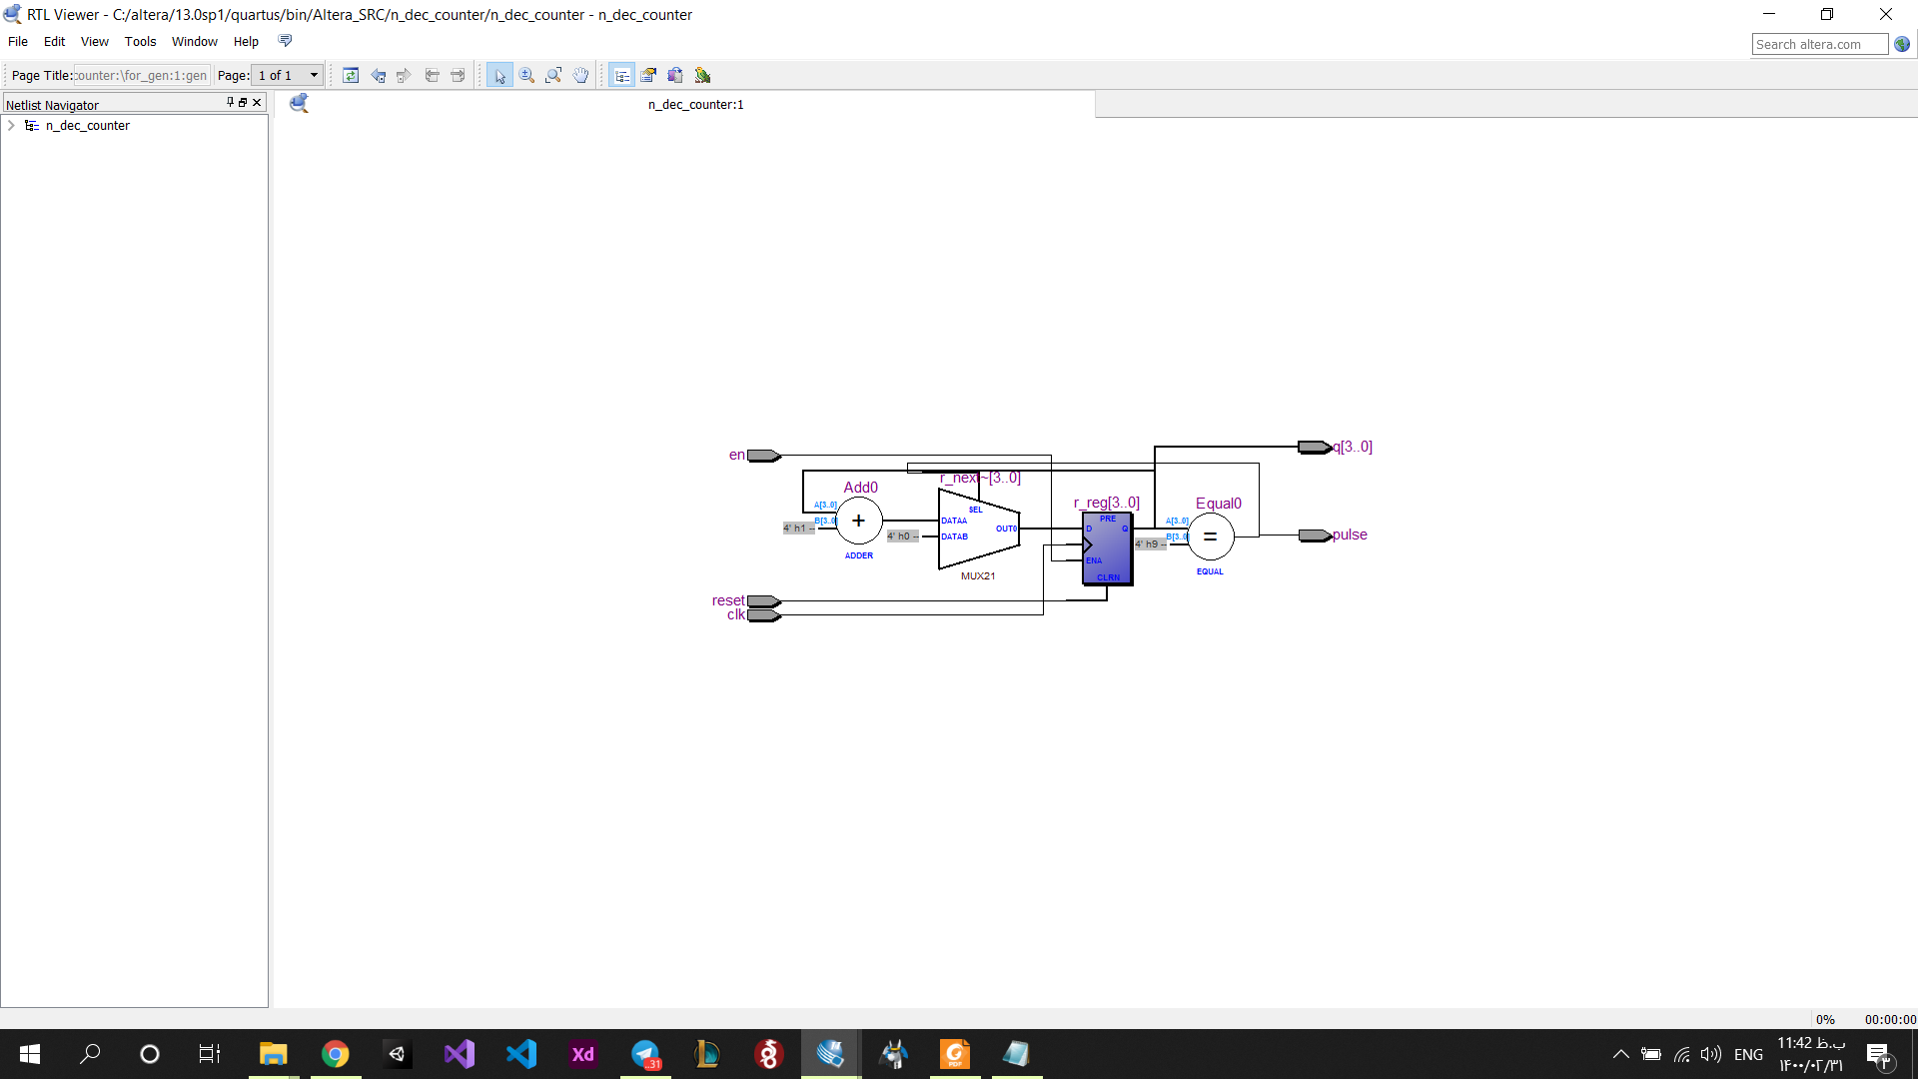

## Post-Mapping

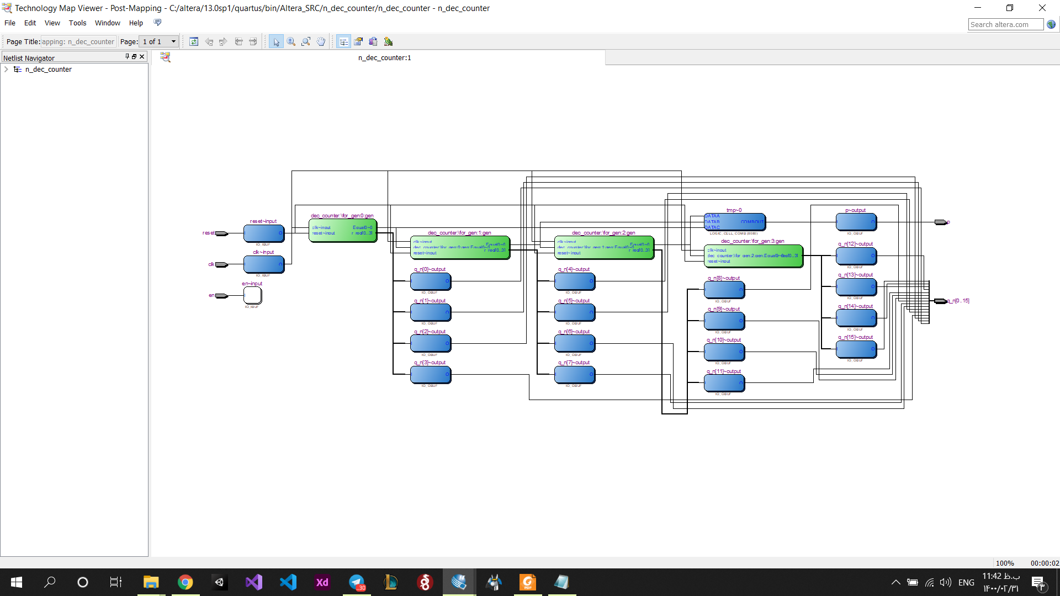

## Simulation

### اسکرین شات

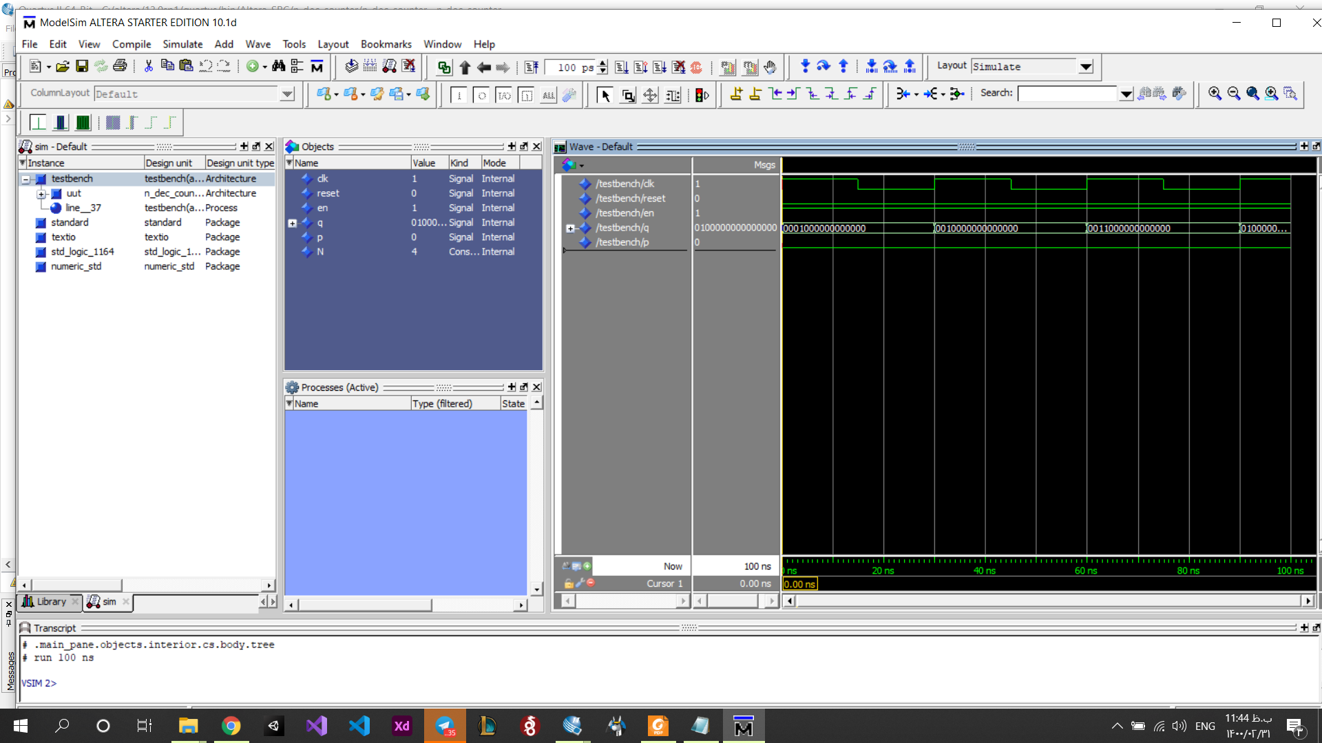

### توضیح عملکرد

در هر کلاک شمارنده یک مجموعه بیت نمایش داده میشود که هر 4 بیت آن نمایانگر یک رقم از 4 رقم عدد میباشد.

# Question2

## Code

### Fifo controller

library ieee;

use ieee.std_logic_1164.all;

use ieee.numeric_std.all;

-- use ieee.numeric_std.all;

-- use IEEE.STD_LOGIC_UNSIGNED.all;

entity fifo_controller is

generic(

address_width : integer:= 2

);

port (

clk, reset : in std_logic;

wr,rd : in std_logic;

full, empty : out std_logic;

w_address,r_address : out std_logic_vector (address_width-1 downto 0) );

end fifo_controller;

architecture rtl of fifo_controller is

signal reader_pointer : unsigned(address_width downto 0) := "000";

signal writer_pointer : unsigned(address_width downto 0) := "000";

-- signal reader_pointer : std_logic_vector(3 downto 0);

-- signal writer_pointer : std_logic_vector(3 downto 0);

signal full_fifo : std_logic;

signal empty_fifo : std_logic;

begin

process(wr,clk,reset)

begin

if(reset = '1') then

-- reader_pointer <= "0000";

writer_pointer <= (others => '0');

full_fifo <= '0';

-- empty_fifo <= '0';

elsif(clk'event and clk ='1') then

if(wr = '1')then

if((reader_pointer(1 downto 0) = writer_pointer(1 downto 0)) and (reader_pointer(2) /= writer_pointer(2)))then

full_fifo <= '1';

elsif(writer_pointer = "111") then

writer_pointer <= "000";

else

writer_pointer <= writer_pointer + 1;

end if;

if(full_fifo = '1') then

full <= '1';

else

-- i don't know what todod

-- maybe send w_address

w_address <= std_logic_vector(writer_pointer(address_width-1 downto 0));

-- w_address <= writer_pointer(2 downto 0);

end if;

end if;

end if;

end process;

process(rd,clk,reset)

begin

if(reset = '1') then

reader_pointer <= "000";

-- writer_pointer <= "0000";

-- full_fifo <= '0';

empty_fifo <= '0';

elsif(clk'event and clk ='1') then

if(rd = '1') then

if(reader_pointer = writer_pointer) then

empty_fifo <= '1';

elsif(reader_pointer = "111") then

reader_pointer <= "000";

else

reader_pointer <= reader_pointer + 1;

end if;

if(empty_fifo = '1') then

empty <= '1';

else

-- i don't know what todod

-- maybe send r_address

r_address <= std_logic_vector(reader_pointer(address_width-1 downto 0));

-- r_address <= reader_pointer(2 downto 0);

end if;

end if;

end if;

end process;

end architecture;

### Fifo buffer

library ieee;

use ieee.std_logic_1164.all;

entity fifo_buffer is

generic (

data_width : integer:= 8;

address_width : integer:= 2

);

port(

clk,reset : in std_logic;

wr_en : in std_logic;

w_address,r_address : in std_logic_vector (address_width-1 downto 0);

w_data : in std_logic_vector(data_width-1 downto 0);

r_data : out std_logic_vector(data_width-1 downto 0)

);

end fifo_buffer;

architecture rtl of fifo_buffer is

constant BIT_ADDR : natural := address_width;

constant BIT_DATA : natural := data_width;

type reg_file_type is array (2**BIT_ADDR-1 downto 0) of

std_logic_vector (BIT_DATA-1 downto 0);

signal array_reg : reg_file_type;

signal array_next : reg_file_type;

signal en : std_logic_vector(2**BIT_ADDR-1 downto 0);

begin

process(clk,reset)

begin

if(reset = '1') then

array_reg(3) <= (others => '0');

array_reg(2) <= (others => '0');

array_reg(1) <= (others => '0');

array_reg(0) <= (others => '0');

elsif ( clk'event and clk='1') then

array_reg(3) <= array_next(3);

array_reg(2) <= array_next(2);

array_reg(1) <= array_next(1);

array_reg(0) <= array_next(0);

end if;

end process;

process(array_reg ,en,w_data)

begin

array_next(3) <= array_reg(3);

array_next(2) <= array_reg(2);

array_next(1) <= array_reg(1);

array_next(0) <= array_reg(0);

if en(3)='1' then

array_next(3) <= w_data;

end if;

if en(2)='1' then

array_next(2) <= w_data;

end if;

if en(1)='1' then

array_next(1) <= w_data;

end if;

if en(0)='1' then

array_next(0) <= w_data;

end if;

end process;

process(wr_en,w_address)

begin

if( wr_en = '0' ) then

en <= (others => '0');

else

case w_address is

when "00" => en <= "0001" ;

when "01" => en <= "0010" ;

when "10" => en <= "0100" ;

when others => en <= "1000" ;

end case;

end if;

end process;

with r_address select

r_data <= array_reg(0) when "00",

array_reg(1) when "01",

array_reg(2) when "10",

array_reg(3) when others;

end rtl;

### Fifo

library ieee;

use ieee.std_logic_1164.all;

use ieee.numeric_std.all;

entity fifo is

generic(

address_width : integer :=2;

data_width : integer := 8

);

port(

clk,reset : in std_logic;

w_data : in std_logic_vector(data_width-1 downto 0);

wr,rd : in std_logic;

r_data : out std_logic_vector(data_width-1 downto 0)

full, empty : out std_logic

);

end fifo;

architecture rtl of fifo is

signal w_address : std_logic_vector(address_width-1 downto 0);

signal r_address : std_logic_vector(address_width-1 downto 0);

signal full_storage : std_logic ;

begin

controller : entity work.fifo_controller(rtl)

generic map(address_width => address_width)

port map(

wr => wr,

rd => rd,

full => full_storage,

empty => empty,

w_address => w_address,

r_address => r_address,

clk => clk,

reset => reset

);

buffer_storage : entity work.fifo_buffer(rtl)

generic map(

data_width => data_width,

address_width => address_width

)

port map(

wr_en => full_storage and wr,

w_address => w_address,

r_address => r_address,

w_data => w_data,

r_data => r_data,

clk => clk,

reset => reset

);

end architecture;

### Fifo Test Bench

library ieee;

use ieee.std_logic_1164.all;

use ieee.numeric_std.all;

entity fifo_tb is

end entity;

architecture sim of fifo_tb is

constant address_width: integer := 2;

constant data_width: integer := 8;

signal wr : std_logic := '0';

signal rd : std_logic := '0';

signal full: std_logic := '0';

signal empty : std_logic := '1';

signal w_address,r_address : std_logic_vector(address_width-1 downto 0) := (others => '0');

signal w_data : std_logic_vector(data_width-1 downto 0) := (others => '0');

signal r_data : std_logic_vector(data_width-1 downto 0);

signal clk : std_logic := '1';

signal reset : std_logic := '1';

begin

fifo_component : entity work.fifo(rtl)

generic map(

address_width => address_width;

data_width => data_width

)

port map(

clk => clk,

reset => reset,

w_data => w_data,

wr => wr,

rd => rd,

r_data => r_data,

full => full,

empty => empty

);

-- clock and data process

process is

begin

wait for 20 ns ;

clk <= '0';

w_data <= "00000001" ;

wait for 20 ns;

clk <= '1';

w_data <= "00000001" ;

end process;

--res

process is

begin

reset <= '1';

wait for 8 * 20 ns;

end process;

process is

begin

wait for 20 ns;

wr <= '1';

rd <= '0';

wait for 20 ns;

wr <= '0';

rd <= '1';

end process;

end architecture;

## Compilation report

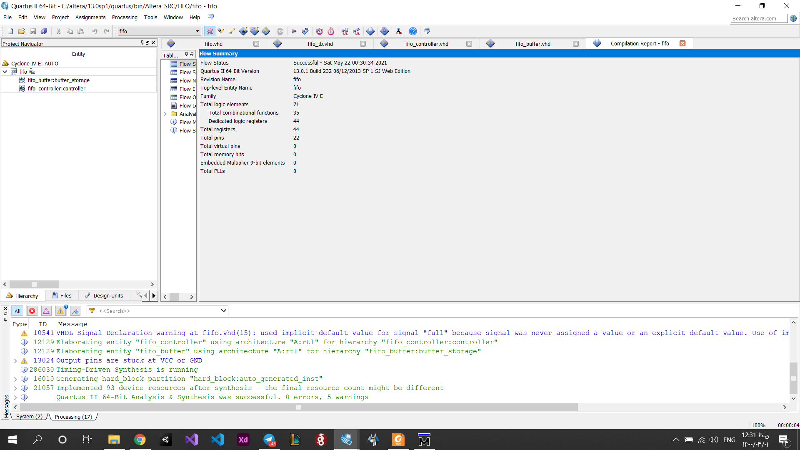

## RTL

### Fifo controller

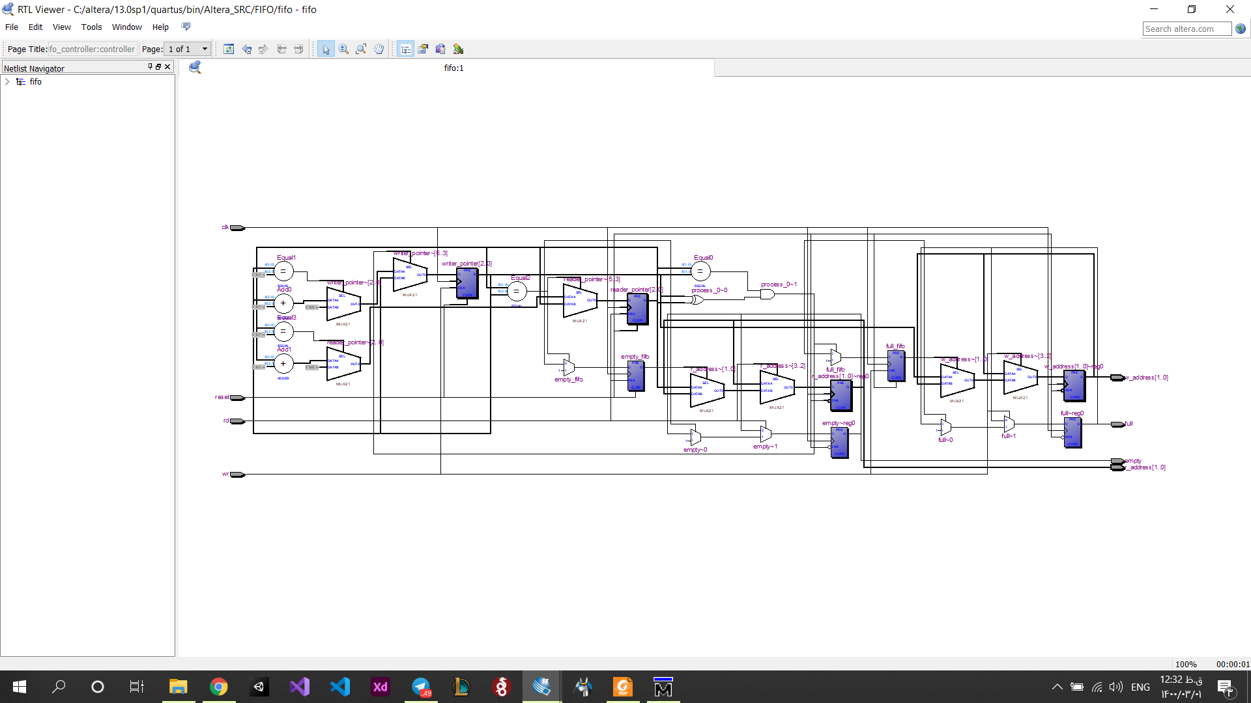

### Fifo buffer

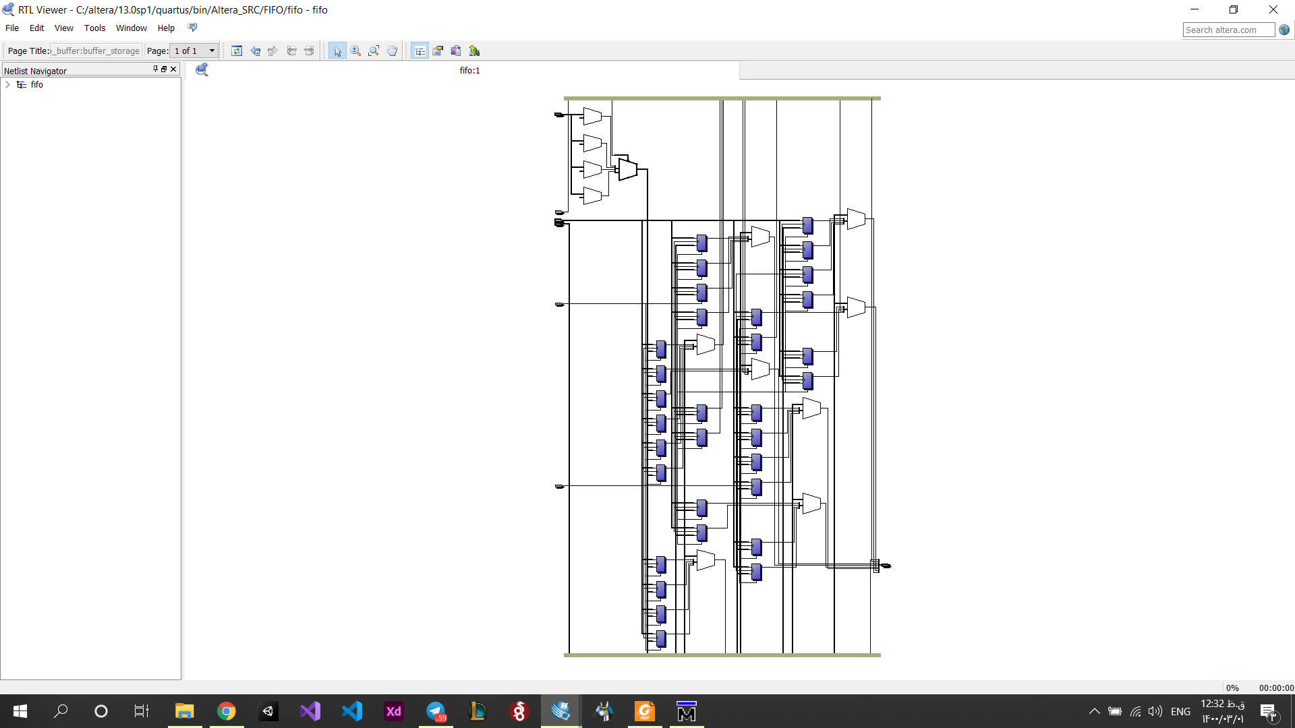

### Fifo

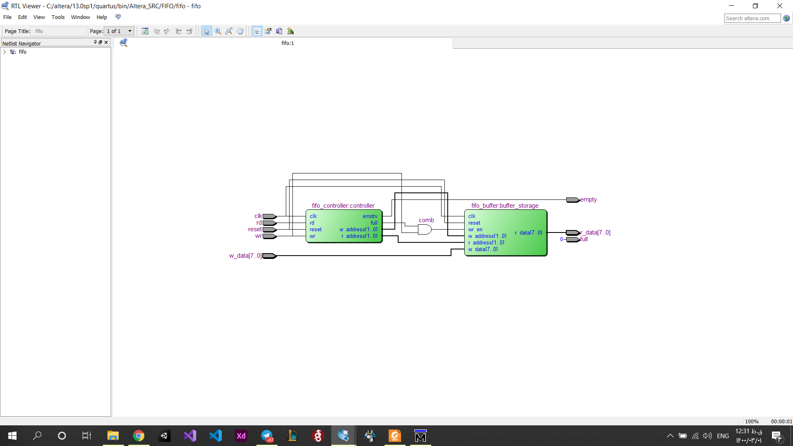

## Post-Mapping

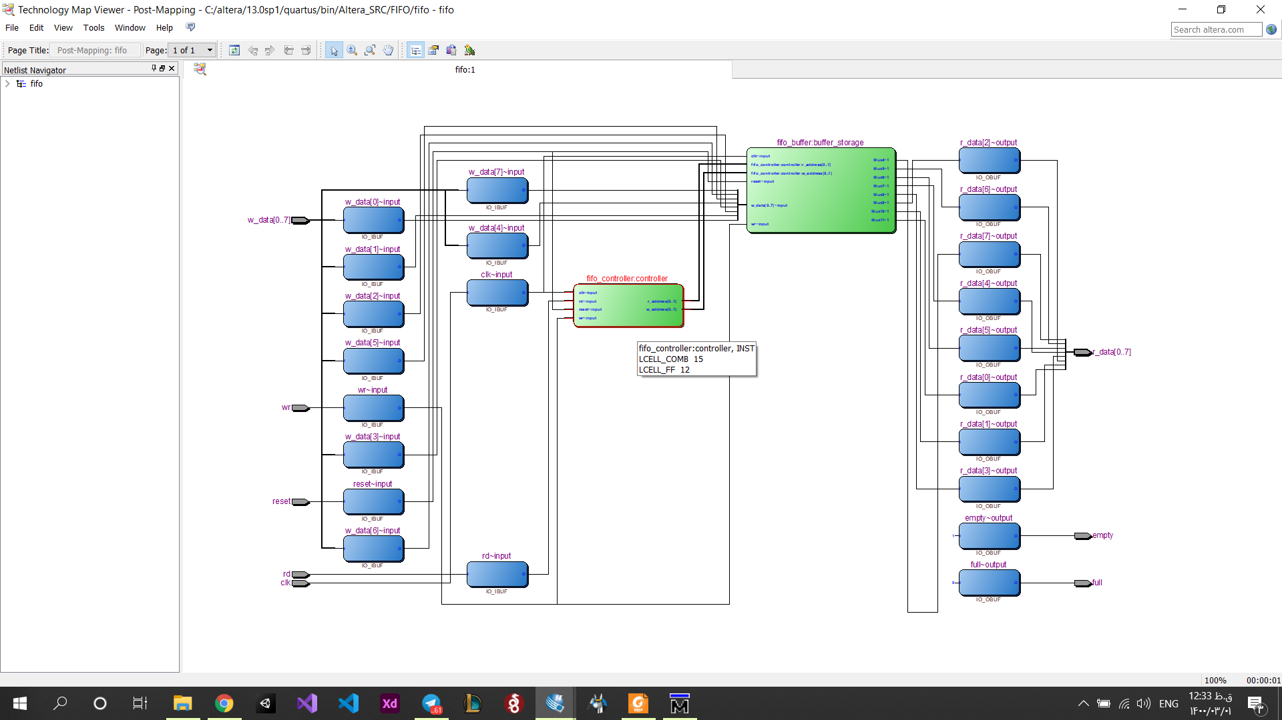

## Simulation

**متاسفانه هر چه قدر تلاش کردیم هعی ارور میداد که error in loading design و در آخر هم متوجه نشدیم. بعدش از خود مدل سیم فایل ها رو اپلود کردیم و در مدل سیم کامپایل رو انجام دادیم. در مدل سیم در کامپایل ۲تا از فایلا ارور میداد در حالیکه در کوارتس این ارور ها رو نداشتیم.**