FunnyFaceLab
The FunnyFaceLab project contains a class, Face which draws a basic face. The face can be positioned and sized in the usual way, using the constructor:
public Face( int x, int y, int width ) { . . .}
The paint function calls several helper-functions:
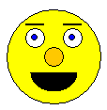
public void paint( Graphics g )
{
paintHead( g );
paintLeftEye(g);
paintRightEye(g);
paintRightEyebrow(g);
paintLeftEyebrow(g);
paintNose(g);
paintMouth( g );
}

Each of those helper functions calls several other helper functions. For example, paintLeftEye is shown below:

protected void paintLeftEye( Graphics g )
{
paintOutlinedCircle( getLeftEyeLocation(), getScleraColor(), g );
paintLeftIris( g );
}

There are several getXXXLocation functions which return a Rectangle object. A Rectangle object has 4 member variables: x, y, width and height. Together these describe a Rectangular region which could be used to draw part of the face (for example, the left eye). Here is a diagram showing all of the rectangles:

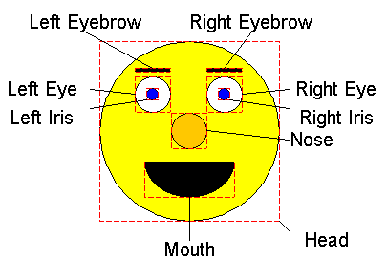

The functions paintOutlinedCircle and paintOutlinedRectangle are static functions which will paint a filled in circle (or rectangle) in the specified color, and then outline it in black.

With the exception of the static functions, all of these functions can be overridden by subclasses.
Running the program should produce this window:

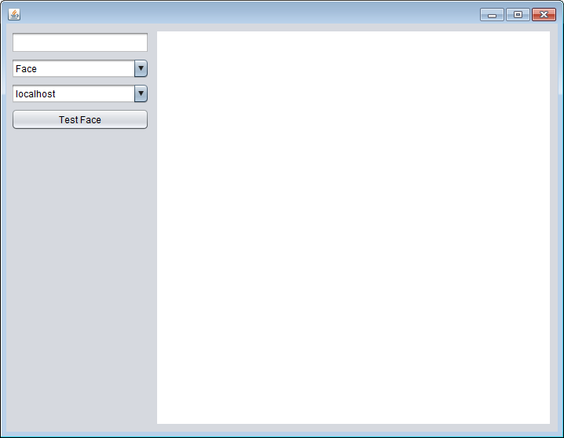

To test out a face, you can select or type the name of the class in the second box (where it says Face). Then click in the white area once to start a box and then again to finish the box. The box should be filled with an instance of the class that you selected. Here is the window after creating two instances of Face and one instance of DemoFace:

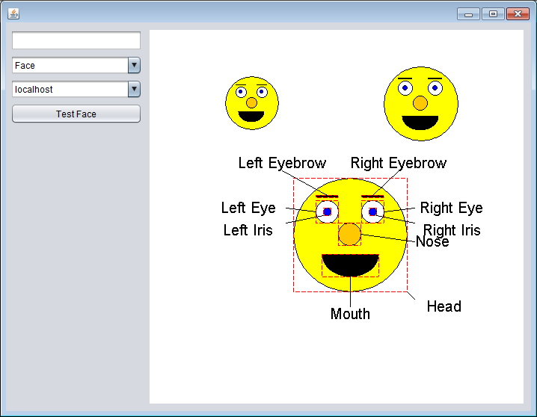

Your job is to write several subclasses of Face. Try to reuse as much of the code from class Face as you can. Even if you override method XXX, don’t forget that you can use super.XXX to get the super-class’s functionality in addition to your new functionality. If you find yourself copy-and-pasting code, find a way to organize your code so that you only write it once, but call it several times. This could be done by creating more helper functions which can be called from different places, or by refactoring code into base classes etc.

Create classes that extend Face and draw the following pictures:

- SuntannedFace – the skin is two shades darker than the normal face’s skin, the nose is red
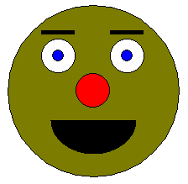
- MustachioedFace – there is a mustache halfway between the nose and the mouth:
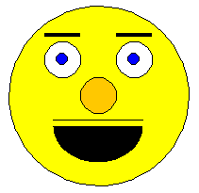
- IgorFace – the eyes are different sizes and he has a single, scraggly tooth and a wart on his nose:
