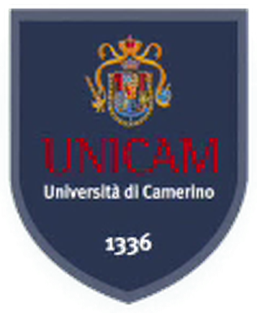
University of Camerino
MSc Computer Science (Artificial Intelligence) · Complex Systems Design

UniBridge
A multilingual assistant for international students

Ahmad Kassar
Professor: Flavio Corradini
November 2026
Contents
1. Problem 3
2. Users and roles 3
3. Architecture 3
3.1 Answer pipeline 5
3.2 Languages 6
4. Data and test sets 6
5. Procedure model 7
6. Evaluation 9
6.1 Retrieval by language 9
6.2 Translating the question before retrieval 10
6.3 Seventeen languages 10
6.4 Answers: extractive, language model, language model with verifier 11
6.5 Handoff 12
7. Security, privacy and cost 12
8. Human oversight 13
9. Limitations 13
10. Future work 13
11. Use of AI tools 13

Author: Ahmad Kassar. Course: Complex Systems Design (Prof. Flavio Corradini). UniBridge runs on the P14 search engine of the same repository (hybrid retrieval, permissions inside retrieval, citations, evaluation harness), which is documented in REPORT.md. Every number below is produced by a committed script and read from a file in eval/results/unibridge/; eval/check_doc_numbers.py checks the decimals of this report against those files.

1. Problem
An international student in Camerino has to follow rules written in Italian: the university's student guide and regulations, the ERDIS Marche call for the regional scholarship, the ministry circular on the admission of foreign students. Many of these students read English, Arabic, Chinese or Persian better than Italian, and a wrong reading has a cost. An application submitted after 28 August 2026 is excluded (Art. 10 of the call); a missing document for the ISEE parificato leaves the application incomplete. General-purpose chatbots answer fluently, but they do not show where an answer comes from and can produce a plausible but wrong date.
We therefore set a narrow goal. UniBridge answers only from official documents, in the language of the question, and shows the Italian sentence behind every claim. When the documents are not enough it says so and helps the student write to the responsible office. For the scholarship, the procedure most students ask about, it offers a guide whose logic is a formal model of the call and whose eligibility checks are deterministic code.

2. Users and roles
Role | Who | Sees (P14 access level)
visitor | prospective student, anyone | public documents (public)
student | enrolled student | + student-only notices (internal)
scholarship / student / international office | office staff | + that office's internal notes (restricted, own office)
unibridge-admin | maintainer | everything

The roles are mapped onto the access levels of P14 (config/principals_unibridge.json), so no new permission code was needed. Student-only notices and internal office notes are not public; the six documents of these kinds in the corpus are synthetic and labelled as such ([SINTETICO] in title and text).

3. Architecture

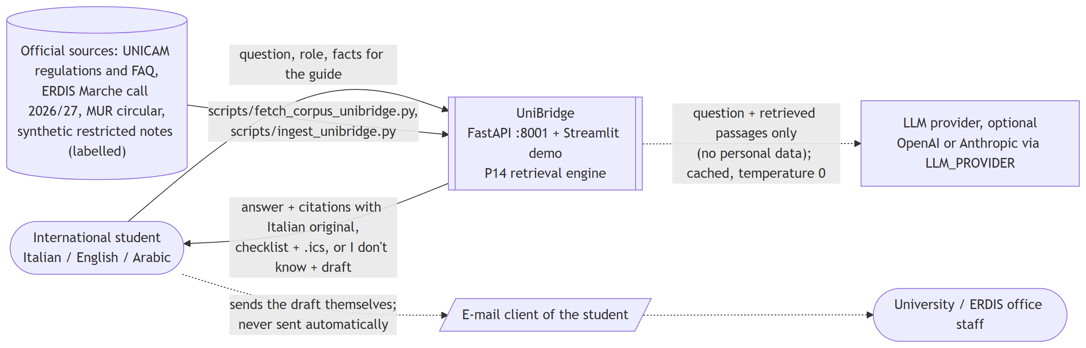
System context

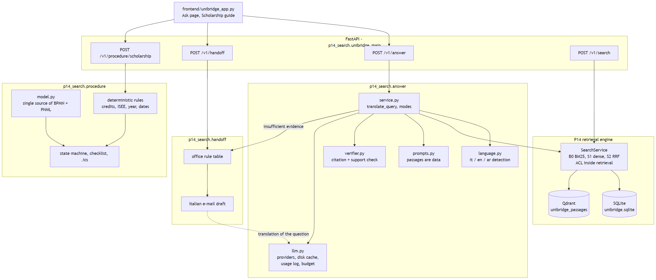
Components
UniBridge is a profile of the P14 service (src/p14_search/unibridge_profile.py): the same code with its own SQLite file, Qdrant collection and principals. Three modules are new. answer/ detects the language, translates the question, asks the language model for an answer with citations, verifies it, and falls back to extractive answers when no model is available; answer/llm.py hides OpenAI and Anthropic behind one interface (chosen by LLM_PROVIDER), with a fake provider for the tests, a disk cache, a usage log and a spending limit. handoff/ chooses the office with a rule table and drafts a formal Italian e-mail, which is never sent. procedure/ holds the scholarship model, the eligibility rules, the state machine, the checklist and the .ics calendar. The endpoints are POST /v1/answer, POST /v1/handoff and POST /v1/procedure/scholarship, next to those of P14; the Streamlit demo (frontend/unibridge_app.py) uses them like any other client.

3.1 Answer pipeline
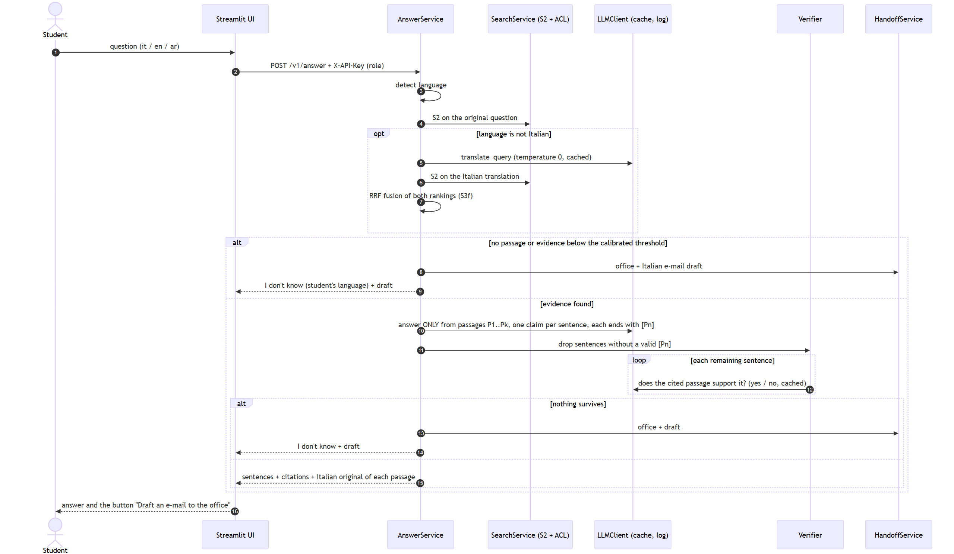
Answer sequence
- Detect the language of the question (17 languages, see Languages below).
- Retrieve with S2 (BM25 + multilingual-e5-small, reciprocal rank fusion); permissions are applied inside retrieval.
- If the question is not Italian and a model is configured, translate it into Italian (temperature 0, cached), retrieve again and fuse the two rankings (S3f, see the translation experiment in the evaluation).
- If no passage passes the evidence threshold calibrated on the tuning split, answer "I don't know" in the student's language and prepare the handoff.
- Otherwise the model answers only from the numbered passages, in the student's language, one claim per sentence, each sentence ending with [Pn]. Passages are wrapped in tags that the passage text cannot close, and the system prompt states that they are data, never instructions.
- The verifier drops sentences without a valid passage id, then asks the same model, sentence by sentence, whether the cited passage supports it (yes/no, cached). If nothing is left, the answer becomes "I don't know" + handoff.
- The response carries every sentence with its passages and the Italian original of each cited passage.
Without an API key, or when the call fails or the budget is reached, the answer is extractive: Italian sentences copied from the passages, each with its citation.

3.2 Languages
The first version supported Italian, English and Arabic. We extended it to the languages that international students in Italy are most likely to read best: Italian, English, Arabic, French, Spanish, Portuguese, German, Romanian, Albanian, Ukrainian, Russian, Turkish, Persian, Urdu, Hindi, Bengali and Simplified Chinese. The list is one table (src/p14_search/i18n.py); the language of a question is identified offline with lingua (n-gram models, deterministic) restricted to these languages. The answer prompt only receives the name of the language, so the answer step needed no change. The fixed texts (the "I don't know" message, the guide's checklist, the interface) are written by hand in Italian, English and Arabic; for the other fourteen languages they were translated once by the language model (scripts/translate_i18n.py), stored in src/p14_search/i18n_llm.json and marked llm_generated and needs_native_review. The details of the scholarship rules stay in English, because they contain the student's own figures; the verdict, the checklist and the deadlines follow the student's language. Arabic, Persian and Urdu are shown right to left.

4. Data and test sets
The corpus (DATA_UNIBRIDGE.md) has 42 real public documents from ERDIS Marche, the University of Camerino and its international office, the Ministry of University and Normattiva, plus the six synthetic restricted notes: 2,330 passages. Raw files are not committed; scripts/fetch_corpus_unibridge.py downloads them again and checks the SHA-256 recorded in the manifest. Licences are recorded per document; the pages of unicam.it have no open licence and are used locally only (OPEN_QUESTIONS U3).
The main question set (eval/queries/unibridge_queries.jsonl) has 155 questions; the 102 of the test split (42 Italian, 30 English, 30 Arabic, 9 out of scope) were frozen with a SHA-256 before any tuning. The Italian questions are real questions taken from official FAQ pages (ERDIS, UNICAM International), so the official answer and the article it cites are the ground truth. English and Arabic versions and the everyday paraphrases were written by the language model and are flagged llm_generated. For the fourteen added languages we built a second test set (eval/queries/unibridge_queries_ml.jsonl) from the same 35 FAQ questions and 9 out-of-scope questions of the frozen test split, translated by the language model into every added language (616 questions). A translation keeps the relevance judgments of its source question; the set was frozen with its own hash before the evaluation.

5. Procedure model

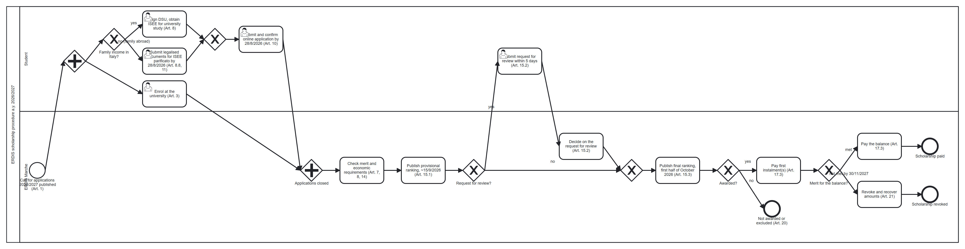
BPMN model of the ERDIS scholarship procedure 2026/2027 (docs/bpmn/scholarship.bpmn)

The ERDIS scholarship procedure 2026/2027 is written once, in src/p14_search/procedure/model.py. The BPMN 2.0 file docs/bpmn/scholarship.bpmn (24 nodes, 26 flows, lanes Student and ERDIS) and the workflow net docs/bpmn/scholarship.pnml (18 places, 20 transitions, 42 arcs) are generated from it, so the diagram, the net and the guide cannot disagree. Every step and deadline is tied to an article of the call (PROCEDURE.md): the application by 28 August 2026, the provisional ranking, the optional request for review within five days, the final ranking, the payment of the instalments, and the revocation when the merit requirement for the balance is not met.
We check soundness in code (eval/results/unibridge/procedure_soundness.json). The net is a workflow net: one source place i, one sink place o, and every node lies on a path from i to o. Its reachability graph has 19 markings; the net is bounded, every reachable marking can still reach the final marking, the final marking is reached cleanly (no tokens left behind), and no transition is dead. The net is therefore sound. pm4py's WOFLAN implementation, run on the PNML file, gives the same result. The steps to verify it in WoPeD are in PROCEDURE.md.
The guide replays the net as a state machine on the student's facts: a transition fires only if it is enabled and the facts or the reference date say it has happened, and the enabled transitions of the final marking are the next steps. Eligibility (credits by year of course, the ISEE and ISPE limits of Art. 8, previous degree, duration of the benefit, residence permit, deadlines) is decided by deterministic code; each rule carries the article that defines it. No language model is involved and the facts are neither stored nor logged. On 15 fictional students, with the expected verdict and checklist written from the call, all 15 are fully correct (procedure_eval.json). The same person wrote the scenarios and the rules, so this shows that the code follows our reading of the call, not that the reading is right.

6. Evaluation
Unless stated otherwise, results are on the frozen test split of 102 questions, with the role visitor and the evidence thresholds calibrated on the tuning split only (calibration.json).

6.1 Retrieval by language
nDCG@10 | B0 BM25 | S1 dense | S2 hybrid
all (93 in scope) | 0.3218 | 0.4101 | 0.4123
Italian (39) | 0.4869 | 0.5469 | 0.5532
English (28) | 0.3907 | 0.3898 | 0.3966
Arabic (26) | 0.0 | 0.227 | 0.2179

We expected keyword search to fail on Arabic questions over Italian documents, and it does: for 100% of the Arabic in-scope test questions BM25 returns no relevant passage in the first ten, and for 92.31% it returns nothing at all, since the two languages share no terms. The dense model recovers part of the loss (nDCG@10 0.227), still far below Italian. The difference between S2 and B0 on Arabic is significant (paired randomization test, p = 0.0017); between S2 and S1 there is no significant difference in any language (p = 0.9021 overall). The permission filter leaked nothing: 0 leaks in 16,626 checked passages (6 roles, 102 questions, 3 systems).

6.2 Translating the question before retrieval
In experiment S3 the language model translates a non-Italian question into Italian before retrieval. We compare S3 (S2 on the translation only) and S3f (reciprocal rank fusion of S2 on the original and S2 on the translation, which is what the answer service does) with S1 and S2. Nothing was tuned on the test split: the translation prompt was fixed in phase 4, the temperature is 0 and the thresholds are those of S2. The 60 translations cost 0.001041 USD.
 | S1 dense | S2 hybrid | S3 translated | S3f fused
nDCG@10, English | 0.3898 | 0.3966 | 0.3148 | 0.5187
nDCG@10, Arabic | 0.227 | 0.2179 | 0.4324 | 0.4295
recall@10, English | 0.3869 | 0.4137 | 0.4301 | 0.7277
recall@10, Arabic | 0.25 | 0.2452 | 0.5256 | 0.6314
false "insufficient evidence", Arabic | 0.6538 | 0.6538 | 0.0769 | 0.0385
nDCG@10, all 102 | 0.4101 | 0.4123 | 0.4476 | 0.5082

For Arabic, translation roughly doubles nDCG@10 and removes most of the false "insufficient evidence" flags. With only 26 Arabic questions the gain of S3 over S2 is not significant at the 0.05 level (p = 0.0954), while the gain of S3f is (p = 0.006). For English, translation alone loses ground and fusion gains. We looked for the reason. The corpus contains English versions of the call and of the teaching regulation; for English questions S2 takes 52 of its 84 top-3 passages from these documents, but only 6 of the 60 grade-2 passages of the qrels are in them, because the ground truth comes from Italian FAQs. Translating into Italian moves retrieval away from passages that are probably relevant but not marked as such; this explanation is measured, not confirmed by human judgment (OPEN_QUESTIONS U5). Over all 102 questions fusion is significantly better than S2 (nDCG@10 p = 0.0012, recall@10 p = 0.0001). Its cost is one out-of-scope question that is no longer flagged (abstention 0.8889 instead of 1.0); the answer step can still decline it. One bias must be kept in mind: the English and Arabic test questions are themselves machine translations of Italian FAQs, and a round trip through the same kind of model may rebuild the Italian wording more easily than a question written by a real student.

6.3 Seventeen languages
On the multilingual test set (616 questions in fourteen languages, plus the Italian originals as a reference; multilingual_latest.json) we measured language identification, retrieval with S1, S2 and S3f, and answers in the default mode (language model + verifier), without any change to prompts, thresholds or verifier.
Language | n | detected | nDCG@10 S2 | nDCG@10 S3f | answered | citation precision | answer in its language
Italian (originals) | 29 | 1.0 | 0.6948 | 0.6948 | 26 | 0.8897 | 1.0
French | 44 | 1.0 | 0.2896 | 0.4929 | 31 | 0.8871 | 1.0
Spanish | 44 | 1.0 | 0.4721 | 0.5516 | 34 | 0.8868 | 1.0
Portuguese | 44 | 0.9773 | 0.3063 | 0.4784 | 29 | 0.9103 | 0.9655
German | 44 | 1.0 | 0.4407 | 0.5602 | 28 | 0.8571 | 0.9643
Romanian | 44 | 1.0 | 0.3221 | 0.4828 | 28 | 0.8536 | 1.0
Albanian | 44 | 1.0 | 0.2495 | 0.4542 | 27 | 0.8185 | 1.0
Ukrainian | 44 | 1.0 | 0.3595 | 0.4504 | 27 | 0.8123 | 1.0
Russian | 44 | 1.0 | 0.3276 | 0.5099 | 27 | 0.9049 | 1.0
Turkish | 44 | 1.0 | 0.3672 | 0.464 | 26 | 0.8615 | 1.0
Persian | 44 | 1.0 | 0.3766 | 0.461 | 28 | 0.9524 | 1.0
Urdu | 44 | 1.0 | 0.3825 | 0.4891 | 29 | 0.8402 | 1.0
Hindi | 44 | 1.0 | 0.4439 | 0.4878 | 30 | 0.8639 | 1.0
Bengali | 44 | 1.0 | 0.3647 | 0.4698 | 31 | 0.7892 | 1.0
Chinese | 44 | 1.0 | 0.2876 | 0.4332 | 25 | 0.884 | 1.0

Over the fourteen added languages the language of the question is identified correctly in 99.8% of cases, and 99.5% of the answers are written in the language of the question. Fusion with the Italian translation raises nDCG@10 from 0.3564 (S2) to 0.4847 (p = 0.0001). Fusion improves nDCG@10 in every one of the fourteen languages. Without it, S2 flags insufficient evidence for 74.08% of the in-scope questions in these languages, because the evidence threshold was calibrated on Italian, English and Arabic; with fusion the share falls to 10.82% of them. The answers still decline more in-scope questions than in Italian, English and Arabic (18.37% against 7.53%), which points to a per-language threshold as the next improvement. The citation precision of the answers is 0.8658 and 100.0% of the out-of-scope questions get "I don't know". The run cost 0.17837 USD.

6.4 Answers: extractive, language model, language model with verifier
Source: answers_latest.json, all 102 test questions, OpenAI gpt-4o-mini at temperature 0. Each configuration has its own response cache, so cost and latency are those of a first run.
102 test questions | extractive | LLM, no verifier | LLM + verifier
answered (not "I don't know") | 69 | 87 | 86
citation precision (cited passage is relevant) | 0.4058 | 0.7802 | 0.7847
sentences without a valid citation | 0.0 | 0.0718 | 0.0
sentences the support check rejects (*) | 0.029 | 0.0943 | 0.0
answer in the language of the question | 0.9275 | 1.0 | 1.0
"I don't know" on the 9 out-of-scope questions | 1.0 | 1.0 | 1.0
"I don't know" on in-scope questions | 0.2581 | 0.0645 | 0.0753
relevant passages given to the answer step | 0.4265 | 0.6089 | 0.6089
LLM calls per answer | 0.0 | 1.49 | 3.54
estimated cost per answer (USD) | 0.0 | 0.000233 | 0.000316
latency p50 / p95 (ms) | 28.1 / 35.5 | 2111.4 / 3888.3 | 2975.5 / 7011.1

(*) The support check is the verifier's own yes/no call, with the same model and prompt. For the configuration without verifier it measures what the verifier would remove; for the configuration with verifier it is 0 by construction. It is not an independent measure of faithfulness: the independent check is the human review of eval/review/unibridge_answers_review.csv (30 answers), which has not been done yet.
By language, with the verifier, citation precision is 0.7644 for Italian, 0.7288 for English and 0.8804 for Arabic. Extractive answers are always Italian sentences and help Arabic speakers very little: only 5 of the 30 Arabic questions get an answer.
The language model roughly doubles citation precision over extractive answers and answers many more questions, above all in Arabic, because it uses the fused retrieval. The verifier removes every uncited sentence and the sentences its own check rejects, at the price of a few more "I don't know" on in-scope questions, about two more calls per answer and a longer tail latency. Citation precision moves only a little with the verifier: most cited passages were already relevant. The verifier can also remove too much. In the demo (ub_03_answer_it_draft.png) the verified answer to "Entro quando devo pagare le tasse universitarie?" keeps only the late-payment fee, although the cited passage also gives the three instalment dates; we report this rather than tune the verifier on the test split. Temperature 0 does not make gpt-4o-mini fully deterministic: three cold runs of the configuration without verifier gave citation precision 0.7946 (answers_20261111-170857.json), 0.801 (answers_20261111-172151.json) and the value in the table, so differences of about two points between configurations are within run-to-run noise. The last run also uses the new language detector (see Languages), which fixed the one Italian test question that the earlier word-list detector had taken for English. The cache makes re-runs identical.

6.5 Handoff
For in-scope test questions the office chosen by the rule table is the expected one in 68.82% of cases (Italian 0.7179, English 0.6786, Arabic 0.6538); in 23.66% no office is chosen and the draft goes to a generic address. Out-of-scope questions never get a draft. Drafts are not sent: the student copies or downloads them.

7. Security, privacy and cost
The API key lives only in .env, which git ignores; .env.example has empty LLM_* values, and before every commit git grep looks for anything that resembles a key. The scholarship guide never calls the language model, and the answer step sends only the question and the passages the user is allowed to see. The question is free text, though, and a student could type personal data into it; the interface does not filter it. Against prompt injection the passages are wrapped as data and uncited sentences are removed, which limits the damage of injected instructions but is not a guarantee. Permissions are applied inside retrieval, before the model sees anything, so a visitor's answer cannot be built from a student-only notice (screenshots ub_04 and ub_05).
Every call uses temperature 0 and at most 600 output tokens for answers; responses are cached on disk under the SHA-256 of provider, model, token limit, temperature and prompt; each call is logged with provider, model, tokens and estimated cost, and calls stop when the estimated spend reaches 5 USD. The whole project, every evaluation included, made 5,458 paid calls for an estimated 0.405717 USD (llm_cost.json).

8. Human oversight
Every answer sentence shows its Italian source, so the student can check it. "I don't know" is a designed outcome that leads to a person in an office, and e-mail drafts are never sent automatically. The scholarship guide states that only the outcome published by ERDIS is binding. Before any real use, people must review the LLM-produced material: eval/review/unibridge_review.csv (Arabic and LLM-drafted questions), eval/review/unibridge_query_translations.csv and eval/review/unibridge_ml_review.csv (translated questions), eval/review/unibridge_i18n_review.csv (interface texts in the added languages) and eval/review/unibridge_answers_review.csv (is each answer sentence supported by its passage?).

9. Limitations
The corpus covers one university, one regional body and one call, as published in November 2026. All test questions not in Italian are machine translations rather than questions written by students, and no native speaker has checked them yet. The relevance judgments come from Italian FAQ answers and the articles they cite; equivalent passages elsewhere, such as the English version of the call, are under-rated. The faithfulness check uses the same model and prompt as the verifier, so only the human review sample is an independent measure. Extractive answers are Italian whatever the language of the question. The rule details of the scholarship guide are in English in every language. The rules cover the 2026/2027 call only: a new call needs a new model and new rules.

10. Future work
Collect questions written by international students and have them reviewed by native speakers; complete the human review of answers; extend the corpus to housing, residence permits and other universities after a licence check of each source; calibrate the "I don't know" threshold per language; open the model in WoPeD and keep it aligned with the next call.

11. Use of AI tools
An AI coding assistant (Claude Code) was used to write code, tests, documentation and diagrams, under the author's direction; design decisions and results were reviewed by the author. A language model (OpenAI gpt-4o-mini, through src/p14_search/answer/llm.py) produced the English and Arabic translations and the paraphrases of the question set, the questions of the multilingual test set, the interface texts of the fourteen added languages, the Italian translations used for retrieval, the answers of the LLM configurations, the yes/no support checks, and the Italian translation of questions in the handoff drafts; all of this is flagged llm_generated. The six synthetic restricted documents were written by an LLM (Claude, during development) and are flagged synthetic and llm_generated. No LLM output is used as ground truth: relevance judgments come from official FAQ answers.

