**Introduction**

Apart from plain water, tea is the widely consumed beverage in the world. Nowadays tea is an aromatic beverage commonly prepared by pouring hot or boiling water over tea leaves. It makes up for with some serious health benefits. Researchers attribute tea’s health properties to polyphenols (a type of [antioxidant](http://jn.nutrition.org/content/132/4/785.full)) and phytochemicals. It gives energy, carbohydrates, fat, protein and minerals etc. Most importantly it has been suggested as a protector from cancer and other diseases.

Here are some major points that shows why tea’s little cousin rocks humans’ health.

* Tea can boost exercise endurance. Scientists have found that the catechins (antioxidants) in green tea extract increase the body’s ability to burn fat as fuel, which accounts for improved [muscle endurance](http://www.ncbi.nlm.nih.gov/pubmed/15563575).
* Drinking tea could help reduce the risk of [heart attack](http://news.bbc.co.uk/2/hi/health/5281046.stm). Tea might also [help protect](http://www.sciencedirect.com/science/article/pii/S0300483X09006040) [against](http://journals.lww.com/jhypertension/pages/articleviewer.aspx?year=2009&issue=04000&article=00017&type=abstract) [cardiovascular and degenerative diseases](http://www.i-sis.org.uk/Green_Tea_The_Elixir_of_Life.php).
* The antioxidants in tea might help protect against a boatload of [cancers](http://www.ncbi.nlm.nih.gov/pubmed/12094635), including [breast](http://www.telegraph.co.uk/health/healthnews/4310418/Three-cups-of-tea-can-cut-breast-cancer-risk-by-a-third.html), colon, [colorectal](http://www.ncbi.nlm.nih.gov/pubmed/17149697), skin, [lung](http://www.ncbi.nlm.nih.gov/pubmed/19128856), esophagus, stomach, small intestine, pancreas, [liver](http://www.ncbi.nlm.nih.gov/pubmed/15930028), [ovarian](http://www.ncbi.nlm.nih.gov/pubmed/17471564), [prostate](http://www.ncbi.nlm.nih.gov/pubmed/17906295) and [oral](http://www.ncbi.nlm.nih.gov/pubmed/19892663) [cancers](http://www.ncbi.nlm.nih.gov/pubmed/11807163). But don’t rely solely on tea to keep a healthy body — tea is [not](http://www.fda.gov/NewsEvents/Newsroom/PressAnnouncements/2005/ucm108452.htm) a [miracle](http://www.ncbi.nlm.nih.gov/pubmed/15869995) [cure](http://www.ncbi.nlm.nih.gov/pubmed/17905170), after all. While more studies than not suggest that tea has cancer-fighting benefits, the current research is mixed.
* Tea is [hydrating](http://news.bbc.co.uk/2/hi/health/5281046.stm) to the [body](http://www.ncbi.nlm.nih.gov/pubmed/21450118).
* Regular tea drinking might also counteract some of the negative effects of [smoking](http://www.ncbi.nlm.nih.gov/pubmed/14519830) and might even lessen the risk of lung cancer.
* Tea might be an effective agent in the prevention and treatment of neurological diseases, especially degenerative diseases (think Alzheimer’s). While many factors influence brain health, [polyphenols](http://www.ncbi.nlm.nih.gov/pubmed/22692966) in green tea may help maintain the parts of the brain that regulate learning and memory.

But the major problem that occurs with drinking tea regularly is diabetes as people used to use sugar with it. Diabetes can strike anyone, from any walk of life.

And it does – in numbers that are dramatically increasing. In the last decade, the cases of people living with diabetes jumped almost 50 percent – to more than 29 million.

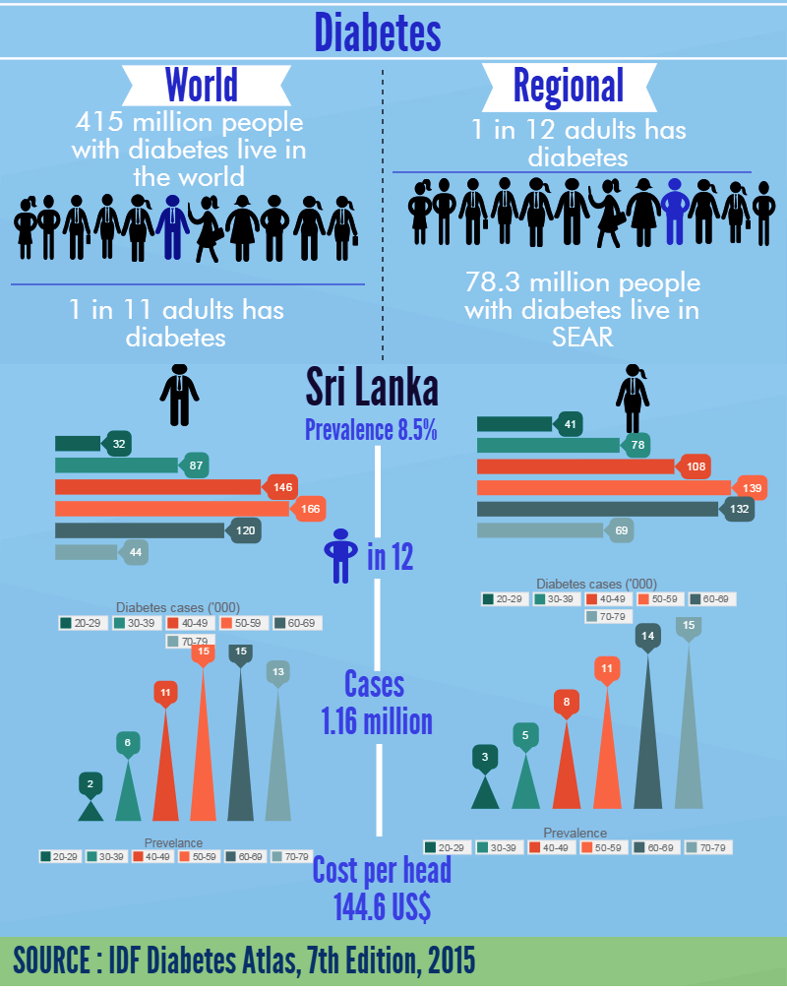Worldwide, it afflicts more than 380 million people.  And the World Health Organization estimates that by 2030, that number of people living with diabetes will more than double.

The Diabetes Association of Sri Lanka (DASL) statistics reveals that there are nearly four million diabetics in Sri Lanka.

Analyzing those points we have decided to implement an automated tea preparing machine with number of features. According to user’s desire he will be able to select how he needs a cup of tea with sugar/without sugar or with coffee. It will be very useful for an office or a working place who are busy with their tight schedules. This is very user friendly and does not depend on human labor. People can make their own cup of tea as they desired without any trouble.