Makeup assignment

Sri Lankan Studies

154130C - Weerasingha N.M

Heritage is a property that is or may be inherited valued things such as historic buildings that have been passed down from previous generations, and relating to things of historic or cultural value that are worthy of preservation. When we built our history considering the heritage of a country is very essential concept. Because heritage may emphasize key points and significant events that have been happened in ancient time. Therefore considering the long traditional history of Sri Lanka it’s important to pay attention to our heritage. Heritage can be classified into various ways. Mainly heritage can be classified as tangible and intangible heritage.

Intangible heritage can be classified into varies categories such as,

* Language
* Literature
* Music
* Drama
* Festivals & Performance
* Rituals and
* Customs.

Practices, representations, expressions, knowledge, skills as well as the instruments, objects, artefacts and cultural spaces associated with that communities, groups and individuals recognize as part of their cultural heritage. Intangible cultural heritage is transmitted from generation to generation, is constantly recreated by communities and groups in response to their environment, their interaction with nature and the history, and provides them with a sense of identity and continuity, thus promoting respect for cultural diversity and human creativity. For the purposes of this Convention, consideration will be given solely to such intangible cultural heritage as is compatible with existing international human rights instruments, as well as with the requirements of mutual respect among communities, groups and individuals, and of sustainable development. By considering all important points of intangible elements we can obtain a lot of facts that will help to build up our history.

**Language**

Sinhala language is peculiar; Indo-Aryan base; linguistically defined as Middle Indian prakriti; the evolution as a language and its association with Buddhism in the Sri Lankan context, have lent it richness and a uniqueness of its own. It responded with the sense of welcome to other incoming cultures, it was able to create a tradition of creativity and expression, which was authentically Sri Lankan. This is not only true about its cultural achievements in the fields of architecture, sculpture, woodwork, etc. but also in its literature.

Sri Lankan Tamil is slightly different; It possesses antiquity and continuity on Sri Lankan soil, clearly has certain specific and unique features and demarcates for itself a cultural space. However, geographical proximity to Tamil Nadu, with its long, chequered history and defiant preservation of cultural traditions, which in many ways are sharply different from the cultures that developed in Indo-Genetic plain, has had a deep resonance on Tamil politics, religion, literature, etc. from the earliest times. Tamil writings from Sri Lanka have a dual existence. They are an integral part of the overall Tamil literary tradition encompassing Tamil literary works from Tamil Nadu, Malaysia, Singapore and Sri Lanka/Ilangai. Nevertheless, a Sri Lankan identity and the Sri Lankaness of its creative writing, especially in the 20th century, have never been in doubt.

**Literature**

Sri Lanka is blessed with a rich repository of narratives and narrative styles in the written and oral traditions as well as a population that is culturally ready to receive such narratives. It was not the preserve of “writers” and “scholars”: Numerous examples depicting “literature” (especially in verse form), as an integral part of communication and debate, embedded in rituals where the focus was on dance or exorcism, with all vocations, particularly agriculture, and even used to comment on social, cultural, religious, ideological, economic, and political issues. Earlier works in Sri Lankan canon have been significantly influenced by styles prevalent in the rest of the Indian subcontinent, but alongside these there has developed a considerable volume of authentically “local” literary works reflecting on kings and significant historical events as well as the lives of ordinary folk. Tamil literature is inspired by works from centuries past, but has the added advantage of being able to draw from the literary traditions of the South of India where the language is spoken too. In more recent times, events and processes have found expression in literary works in both languages. The post-Independence period has been marked in literature and civic life by nationalistic despair, euphoria, cataclysmic political and social upheaval, and by resilience. Nonetheless, insurrections, armed conflict, devastation by tsunami, floods and drought, diseases like Dengue that verge on epidemics, the constitutional denial of democracy, and other governance ills have not stopped writing and reading in Sri Lanka. Indeed, both have thrived as a response to these issues. Consider the fact that a tiny English-speaking population submits over fifty manuscripts every year for the prestigious Gratiaen Award (for English literature) and one can get some idea of the volume of writing in the indigenous languages of Sinhala and Tamil. The fact that there is a thriving market for translations (from English into those languages) is also indicative of the thirst for literature in Sri Lanka. What is perhaps lamentable is the often poor quality of translations from Sinhala and Tamil into English and other languages and of course the small number of good translations, when they do occur. The literary history of Tamil writers in Sri Lanka is far less voluminous than that of their Sinhala counterparts, due partly to a fractured historical presence on the island and the absence of an equivalent temple-based system of education, but the oral traditions cannot be said to be any less rich. Main local literary sources are chronicles (Dynastic Histories) written in Sinhala or Pali. Oldest chronicle written in Pali is the "**Dipavamsa**“. (fifth century A.C). '**Dipavamsa**' provides historical information about the island from the pre-historic era up to the time of king Mahasen. Main local literary source available at present is the "**Mahavamsa**”. First part of 'Mahavamsa' was written in the fifth or sixth century A.C. Writing of this historical chronicle continues, even today written in Pali as the ancient writers had done. The first part of '**Mahavamsa**' provides information till end of the period of king Mahasen. "**Samanthipasadika**" is another historical source. The other important local literary source s are Thupavamsa, Bodhivamsa, Dahatuwamsa, Dhatawamsa. All of them were written in Pali.Later all these sources came to be written in Sinhala as "Sinhala Thupavamsa, inhala Bodhivasa, Sinhala Dhathuvamsa, Dalada Siritha and, Daladha Poojawaliya". Apart from them '**Nikaya Sangrahaya**' and the last two chapters of '**Rajavaliya**' are considered valuable local literary sources.Number of other sources are also available '**Sandesha Kavya** (Epistles), **Kavyasekaraya, Amavatura**' etc.; In order to establish the authenticity of the contents of these various literary sources, It is essential to leave out the exaggerations, false and unreliable information contain there in;

As well as Archaeological Sources of Sri Lanka such as Inscriptions. Inscriptions can be classified into two types. They are

* + - On Metals - Eg. Panakaduwa Copper Plate.
    - On Stones - Eg. Galpotha in Polonnaruwa.  
      The stone inscriptions are important sources to study the history of Sri Lanka. they help to verify the correctness and the authenticity of the information contained in literary sources.

Stone Inscriptions are of 4 types;

* + - Len lipi        (Cave Inscriptions);
    - Giri lipi        (Rock Inscriptions);
    - Tam lipi       (Pillar Inscriptions);
    - Puwaru lipi   (Slab Inscriptions);

Local sources of literature very little is mentioned about the local readers, but the stone inscriptions in Thammenna, Habessa, Kusalanakanda, Sandagiri Vehera, Yatahalena and Bowattegala mention about some of them. Stone Inscriptions often confirm information given in the literary sources. Information given about 'Dasa Maha Yodha' or ten giants(commanders) of king Dutugemunu in 'Mahavamsa' is confirmed by stone inscriptions;

* + - Sithulpauwa stone inscription about Nandimitra;
    - Wellelalugoda stone inscription about Pussadewa;

Information get from these stone inscriptions proves that the 'Dasa Maha Yodha' in 'Mahavamsa' were real historical Characters and Not fictitious ones.

**Dances**

Dancing styles evolved over many centuries, and the process enriched dancing culture while preserving age old traditional dances. Contemporary and popular dance forms are diverse, and range from classical dance styles such as up/low-country dancing and Bharatha Natyam which demand years of rigorous training and discipline to lighter dance styles such as Bollywood dancing. Dance is paramount in Sri Lankan arts and culture. Dancing originated in Sri Lanka as part of religious and ritual ceremonies held to expel disasters and welcome prosperity, happiness and good health. One of the oldest styles is Kohomba Kankariya, a ritual dance initiated in 4th century BC during the period of King Pandukhabaya. During the 18th century, while King Narendrasighe was ruling in Kandy, upcountry dance styles were further evolved. Consort of King Narendrasigha, an Indian princess/, and, Indian musicians and dancers were invited to Kandy, and 18 Vannams developed as a collaborative effort. Gini Sisila (subduing fire or fire dance), a specialized dance form, originated in southern Sri Lanka, with dancer places a burning torch in his mouth. Absolute faith of the dancer protects him from burns & performed by specialized and highly skilled dancers. The traditional dances of Sri Lanka have their origin in rites and rituals associated with folk beliefs:

* Three distinct dance forms known as:
  + Kandyan dancing in the highlands;
  + Low country dancing in the coastal region; and,
  + Sabaragamuwa dancing in the Province of Sabaragamuwa

.

* + Bharatha Natyam

Kandyan dance is considered the classical dance of Sri Lanka. In Sanskrit terminology it is considered pure dance. It features a highly developed system of "tala" (rhythm), provided by cymbals called "thalampataa”. There are five distinct types; the ves, naiyandi, uddekki, pantheru, and vannams. Three classical dance forms differ in their styles of body-movements and gestures, in the costumes worn by the performers, and in the shape and size of the drums used to provide rhythmic sound patterns to accompany the dancing. Drum used in Kandyan dancing is known as the Geta Bera, the drum in Ruhunu dancing as the "Yak Bera", and drum in Sabaragamu dancing as the "Davula" (the word Bera or Bereya in Sinhale means "Drum"). Geta Bera is beaten with hands also Yak Bera, while Davula is played with a stick on one side and with one hand on other side; Geta Bera body tapers on both sides while Yak Bera and the Davula both have cylindrical bodies.Main distinguishing feature between Kandyan and Sabaragamu dancing, and Ruhunu dancing, is that Ruhunu dancers wear mask. Low country dances/ Ruhunu dances are highly ritualistic and are performed to appease evil spirits causing sicknesses. They can be seen mainly in coastal region of the island. Dancers wearing colourful masks depicting demons, birds and reptiles dance till dawn. Drums are of a different kind from the Kandyan drums. Sabaragamuwa dancing performed in Ratnapura and are associated with the worshiping of God Saman whose main shrine is at Ratnapura.

Exept those dancing styles there are ves dance, nayyadi dance, udakki dance, pantheru dance, wannams, devil dance, thelme dance etc.

**MUSIC**

Caste-based folk poems (*kavi*) originated as communal song shared within individual groups as they engaged in daily work. Today, they remain a popular form of cultural expression. Kavi was also sung to accompany annual rituals. Despite these ancient rites are rarely performed in contemporary Sri Lanka, preserved songs are still performed by folk musicians. Another traditional Sri Lankan folk style is called the *virindu,* involves an improvised poem sung to the beaten melody of a Rabana. Traditional song contests were held in which two virindu singers would compete through spontaneous verse. Portuguese influenced Baila has been a popular folk tradition along the coastal districts in the past five hundred years and is now part of the mainstream music culture.

Likewise there are many more intangible elements that are helps use to build our history. As well as there are very essential tangible heritage in Sri Lanka which can be mainly highlights in our history. Even UNESCO association also named some of places as world heritages.

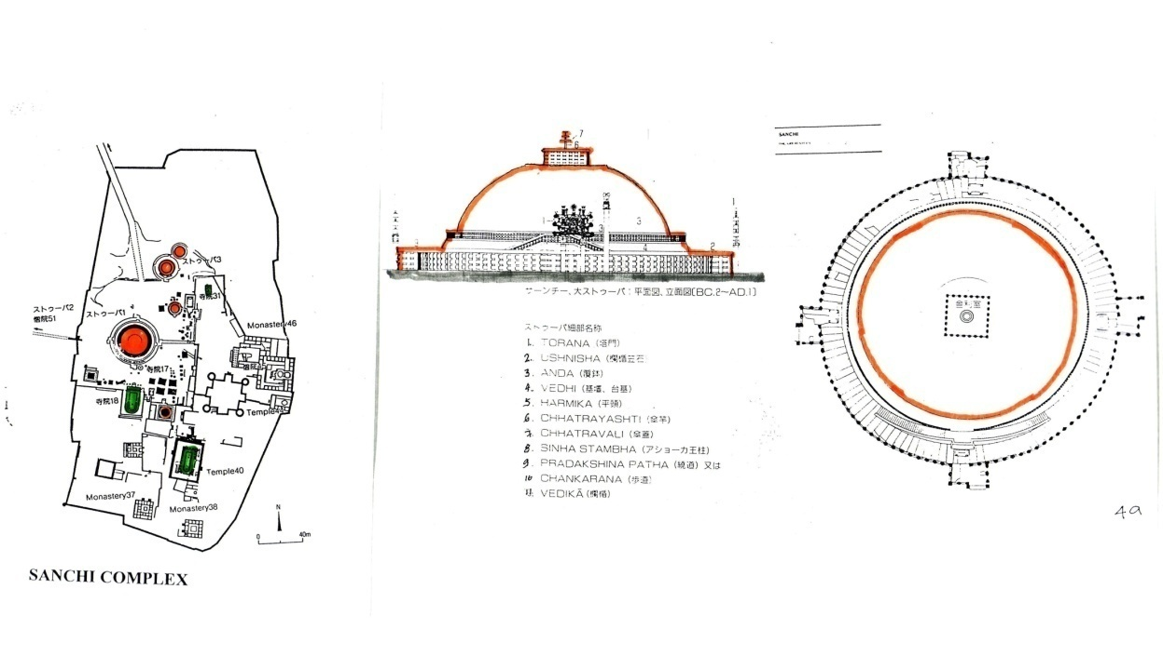Tangible heritage can be classified into various categories such as architectures,Sculpture, Plantings, handicrafts etc.

When we consider the religious architecture there are buddist religious architectures, hindu architectures, Christian architectures, Islamic architectures etc.

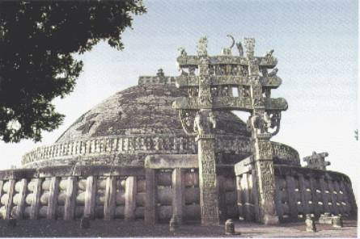sanchi stupa structure:-

Using indian structures Sri Lankan kings also designed stupa designs.

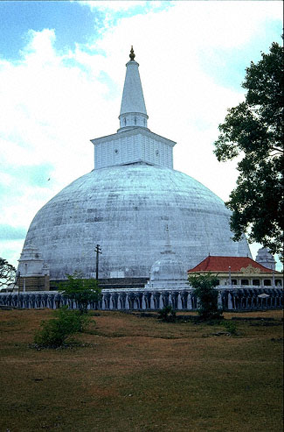

There are six main shapes of stupas in Sri Lanka.

Dhanyakara (Heap of Paddy) - 01

Kelaniya

Bubbulakara (Bubble-shape) – 02

Kirivehera (P’naruwa)

Ghatakara (Pot-shape) - 03

Yahangala

Ghantakara (Bell-shape) – 04

Mahiyangana

Amlakara (Onion-shape) - 05

Dedigama Reliquary

Padmakara (Shape of Lotus) - 06

Sankapala Relief

Earliest attempts to represent Buddha symbolically in Asoka Period. Based on the concept of Ghandhakuti/ perfumed chamber, where Buddha had resided in Jetavana. Stupa, Bo-tree Shrine and Avasa Ge were three main architectural elements of monasteries of this period. Each adopted and accommodated Buddha figures within its own designs. These changes were visible soon after the latter part of the 1st century AD.Budu Madura is another special place where Buddhists worship load Buddha statue. This is very important place where we can find key points in history, considering the begging of the Buddha statues and who are the kings that designed this concept.And also we can find how Mahayana has influenced on the designs and constructions which built in those eras.Polonnaruwa, dabadeniya, kurunegala periods were highly involved in constructing various buildings

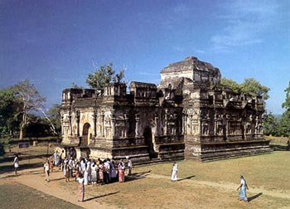 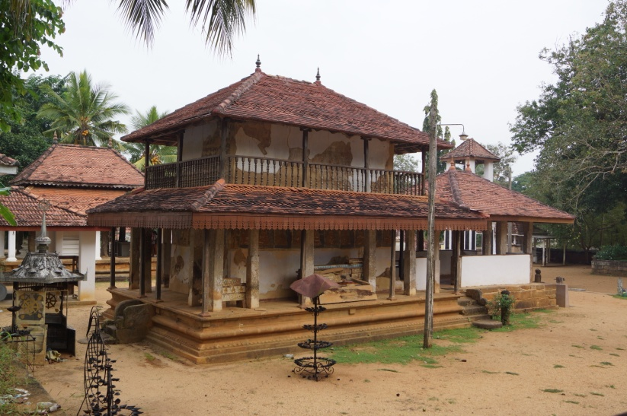

And also we can pay attention to Sri Lankan vernacular architecture. How villages, houses, granaries, wayside residing places, folk shrines had been constructed according to the tradition and cultural effects in these eras.Not only that we can get to know how the faced to the climatic changes, natural phenomena, technological forces etc. As well as how they adopted to the environmental behaviors.

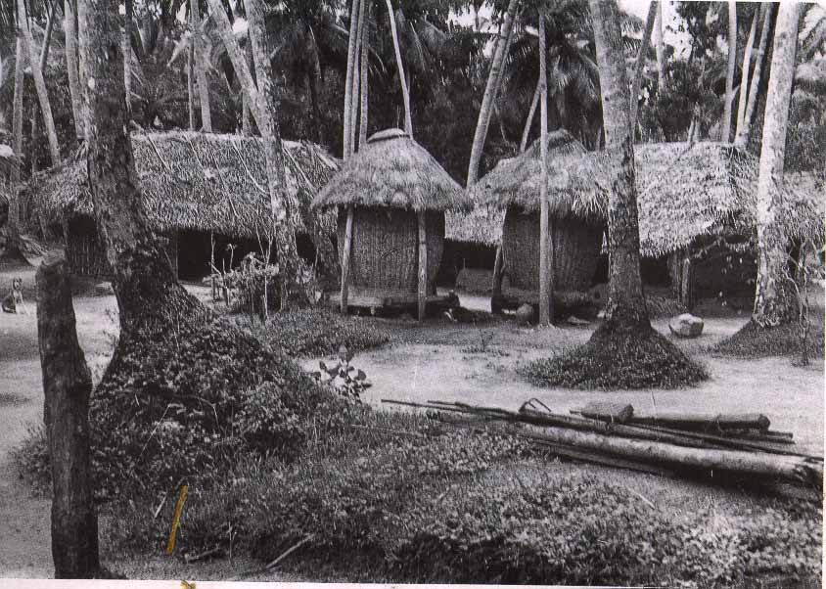

And also Sri Lankan Iconography/Sculptures are one of significant element for building up our history, how they designed art & architectural inventions using their technologies. Sigiriya is one of world heritage that located in Sri Lanka, is a amazing creation. It’s difficult to understand how they had done those great designs and constructions those days. As well as there are many more places that helps us to build our long traditional history. As I mentioned above those key points are highly express the relativity for the history.Eventually we all are very lucky enough to born in country like Sri Lanka and here onwards our responsibility is to protect our heritage that we have been gifted from history.