YOLO26
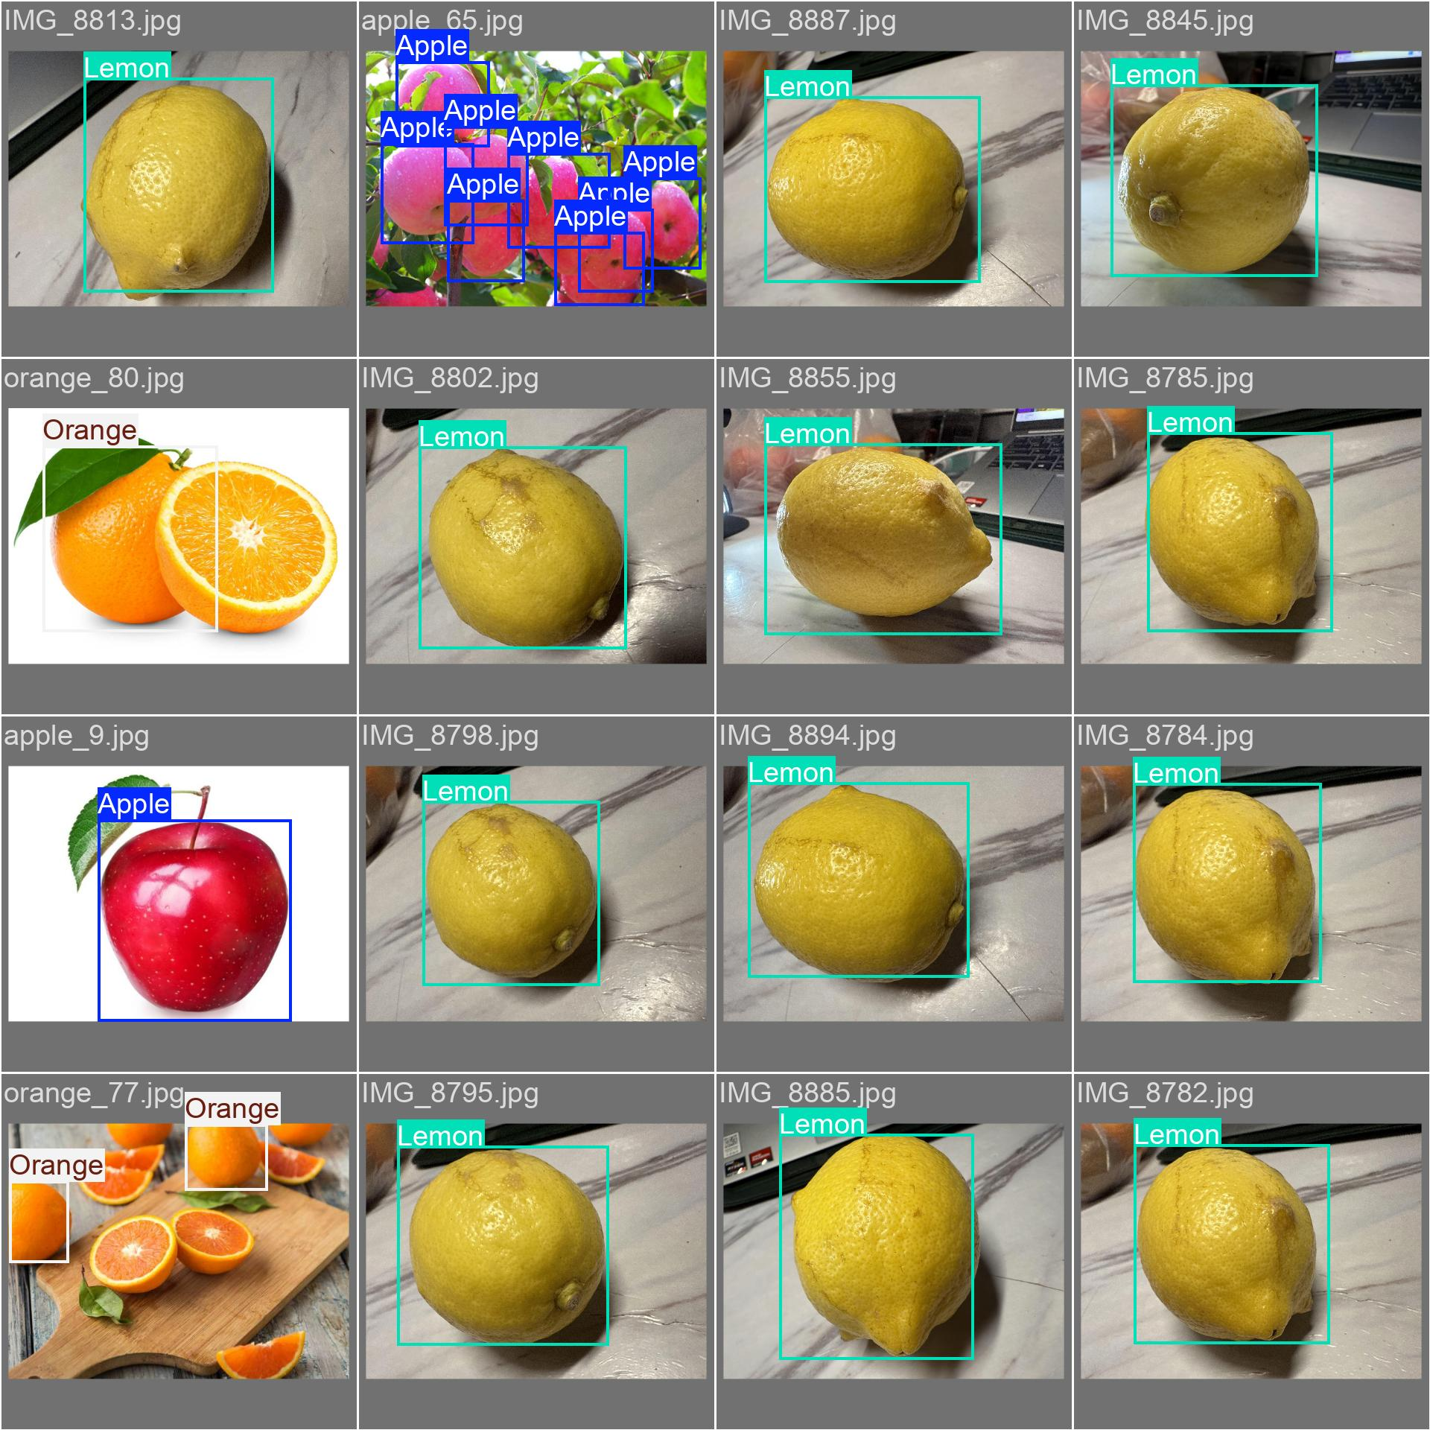
Now, we will create our model with yolo 26 to recognize crop. The work contains 7 mains parts.
- Problem definition and data strategy
- Data annotation (Labeling)
- Dataset splitting and configuration
- Architectural selection (Model scaling)
- Model training
- Evaluation and Metric
- Inference (real world deployment)

--------------------------------------------------------------------------------------------------------
1- fruit recognition (in chinese): https://www.cnblogs.com/baoto/p/19670342

