
Introduction
In this part of the work, we will work on the thread 1 which is the design of a system allowing the autonomous navigation of the robot in the picking path, and to achieve this goal we will use ROS2.
We planed to use Gazebo for the simulation of the robot but my computer doesn’t run Gazebo correctly, Gazebo is slow and the optimisation to make it rapid makes the car disappear. But Gazebo is not mandatory for the project, it is true that it can be useful, but we can use the ressources ROS2 gives for the robot simulation.

II-Gazebo installation :
After the configuration and the installation of the ressources related to Gazebo, I got the following window of Gazebo.
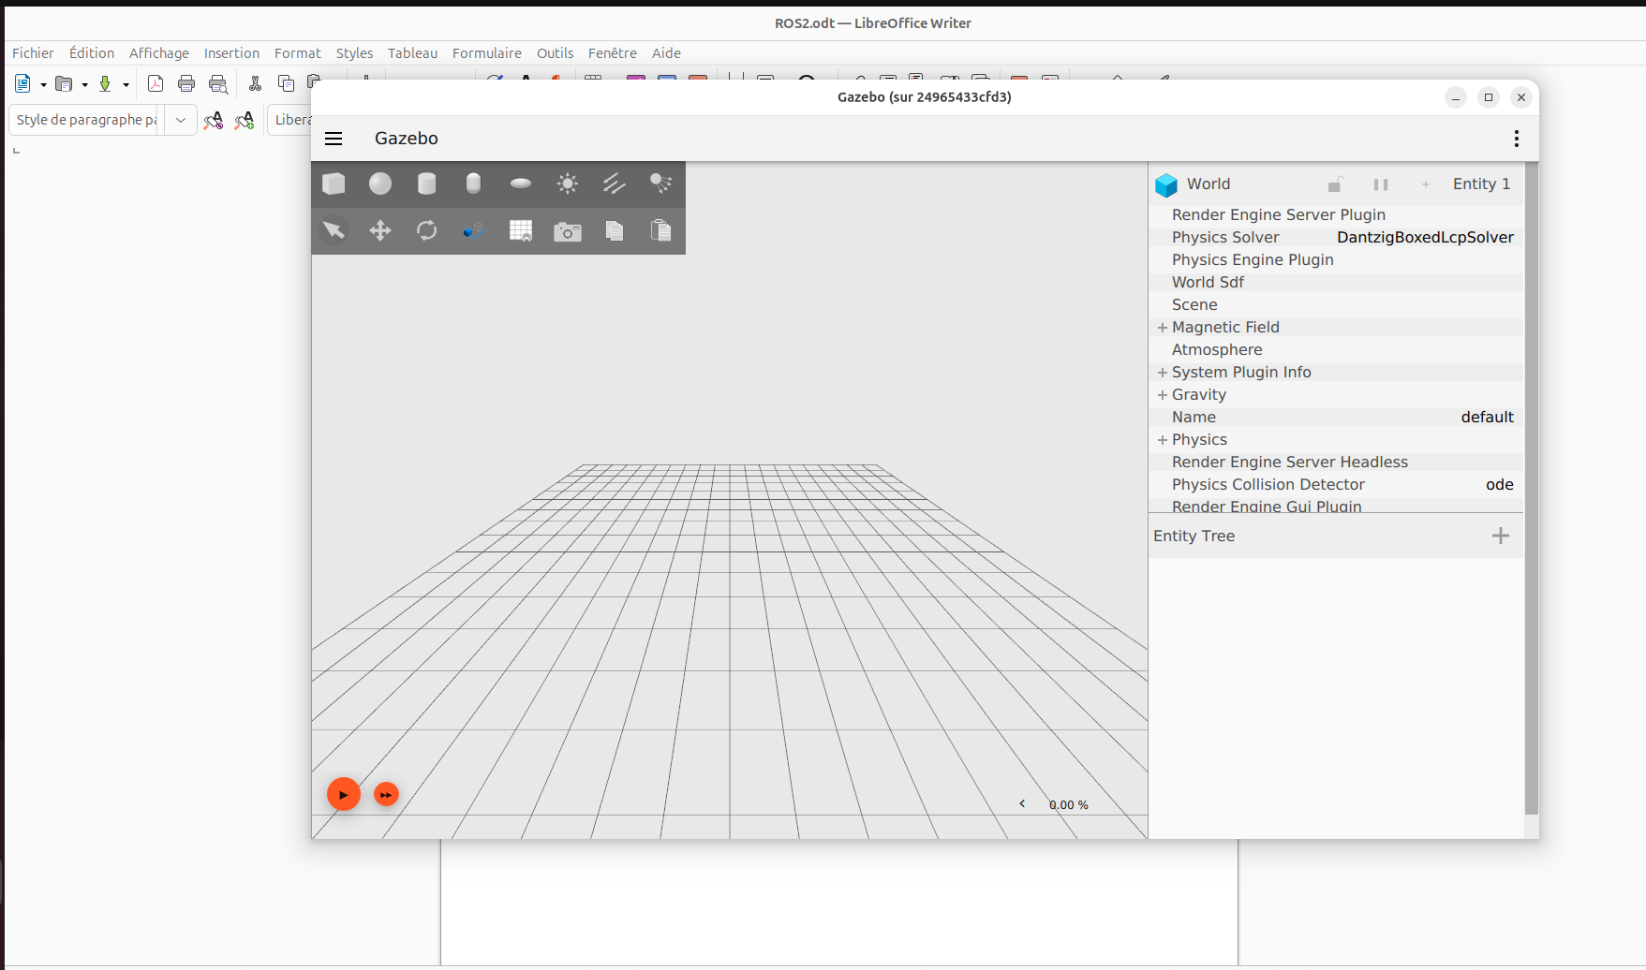
Result of the first simulation :
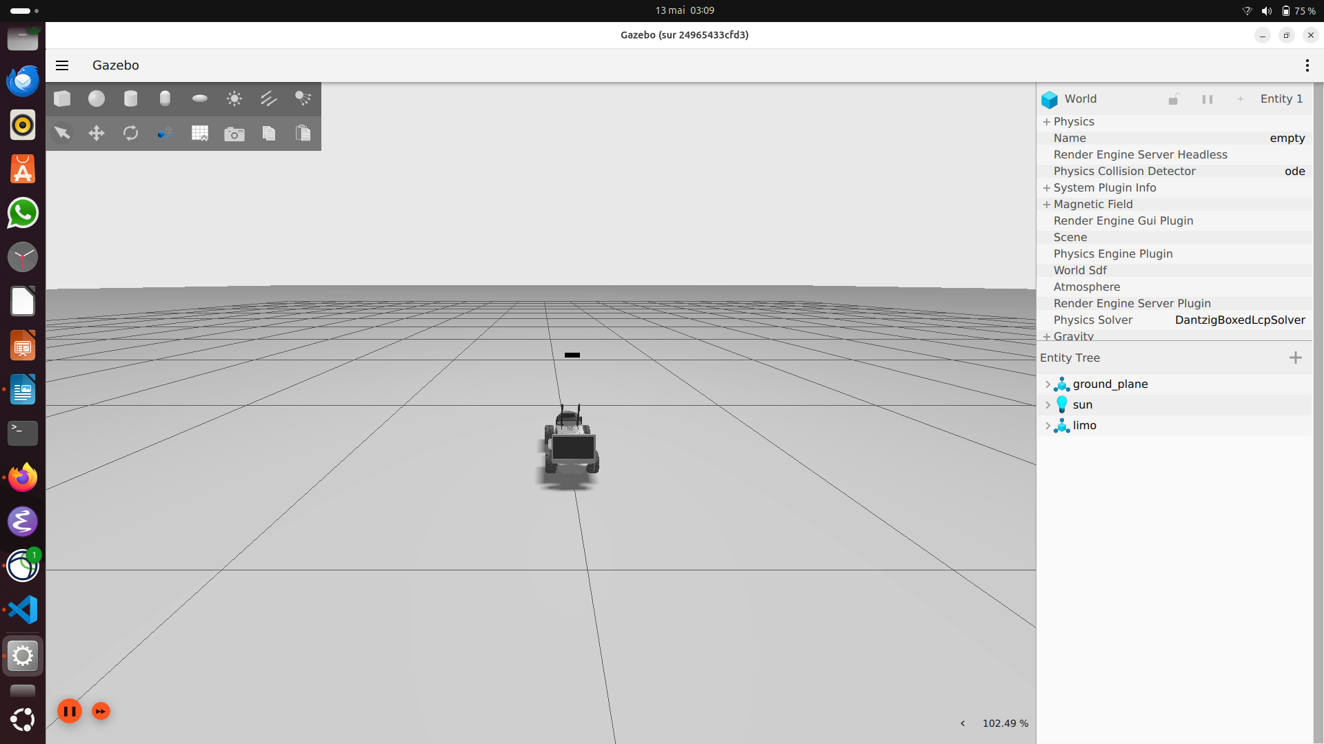
There are two problem with the simulation, the first one is that the car is Limo 01 instead of 02, and the second one is that the simulation is very slow on my computer, the alternative was to use the Lab computer but I found out that the Lab has only screens not the central processing unit. Finally, I plan to use the ressources given by ROS2 and give up Gazebo, like Rviz.

III-Get starting with ROS2

A- How to run ROS2
Here are the steps to runs ROS2 and use it :

On host terminal (Ubuntu 25.04) : In the container :
1- Allow the screen acces for Gzebo 1- enter the container :
xhost +local:docker docker exec -it limo_navigation bash
2- Checking if containers exist : 2- sourcing the container :
docker ps -a source /opt/ros/humble/setup.bash

3- Start the container :
docker start limo_navigation

4- verify if the container is running :
docker ps

Listener :
- To listen :
ros2 topic echo /chatter std_msgs/msg/String

Subscriber :
-To send the data :
ros2 topic pub --rate 1 /chatter std_msgs/msg/String "{data: 'LIMO robot is ready'}"

B- Running executables
- To see the packages: ros2 pkg list

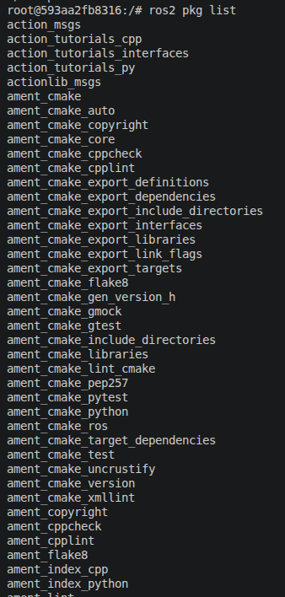

- To see the executables : ros2 pkg executables
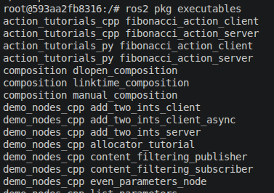
- To see the executable of the package Turtle : ros2 pkg executables turtlesim
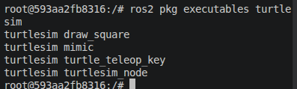
-To run an executable : ros2 run package_name executable_name
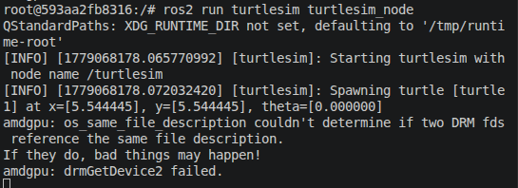
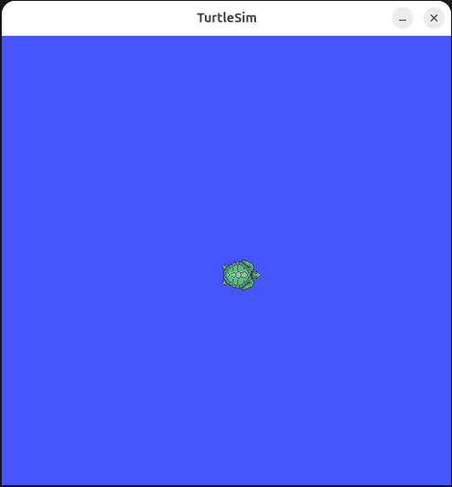

We can execute many executables at the same time :
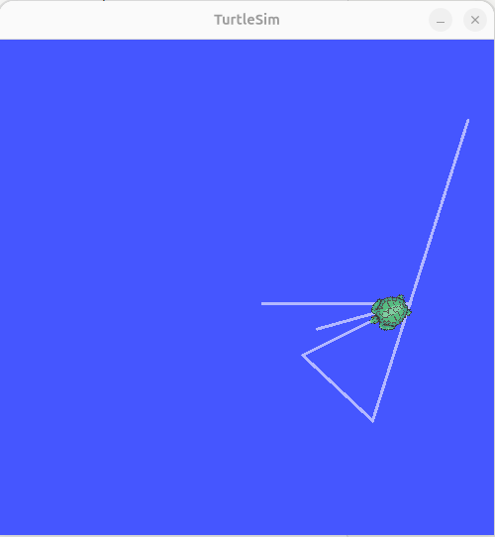
for example, here I execute the executables turtlesim_node to show the windows and turtle_teleop_key to move the turtle from my keyboard.
ROS2 works by making nodes communicate between them, and to do it, it use topics, actions or services.
We can know what node are communicating with each other when a communication is established.
We use : ros2 node list
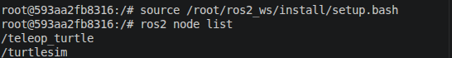
TOPICS
In the topics we have a Publisher (sender) and a Subscriber ( receiver), they communicate between topics.

SERVICES
In the services we have a Server and a Client where the client require some data and the server need to respond before the client receive the data. It’s mean that the server is the one which will decide if the client will receive or not the data.

Calling a services : In this case, we call for the spawning of a new turtle.
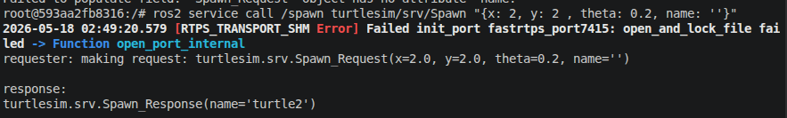

We can see the response in the terminal.

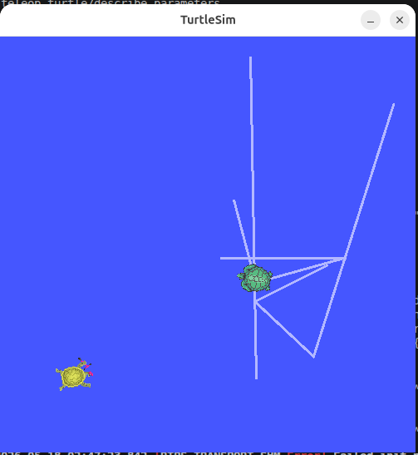
Result :
PARAMETERS
There are used to input data into the nodes. We pass parameters in the nodes.
We can see the differents parameters by taping : ros2 param list.
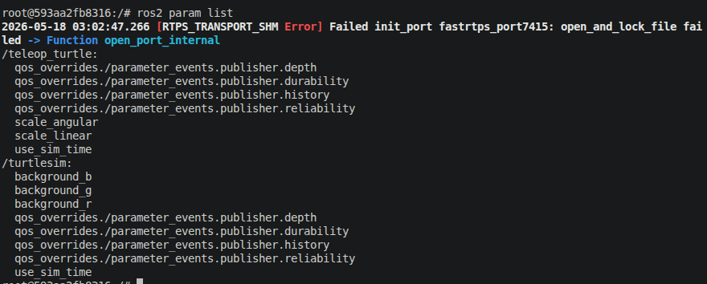
As we can see, there are two different types of parameters: those of /teleop_turtle and those of /turtlesim. This is because there are two running executables.

-To get a parameter value : ros2 param get node_name parameter_name
for example : ros2 param get /turtlesim background_g
What is the error in red ?
This is due that I am in docker. When we send a request, the FastDDS looks for the fastest possible way to talk to other node. And first is tries to use the Shared Memory (SHM) which allow to talk to other node using the RAM. As we are into Docker, Docker isolate the container so FastDDS can not acces the SHM and then display this error in red.

It’s just an error for trying to access to a non-autorized memory space.

