1- Image and Video reading
Image reading
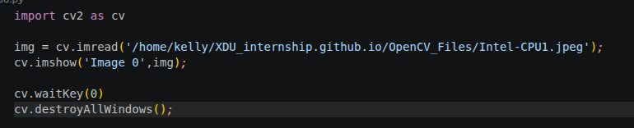
Execution error :
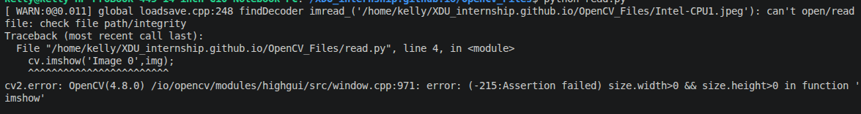
Video reading
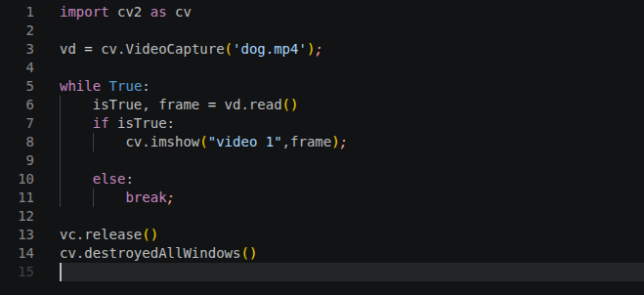
The execution of this create a window that disappears as soon as it appears. We need to manage the time. That is the problem that the following code solve.
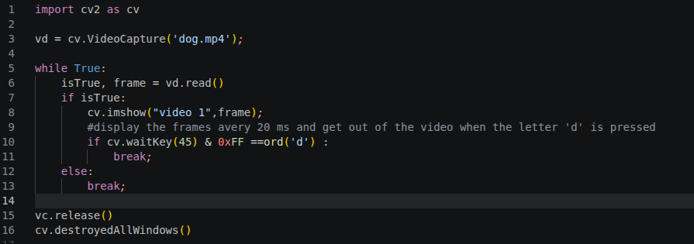
cv.waitKey(20) allow to display the frame every 20 ms and it returns a 32 bits number that the 8 last bits determine the state of the key board. If these last 8 bits are off => we continue to display but if the are on we interrupt the display, and we use the charateristic to say to OpenCv if the letter ‘d’ is pressed stop display otherwise continue. That is what is interpreted by

if cv.waitKey(45) & 0xFF ==ord('d') :

We can decide to display slowly or rapidely by changing x in cv.waitKey(x)

2- Rescaling and resizing a Window
Rescaling a video ( works for image, video and live video)
simple codes ( refer to code)

This will allow us to adapt the display code to tha abalities of the camera we will use.
Some reasons why resizing video is important.
-computational efficiency :
Processing a video frame-to_frame can be computationally expensive.A standard 1080p HD contains over 2 millions of pixels. If we are running a complex algorithm (like face detection or object tracking) on every single pixel, the frame rate will drop signicantly.

1-The math : reducing the frame dimension by half (e.g., 1080p to 540p) reducing the total pixels counted by 75 %.
2-result : the code run much faster, often moving from « laggy » to « real-time ».

-Machine Learning contraints :
Most AI and deep learning model (like YOLO, SSD or Mediapipe) have a fixed input size. For example, is a model has been trained to see images at 224x224 pixels, it can’t process a 1920x1080 video directly. We much then resize the video frames to match the model’s architecture before feeding them in.

-Aspect ratio and normalization :
When dealing with a multiple video sources, they often come in different resolutions.

1-consistency : resizing allow to standardize our datas so the analysis logic remains the same regardless of the source.
2-Normalization : it help reducing noise and high-frequencis that might not be necessary for a specific task, such as detecting the presence of a large vehicule.

/!\ Difference between rescaling and resizing
Resizing : it force a output image to a certains size where the proportionality between width and height can be changed.
-Goal : force an image into a fixed container.
-Risk : If the target dimensions don’t match with the original proportions, the images will loocked stretched or squashed.

Eg :
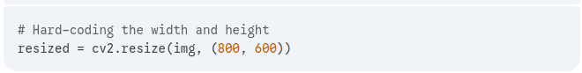
Rescale : keep the proportionality between them. And it is done based on a scale factor or a percentage (e.g : make a image 50 % smaller)

Resizing a video ( works for only live video)
simple codes ( refer to code)

3- Drawing shape and putting text
Drawing shape
For this numpy is necessary.
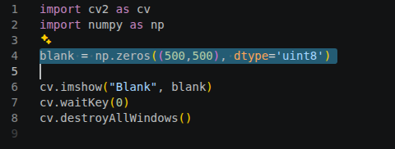
Numpy is a library of Python allowing to work with array of number. OpenCV doesn’thave its own library of number, it totaly rely on numpy.
In the code above,
blank = np.zeros((500,500), dtype='uint8')
-np.zeros() : we create an array full of zero, but it is for initialization.
-(500,500) : means 500 rows and 500 columns. That’s also means we want 500x500 pixels.
-dtype =’unit8’: means « unsigned interger, 8bits » , and so each pixel can take 256 (2⁸) values from 0 (black) to 255 ( white).

4- Essential functions
Converting to grayscale

Converting an image to grayscale is one of the most fundamental steps in computer vision. While we lose color information, we gain a massive advantage in computational efficiency and data clarity.
Here are the primary reasons why we do it:

1. Dimensionality Reduction (Speed)
A standard color image is stored in three channels: Red, Green, and Blue (RGB/BGR). A grayscale image has only one channel (intensity).
- The Math: If you have a $1080p$ image, a color version has roughly 6.2 million values for the computer to process. A grayscale version has only 2 million.
- The Result: By converting to grayscale, you effectively reduce the data by 66%. This allows algorithms like face detection or object tracking to run in real-time on hardware with limited power, like a Raspberry Pi or a drone.

2. Simplification of Features
For many computer vision tasks, color is a distraction. If you are trying to detect the edges of a CPU or the shape of a car, the actual color (blue, red, or silver) doesn't matter as much as the contrast and intensity changes.
- Edge Detection: Algorithms like Canny Edge Detection look for changes in brightness to find outlines. These gradients are much easier to calculate on a single-channel grayscale image than across three different color channels.
- Object Recognition: Features like corners, blobs, and textures are defined by their shape and shadow, not their hue.

3. Standardizing Lighting Conditions
Colors change drastically depending on the light source (yellow indoor lights vs. blue outdoor shadows). Grayscale helps normalize these variations by focusing on luminance (brightness). This makes a vision system more "robust," meaning it is less likely to be fooled by a change in lighting.

4. Requirement for Other Algorithms
Many advanced OpenCV functions and machine learning models are mathematically designed to work only on single-channel images.
- Thresholding: Turning an image into pure black and white (binary) requires a grayscale input first.
- Histograms: Analyzing the distribution of light in an image is more straightforward in grayscale.
- Morphological Operations: Dilating or eroding shapes to clean up noise typically happens on grayscale or binary images.

Feature | Color Image (BGR) | Grayscale Image
Channels | 3 (Red, Green, Blue) | 1 (Intensity)
Complexity | High | Low
Best For | Human viewing, color-based sorting | Edge detection, SLAM, AI models
Processing Speed | Slower | Significantly Faster

