Draft
This document is to test eveything that come in my mind while working.

1- readig 2 different videos resized with a scale = 0.5
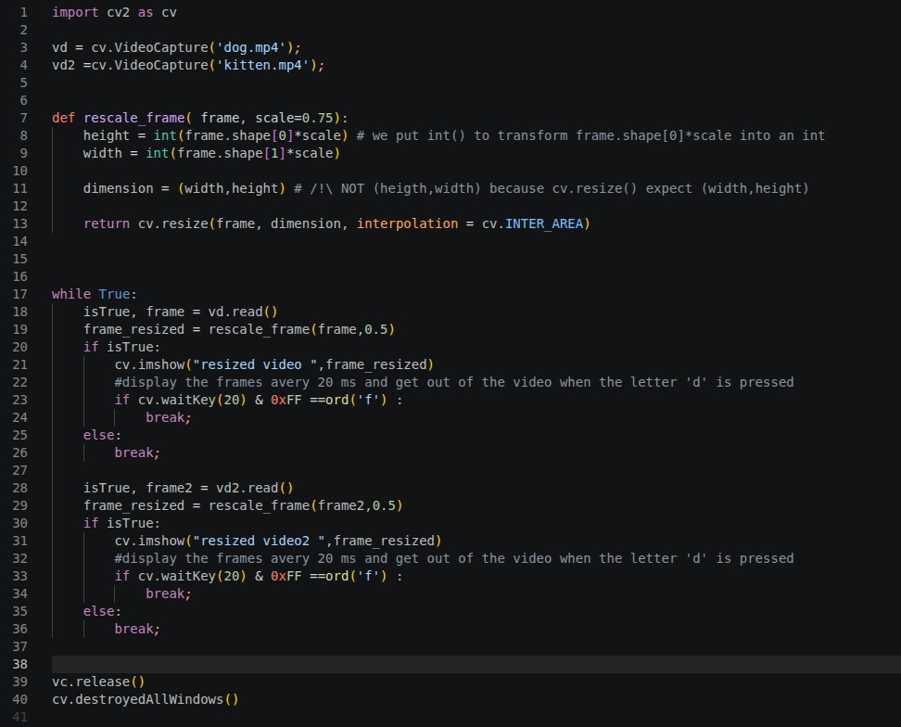
result :

