1- Image and Video reading
Image reading
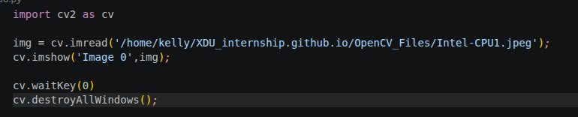
Execution error :
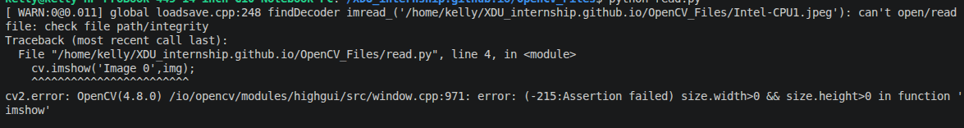
Video reading
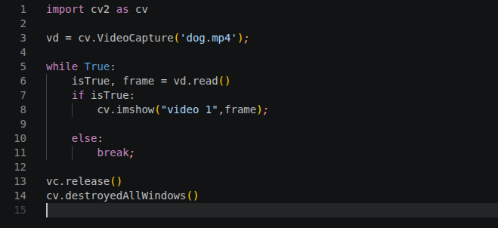
The execution of this create a window that disappears as soon as it appears. We need to manage the time. That is the problem that the following code solve.
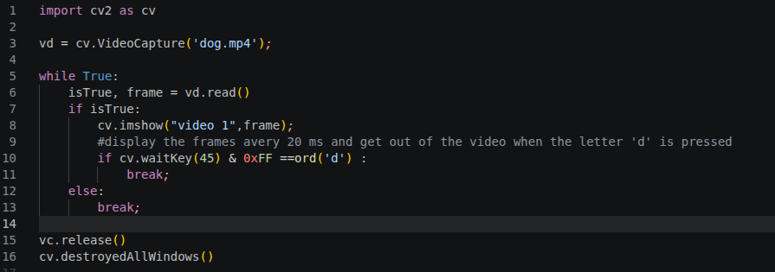
cv.waitKey(20) allow to display the frame every 20 ms and it returns a 32 bits number that the 8 last bits determine the state of the key board. If these last 8 bits are off => we continue to display but if the are on we interrupt the display, and we use the charateristic to say to OpenCv if the letter ‘d’ is pressed stop display otherwise continue. That is what is interpreted by

if cv.waitKey(45) & 0xFF ==ord('d') :

We can decide to display slowly or rapidely by changing x in cv.waitKey(x)

2- Rescaling and resizing a Window
Rescaling a video ( works for image, video and live video)
simple codes ( refer to code)

This will allow us to adapt the display code to tha abalities of the camera we will use.
Some reasons why resizing video is important.
-computational efficiency :
Processing a video frame-to_frame can be computationally expensive.A standard 1080p HD contains over 2 millions of pixels. If we are running a complex algorithm (like face detection or object tracking) on every single pixel, the frame rate will drop signicantly.

1-The math : reducing the frame dimension by half (e.g., 1080p to 540p) reducing the total pixels counted by 75 %.
2-result : the code run much faster, often moving from « laggy » to « real-time ».

-Machine Learning contraints :
Most AI and deep learning model (like YOLO, SSD or Mediapipe) have a fixed input size. For example, is a model has been trained to see images at 224x224 pixels, it can’t process a 1920x1080 video directly. We much then resize the video frames to match the model’s architecture before feeding them in.

-Aspect ratio and normalization :
When dealing with a multiple video sources, they often come in different resolutions.

1-consistency : resizing allow to standardize our datas so the analysis logic remains the same regardless of the source.
2-Normalization : it help reducing noise and high-frequencis that might not be necessary for a specific task, such as detecting the presence of a large vehicule.

/!\ Difference between rescaling and resizing
Resizing : it force a output image to a certains size where the proportionality between width and height can be changed.
-Goal : force an image into a fixed container.
-Risk : If the target dimensions don’t match with the original proportions, the images will loocked stretched or squashed.

Eg :
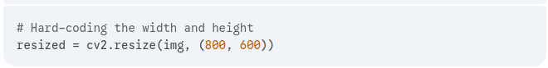
Rescale : keep the proportionality between them. And it is done based on a scale factor or a percentage (e.g : make a image 50 % smaller)

Resizing a video ( works for only live video)
simple codes ( refer to code)

