
Summary
1- Image and Video reading
2- Rescaling and resizing a Window
3- Drawing shape and putting text
Introduction
In the project, OpenCV is used for crop recognition; it is the platform of the project which performs the operations for image and video processing. It will be linked to ROS to control the car and the robot arm.

The goal of this work is to master OpenCV and know how it works; for that, I used a complete dataset (image, video) on the internet for learning OpenCV.

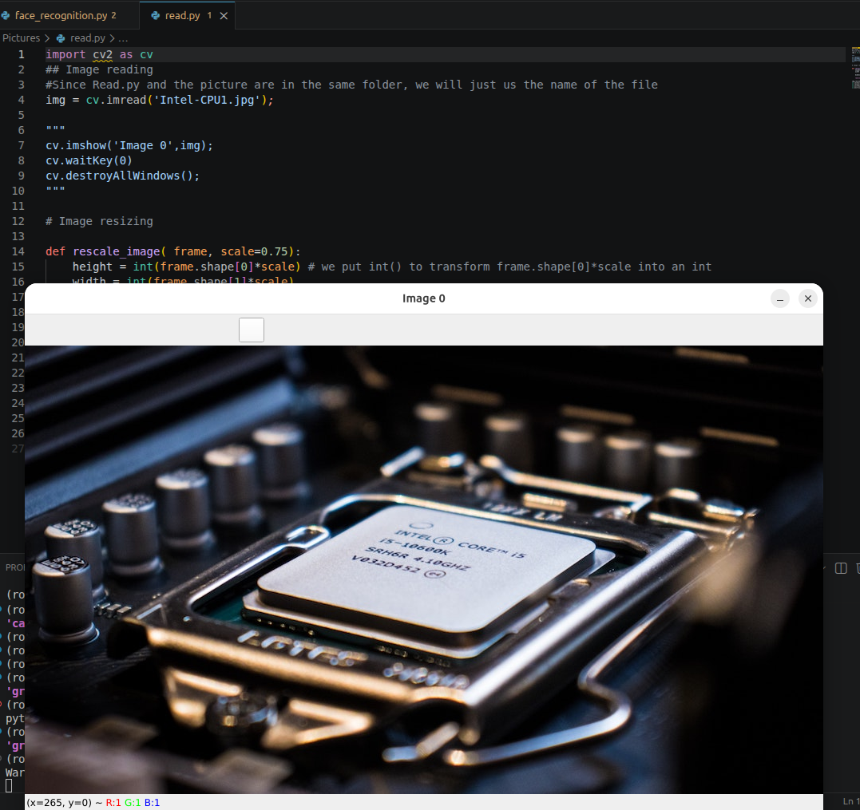

1- Image and Video reading
Image reading
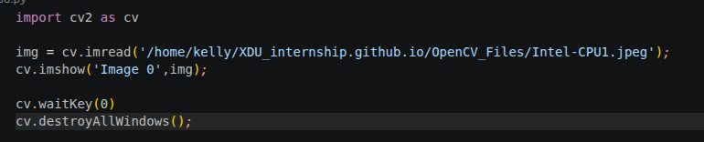
Result:

Video reading

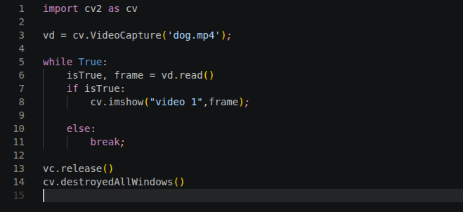
The execution of this create a window that disappears as soon as it appears. We need to manage the time. That is the problem that the following code solve.
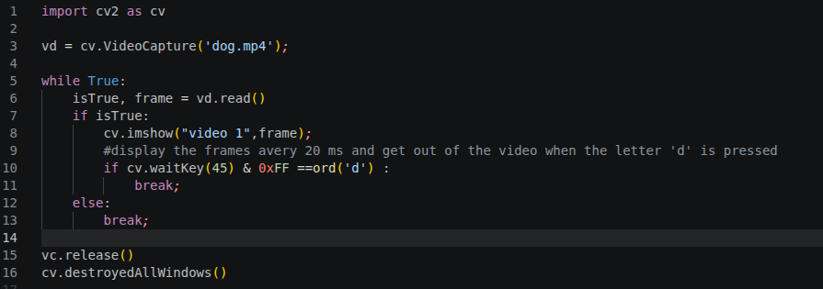
cv.waitKey(45) allows to display the frame every 45 ms and it returns a 32 bits number that the 8 last bits determine the state of the keyboard. If these last 8 bits are OFF, then we continue to display but if they are ON we interrupt the display. We use this charateristic to say to OpenCV if the letter ‘d’ is pressed stop display otherwise continue. That is what is interpreted by “ if cv.waitKey(45)&0xFF ==ord(‘d’) ”. We can decide to display slowly or rapidly by changing x in cv.waitKey(x).

2- Rescaling and resizing a Window
Rescaling a video (works for image, video and live video)

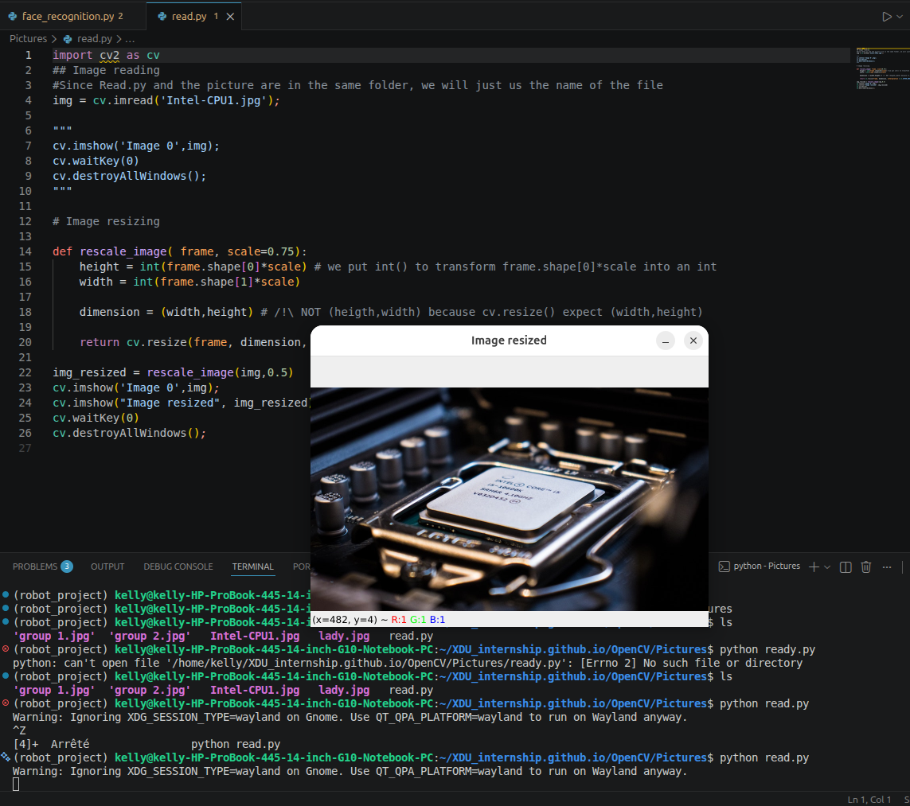

Rescaling an image or video will allow us to adapt the display code to the abilities of the camera we will use. Some reasons why resizing video is important.

- Computational efficiency:
Processing a video frame-to frame can be computationally expensive. A standard 1080p HD contains over 2 million of pixels. If we are running a complex algorithm (like face detection or object tracking) on every single pixel, the frame rate will drop signicantly.
- The math: reducing the frame dimension by half (e.g., 1080p to 540p) reducing the total pixels counted by 75 %.
- Result: the code run much faster, often moving from « laggy » to « real-time ».

- Machine Learning constraints:
Most AI and deep learning model (like YOLO, SSD or Mediapipe) have a fixed input size. For example, is a model has been trained to see images at 224x224 pixels, it can’t process a 1920x1080 video directly. We much then resize the video frames to match the model’s architecture before feeding them in.

- Aspect ratio and normalization:
When dealing with multiple video sources, they often come in different resolutions, and rescaling the image or video gives the following advantages:
- Consistency: resizing allow to standardize our data so the analysis logic remains the same regardless of the source.
- Normalization: it helps reducing noise and high frequencies that might not be necessary for a specific task, such as detecting the presence of a large vehicle.

Difference between rescaling and resizing
Resizing:
It forces an output image to a certain size where the proportionality between width and height can be changed.
- Goal: force an image into a fixed container.
- Risk: If the target dimensions don’t match with the original proportions, the images will loock stretched or squashed.

Rescale:
Keeps the proportionality between them. And it is done based on a scale factor or a percentage (e.g: make an image 50 % smaller)

Resizing a video (works for only live video)
(refer to code)

3- Drawing shape and putting text
Theses functions will allow us to write the name of the crop recognized on the screen.

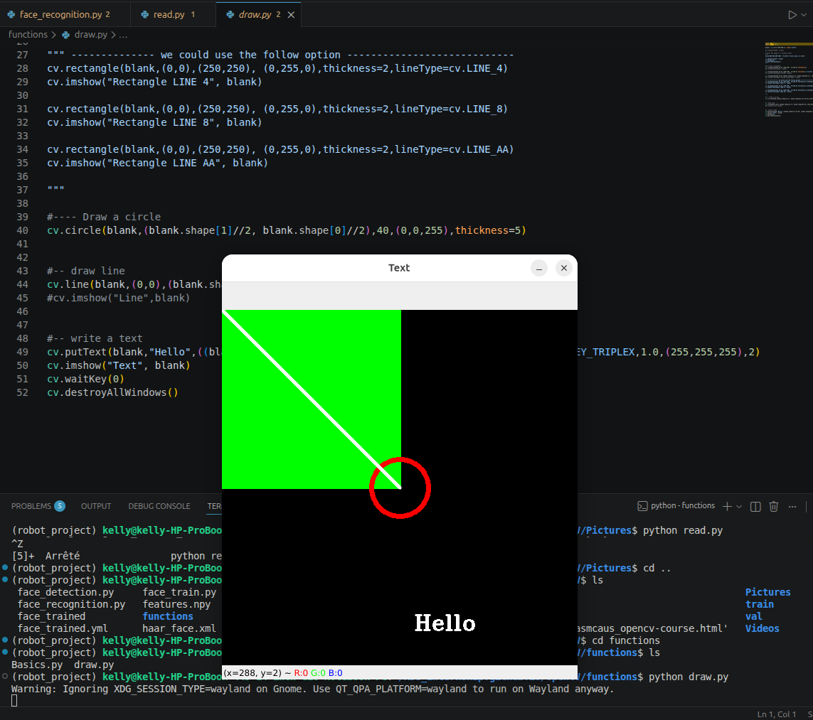
In the code blank = np.zeros((500,500), dtype=’uint8’)
-np.zeros(): we create an array full of zero, but it is for initialization.
-(500,500): means 500 rows and 500 columns. That’s also means we want 500x500 pixels.
-dtype =’unit8’: means « unsigned interger, 8bits », and so each pixel can take 256 (2⁸) values from 0 (black) to 255 (white).

4- Face detection
This part is just for a human face detection, no matter what the face is.
For doing this, we will use a classifier, and the one we use here is “Haar Cascade”.
With the original image we have the following result:
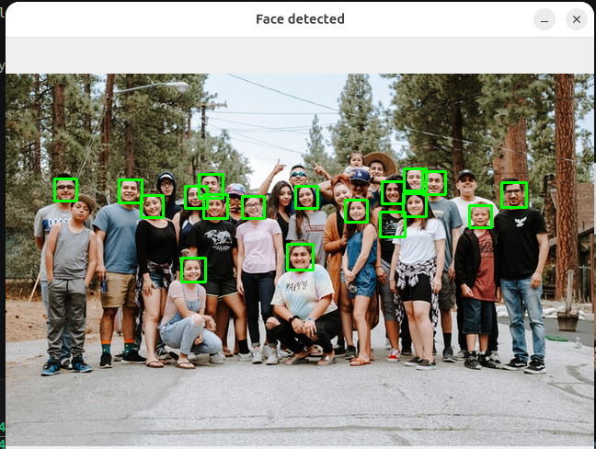
Efficiency:
17/27 faces detected.
With the image resized with the scale=1.5 we have wjat follows:
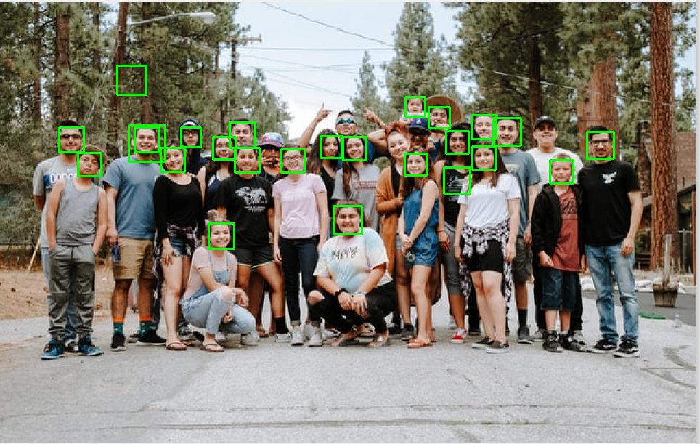
Efficiency: 23/27 faces detected.
By Augmenting the size of the image we have a good face detection. But we can also increase the efficiency by changing scaleFactor and minNeighbors.
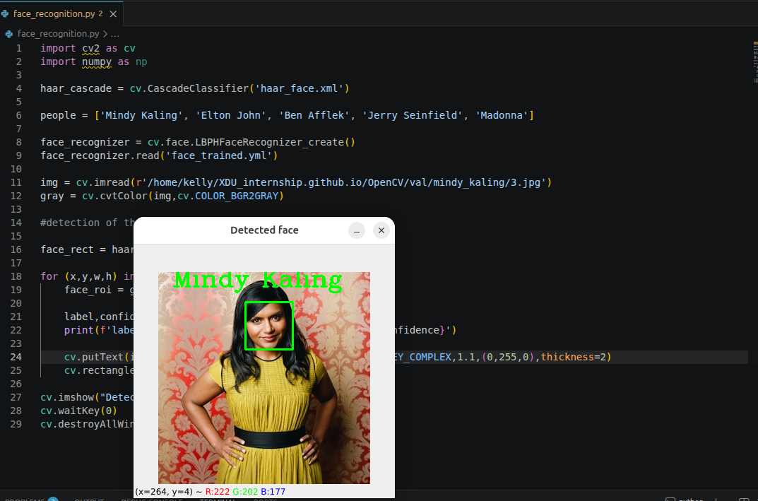
For : -scaleFactor = 1.25 and minNeighbors =1.
Efficiency:
23/ 27 faces detected.

For: -scaleFactor =1.255 and minNeighbors = 1.
Efficiency:
24/27 face detected.

5- Face recognition
After the face detection, I trained the model for the face recognition, and here is the result.

