Week 6 — ATT&CK Framework: Mapping a Spearphishing Attachment Chain

Project and weekly task
Project topic: Detecting Spearphishing Attacks in Corporate Networks. Student: Danial Rahman. Group: CS-2421. Course: Introduction to Threat Hunting (ITH). Date: 24 October 2026.
Section 3.3 of the 2026–2027 syllabus sets the Week 6 practice task as: study one specific ATT&CK technique (e.g. T1059 — Command-Line Interface), simulate an attack and map the results to ATT&CK tactics and techniques, with the MITRE ATT&CK Navigator documentation as recommended reading. This increment applies that task to our group topic. The technique we study in depth is T1566.001 — Spearphishing Attachment, and we follow it through the execution chain it triggers so the mapping covers a full initial-access-to-C2 sequence rather than a single cell.
Week 4 organised the RSA breach with the Cyber Kill Chain; Week 5 built a hypothesis-driven PowerShell hunt in Splunk. Week 6 keeps the same phishing theme but moves to the ATT&CK framework: we describe a technique precisely, generate synthetic telemetry for it, and produce an ATT&CK Navigator layer. All data is synthetic and nothing is executed (see Safety and scope).

The ATT&CK framework in brief
ATT&CK organises adversary behaviour into tactics (the attacker’s goal — e.g. Initial Access, Execution), techniques (how the goal is achieved — e.g. Spearphishing Attachment), sub-techniques (specific variants), and procedures (concrete in-the-wild implementations). We use Enterprise ATT&CK v20, read directly from MITRE’s official STIX bundle; the facts below (names, tactics, group counts, mitigations, detection strategies) are extracted by scripts/build_attack_reference.py into data/attack_v20_subset.json so they are verifiable and reproducible, not quoted from memory.
Note on tactic naming: in ATT&CK v20 the tactic that earlier versions called Defense Evasion is represented in the STIX data under the shortname stealth. We use the familiar label “Defense Evasion” in prose and figures.

Technique studied: T1566.001 — Spearphishing Attachment
- Tactic: Initial Access (TA0001)
- ATT&CK version: 2.2 · URL: https://attack.mitre.org/techniques/T1566/001/
- Description (MITRE): adversaries send spearphishing emails with a malicious attachment to gain access to victim systems. The attachment (an Office document, executable, PDF or archive) relies on User Execution (T1204.002) after the recipient opens it.
- Prevalence: attributed to 79 named groups and 62 pieces of software in ATT&CK v20 — among the most widely used initial-access techniques, which is why it anchors our project.
- Mitigations (MITRE): M1017 User Training, M1018 User Account Management, M1021 Restrict Web-Based Content, M1031 Network Intrusion Prevention, M1047 Audit, M1049 Antivirus/Antimalware, M1054 Software Configuration.
- MITRE detection strategy DET0236 correlates inbound email metadata → attachment on disk → process execution → outbound network activity — exactly the behavioural chain our hunt reconstructs. Its Windows analytic (AN0655) names the log sources we model: mail-gateway content, Sysmon EventCode 11 (file create), EventCode 1 (process create) and EventCode 3/22 (network/DNS).

The simulated attack chain
We model one suspicious host (FIN-WS01) carried through five ATT&CK techniques, plus three control hosts that look similar but must not be confused with the attack.
# | Observed step (synthetic) | Technique | Tactic
1 | Mail gateway delivers a macro-document attachment; sender fails SPF/DMARC | T1566.001 Spearphishing Attachment | Initial Access
2 | User opens the document; WINWORD.EXE writes it to \Downloads\ and spawns a child | T1204.002 Malicious File | Execution
3 | The child process is powershell.exe | T1059.001 PowerShell | Execution
4 | Its command line carries an -EncodedCommand argument | T1027.010 Command Obfuscation | Defense Evasion
5 | The same PowerShell process opens an outbound TCP/443 session | T1071.001 Web Protocols | Command & Control
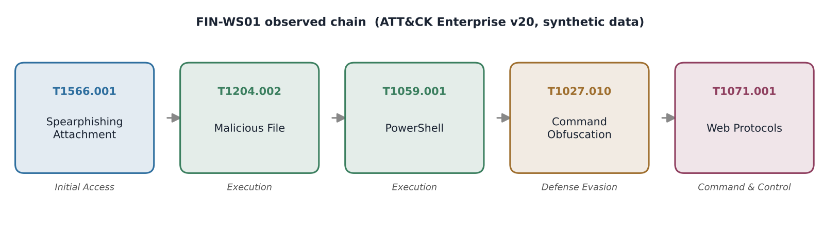
Observed ATT&CK chain on FIN-WS01
This is the mapping the syllabus asks for: each observed artefact is tied to a specific ATT&CK technique and its tactic, forming a path across the matrix rather than a single technique in isolation.

Safety and scope
Nothing in this increment is live or dangerous:
- No email is generated. Mail activity is represented as mail-gateway log records (data/mail_events.ndjson) — sender, recipient, SPF/DKIM/DMARC verdict and an attachment name plus the SHA-256 of a short harmless placeholder string. There is no message body, no macro, no script and no attachment file.
- No process runs and no connection is made. Endpoint activity is synthetic telemetry in the Sysmon schema (data/endpoint_events.ndjson, EventID 1/3/11). The “encoded command” values are short Base64 of harmless placeholder text.
- Nothing resolves or routes. Senders use the reserved .example TLD; all IPs are from the RFC 5737 documentation ranges (192.0.2.0/24, 198.51.100.0/24, 203.0.113.0/24).
The generator is deterministic, so every figure and count in this report is reproducible with python3 scripts/generate_telemetry.py.

The hunt: narrowing four hosts to one candidate
scripts/hunt_and_map.py reads the telemetry and applies the DET0236 logic: mail reputation → Office writes a document → Office spawns an interpreter → encoded argument → egress from the same process entity. The last condition is the key discriminator and reuses the process-correlation lesson from Week 5.
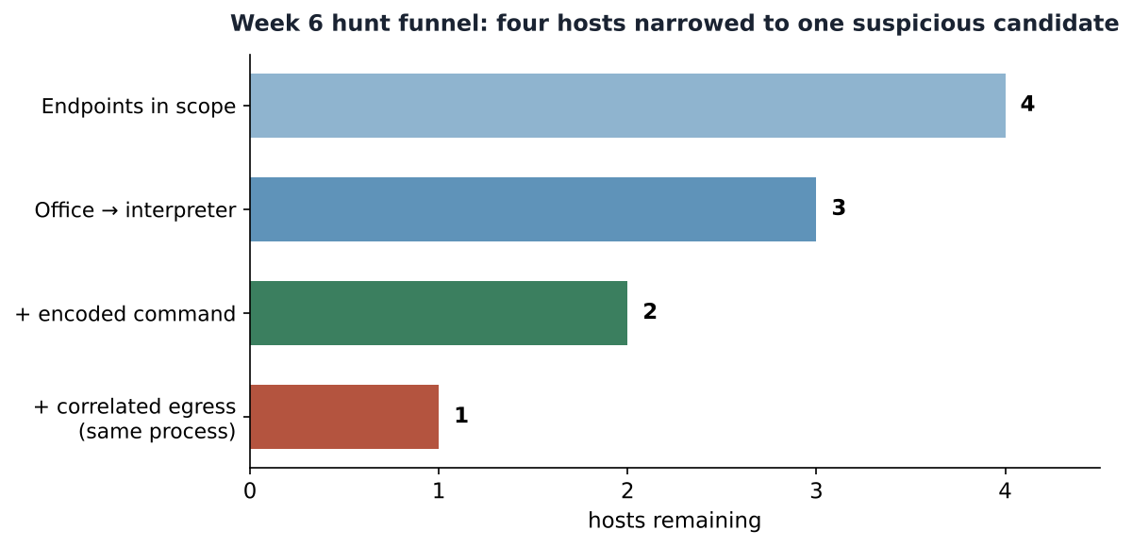
Hunt funnel
Host | Disposition | Techniques mapped
FIN-WS01 | SUSPICIOUS — full delivery-to-C2 chain, investigate | T1566.001, T1204.002, T1059.001, T1027.010, T1071.001
FIN-WS02 | BENIGN — no Office→interpreter chain (PDF opened from Explorer) | none
FIN-WS03 | BENIGN MATCH — Excel→PowerShell but no encoding, internal destination; approved automation | T1204.002, T1059.001
FIN-WS04 | PARTIAL — encoded Office PowerShell, but outbound traffic belonged to a different process | T1204.002, T1059.001, T1027.010
FIN-WS03 and FIN-WS04 are deliberate controls. FIN-WS03 shows that “Office spawned PowerShell” alone is a false positive (approved reporting automation). FIN-WS04 shows why host-only correlation is too broad: the encoded PowerShell and the outbound connection are real, but they are not the same process, so FIN-WS04 is excluded from the C2 step. Only FIN-WS01 satisfies the complete chain.

ATT&CK Navigator layer
attack/navigator_layer.json is a valid Navigator 4.5 layer (ATT&CK v20). Each technique is scored by the number of synthetic hosts exhibiting it, so the attack path lights up on the matrix. To view it: open ATT&CK Navigator → Open Existing Layer → Upload from local → select the file.

Limitations
The dataset has four hosts and a single attack path; the counts show that the logic behaves as intended, not detection accuracy. A real spearphishing hunt would add the email body, attachment detonation, document-macro telemetry, DNS and proxy logs, and would treat -EncodedCommand as one indicator among many (legitimate tools also encode commands). The mapping reflects our modelled chain; an attacker could reach the same tactics through other techniques (e.g. T1566.002 link-based delivery, or mshta/regsvr32 execution).

What Week 6 adds to the project
A precise ATT&CK technique study grounded in the official v20 STIX data, a safe synthetic telemetry set for a spearphishing chain, a reproducible hunt that maps observations to five techniques across four tactics, two figures, and an importable Navigator layer. Week 7 implements MITRE CAR analytics that detect the execution stage of this same chain in a SIEM.

References
- [R1] MITRE ATT&CK — Spearphishing Attachment T1566.001. https://attack.mitre.org/techniques/T1566/001/
- [R2] MITRE ATT&CK — User Execution: Malicious File T1204.002. https://attack.mitre.org/techniques/T1204/002/
- [R3] MITRE ATT&CK — PowerShell T1059.001. https://attack.mitre.org/techniques/T1059/001/
- [R4] MITRE ATT&CK — Command Obfuscation T1027.010. https://attack.mitre.org/techniques/T1027/010/
- [R5] MITRE ATT&CK — Web Protocols T1071.001. https://attack.mitre.org/techniques/T1071/001/
- [R6] MITRE ATT&CK Navigator. https://mitre-attack.github.io/attack-navigator/
- [R7] MITRE ATT&CK STIX data (enterprise-attack v20). https://github.com/mitre-attack/attack-stix-data
- [R8] RFC 5737 — IPv4 Address Blocks Reserved for Documentation. https://datatracker.ietf.org/doc/html/rfc5737

