Week 7 — Using MITRE CAR: Implementing and Executing Analytics in a SIEM

Project and weekly task
Project topic: Detecting Spearphishing Attacks in Corporate Networks. Student: Danial Rahman. Group: CS-2421. Course: Introduction to Threat Hunting (ITH). Date: 24 October 2026.
Section 3.3 of the 2026–2027 syllabus sets the Week 7 practice task as: select an analytic model from CAR and implement it in a SIEM; map the analytic to related ATT&CK techniques, with the MITRE CAR documentation as recommended reading. This increment selects two analytics from the MITRE Cyber Analytics Repository (CAR), implements them as portable Sigma rules, converts them to Splunk SPL and SQLite with pySigma, and executes the SQLite form against a log store built from the Week 6 telemetry. It then maps each analytic back to ATT&CK v20.
This continues the same phishing chain: Week 6 mapped the behaviour (T1566.001 → … → T1071.001); Week 7 builds the detections for its execution stage and shows how raw CAR analytics are tuned to cut false positives.

Analytics vs detections
CAR distinguishes an analytic (a documented, data-model-based hunting idea, often vendor-neutral pseudocode) from a detection (a concrete query that runs in one product). The syllabus task is to take the analytic and realise it as a detection in a SIEM. We make that bridge explicit with a pipeline:
MITRE CAR analytic -> Sigma rule (rules/*.yml) -> pySigma backend -> SPL (Splunk) + SQLite -> executed results
Writing the rule once in Sigma and converting it means the same analytic runs in Splunk (the group lab) and in a local SQLite store (reproducible here with no SIEM licence).

Analytics selected
CAR-2014-04-003 — PowerShell Execution (https://car.mitre.org/analytics/CAR-2014-04-003/). CAR’s pseudocode is: filter processes where exe == "powershell.exe" AND parent_exe != "explorer.exe". It maps to T1059.001 (PowerShell) and is deliberately broad. We implement it in two forms:
- rules/car_2014_04_003_powershell.yml — the raw analytic, faithful to the CAR pseudocode.
- rules/car_2014_04_003_powershell_tuned.yml — a tuned variant that keeps only an Office parent and an encoded-command argument, adding coverage of T1027.010 (Command Obfuscation) and T1204.002 (Malicious File). This is the detection aligned to our phishing chain.
CAR-2013-02-003 — Processes Spawning cmd.exe (https://car.mitre.org/analytics/CAR-2013-02-003/). CAR notes that when a document or mail reader launches cmd.exe it “may suggest that a malicious document has been loaded.” rules/car_2013_02_003_cmd_parent.yml keeps cmd.exe with an Office/reader parent, covering T1059.003 (Windows Command Shell) for the Office→cmd→PowerShell variant of the attack.

Conversion with pySigma
scripts/convert_rules.py loads each rule, applies the Sysmon pipeline for the Splunk output, and writes queries/*.spl and queries/*.sql. Representative output:
Raw CAR-2014-04-003, Splunk:
EventID=1 Image="*\\powershell.exe" NOT ParentImage="*\\explorer.exe"
Tuned CAR-2014-04-003, Splunk:
EventID=1 Image="*\\powershell.exe"
ParentImage IN ("*\\WINWORD.EXE", "*\\EXCEL.EXE", "*\\POWERPNT.EXE")
CommandLine IN ("* -enc *", "* -enc*", "*-EncodedCommand*")
Tuned CAR-2014-04-003, SQLite (executed here):
SELECT * FROM logs WHERE EventID=1
AND (Image LIKE '%\powershell.exe' ESCAPE '\'
AND (ParentImage LIKE '%\WINWORD.EXE' ESCAPE '\' OR ParentImage LIKE '%\EXCEL.EXE' ESCAPE '\'
OR ParentImage LIKE '%\POWERPNT.EXE' ESCAPE '\')
AND (CommandLine LIKE '% -enc %' ESCAPE '\' OR CommandLine LIKE '% -enc%' ESCAPE '\'
OR CommandLine LIKE '%-EncodedCommand%' ESCAPE '\'))
Backend and pipeline versions are recorded in docs/conversion.json.

Execution
scripts/run_hunt.py builds an in-memory SQLite table from the Sysmon-schema data/endpoint_events.ndjson (4 process-creation records across FIN-WS01–04), loads each committed queries/*.sql, and runs it. This is real query execution against a real data store, not a hand-written simulation of query behaviour. Full log: docs/execution_output.txt.
Analytic | Rows | Hosts matched
CAR-2014-04-003 raw | 3 | FIN-WS01, FIN-WS03, FIN-WS04
CAR-2014-04-003 tuned | 2 | FIN-WS01, FIN-WS04
CAR-2013-02-003 (cmd variant) | 0 | none
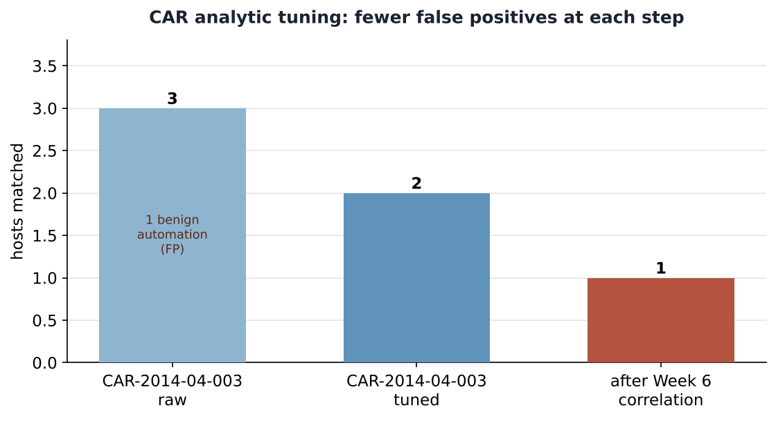
Raw vs tuned matches

Interpretation: tuning removes false positives
The raw analytic matches three hosts, including FIN-WS03 — approved Excel reporting automation (svc_report running a signed .ps1 to an internal file server). Treated as an alert, that is a false positive. The tuned analytic requires an Office parent and an encoded command, dropping FIN-WS03 and leaving FIN-WS01 and FIN-WS04.
FIN-WS04 still matches the tuned rule because, at the single-process-event level, it genuinely is encoded PowerShell launched by Word. It is only dismissed by the Week 6 correlation step: its outbound connection belonged to a different process (chrome.exe), so it never completes the chain. This is the lesson the three increments build toward — a single analytic finds candidates; correlation and analyst context resolve them. Raw 3 → tuned 2 → correlated 1 is the funnel.
CAR-2013-02-003 returns zero rows here because the simulated chain used PowerShell rather than cmd.exe. It is kept deliberately as coverage for the Office→cmd→PowerShell variant; a zero-row analytic that encodes a real hypothesis is still a useful part of a detection set.

ATT&CK mapping and coverage layer
Analytic | ATT&CK techniques
CAR-2014-04-003 raw | T1059.001
CAR-2014-04-003 tuned | T1059.001, T1027.010, T1204.002
CAR-2013-02-003 | T1059.003, T1204.002
attack/navigator_layer.json is an importable ATT&CK Navigator layer (v20) showing this coverage. It overlaps the Week 6 layer on the Execution tactic, which is the point: Week 6 maps the adversary behaviour, Week 7 maps what our analytics actually detect.

Limitations
The SQLite store holds four synthetic records, so the row counts demonstrate rule logic and tuning effect, not real-world precision or recall. The SPL is generated for a standard Sysmon index and should be validated in the group’s Splunk lab against real field extractions before use. Pattern-matching on -enc catches only the abbreviations listed; real obfuscation detection needs deobfuscation and script-block logging (EventID 4104). The analytics cover the execution stage of one chain; full spearphishing detection also needs mail, file-create and network analytics (the Week 6 DET0236 strategy).

Reproduce
cd week7
python3 -m pip install "pysigma>=1.5,<2" "pysigma-backend-splunk>=1.1,<2" \
"pysigma-backend-sqlite>=2.1,<3" "pysigma-pipeline-sysmon>=1,<2" "pysigma-pipeline-windows>=1,<2"
python3 scripts/convert_rules.py # rules -> queries/*.spl + queries/*.sql
python3 scripts/run_hunt.py # execute SQLite queries, write docs/*
python3 scripts/make_figures.py # render figure + Navigator layer
For the Splunk lab: ingest data/endpoint_events.ndjson into a Sysmon index and paste queries/*.spl into Search & Reporting. Do not present saved results as a live run.

References
- [R1] MITRE CAR — CAR-2014-04-003 PowerShell Execution. https://car.mitre.org/analytics/CAR-2014-04-003/
- [R2] MITRE CAR — CAR-2013-02-003 Processes Spawning cmd.exe. https://car.mitre.org/analytics/CAR-2013-02-003/
- [R3] MITRE CAR documentation. https://car.mitre.org/
- [R4] Sigma — generic signature format. https://github.com/SigmaHQ/sigma
- [R5] pySigma. https://github.com/SigmaHQ/pySigma
- [R6] MITRE ATT&CK — T1059.001, T1059.003, T1027.010, T1204.002. https://attack.mitre.org/
- [R7] MITRE ATT&CK Navigator. https://mitre-attack.github.io/attack-navigator/

