CS-114

Jawaharlal Nehru University

Project Report

On

"Online Tutorials"

Submitted

By

Mallika Sinha

Kasturi Sharma

Pawan Kumar

Sushant Maji

Under The Guidance of

**Professor Karan Singh**



School of Computer and System Science (SC&SS)

JNU, New Delhi-110067

Table of Content

**1. INTRODUCTION**

1.1 Concept of Online Tutorial 3

1.2 Advantage of Online Tutorial 3

**2. OBJECTIVES 3-7**

**3.** **SOFTWARE AND HARDWARE SPECIFICATION 7-8**

**4. REQUIREMENT SPECIFICATION 8**

**5. SYSTEM ANALYSIS**

5.1 ER-Diagram 9

**6. DATABASE TABLE 10**

**7. SOURCE CODE 11-41**

**8. USER MANUAL 42-51**

**9. References 52**

1. Introduction

1.1 Concept of Online Tutorial

Our project name is "Online Tutorial" which will provide free access of videos to all the students studying from class 1 to class 10. Education is a shared responsibility between us all: governments, schools, teachers, parents and private actors and must not be made too much commercialized. The government of every country should invest more money in the education since they are the pillar of the nation and can help for more sustainable development of the country. According to UNESCO about 264 million children don't go to school. Our small effort can help children to learn things online by e-learning process. So as our demo project we want to develop the online tutorial for school in free of cost.

1.2 Advantages of Online Tutorial

There are mainly 2 advantages of our project:

-You can watch videos anytime anywhere

-You don't need to pay for our online videos

2. Objectives

The main objective of our project is that tutor can sign up , upload the videos , edit the videos. Student can sign up and view the videos and after login continue watching the videos. Admin can verify the videos and delete the videos. Basically our project has 3 main modules:

* Tutor Module
* Student Module
* Admin Module

**Tutor Module:**

**-**To become a tutor, he/she needs to fill up the ‘Become a tutor’ form.

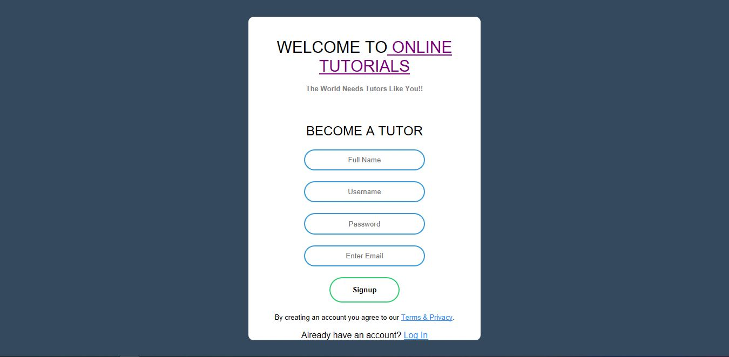

-Then he/she will be able to upload the videos.

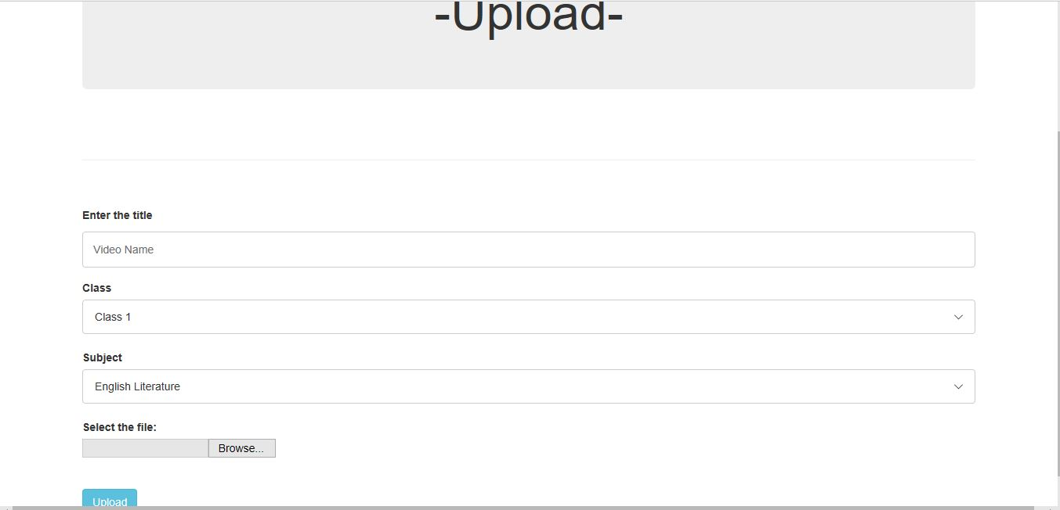

-The tutor can add/update/delete the videos from teacher dashboard.

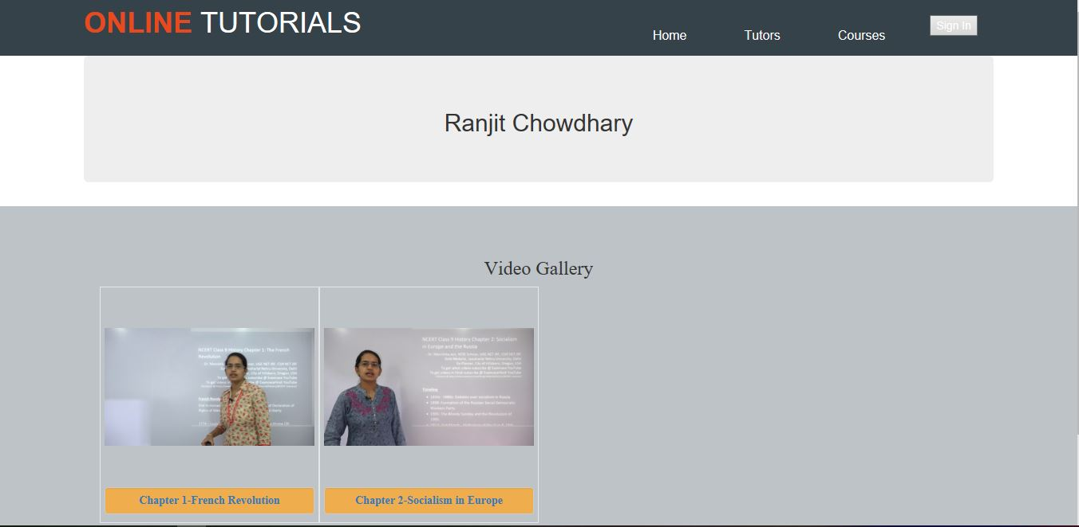

**Student Module:**

-To watch the videos students need to sign up.



-After that according to the class wise student can select the subjects from subject list.

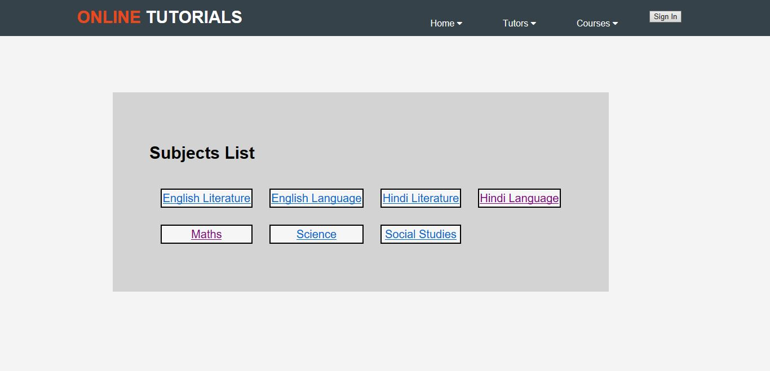

-Student will click on the subject and can watch the video

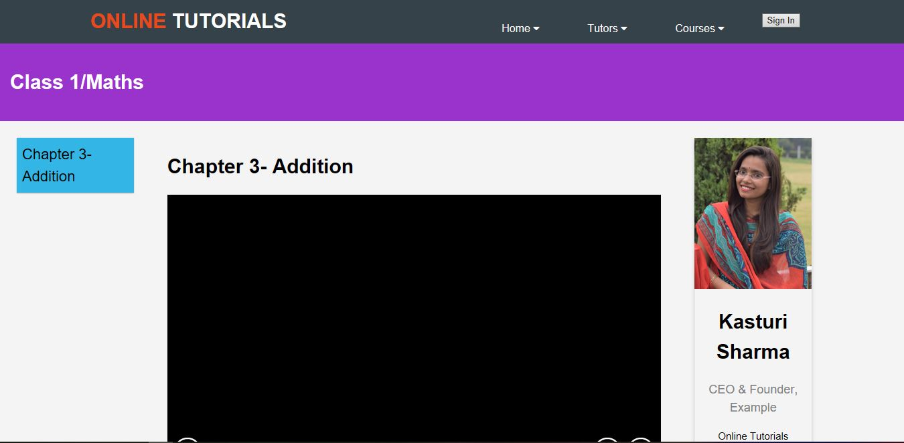

-Also there is discussion forum where student can comment once they login to discussion forum.

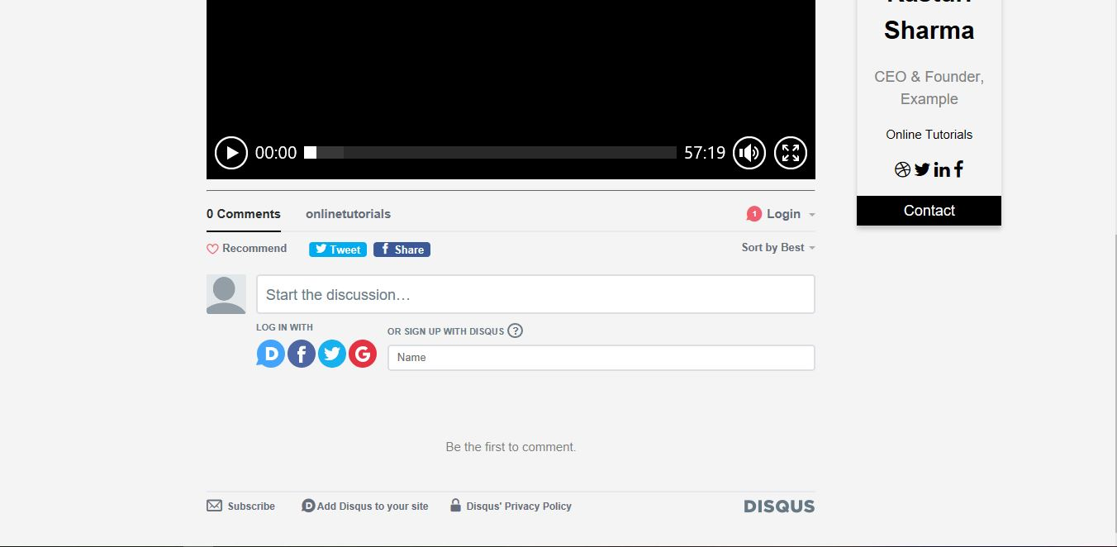

3. Software and Hardware Requirement Specification

A technical stack is a combination of software products and programming languages used to create a web or mobile application. Applications have two software components: Client-side and Server-side, also known as front-end and back-end respectively.

Server Side **(**Backend Side technical stack**)**

The back-end contains the business logic that work behind the scenes to drive our application.

* For backend following tools we will use:
  + Programming Language: PHP
  + Database: MySQL
  + Web Server: Apache
  + Operating System: Window 10
  + Ram:4GB
  + Hard Disk:1TB

Client Side(Frontend Side Technical Stack )

The front-end is the visual part of your application that users will see and interact with.This interaction can happen through a web browser or a mobile app.When building for the web, the front-end tech stack is made up of:

* For Browser:
  + HTML (Markup Language)
  + CSS (Style Sheet Language)
  + JavaScript (Scripting Language)
  + Bootstrap (For Responsive web pages)

4. Requirement Specification

The main requirement of our project is:

* It keeps all the tutorial videos from class 1 to 10 for each subject.
* Teacher can update, add and delete the videos in there teacher’s dashboard.
* Student can continue to watch there tutorials from where they had left before.
* Admin should verify the videos uploaded by tutor, then only user can see the videos.
* Admin can delete the videos if required.

5. System Analysis

5.1 ER-Diagram

The ER Model is represented by means of an ER diagram. Any object, for example, entities, attributes of an entity, relationship sets, and attributes of relationship sets, can be represented with the help of an ER diagram. Entities are represented by means of rectangles. Rectangles are named with the entity set they represent. Attributes are the properties of entities. Attributes are represented by means of ellipses. Every ellipse represents one attribute and is directly connected to its entity (rectangle). Relationships are represented by diamond-shaped box. Name of the relationship is written inside the diamond-box. All the entities (rectangles) participating in a relationship, are connected to it by a line.

The ER-diagram of our project is shown below:

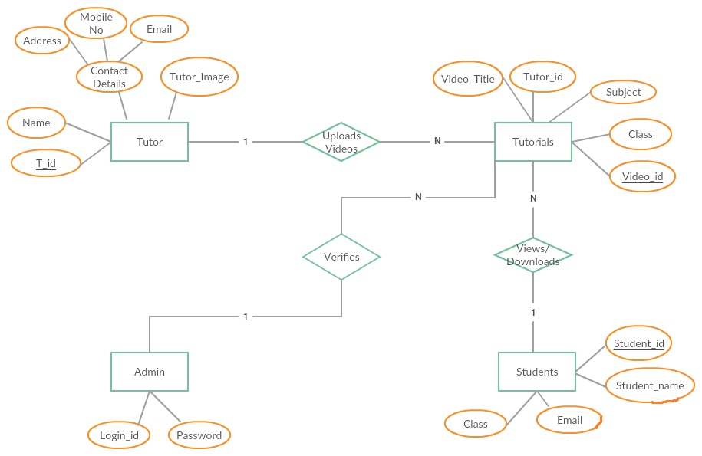

6. Database Tables:

a. Login Table

|  |  |
| --- | --- |
| Attribute | Data Type |
| Id | Varchar |
| password | Varchar |

b. Users Table

|  |  |
| --- | --- |
| Attribute | Data Type |
| Username | Varchar |
| Password | Varchar |
| Email | Varchar |

c. TutorLogin Table

|  |  |
| --- | --- |
| Attribute | Data Type |
| tutorName | Varchar |
| tutorPass | Varchar |

d. Tutors Table

|  |  |
| --- | --- |
| Attribute | Data Type |
| tutorId | Int (Auto Increment) |
| tutorName | Varchar |
| tutorUserName | Varchar |
| tutorPass | Varchar |
| tutorEmail | Varchar |

e. Videos Table

|  |  |
| --- | --- |
| Attribute | Data Type |
| videoId | Int (Auto Increment) |
| videoName | Varchar |
| Class | Varchar |
| Subject | Varchar |
| Link | Varchar |
| tutorId | Int(From tutors Table) |

7. Source Code:

* Index page

<!DOCTYPE html>

<html>

<head>

<meta charset="utf-8">

<meta name="viewport" content="width=device-width, initial-scale=1.0">

<title>ONLINE EXAM | WELCOME</title>

<link rel="stylesheet" href="https://cdnjs.cloudflare.com/ajax/libs/font-awesome/4.7.0/css/font-awesome.min.css">

<link rel="stylesheet" type="text/css" href="style.css">

</head>

<body>

<header>

<div class="container">

<div id="branding">

<h1><a href="index.php"><span class="highlight">ONLINE</span> TUTORIALS</a> </h1>

</div>

<nav>

<ul>

<li><div class="dropdown">

<button class="dropbtn"><a href="index.php">Home </a>

<i class="fa fa-caret-down"></i>

</button>

<div class="dropdown-content">

<a href="aboutus.html">About Us</a>

<a href="contact.html">Contact Us</a>

</div>

</div>

</li>

<li>

<div class="dropdown">

<button class="dropbtn">Tutors

<i class="fa fa-caret-down"></i>

</button>

<div class="dropdown-content">

<a href="teacherDashboard.html">Kasturi Sharma</a>

<a href="teacherDashboard.html">Mallika Sinha</a>

<a href="teacherDashboard.html">Pawan Kumar</a>

<a href="teacherDashboard.html">Sushant Maji</a><hr>

<a href="teacherDashboard.html">Become a Tutor</a>

</div>

</div>

</li>

<li>

<div class="dropdown">

<button class="dropbtn">Courses

<i class="fa fa-caret-down"></i>

</button>

<div class="dropdown-content">

<a href="subjects.html">Class 1</a>

<a href="subjects.html">Class 2</a>

<a href="subjects.html">Class 3</a>

<a href="subjects.html">Class 4</a>

<a href="subjects.html">Class 5</a>

<a href="subjects.html">Class 6</a>

<a href="subjects.html">Class 7</a>

<a href="subjects.html">Class 8</a>

<a href="subjects.html">Class 9</a>

<a href="subjects.html">Class 10</a>

</div>

</div>

</li>

<li> <button id="myBtn">Sign In</button></li>

</ul>

<!-- Trigger/Open The Modal -->

<div id="myModal" class="modal">

<!-- Modal content -->

<div class="modal-content">

<span class="close">&times;</span>

<form class="boxlog" action="login.php" method="post">

<div class="heading"><h1>WELCOME TO Online Tutorials</h1></div>

<h4>Enroll in courses and watch lessons from India's best educators</h4>

<div class="btn-group">

<button class="btn1"><span>Google</span></button>

<button class="btn2"><span>Facebook</span></button>

</div>

<div class="signup">

<h2>Login</h2>

<input type="text" name="username" placeholder="Username">

<input type="Password" name="password" placeholder="Password">

<input type="submit" name="sign" value="sign">

</div>

<p class="term">By creating an account you agree to our <a href="#" style="color:dodgerblue">Terms & Privacy</a>.</p>

<p style="color: #000;">Don't have an account? <a href="signup.html" style="color:dodgerblue">Sign up</a></p>

</form>

</div>

</div>

<script type="text/javascript" src="modal.js"></script>

</nav>

</div>

</header>

<section id="showcase">

<div id="snow_fall">

<div class="bgimage">

<div class="container">

<h1> Your ultimate destination for online assessment</h1>

<p> Prepare candidates to perform extraordinarily with an easy to use highly interactive platform and simplify the assessment cycle.</p>

<button id="buttonone"><a href="watchdemo.html"> WATCH OUR VIDEO</a> </button>

</div>

</div>

<script type="text/javascript" src="particles.js"></script>

<script type="text/javascript" src="app.js"></script>

</div>

</section>

<section id="newsletter">

<div class="container">

<h1> Subscribe To Our Newsletter</h1>

<form>

<input type="email" placeholder="Enter Email...">

<button type="submit" class="button_1"> Subscribe </button>

</form>

</div>

</section>

<section id="boxes">

<div class="box">

<h3 > Create Questions </h3>

</div>

<div class="box">

<h3> Design Test </h3>

</div>

<div class="box">

<h3> Assign Test </h3>

</div>

<div class="box">

<h3> Generate Result </h3>

</div>

</section>

<section id="works">

<div class="work">

<h4> Easy to learn and use </h4>

<p> One-stop-destination for examination, preparation, recruitment, and more. Specially designed online examination system to solve all your preparation worries. The platform is smooth to use with a translational flow of information. </p>

</div>

<div class="work">

<h3> Highly interactive interface </h3>

<p> A click to the next trick, simple registration, signing- in, synchronized processing, secured encoding and decoding of information and more. </p>

</div>

<div class="work">

<h3> Advanced reporting system </h3>

<p> Instant scorecard generation, computational analysis, efficient feedback sharing to boost up your performance and precision. An ultimate combination of detailed and drilled methodologies that will eventually complement your skills and grades. </p>

</div>

<div class="work">

<h3> Splendid support </h3>

<p> Your request and our actions to strive triggered support. A dedicated team is working round the clock to provide 24 X 7 streamlined access to our technical experts . </p>

</div>

<div class="work">

<h3> Smart subscription </h3>

<p> Premium selection to the suited subscription that will match your preferences and priorities of using the online assessment platform. </p>

</div>

<div class="work">

<h3> Active accessibility </h3>

<p> Go wherever you want to and practice whenever you want, using the next level online tutorial platform. Experience a lag-free synchronized performance of online tutorial on your mobile devices. </p>

</div>

</section>

<div class="footer">

<p> © 2018 Ginger Webs Pvt. Ltd, All rights reserved | Powered by onlinetutorial.com </p> </div>

</body>

</html>

* About us

<!DOCTYPE html>

<html>

<head>

<meta charset="utf-8">

<meta name="viewport" content="width=device-width, initial-scale=1">

<link rel="stylesheet" type="text/css" href="aboutusStyle.css">

<link rel="stylesheet" href="https://maxcdn.bootstrapcdn.com/bootstrap/3.4.0/css/bootstrap.min.css">

<script src="https://ajax.googleapis.com/ajax/libs/jquery/3.3.1/jquery.min.js"></script>

<script src="https://maxcdn.bootstrapcdn.com/bootstrap/3.4.0/js/bootstrap.min.js"></script>

<title>ONLINE EXAM | WELCOME</title>

</head>

<body>

<header>

<div class="container">

<div id="branding">

<h1><span class="highlight">ONLINE</span> TUTORIALS </h1>

</div>

<nav>

<ul>

<li><div class="dropdown">

<button class="dropbtn"><a href="index.php">Home </a>

<i class="fa fa-caret-down"></i>

</button>

<div class="dropdown-content">

<a href="aboutus.html">About Us</a>

<a href="contact.html">Contact Us</a>

</div>

</div>

</li>

<li>

<div class="dropdown">

<button class="dropbtn">Tutors

<i class="fa fa-caret-down"></i>

</button>

<div class="dropdown-content">

<a href="#">Kasturi Sharma</a>

<a href="#">Mallika Sinha</a>

<a href="#">Pawan Kumar</a>

<a href="#">Sushant Maji</a><hr>

<a href="#">Become a Tutor</a>

</div>

</div>

</li>

<li>

<div class="dropdown">

<button class="dropbtn">Courses

<i class="fa fa-caret-down"></i>

</button>

<div class="dropdown-content">

<a href="subjects.html">Class 1</a>

<a href="subjects.html">Class 2</a>

<a href="subjects.html">Class 3</a>

<a href="subjects.html">Class 4</a>

<a href="subjects.html">Class 5</a>

<a href="subjects.html">Class 6</a>

<a href="subjects.html">Class 7</a>

<a href="subjects.html">Class 8</a>

<a href="subjects.html">Class 9</a>

<a href="subjects.html">Class 10</a>

</div>

</div>

</li>

<li> <button id="myBtn">Sign In</button></li>

</ul>

<!-- Trigger/Open The Modal -->

<div id="myModal" class="modal">

<!-- Modal content -->

<div class="modal-content">

<span class="close">&times;</span>

<form class="boxlog" action="login.php" method="post">

<div class="heading"><h1>WELCOME TO Online Tutorials</h1></div>

<h4>Enroll in courses and watch lessons from India's best educators</h4>

<div class="btn-group">

<button class="btn1"><span>Google</span></button>

<button class="btn2"><span>Facebook</span></button>

</div>

<div class="signup">

<h2>Login</h2>

<input type="text" name="username" placeholder="Username">

<input type="Password" name="password" placeholder="Password">

<input type="submit" name="sign" value="sign">

</div>

<p class="term">By creating an account you agree to our <a href="#" style="color:dodgerblue">Terms & Privacy</a>.</p>

<p style="color: #000;">Don't have an account? <a href="signup.html" style="color:dodgerblue">Sign up</a></p>

</form>

</div>

</div>

<script type="text/javascript" src="modal.js"></script>

</nav>

</div>

</header>

<div class="container" style="text-align: center;">

<div class ="jumbotron text-center">

<h1>-Our Motive-</h1>

<p>To provide free online education to all the student in all over the world</p>

</div>

</div>

<div class = "container" style="text-align: center;">

<p style="Arial, Helvetica, sans-serif;font-size:20px;">

Welcome to Online tutorial, your number one source for all kind of Tutorial from Nursury to Higher Secondry.Online Tutorial is an educational technology based in Jawaharlal Nehru University,New Dehli, India. Started in 2019, it is a platform that offers online education in India. Online Tutorial educators consist of either students who have cleared various exams or mentors who have teaching experience.

</p>

<hr>

<p style="Arial, Helvetica, sans-serif;font-size:20px;">

We're dedicated to giving you the very best , with a focus on Uniqueness,Good material and Easy to understand.Founded in 2019 by Kasturi Sharma, Mallika Sinha, Pawan Kumar, and Sushant Maji has come a long way from its beginnings in a Lab of School of Computer and System Sciences,Jawaharlal Nehru University, Under the Guidence of Dr. Karan Singh. To provide video tutorial to school students for free of cost.

The viewers will be from nursery to higher secondary so that they can learn at their own.

They will be provided with the full documents of the tutorials.

</p>

</div>

<div class= "container" style="text-align: center;">

<div class ="jumbotron text-center">

<h1>-Leadership-</h1>

<div class="row">

<div class="col-sm-6">

<img src="img\kasturi.jpg" class="img-circle img-responsive center-block" alt="Kasturi Sharma" width="200" height="150">

<h3><b>Kasturi Sharma</b></h3>

<h4>Co-Founder & CEO</h4>

<p style="Arial, Helvetica, sans-serif;font-size:15px;">Classroom education in India has stifled many brilliant minds. With Online Tutorial, India's education platform, we are changing that.We have on board some of the top educators in the country</p>

</div>

<div class="col-sm-6">

<img src="img\mallika.jpg" class="img-circle img-responsive center-block" alt="Mallika Sinha" width="200" height="150">

<h3><b>Mallika Sinha</b></h3>

<h4>Co-Founder & CEO</h4>

<p style="Arial, Helvetica, sans-serif;font-size:15px;">Classroom education in India has stifled many brilliant minds. With Online Tutorial, India's education platform, we are changing that.We have on board some of the top educators in the country</p>

</div>

</div>

<div class="row">

<div class="col-sm-6">

<img src="img\pawan.jpg" class="img-circle img-responsive center-block" alt="Pawan Kumar" width ="170" height="150">

<h3><b>Pawan Kumar</b></h3>

<h4>Cheif Technology Officer</h4>

<p style="Arial, Helvetica, sans-serif;font-size:15px;">Classroom education in India has stifled many brilliant minds. With Online Tutorial, India's education platform, we are changing that.We have on board some of the top educators in the country</p>

</div>

<div class="col-sm-6">

<img src="img/sushant.jpg" class="img-circle img-responsive center-block" alt="Sushant Majhi" width="200" height="150">

<h3><b>Sushant Majhi</b></h3>

<h4>Chief Revenue Officer</h4>

<p style="Arial, Helvetica, sans-serif;font-size:15px;">Classroom education in India has stifled many brilliant minds. With Online Tutorial, India's education platform, we are changing that.We have on board some of the top educators in the country</p>

</div>

</div>

</div>

</div>

</div>

<section id="newsletter">

<div class="container"><br><br><br><br><br><br>

<h1> Subscribe To Our Newsletter</h1>

<form>

<input type="email" placeholder="Enter Email...">

<button type="submit" class="button_1"> Subscribe </button>

</form>

</div>

</section>

<footer>

<P> © 2019 Social Pvt. Ltd, All rights reserved | Powered by onlinetutorials.com </P>

</footer>

</body>

</html>

* Login page

<!DOCTYPE html>

<html lang="en" dir="ltr">

<head>

<meta charset="utf-8">

<meta name="viewport" content="width=device-width, initial-scale=1">

<title>Login FORM</title>

<link rel="stylesheet" type="text/css" href="loginstyle.css">

</head>

<body>

<form class="box" action="login.php" method="post">

<div class="heading"><h1>WELCOME TO Online Tutorials</h1></div>

<h4>Enroll in courses and watch lessons from India's best educators</h4>

<div class="btn-group">

<button class="btn1"><span>Google</span></button>

<button class="btn2"><span>Facebook</span></button>

</div>

<div class="signup">

<h2>Login</h2>

<input type="text" name="username" placeholder="Username">

<input type="Password" name="password" placeholder="Password">

<input type="submit" name="sign" value="sign">

</div>

<p class="term">By creating an account you agree to our <a href="#" style="color:dodgerblue">Terms & Privacy</a>.</p>

<p>Don't have an account? <a href="signup.html" style="color:dodgerblue">Sign up</a></p>

</form>

</body>

</html>

* Sign up page

<!DOCTYPE html>

<html lang="en" dir="ltr">

<head>

<meta charset="utf-8">

<meta name="viewport" content="width=device-width, initial-scale=1">

<title>Sign Up FORM</title>

<link rel="stylesheet" type="text/css" href="signupstyle.css">

</head>

<body>

<form class="box" action="signup.php" method="post">

<div class="heading"><h1>WELCOME TO TLS</h1></div>

<h4>Enroll in courses and watch lessons from India's best educators</h4>

<div class="btn-group">

<button class="btn1"><span>Google</span></button>

<button class="btn2"><span>Facebook</span></button>

</div>

<div class="signup">

<h2>Signup</h2>

<input type="text" name="username" placeholder="Username">

<input type="Password" name="password" placeholder="Password">

<input type="Email" name="email" placeholder="Enter Email">

<input type="submit" name="Signup" value="Signup">

</div>

<p class="term">By creating an account you agree to our <a href="#" style="color:dodgerblue">Terms & Privacy</a>.</p>

<p>Already have an account? <a href="loginpage.html" style="color:dodgerblue">Log In</a></p>

</form>

</body>

</html>

* Teacher dashboard

<!DOCTYPE html>

<html>

<head>

<meta charset="utf-8">

<meta name="viewport" content="width=device-width, initial-scale=1">

<link rel="stylesheet" type="text/css" href="teacherdashboardStyle.css"><link rel="stylesheet" href="https://maxcdn.bootstrapcdn.com/bootstrap/3.4.0/css/bootstrap.min.css">

<script src="https://ajax.googleapis.com/ajax/libs/jquery/3.3.1/jquery.min.js"></script>

<script src="https://maxcdn.bootstrapcdn.com/bootstrap/3.4.0/js/bootstrap.min.js"></script>

<title>ONLINE EXAM | WELCOME</title>

</head>

<body>

<header>

<div class="container">

<div id="branding">

<h1><span class="highlight">ONLINE</span> TUTORIALS </h1>

</div>

<nav>

<ul>

<li><div class="dropdown">

<button class="dropbtn"><a href="index.php">Home </a>

<i class="fa fa-caret-down"></i>

</button>

<div class="dropdown-content">

<a href="aboutus.html">About Us</a>

<a href="contact.html">Contact Us</a>

</div>

</div>

</li>

<li>

<div class="dropdown">

<button class="dropbtn">Tutors

<i class="fa fa-caret-down"></i>

</button>

<div class="dropdown-content">

<a href="#">Kasturi Sharma</a>

<a href="#">Mallika Sinha</a>

<a href="#">Pawan Kumar</a>

<a href="#">Sushant Maji</a><hr>

<a href="#">Become a Tutor</a>

</div>

</div>

</li>

<li>

<div class="dropdown">

<button class="dropbtn">Courses

<i class="fa fa-caret-down"></i>

</button>

<div class="dropdown-content">

<a href="subjects.html">Class 1</a>

<a href="subjects.html">Class 2</a>

<a href="subjects.html">Class 3</a>

<a href="subjects.html">Class 4</a>

<a href="subjects.html">Class 5</a>

<a href="subjects.html">Class 6</a>

<a href="subjects.html">Class 7</a>

<a href="subjects.html">Class 8</a>

<a href="subjects.html">Class 9</a>

<a href="subjects.html">Class 10</a>

</div>

</div>

</li>

<li> <button id="myBtn">Sign In</button></li>

</ul>

<!-- Trigger/Open The Modal -->

<div id="myModal" class="modal">

<!-- Modal content -->

<div class="modal-content">

<span class="close">&times;</span>

<form class="boxlog" action="login.php" method="post">

<div class="heading"><h1>WELCOME TO Online Tutorials</h1></div>

<h4>Enroll in courses and watch lessons from India's best educators</h4>

<div class="btn-group">

<button class="btn1"><span>Google</span></button>

<button class="btn2"><span>Facebook</span></button>

</div>

<div class="signup">

<h2>Login</h2>

<input type="text" name="username" placeholder="Username">

<input type="Password" name="password" placeholder="Password">

<input type="submit" name="sign" value="sign">

</div>

<p class="term">By creating an account you agree to our <a href="#" style="color:dodgerblue">Terms & Privacy</a>.</p>

<p style="color: #000;">Don't have an account? <a href="signup.html" style="color:dodgerblue">Sign up</a></p>

</form>

</div>

</div>

<script type="text/javascript" src="modal.js"></script>

</nav>

</div>

</header>

<div class="container">

<div class="jumbotron text-center">

<h2>Videos List</h2>

</div>

</div>

<div class="container-fluid pb-video-container">

<div class="col-md-10 col-md-offset-1">

<div class="row pb-row">

<div class="col-md-3 pb-video">

<video class="pb-video-frame" width="100%" height="240" controls><source src="video1.mp4" type="video/mp4" frameborder="0" allowfullscreen></video>

<label class="form-control label-warning text-center">HTML BASIC</label>

</div>

<div class="col-md-3 pb-video">

<video class="pb-video-frame" width="100%" height="240" controls><source src="video2.mp4" frameborder="0" allowfullscreen></video>

<label class="form-control label-warning text-center">css basic</label>

</div>

<div class="col-md-3 pb-video">

<video class="pb-video-frame " width="100%" height="230" controls><source src="video3.mp4" frameborder="0" allowfullscreen></video>

<label class="form-control label-warning text-center">Git hub</label>

</div>

<div class="col-md-3 pb-video">

<video class="pb-video-frame" width="100%" height="230" controls><source src="video4.mp4" frameborder="0" allowfullscreen></video>

<label class="form-control label-warning text-center">Javascript</label>

</div>

</div>

<div class="row pb-row">

<div class="col-md-3 pb-video">

<video class="pb-video-frame" width="100%" height="230" controls><source src="video5.mp4" frameborder="0" allowfullscreen></video>

<label class="form-control label-warning text-center">Java</label>

</div>

<div class="col-md-3 pb-video">

<video class="pb-video-frame" width="100%" height="230" controls><source src="video6.mp4" frameborder="0" allowfullscreen></video>

<label class="form-control label-warning text-center">Computer Graphics</label>

</div>

<div class="col-md-3 pb-video">

<video class="pb-video-frame" width="100%" height="230" controls><source src="video7.mp4" frameborder="0" allowfullscreen></video>

<label class="form-control label-warning text-center">Software Engineering</label>

</div>

<div class="col-md-3 pb-video">

<video class="pb-video-frame" width="100%" height="230" controls><source src="video8.mp4" frameborder="0" allowfullscreen></video>

<label class="form-control label-warning text-center">Machine learning</label>

</div>

</div>

</div>

</div>

<button type="button" class="btn btn-primary btn-lg" style="margin-left:100px ">Add</button>

<button type="button" class="btn btn-danger btn-lg" style="margin-left:20px">Delete</button>

<style>

}

</style>

<footer>

<P> © 2019 Social Pvt. Ltd, All rights reserved | Powered by onlinetutorials.com </P>

</footer>

</body>

</html>

* Student dashboard

<!DOCTYPE html>

<html>

<head>

<meta charset="utf-8">

<meta name="viewport" content="width=device-width, initial-scale=1">

<link rel="stylesheet" type="text/css" href="teacherdashboardStyle.css"><link rel="stylesheet" href="https://maxcdn.bootstrapcdn.com/bootstrap/3.4.0/css/bootstrap.min.css">

<script src="https://ajax.googleapis.com/ajax/libs/jquery/3.3.1/jquery.min.js"></script>

<script src="https://maxcdn.bootstrapcdn.com/bootstrap/3.4.0/js/bootstrap.min.js"></script>

<title>ONLINE EXAM | WELCOME</title>

</head>

<body>

<header>

<div class="container">

<div id="branding">

<h1><span class="highlight">ONLINE</span> TUTORIALS </h1>

</div>

<nav>

<ul>

<li><div class="dropdown">

<button class="dropbtn"><a href="index.php">Home </a>

<i class="fa fa-caret-down"></i>

</button>

<div class="dropdown-content">

<a href="aboutus.html">About Us</a>

<a href="contact.html">Contact Us</a>

</div>

</div>

</li>

<li>

<div class="dropdown">

<button class="dropbtn">Tutors

<i class="fa fa-caret-down"></i>

</button>

<div class="dropdown-content">

<a href="#">Kasturi Sharma</a>

<a href="#">Mallika Sinha</a>

<a href="#">Pawan Kumar</a>

<a href="#">Sushant Maji</a><hr>

<a href="#">Become a Tutor</a>

</div>

</div>

</li>

<li>

<div class="dropdown">

<button class="dropbtn">Courses

<i class="fa fa-caret-down"></i>

</button>

<div class="dropdown-content">

<a href="subjects.html">Class 1</a>

<a href="subjects.html">Class 2</a>

<a href="subjects.html">Class 3</a>

<a href="subjects.html">Class 4</a>

<a href="subjects.html">Class 5</a>

<a href="subjects.html">Class 6</a>

<a href="subjects.html">Class 7</a>

<a href="subjects.html">Class 8</a>

<a href="subjects.html">Class 9</a>

<a href="subjects.html">Class 10</a>

</div>

</div>

</li>

<li> <button id="myBtn">Sign In</button></li>

</ul>

<!-- Trigger/Open The Modal -->

<div id="myModal" class="modal">

<!-- Modal content -->

<div class="modal-content">

<span class="close">&times;</span>

<form class="boxlog" action="login.php" method="post">

<div class="heading"><h1>WELCOME TO Online Tutorials</h1></div>

<h4>Enroll in courses and watch lessons from India's best educators</h4>

<div class="btn-group">

<button class="btn1"><span>Google</span></button>

<button class="btn2"><span>Facebook</span></button>

</div>

<div class="signup">

<h2>Login</h2>

<input type="text" name="username" placeholder="Username">

<input type="Password" name="password" placeholder="Password">

<input type="submit" name="sign" value="sign">

</div>

<p class="term">By creating an account you agree to our <a href="#" style="color:dodgerblue">Terms & Privacy</a>.</p>

<p style="color: #000;">Don't have an account? <a href="signup.html" style="color:dodgerblue">Sign up</a></p>

</form>

</div>

</div>

<script type="text/javascript" src="modal.js"></script>

</nav>

</div>

</header>

<div class="container">

<div class="jumbotron ">

<h2>to be continue.....</h2>

</div>

</div>

<div class="container-fluid pb-video-container">

<div class="col-md-10 col-md-offset-1">

<div class="row pb-row">

<div class="col-md-3 pb-video">

<video class="pb-video-frame" width="100%" height="240" controls><source src="video1.mp4" type="video/mp4" frameborder="0" allowfullscreen></video>

<label class="form-control label-warning text-center">English</label>

<h3><p class="text-success">this is test sentence.</p></h3>

<h4><p class="text-muted">This text is muted.</p></h4>

</div>

<div class="col-md-3 pb-video">

<video class="pb-video-frame" width="100%" height="240" controls><source src="video2.mp4" frameborder="0" allowfullscreen></video>

<label class="form-control label-warning text-center">Math</label>

<h3><p class="text-success">this is test sentence.</p></h3>

<h4><p class="text-muted">This text is muted.</p></h4>

</div>

<div class="col-md-3 pb-video">

<video class="pb-video-frame " width="100%" height="230" controls><source src="video3.mp4" frameborder="0" allowfullscreen></video>

<label class="form-control label-warning text-center">Biology</label>

<h3><p class="text-success">this is test sentence.</p></h3>

<h4><p class="text-muted">This text is muted.</p></h4>

</div>

<div class="col-md-3 pb-video">

<video class="pb-video-frame" width="100%" height="230" controls><source src="video4.mp4" frameborder="0" allowfullscreen></video>

<label class="form-control label-warning text-center">Chemisry</label>

<h3><p class="text-success">this is test sentence.</p></h3>

<h4><p class="text-muted">This text is muted.</p></h4>

</div>

</div>

</div>

</div>

p<footer>

<P> © 2019 Social Pvt. Ltd, All rights reserved | Powered by onlinetutorials.com </P

</footer>

</body></html>

8. User manual:

-At first go to our website onlinetutorials.com then you will see the our home page.

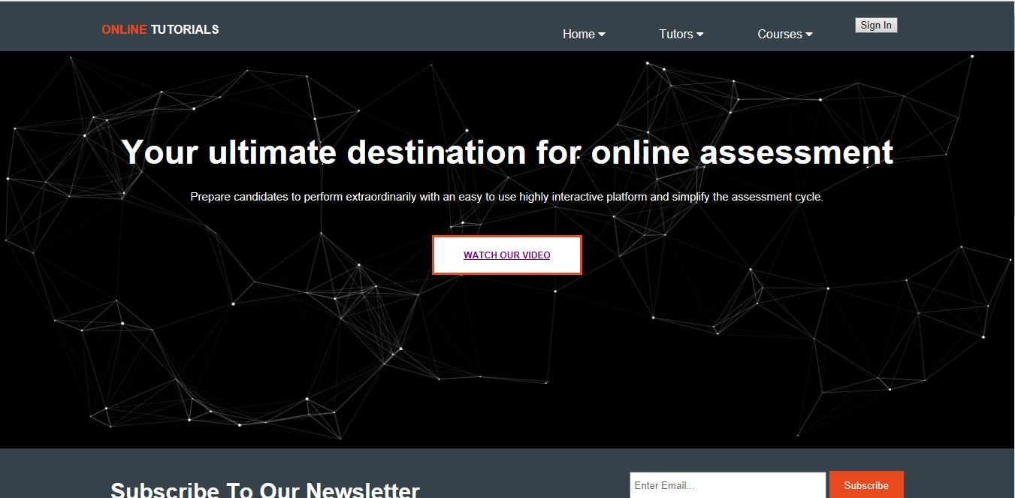

-Then to view the video as a student you need to sign up at first.



-after signup you need to login.

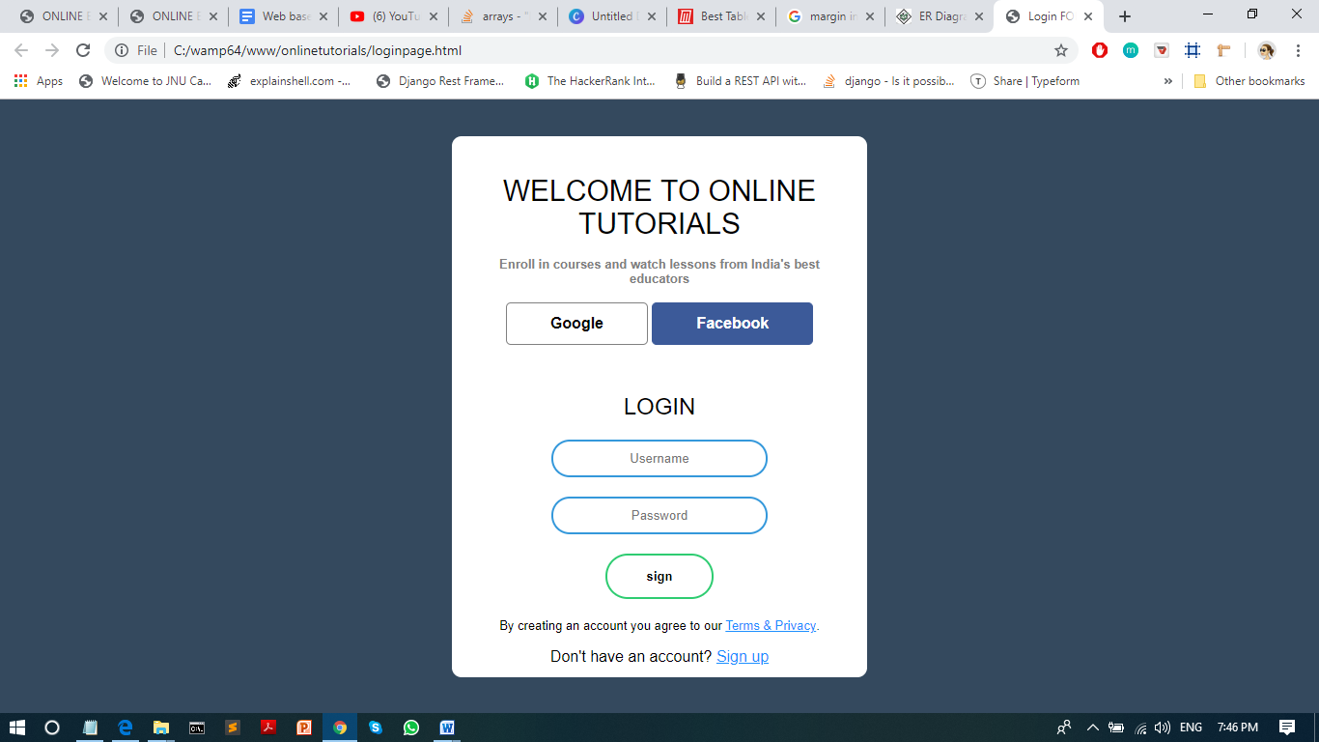

-then you need to select the class.

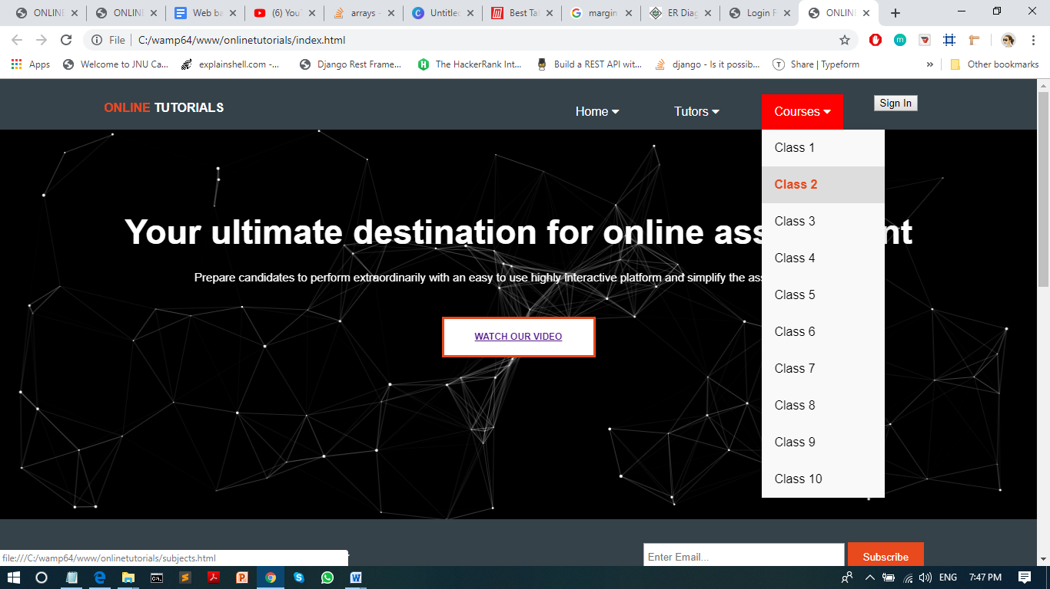

-after selecting class you can see the subjects of that particular class



-when you click on any subject, you can open the video



-if you want to comment on the video you can comment as well, below there is discussion forum



-if you want to upload videos, you need to sign up as a tutor. In dropdown menu there is option become tutor.

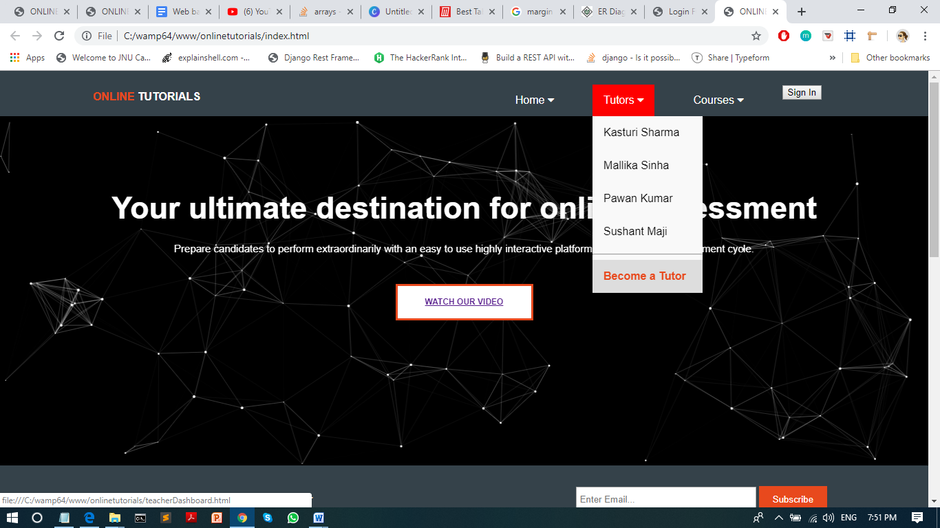

-when you click on become a tutor, you will get login page bt before you need to click on sign up link

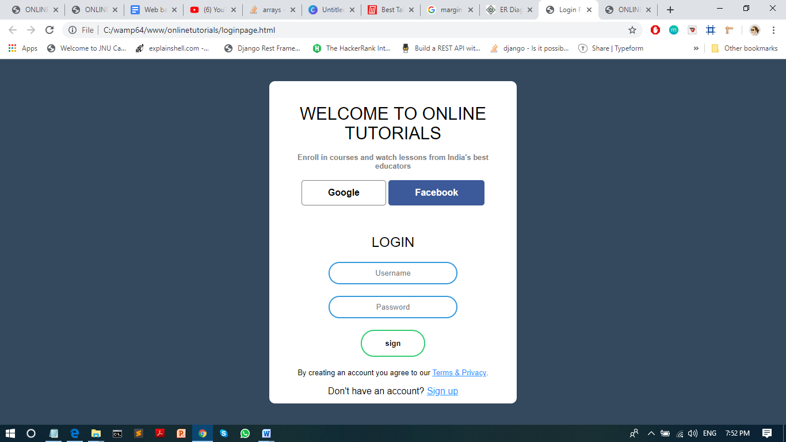

-then you need to sign up



-after sign up you will go to teacher dashboard where you can add the videos

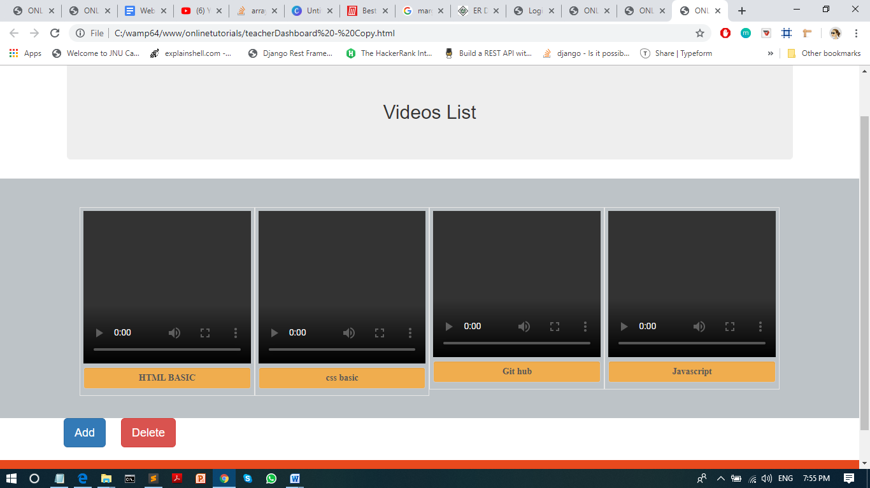

-if you want to upload video click on add button and you can upload video



-after adding you can see the tutor name and videos when you login

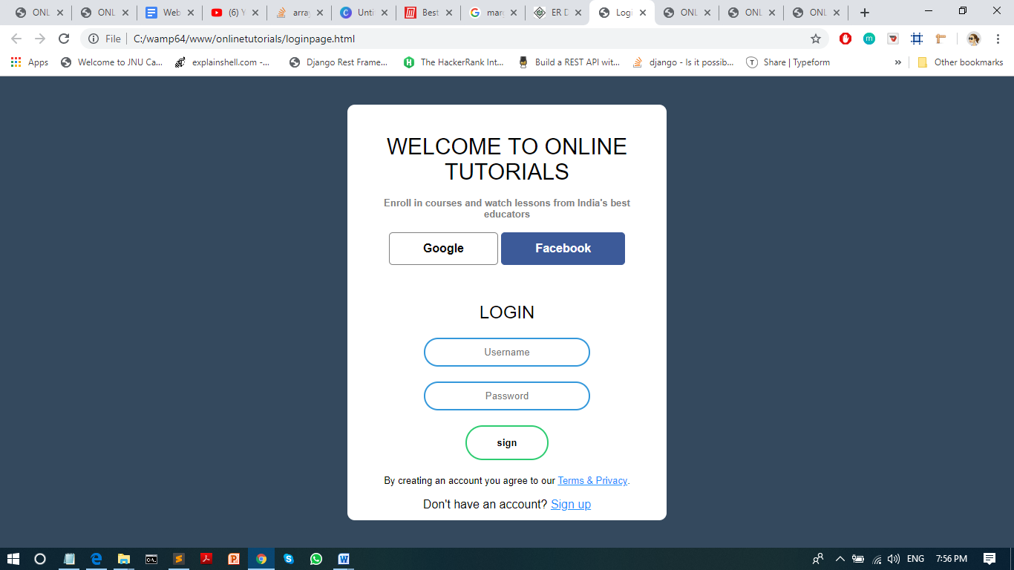



-if you want to see our about us page and contact us page, then click on home menu , there you will see two submenu -about us and contact us.

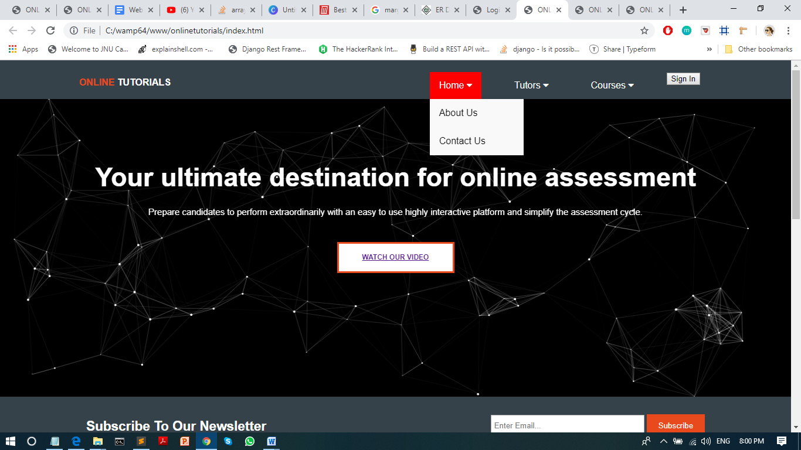

-about us page

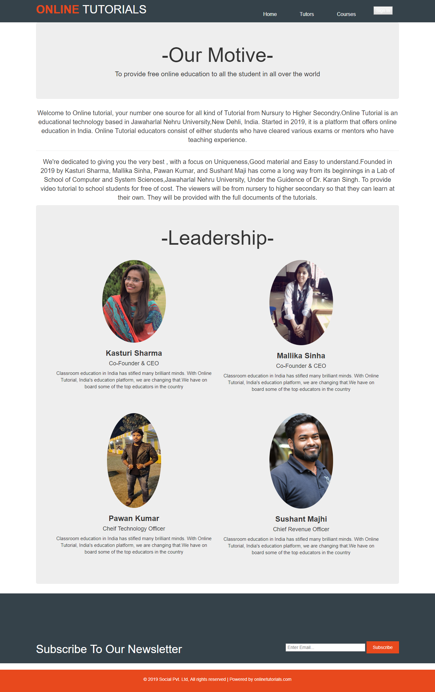

-contact us

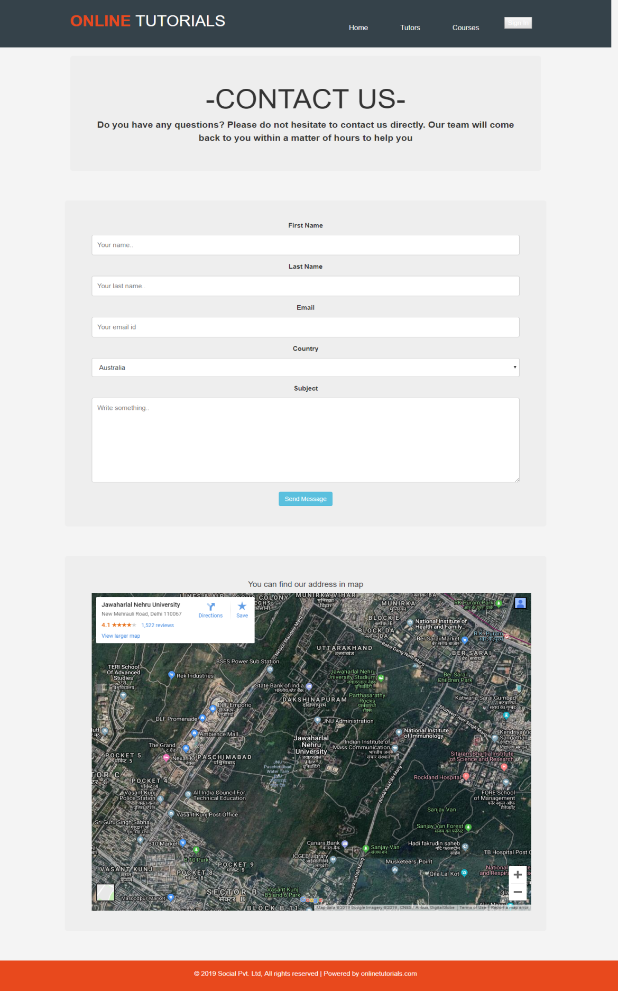

9. References

* <https://unacademy.com/>
* [https://www.w3schools.com](https://www.w3schools.com/)/
* <https://www.google.com/>
* <https://www.youtube.com/>
* Prentice hall internet and world wide web how to program