Project Overview
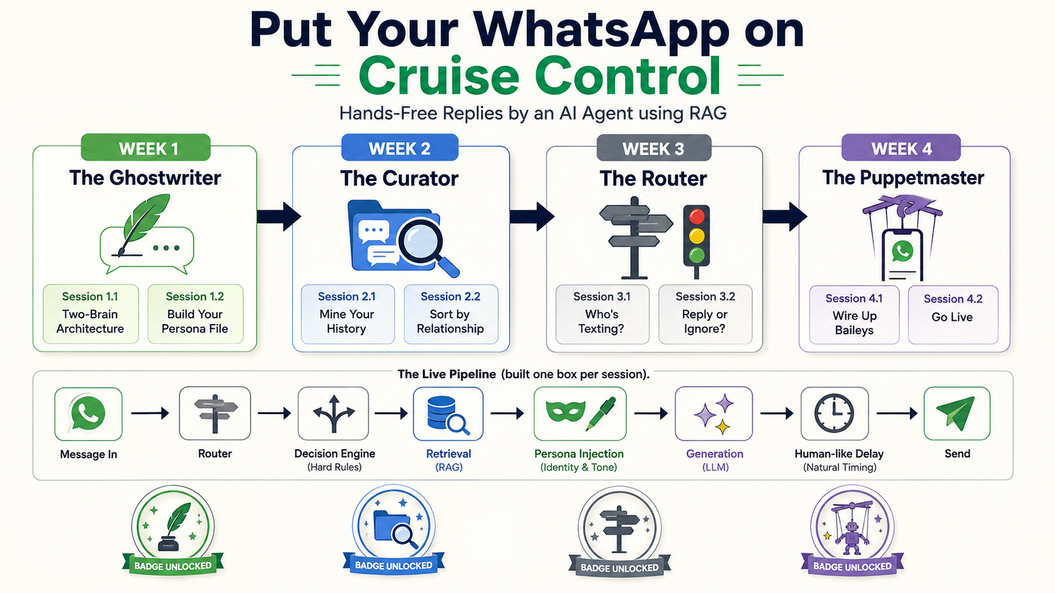

Put Your WhatsApp on Cruise Control

Hands-Free Replies by an AI Agent using RAG

What Is This Project?
We're training an AI agent on your own WhatsApp chats so it can reply in your exact style — your phrasing, your Hinglish, your emojis, and the way your tone naturally shifts between family, friends, and colleagues. When a message arrives, your agent reads it, decides whether you'd actually reply, retrieves how you've talked before, and answers as you— live, on real WhatsApp. This isn't a chatbot. It's a retrieval-grounded persona agent, built by you, over four weeks.

What We Want to Achieve
- A working, live AI agent connected to real WhatsApp — not a demo running only on your laptop
- An agent that sounds authentically like you — not a generic assistant wearing your name
- An agent with judgment — one that knows exactly when to reply, and when to stay silent
- A fully public, demoable proof of work: a GitHub repo, a live console, and a recorded demo
- All of it built entirely on free-tier tools — no budget required, no paid API keys needed

What We'll Learn
- RAG (Retrieval-Augmented Generation) — and why it beats fine-tuning when you want something personalized, not retrained
- Prompt engineering for tone and persona — how to make an AI sound like a specific person, not a specific model
- Rule-based decision systems working alongside AI — cheap logic first, AI only when it's genuinely needed
- Vector databases and embeddings — how machines search by meaning, not just exact text
- Building and wiring a real, live automation pipeline — from a raw data export all the way to a message sent in the real world
- Using GitHub Copilot as an actual build partner — not autocomplete, a collaborator you direct with clear prompts

How We'll Go About This
Week 1 — The Ghostwriter: Teach it your voice
Week 2 — The Curator: Mine your chat history
Week 3 — The Router: Teach it when to speak
Week 4 — The Puppetmaster: Go live on WhatsApp
Each week ships something real and demoable. By the end of Week 4, you won't just have learned about RAG agents — you'll have shipped one, live, on your own WhatsApp.

Week 1 — The Ghostwriter

WEEK 1 — The Ghostwriter

Teach It Your Voice
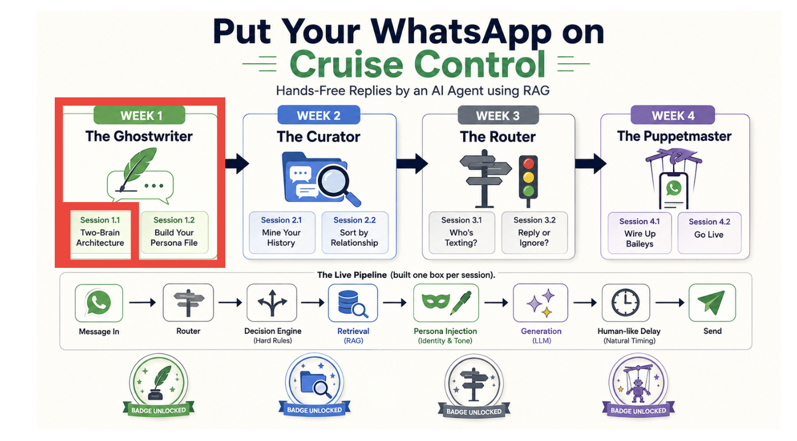

Session 1.1 — "Two-Brain Architecture"
Why a texting clone needs a persona and a memory — and why RAG beats fine-tuning here
One liner | A texting clone isn't just a model — it needs a self. This session maps the full two-brain architecture you'll build over 4 weeks.
OVERVIEW | In this session you'll see why the best WhatsApp clones don't fine-tune a model — they retrieve. You'll understand the two-brain design:  - a persona brain (who you are, authored once as a few-shot prompt)  - and a history brain (how you've actually replied, retrieved from your chats via RAG).  You'll map the full pipeline — message in, route by relationship, retrieve, generate, send — and understand exactly what you're building and why it runs free and local. No code yet, full conceptual clarity.
FREE TOOL | Excalidraw (architecture diagram) — free
PAID UPGRADE | n/a

Session 1.1

Dependencies

Install your vs code - https://code.visualstudio.com/
Github account - https://github.com/

Part 0 — Environment Readiness Check (do this first, before anything else)
Before touching any session content, confirm your machine actually has what this whole 4-week project needs. Some of this you already need today
- Node,
- Python,
- VS Code,
- Git
- Copilot Github;
- some of it you won't need until later weeks
  - Baileys,
  - ChromaDB,
  - Streamlit — those are called out as "later" so you're not installing things you don't need yet, but you now know the full list up front so nothing surprises you mid-build.

0.1 — One-command health check (macOS/Linux)
Paste this whole block into your terminal. It checks everything needed right now and tells you exactly what's missing, with nothing silently skipped:
echo "== Node.js =="; node -v 2>/dev/null || echo "❌ Node not found"
echo "== Python =="; python3 --version 2>/dev/null || echo "❌ python3 not found"
echo "== pip =="; python3 -m pip --version 2>/dev/null || echo "❌ pip not found (try: python3 -m ensurepip)"
echo "== Git =="; git --version 2>/dev/null || echo "❌ Git not found"
echo "== VS Code CLI =="; code --version 2>/dev/null || echo "❌ 'code' command not found — see fix below"
echo "== VS Code extensions =="
code --list-extensions 2>/dev/null | grep -qi "github.copilot$" && echo "✅ GitHub Copilot" || echo "❌ GitHub Copilot missing"
code --list-extensions 2>/dev/null | grep -qi "github.copilot-chat" && echo "✅ GitHub Copilot Chat" || echo "❌ GitHub Copilot Chat missing"
code --list-extensions 2>/dev/null | grep -qi "ms-python.python" && echo "✅ Python extension" || echo "❌ Python extension missing"

0.2 — Windows (PowerShell) version
Write-Host "== Node.js =="; node -v
Write-Host "== Python =="; python --version
Write-Host "== pip =="; python -m pip --version
Write-Host "== Git =="; git --version
Write-Host "== VS Code CLI =="; code --version
Write-Host "== VS Code extensions =="
code --list-extensions | Select-String -Pattern "github.copilot$|github.copilot-chat|ms-python.python"

0.3 — The full readiness checklist, with fixes

# | What to check | How to check | If missing
1 | Node.js 18+ | node -v | Install from nodejs.org (LTS version)
2 | Python 3.10+ | python3 --version (Mac/Linux) or python --version (Windows) | Install from python.org, or via pyenv/brew on Mac
3 | pip working | python3 -m pip --version | Run python3 -m ensurepip --upgrade. If you use pyenv and see "pip: command not found," see the fix note below
4 | Git installed | git --version | Mac: xcode-select --install. Windows: install from git-scm.com
5 | VS Code installed | Open the app, or code --version in terminal | Download from code.visualstudio.com
6 | code CLI command works | code --version | In VS Code: Cmd/Ctrl+Shift+P → "Shell Command: Install 'code' command in PATH" → restart terminal
7 | GitHub Copilot extension | code --list-extensions | grep copilot | code --install-extension GitHub.copilot (requires an active Copilot subscription/trial signed in via GitHub account)
8 | GitHub Copilot Chat extension | same as above | code --install-extension GitHub.copilot-chat
9 | Python extension for VS Code | same as above | code --install-extension ms-python.python
10 | A GitHub account, logged into VS Code | Click the Accounts icon (bottom-left in VS Code) — should show you signed in | Sign in via the Accounts icon, or github.com/join if you don't have an account
11 | A free Gemini API key | N/A — just get it now so you're not blocked later | Get one at aistudio.google.com → "Get API key"
12 | A WhatsApp export of your own chats | N/A | On your phone: open a chat → ⋮ menu → More → Export chat → Without Media
13 | A dedicated/secondary WhatsApp number | N/A | Any spare SIM or a second WhatsApp Business account — never use your primary number for this project

0.4 — Common fix: pip: command not found (pyenv users on Mac)
If you use pyenv and see something like:
pyenv: pip: command not found
The 'pip' command exists in these Python versions: 3.10.14

this means pyenv has no active Python version selected — pip itself isn't actually missing. Fix it one of two ways:
- Quick, one-off: always call python3 -m pip install <package> instead of bare pip install <package> — this works regardless of pyenv's active version state.
- Permanent fix: pyenv global 3.10.14, then close and reopen your terminal fully, then confirm with python3 --version and pip --version.

0.5 — Full Install Instructions (if you're starting from zero)
If any of Node, Python, pip, npm, Git, or VS Code came back missing in the health check above, install them in this order — each one is quick, and npm/pip come bundled with Node/Python respectively, so you're really only installing 4 things, not 6.

macOS
Recommended path: install Homebrew first, then everything else through it (Homebrew is Mac's standard package manager — one tool, one install command, no version confusion later):
# 1. Install Homebrew (skip if `brew --version` already works)
/bin/bash -c "$(curl -fsSL https://raw.githubusercontent.com/Homebrew/install/HEAD/install.sh)"

# 2. Install Node.js (this also installs npm automatically — no separate step needed)
brew install node

# 3. Install Python (this also installs pip automatically — no separate step needed)
brew install python

# 4. Install Git
brew install git

# 5. Verify everything
node -v && npm -v && python3 --version && python3 -m pip --version && git --version

Install VS Code:
- Go to code.visualstudio.com and download the macOS build.
- Drag Visual Studio Code.app into your Applications folder.
- Open VS Code once from Applications (this matters — the code terminal command below won't register until you've launched the app at least once).
- In VS Code: Cmd+Shift+P → type "Shell Command" → select "Shell Command: Install 'code' command in PATH".
- Close your terminal completely and reopen it, then confirm: code --version.

Windows
Recommended path: download official installers directly (no package manager required, though winget works too if you already use it):
- Node.js (includes npm):
  - Go to nodejs.org → download the LTS Windows installer (.msi).
  - Run it. On the "Custom Setup" screen, make sure "Add to PATH" stays checked (it's checked by default — just don't uncheck it).
  - Finish the install, then open a new PowerShell window and confirm: node -v and npm -v.
- Python (includes pip):
  - Go to python.org/downloads → download the latest Python 3.x Windows installer.
  - Run it. This is the step people most often get wrong: on the very first install screen, tick the checkbox "Add python.exe to PATH" at the bottom before clicking "Install Now."
  - Finish the install, open a new PowerShell window, and confirm: python --version and python -m pip --version.
  - (Windows uses python, not python3 — unlike Mac/Linux. Keep that in mind when a guide says python3.)
- Git:
  - Go to git-scm.com/download/win → download and run the installer.
  - Default options are fine for everything — just click "Next" through the installer.
  - Confirm in a new terminal: git --version.
- VS Code:
  - Go to code.visualstudio.com → download the Windows installer.
  - Run it. On the "Select Additional Tasks" screen, make sure "Add to PATH" is checked (it's checked by default).
  - Finish, open a new terminal, and confirm: code --version.
Alternative (if you already use winget):
winget install OpenJS.NodeJS.LTS
winget install Python.Python.3.12
winget install Git.Git
winget install Microsoft.VisualStudioCode

Close and reopen your terminal after these before verifying versions.

After installing on either OS: add the VS Code extensions
Once code --version works on either platform, install the three extensions the same way regardless of OS:
code --install-extension GitHub.copilot
code --install-extension GitHub.copilot-chat
code --install-extension ms-python.python

(GitHub Copilot itself requires a GitHub account with an active Copilot subscription or free trial — if you're prompted to sign in after installing, that's expected; sign in via the VS Code Accounts icon in the bottom-left corner.)

0.7 — Readiness checklist (tick these off before Session 1.1 proper)
- [✅ / ❌ ] Node.js 18+ installed and node -v prints a version
- [✅ / ❌ ] Python 3.10+ installed and python3 --version prints a version
- [✅ / ❌ ] pip resolves without error
- [✅ / ❌ ] Git installed
- ✅ / ❌ ] VS Code installed and the code terminal command works
- [✅ / ❌ ] GitHub Copilot + Copilot Chat extensions installed and signed in
- [✅ / ❌ ] Python extension installed
- [✅ / ❌ ] Gemini API key obtained and saved somewhere safe (you'll put it in .env in Session 1.2)
- [✅ / ❌ ] WhatsApp export downloaded (or a plan for when you'll do it before Session 1.2/2.1)
- [✅ / ❌ ] Aware you'll need a dedicated/secondary WhatsApp number later (Session 4.1) — no action needed yet
Once every box above is checked, you're cleared to move into Session 1.1 proper.

Session content

Part 1 — Why This Session Exists (read this first)
Every other session in this cohort will hand you a Copilot prompt and ask you to write code. This one won't — on purpose. If you skip straight to building in Week 2 without a clear mental model, you'll end up with files that "sort of work" but you won't know why something breaks when it does, because you never built a map of how the pieces connect.
Think of this session as reading the blueprint before you pour concrete. By the end of this session you should be able to explain — out loud, to a non-technical friend —
- what this project is, in one paragraph,
- without using the words "RAG," "embedding," or "LLM."
- That's the actual bar for "done" on this session.

Part 2 — Why Not Just Fine-Tune a Model?
What "fine-tuning" would even mean here: you'd take all your WhatsApp messages, and retrain an AI model's internal weights on them, so the model itself "becomes" more like you.
Why that's the wrong tool for this job — four concrete reasons:
- Cost and access. Fine-tuning a capable model requires either paid API fine-tuning access (cost money, ongoing) or running your own GPU (expensive, and most laptops can't do it). This cohort is built free-tier only. RAG (Retrieval-Augmented Generation) needs none of that — it works with a model you never modify, you just feed it the right context at the right moment.
- It goes stale. If you fine-tune on last year's chats, the model is frozen in last year's version of you. RAG's memory is just a database — add new messages any time, and the agent's "memory" updates instantly, no retraining.
- It's a black box. If a fine-tuned model says something weird, you can't easily tell why — the "reason" is buried in millions of adjusted weights. With RAG, you can always ask "why did it say that?" and get a real answer: "because these 3 past messages were retrieved as similar, and this persona tone was applied." That traceability is exactly what your Cruise Control Console will show live in Week 4.
- It doesn't separate identity from memory.
  - Fine-tuning mashes together "how you generally talk" and
  - "what you said to this specific person" into one blob. RAG keeps these as two clean, separate things — which is exactly why the architecture is called "two-brain."

Part 3 — The Two Brains, Explained Exhaustively

Brain 1: The Persona Brain
- What it is: a single file (you'll build this in Session 1.2) written once, by hand, describing who you are when you text —
  - your identity, your interests, and specifically
  - the tone you use with family vs. friends vs. colleagues,
  - your Hinglish habits, your typical emoji use, your typical message length.
- How the AI uses it: every single time the agent is about to generate a reply, this file gets read in full and placed at the top of the prompt, as a kind of character sheet.
  - This is called a "few-shot prompt" — you're not training the model, you're just reminding it, every time, "here's who you're playing."
- What it does NOT contain: specific past conversations. It's tone and identity, not memory.
- Analogy: if you were hiring an actor to play "you" in a scene, the persona brain is the character brief you'd hand them before every single take.

Brain 2: The History Brain
- What it is: your actual past WhatsApp messages, cleaned up into pairs — "they said X, I replied Y" — and stored so they can be searched by meaning, not just by exact text match.
- Why it's split by relationship: your history brain isn't one giant pile. It's split into separate boxes — family, friends, professional, unknown — so that when your boss texts you, the agent only ever searches your professional-tone history, never your inside jokes with friends.
- How the AI uses it: when a new message arrives, the agent searches the right box for the 2-3 most similar things anyone has said to you before, and reads off how you actually replied back then. Those real examples get added to the prompt alongside the persona.
- Analogy: if the persona brain is the character brief, the history brain is the actor's own diary of "here's exactly what I said the last three times someone said something like this to me."

Why Both, Together
Persona alone = sounds like a caricature of you (right tone, but generic content).
History alone = sounds like you, but with no personality glue tying it together, and it can't handle a brand-new type of message it's never seen before.
Together: the persona keeps things in character even for a first-of-its-kind message, and the history keeps things specific and real whenever something similar has happened before.

Part 4 — The Full Pipeline, Stage by Stage (this is what you'll diagram)
Walk through this exactly as an incoming message would:
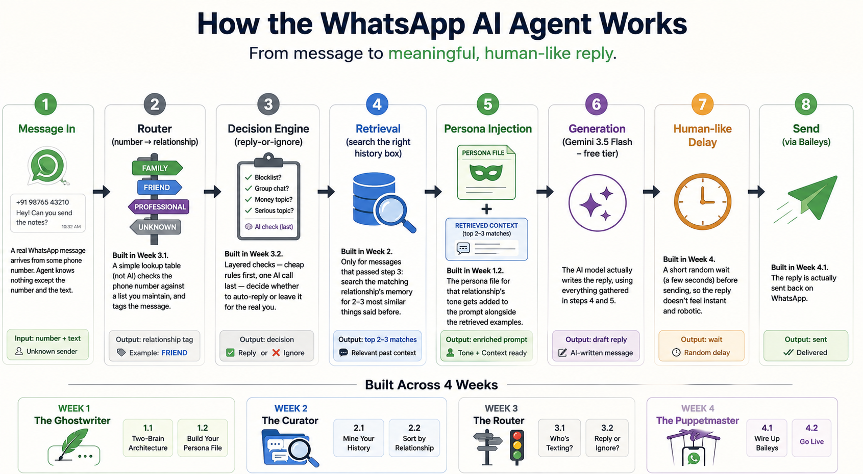
- Message In — A real WhatsApp message arrives from some phone number. At this point, the agent knows nothing except the number and the text.
- Router (number → relationship) — Built in Week 3.1. A simple lookup table (not AI) checks the phone number against a list you maintain yourself, and tags the message as family / friend / professional / unknown.
- Decision Engine (reply-or-ignore) — Built in Week 3.2. A layered set of checks — cheap rules first, one AI call last — decides whether this message even deserves an automatic reply, or whether it should be left for the real you (money questions, serious topics, strangers, group chats).
- Retrieval (search the right history box) — Built in Week 2. Only for messages that passed step 3: the agent searches the matching relationship's memory for the 2-3 most similar things said to you before.
- Persona Injection — Built in Week 1.2. The persona file for that relationship's tone gets added to the prompt alongside the retrieved examples.
- Generation — The AI model (Gemini 3.5 Flash, free tier) actually writes the reply, using everything gathered in steps 4 and 5.
- Human-like Delay — Built in Week 4. A short random wait (a few seconds) before sending, so the reply doesn't feel instant and robotic.
- Send (via Baileys) — Built in Week 4.1. The reply is actually sent back on WhatsApp.
The one sentence to memorize: message in → who is it → should I even reply → what have I said before to people like this → who am I when I talk to them → write it → wait a beat → send it.

Part 5 — FREE TOOL: Excalidraw — Exact Step-by-Step Exercise
This is the one hands-on task for this session. Do not skip it — the act of drawing this yourself is what turns "I read about it" into "I understand it."

Step-by-step instructions
- Go to https://excalidraw.com/ in your browser — no account or install needed, it's entirely free and runs in-browser.
- Set the canvas to a horizontal orientation (it defaults this way) — you're drawing a left-to-right pipeline.
- Draw 8 rectangles in a horizontal row, one for each pipeline stage from Part 4 above, in this exact order: Message In → Router → Decision Engine → Retrieval → Persona Injection → Generation → Human-like Delay → Send (Baileys)
- Label each rectangle with its stage name (double-click a rectangle to add text inside it).
- Color-code by "brain" so the two-brain idea is visually obvious:
  - Router and Decision Engine → gray (these are rule-based, no AI)
  - Retrieval → blue (this is the History Brain)
  - Persona Injection → green (this is the Persona Brain)
  - Generation → purple (this is where both brains combine and the actual AI call happens)
  - Message In, Human-like Delay, Send → keep default/white (these are just plumbing, not "brain" steps)
- Draw arrows connecting each box to the next, left to right, in order.
- Below the Router box, add a small side-note text box: "looks up phone number in a table I maintain — no AI"
- Below the Decision Engine box, add a side-note: "cheap rules first, one AI call only if truly ambiguous"
- Below the Retrieval box, add a side-note: "searches only the matching relationship's memory (family/friend/professional/unknown)"
- Add a title text at the top: "WhatsApp Cruise Control — Two-Brain Pipeline"
- Select all elements (Ctrl/Cmd+A), then export: menu (top-left) → Export image → PNG → save it into your project as docs/architecture_diagram.png.
- Also export the underlying Excalidraw file itself (.excalidraw format) via the same export menu, and save it as docs/architecture_diagram.excalidraw — this lets you (or Copilot, later) re-open and edit it instead of redrawing from scratch.

Optional: get Copilot to generate a starting version for you
If you'd rather start from a draft and then hand-edit it in Excalidraw, paste this in Copilot Chat first, then recreate the boxes in Excalidraw using its output as your labels/notes:
Generate a Mermaid flowchart for this pipeline: WhatsApp message in -> Router
(number -> relationship lookup, no AI) -> Decision Engine (hard rules -> signal
rules -> intent check -> reply policy, mostly no AI) -> Retrieval (query the
matching relationship's ChromaDB collection, the "history brain") -> Persona
Injection (the "persona brain") -> LLM generation (both brains combine here) ->
human-like delay -> Baileys send. Label which stages are the persona brain,
which are the history brain, and which are plain rule-based logic with no AI
at all. Output it as a markdown code block I can paste into README.md.

Paste the Mermaid output into README.md under an "Architecture" heading as a text-based backup of the same diagram — some people find the Mermaid version easier to keep up to date as the project evolves, since it's just text, not a drawing file.

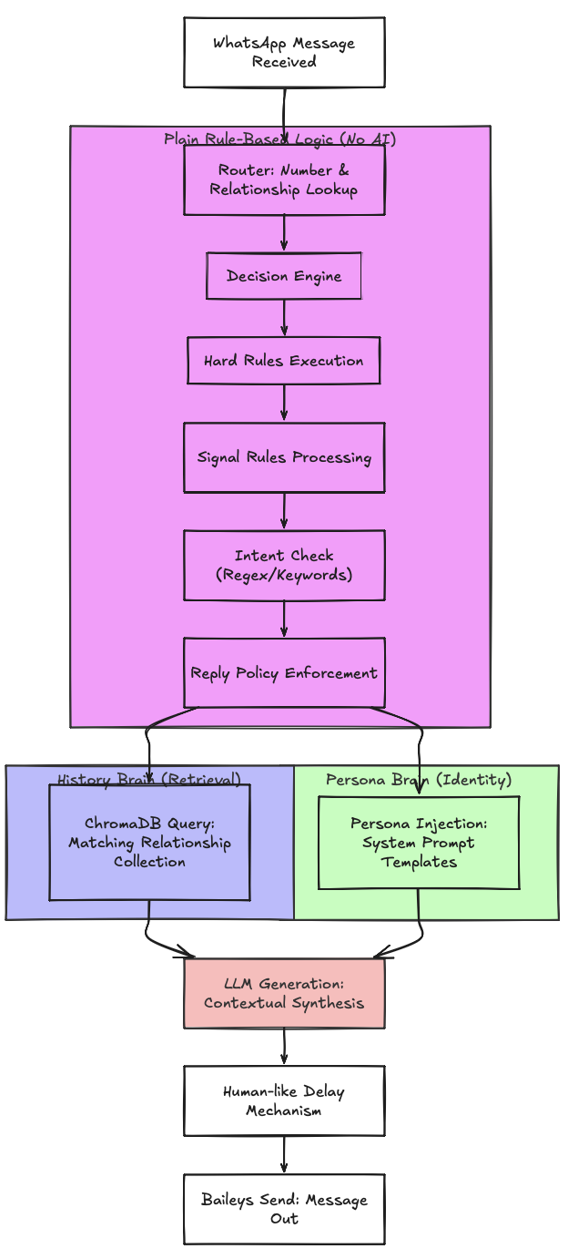

Part 6 — Step-by-Step Execution Checklist
- [✅ / ❌ ] Read Part 2 and be able to explain, out loud, why RAG beats fine-tuning for this project, without notes
- [ ✅ / ❌] Read Part 3 and be able to state, in one sentence each, what the persona brain contains and what the history brain contains
- [✅ / ❌ ] Read Part 4 and be able to list all 8 pipeline stages from memory, in order
- [✅ / ❌ ] Open Excalidraw and complete steps 1–12 in Part 5
- ✅ / ❌[ ] Save docs/architecture_diagram.png and docs/architecture_diagram.excalidraw into your project repo
- [✅ / ❌ ] (Optional) Also save a Mermaid version into README.md under an "Architecture" section
- [✅ / ❌ ] Complete the understanding checkpoint in Part 8 before moving on to Session 1.2

Checkpoint

Part 7 — Understanding Checkpoint
Answer these:
- In your own words, why doesn't this project fine-tune a model on your chat history?
- What's the difference between what the persona brain knows and what the history brain knows?
- Why is the history brain split into separate boxes per relationship, instead of one big searchable pile of every message you've ever sent?
- Which two stages in your diagram represent the two "brains," and which stages are just plain rule-based plumbing with no AI involved at all?

Output

What You've Actually Produced By the End of This Session
Even though nothing is "graded" until the Week 1 assignment (which is Session 1.2's deliverable), you now have two real artifacts sitting in your repo:
- docs/architecture_diagram.png — your visual reference for the rest of the build
- docs/architecture_diagram.excalidraw — the editable source file, in case the architecture needs a tweak later
You will point back to this diagram constantly over the next 4 weeks — every session builds exactly one box from it. Keep it visible (pin it, print it, whatever works) while you build Weeks 2–4.

Arch Output
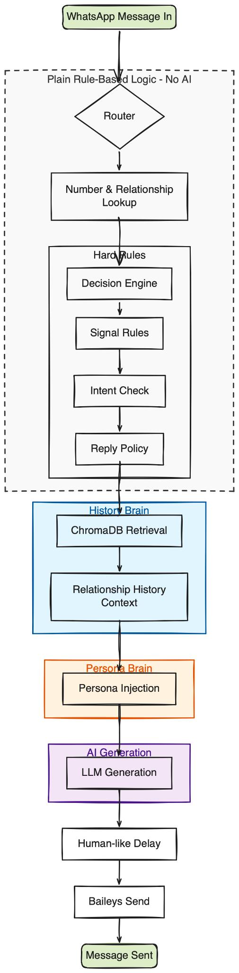

Session 1.2
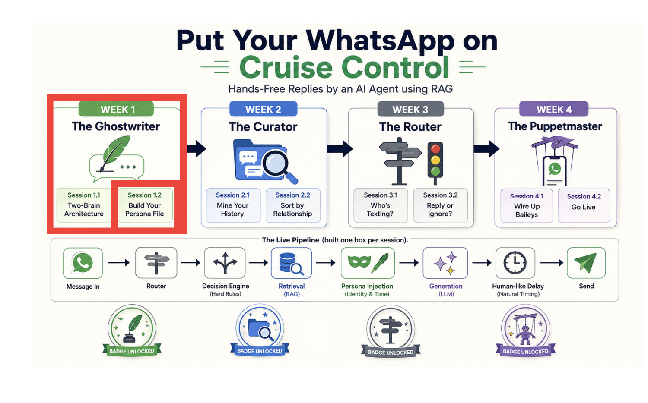

Week 2 - The Curator

Session 2.1
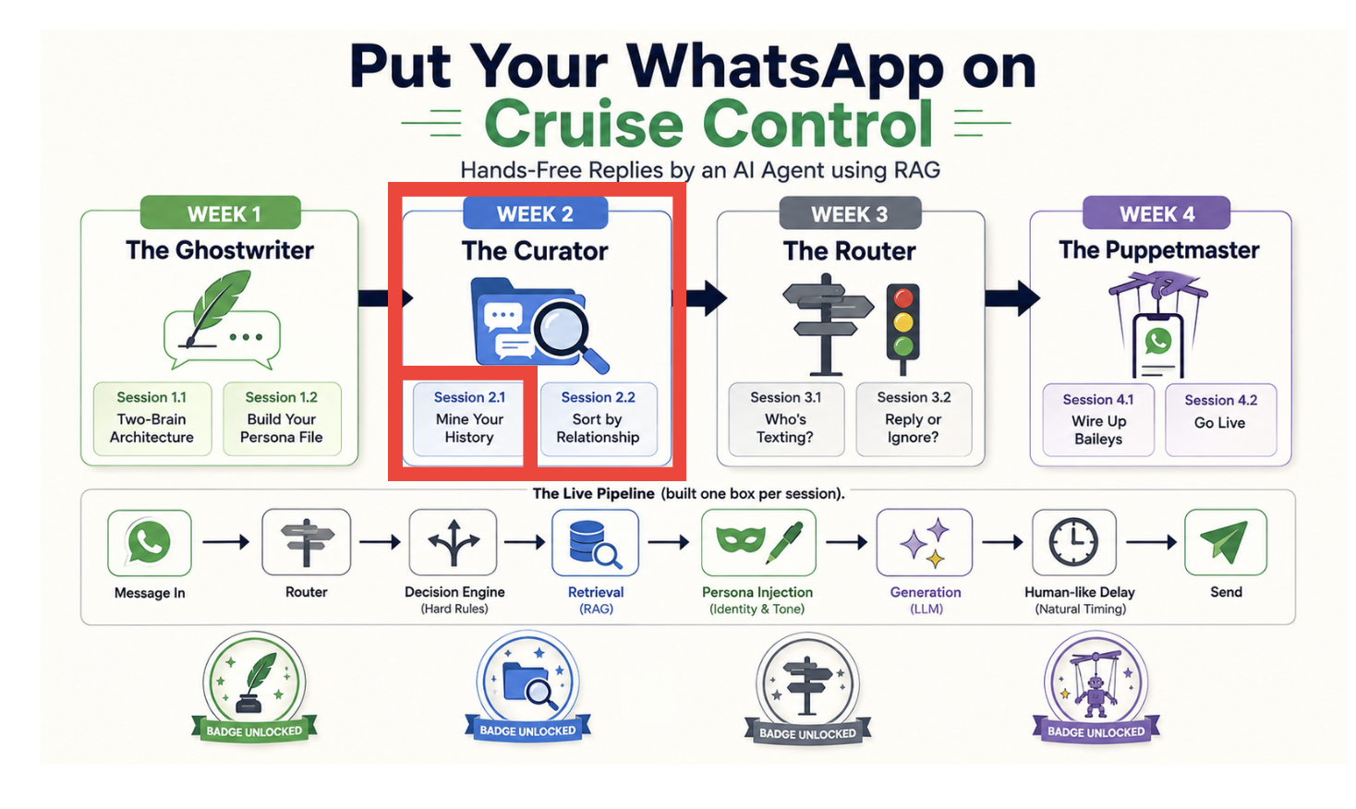

Session 2.2
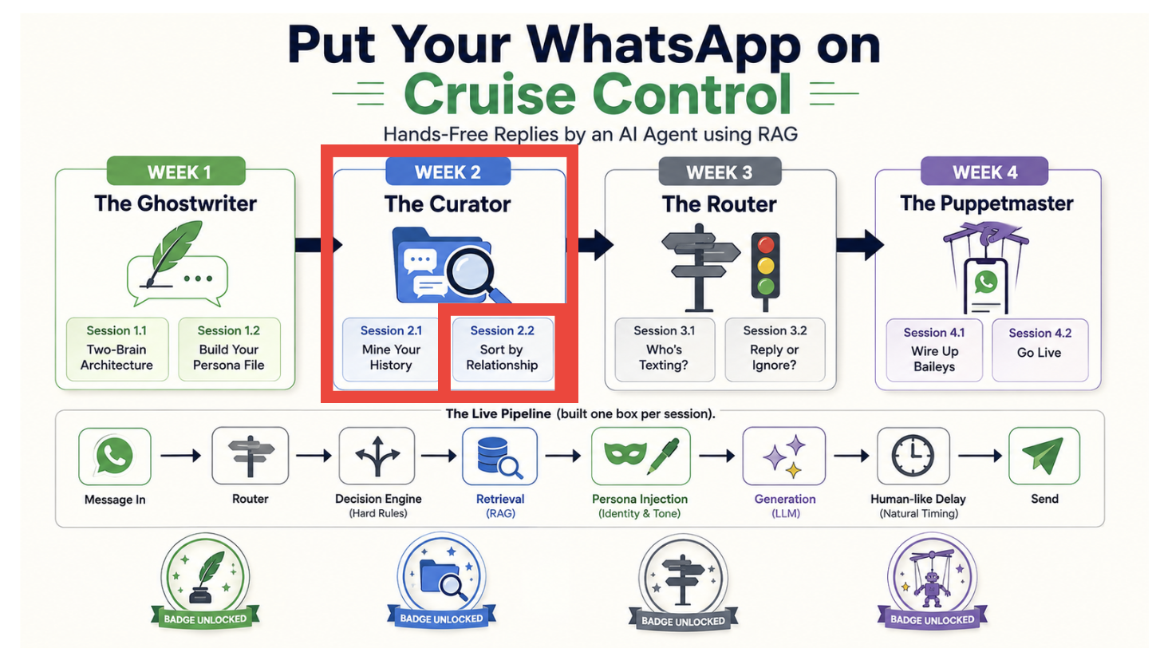

Week 3 - The Router

Session 3.1
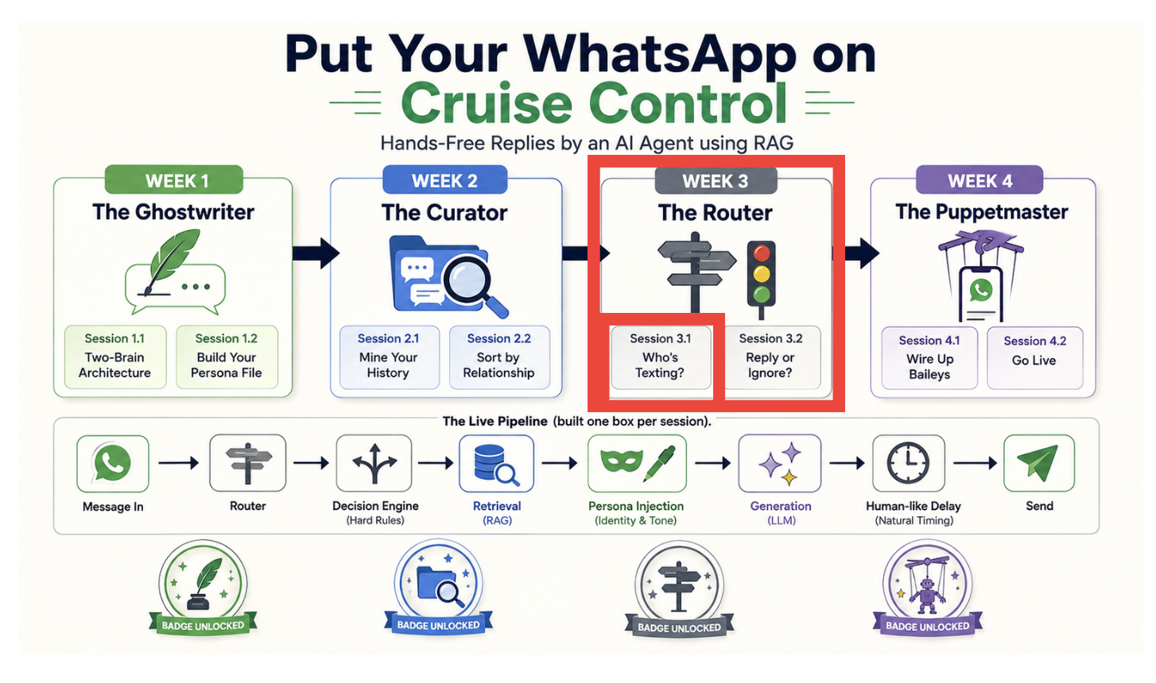

Session 3.2
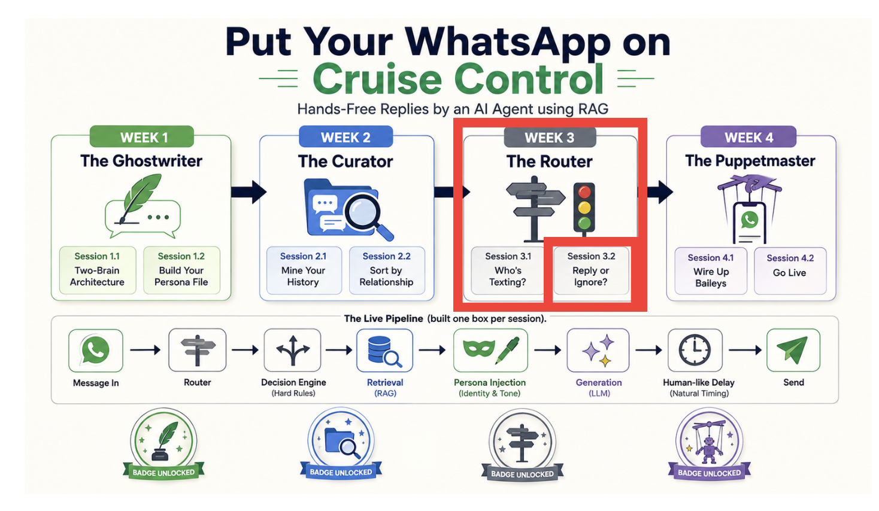

Week 4 - The PuppetMaster

Session 4.1
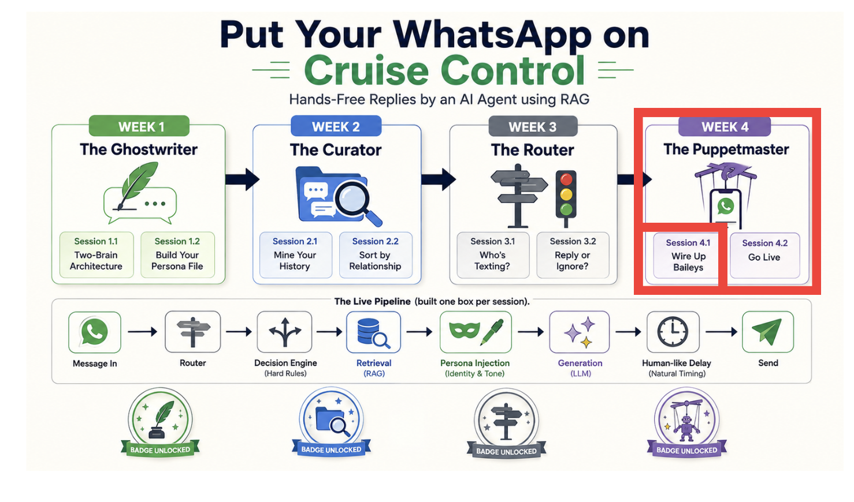

Session 4.2
