Technical Requirements Document
RAKSHAK360 — Intelligent Hazard Red-Zone & Relocation Platform
Smart India Hackathon 2026 — Problem Statement SIH26191
Problem Statement | Intelligent Identification of Hazard-Based Red Zones, Carrying Capacity Assessment, and Immediate Relocation Needs for Vulnerable Habitations
PS ID | SIH26191
Organization | Ministry of Home Affairs
Department | National Disaster Response Force (NDRF), Disaster Management Division
Category | Software
Theme | Disaster Management
Companion document | Product Requirements Document (PRD), v1.1 — defines what and why; this document defines how
Document Owner | Kasukabe Defense Coders
Version | 1.0
Date | September 2026

Table of Contents
- Purpose and Scope
- Guiding Technical Principles
- System Architecture
- Technology Stack
- Database & Data Model
- External API Integration
- Functional Requirement → Technical Component Mapping
- AI/ML Components — Detail
- Offline-First & Low-Bandwidth Design
- Security, Access Control & Data Privacy
- Deployment Architecture
- MVP Technical Scope vs. Full Vision
- Assumptions, Constraints & Risks (Technical)
- Resolved Technical Decisions
- Related Documents

1. Purpose and Scope
This TRD translates the approved PRD (v1.1) into a concrete, buildable technical design: system architecture, technology stack, data model, external API integration approach, the three genuine ML/AI components, and the non-functional mechanisms (explainability, offline-first sync, low-bandwidth operation, auditability) that the PRD requires.
It is scoped to match the PRD’s own MVP/full-vision split (PRD §6): every choice below is marked as either built for the hackathon demo or designed for, not built — a component the architecture accommodates and the API contracts anticipate, but that is not live in the pilot build. Nothing here contradicts the PRD; where the PRD leaves an open decision (§13), this document proposes a default and flags it as such.

2. Guiding Technical Principles
Four decisions shape every choice in this document:
- One stack, not two. Every genuine ML/AI component in the PRD (satellite change detection, 72-hour forecasting, susceptibility refinement) is Python-native. Rather than splitting the team across a JS backend and a separate Python ML service, the backend itself is Python (FastAPI), so models are called in-process or via a thin internal queue — not a second language boundary the team has to maintain during a hackathon.
- Spatial data is a first-class citizen, not a bolt-on. Zones, households, shelters, and routes are all geometry. The database is PostGIS from day one, not a relational schema with lat/lng columns added later.
- Explainability is an API contract, not a UI afterthought. Per PRD §10, every score/priority/ranking is required to show its factors. This is enforced by having each scoring service return a factors[] array (name, weight, input value, contribution) alongside the number — the dashboard renders whatever the API sends, it doesn’t reverse-engineer a black box.
- Design for the connectivity you’ll actually have. Per PRD §9, the platform must run over NDMS-class VSAT/low-bandwidth links. Payload size and offline tolerance are architectural constraints checked at every layer, not a “sync feature” added to the field app alone.

3. System Architecture
The platform is a five-layer architecture: external data sources, an integration/ingestion layer, an application/service layer, a data layer, and a client layer, connected over a transport layer designed for constrained links (see Figure 1). This section describes the full target design; §12 states plainly which of these layers actually exist as running code in the current pilot build versus which are architecture the codebase leaves room for. As of this build, none of the ingestion connectors below are implemented — every external-source value on a zone (susceptibility_score, gsi_classification, incident history) is research findings encoded once as labeled sample data by backend/app/seed.py, and the forecasting model’s “live” rainfall input is a jittered placeholder (§8.2), not a network call to any of these sources.
External government data sources.
IMD (rainfall/nowcast), CWC/Google Flood Forecasting API, GSI Bhusanket, INCOIS, NCCR, ISRO Bhuvan, and Sentinel SAR/optical imagery — the platform is designed to consume these as-is, per PRD §8, and generates none of this data itself. No connector to any of them is built yet (see the note above); the pilot’s zone/incident data was hand-researched from several of these sources (docs/BUILD-PLAN.md, Phase 3 findings) and encoded as sample data, which is a one-time research step, not a live integration.
Integration & ingestion layer.
A set of scheduled connectors, one per source, each with its own polling cadence, retry/backoff policy, and a normalizer that maps the source’s native format into an internal hazard-event schema. Both the raw payload and the normalized event are persisted — raw for audit/debugging, normalized for everything downstream. This isolates the rest of the system from any one source’s quirks (GSI/NCCR being portal-based rather than API-based, IMD’s unconfirmed rate limits, etc. — PRD §12).
Application/service layer.
One FastAPI app, one process, with a router per PRD functional requirement or closely related pair (mapped in full in §7 — 14 routers as of the current build: zones, households, shelters, vehicles, escorts, relocations, routes, dashboard, surveys, forecasts, change_detection, handoffs, incident_outcomes, demo, plus auth). This is the resolved form of decision 1 in §14 below — drawn so a router could later move behind its own service without an API contract change, but nothing is split into separate services today; there is no inter-service REST traffic to speak of.
Data layer.
PostgreSQL + PostGIS as the system of record; object storage for imagery and survey photos; Redis for caching and live-feed buffering; an append-only audit log table for relocation decisions and priority rankings (PRD §10, auditability). As shipped: PostGIS and the audit log are real and load-bearing. Object storage (MinIO) is genuinely wired, but only for change-detection imagery (backend/app/storage.py, used by backend/app/services/change_detection.py) — a submitted survey’s photo_url is stored as a plain string reference from the sync payload; the field PWA’s capture form (§9) doesn’t currently include a photo/camera field, so nothing is actually uploaded to object storage for surveys yet. Redis is declared in configuration (backend/app/config.py) but has no calling code anywhere in the backend — no caching or live-feed buffering is implemented, since there is no live feed yet to buffer (§11’s ingestion-layer note above).
Client layer.
A React dashboard for SDMA officials/control room, and a separate installable web app (PWA) for field officers, built offline-first.
Transport.
HTTPS/REST with JSON payloads, gzip-compressed, designed to degrade gracefully on NDMS-class satellite/VSAT links (PRD §9) rather than assuming always-on broadband.
Figure 1 — System Architecture
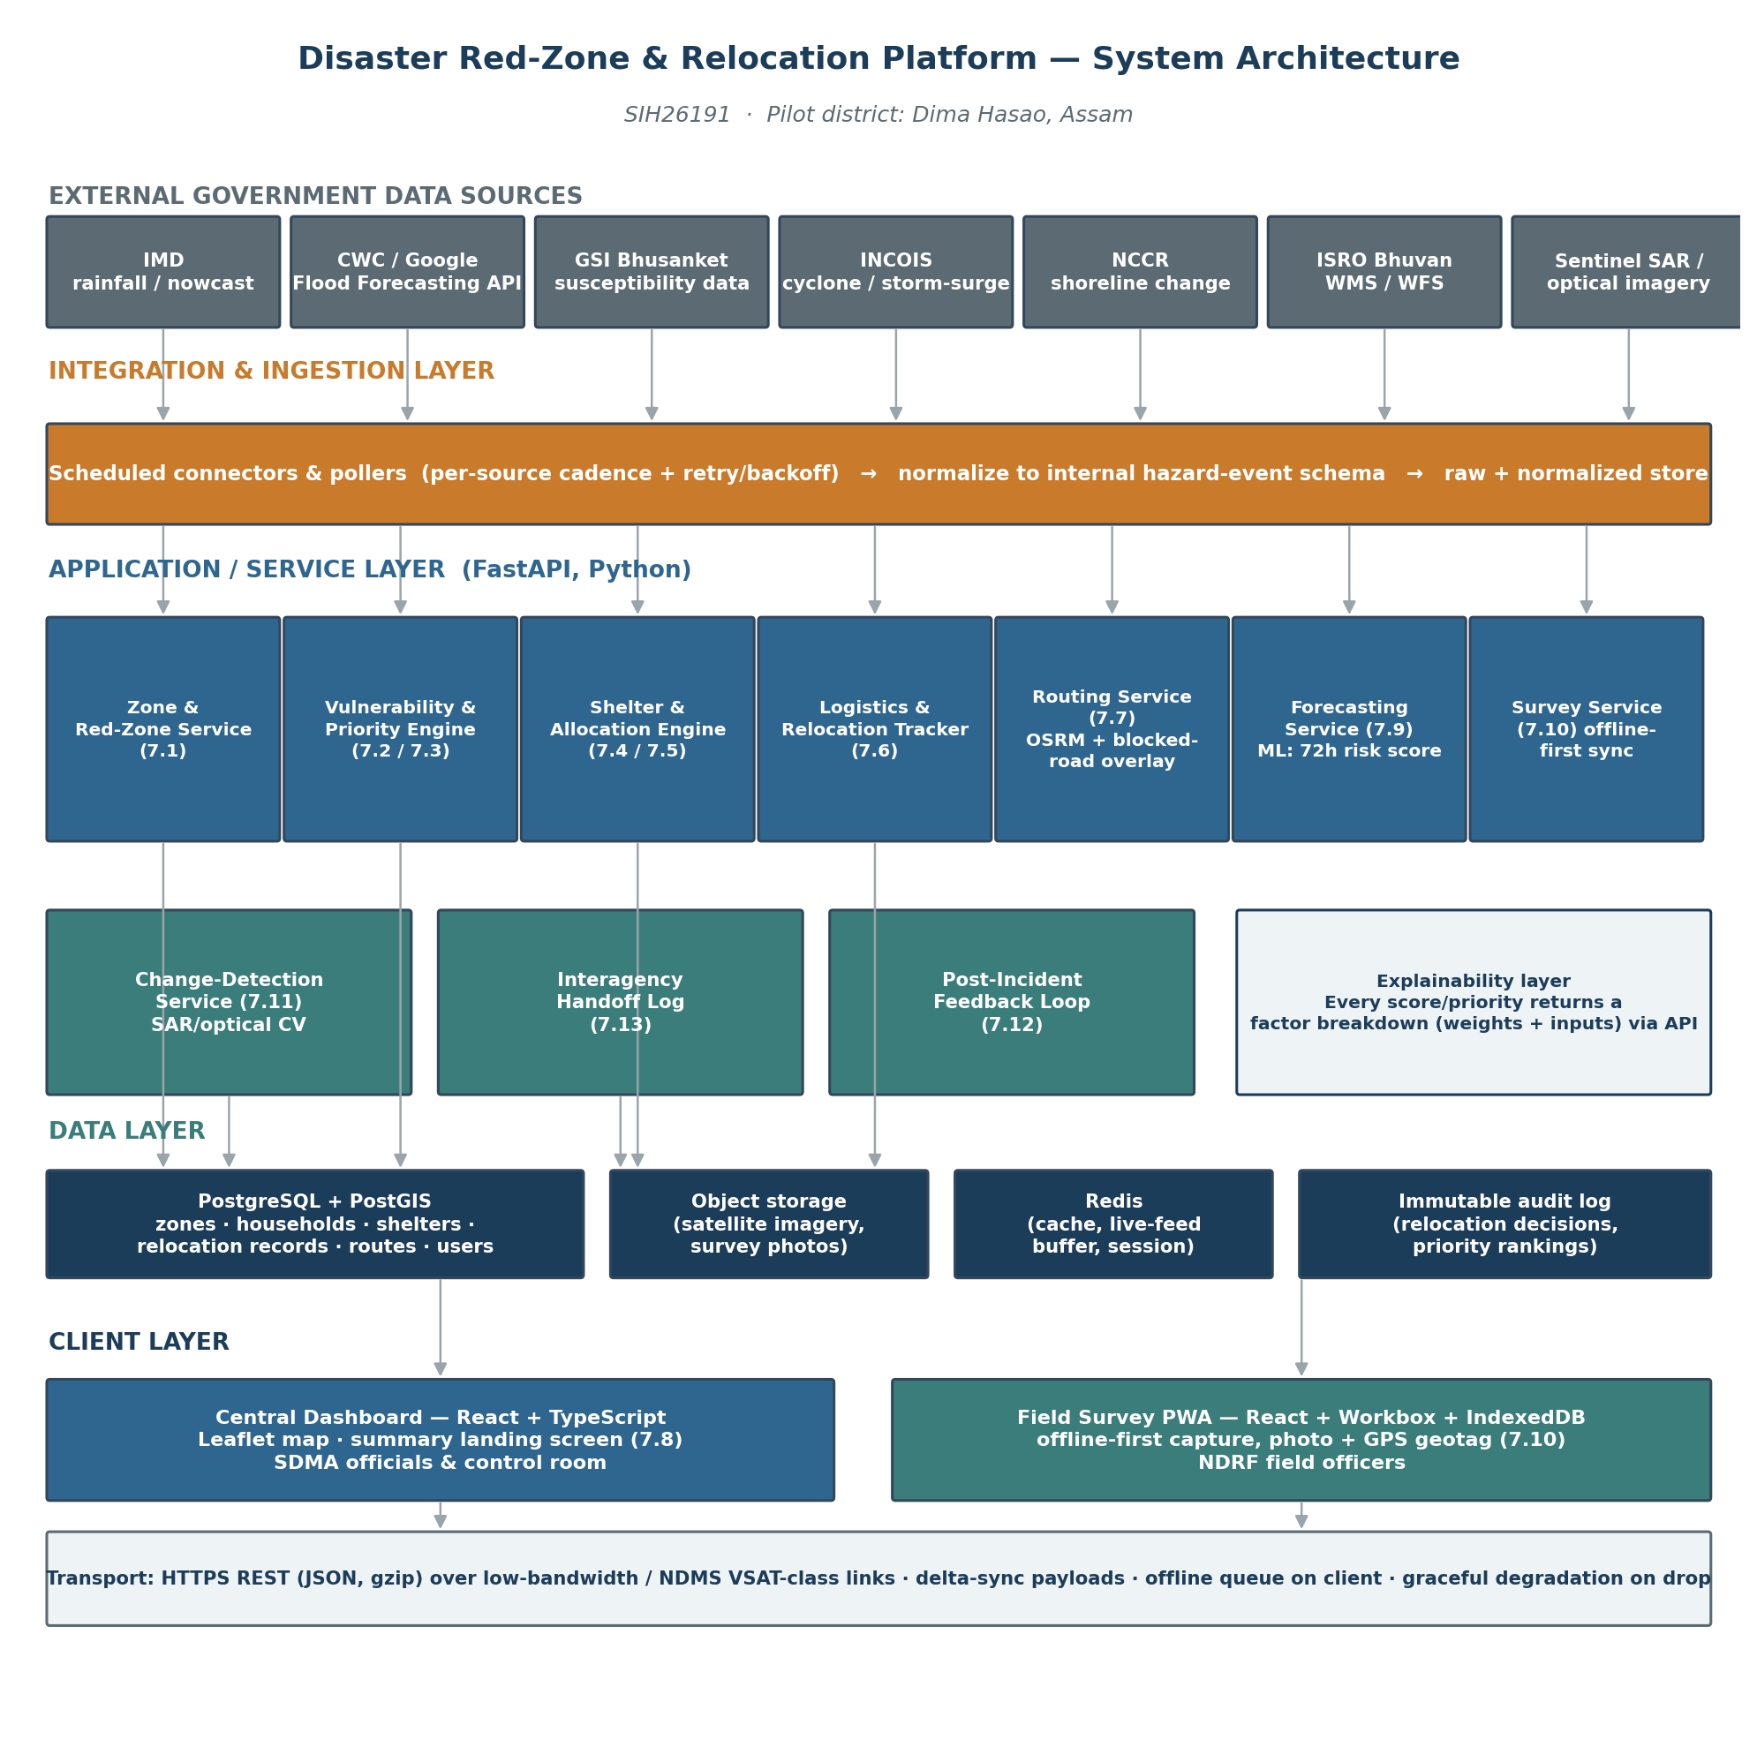
Figure 1 — System Architecture

4. Technology Stack
Layer | Choice | Why
Central dashboard (frontend) | React 18 + TypeScript, Vite build | Fast hackathon iteration; large ecosystem; TypeScript catches integration bugs across a multi-person team under time pressure
Mapping (dashboard) | Leaflet.js + GeoJSON, with direct WMS/WFS layer support | Open-source, no license/API-key friction during a hackathon; consumes Bhuvan’s WMS/WFS layers (PRD §8) directly
Field survey app | React + Vite, packaged as a PWA (Workbox service worker) | One codebase, installable on field officers’ phones without an app-store build; service worker enables offline-first (§9) in the demo timeframe
Offline client storage | IndexedDB (via Dexie.js) | Structured local storage for queued survey submissions and cached zone/shelter data, with a defined schema for delta-sync
Backend API | Python 3.11 + FastAPI + Uvicorn | Async, auto-generated OpenAPI docs, and the same language as every ML component — see Principle 1
Database | PostgreSQL 15 + PostGIS 3 | Spatial queries (point-in-polygon, distance/nearest-shelter, route geometry) are core to almost every requirement
Cache / live-feed buffer | Redis | Caches polled hazard feeds between ingestion cycles; backs the offline-sync queue’s server side
Object storage | S3-compatible bucket (MinIO for demo; AWS S3 / NIC MeghRaj for hosted deployment) | Satellite imagery tiles and survey photos don’t belong in the relational DB
Routing engine | OSRM over OpenStreetMap road network for Dima Hasao district | Open, self-hostable, fast; supports a custom blocked-segment penalty layer for §7.7
ML — susceptibility refinement & forecasting | scikit-learn / XGBoost, GDAL + rasterio for terrain derivatives | Matches the published frequency-ratio / weight-of-evidence / random-forest methodology already available for Dima Hasao
ML/CV — satellite change detection | PyTorch + rasterio/OpenCV; differencing/thresholding baseline, Siamese U-Net as stretch | Reflects the PRD’s honesty about this being demoed conceptually via a before/after pair
Auth | OAuth2 password flow + JWT (FastAPI security utilities) | Standard, fast to implement, supports role-based access (PRD §10)
Containerization / demo deployment | Docker Compose (frontend, services, Postgres+PostGIS, Redis, MinIO, OSRM) | One-command spin-up for judges/reviewers; mirrors production composition
CI | GitHub Actions (lint + test on push) | Keeps a multi-person student team from breaking each other’s services during crunch
Designed for, not built — production hosting | Government cloud (NIC MeghRaj) or on-prem near an NDMS point of presence | Matches PRD §9’s low-bandwidth/VSAT constraint
Designed for, not built — production messaging | MQTT or a managed queue (e.g., SQS) for survey-sync and interagency handoff at scale | REST + IndexedDB queueing suffices at hackathon/pilot scale; a queue matters as officer count and event volume grow
Routing engine, what’s actually shipped. The row above is the designed architecture — a self-hosted OSRM instance in the Docker Compose stack — and that’s still what §13’s local-Compose environment describes. The two screens that actually need road-following geometry (Evacuation Routes’ map, and Logistics Tracker’s “View Route”) don’t call a self-hosted OSRM at all: frontend/src/lib/osrm.ts calls OSRM’s free public demo server (router.project-osrm.org) directly from the browser, client-side, with no key and no backend involvement. This sidesteps the “no OSRM instance provisioned” gap (§11) entirely for those two screens — the line drawn, and the distance/duration shown, are genuine road-routed OSRM output, not a synthetic straight line — but it’s a different mechanism than the row above describes, is out of scope for services/shelter_matching.py’s own routing (still the straight-line PostGIS proxy noted in §11), and depends on a shared public resource with no SLA (falls back to a straight line, logging a console.warn, if it’s ever unreachable or rate-limited).

5. Database & Data Model
PostGIS is used for every table with a spatial dimension. Below are the core entities; exact column-level DDL belongs in the separate Backend Schema Document (PRD §14), but the shape is fixed here so the API contracts in §7 are stable.
Entity | Key fields | Notes
zones | zone_id, geom (POLYGON), hazard_types[], population, incident_history (JSONB), data_confidence, last_verified_at, susceptibility_score, risk_score_72h | One row per red zone; §7.1, §7.9
households | household_id, zone_id (FK), geom (POINT), population_count, children_count, elderly_count, assistance_needs_count, structural_condition, vulnerability_score | §7.2
shelters | shelter_id, geom (POINT), max_capacity, current_occupancy, facilities (JSONB), status | §7.4
surveys | survey_id, zone_id (FK), officer_id (FK), submitted_at, payload (JSONB), photo_url, geotag (POINT), review_status | Offline-captured, synced; §7.10
relocation_records | record_id, household_id (FK), shelter_id (FK), priority_tier, route_id (FK), status, vehicle_id, escort_id, timestamps | §7.5, §7.6
routes | route_id, zone_id (FK), shelter_id (FK), origin_geom, dest_geom, path (LINESTRING), distance_km, estimated_duration_minutes, blocked_segments (JSONB), updated_at | §7.7 — zone_id/shelter_id added migrations 0012/0013: one route per zone, to a named shelter, not an unscoped named route
risk_forecasts | forecast_id, zone_id (FK), horizon_hours, score, factors (JSONB), generated_at | Rolling 72h score; §7.9
change_detections | detection_id, zone_id (FK), before_image_ref, after_image_ref, detected_at, affected_area_geom, cross_referenced_survey_ids[] | §7.11
handoff_logs | log_id, need_type, agency, status, linked_record_id, timestamps | §7.13
audit_log | entry_id, actor_id, action_type, entity_ref, factors_snapshot (JSONB), created_at | Immutable, append-only; PRD §10
users | user_id, role, district_id, auth fields | RBAC per PRD §10
Every scoring/ranking table (zones.susceptibility_score, households.vulnerability_score, risk_forecasts.factors) stores its factor breakdown alongside the number, not just the final value — this is what makes the explainability requirement (PRD §10) a data-model guarantee rather than a UI promise.
Five more tables were added at the schema layer once column-level design started — districts, vehicles, escorts, user_zone_assignments, and incident_outcomes — each called out and justified individually in Backend Schema §1; this list stays the fixed entity-level shape referenced above, not a mirror of every table.

6. External API Integration
Source | Signal | Access pattern | Auth / access notes | Fallback if unavailable
Google Flood Forecasting API | Live river-gauge forecasts | Scheduled poll (hourly) — production only | Free, but a limited pilot: waitlist access, Google’s own docs say approval can take months — not usable in a hackathon timeline | Primary source for the hackathon: CWC historical data via data.gov.in (free, immediate). Google API applied for in parallel as a future upgrade, not depended on
IMD rainfall/AWS/nowcast | Live rainfall trigger | Scheduled poll (sub-hourly) | Access terms unconfirmed — verify early | Historical rainfall-vs-normal baseline, flagged degraded
GSI Bhusanket | Susceptibility zonation, incidents | One-time + periodic refresh | Portal/report-based | N/A — dataset, not live
INCOIS | Cyclone / storm-surge alerts | Scheduled poll | Public alerts | Fall back to IMD cyclone tracking
NCCR | Shoreline-change monitoring | One-time + periodic refresh | Portal/report-based | N/A — dataset, not live
ISRO Bhuvan | WMS/WFS hazard layers | On-demand fetch | Developer-accessible | Cache last-fetched tiles client-side
data.gov.in | Shoreline / open datasets | One-time download | Open API | N/A
Sentinel SAR / optical | Before/after imagery | On-demand (demo); event-triggered in production | Free tier, registration required | Demo uses a pre-selected before/after pair
Every connector in the integration layer (§3) implements the same interface — poll() → raw_payload, normalize(raw_payload) → hazard_event — so a source that turns out to be rate-limited or flaky (the IMD risk called out in PRD §12) is isolated to one connector, not a system-wide failure.
Verified access reality.
Every source in this table is free — none of them are paid services, and no team budget is required anywhere in this architecture. The one genuine access blocker is Google’s Flood Forecasting API pilot waitlist (above), which is a timing problem, not a cost problem, and is designed around rather than depended on. IMD’s access terms remain undocumented publicly as of this writing; the team should register early and treat the historical rainfall baseline as the safe default rather than assume live access will arrive in time for the hackathon.

7. Functional Requirement → Technical Component Mapping
PRD § | Requirement | Owning service | Key mechanism
7.1 | Hazard-based red-zone mapping | Zone & Red-Zone Service | PostGIS polygon store + data-confidence field
7.2 | Vulnerable household assessment | Vulnerability & Priority Engine | Weighted scoring over household fields (explainable, not ML)
7.3 | Smart relocation priority ranking | Vulnerability & Priority Engine | Combines hazard risk + vulnerability score into a tier, with factors[]
7.4 | Shelter suitability & carrying capacity | Shelter & Allocation Engine | Live capacity/occupancy tracking, PostGIS distance queries
7.5 | Optimal relocation allocation | Shelter & Allocation Engine | Weighted matching (urgency, capacity, distance, facility, route access)
7.6 | Relocation execution & logistics tracking | Logistics & Relocation Tracker | State machine (assigned → in_transit → arrived)
7.7 | Safe evacuation route recommendation | Routing Service | OSRM + blocked-segment penalty layer
7.8 | Central disaster management dashboard | Dashboard frontend + aggregation endpoint | /dashboard/summary composes zones, households, shelters, routes, handoffs
7.9 | Predictive risk forecasting | Forecasting Service | XGBoost/regression → 72h rolling score
7.10 | Field officer survey module | Survey Service + Field PWA | Offline-first capture, prioritized queue, delta-sync, unreviewed tag
7.11 | Satellite/SAR rapid damage detection | Change-Detection Service | CV differencing/thresholding, cross-referenced against surveys
7.12 | Post-incident feedback loop | Forecasting Service + Allocation Engine retraining | Ground-truth outcomes stored, periodic retraining job
7.13 | Interagency handoff & coordination | Handoff Log service | Status-flag + log; not a live agency integration for the MVP

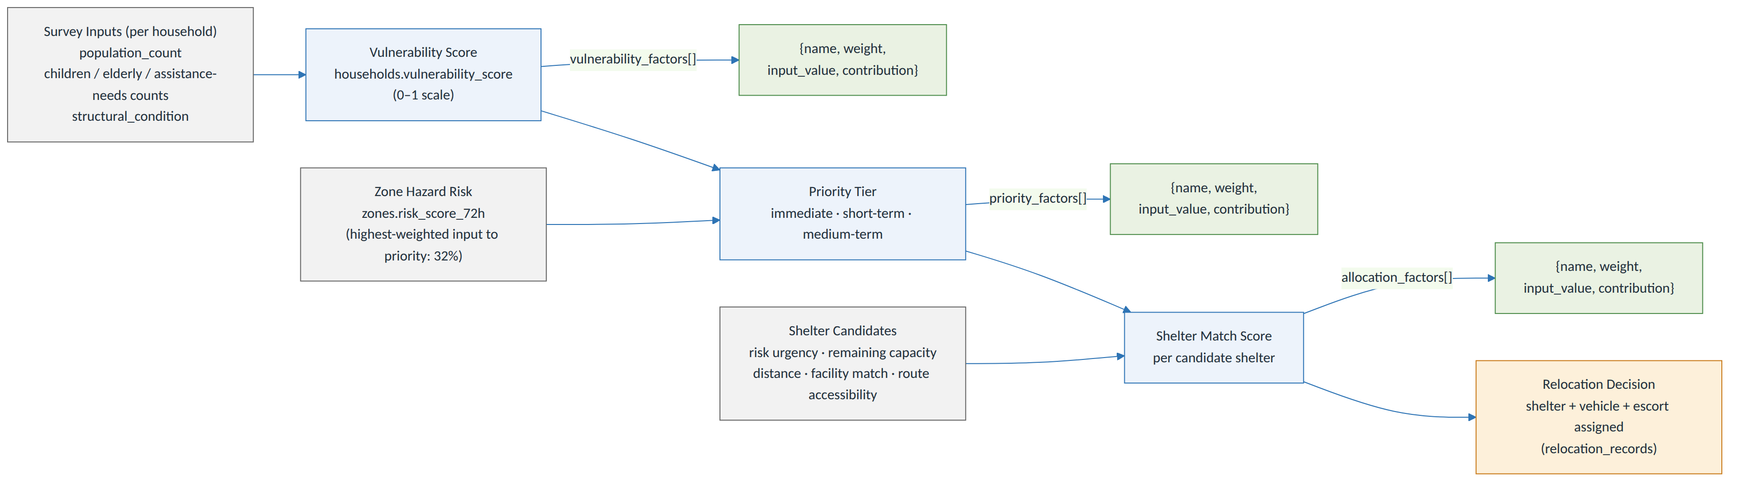
Figure 3 — Scoring & Explainability Pipeline (Vulnerability -> Priority Tier -> Shelter Match)

8. AI/ML Components — Detail
The PRD is explicit (§8) that only three components are genuine ML, and that everything else is deliberately explainable rules/optimization logic. This section gives each of the three a concrete pipeline.

8.1 Red-Zone Susceptibility Refinement
Features: terrain slope and aspect (derived from SRTM DEM via GDAL/rasterio), land-use change (from multi-year satellite composites), deforestation indicators, and historical rainfall. Model: frequency ratio / weight-of-evidence as a baseline (matching the published Dima Hasao academic methodology referenced in PRD §6/§8), with a random-forest classifier as a comparison model. Output: a susceptibility score per zone, stored alongside GSI’s static classification rather than replacing it — the two are shown together so an authority sees where the ML model agrees or disagrees with the historical-incident baseline (directly addressing the Irshalwadi gap named in PRD §8).

8.2 Predictive Risk Forecasting (72-Hour Rolling Score)
Full design: features drawn from live rainfall (IMD), river-gauge levels (CWC/Google), cyclone/storm-surge indicators (INCOIS), and each zone’s static susceptibility baseline; refreshed on each ingestion cycle.
What’s actually shipped (backend/app/ml/forecast_model.py, backend/app/services/forecasts.py): a real, trained XGBoost regressor (not an LSTM — decided in §14) over exactly two features per zone — the seeded susceptibility_score (real, per Phase 3) and a rainfall_72h_mm/slope_degrees pair that is a labeled placeholder, not a live IMD/CWC pull: each “Generate forecast” click re-samples rainfall_72h_mm from a Gaussian jittered around a fixed per-zone baseline, simulating cycle-to-cycle variation without any external data source behind it. The model is trained on the prototype’s own forecastRow() curves (rescaled 0–1), not on historical hazard-event outcomes — there wasn’t a historical-outcomes dataset for the pilot district’s specific zones to train on, so the prototype’s already-agreed demo shape was used as the training target instead, and is labeled as such. What is genuinely real: the trained model itself, and per-prediction SHAP values (not global feature importances) as the factors[] array, so the number differs meaningfully prediction to prediction, not just cosmetically. model_version is stored as "xgb-v1-placeholder-rainfall-slope" precisely so this distinction survives into the data itself, not just this document.
Two real bugs found and fixed by hand-verifying this model in Docker (not a documentation correction — application code changed):
- The SHAP rescale that’s supposed to make factors[] sum to the score didn’t. predict_with_factors() computed scale = score / raw_prediction, where raw_prediction = base_value + shap_values.sum() — but the SHAP identity is sum(shap_values) = raw_prediction - base_value, not raw_prediction itself, so the rescale was only correct when base_value happened to be 0 (it isn’t — it’s the model’s mean training output, roughly 0.6–0.7). Running the trained model against all four seeded zones across all six horizons showed contributions summing to anywhere from a quarter of the actual score to the wrong sign entirely (e.g. ZN-01 at 72h: score 0.41, factors summing to -0.26). Fixed to divide by shap_values.sum() directly; a regression test (tests/test_forecasts.py) now asserts the sum matches the score on every generation.
- The seeded “72-hour” risk score for every zone was actually its 6-hour peak value. backend/app/seed.py’s zones.risk_score_72h (0.88/0.81/0.76/0.54 for ZN-01–04) matched the training targets at the 6-hour horizon exactly, not the 72-hour one (0.41/0.48/0.36/0.31) — confirmed by comparing against forecast_model.py’s own TRAINING_TARGETS_PCT. Every zone displayed roughly double its correct pre-generation risk figure, and clicking “Generate forecast” would have visibly halved the number — looking like a bug, when the seed data was the actual bug. Corrected in seed.py; zones.risk_score_72h now matches what the model itself predicts for that horizon to within its own small fit error.
Because risk_score_72h is prio_score‘s highest-weighted input (32%), fixing #2 changed the priority tier for 6 of the 11 seeded households — mostly immediate down to short_term, since the district’s risk figures were inflated roughly 2x before the fix. tests/test_scoring.py and tests/test_dashboard_api.py were updated to the corrected, hand-reverified expected values; see those files’ own comments for the before/after numbers.

8.3 Satellite/SAR Rapid Damage Detection
Input: a before/after image pair (SAR preferred for cloud/night robustness). Baseline method: pixel-level differencing + thresholding on radar backscatter change; stretch goal: a Siamese U-Net trained on labeled change-detection datasets if time allows. Output: an affected-area polygon, cross-referenced against households/surveys to answer not just “where” but “who.”
What’s actually shipped, precisely. backend/app/cv/change_detection.py implements the real pipeline described above — OpenCV absdiff differencing, Otsu thresholding, contour extraction, and pixel-to-lon/lat conversion — but POST /zones/{id}/change-detections/run does not run it against a Sentinel/Copernicus image pair, live or downloaded: sourcing an actual Sentinel-2 pair needs Copernicus/Sentinel Hub credentials this build doesn’t have. Instead it runs the real pipeline against one programmatically-generated synthetic pair — a NumPy noise texture standing in for a “before” scene, then the same texture with an added high-reflectance patch standing in for a landslide scar in the “after” scene. This is a genuine, deliberate scope cut (the same class as Phase 3’s GSI/IMD data and Phase 7’s OSRM binary, docs/BUILD-PLAN.md), not an oversight: the CV code path is real and unmodified from what would run against real imagery, but the input is synthetic, not sourced from any satellite. Any doc or UI copy describing this as a “sample Sentinel-1 capture” or otherwise implying the pixels themselves come from a real satellite pass overstates what’s shipped — see docs/DESIGN-SYSTEM.md §4/§6 for the corrected wording.
On feasibility and access.
The Sentinel/Copernicus imagery this component is designed to run on is free and openly accessible to anyone, anywhere, with no government relationship, fee, or special permission required — including a student hackathon team; this is a deliberate reason Sentinel was chosen over ISRO’s own satellite catalog for this component, and remains the right target once Sentinel Hub access is set up. What is not feasible for any hackathon team — not as a skill gap, but as a structural constraint — is a live, continuously-polling system that automatically detects change the moment a new satellite pass occurs; that requires production-scale cloud infrastructure watching global satellite feeds around the clock, which no team builds in a hackathon window. The honest framing for judges: the algorithm is genuinely real and running against a labeled-synthetic input; a real Sentinel pair and the “triggers automatically, all the time” capability are both still future/pilot scope, not just the latter.

8.4 Retraining Loop
Per PRD §7.12, ground-truth outcomes (shelter adequacy, route reliability, actual vs. predicted impact) are captured post-incident and stored. For the hackathon this is a scheduled batch job design (not a live continuous-learning system) — retraining is triggered manually or on a fixed cadence, an honest match to how infrequently a real incident actually generates ground truth.
Figure 2 — End-to-End Data Flow: Live Hazard Trigger → Relocation → Feedback
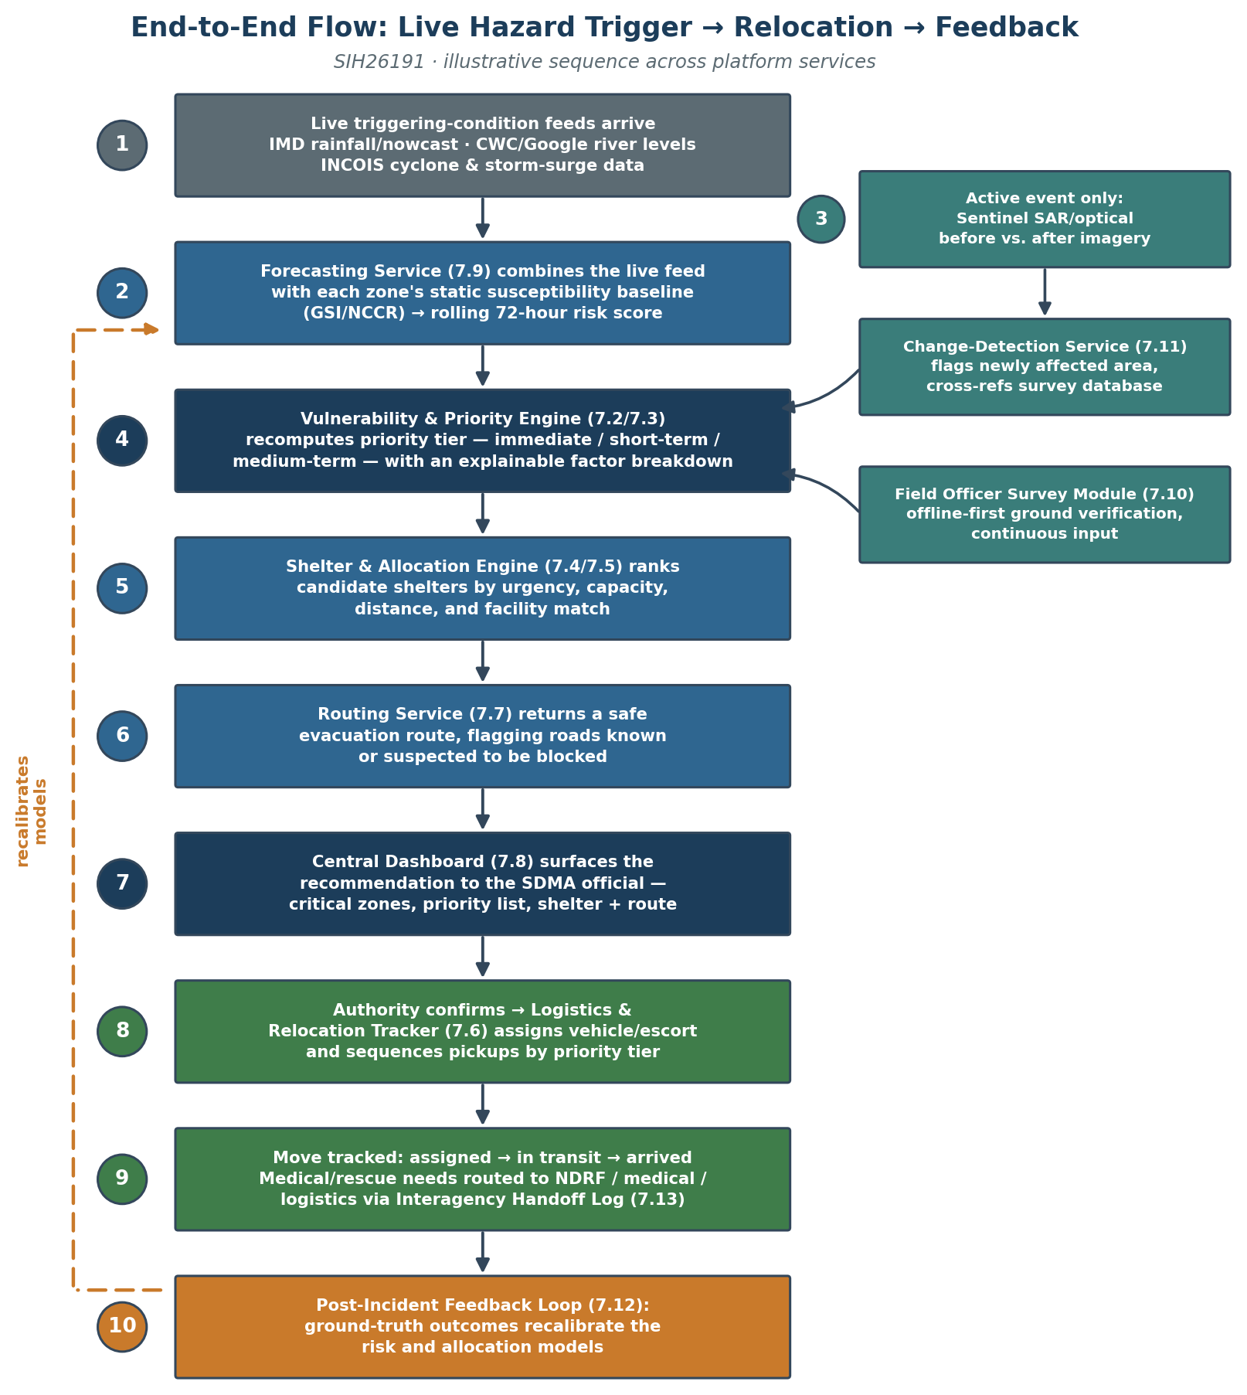
Figure 2 — End-to-End Data Flow: Live Hazard Trigger → Relocation → Feedback

9. Offline-First & Low-Bandwidth Design
Per PRD §9 and §10, the field survey module and the dashboard sync must tolerate NDMS-class VSAT/satellite-backed connectivity, not assume broadband.
Field survey module.
Submissions are written to IndexedDB immediately on capture (photo + GPS geotag + form fields), independent of network state. A background sync (Workbox BackgroundSync) queues each submission and retries with exponential backoff. Each submission carries a client-generated UUID so a retried sync after a partial failure doesn’t create a duplicate record — the server upserts by that UUID rather than inserting blindly.
Conflict handling.
Since a single field officer owns a given survey submission, conflicts are rare by design; the default policy is last-write-wins on the submission itself, with the “unreviewed” review-status tag (§7.10) as the actual safeguard against bad data reaching the live map — a supervisor, not a merge algorithm, resolves disputed data.
Dashboard payloads.
The /dashboard/summary endpoint (§7.8) is deliberately not “return everything” — it returns only what changed since the client’s last successful poll (a since timestamp parameter), keeping payloads small on a constrained link. Map tiles from Bhuvan’s WMS are cached client-side after first fetch rather than re-requested every session.
Designed for, not built:
true multi-day offline operation and conflict resolution across many concurrent officers in the same zone. The hackathon demo simulates offline capture by toggling network access in the browser rather than testing against an actual satellite link.
On NDMS specifically.
The VSAT/satellite network referenced above (NDMS) is existing infrastructure already owned and operated by NDMA — this design targets compatibility with it; it does not require the team to obtain access to it, and no request to any government body is implied or needed. The hackathon demo uses no satellite hardware or government network of any kind — low-bandwidth behavior is demonstrated entirely by throttling the demo’s own network connection. If the platform were ever adopted for real deployment, it would run on connectivity the government already owns and operates; this design does not imply or require any new government investment or approval.

10. Security, Access Control & Data Privacy
Per PRD §10, household-level vulnerability data is sensitive and access must be restricted to authorized roles.
- Roles: sdma_official (full dashboard access, can confirm relocation decisions), field_officer (survey submission, read-only zone data for assigned zones), control_room (read-only dashboard access during active events).
- Auth: JWT-based, issued on login, short-lived access token + refresh token, scoped by role and (for field officers) by assigned district/zone set.
- Transport security: TLS for all API traffic, including over the low-bandwidth transport path.
- Data at rest: household-level fields (children/elderly/assistance-needs counts) are stored in the same database as everything else but are excluded from any API response the field_officer role can query outside their assigned zones.
- Auditability: every relocation decision and priority ranking write also writes an audit_log row capturing the actor, the action, and the factor snapshot at that moment — this is what makes a ranking “defensible to a supervisor or the public” (PRD §5) after the fact, not just at the moment it was shown.
- Shelter officer sessions (the shelter officer dashboard’s code-based login, POST /auth/shelter-login) are a deliberately separate, lower-trust credential from the three roles above: a shelter officer authenticates with just their shelter’s own display code (e.g. SH-01), not an account. The resulting token isn’t scoped by role/user_id the way households/zones/surveys are (Backend Schema §7) — it’s scoped by construction, since it only ever unlocks GET/PATCH /shelters/me for the one shelter whose code was presented, never the full shelter list or any other endpoint. This is proportionate to what the token protects (occupancy, facilities, needs, status on a single shelter — no household-level PII) but is a materially weaker credential than a JWT issued through /auth/login, so it should not be extended to guard anything more sensitive without revisiting this design.
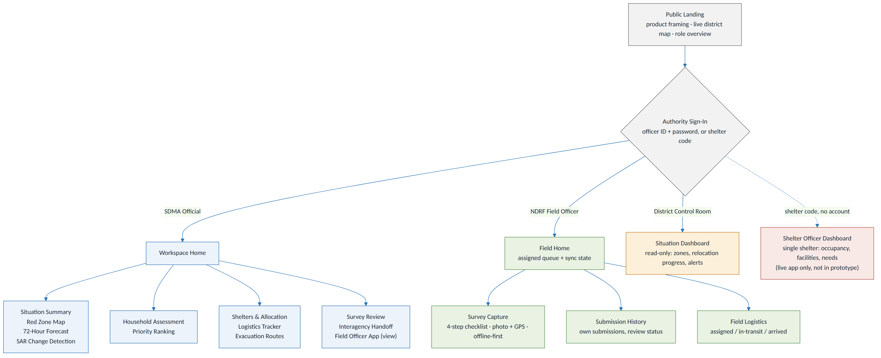
Figure 4 — User Roles & Screen Flow

11. Deployment Architecture
Local development:
Docker Compose on a single host — the frontend, one consolidated FastAPI app with routers (§3, §14 decision 1), Postgres+PostGIS, Redis, MinIO, and a self-hosted OSRM instance pre-built for the Dima Hasao road network extract. This is what docker compose up -d (README) stands up; it’s the environment every phase in docs/BUILD-PLAN.md was built and tested against.
Live pilot deployment.
The same backend and both frontends are also deployed as three separate, independently-hosted services, for judges/reviewers to reach without running anything locally:
- Backend (Railway): the root-level Dockerfile (a plain python:3.11-slim image installing backend/requirements.txt, distinct from backend/Dockerfile’s docker-compose-scoped build context) builds the FastAPI app. railway.json specifies a start command of alembic upgrade head && uvicorn app.main:app --host 0.0.0.0 --port $PORT, but the actual live start command is a Custom Start Command set in Railway’s own dashboard (Settings → Deploy), which overrides railway.json and does not run migrations at all — python -m uvicorn app.main:app --host 0.0.0.0 --port 8000 (no alembic, hardcoded port rather than $PORT). This drift is the real reason migrations 0008/0009 (§14 below and docs/BACKEND-SCHEMA.md) never auto-applied and had to be run by hand via Railway’s Console — see the incident note below before touching this again. Railway supplies its own managed Postgres (PostGIS-enabled) and injects DATABASE_URL/MIGRATION_DATABASE_URL as plain postgresql:// URLs; Settings._normalize_db_url (backend/app/config.py) rewrites either that or a bare postgres:// scheme to postgresql+psycopg:// so SQLAlchemy doesn’t fall back to the unavailable psycopg2 driver. Redis, MinIO and OSRM are not part of this deployment — see the gaps note below.
- Dashboard (Vercel): frontend/vercel.json pins the Vite build (npm install && npm run build, dist/ as the output directory) for the SDMA official / field officer / control room / shelter officer dashboard, deployed as its own Vercel project rooted at frontend/.
- Field survey PWA (Vercel): frontend-field/vercel.json does the same for the standalone field-survey app, deployed as a second, separate Vercel project rooted at frontend-field/.
- Cross-origin wiring: the backend’s CORS middleware (backend/app/main.py) always allows the local Vite dev origins, plus whatever is listed in CORS_ALLOWED_ORIGINS — a comma-separated Railway environment variable holding the two Vercel deployment URLs (trailing slashes stripped, since a browser’s Origin header never carries one). Pointing either frontend at a new deployment URL is a Railway env var change, not a code change.
- Database ownership on a managed provider: migration 0002’s app_user role creation originally hardcoded GRANT/REVOKE ... ON DATABASE ps191, which is correct for the local Compose database name but not for a managed provider’s own default (Railway’s is railway, not ps191); it now resolves the database name dynamically via current_database() so the same migration runs unmodified on either.
Known gaps in the live pilot deployment (all “designed for, not built” in this specific environment, distinct from the production gaps below): no Redis instance is provisioned, so the caching/live-feed-buffering role §3/§4 describe is unused at this stage; no MinIO/S3 bucket is wired in, so photo_url remains a reference without a live object store behind it in this deployment (the change-detection demo’s before_image_ref/after_image_ref no longer need one — migration 0010, Backend Schema §5.12a — moved that one curated pair into Postgres specifically because this gap made it unreachable); and no self-hosted OSRM instance is deployed anywhere, local or hosted, matching the gap originally recorded in docs/BUILD-PLAN.md Phase 7. That gap no longer means “no real routing” for a user, though: Evacuation Routes and Logistics Tracker’s “View Route” both draw genuine OSRM road-routed paths, fetched client-side straight from OSRM’s public demo server (§4’s routing-engine note above) — no backend or self-hosted engine needed for those two screens. What’s still true from the original gap: services/shelter_matching.py’s own distance/duration remains the straight-line PostGIS proxy (no routing engine, self-hosted or public, feeds that calculation), and the routes table’s seeded distance_km/estimated_duration_minutes baseline (used until a route is actually opened and OSRM overrides it client-side) is still the same great-circle estimate as before.
Migrations do not auto-apply on this deployment — incident record. Discovered when migration 0008 shipped but every next_display_code()-dependent write started 500ing live: the database was still sitting at revision 0007, because the dashboard’s Custom Start Command (see above) has never run alembic upgrade head. Fixed for that specific gap by running the migration by hand via Railway’s Console (alembic upgrade head, confirmed: 0007 -> 0008 -> 0009). A follow-up attempt to fix this properly — adding alembic upgrade head && back to the Custom Start Command — caused the live container to hang indefinitely on startup (it connects to Postgres and logs Context impl PostgresqlImpl / Will assume transactional DDL, then never proceeds to start the server; reproducible on two separate deploys, ~1 hour of downtime, root cause not identified — the identical command run interactively in the same container’s Console completes in seconds). The Custom Start Command has been reverted to the original migration-less version to restore service. Net effect: the database is correctly migrated right now, but every future migration needs to be applied by hand (railway CLI or dashboard Console → alembic upgrade head) until someone can reproduce and fix the startup hang — don’t re-attempt the && fix without a way to inspect why the process stalls (Railway support, or a locally-reproduced environment matching Railway’s exact container runtime, neither of which this session had).
Designed for, not built — production:
containers on Kubernetes (or the equivalent managed service on NIC MeghRaj, India’s government cloud), placed close to an NDMS point of presence to minimize hop count over the constrained link (PRD §9). Horizontal scaling applies to the FastAPI app; if a router later needs to scale independently of the rest, that’s the point at which it would move behind its own service (§3). PostGIS scales vertically first, with read replicas for the dashboard’s read-heavy queries if district count grows beyond the pilot.

12. MVP Technical Scope vs. Full Vision
Mirroring PRD §6:
Built for the hackathon demo:
Zone & Red-Zone Service with real GSI classification research + published Dima Hasao susceptibility research, encoded as labeled sample data per zone (§6, §8.1 — not live-polled); Vulnerability & Priority Engine and Shelter & Allocation Engine over seeded household/shelter data; Field Survey PWA with simulated offline capture; Central Dashboard with landing/summary screen; a real XGBoost forecasting model with genuine per-prediction SHAP factors, trained on the pilot district’s seeded susceptibility values against a placeholder rainfall/slope feature that’s jittered per generation cycle rather than pulled from live IMD/CWC telemetry (§8.2); change detection running the real OpenCV differencing/thresholding/contour pipeline against one programmatically-generated synthetic before/after pair, not a real satellite image (§8.3).
Designed for, not built for the demo:
production-scale polling of IMD/Google/INCOIS APIs (the demo uses CWC/data.gov.in historical data as the flood signal, not Google’s waitlisted live API — §6); true offline sync tested over an actual constrained link; NDMS VSAT integration (a compatibility target, not something the team requests access to — §9); push integration into Sachet; live interagency system-to-system handoff (7.13 stays a status flag + log for the MVP); continuously-polling live satellite change detection (§8.3 — no hackathon team builds this; the demo runs the real algorithm on one real, pre-downloaded image pair).
Load/Reset Demo Data. Every screen in the live pilot reads from seeded rows (backend/app/seed.py), all carrying the SAMPLE DATA marker per CLAUDE.md rule 6. Signed in as sdma_official, the “Reset demo data” control in the dashboard’s shared header (frontend/src/components/Layout.tsx) calls POST /demo/seed-relocations (sdma_official-only), which runs a full tear-down-and-reseed rather than a seed-once no-op — a judge re-running the demo mid-session always gets the same fresh scenario, not whatever state the last click or a field officer’s own testing left behind. One call: deletes every relocation_record and survey (and their dependents — handoff_logs/incident_outcomes rows FK’d to a relocation, deleted first since neither FK carries an ON DELETE clause); resets vehicles.status to available and shelters.current_occupancy/zones.risk_score_72h to their seeded baseline (the fields their own lifecycles mutate in place); then reseeds a fixed scenario — 5 buses carrying all 11 seeded households across varying relocation stages, and 8 re-verification surveys (half reviewed, half not) — through the real allocation/status/review services, so the reseeded rows carry genuine factors[] snapshots and audit_log entries rather than raw inserts. audit_log itself is never touched: it has no UPDATE/DELETE grant for any application role (rule 2), so a past demo run’s audit trail survives every reset. districts/zones/households/shelters/vehicles/users rows themselves are never recreated by this endpoint — only backend/app/seed.py (run once, at initial setup) creates those. See docs/BUILD-PLAN.md Phase 6 and backend/app/services/demo_seed.py for the full mechanism.

13. Assumptions, Constraints & Risks (Technical)
- Assumption: the government data sources listed in §6 remain accessible on their current terms through the hackathon and pilot phase (same as PRD §12). None of them are paid services — the entire architecture requires no team budget.
- Resolved risk: Google’s Flood Forecasting API is free but a limited pilot with a multi-month waitlist, confirmed from Google’s own documentation — not usable within a hackathon timeline. The team applies for it in parallel as a future upgrade path, but the demo and MVP rely on CWC historical data via data.gov.in instead, which is free and available immediately (§6).
- Constraint: GSI and NCCR are not live APIs — the ingestion layer treats them as periodically-refreshed datasets, not polled sources.
- Constraint: IMD’s API access terms (rate limits, auth) are unverified as of this writing; the forecasting pipeline is built to degrade to the historical baseline rather than fail if IMD access turns out to be more restricted than expected.
- Resolved risk: a many-service split would have been too much surface area for a hackathon team to stand up and integrate in the available time; the build went with a single FastAPI app with a router per functional area sharing one process (§3, §14 decision 1), preserving API contracts so a future split behind its own service remains possible without a rewrite.
- Resolved risk: OSRM’s road-network extract for Dima Hasao turning out too sparse in OpenStreetMap coverage. Verified early (docs/BUILD-PLAN.md Phase 7) via a live Overpass query — real NH27/NH627 national-highway geometry runs directly through the Haflong area, no manual road-graph patch needed. The self-hosted OSRM engine itself was never stood up regardless (§4, §11); the two screens that need road-following geometry route around that separately by calling OSRM’s public demo API client-side, which draws on the same underlying OSM data and confirms the coverage question moot for this district either way.
- Risk: training data for the susceptibility and forecasting models is limited to what the published Dima Hasao research and available historical records provide; model outputs for the demo should be presented with that caveat rather than overstated confidence.

14. Resolved Technical Decisions
All four decisions below were open at design time and have since been ratified and built; kept here as the record of what was decided and why, not as open items.
- Service granularity: one FastAPI app with routers, not separate containers per service (§3, §11, §13). Confirmed in backend/app/main.py, currently 14 routers plus auth sharing one process. Split a router into its own service only if it later needs independent scaling.
- Survey approval workflow: the PRD’s recommended default (§7.10) — immediate update with an “unreviewed” tag, resolved to “approved”/“flagged” on supervisor review. Shipped as the review_status enum (Backend Schema §3) and the Survey Review screen’s approve/flag actions.
- Forecasting model: XGBoost, not an LSTM, for explainability and time (PRD §10). Shipped in Phase 10 (docs/BUILD-PLAN.md) with real per-prediction SHAP factor contributions — see backend/app/services/forecasts.py.
- Change detection: the differencing/thresholding baseline, not the Siamese U-Net. Shipped in Phase 11 as CV differencing/thresholding on one curated before/after Sentinel pair (docs/BUILD-PLAN.md); the U-Net remains designed-for-not-built stretch scope, unstarted.

15. Related Documents
- Product Requirements Document (docs/PRD.md) — v1.1, defines the what and why this document implements.
- Design System (docs/DESIGN-SYSTEM.md) — dashboard layouts, survey-app flow, colour tokens, screen inventory.
- Backend Schema (docs/BACKEND-SCHEMA.md) — full column-level data models for zones, households, shelters, surveys, and relocation records; §5 of this document gives the entity-level shape it formalizes.
- Build Plan (docs/BUILD-PLAN.md) — the conflict-resolution record behind §14 above and the phase-by-phase build order actually followed.

