The EKF is a tunable compromise, not a transcription of Zeebe
Answer to the “too good to be true” concern — R_ecc sweep + age-dependent uncertainty CycloAstro, July 2026. Run: results/compromise_sweep/ (script compromise_sweep.py, 0–10 Myr, 100-yr cadence, no gating).

1. The concern
The production EKF tracks Zeebe ZB20a to |ZB−EKF| ≈ 1.2×10⁻⁵. The natural objection: if the filter just sits on the reference, what has been gained?
The answer: the closeness is a choice, set by one physical knob — the eccentricity measurement covariance R_ecc = σ_z². Turn the knob and the same filter, unchanged, produces any compromise between the two sources of information. We demonstrate this two ways below, with the estimate’s position measured against both anchors: the Zeebe reference and an independent pure REBOUND integration (no filter).

2. What one number means — and a correction to our earlier demo
The gain along the measured direction is K_H = HPH′/(HPH′ + σ_z²). Our earlier three-value demo (σ_z = 3/9/30×10⁻⁵ → K_H = 0.92/0.60/0.14) showed K_H is tunable, but all three trajectories still looked glued to Zeebe. The reason is a real quantitative insight:
With measurements every 100 yr, corrections accumulate. The steady-state offset from Zeebe scales like (model drift per epoch)/K_H, so even K_H = 0.14 erases REBOUND’s slow drift. A trajectory that sits midway between the anchors requires K_H ≪ 0.5 — the per-update gain and the position of the trajectory are different quantities.
We therefore measure the compromise in trajectory space: over the 5–10 Myr window (where the two anchors have visibly separated, RMS separation 5.2×10⁻³) we compute the RMS distance of the estimate to each anchor and the position fraction λ = d(Zeebe)/(d(Zeebe)+d(REBOUND)) — λ = 0 means “on Zeebe”, λ = 1 means “on REBOUND”.

3. The sweep: seven settings of one knob
σ_z | K_H (mean) | RMS to Zeebe | RMS to REBOUND | λ
3×10⁻⁵ (production) | 0.92 | 9.7×10⁻⁶ | 5.2×10⁻³ | 0.00
9×10⁻⁵ | 0.60 | 9.8×10⁻⁵ | 5.2×10⁻³ | 0.02
3×10⁻⁴ | 0.14 | 8.2×10⁻⁴ | 5.3×10⁻³ | 0.13
1×10⁻³ | 0.016 | 6.2×10⁻⁴ | 5.1×10⁻³ | 0.11
3×10⁻³ | 1.9×10⁻³ | 1.5×10⁻³ | 4.3×10⁻³ | 0.26
1×10⁻² | 1.7×10⁻⁴ | 3.3×10⁻³ | 2.4×10⁻³ | 0.58
3×10⁻² | 1.9×10⁻⁵ | 4.9×10⁻³ | 4.9×10⁻⁴ | 0.91
The dial spans the full range: from indistinguishable-from-Zeebe (λ ≈ 0) to indistinguishable-from-REBOUND (λ = 0.91), with the balanced trajectory (equal distance to both anchors) at σ_z ≈ 7.5×10⁻³. Distances of neighbouring intermediate settings vary at the chaotic-realization level (e.g. the 3×10⁻⁴ vs 1×10⁻³ rows), so the dial is smooth only to within that variance — that is physics, not tuning error.
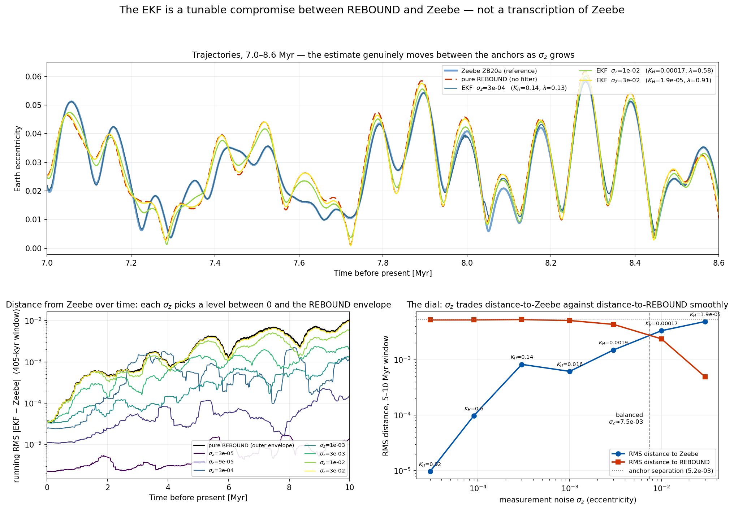
The sweep
Top: in the 7.0–8.6 Myr window the estimate genuinely moves between the anchors as σ_z grows. Bottom-left: distance from Zeebe over time — each σ_z picks a level between zero and the pure-REBOUND envelope. Bottom-right: the dial — RMS distance to each anchor crosses smoothly.

4. Age-dependent uncertainty (the geological version)
A geological reference deserves less trust deeper in time. We ran the same filter once with σ_z growing with age: σ_z(t) = 3×10⁻⁵ × 10^(t/4 Myr) (×10 per 4 Myr; the rate is an illustrative modeling choice, to be calibrated when real proxy uncertainties are available). The gain follows automatically: K_H = 0.96 at present decaying to 2.5×10⁻⁴ at 10 Myr.
The result is a graceful, automatic hand-off in a single run: young ages track Zeebe (distance ~10⁻⁶–10⁻⁵), and as the assumed uncertainty grows the filter releases the reference (here starting near ~2.5 Myr, complete by ~5 Myr).
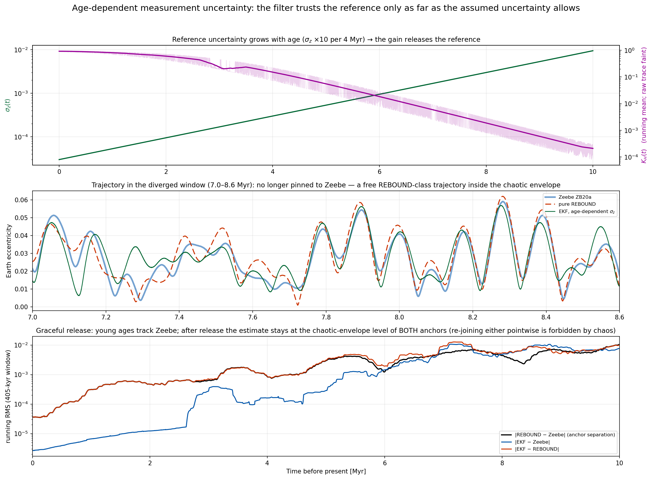
Age ramp
Honest caveat: after release, the estimate is a free REBOUND-class trajectory. It stays inside the chaotic envelope, but it does not re-join either anchor point-by-point — two nearby trajectories of the chaotic inner Solar System separate on the ~5 Myr Lyapunov time, so past the release the distance to both anchors sits at the envelope level (λ = 0.48 in the 5–10 Myr window). This is exactly the behaviour a defensible reconstruction should have: agreement where the reference is trustworthy, honest REBOUND-level uncertainty where it is not. It is also the native mechanism behind our production hand-off to pure REBOUND past ~8 Myr.

5. Take-away
- The production setting σ_z = 3×10⁻⁵ is not the filter “cheating off” Zeebe; it is the deliberate, physically-motivated end of a continuous, demonstrated dial (trust the reference at 3×10⁻⁵ eccentricity where it is reliable).
- The same knob, made age-dependent, yields the geologically natural behaviour: trust decays with age and the filter hands over to pure dynamics automatically.
- When real proxy data with quantified uncertainties arrive (e.g. the 53–58 Mya window), those σ values plug directly into this same R_ecc slot.

Reproduce
%run "/Users/kasulasan/Projects/The CycloAstro Project/cycloastro_python/cycloastro_tests.py"
%run "/Users/kasulasan/Projects/The CycloAstro Project/cycloastro_python/compromise_sweep.py"
(~6 min wall on 8 cores; add --replot to regenerate figures from the saved CSVs without re-running the filters. All parameters, versions and timings are recorded in results/compromise_sweep/config.json.)

