1.2

1.What should be the output of the following Script?.

v <- c( 2,5.5,6)

t <- c(8, 3, 4)

print(v%/%t)

OUTPUT : 0 1 1

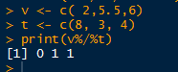

2. You have 25 excel files with names as xx_1.xlsx, xx_2.xlsx,........xx_25.xlsx in a dir.

Write a program to extract the contents of each excel sheet and make it one df.

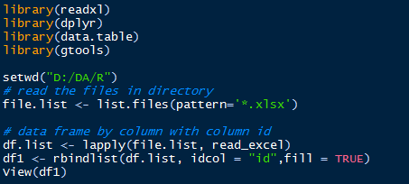

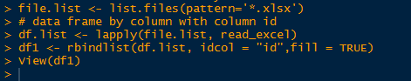

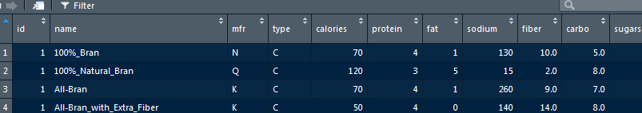

3. If the above 25 files were csv files, what would be your script to read?

