# Introduction

## Purpose

Green Thumb Gardening mainly a seed and plant selling company along with the garden maintenance tools and services which is manually operated using Facebook advertisements and other social media platforms. They planning to expand their reachability to the customers by digitalizing their manually operated business as especially they have limitations with the laws impacted by COVID19 for current operations in the business. Such as limited employees, limitations on how many customers can have at a time…etc. Completion of this project enables the customer to order their products and services online and make payments online without any interactions with the employees or public prior to service.

## Objective

* Customer should be able to order products and services online
* Customer should be able to make the payments online
* Customer should be able to rate and give the feedback online
* Employee should be able to order, update and check the inventories online
* Employee should be able to generate reports through the new system

## Scope and Limitations

**Scope**

* Study the current operations and progress they making with current system using online resources.
* The implementation of the website has to be finished within specified time frame.
* During the project, between project development team and between the team and the customer should have a better frequent communication with the updates.
* As the first deployment of the website it will only allow the most essential basic functionalities.
* Costs has to be within the specified budget.

**Limitations**

* Limited data access.
* Method and data collection process.
* Time constraints.
* Lack of human resources for the completion of the project.

## Assumptions

* After completion of this project, it will be able to meet the specified goals in the objectives.
* Towards the completion of this project the team has all the resources and skills.
* The website must meet all the written specifications, be thoroughly tested, and be completed on time.

# Project Organization

## Company Profile

**KENT IT SOLUTIONS**

Kent IT solutions is an Australian IT solution provider. Established in 2020 during the Pandemic to reach the customers problems by expanding their small business by providing IT solutions.

Our Mission: our commitment is to offer consultations and solutions based on latest IT technologies to reach the customer requirements.

Our Vision is to become the main driving force behind converting the small business into a digitalize platforms.

Our Services:

1. **Database Management:** database creation, management and deployment according to the business and customer requirement.
2. **UI/UX:** design and integrate a user-friendly interface for better user experience using the latest technologies available.
3. **CRM:** developing customer relationship management systems with integration of online payment methods.

## Organization Chart

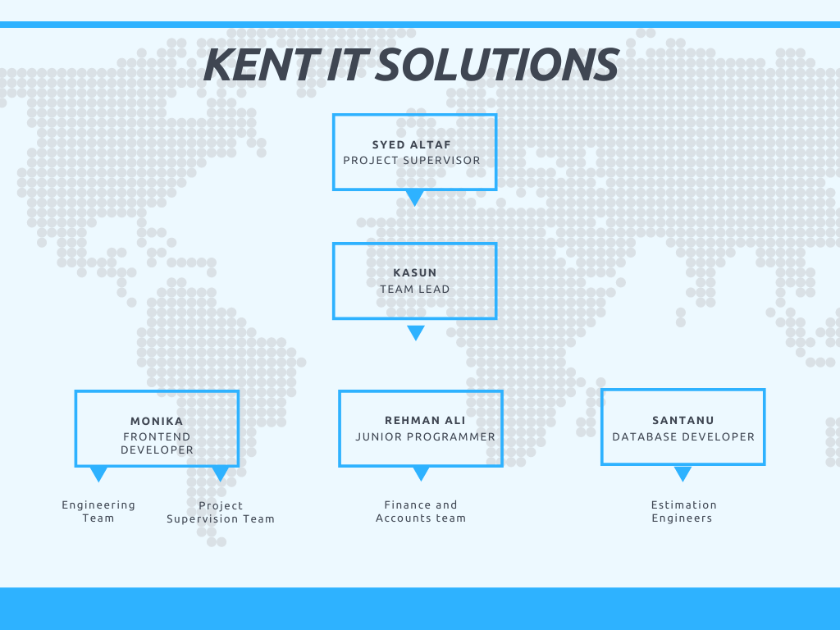

## Roles and Responsibilities

|  |  |  |  |
| --- | --- | --- | --- |
| **Name** | **Role** | **Position** | **Contact information** |
| Mr. Syed. Altaf | Project Manager | Manager | Syed.Altaf@kent.edu.au |
| Ms. Monika | Team Member | Front-End Developer | K170839@student.kent.edu.au |
| Mr. Kasun | Team Lead | Team Leader | K191289@student.kent.edu.au |
| Mr. Santanu | Team member | Database Developer | K190133@student.kent.edu.au |
| Mr. Rehman | Team member | Junior programmer | K190801@student.kent.edu.au |

# Project Deliverables and Budgets

## Functional Requirements

The below given functional requirements provides us with the functions of our Green Thumb Gardening.

**User Management:** This set of Functional requirement helps Green Thumb Gardening in managing their user by creating, managing and deleting the user account.

**Costumers Management:** It defines the function of client interface of our proposed project of green thumb gardening. It Includes Client Login, orders and checkout.

**Inventory Management:** This set of requirement covers the stock management of Green Thumb Gardening. It includes features like adding up of new tools or seeds and gives update on the stock.

**Order Management:** The roles of the Order Justification abilities of our proposed project are defined by the collection of requirements. This feature includes a list of purchasing items, a shopping cart, and a payment process.

## Non-Functional Requirements:

This section of the report defines the Non-functional requirement of the Green Thumb Gardening.

**Data Security:**  The proposed system will increase the data security by limiting its access to authorized person only.

**Accessibility:** The proposed system would be easily accessible to wide range people.

**Availability:** The proposed system will be available 24/7 to all its users.

**Speed:**  The data access speed for both client and users’ needs to be reasonable

# Budget Breakdown

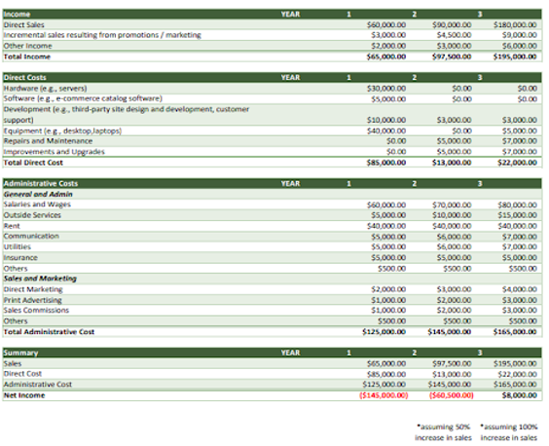

# Schedule and Resources

Work Breakdown Structure (WBS)

# Gantt chart

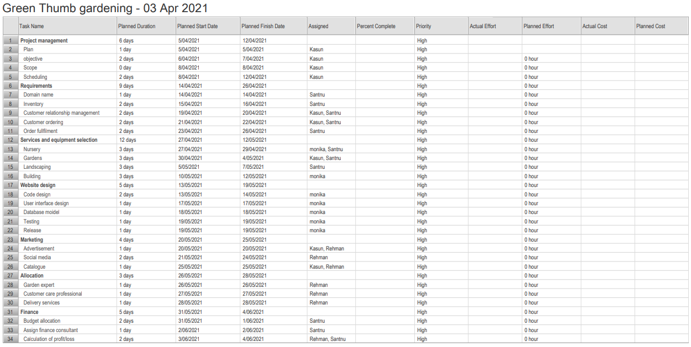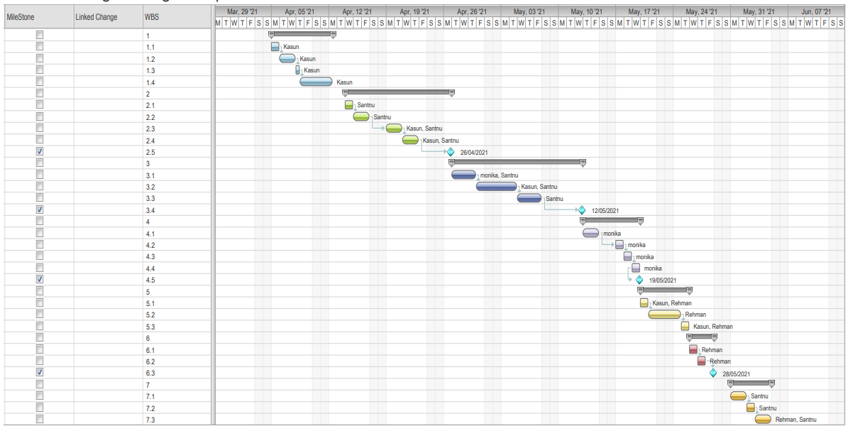

# Risk Management Plan

|  |  |  |  |
| --- | --- | --- | --- |
| **Risk** | **Description** | **Risk impact** | **Mitigation plan** |
| 1 | Lack of communication | High | Schedule routine meetings every day.  Upload the updates to GitHub. |
| 2 | Poor documentation | moderate | Always encourage the team to document everything.  Until the documentation the mark the work is incomplete. |
| 3 | Failure to deliver on time | High | Team should work extra hours to meet the deadline |
| 4 | Poor quality code | High | Check everyone’s codes by everyone to avoid the poor quality. |
| 5 | Poor productivity | High | Do a SWOT analysis of members before appointing to tasks |
| 6 | Low stakeholder engagement | High | Try to schedule routine meetings with them and not possible research instead |
| 7 | Inadequate human resources | High | Divide the left between rest of the team members or request for a new member |