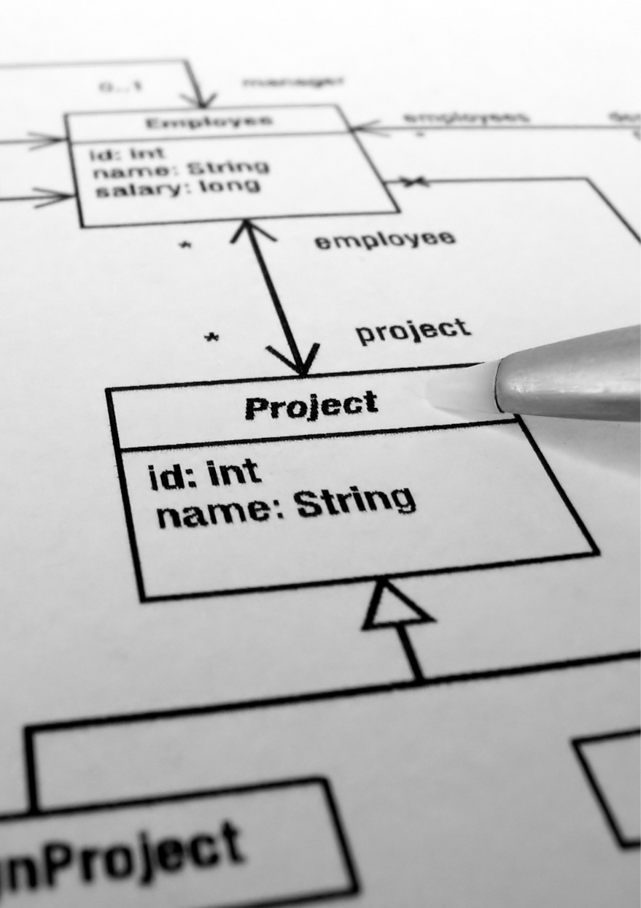

Class Diagrams for the

Proposed System
  - POWER WORLD GYM - KIRIBATHGODA
IM/2022/001 – A.M.K.C.S.B.Abeykoon

BSO Selection
Of the three Business System Options (BSOs) presented, the client has suggested proceeding with BSO 3: The Integrated Growth & Insights Platform. This option represents the complete proposed system, building upon the automated access control of BSO 1 and the member self-service portal of BSO 2 by integrating a powerful data analytics layer for both members and management.
This option was selected as it is the only one that provides a strategic, long-term advantage. While BSO 1 secures revenue and BSO 2 improves efficiency, BSO 3 uses data to directly drive growth and member retention. It empowers members with progress tracking and dashboards, significantly enhancing engagement. Simultaneously, it provides management with real-time insights into attendance trends and revenue, enabling informed decisions on marketing and operations. This transforms the gym into a data-informed, modern service, maximizing return on investment and creating a sustainable competitive edge.

Entity Class Diagram
An entity class diagram represents the main data objects within a system, their attributes, and the connections between them. It provides the underlying structure for how information is stored and related. This diagram forms the basis of the data model, ensuring organized and consistent handling of system information.

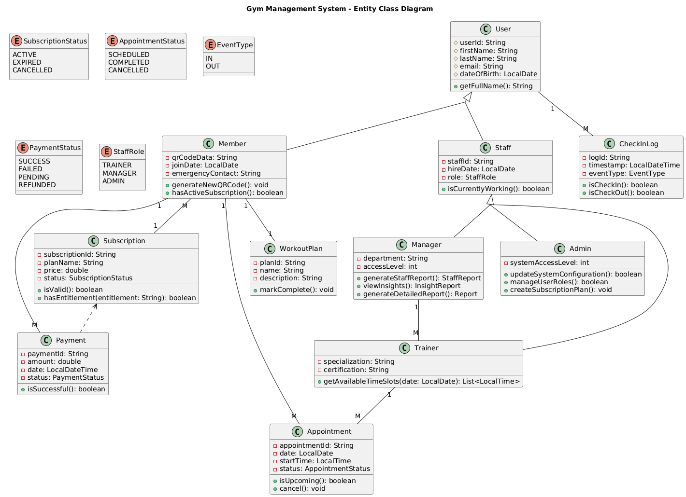

Interface Class Diagram
An interface class diagram illustrates how different interfaces connect users with system functions and components. It shows the pathways through which information flows between users and processes. By capturing areas such as interaction, input, and output, this diagram ensures smooth communication and accessibility throughout the system environment.

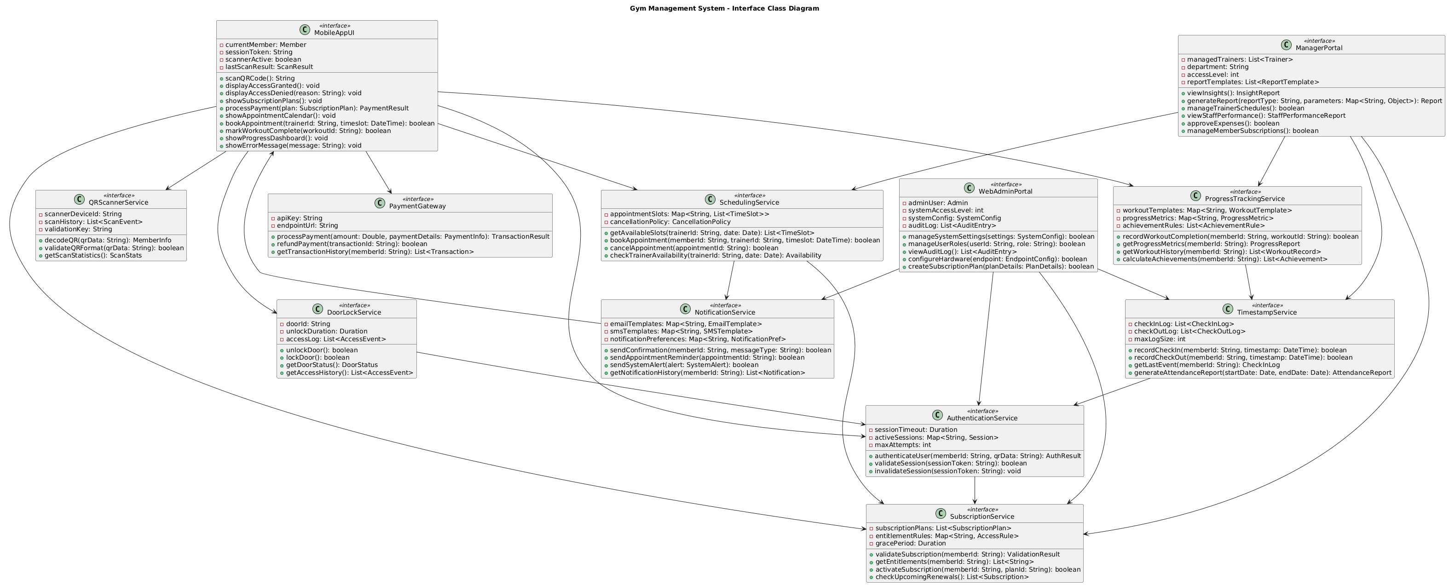

Controller Class Diagram
A controller class diagram describes the logic that manages interactions between users, interfaces, and system processes. It coordinates actions, routes input, and oversees backend execution. This diagram defines the operational flow, ensuring that user commands are correctly handled and integrated with system functions for consistent and reliable performance.

