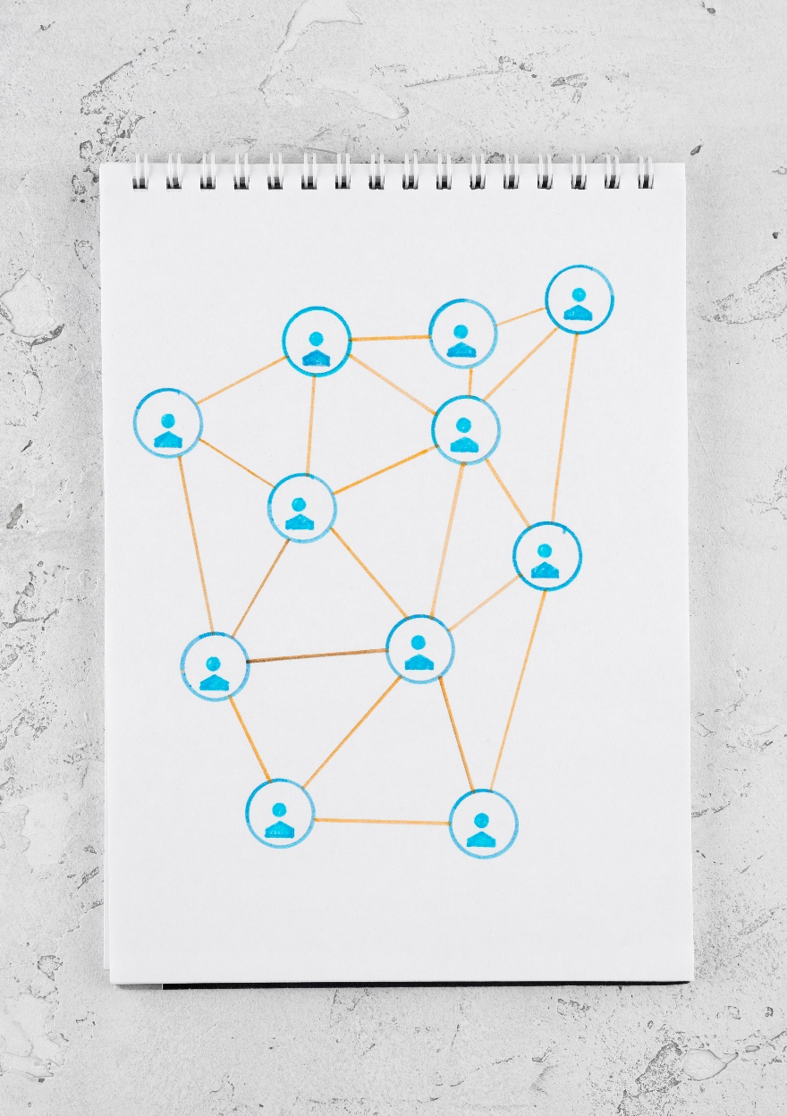

ER, DATA DICTIONARY AND SEQUENCE DIAGRAMS
  - POWER WORLD GYM - KIRIBATHGODA
IM/2022/001 – A.M.K.C.S.B. Abeykoon

Entity-Relationship Diagram
The ER diagram graphically represents the structure of the database system, containing entities such as Member, Trainer, Staff, Subscription, Payment, and Attendance, among others, along with their respective relationships. It organizes the data in a structured way to support the smooth operation of the gym management system, including managing memberships, tracking payments, scheduling sessions, and monitoring attendance.
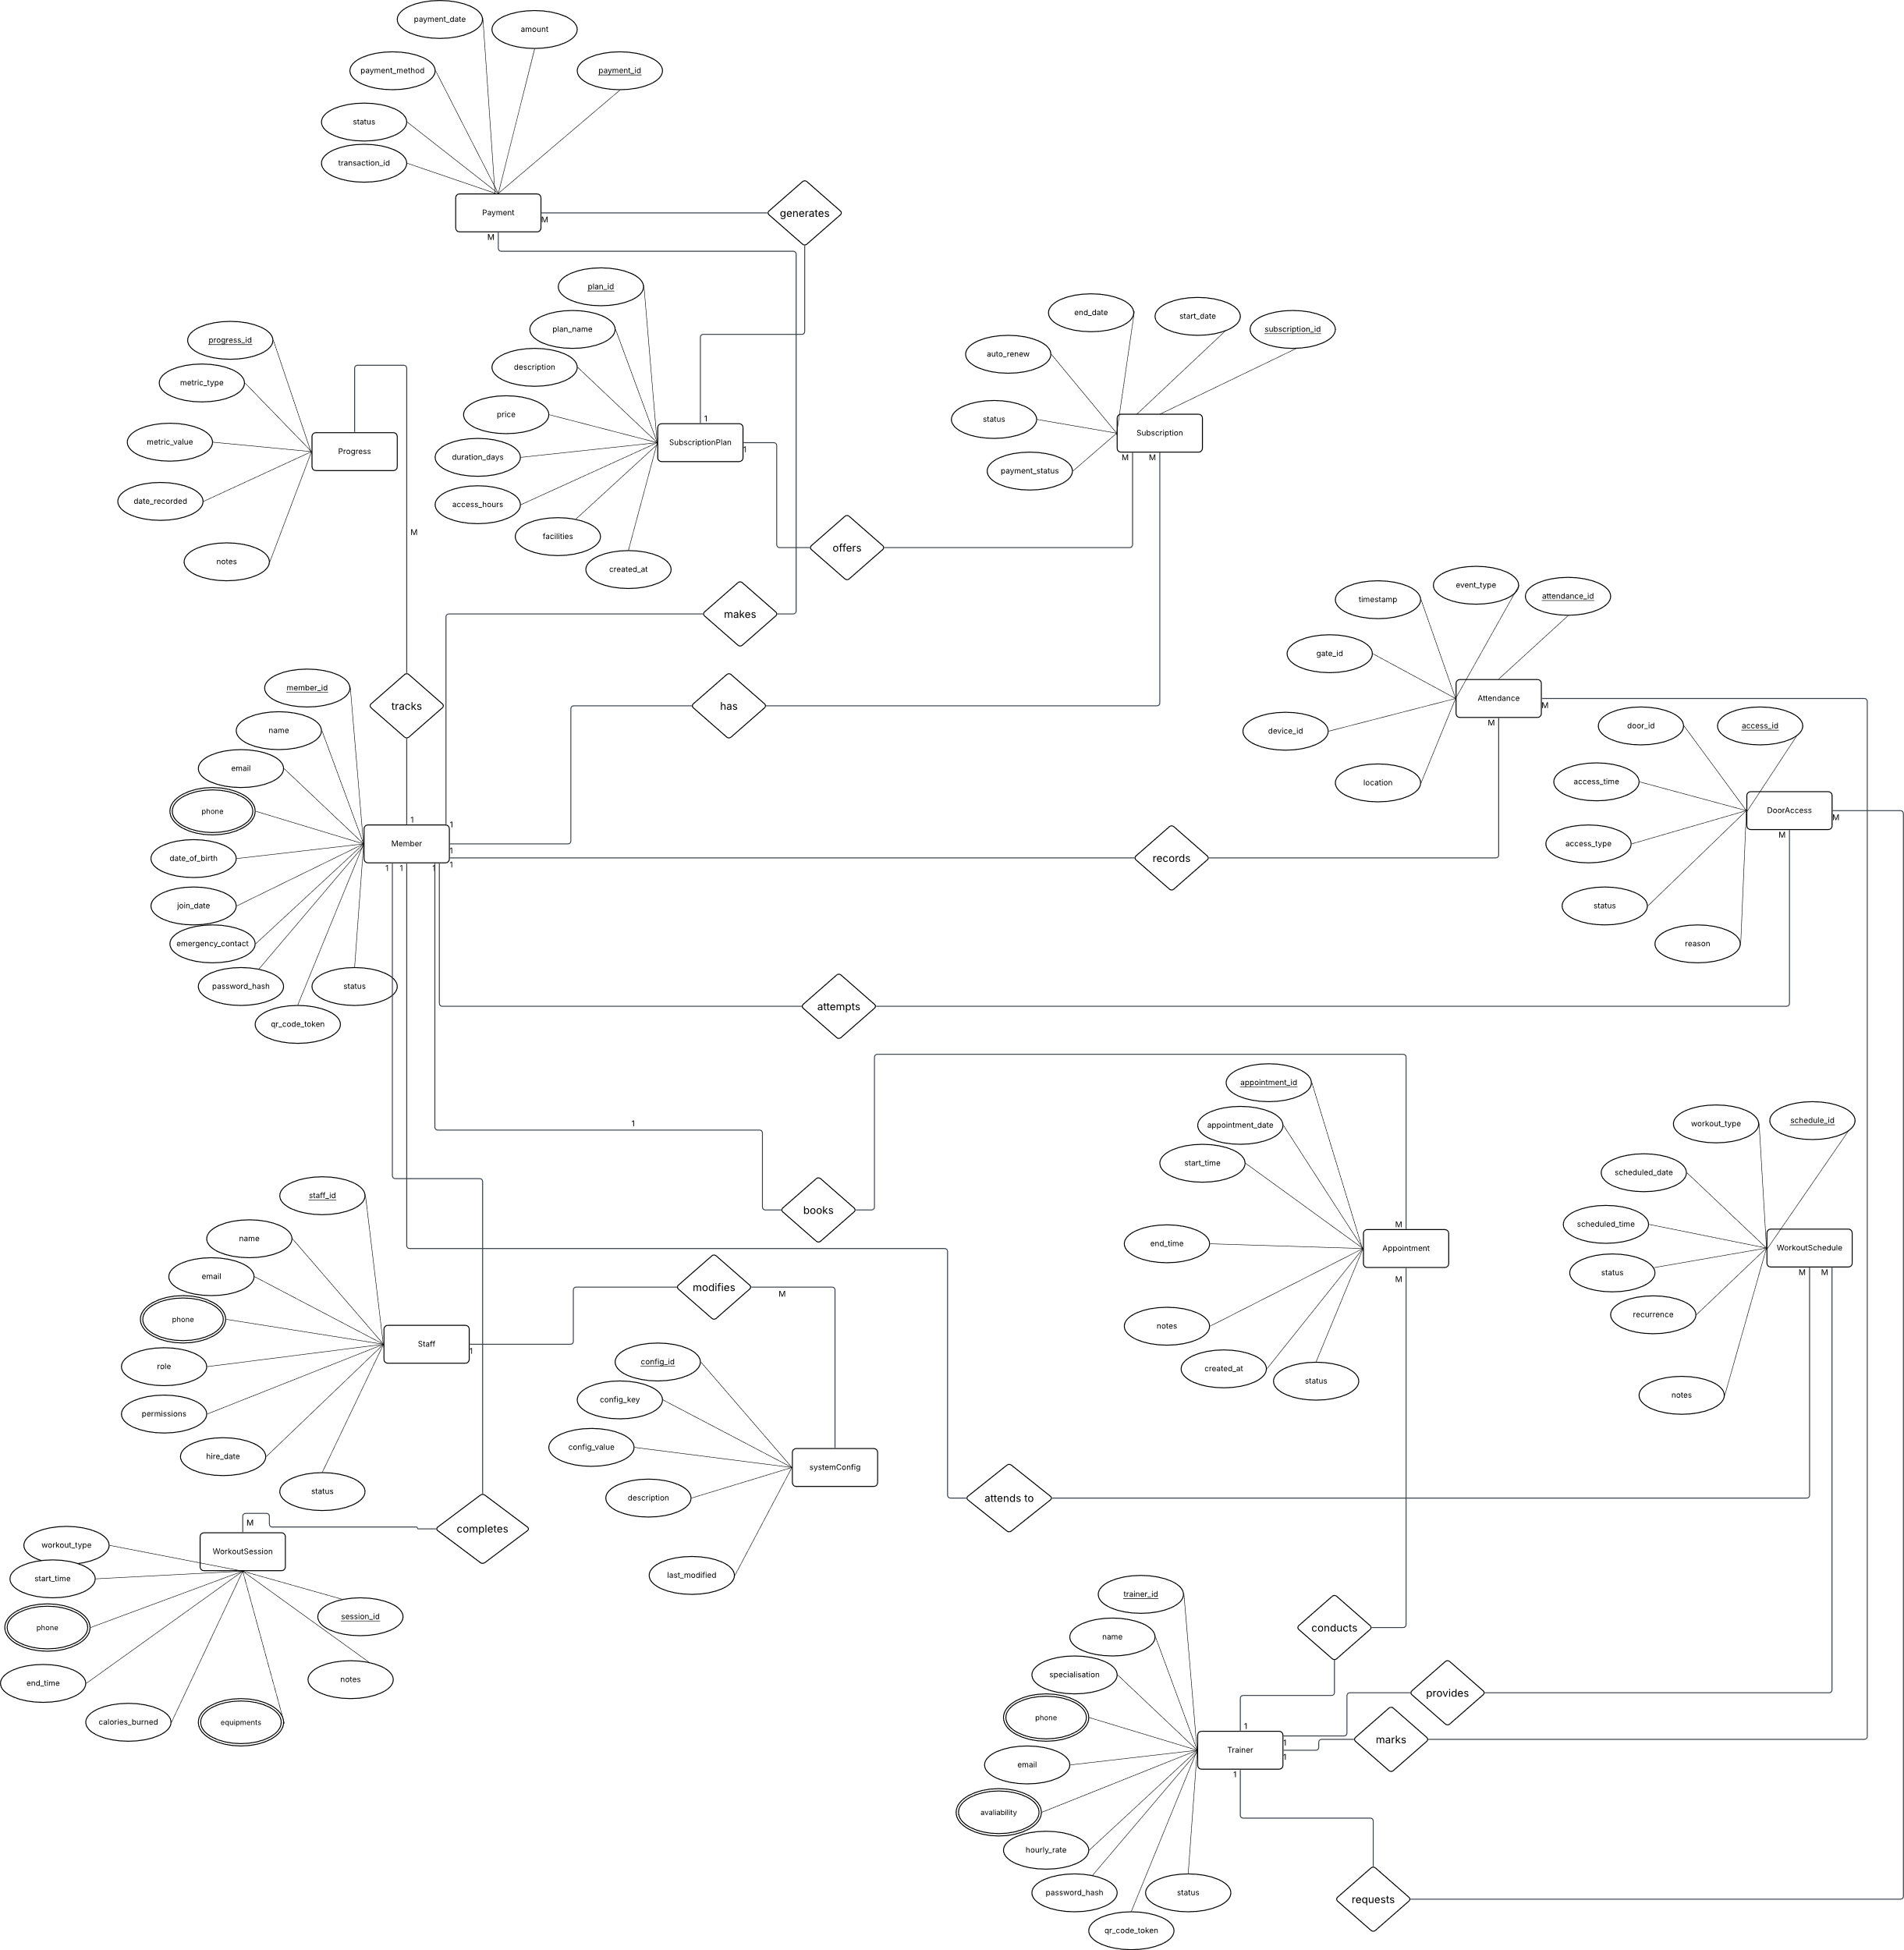
Relational Data Model
The ER diagram forms the basis of the relational model, converting entities and relationships into tables with fields and keys for efficient data management.

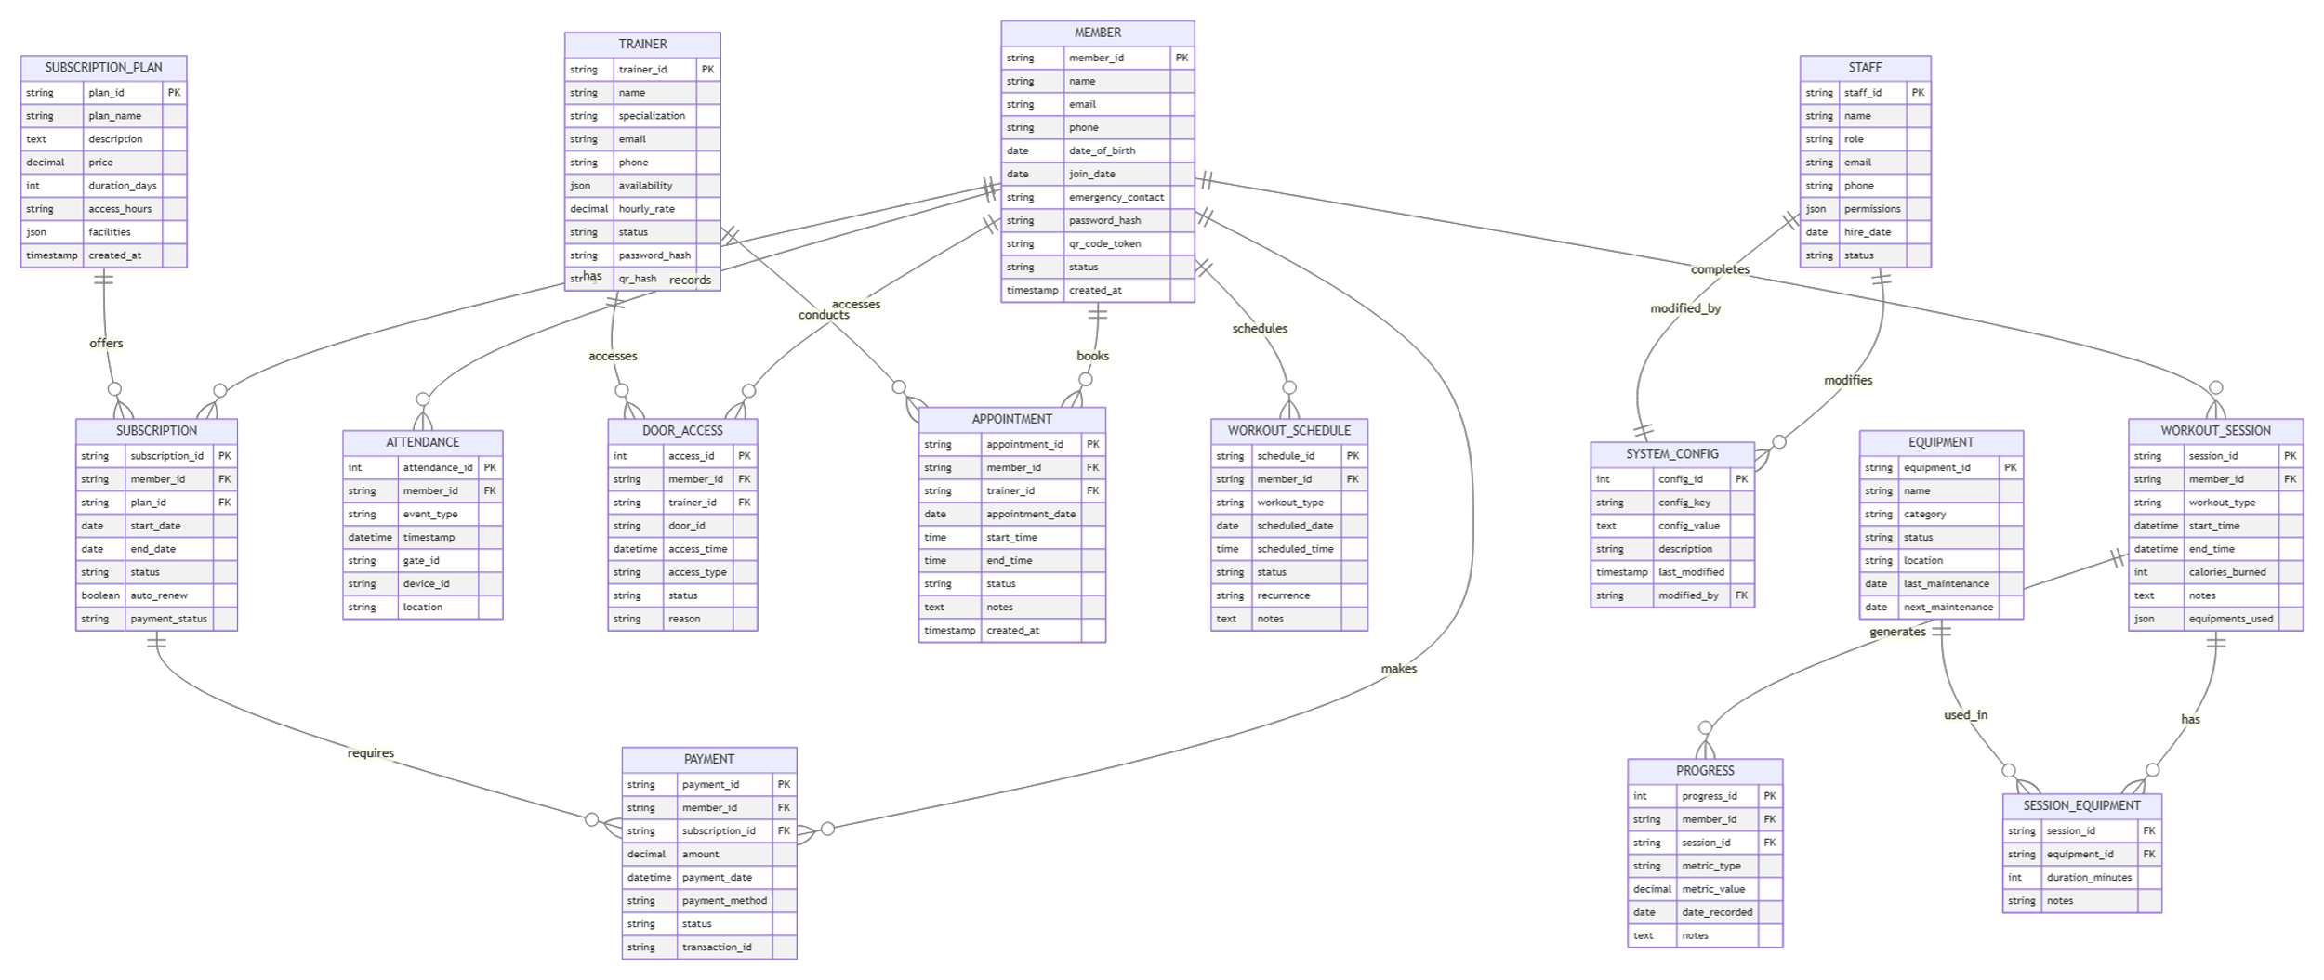

Complete Data Dictionary
A data dictionary is a detailed description of the structure of a database. It defines each table, its fields, data types, constraints, and relationships. By using the data dictionary, the database can be accurately understood, maintained, and rebuilt if needed.

MEMBER Table
Description: Stores all gym member information and authentication details
Column Name | Data Type | Constraints | Description | Example
member_id | VARCHAR(20) | PRIMARY KEY | Unique member identifier | MEM001
name | VARCHAR(100) | NOT NULL | Full name of member | John Smith
email | VARCHAR(100) | UNIQUE, NOT NULL | Contact email | john.smith@email.com
phone | VARCHAR(15) | NULL | Phone number | +94123456789
date_of_birth | DATE | NULL | Birth date | 1990-05-15
join_date | DATE | NOT NULL | Membership start date | 2024-01-15
emergency_contact | VARCHAR(100) | NULL | Emergency contact | Jane Smith - 0771234567
password_hash | VARCHAR(255) | NULL | Hashed password | bcrypt hash
qr_code_token | VARCHAR(100) | UNIQUE | QR code token | qr_abc123def456
status | ENUM('active','inactive','suspended') | DEFAULT 'active' | Status | active
created_at | TIMESTAMP | DEFAULT CURRENT_TIMESTAMP | Creation timestamp | 2024-01-15 09:30:00

TRAINER Table
Description: Stores trainer information and authentication details
Column Name | Data Type | Constraints | Description | Example
trainer_id | VARCHAR(10) | PRIMARY KEY | Unique trainer identifier | TRN001
name | VARCHAR(100) | NOT NULL | Full name | Sarah Johnson
specialization | VARCHAR(100) | NULL | Specialization | Weightlifting, Yoga
email | VARCHAR(100) | UNIQUE, NOT NULL | Contact email | sarah.j@email.com
phone | VARCHAR(15) | NULL | Phone number | +94123456788
availability | JSON | NULL | Availability schedule | {"mon": ["09:00-17:00"]}
hourly_rate | DECIMAL(8,2) | NULL | Hourly rate | 2500.00
status | ENUM('active','inactive') | DEFAULT 'active' | Status | active
password_hash | VARCHAR(255) | NULL | Hashed password | bcrypt hash
qr_hash | VARCHAR(100) | UNIQUE | QR hash for access | qr_trainer_xyz789

STAFF Table
Description: Stores staff members information and roles
Column Name | Data Type | Constraints | Description | Example
staff_id | VARCHAR(10) | PRIMARY KEY | Unique staff identifier | STF001
name | VARCHAR(100) | NOT NULL | Full name | Mike Davis
role | ENUM('admin','instructor','receptionist','manager') | NOT NULL | Staff role | admin
email | VARCHAR(100) | UNIQUE, NOT NULL | Contact email | mike.d@email.com
phone | VARCHAR(15) | NULL | Phone number | +94123456787
permissions | JSON | NULL | Permissions | {"can_manage_members": true}
hire_date | DATE | NOT NULL | Hire date | 2023-06-01
status | ENUM('active','inactive') | DEFAULT 'active' | Status | active

SUBSCRIPTION_PLAN Table
Description: Stores available subscription plans and pricing
Column Name | Data Type | Constraints | Description | Example
plan_id | VARCHAR(10) | PRIMARY KEY | Unique plan identifier | PLAN001
plan_name | VARCHAR(50) | NOT NULL | Plan name | Basic Monthly
description | TEXT | NULL | Plan description | Access to gym equipment
price | DECIMAL(10,2) | NOT NULL | Price | 3000.00
duration_days | INT | NOT NULL | Duration in days | 30
access_hours | VARCHAR(100) | NULL | Access hours | 06:00-22:00
facilities | JSON | NULL | Facilities access | {"gym": true, "pool": false}
created_at | TIMESTAMP | DEFAULT CURRENT_TIMESTAMP | Creation time | 2024-01-01 00:00:00

SUBSCRIPTION Table
Description: Stores member subscription records and status
Column Name | Data Type | Constraints | Description | Example
subscription_id | VARCHAR(20) | PRIMARY KEY | Unique subscription ID | SUB00120240115
member_id | VARCHAR(20) | FOREIGN KEY | Member reference | MEM001
plan_id | VARCHAR(10) | FOREIGN KEY | Plan reference | PLAN001
start_date | DATE | NOT NULL | Start date | 2024-01-15
end_date | DATE | NOT NULL | End date | 2024-02-14
status | ENUM('active','expired','cancelled') | DEFAULT 'active' | Status | active
auto_renew | BOOLEAN | DEFAULT TRUE | Auto-renewal | true
payment_status | ENUM('paid','pending','failed') | DEFAULT 'pending' | Payment status | paid

ATTENDANCE Table
Description: Records member check-in and check-out timestamps
Column Name | Data Type | Constraints | Description | Example
attendance_id | INT | PRIMARY KEY, AUTO_INCREMENT | Unique attendance ID | 1
member_id | VARCHAR(20) | FOREIGN KEY | Member reference | MEM001
event_type | ENUM('IN','OUT') | NOT NULL | Event type | IN
timestamp | DATETIME | NOT NULL | Event time | 2024-01-15 08:30:00
gate_id | VARCHAR(10) | NULL | Gate identifier | GATE01
device_id | VARCHAR(20) | NULL | Device identifier | SCANNER01
location | VARCHAR(50) | NULL | Location | Main Entrance

DOOR_ACCESS Table
Description: Records door access attempts for members and trainers
Column Name | Data Type | Constraints | Description | Example
access_id | INT | PRIMARY KEY, AUTO_INCREMENT | Unique access ID | 1
member_id | VARCHAR(20) | FOREIGN KEY, NULL | Member reference | MEM001
trainer_id | VARCHAR(10) | FOREIGN KEY, NULL | Trainer reference | TRN001
door_id | VARCHAR(10) | NOT NULL | Door identifier | DOOR01
access_time | DATETIME | NOT NULL | Access time | 2024-01-15 08:30:00
access_type | ENUM('entry','exit') | NOT NULL | Access type | entry
status | ENUM('granted','denied') | NOT NULL | Access status | granted
reason | VARCHAR(200) | NULL | Reason for denial | Subscription expired

APPOINTMENT Table
Description: Stores trainer appointments and scheduling information
Column Name | Data Type | Constraints | Description | Example
appointment_id | VARCHAR(20) | PRIMARY KEY | Unique appointment ID | APP00120240115
member_id | VARCHAR(20) | FOREIGN KEY | Member reference | MEM001
trainer_id | VARCHAR(10) | FOREIGN KEY | Trainer reference | TRN001
appointment_date | DATE | NOT NULL | Appointment date | 2024-01-15
start_time | TIME | NOT NULL | Start time | 09:00:00
end_time | TIME | NOT NULL | End time | 10:00:00
status | ENUM('scheduled','completed','cancelled','no-show') | DEFAULT 'scheduled' | Status | scheduled
notes | TEXT | NULL | Notes | Initial consultation
created_at | TIMESTAMP | DEFAULT CURRENT_TIMESTAMP | Creation time | 2024-01-10 14:00:00

WORKOUT_SCHEDULE Table
Description: Stores scheduled workouts for members
Column Name | Data Type | Constraints | Description | Example
schedule_id | VARCHAR(20) | PRIMARY KEY | Unique schedule ID | WS00120240115
member_id | VARCHAR(20) | FOREIGN KEY | Member reference | MEM001
workout_type | VARCHAR(50) | NOT NULL | Workout type | Cardio
scheduled_date | DATE | NOT NULL | Scheduled date | 2024-01-15
scheduled_time | TIME | NULL | Scheduled time | 08:00:00
status | ENUM('pending','completed','skipped') | DEFAULT 'pending' | Status | pending
recurrence | ENUM('none','daily','weekly','monthly') | DEFAULT 'none' | Recurrence | none
notes | TEXT | NULL | Notes | Morning run

WORKOUT_SESSION Table
Description: Records completed workout sessions with equipment usage
Column Name | Data Type | Constraints | Description | Example
session_id | VARCHAR(20) | PRIMARY KEY | Unique session ID | SESS00120240115
member_id | VARCHAR(20) | FOREIGN KEY | Member reference | MEM001
workout_type | VARCHAR(50) | NOT NULL | Workout type | Strength Training
start_time | DATETIME | NOT NULL | Start time | 2024-01-15 08:30:00
end_time | DATETIME | NULL | End time | 2024-01-15 09:30:00
calories_burned | INT | NULL | Calories burned | 450
notes | TEXT | NULL | Notes | Chest and triceps
equipments_used | JSON | NULL | Equipment used | [{"equipment": "Bench Press", "duration": 20}]

PROGRESS Table
Description: Tracks member progress metrics and measurements
Column Name | Data Type | Constraints | Description | Example
progress_id | INT | PRIMARY KEY, AUTO_INCREMENT | Unique progress ID | 1
member_id | VARCHAR(20) | FOREIGN KEY | Member reference | MEM001
session_id | VARCHAR(20) | FOREIGN KEY, NULL | Session reference | SESS00120240115
metric_type | VARCHAR(50) | NOT NULL | Metric type | weight, body_fat
metric_value | DECIMAL(10,2) | NOT NULL | Metric value | 75.5
date_recorded | DATE | NOT NULL | Date recorded | 2024-01-15
notes | TEXT | NULL | Notes | After workout

PAYMENT Table
Description: Stores payment records and transaction details
Column Name | Data Type | Constraints | Description | Example
payment_id | VARCHAR(20) | PRIMARY KEY | Unique payment ID | PAY00120240115
member_id | VARCHAR(20) | FOREIGN KEY | Member reference | MEM001
subscription_id | VARCHAR(20) | FOREIGN KEY | Subscription reference | SUB00120240115
amount | DECIMAL(10,2) | NOT NULL | Payment amount | 3000.00
payment_date | DATETIME | NOT NULL | Payment date | 2024-01-15 10:00:00
payment_method | VARCHAR(50) | NOT NULL | Payment method | credit_card
status | ENUM('success','failed','pending') | NOT NULL | Payment status | success
transaction_id | VARCHAR(100) | NULL | Transaction ID | txn_123456

SYSTEM_CONFIG Table
Description: Stores system configuration settings and parameters
Column Name | Data Type | Constraints | Description | Example
config_id | INT | PRIMARY KEY, AUTO_INCREMENT | Unique config ID | 1
config_key | VARCHAR(100) | UNIQUE, NOT NULL | Configuration key | gym.opening.hours
config_value | TEXT | NOT NULL | Configuration value | 06:00-22:00
description | VARCHAR(200) | NULL | Description | Gym opening hours
last_modified | TIMESTAMP | DEFAULT CURRENT_TIMESTAMP ON UPDATE | Last modified | 2024-01-15 12:00:00
modified_by | VARCHAR(10) | FOREIGN KEY | Staff who modified | STF001

EQUIPMENT Table
Description: Stores gym equipment information and maintenance records
Column Name | Data Type | Constraints | Description | Example
equipment_id | VARCHAR(10) | PRIMARY KEY | Unique equipment ID | EQ001
name | VARCHAR(100) | NOT NULL | Equipment name | Treadmill
category | VARCHAR(50) | NULL | Category | Cardio
status | ENUM('active','maintenance','inactive') | DEFAULT 'active' | Status | active
location | VARCHAR(50) | NULL | Location | Cardio Zone
last_maintenance | DATE | NULL | Last maintenance | 2024-01-01
next_maintenance | DATE | NULL | Next maintenance | 2024-02-01

SESSION_EQUIPMENT Table
Description: Links workout sessions with equipment used.
Column Name | Data Type | Constraints | Description | Example
session_id | VARCHAR(20) | FOREIGN KEY, PRIMARY KEY | Session reference | SESS00120240115
equipment_id | VARCHAR(10) | FOREIGN KEY, PRIMARY KEY | Equipment reference | EQ001
duration_minutes | INT | NOT NULL | Duration of use | 30
notes | VARCHAR(200) | NULL | Usage notes | Used for warm-up

Sequence Diagrams
Sequence diagrams illustrate the step-by-step interactions between system components during a process. They show how messages are exchanged between actors and the system over time, making the flow of activities and system behavior easier to understand.

UC-01: Scan QR Code - Sequence Diagram

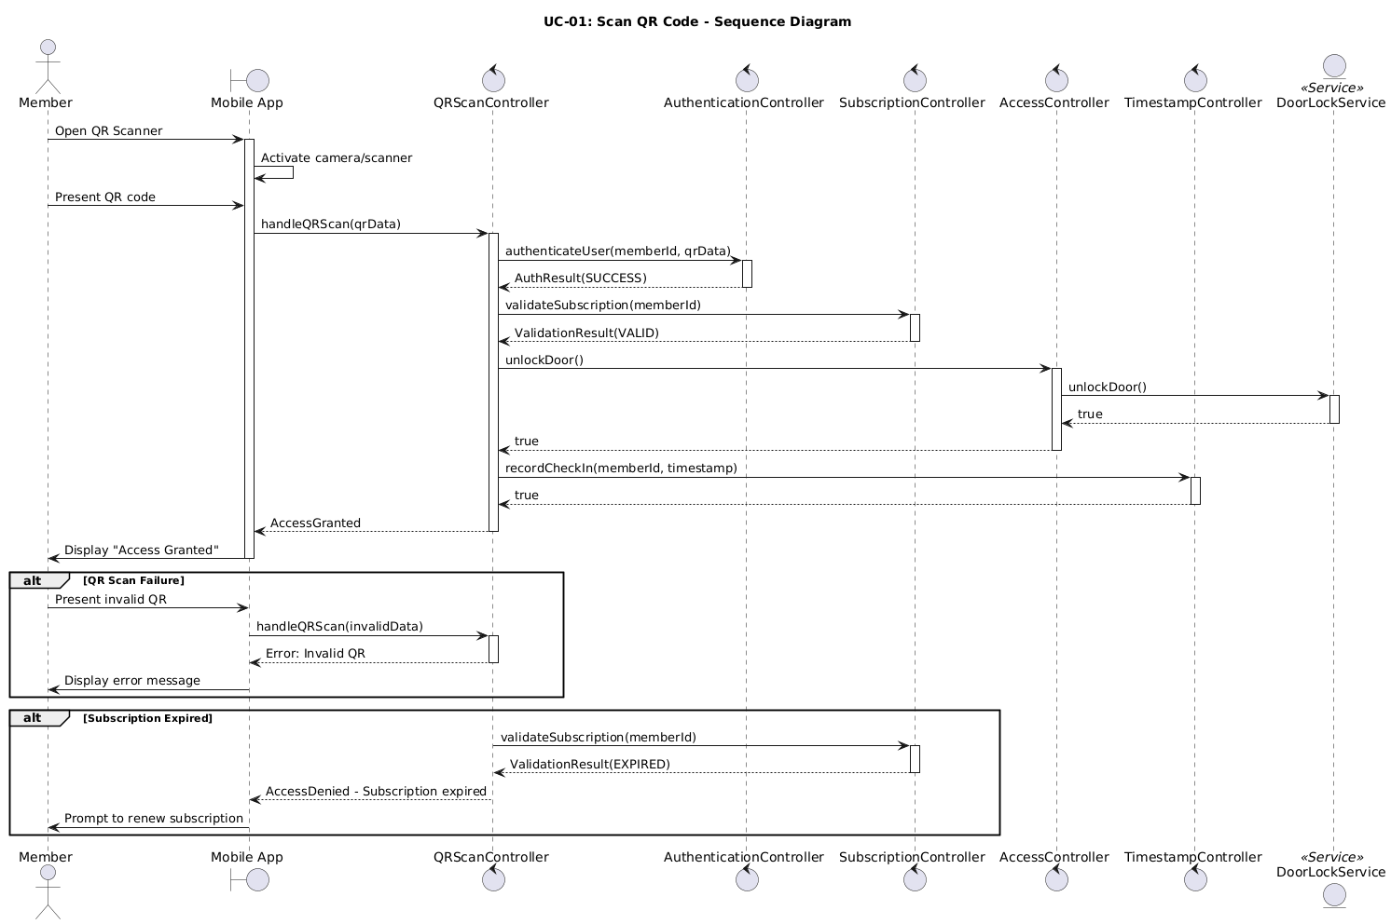

UC-02: Validate Subscription - Sequence Diagram

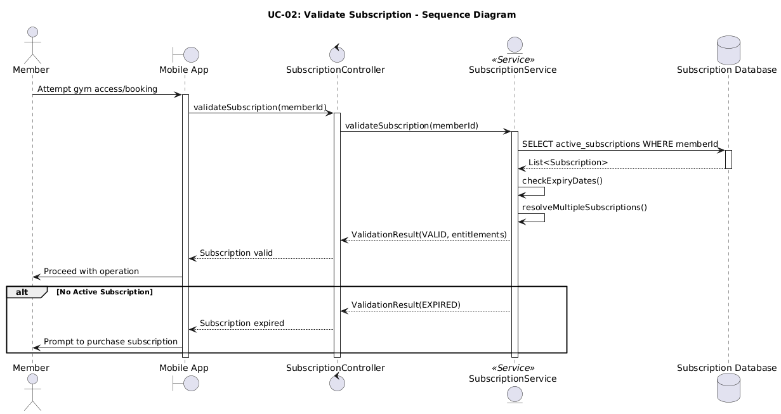

UC-03: Authenticate User - Sequence Diagram

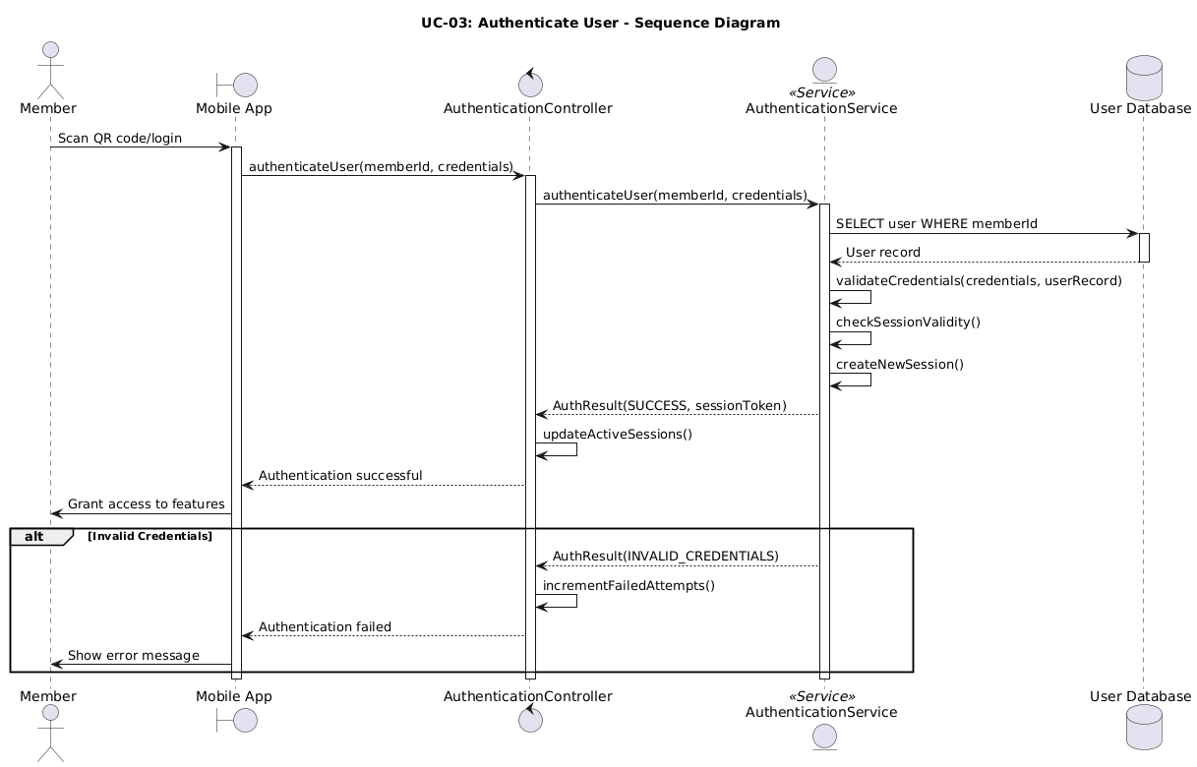

UC-04: Record Timestamp - Sequence Diagram

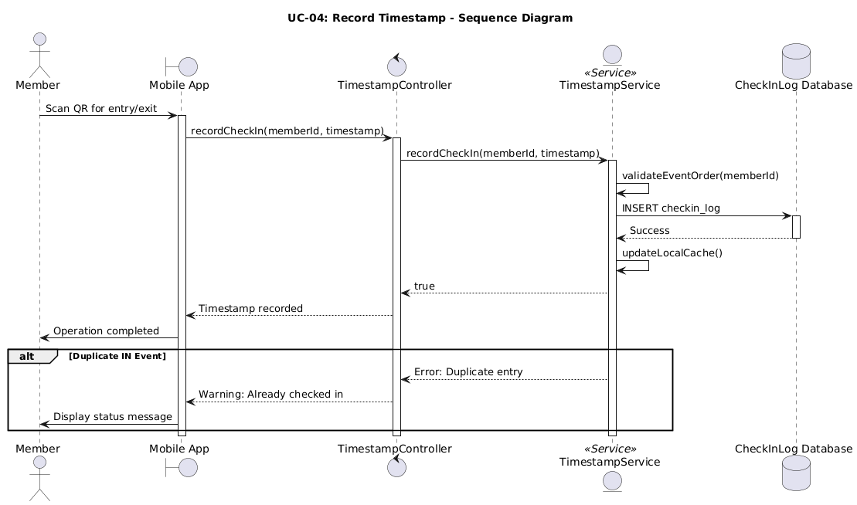

UC-05: Buy Subscription - Sequence Diagram

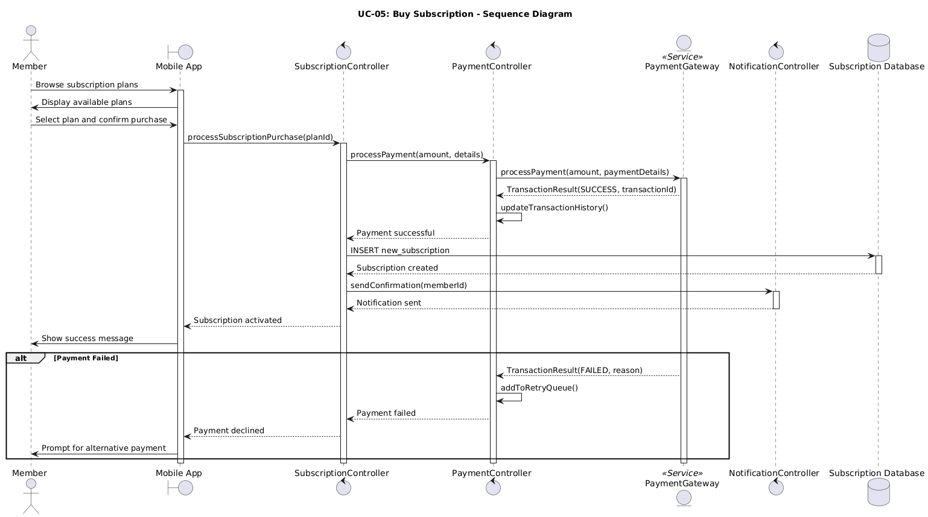

UC-06: Make an Appointment - Sequence Diagram

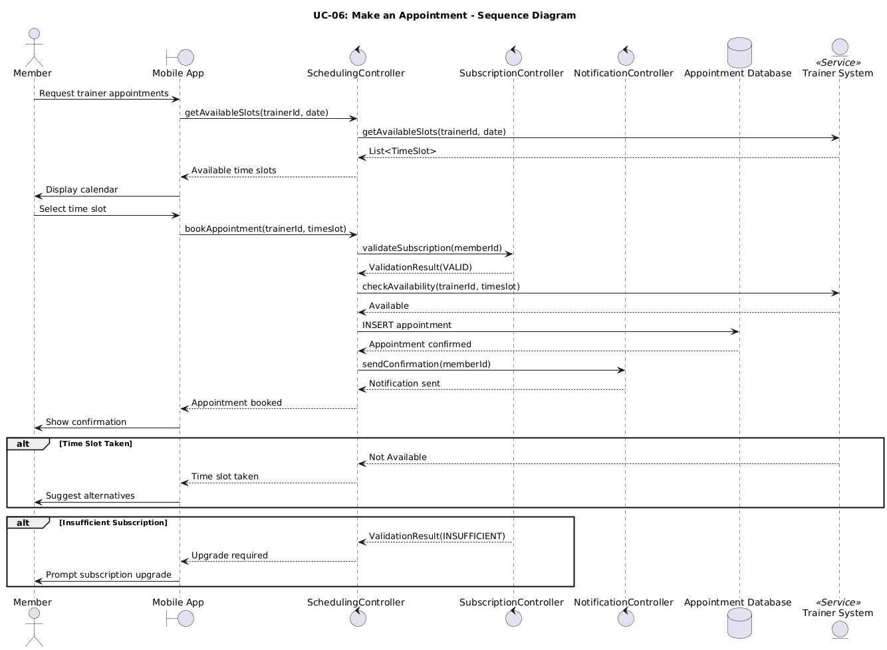

UC-07: Mark Workout Done - Sequence Diagram

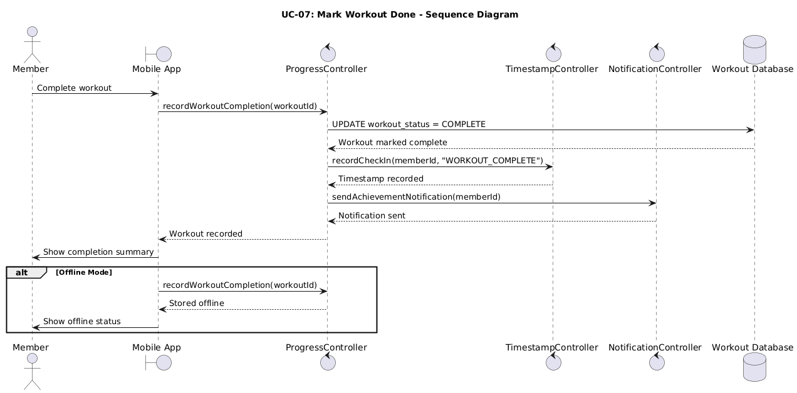

UC-08: View/Track Progress - Sequence Diagram

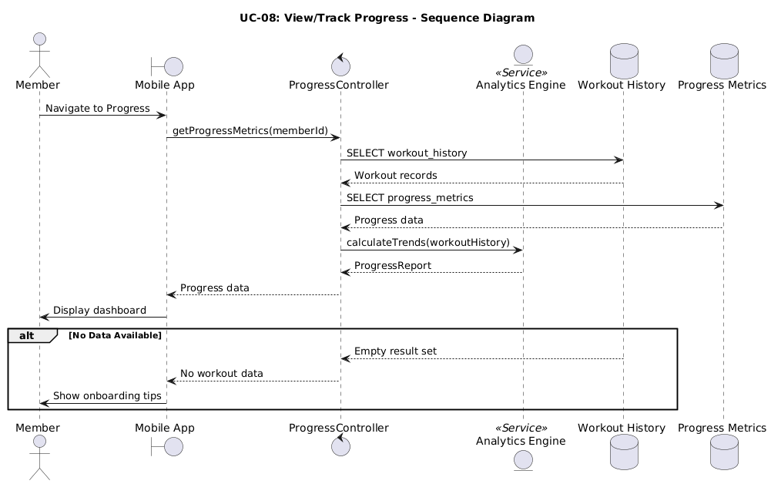

UC-09: Enter/Leave Gym (Staff) - Sequence Diagram

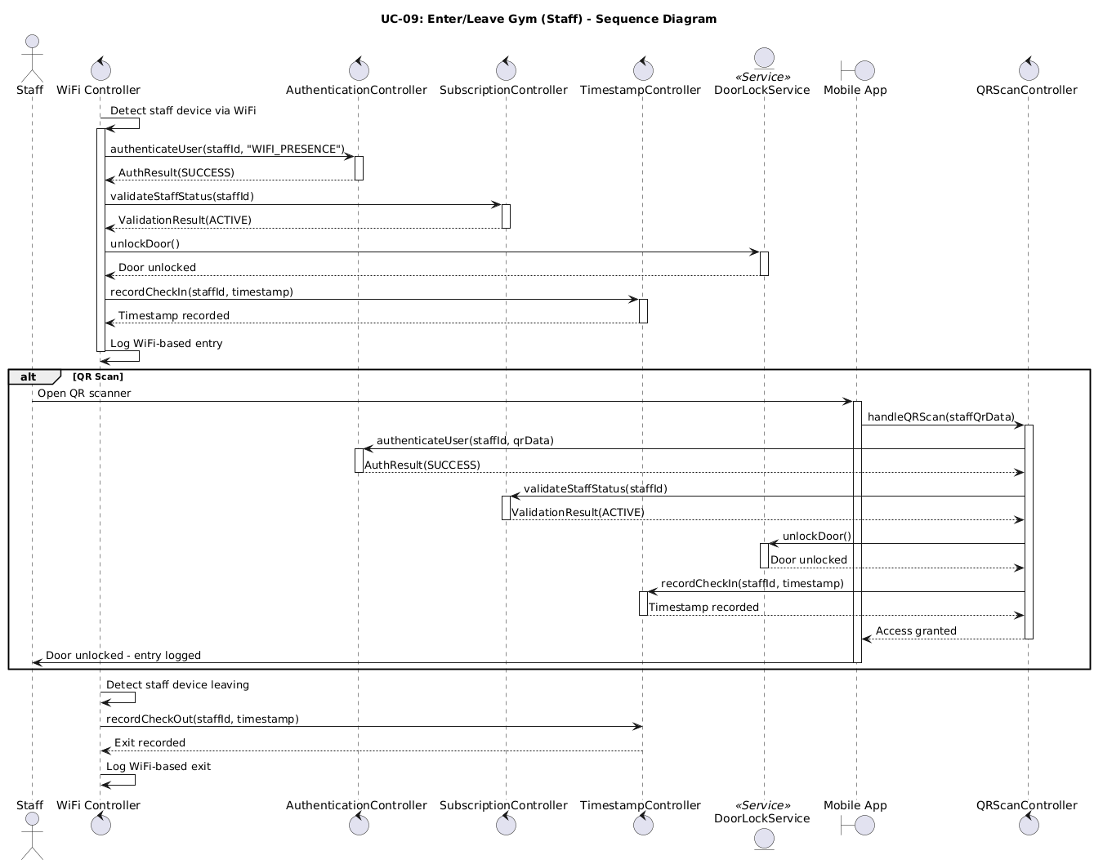

UC-10: Change/Modify Workout Schedule - Sequence Diagram

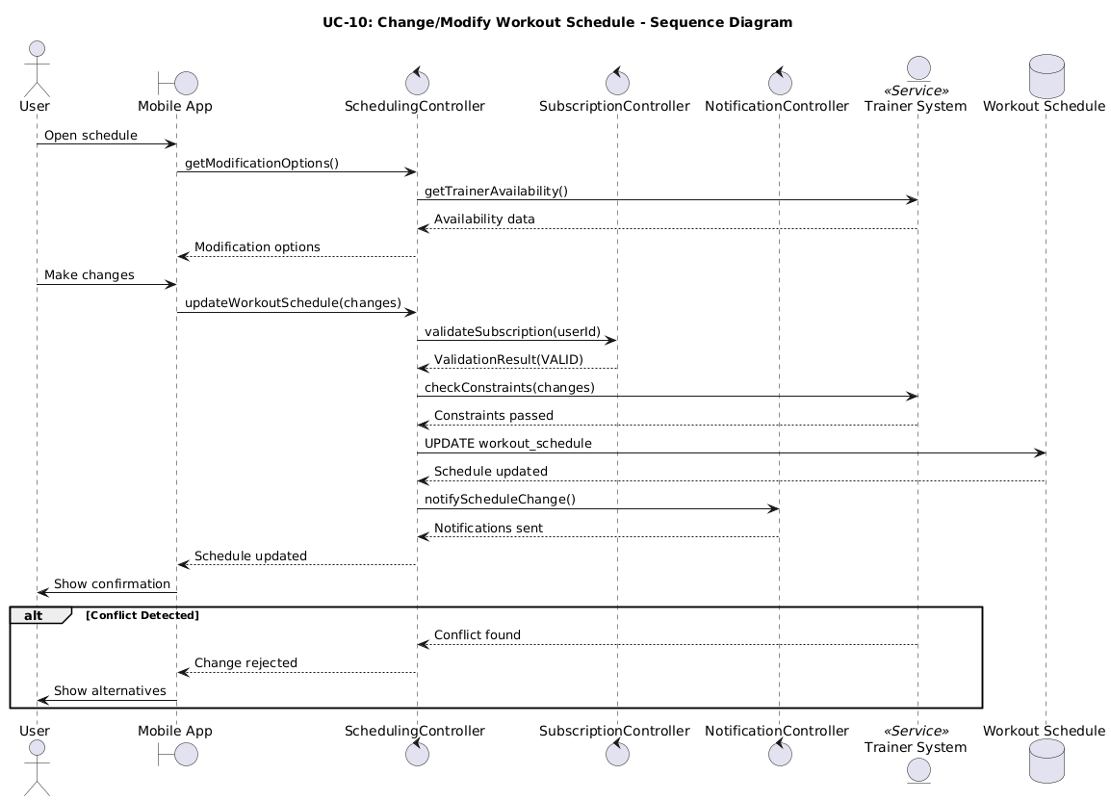

UC-11: View Insights - Sequence Diagram

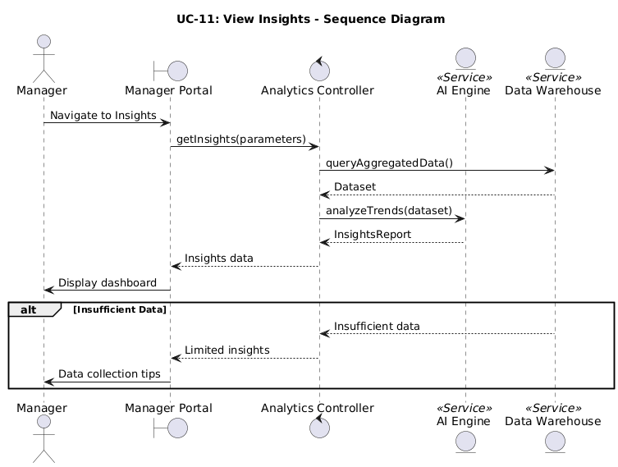

UC-12: Access Detailed Reports - Sequence Diagram

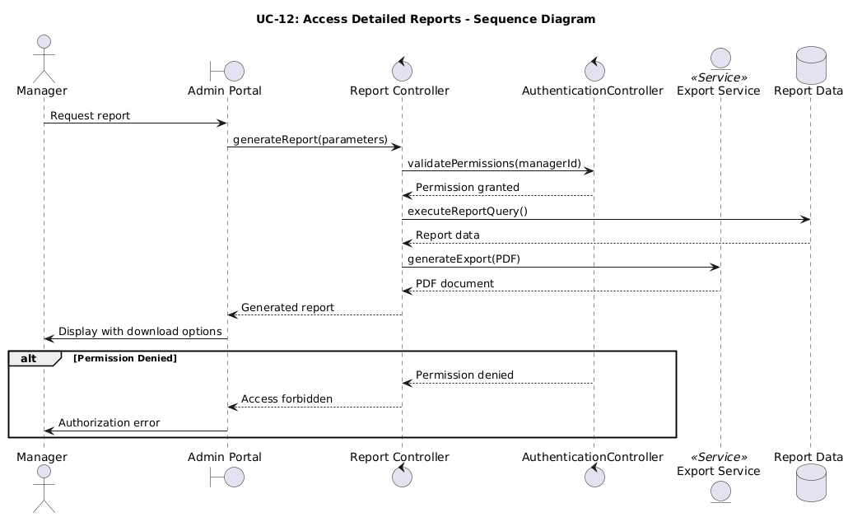

UC-13: Manage Entire System - Sequence Diagram





