

Proposed System Analysis
  - Power world gym - kiribathgoda
IM/2022/001 – A.M.K.C.S.B. Abeykoon

Introduction

The proposed Gym Management System is designed to address the inefficiencies identified in the current manual and semi-digital processes at Power World Gym. The existing system relies heavily on physical registration cards, paper-based attendance logs, and static workout schedules, which limit accuracy, monitoring, and member engagement. These outdated methods also make it difficult for administrators and instructors to track member activities, manage subscriptions effectively, and provide personalized support.
To overcome these challenges, the new system integrates features such as QR-based member authentication, automated subscription validation, real-time attendance tracking, workout scheduling, and progress monitoring. It further supports advanced functionalities like trainer appointments, progress analytics, detailed reporting, and centralized administrative control. By streamlining operations and digitizing core workflows, the proposed solution ensures efficiency, security, and improved member experience while providing management with valuable insights for decision-making.

Use-Case Diagram

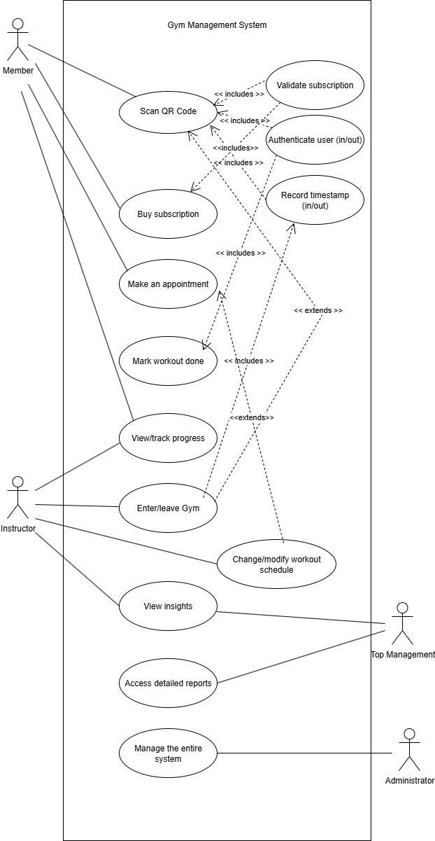

Use Case Descriptors

UC-01 — Scan QR Code

Field | Description
Brief | Member scans a gym QR code (at the entrance) so the system can identify them, validate membership and log their arrival/departure.
Primary actor | Member (or Staff scanning on member’s behalf)
Secondary actors | Gym System (backend), QR scanner device (mobile app), Authentication service, Subscription service, Timestamp service, Door unlocking system
Preconditions | Member has a valid account in the system; QR code is displayed using a display; network available.
Postconditions (success) | Member is authenticated (door opened), subscription validated, and entrance (or exit) timestamp is recorded.
Postconditions (failure) | Scan fails or authentication/validation fails; no timestamp recorded; member is shown an error and instructions.
Trigger | Member (or staff) presents QR; device scans it.
Main success scenario | 1. Member opens scanner or presents printed QR to kiosk.  2. Scanner reads QR code (memberID / session token / check-in code).  3. System fetches member profile using QR data.  4. System calls Validate subscription (UC-02).  5. System calls Authenticate user (UC-03) to confirm identity/session.  6. System calls to unlock the door.  7. System calls Record timestamp (UC-04) to log arrival/exit.
Extensions / alternate flows | QR unreadable → scanner asks to retry or type member ID.  Subscription invalid/expired → prompt to Buy subscription (UC-05) or display restricted access message.  Authentication fails → display the error message.  Timestamp logging unavailable → store locally.
Special requirements | Secure QR code (signed or one-time token), rate-limiting to prevent replay, low-latency response at gym entrance, clear accessible UI messages.
Notes | Diagram shows this use case includes UC-02, UC-03 and UC-04.

UC-02 — Validate subscription

Field | Description
Brief | Check membership/subscription status and entitlements for a member.
Primary actor | Gym System (triggered by other use cases)
Secondary actors | Billing/subscriptions service, Payment gateway, Membership database
Preconditions | Member record exists; subscription data available.
Postconditions (success) | Returns valid/invalid status and entitlements (access hours, facility restrictions).
Postconditions (failure) | Unable to determine status (service down) or subscription not valid.
Trigger | Called by scanning, entry attempts, or feature access requests (e.g., booking class).
Main success scenario | 1. Request arrives with member ID.  2. Service looks up active subscriptions and entitlements.  3. Service returns validation result and expiry/limits.
Extensions / alternate flows | Member has multiple subscriptions — resolve priority and return effective entitlement.  Any failure → return error code and message prompting user action (renew, contact support).

UC-03 — Authenticate user (in/out)

Field | Description
Brief | Verify the identity of the person scanning in/out and opening the door.
Primary actor | Member; Staff (for manual auth)
Secondary actors | Authentication service, Identity provider (IDP), device (mobile)
Preconditions | Member has authentication credentials.
Postconditions (success) | Member is marked authenticated, door unlocked.
Postconditions (failure) | Authentication denied; entry blocked.
Trigger | Called by Scan QR Code.
Main success scenario | 1. Member scans the QR Code and door unlocks.
Extensions / alternate flows | 1. Invalid QR Code.  2. Subscription Expired.  3. QR Code Timed out.

UC-04 — Record timestamp (in/out)

Field | Description
Brief | Create a log entry for member arrival or departure.
Primary actor | Gym System (backend), triggered by scan/auth events
Secondary actors | Time-series database, member profile service
Preconditions | Member authenticated and subscription validated (if required).
Postconditions (success) | Persistent timestamp record with memberID, time, location and event type (IN/OUT).
Postconditions (failure) | No record created.
Trigger | Authentication success; manual check-in/out by staff; scheduled auto-checkout.
Main success scenario | 1. Received event (memberID, IN/OUT).  2. Validate event ordering (prevent duplicate INs or OUTs).  3. Persist timestamp with metadata (deviceID, gateID).  4. Return acknowledgement.
Extensions / alternate flows | Duplicate IN detected → flag for staff review and optionally deny second IN.  DB write fails → notify the administrator.

UC-05 — Buy subscription

Field | Description
Brief | Member purchases or renews a subscription via the app or website.
Primary actor | Member
Secondary actors | Payment gateway, Billing service, Validate subscription (UC-02), Email/notification service
Preconditions | Member account exists; payment method available.
Postconditions (success) | Subscription becomes active or extended and member receives confirmation; subscription data updated in system.
Postconditions (failure) | Payment fails; system rolls back partial changes; member notified.
Trigger | Member selects new plan or renewal from UI.
Main success scenario | 1. Member selects plan and payment method.  2. System shows price & terms; member confirms.  3. System processes payment via gateway.  4. Billing service activates subscription and updates member record.  5. System calls Validate subscription to ensure new status is visible.  6. Confirmation sent to member.
Extensions / alternate flows | Payment declined → show error, allow retry or alternate payment.  Activation fails → scheduled activation and notify member with expected time.

UC-06 — Make an appointment

Field | Description
Brief | Member schedules a trainer appointment.
Primary actor | Member, Instructor
Secondary actors | Scheduling system, Trainer/staff, Validate subscription (UC-02), Notification service, Record timestamp (UC-04)
Preconditions | Member authenticated; scheduling data (availability) up-to-date.
Postconditions (success) | Appointment is created, calendar updated, notifications sent to member/trainer.
Postconditions (failure) | Time slot unavailable; appointment not created.
Trigger | Member selects time slot and preferred instructor in app.
Main success scenario | 1. Member browses available slots, instructor and selects one.  2. System verifies member entitlement via Validate subscription.  3. System confirms slot availability and reserves it.  4. System saves appointment and notifies participants.  5. Optionally, system may create a calendar entry and reminder.
Extensions / alternate flows | Insufficient entitlement → prompt to upgrade subscription (UC-05).  Slot was taken concurrently → present next available alternatives.  Member cancels → apply cancellation policy and notify trainer.

UC-07 — Mark workout done

Field | Description
Brief | Member marks a scheduled workout or completed routine as done (for progress tracking).
Primary actor | Member
Secondary actors | Workout scheduler, Progress tracking module (UC-08), Record timestamp (UC-04), Notification service
Preconditions | Member has a workout scheduled or a routine to complete.
Postconditions (success) | Workout status marked complete, progress metrics updated, timestamp recorded.
Postconditions (failure) | System fails to update progress; member warned and retry option given.
Trigger | Member presses “Done” in app, or system auto-detects completion (optional) – upon leaving.
Main success scenario | 1. Member opens the session and marks it completed.  2. System verifies session identity and marks status complete.  3. System calls Record timestamp to log completion time.  4. Progress statistics are recalculated and updates shown to member.
Extensions / alternate flows | Member attempts to mark before required activities finished → prompt confirmation.  Offline → persist locally and sync later.

UC-08 — View / Track progress

Field | Description
Brief | Member views historical workout data, trends and statistics.
Primary actor | Member
Secondary actors | Progress analytics, Data storage, Mark workout done (UC-07)
Preconditions | Member has historical workout data (timestamps, routines, measurements).
Postconditions (success) | Dashboard is displayed with up-to-date metrics and visualizations.
Postconditions (failure) | Partial data shown with message, or no data if none exists.
Trigger | Member opens progress page.
Main success scenario | 1. Member navigates to progress screen.  2. System gathers activity history, workout completion, and measurement data.  3. Analytics engine computes trends (consistency, volume, personal records).  4. System displays graphs, summaries and suggestions.
Extensions / alternate flows | System permissions missing (e.g., wearable integration) → show authorized steps.  Insufficient data → show tips to get started.

UC-09 — Enter / Leave Gym

Field | Description
Brief | Use case representing physical access for staff; may extend or be realized by scanning QR, staff presence within gym.
Primary actor | Staff
Secondary actors | Door control system, Scan QR Code (UC-01), Record timestamp (UC-04), Wi-Fi
Preconditions | Door hardware functioning; Gym Wi-Fi connection is up and running.
Postconditions (success) | Staff member enters or leaves; access record logged.
Postconditions (failure) | Entry denied and staff alerted.
Trigger | Staff member attempts to enter or exit facility.
Main success scenario | 1. Member requests access (QR scan) or presence detected via Wi-Fi.  2. System validates and authenticates (UC-02, UC-03).  3. Door unlocks, and Record timestamp captures IN/OUT.

UC-10 — Change / Modify workout schedule

Field | Description
Brief | Member or instructor edits a workout plan.
Primary actor | Member; Instructor
Secondary actors | Workout scheduler, Notification service, Progress module
Preconditions | User authenticated and authorized to change the schedule.
Postconditions (success) | Schedule updated; affected participants notified.
Postconditions (failure) | Conflict detected and change rejected or queued for approval.
Trigger | User selects edit/reschedule.
Main success scenario | 1. User opens schedule and edits exercises/times.  2. System verifies constraints (trainer availability, subscription entitlements).  3. System saves changes and sends notifications.
Extensions / alternate flows | Conflicting appointments → present alternatives or request approval.

UC-11 — View insights

Field | Description
Brief | Instructor or manager views higher-level insights (trends, recommended actions, occupancy patterns).
Primary actor | Manager; Instructor
Secondary actors | Analytics engine (including AI), Data warehouse, Notifications
Preconditions | Sufficient aggregated data available.
Postconditions (success) | Insights generated and displayed; optionally action items suggested.
Postconditions (failure) | Insufficient data for certain insights → system limits results and suggests how to collect more.
Trigger | User opens Insights page or system sends proactive insights.
Main success scenario | 1. User requests insights.  2. System runs analytics on activity, attendance, and performance.  3. Results and suggestions displayed.

UC-12 — Access detailed reports

Field | Description
Brief | Managers or authorized staff generate/export detailed reports (attendance, revenue, utilization).
Primary actor | Manager / Admin
Secondary actors | Reporting subsystem, Database, Export service (PDF/CSV), Authentication/Authorization service
Preconditions | User has proper role and permissions.
Postconditions (success) | Report generated and downloadable; logs of access stored.
Postconditions (failure) | Report generation error; user informed.
Trigger | Manager selects report parameters and requests generation.
Main success scenario | 1. Manager picks report type, date range and filters.  2. System validates permission and retrieves data.  3. Report compiled and presented; export options provided.

UC-13 — Manage the entire system

Field | Description
Brief | Admin-level operations: configure facilities, user roles, pricing plans, hardware endpoints, and overall system settings.
Primary actor | System Administrator
Secondary actors | All subsystems (billing, auth, scheduler, door controllers)
Preconditions | Admin authenticated with appropriate privileges.
Postconditions (success) | System configuration updated; changes applied to dependent services.
Postconditions (failure) | Partial updates rolled back; admin alerted.
Trigger | Admin chooses management task (create plan, change pricing, add location).
Main success scenario | 1. Admin opens Admin console.  2. Admin selects a management function (e.g., create a subscription plan).  3. System validates inputs and saves changes.  4. System logs action and informs affected components/users if necessary.

Activity Diagrams

UC-01 — Scan QR Code

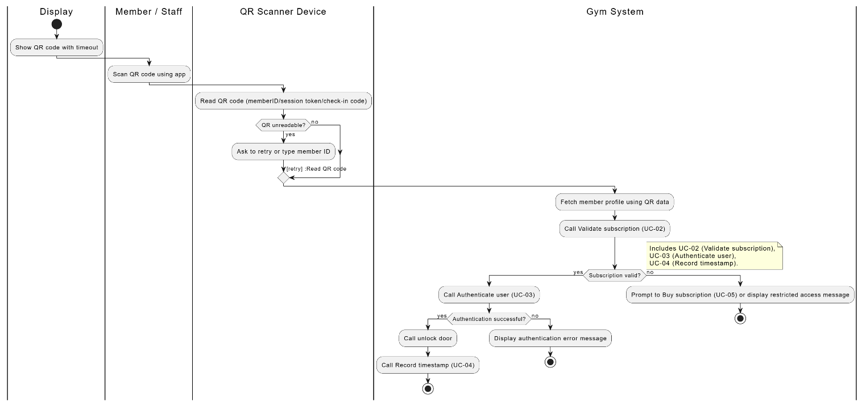

UC-02 — Validate subscription

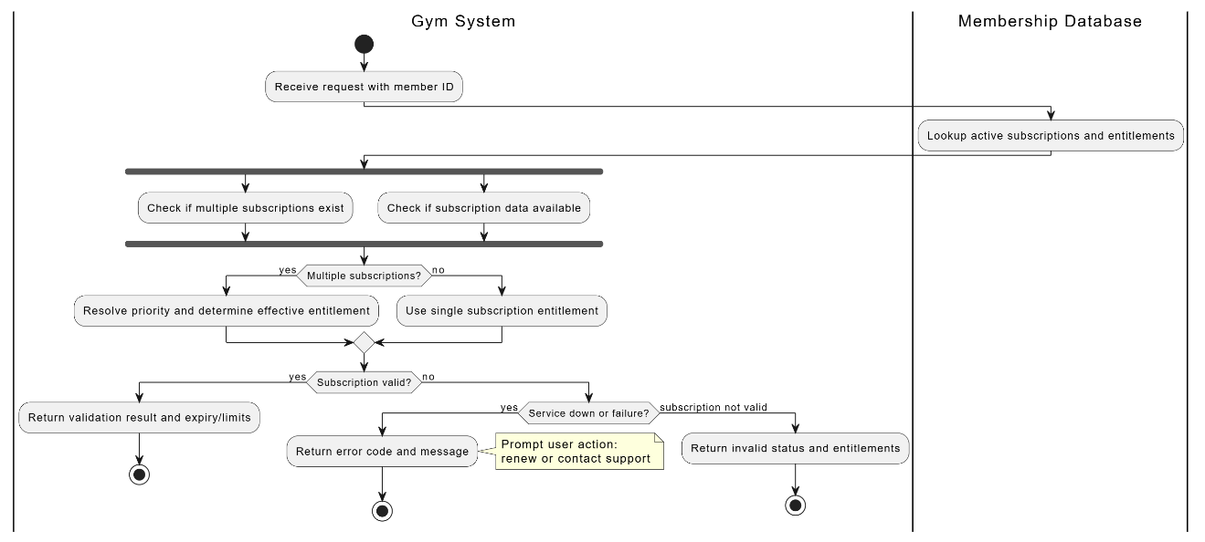

UC-03 — Authenticate user (in/out)

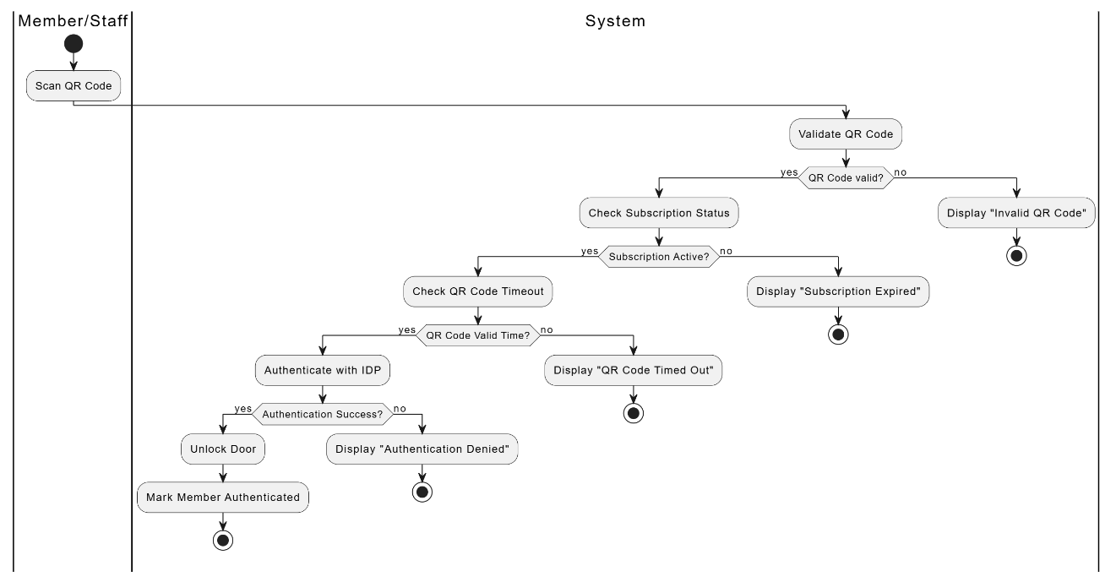

UC-04 — Record timestamp (in/out)

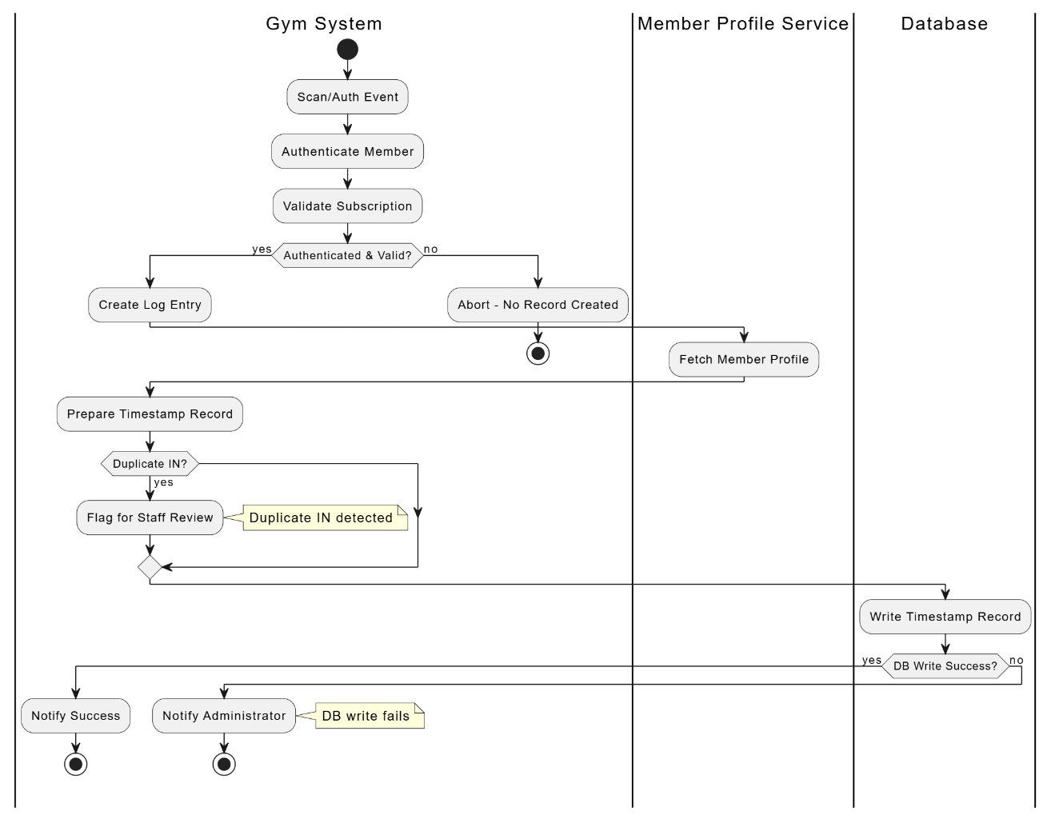

UC-05 — Buy subscription

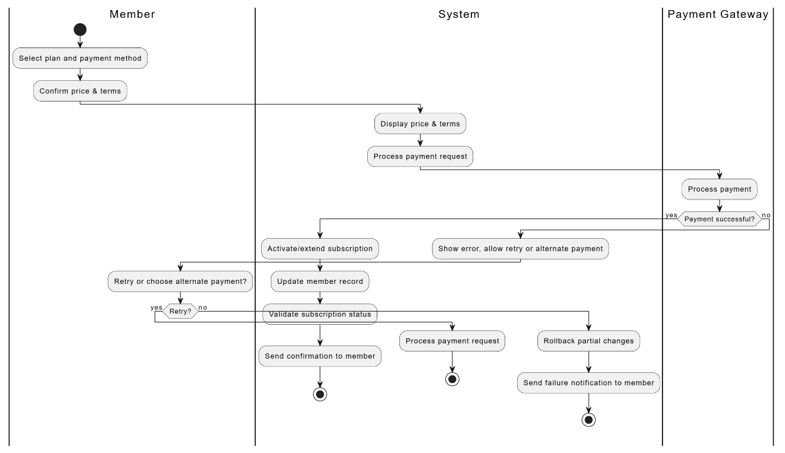

UC-06 — Make an appointment

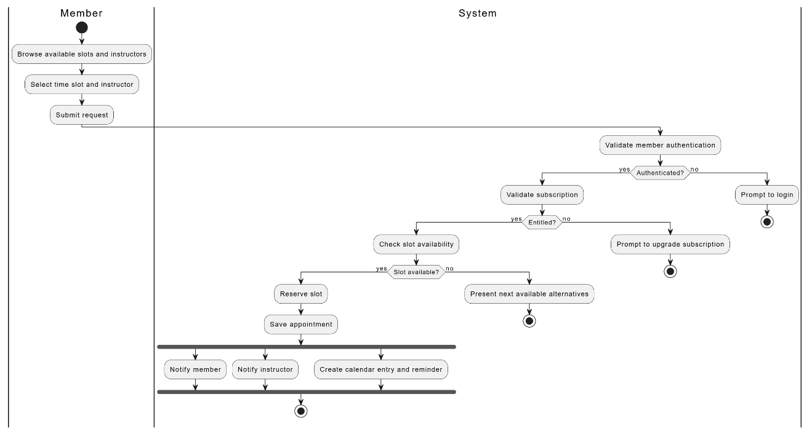

UC-07 — Mark workout done

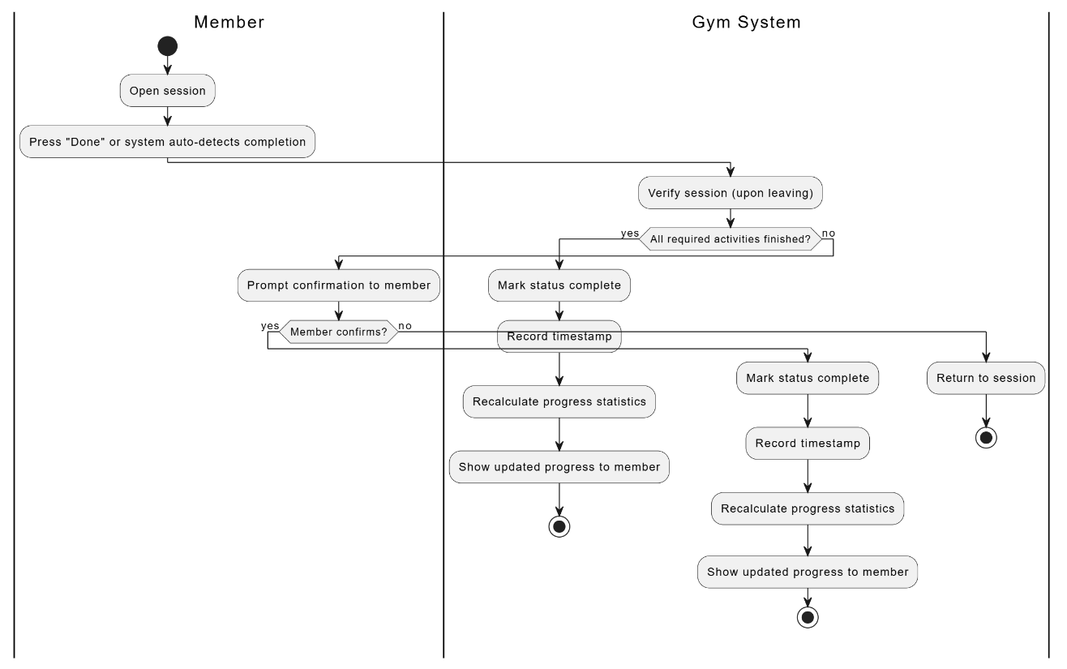

UC-08 — View / Track progress

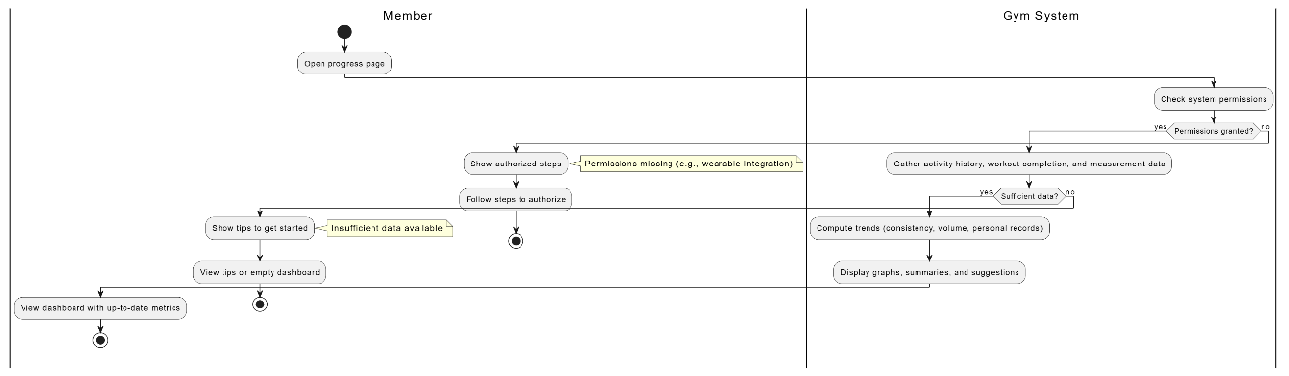

UC-09 — Enter / Leave Gym

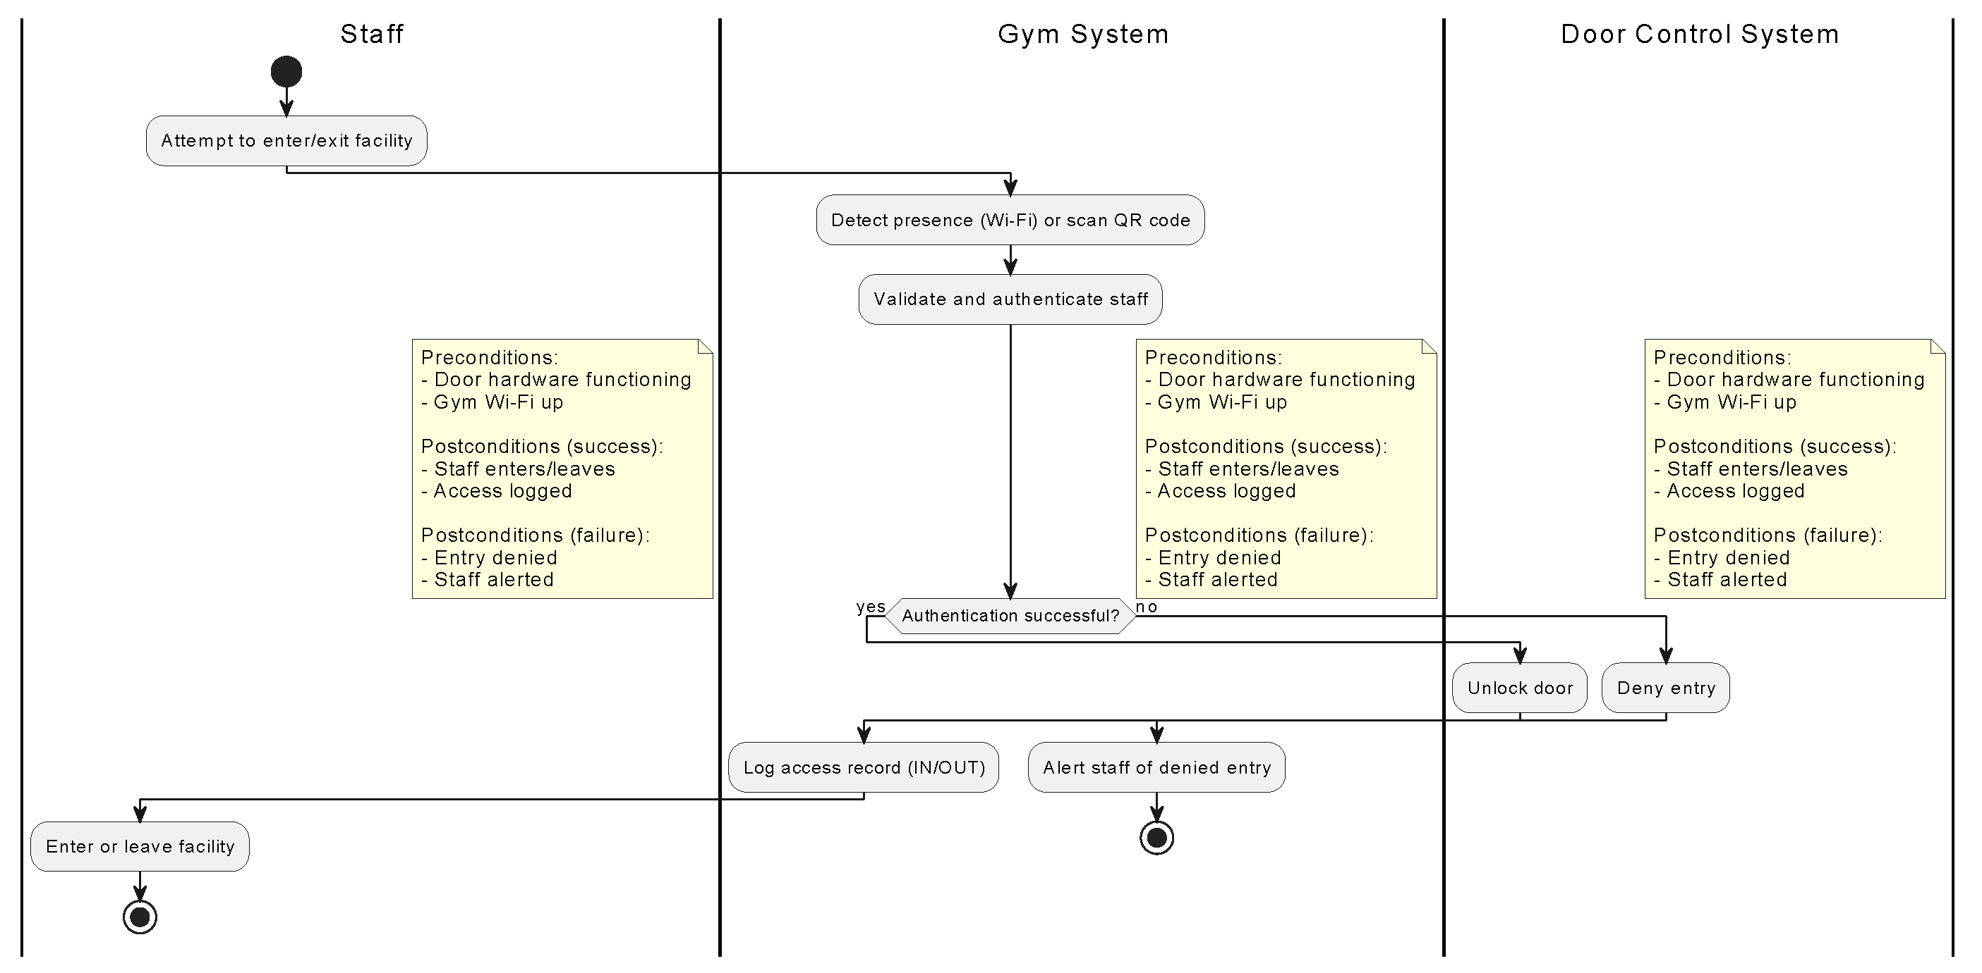

UC-10 — Change / Modify workout schedule

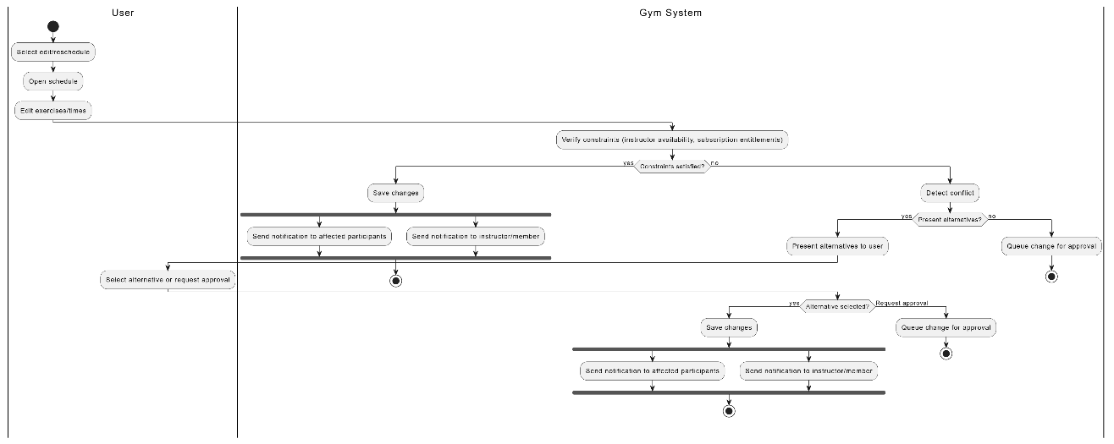

UC-11 — View insights

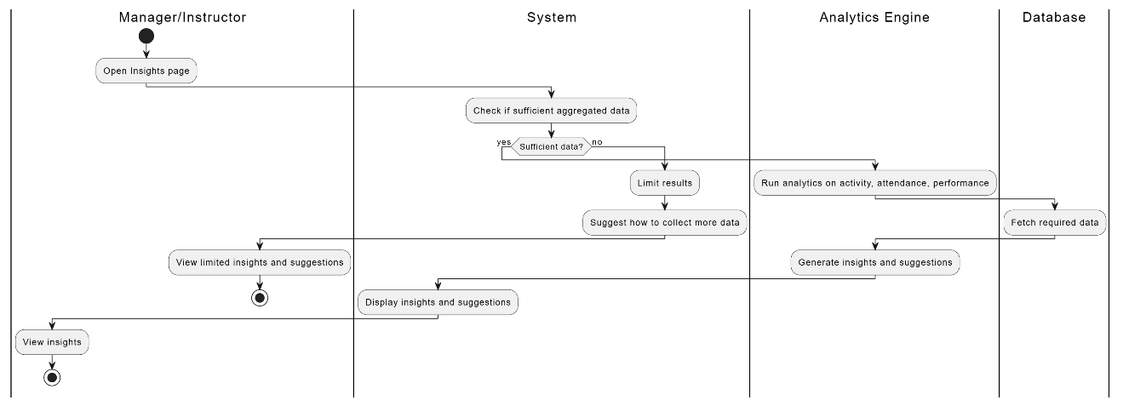

UC-12 — Access detailed reports
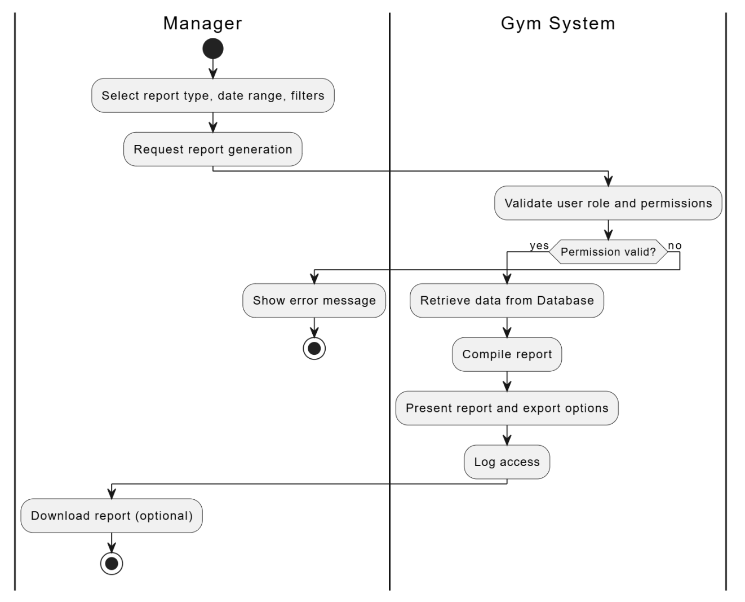

UC-13 — Manage the entire system





