**Project 1 Report, ECE 563**

**Name: Viswanatha Kasyap Pasumarthy**

**Student ID - 200310870**

**Raw data link -** <https://docs.google.com/spreadsheets/d/1OzS-G9ArFtqTvpVGMNo0vd4sL4YpQCoP-EtgMlMKUC0/edit?usp=sharing>

# 1 – Benchmark 1 – gcc_trace

**AAT vs L1 Associativity for L1 cache only.**

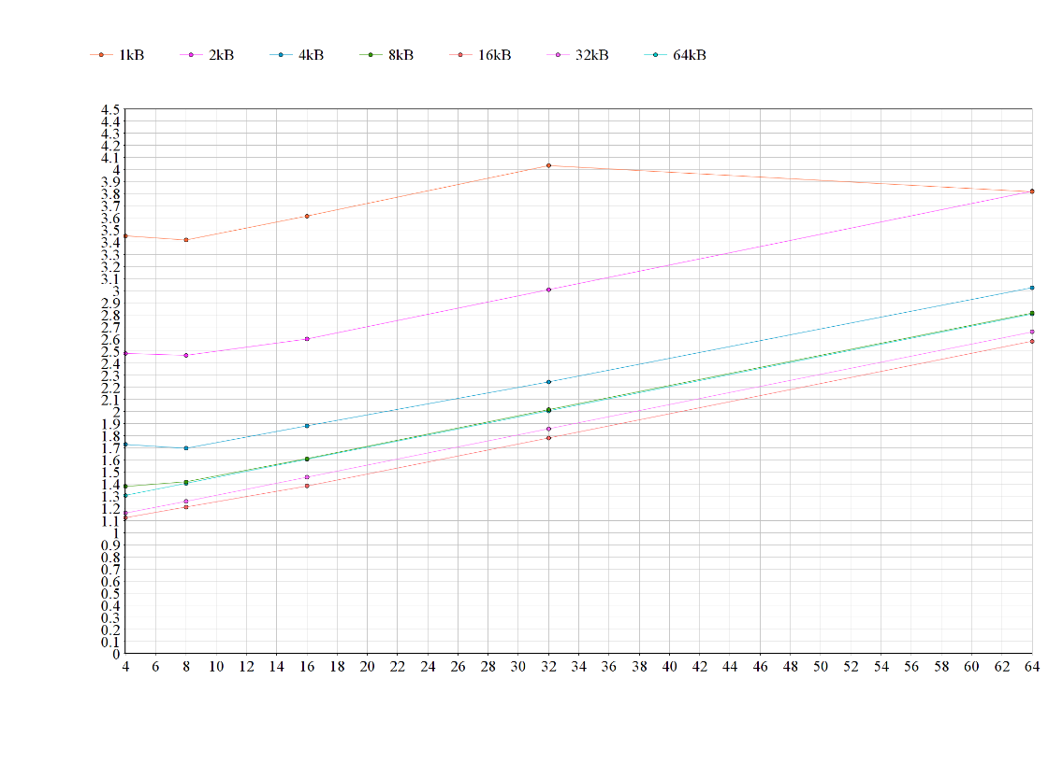

**AAT vs L2 Associativity for L1 and L2 only. (No sectored cache)**

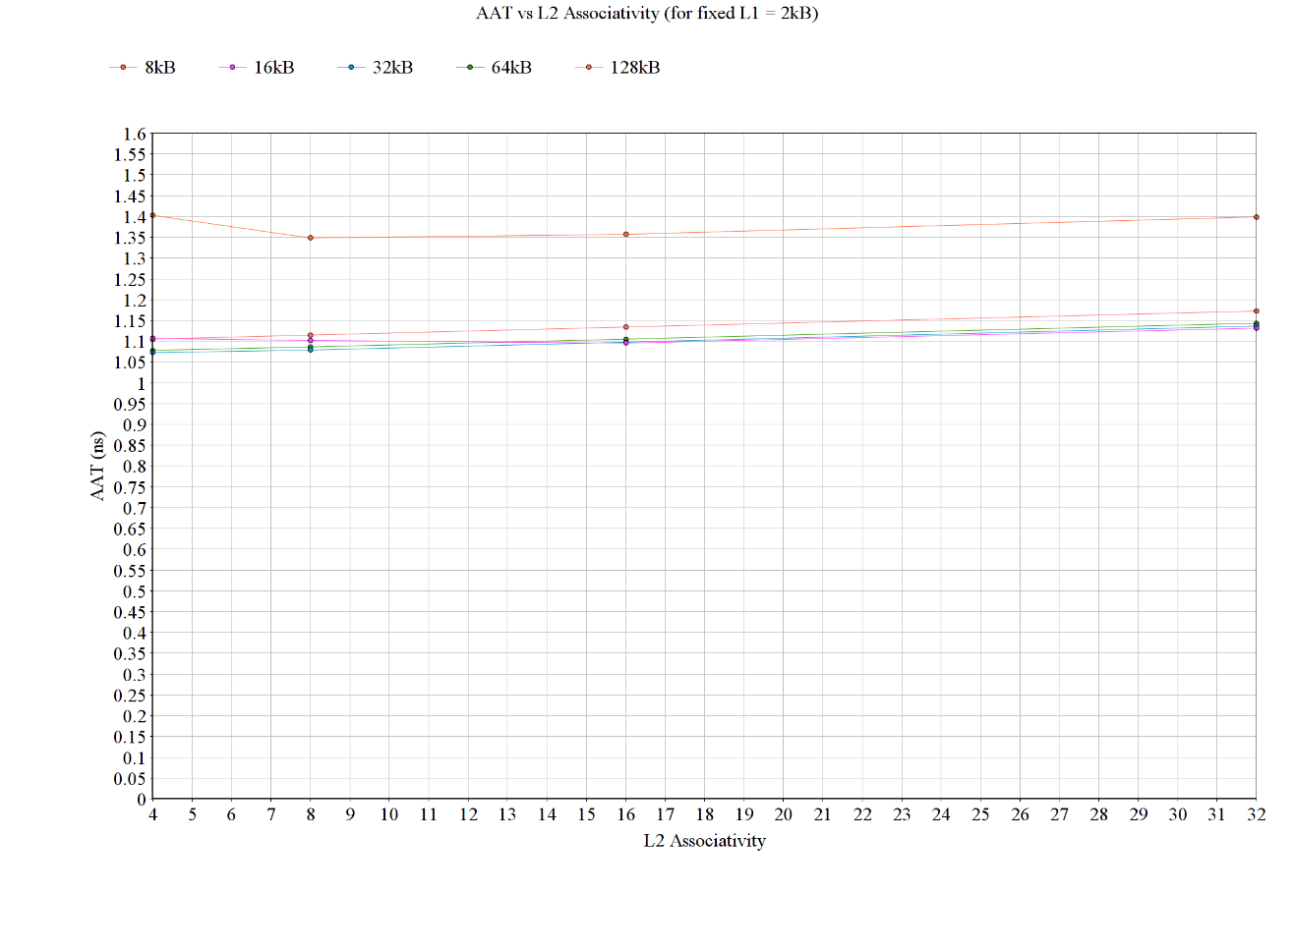

**AAT vs P**

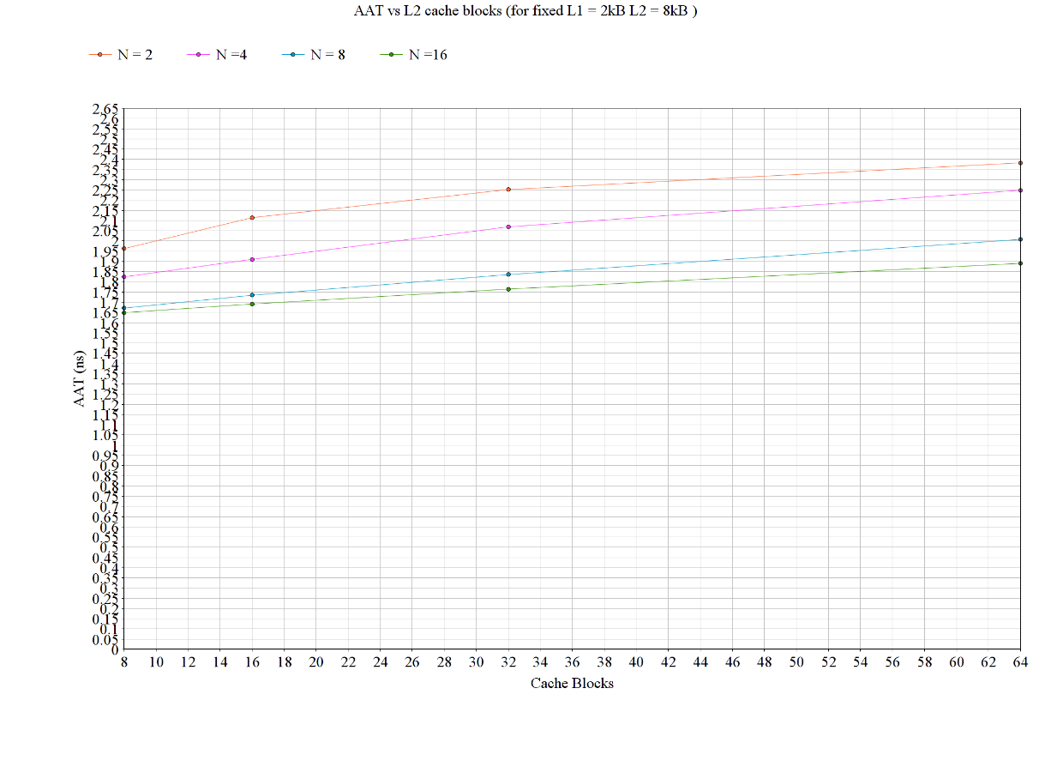

**Lowest access time configurations**

L1 only – L1 size 16 kB, L1 Associativity 4. – 1.228ns

L1 and L2 only – L1 size 2048, L1 Associativity 4, L2 size 32 kB, L2 Associativity 4 – 1.073 ns

L1 and sectored L2 - L1 size 0248, L1 Associativity 4, L2 size 8kB, L2 Associativity 1, P 8, N 16. – 1.649 ns

**Data Table**

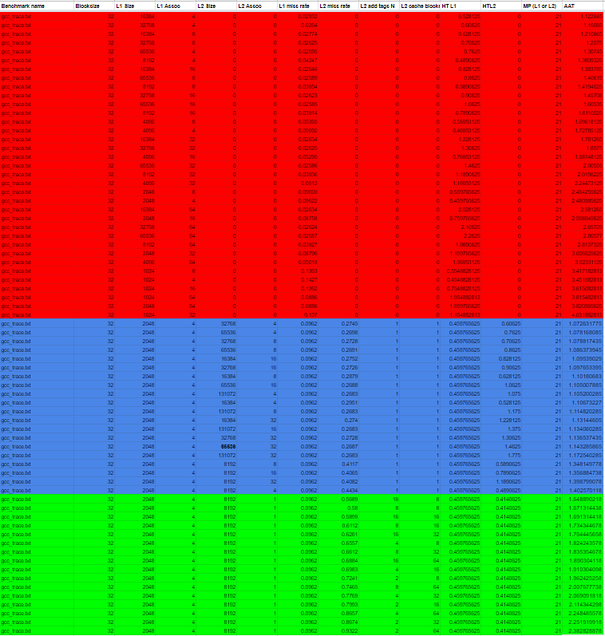

# 2 – Benchmark 2 go_trace

**AAT vs L1 Associativity for L1 cache only.**

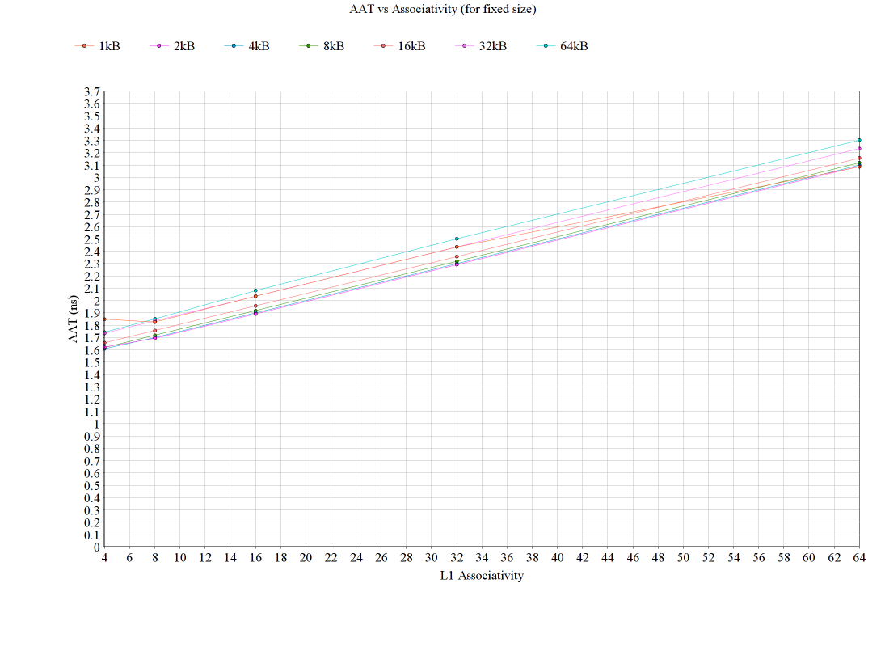

**AAT vs L2 Associativity for L1 and L2 only. (No sectored cache)**

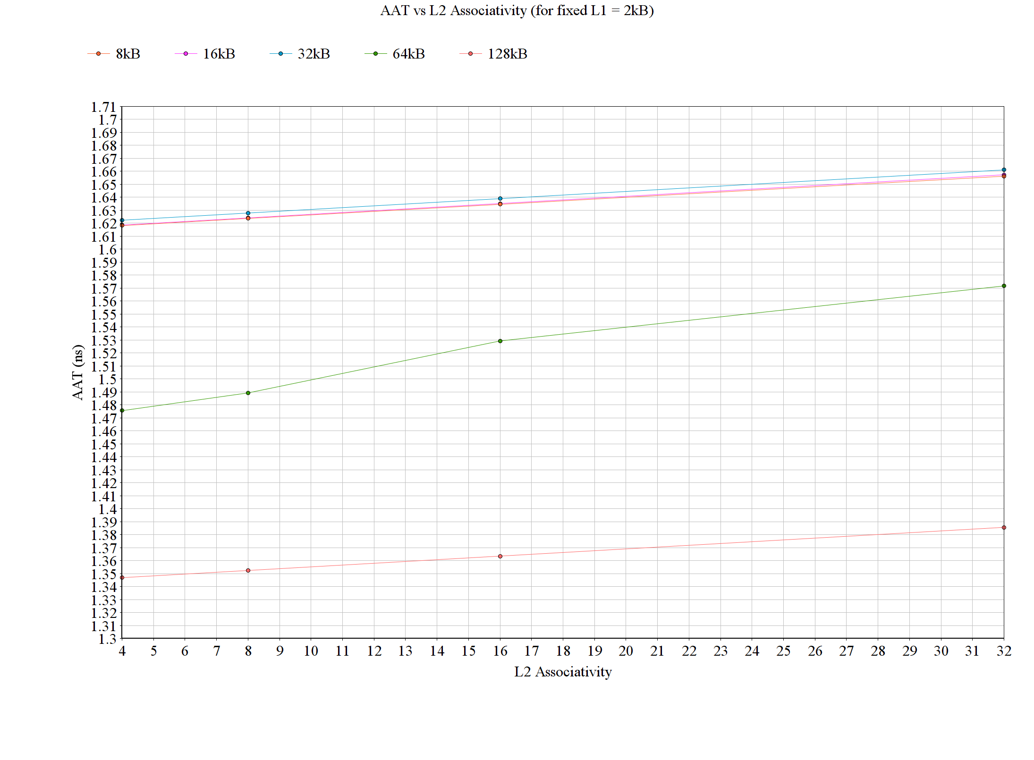

**AAT vs P**

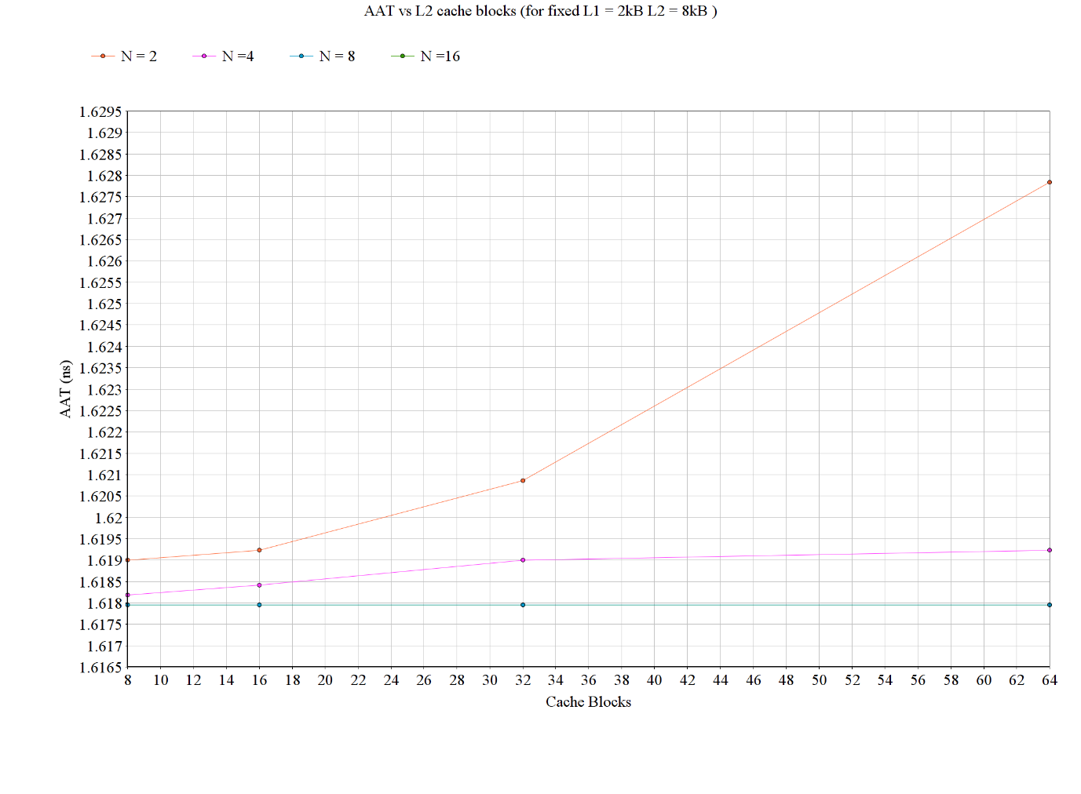

**Lowest access time configurations**

L1 only – L1 size 4 kB, L1 Associativity 4. – 1.609ns

L1 and L2 only – L1 size 2kB, L1 Associativity 4, L2 size 128 kB, L2 Associativity 4 – 1.347 ns

L1 and sectored L2 - L1 size 2kB, L1 Associativity 4, L2 size 8kB, L2 Associativity 1, P 8, N 8. – 1.618 ns

**Data Table**

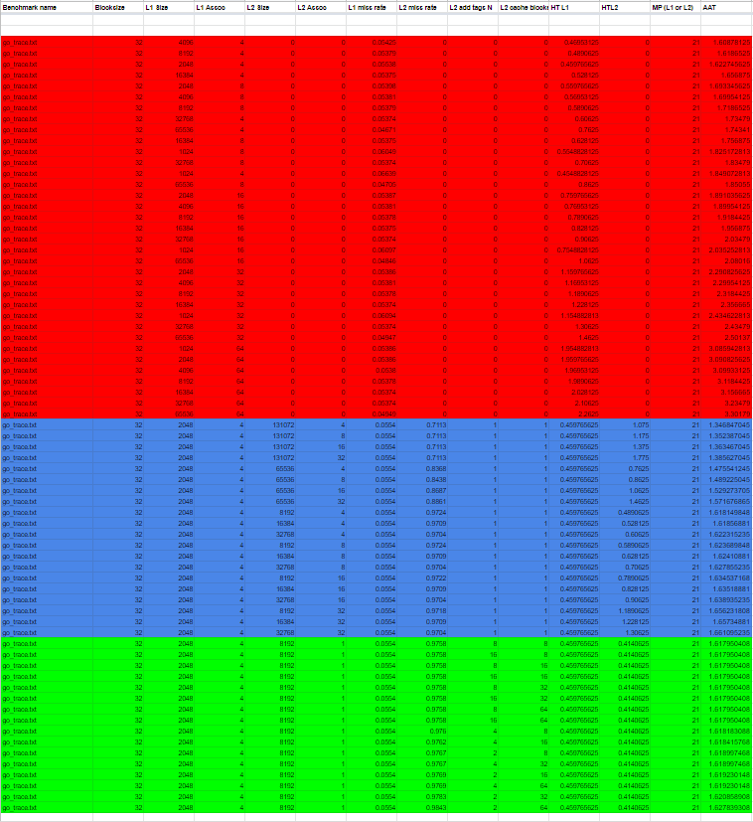

# 3 – Benchmark 3 perl_trace

**AAT vs L1 Associativity for L1 cache only.**

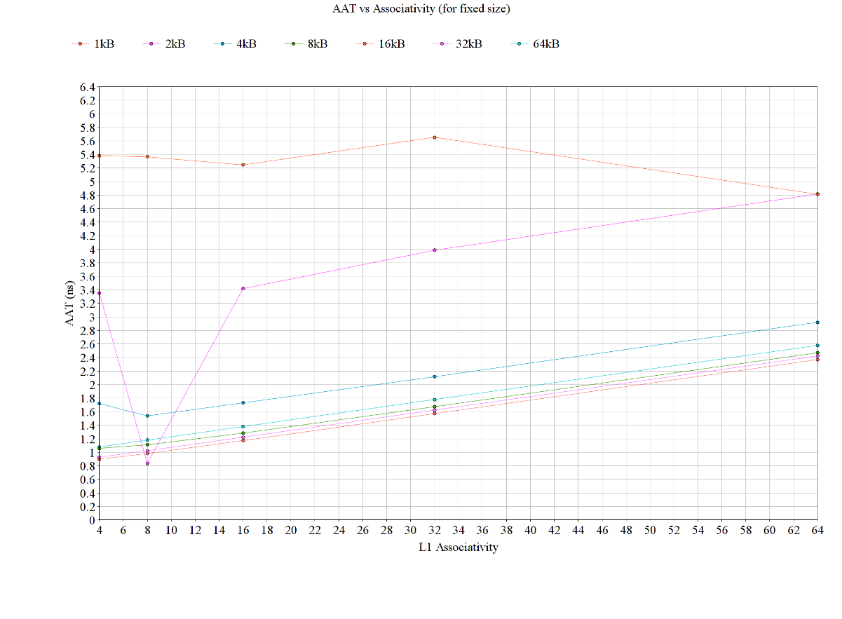

**AAT vs L2 Associativity for L1 and L2 only. (No sectored cache)**

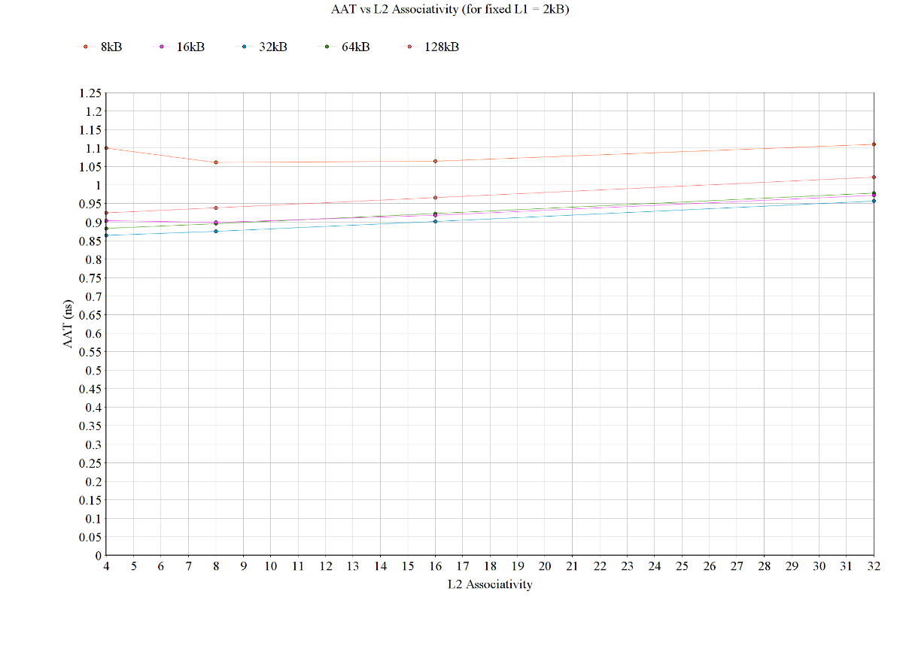

**AAT vs P**

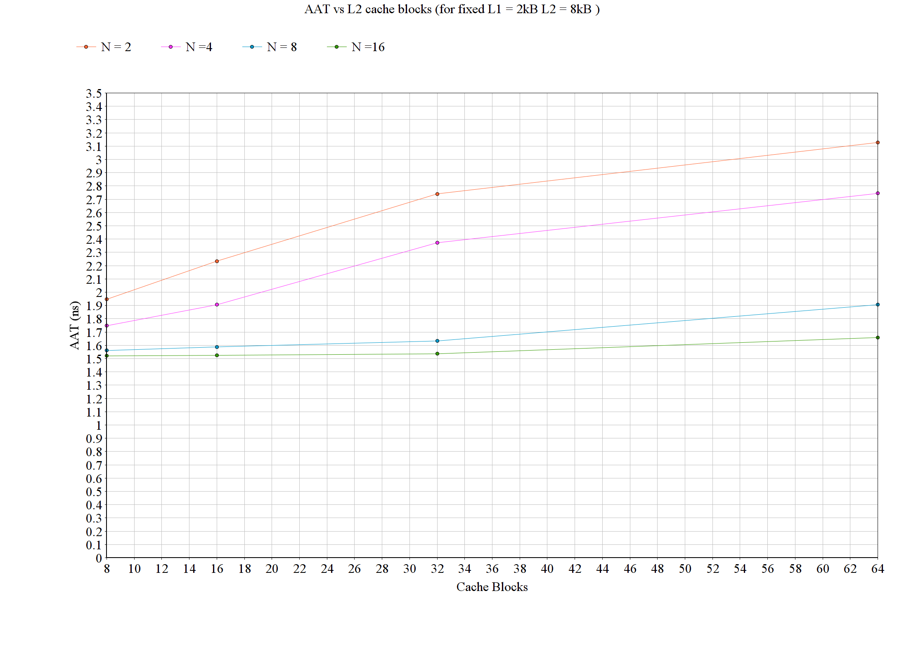

**Lowest access time configurations**

L1 only – L1 size 2 kB, L1 Associativity 4. – 0.835ns

L1 and L2 only – L1 size 2kB, L1 Associativity 4, L2 size 32 kB, L2 Associativity 4 – 0.864ns

L1 and sectored L2 - L1 size 2kB, L1 Associativity 4, L2 size 8kB, L2 Associativity 1, P 8, N 16. – 1.520 ns

**Data Table**

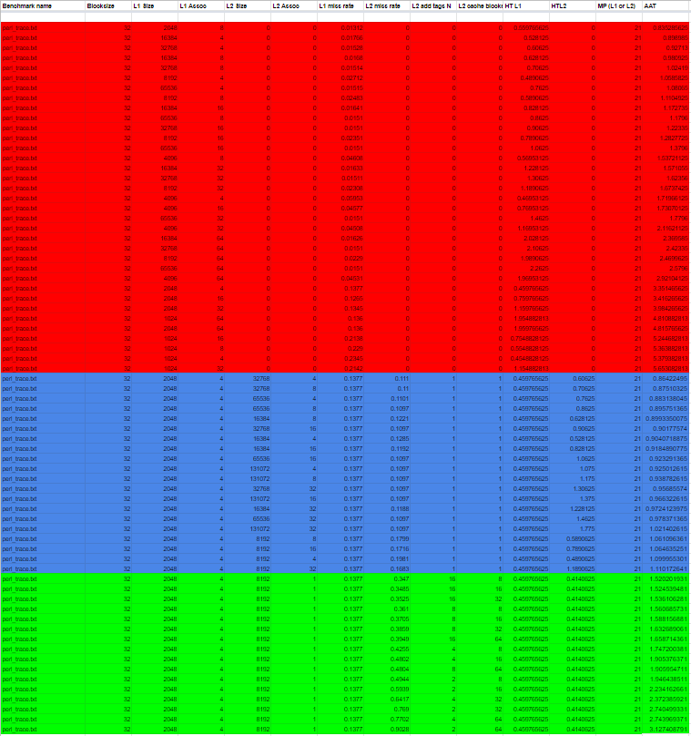

# 4 – Benchmark 4 vortex_trace

**AAT vs L1 Associativity for L1 cache only**.

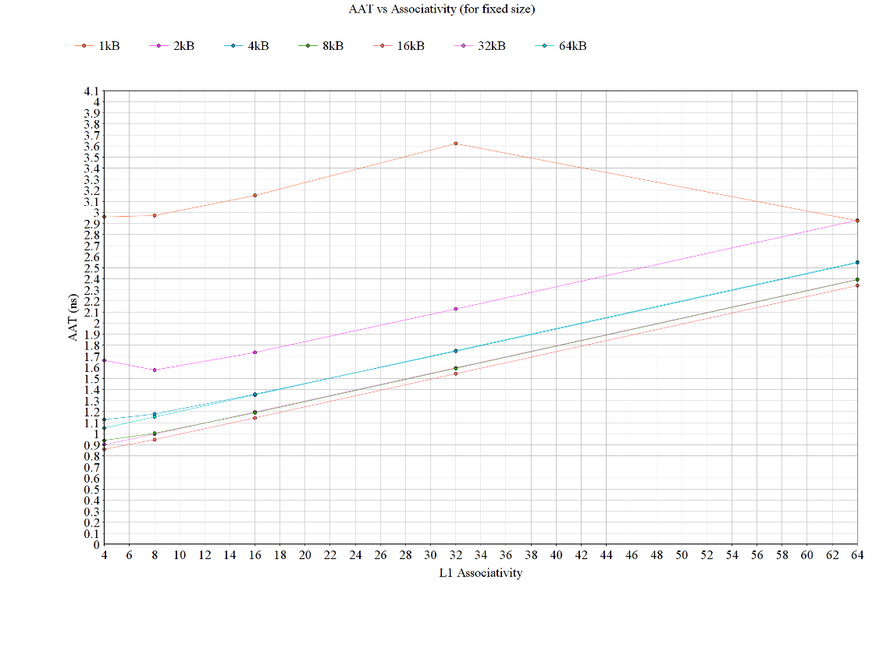

**AAT vs L2 Associativity for L1 and L2 only. (No sectored cache)**

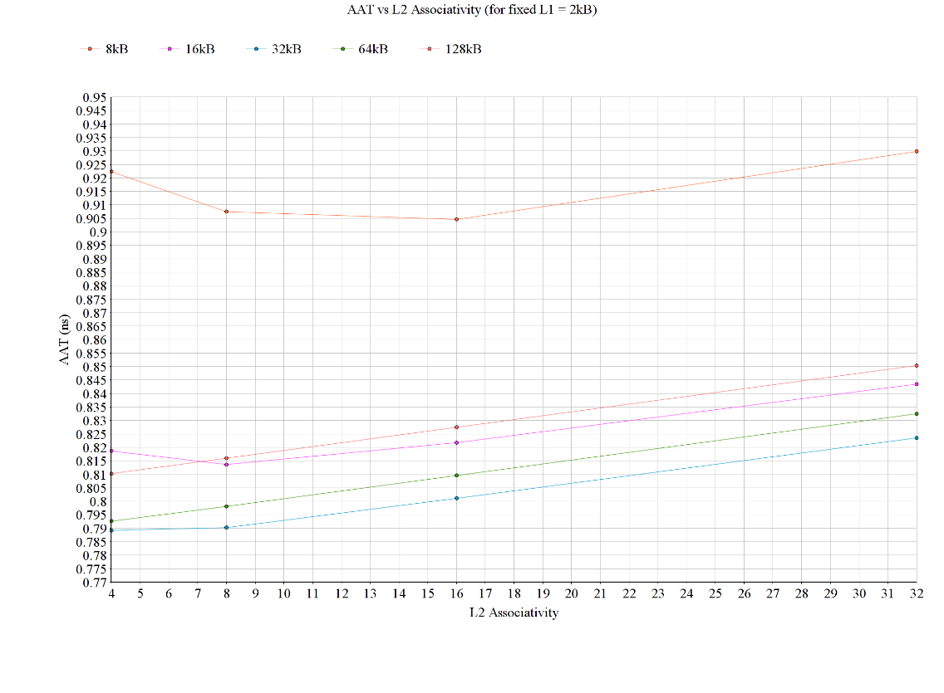

**AAT vs P**

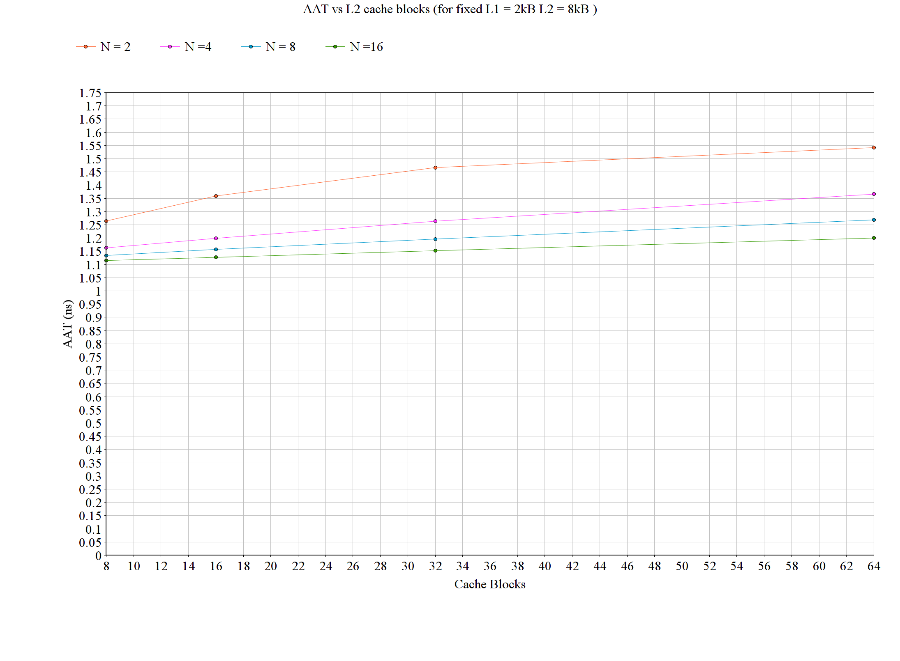

**Lowest access time configurations**

L1 only – L1 size 16 kB, L1 Associativity 4. – 0.859ns

L1 and L2 only – L1 size 2kB, L1 Associativity 4, L2 size 32 kB, L2 Associativity 4 – 0.789ns

L1 and sectored L2 - L1 size 2kB, L1 Associativity 4, L2 size 8kB, L2 Associativity 1, P 8, N 16. – 1.115ns

**Data Table**

