Predicting customer churn in E-commerce: a logistic regression approach

Maciej Kasztelanic, student id: 433973,

Sergio Carcamo Jara, student id: 466116

Date: 05.06.2024, Warsaw

# Abstract

This report aims to predict customer churn in the e-commerce sector by developing a statistical model, checking its correctness and analyzing the importance of its features. The dataset consists of customer data from a global online retailer, including both transactional and non-transactional client characteristics. The selected model, which was used to predict churn, binary dependent variable, was logit which was reduced using general to specific approach. The model was estimated based on multiple variables and additional interactions between them. By identifying critical pain points that lead to customer churn, like too much focus on Singles, or pointing to best-selling categories the study provides insights into enhancing customer satisfaction and retention strategies. It led us to rejecting the hypothesis and stating that churn can in fact be predicted based on individual client characteristics.

# Introduction

Customer churn, the phenomenon where customers terminate their relationship with a company or service provider, poses a significant challenge for businesses, particularly in the highly competitive e-commerce industry. Retaining existing customers is crucial for sustaining revenue streams and long-term growth. The hypothesis under examination is that client churn is not dependent on his individual characteristics and preferences, followed by the secondary hypothesis which wants to answer if client who use the service for a longer time are less likely to churn. Those hypotheses align with the notion that customer loyalty and satisfaction tend to increase over time, reducing the likelihood of losing such clients. The importance of this research lies in its potential to inform customer retention strategies and optimize resource allocation for the e-commerce business. By identifying the key drivers of customer churn and developing accurate predictive models the company can implement targeted interventions, and ultimately enhance customer loyalty and profitability.

# Chapter 1. Literature review

## Churn and customer retention analysis

The term “churn” is derived from the words “change” and “turn” and refers to discontinuation of a contract, that is a situation in which a customer stops using a specific service[1]. With proper management of customers, we can minimize the susceptibility to churn and maximize the profitability of the company. Churn Prediction can also be described as a method which helps in identifying possible churners in advance[2].

In a globalized world with many competitors, winning new customers is a hard and costly task, therefore many companies are focusing on retaining the existing customers instead[3]. To prevent the customers from abandoning the provider, it is important to understand the reasons for their decision and predict with enough anticipation that the decision is going to be taken. Then, action can be taken to retain the customer. However, it is not possible to retain all customers willing to terminate their contracts. Some customers decide to stop using the service at all (for example due to financial problems or changes in their interests or needs), while others want to switch to another provider. It is more important for the company to try to retain the latter group. Also, not all customers are equally profitable for the company. While losing the less profitable ones can have a negative impact, it is reasonable to focus the efforts on retaining the more profitable ones[4].

To predict churn, different types of data about the customer can be useful, for example customer behavior, customer perceptions of the service, customer demographics and macroenvironment variables[5]. The prediction can be done with the use of different models, out of which logistic regression and decision trees have been the most popular, but artificial neural networks, support vector machines and others have also been used. The choice of a specific model is case-specific. Several studies have been conducted to compare the performance of different models that received better results with logistic regression than with artificial neural networks, decision trees and some other methods.

## Logistic regression

When predicting a binary outcome variable, such as customer churn, several modeling approaches can be employed, including logit and probit models. The logit model, also known as the logistic regression model, utilizes the logistic function to model the probability of the binary outcome. Notably, the logit model offers a slight computational advantage over its probit counterpart, as the logistic function is slightly more straightforward to compute[6]. Probit models employ the cumulative distribution function (CDF) of the standard normal distribution as the link function, mapping the linear predictor to the probability of the binary outcome. In contrast, logit models utilize the logistic function, also known as the sigmoid curve, as the link function.

A notable advantage of logit models lies in the interpretability of their coefficients. Specifically, the coefficients in a logit model can be directly interpreted as the log odds ratios. By exponentiating the coefficient, one obtains the multiplicative change in the odds of the outcome occurring for a unit increase in the corresponding independent variable, holding all other variables constant. Furthermore, multiplying the coefficient by 100 provides an approximate percentage change in the odds given a unit change in the independent variable[7].

While probit models offer an alternative approach to modeling binary outcomes, the interpretation of their coefficients is less straightforward. The coefficients in a probit model represent the change in the z-score or the standard normal quantile corresponding to a unit change in the predictor variable.

# Chapter 2. Data overview and preparation

## 2.1 Data overview

The dataset under analysis is titled "Ecommerce Customer Churn Analysis and Prediction" and originates from an online retail enterprise. It encompasses customer-centric data, comprising 5,630 observations (rows) and 20 variables (columns). The columns specified are listed as follows:

* CustomerID: Unique customer ID (as an integer),
* Churn: Churn Flag (1=Churn, 0=Not Churn),
* Tenure: Tenure of customer in organization (in months),
* PreferredLoginDevice: Preferred login device of customer (Mobile Phone, Computer, Phone),
* CityTier: City tier (values from 1 to 3),
* WarehouseToHome: Distance in between warehouse to home of customer,
* PreferredPaymentMode: Preferred payment method of customer (Debit Card, Credit Card and others),
* Gender: Gender of customer (1=Male, 0=Female),
* HourSpendOnApp: Number of hours spend on mobile application or website,
* NumberOfDeviceRegistered: Total number of devices is registered by a particular customer,
* PreferedOrderCat: Preferred order category of customer in last month (Laptop & Accessory, Mobile Phone and others)
* SatisfactionScore: Score of customer satisfaction on service (1 to 5)
* MaritalStatus: Marital status of customer (Married, Single, Divorced),
* NumberOfAddress: Total number of addresses added by the customer,
* Complain: Whether any complaint has been raised in last month (1=Yes, 0=No),
* OrderAmountHikeFromlastYear: Increase in orders from last year as a percentage,
* CouponUsed: Did the client use a coupon (1=Yes, 0=No),
* OrderCount: Total number of orders placed in last month,
* DaySinceLastOrder: Days since the last order by customer,
* CashbackAmount: Average cashback in last month.

We can see that the columns represent mostly client characteristics, hence building a model based on them will help us determine the validity of the hypothesis which states that the churn is not determined by the individual client characteristics.

## 2.2 Exploratory data analysis

### 2.2.1 Quantitative variables

The dataset exhibits a balanced composition, with 10 of the 20 columns representing quantitative variables (excluding customerID), enabling robust statistical analyses and numerical modeling techniques. The distributions of all the variables are shown in Plot 1.

Plot 1. Violin plots of quantitative variables in the dataset

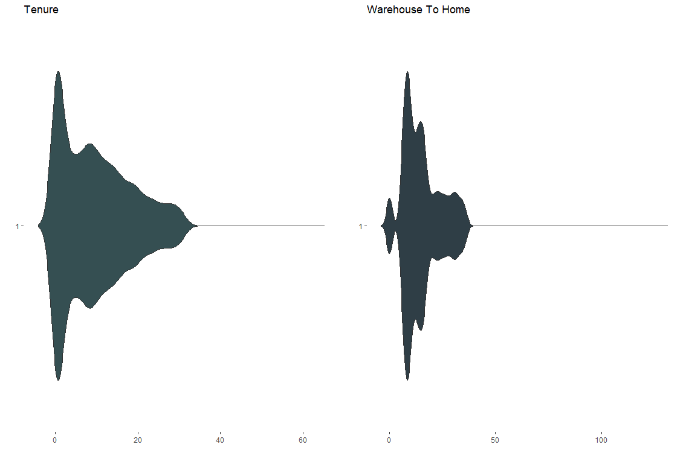

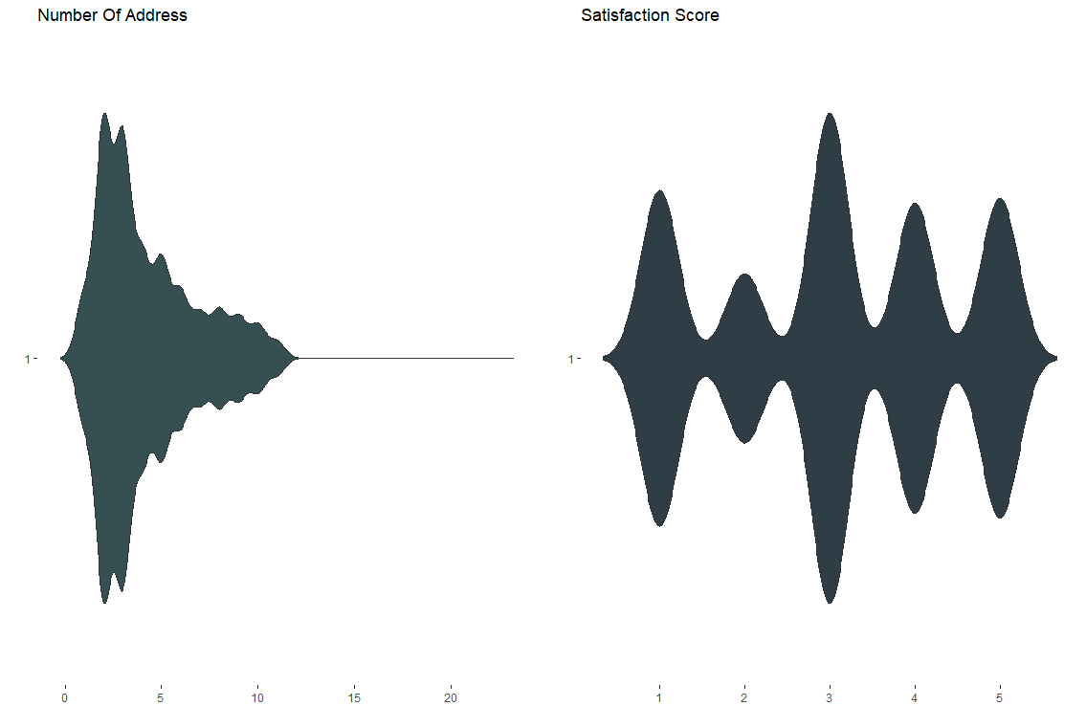

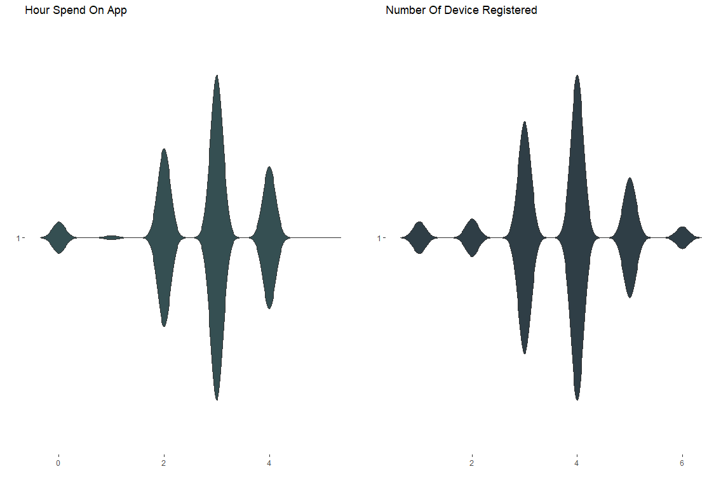

The distribution of customer tenure is right skewed, indicating a higher concentration of customers with relatively shorter tenures. The median tenure is 8 months, suggesting that most customers do not maintain an extended association with the company. This observation underscores the importance of implementing effective customer retention strategies to mitigate churn rates.

The variable representing the distance from the warehouse to the customer’s house displays several outliers as evidenced by the plot. The median distance is 13 units, indicating a central tendency within reasonable proximity. However, the presence of outliers warrants further investigation to identify potential factors contributing to these extreme values.

An examination of the cashback amounts variable reveals that most data points exhibit a value of at least 100 units, with lower values being identified as outliers. This pattern suggests a potential incentive program or promotional strategy aimed at encouraging customer loyalty and retention.

The distribution of the order amount hike from the previous year, expressed as a percentage, demonstrates that most customers increased their order volumes compared to the prior year. However, it is worth noting that almost 5% of customers did not increase their number of orders, potentially indicating that they may churn in the future.

The variable representing the number of addresses associated with each customer exhibits a right-skewed distribution, with a median of 3 addresses. While the central tendency suggests a reasonable number of addresses per customer, the presence of outliers like a customer with 22 addresses should lead to further investigation to understand the factors that contribute to such extreme values.

### 2.2.2 Qualitative variables

The analysis of the categorical variables reveals some insightful patterns. The churn rate among customers stands at 16.8%, indicating a significant portion of the customer base unwilling to reuse the service. Regarding demographic characteristics, 60% of customers identify as male, while 53% report being married. Furthermore, 28.4% of the total customer base has registered a formal complaint, highlighting potential areas for improvement in customer service and satisfaction.

In terms of customer preferences and behavior, the most prevalent login device is the phone, suggesting a strong inclination towards mobile accessibility. The preferred payment method is the debit card, followed closely by the credit card, indicating a preference for electronic payment options over traditional methods.

Notably, the most popular product category among customers is Laptop and accessories as well as mobile devices, underscoring the demand for portable computing solutions within the customer base. This insight could inform targeted marketing strategies and product development initiatives tailored to this segment's needs. The categorical variables are presented on Plot 2.

Plot 2. Bar plots of all categorical variables

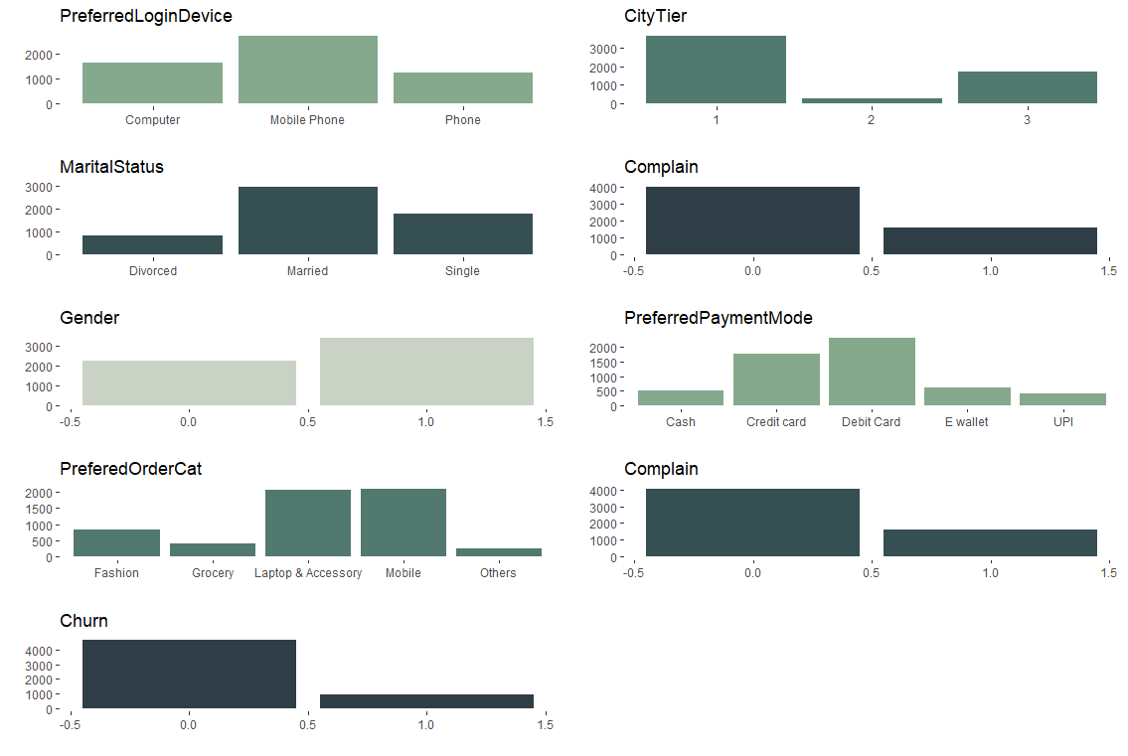

## 2.3 Data transformation

To properly handle categorical variables into the modeling process, the technique of one-hot encoding was used. This approach involves transforming categorical data into a binary numerical format, where each category is represented by a distinct binary variable. For instance, the Gender variable was encoded into a binary format, with the category "Male" represented by 1 and "Female" by 0. A similar strategy was adopted for the PreferredLoginDevice variable, where binary variables were created for each device type, effectively replacing the original categorical variable. The one-hot encoding strategy is particularly well-suited for handling non-ordinal categorical data, as it preserves the distinctiveness of each category while enabling their inclusion in numerical models. This transformation was consistently applied to the CityTier, PreferredOrderCat, and MaritalStatus variables. Each categorical variable was converted into multiple binary variables corresponding to their respective categories, while the original columns were excluded from the dataset. To ensure data integrity and consistency, a standardization process was implemented for the PreferredPaymentMode variable. Categories such as "Cash on Delivery" and "COD" were consolidated under the single category "Cash," while credit card payment modes like "CC" and "Credit Card" were unified under "Credit card." This step aimed to ensure accurate interpretation and representation of the data. Subsequently, one-hot encoding was applied to the standardized PreferredPaymentMode variable, and the original column was removed.

The encoding we used was first used to enhance the model's ability to distinguish between significant and insignificant variables during the evaluation process. Secondly it helps us in the removal process of the insignificant variables during the general to specific approach which will be covered in the next chapter.

The dataset was anonymized and simplified by removing the CustomerID column. This variable does not contribute to our model and may potentially increase bias if included.

For further model evaluation we also used three interactions between variables, which are: Gender with Complaint, OrderCount with DaysSinceLastOrder and lastly NumberOfDevicesRegistered with SatisfactionScore. The inclusion of these interaction terms allowed for a more comprehensive examination of the intricate relationships among variables, potentially enhancing the model's ability to capture complex patterns and improving its predictive performance in forecasting customer churn.

# Chapter 3. Model estimation

## 3.1 Choice between logit and probit

To accurately capture the determinants of the dummy dependent variable the most used approach is the logistic regression, where we can either choose the probit or the logit model. Both models estimate the probability of success and failure (two levels of the dependent variable) as a function of the independent variables, and both models capture the nonlinear relationship between the predictors and the outcome. Their key difference is that logit uses the logistic sigmoid function as a link between linear predictor to the probability, while the probit uses cumulative normal distribution function. Their tails of the distribution also differ as the logit has heavier tails, which makes it more robust to the outliers or extreme values in the predictors. On Plot 3 the difference between the model functions is shown.

Plot 3. Functions used for both models to capture the linear predictor to the probability.

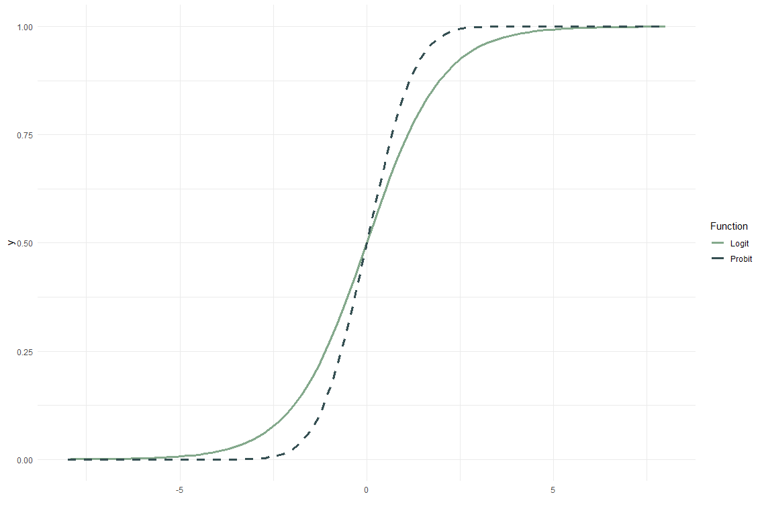

For most scenarios the probit and logit model tend to fit data equally well, but the logit works better when there are extreme values or outliers in the independent variables. Hahn and Soyer in their paper[8] suggested that to properly select between the two approaches, one should use the information criteria like AIC (Akaike Information Criterion) or BIC (Bayesian Information Criterion). The steps are to evaluate both general models for probit and logit to choose one with the lower criterion value.

The general model can be represented as:

$Churn \sim β_{0}+ β_{1}Tenure+ β_{2}WarehouseToHome+ β_{3}Gender+ β_{4}HoursSpendOnApp+ β_{5}NumberOfDeviceRegistered+ β_{6}SatisfactionScore+ β_{7}NumberOfAddress+β_{8}Complain+β_{9}OrderAmountHikeFromlastYear+β_{10}CouponUsed+β_{11}OrderCount+β_{12}DaySinceLastOrder+β_{13}CashbackAmount+β_{14}LoginDevice+β_{15}PaymentMode+β_{16}CityTier+β_{17}OrderCat+β_{18}MartialStatus+β_{19}\left(Gender*Complain\right)+β_{20}\left(OrderCount*DaySinceLastOrder\right)+β_{21}(NUmberOfDeviceRegistered*SatisfactionScore)$

Where Churn is the dependent variable, $β_{0}$ is the intercept, and the rest of $β$ are the coefficients of independent variables. Those dependent variables represent the model without yet created dummy variables from the categorical columns. For logit we then transform the linear predictor η using logistic link function, and for probit η is transformed using the cumulative distribution function. We can evaluate both models and determine which has smaller AIC. For future variable selection we changed the qualitative variables into binary form, treating one level of each as a base level. Table 1 represents both model estimation with their corresponding information criteria.

Table 1. Comparison of logit and probit general models

=======================================================================

Dependent variable:

----------------------------

Churn

logistic probit

Logit Model Probit Model

(1) (2)

-----------------------------------------------------------------------

Tenure -0.226*** -0.110***

(0.011) (0.005)

WarehouseToHome 0.027*** 0.014***

(0.005) (0.003)

Gender 0.155 0.077

(0.125) (0.067)

HourSpendOnApp -0.027 -0.001

(0.055) (0.030)

NumberOfDeviceRegistered 0.709*** 0.367***

(0.130) (0.069)

SatisfactionScore 0.604*** 0.306***

(0.143) (0.076)

NumberOfAddress 0.243*** 0.130***

(0.019) (0.010)

Complain 1.550*** 0.819***

(0.153) (0.083)

OrderAmountHikeFromlastYear -0.005 -0.0003

(0.012) (0.006)

CouponUsed 0.063* 0.033*

(0.034) (0.018)

OrderCount 0.052 0.038**

(0.033) (0.017)

DaySinceLastOrder -0.127*** -0.070***

(0.023) (0.012)

CashbackAmount -0.014*** -0.008***

(0.003) (0.001)

LoginDevice_MPhone -0.416*** -0.196***

(0.114) (0.062)

LoginDevice_Phone -0.468*** -0.207***

(0.129) (0.072)

PaymentMode_CCard -0.691*** -0.438***

(0.166) (0.090)

PaymentMode_DCard -0.499*** -0.367***

(0.161) (0.087)

PaymentMode_EWallet 0.087 -0.048

(0.208) (0.113)

PaymentMode_UPI -0.817*** -0.520***

(0.232) (0.127)

CityTier2 0.841*** 0.403***

(0.234) (0.129)

CityTier3 0.661*** 0.348***

(0.122) (0.066)

OrderCat_Grocery 0.620* 0.232

(0.363) (0.188)

OrderCat_Laptop -1.706*** -0.952***

(0.191) (0.101)

OrderCat_Mobile -0.831*** -0.511***

(0.229) (0.123)

OrderCat_Other 2.312*** 1.161***

(0.447) (0.234)

Martial_Divorced -0.726*** -0.414***

(0.140) (0.076)

Martial_Married -1.027*** -0.571***

(0.102) (0.055)

Gender:Complain 0.475** 0.264**

(0.194) (0.106)

OrderCount:DaySinceLastOrder 0.010*** 0.005***

(0.003) (0.002)

NumberOfDeviceRegistered:SatisfactionScore -0.086** -0.044**

(0.036) (0.019)

Constant -1.588** -0.668*

(0.734) (0.393)

-----------------------------------------------------------------------

Observations 5,630 5,630

Log Likelihood -1,541.030 -1,576.153

Akaike Inf. Crit. 3,144.059 3,214.307

=======================================================================

We can clearly see that the AIC for the logit model is lower than the one calculated for probit. Both are relatively high (3144 and more), which indicates a rather poor fit of the models to the data. By ranking the models from the lowest AIC to highest, we will choose to proceed with the analysis for the logit model, as it shows a slightly better fit.

One of the logit model properties is that the coefficients represent the change in the log odds of the outcome for a one unit increase in the predictor variable holding other variables constant. The coefficients indicate only the direction of the relationship between predictors and marginal effects are used to quantify the actual influence of change in the probability of success. In our general model, we would be able to say, that being a Male increases the probability of Churn and nothing more for now. Also, logit model expresses the relationship between the dependent variable and the independent variable as odds[9]. The logit is a natural logarithm of the odds:

$$logit\left(P\right)=\ln{(\frac{P}{1-P}})$$

So, the model can be written as:

$$ln\left(\frac{P\left(Y=1 | X\right)}{1-P\left(Y=1 | X\right)}\right)= β_{0}+β_{1}X_{1}+β_{2}X_{2}+… β_{i}X_{i}$$

## 3.2 Testing general and null model

To check whether the general model is statistically better than the nested model – here is a null model where we estimate the outcome only with an intercept – we can perform a likelihood ratio test (LRT). The null hypothesis of the test states that the simpler model provides an adequate fit to the data, or that adding additional parameters to the model won’t improve its quality. The results of the likelihood ratio test are shown in Table 2.

Table 2. Likelihood ratio test for general and null model

=========================================

LogLik Df Chisq Pr(> Chisq)

-----------------------------------------

1 31 -1,541.030

2 1 -2,552.158 -30 2,022.257 0

As the p-value of the test is 0, we can reject the null hypothesis, and state that the general model is better than the null model only with an intercept.

## 3.3 General to specific variable selection

Knowing that the general model is of better quality than the null one, we can now focus on improving its quality further, by proper variable selection. First, we need to ensure that all insignificant variables in the model are jointly significant. For this purpose, we will evaluate a model with Churn as a dependent variable and all the insignificant variables will be predictors. Then we compare two models using ANOVA test, with null hypothesis stating that the simpler, reduced model fits the data as well as the general model. The p-value equal to 0 provides strong evidence to reject the null hypothesis, which means we will need to take a general to specific approach to reduce the number of variables, keeping the quality of the model. Such approach consists of multiple steps:

1. We find the independent variable with the highest p-value,
2. We evaluate the general model without the chosen variable,
3. We use ANOVA test to determine whether the reduced model is as good as the general model,
4. We continue this process until there are no insignificant variables in the model.

Table 3 Shows the comparison of the general model and the final model.

Table 3. General and Final model comparison

=======================================================================

Dependent variable:

----------------------------

Churn

General Model Final Model

(1) (2)

-----------------------------------------------------------------------

Tenure -0.226*** -0.225***

(0.011) (0.011)

WarehouseToHome 0.027*** 0.027***

(0.005) (0.005)

Gender 0.155 0.149

(0.125) (0.125)

HourSpendOnApp -0.027

(0.055)

NumberOfDeviceRegistered 0.709*** 0.700***

(0.130) (0.129)

SatisfactionScore 0.604*** 0.608***

(0.143) (0.143)

NumberOfAddress 0.243*** 0.241***

(0.019) (0.019)

Complain 1.550*** 1.541***

(0.153) (0.153)

OrderAmountHikeFromlastYear -0.005

(0.012)

CouponUsed 0.063*

(0.034)

OrderCount 0.052 0.085***

(0.033) (0.028)

Complain:Gender 0.475** 0.477**

(0.193)

DaySinceLastOrder:OrderCount 0.010***

(0.003)

DaySinceLastOrder -0.127*** -0.124***

(0.023) (0.023)

CashbackAmount -0.014*** -0.012***

(0.003) (0.003)

LoginDevice_MPhone -0.416*** -0.436***

(0.114) (0.113)

LoginDevice_Phone -0.468*** -0.454***

(0.129) (0.128)

PaymentMode_CCard -0.691*** -0.734***

(0.166) (0.137)

PaymentMode_DCard -0.499*** -0.542***

(0.161) (0.128)

PaymentMode_EWallet 0.087

(0.208)

PaymentMode_UPI -0.817*** -0.851***

(0.232) (0.212)

CityTier2 0.841*** 0.839***

(0.234) (0.233)

CityTier3 0.661*** 0.677***

(0.122) (0.115)

OrderCat_Grocery 0.620*

(0.363)

OrderCat_Laptop -1.706*** -1.705***

(0.191) (0.189)

OrderCat_Mobile -0.831*** -0.790***

(0.229) (0.225)

OrderCat_Other 2.312*** 2.065***

(0.447) (0.393)

Martial_Divorced -0.726*** -0.727***

(0.140) (0.140)

Martial_Married -1.027*** -1.028***

(0.102) (0.102)

Gender:Complain 0.475**

(0.194)

OrderCount:DaySinceLastOrder 0.010***

(0.003)

NumberOfDeviceRegistered:SatisfactionScore -0.086** -0.088**

(0.036) (0.036)

Constant -1.588** -1.930***

(0.734) (0.699)

-----------------------------------------------------------------------

Observations 5,630 5,630

Log Likelihood -1,541.030 -1,544.271

Akaike Inf. Crit. 3,144.059 3,140.543

=======================================================================

The final improved the information criteria to 3140, which means the final model better fits the data. It now consists of 13 dummy variables, 7 continuous variables and 3 interactions. The approach helped remove irrelevant variables that could lead to overfitting, while still capturing key drivers of the outcome variable.

## 3.4 Model Evaluation

To be certain of the goodness of the model, we must evaluate it based on the following criteria:

1. Pseudo R-Squared – how good the model fits the data (Tjur, McKelvey-Zavoina, Count R-squared, Adjusted Count R-squared),
2. Goodness of fit tests - how good the model fits the data (Hosmer-Lemeshow, Osius-Rojek test),
3. Link test – evaluates the specification of the link function in a regression model,
4. Wald test – assesses the significance of individual predictors in a regression model.

The tests will help us understand how well the specified form of the model fits the data, and the importance of individual predictors in the model. Knowing the AIC for the model is high, we expect that the tests will also reflect the poor fit of the data to the model.

### 3.4.1 Pseudo R-Squared

The logistic regression models don’t have a true R-squared measure because they model the log odds of a binary outcome as a linear combination of the predictors, not directly modeling the outcome variable itself. In linear regression R-squared represents a proportion of variance in the outcome explained by the predictors, which can’t be directly achieved in logistic regression. Also, the logistic model assumes a non-linear relationship between the predictors and the output probability, which violates the linear assumption of the R-squared calculation. The pseudo R-squared statistics, based on the log-likelihood function have been proposed as approximations to quantify the goodness of fit of logistic regression models. All the calculated R-squared measures are shown in Table 4.

Table 4. Different pseudo R-squared statistics

|  |  |  |  |
| --- | --- | --- | --- |
| Tjur | McKelveyZavoina | Count R2 | Adj Count R2 |
| 0.4120765 | 0.6519568 | 0.8912966 | 0.3544304 |

Many pseudo R-squared statistics are not interpretable, but the one listed above has a logical interpretation. The first one shows how well the model discriminates between success and failure, where the value Tjur R-square = 0.412 indicates that the discrimination is not very sufficient.

McKelvey-Zavoina can be interpreted similarly to the R-squared in linear regression models, which indicate the proportion of variance in the latent variable that the model explains. With the value 0.652 we can conclude that the model explains over 65% of the variance in the unobserved tendency of a client to churn.

Count R-squared assesses the accuracy of predictions made by the model in terms of counts or frequency of events. High value of this statistic – 0.891 indicates that the model predicts the observed count well, but it is very likely due to the fact of unbalanced data, where success event occurs only around 17% of the time.

To counteract this imbalance, we can calculate Adjusted Count R-squared. It adjusts the Count R-squared by considering the most frequent outcome to provide a more accurate assessment of the models’ predictive performance. As we can see it dropped significantly to 0.354, therefore we can conclude that the model struggles to predict the success event correctly and creates many false positives.

### 3.4.2 Goodness of fit

A goodness of fit (GOF) test evaluates how accurately a model represents a set of observations. It measures the difference between observed values and the values predicted by the model, summarizing the overall fit.[10] All GOF tests state a null hypothesis that the fitted model is correct in all aspects, so it fits the data well. We performed two different tests to measure the goodness of fit. Their results can be seen in Table 5.

Table 5. Goodness of fit tests results

|  |  |  |  |
| --- | --- | --- | --- |
| Test | Statistic | Value | p-value |
| Hosmer Lemeshow | Chi Square | 151.73 | 0.00000 |
| Osius Rojek | Z | 1.385 | 0.1658 |

The first one in use is Hosmer-Lemeshow which is commonly used due to its simplicity, and it is useful for detecting overall lack of fit. It is sensitive to misspecification like incorrect link function, lack of significant predictor interactions or incorrect distribution assumption. Our calculation resulted in a p-value of the test under the significant level, so the null hypothesis can be rejected. The results show that the model lacks fit to the data.

Osius Rojekt test tries to assess the fit of the model by comparing the observed and expected frequencies across all possible covariate patterns[11]. The test is more powerful than the Hosmer-Lemeshow in determining the misspecifications of the model. A p-value higher than the significance level means we fail to reject the null hypothesis stating that the model fits the data well. It suggests that the data is not significantly different from what would be expected under the null hypothesis, and that there is 16.58% probability of obtaining a test statistic at least as extreme as the one calculated from the observed data.

### 3.4.3 Link Test

Link test is a diagnostic tool used to check for model specification errors by comparing the predicted values and their squared terms. Its null hypothesis states that the model is properly specified, and the used function is adequate to the specificity of the data. Table 6 shows the output of the link test.

Table 6. Link test results

==========================================================

Estimate Std. Error z value Pr(> Chisq)

----------------------------------------------------------

(Intercept) -0.01025 0.05724 -0.179 0.858

yhat 1.22778 0.04143 29.63 0.000

yhat2 0.07399 0.00607 12.19 0.000

----------------------------------------------------------

Both yhat and yhat2 are statistically significant, which means there is no need to include or omit any other variable from the model. It also indicates that the predicted yhat is very identical to the real y (dependent variable) values.

### 3.4.4 Wald Test

Wald test evaluates whether one or more coefficients in a model are significantly different from a hypothesized value, typically zero. It is usually used to measure if some independent variables contribute significantly to the model’s predictive ability[12]. The test was performed as a comparison of a final model, with a final model with one insignificant variable added, that was removed during the general to specific variable selection. The results of the test are shown in Table 7.

Table 7. Wald test results (1 – final model, 2 – model with the omitted variable)

=============================================

Res.Df Df F Pr(> F)

---------------------------------------------

1 5604

2 5603 1 0.5199 0.4709

---------------------------------------------

With the p-value more than the significance level, we fail to reject the null hypothesis, and can conclude that the coefficients of the omitted variables are significantly different from zero.

# Chapter 4. Results and findings

## Hypothesis testing

The logit model analysis provided valuable insights into the factors that drive customer churn in the ecommerce industry. The model’s results the significant customer attributes and order data and quantified their respective impacts into insights for customer retention strategies. Based on the tests results in previous chapter, we can reject the null hypothesis which stated that “Client Churn is not determined by individual characteristics of the client”. Significance of variables in the final model, as well as the proper link function used in the model, and a well fitted model for the data let us state that individual characteristics of the client are in fact significant insights into predicting clients Churn. Also, the negative sign before the tenure predictor let us state about the correctness of the secondary hypothesis that the longer client uses the business the less likely he is to churn. Table 8 provides all significant predictors of client churn.

Table 8. Model with all significant variables

======================================================================

Dependent variable:

---------------------------

Churn

----------------------------------------------------------------------

Tenure -0.225***

(0.011)

WarehouseToHome 0.027***

(0.005)

NumberOfDeviceRegistered 0.700***

(0.129)

SatisfactionScore 0.608***

(0.143)

NumberOfAddress 0.241***

(0.019)

Complain 1.541***

(0.153)

DaySinceLastOrder -0.124***

(0.023)

CashbackAmount -0.012***

(0.003)

LoginDevice_MPhone -0.436***

(0.113)

LoginDevice_Phone -0.454***

(0.128)

PaymentMode_CCard -0.734***

(0.137)

PaymentMode_DCard -0.542***

(0.128)

PaymentMode_UPI -0.851***

(0.212)

CityTier2 0.839***

(0.233)

CityTier3 0.677***

(0.115)

OrderCat_Laptop -1.705***

(0.189)

OrderCat_Mobile -0.790***

(0.225)

OrderCat_Other 2.065***

(0.393)

Martial_Divorced -0.727***

(0.140)

Martial_Married -1.028***

(0.102)

OrderCount 0.085***

(0.028)

Complain:Gender 0.477**

(0.193)

DaySinceLastOrder:OrderCount 0.010***

(0.003)

NumberOfDeviceRegistered:SatisfactionScore -0.088**

(0.036)

Constant -1.930***

(0.699)

----------------------------------------------------------------------

Observations 5,630

Log Likelihood -1,544.271

Akaike Inf. Crit. 3,140.543

======================================================================

What can be interpreted from the table is only the direction of effect each variable has. For example, a positive and statistically significant coefficient of 0.839 for the CityTier2 variable indicates that when a customer lives in a city with second tier, he is more likely to churn, holding all other variables constant.

## 4.2 Marginal Effects

### Marginal Effects for average characteristics

Marginal effects for average characteristics measure a change in the outcome variable after a one-unit increase of a given independent variable. It is an intuitive way to interpret the effects of variables in nonlinear models like logit. The results of the marginal effects for average characteristics are presented in Table 9.

Table 9. Final model marginal effects for average characteristics

dF/dx Std. Err. z P>|z|

Tenure -0.01334864 0.00065422 -20.4040 < 2.2e-16 ***

WarehouseToHome 0.00172198 0.00035501 4.8506 1.231e-06 ***

NumberOfDeviceRegistered 0.04459504 0.00830703 5.3683 7.946e-08 ***

SatisfactionScore 0.03735082 0.00922481 4.0490 5.145e-05 ***

NumberOfAddress 0.01583138 0.00132828 11.9187 < 2.2e-16 ***

Complain 0.13034870 0.01702175 7.6578 1.892e-14 ***

DaySinceLastOrder -0.00815673 0.00145587 -5.6027 2.111e-08 ***

CashbackAmount -0.00088329 0.00016373 -5.3948 6.860e-08 ***

LoginDevice_MPhone -0.02508323 0.00745394 -3.3651 0.0007652 ***

LoginDevice_Phone -0.02279651 0.00720861 -3.1624 0.0015647 **

PaymentMode_CCard -0.04552051 0.00752592 -6.0485 1.462e-09 ***

PaymentMode_DCard -0.04030521 0.00803362 -5.0171 5.247e-07 ***

PaymentMode_UPI -0.04341924 0.00716754 -6.0578 1.380e-09 ***

CityTier2 0.06332043 0.02563457 2.4701 0.0135068 *

CityTier3 0.04539262 0.00929947 4.8812 1.054e-06 ***

OrderCat_Laptop -0.09954252 0.01007081 -9.8843 < 2.2e-16 ***

OrderCat_Mobile -0.05418730 0.01243931 -4.3561 1.324e-05 ***

OrderCat_Other 0.23108282 0.06628527 3.4862 0.0004900 ***

Martial_Divorced -0.04005465 0.00617933 -6.4820 9.049e-11 ***

Martial_Married -0.07254368 0.00782915 -9.2658 < 2.2e-16 ***

OrderCount 0.00663156 0.00179257 3.6995 0.0002161 ***

Complain:Gender 0.03712860 0.01676541 2.2146 0.0267878 *

DaySinceLastOrder:OrderCount 0.00055291 0.00022252 2.4847 0.0129649 *

DeviceRegistered:SatScore -0.00539421 0.00230959 -2.3356 0.0195137 *

As there are plenty of results to interpret, I will only highlight some. For example, when a customer with average characteristics has complained his probability of churn increases by 13 percentage points which is the highest effect any variable has, and which seems intuitive. Also, when the same client’s tenure increases by one unit his probability of churn decreases by 1 percentage point.

### 4.2.2 Marginal Effects for user defined characteristics

Previously explained marginal effects were for all the independent variables on the level of average value of that variable. The same effects can be calculated for any other possible mix of the variable levels and will be interpreted in the exact same way but as marginal effects for given characteristics. Our calculated marginal effects can be viewed in Table 10.

Table 10. Final model marginal effects for user defined characteristics

Marginal effects at X=

Tenure -0.027028036 12

WarehouseToHome 0.003188164 15

NumberOfDeviceRegistered 0.084034855 3

SatisfactionScore 0.073044949 4

NumberOfAddress 0.029005094 2

Complain! 0.361203241 1

DaySinceLastOrder -0.014912818 8

CashbackAmount -0.001424882 50

LoginDevice_MPhone! -0.074866204 1

LoginDevice_Phone! -0.077552522 0

PaymentMode_CCard! -0.115583609 1

PaymentMode_DCard! -0.090241283 0

PaymentMode_UPI! -0.129375932 0

CityTier2! 0.188473067 0

CityTier3! 0.148808516 1

OrderCat_Laptop! -0.199728666 0

OrderCat_Mobile! -0.122410101 1

OrderCat_Other! 0.474864949 0

Martial_Divorced! -0.114735871 0

Martial_Married! -0.148228703 1

OrderCount 0.010197178 5

Complain:Gender 0.057314831 0

DaySinceLastOrder:OrderCount 0.001155346 40

DeviceRegistered:SatScore -0.010539221 12

Table shows that for example for client with 12 months using the service (tenure = 12), if he would use it for one more month the churn is less likely by 27 percentage points. Also, a client who already ordered 5 times, his next order would increase the probability of churn by 1 percentage points.

### 4.2.3 Average Marginal Effects

Table 11. Final model average marginal effects

dF/dx Std. Err. z P>|z|

Tenure -0.01760792 0.00075804 -23.2283 < 2.2e-16 ***

WarehouseToHome 0.00227143 0.00045762 4.9636 6.921e-07 ***

NumberOfDeviceRegistered 0.05882442 0.01087280 5.4102 6.294e-08 ***

SatisfactionScore 0.04926871 0.01211086 4.0681 4.739e-05 ***

NumberOfAddress 0.02088286 0.00153924 13.5670 < 2.2e-16 ***

Complain 0.14902299 0.01644709 9.0607 < 2.2e-16 ***

DaySinceLastOrder -0.01075938 0.00188398 -5.7110 1.123e-08 ***

CashbackAmount -0.00116513 0.00021426 -5.4380 5.388e-08 ***

LoginDevice_MPhone -0.03304347 0.00968342 -3.4124 0.0006440 ***

LoginDevice_Phone -0.03173836 0.01055943 -3.0057 0.0026498 **

PaymentMode_CCard -0.06452035 0.01081820 -5.9641 2.460e-09 ***

PaymentMode_DCard -0.05443717 0.01069026 -5.0922 3.539e-07 ***

PaymentMode_UPI -0.06968507 0.01388398 -5.0191 5.191e-07 ***

CityTier2 0.07027926 0.02463199 2.8532 0.0043285 **

CityTier3 0.05599503 0.01058140 5.2918 1.211e-07 ***

OrderCat_Laptop -0.14167807 0.01350936 -10.4874 < 2.2e-16 ***

OrderCat_Mobile -0.07456757 0.01756982 -4.2441 2.195e-05 ***

OrderCat_Other 0.20370147 0.04559982 4.4672 7.927e-06 ***

Martial_Divorced -0.06054504 0.01014321 -5.9690 2.387e-09 ***

Martial_Married -0.09340771 0.00890035 -10.4948 < 2.2e-16 ***

OrderCount 0.00874756 0.00236349 3.7011 0.0002147 ***

Complain:Gender 0.04538606 0.01902041 2.3862 0.0170246 *

DaySinceLastOrder:OrderCount 0.00072933 0.00029206 2.4972 0.0125187 *

DeviceRegistered:SatScore -0.00711540 0.00305136 -2.3319 0.0197071 *

The third way of how the marginal effects can be calculated is the average marginal effects. The measure of the marginal effect averaged across all observations in the data, so the average effect of a change in the independent variable on a predicted probability of outcome. An interpretation for example is that on average a one unit increase in number in registered devices is associated with a 5.8 percentage points increase of the Y.

## 4.3 Findings

Churn predictions and its management is a very practical and useful tool for business in every industry. Therefore, after building the model, it is important to analyze the results in a business context. Some of the results shown in the marginal effects are obvious for the Ecommerce business, such as the fact that with higher tenure the client is less likely to churn, or that when he complains he probably won’t use the service again. Based on the results we can also construct a statement that users who order electronic devices (Laptop / Mobile category) are more probable to stay and use the service once more, which can’t be said for those who buy from other categories. On average and user who bought product from “Others” will be 20 percentage points more likely to churn.

We can also interpret the results for payment methods. On average, users who pay in a digital way (Card, UPI) decrease the log-odds of churn compared to using cash (as cash is treated as a reference level). A conclusion might be provided that to keep more clients it should encourage them to use cashless payment methods.

Lastly the studied ecommerce business should mostly focus on the Divorced and Married people, who show less probability to churn than base status – Single. The model also showed that variables such as hours that users spend on the app, or the number of coupons used does not influence the churn.

# Bibliography

* “Churn Prediction”. V. Lazarov, M. Capota (2007)
* “Customer churn analysis in telecom industry”. K. Dahiya, S. Bhatia (2015)
* “Intelligent data analysis approaches to churn as a business problem: a survey”. D.L. García, A. Nebot, A. Vellido (2017)
* “Customer attrition analysis for financial services using proportional hazard models”. D.V. den Polen, B. Lariviere (2004)
* “Probit and Logit Models: Differences in the Multivariate Realm”. E. Hahn (2005)
* “Determinants of Auditor Choice in Non-Financial Listed Firms on the Vietnamese Stock Market”. Phung Anh Thu, Thai Hong Thuy Khank (2021)
* „Logistic Regression: A Brief Primer”. Jill C. Stoltzfus (2011)
* „Goodness-of-Tests for Logistic Regression”. Sutan Wu (2010)
* „Goodness-of-fit for Logistic Regression: Simulation Results”. D.W. Hosmer, N.L. Hjort (2002)
* <https://www.statlect.com/fundamentals-of-statistics/Wald-test> (access date: 22.05.2024)

1. “Churn Prediction”. V. Lazarov, M. Capota (2007)
2. “Customer churn analysis in telecom industry”. K. Dahiya, S. Bhatia (2015)
3. “Intelligent data analysis approaches to churn as a business problem: a survey”. D.L. García, A. Nebot, A. Vellido (2017)
4. “Intelligent data analysis …”. D.L. García, A. Nebot, A. Vellido (2017)
5. “Customer attrition analysis for financial services using proportional hazard models”. D.V. den Polen, B. Lariviere (2004)
6. “Probit and Logit Models: Differences in the Multivariate Realm”. E. Hahn (2005)
7. “Determinants of Auditor Choice in Non-Financial Listed Firms on the Vietnamese Stock Market”. Phung Anh Thu, Thai Hong Thuy Khank (2021)
8. „Probit and Logit Models: Differences in the Multivariate Realm”. E. Hahn (2005)
9. „Logistic Regression: A Brief Primer”. Jill C. Stoltzfus (2011)
10. „Goodness-of-Tests for Logistic Regression”. Sutan Wu (2010)
11. „Goodness-of-fit for Logistic Regression: Simulation Results”. D.W. Hosmer, N.L. Hjort (2002)
12. <https://www.statlect.com/fundamentals-of-statistics/Wald-test> (access date: 22.05.2024)