class04.R
kateruiz
2026-01-16
x <- 1:50
plot(x)
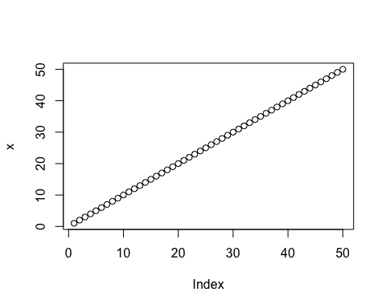
plot (x, sin(x), typ="l", col="blue", lwd=3, xlab="Is it lunch time yet")
