Industry Project – Research Document
Host Resource-Sizing Recommendation
Standing Lab Environment: Multi-Node Cluster, Demo Application and Observability Stack
Report Title | Task 10 – Cluster Resource-Sizing Research and Recommendation (Revision 2)
Student | Kabir Singh Thukrai
Student ID | 99281336
Course | BCIS309 – Work Integrated Learning Project
Industry Supervisor | Abdul Rehman
Academic Supervisor | Bernards Otinpong
Date | 14 October 2026

1. Objective
This report recommends how much CPU, memory and disk the DSYS601 lab needs. The first version used Rancher's published chart defaults, which are not the chart installed in this lab. This revision is based on my own measurements of the running lab. The final sizing decision stays with the supervisors.

2. What Is Being Sized
Each student runs their own Ubuntu VM on a lab PC. The VM runs a 3-node Kind cluster, the demo app (frontend, API and Redis) and the monitoring stack (kube-prometheus-stack 91.5.3). So two things need sizing: the student VM and the lab PC.

3. Method
I rebuilt the lab from GitHub on 14 October 2026 (Figure 1) and measured it twice on my development VM (4 vCPU, 10 GB RAM):
- Idle (16:35): healthy lab, nothing extra running.
- Peak (16:51): all four Task 9 failure tests running for 13 minutes, with all four DSYS601 alerts firing. This is the busiest the lab gets.
I used free -h for the whole VM, docker stats for each Kind node, Prometheus queries for each namespace, and df -h and docker system df for disk. kubectl top does not work on Kind because it needs metrics-server, which Kind does not install (Kubernetes, n.d.), so I used Prometheus instead. The raw output is in the repository (Thukral, 2026a).
Figure 1
Lab Rebuilt From GitHub With ./reset-lab.sh Before Measuring (14 October 2026)
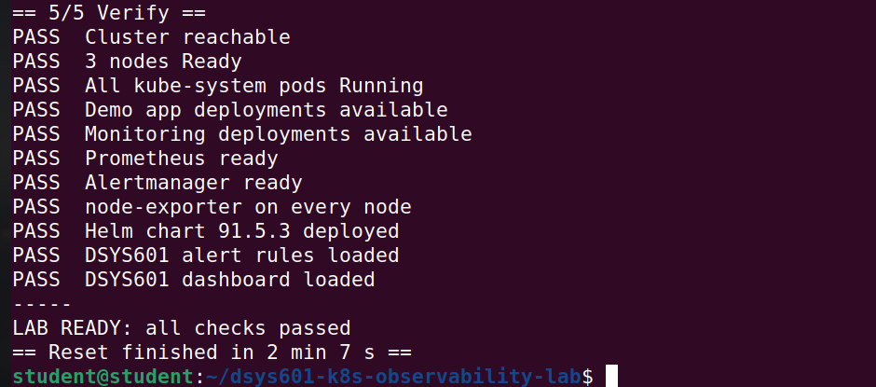

4. Results
Measure | Idle | Peak
Whole VM memory used | 3.1 GiB | 4.3 GiB
Kubernetes system (kube-system) | 738 MiB | 766 MiB
Monitoring stack | 732 MiB | 806 MiB
Demo app (plus test pods at peak) | 15 MiB | 108 MiB
CPU used by all containers | 0.09 cores | 0.09 cores
Disk used by the lab (images + node volumes) | 6.4 GB | –

Figure 2
Idle Measurement: VM Memory, Kind Nodes and Disk (16:35)
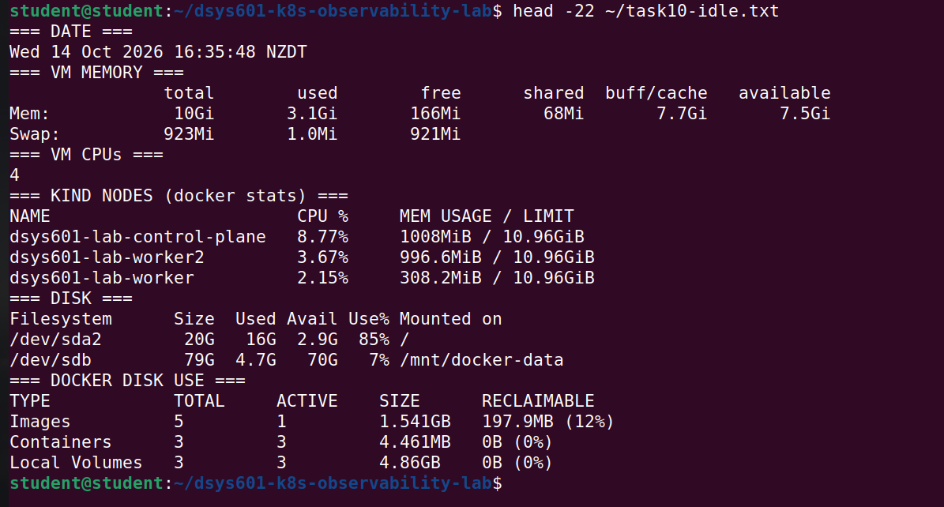
Figure 3
Idle Measurement: Memory and CPU by Namespace From Prometheus
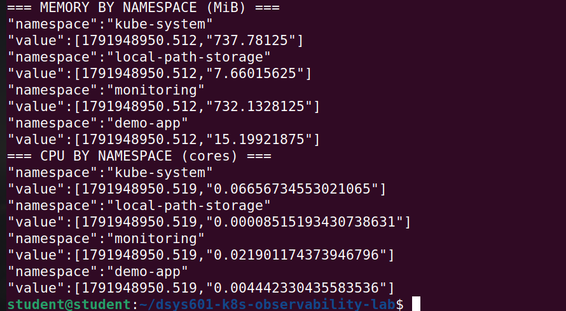
Figure 4
Peak Measurement During the Failure Tests: VM Memory and Kind Nodes (16:51)
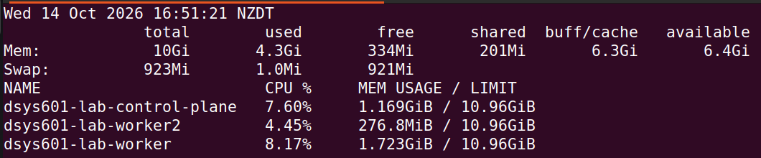
Figure 5
Peak Measurement: All Four DSYS601 Alerts Firing, With Memory and CPU by Namespace
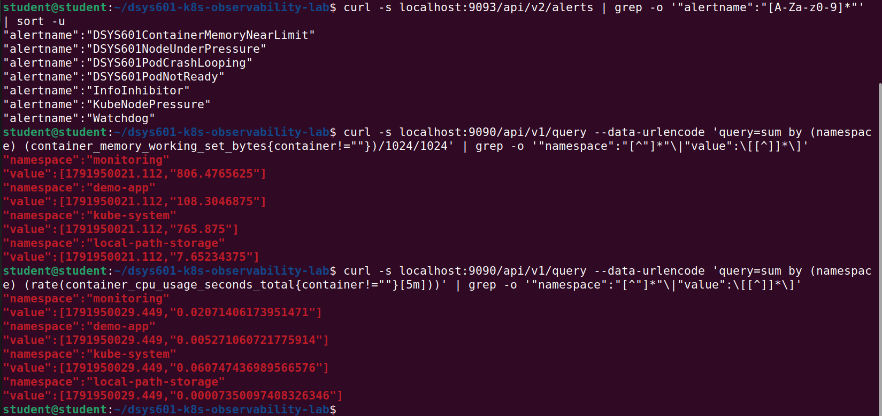
Figures 2 to 5 show the raw output. Memory is the main resource. CPU is not a constraint, as the containers used less than a tenth of one core even during the failure tests. Each node-exporter used about 26 MiB (27.6 MiB at most over two days, Figure 6). It had no memory request before (Thukral, 2026e), so I have now set it to 32 Mi (Figure 7).
Figure 6
node-exporter Memory Now and Highest Over Two Days (MiB)
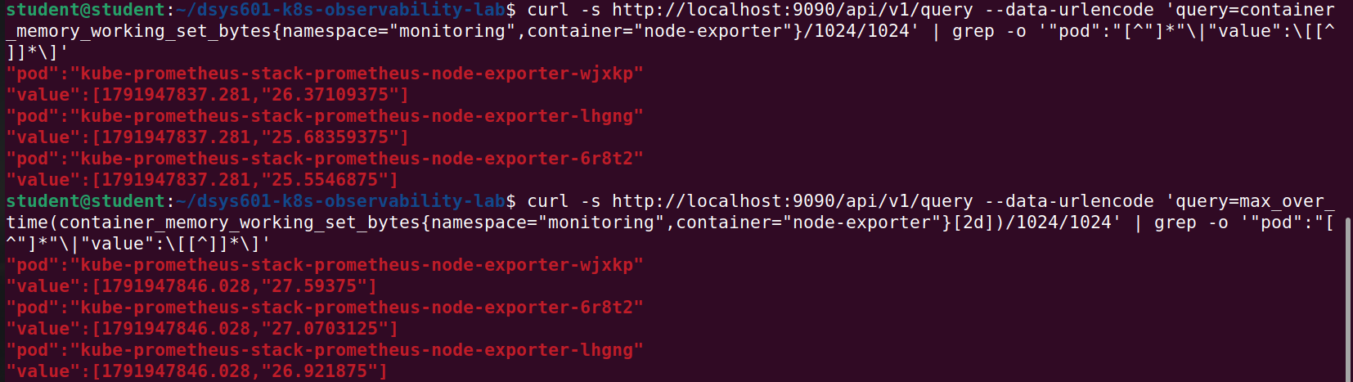
Figure 7
node-exporter Memory Request of 32Mi Applied After the Rebuild
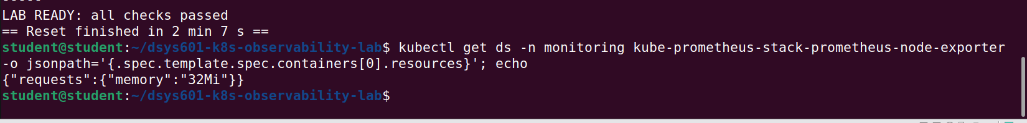

Comparison with the first version
The first version sized the monitoring stack at 2,210 MiB (requests) to 3,950 MiB (limits) from Rancher's defaults (Rancher, n.d.). The measured stack uses 732–806 MiB, about a third of that. This is why the first version over-estimated and recommended 12 GB of RAM.

5. Disk
The 50 GB figure in the first version came from Rancher's guidance for a persistent volume that keeps Prometheus data long term (Rancher, n.d.). It does not apply here, because Prometheus keeps only 2 days of data and uses emptyDir, so the data is deleted on every reset (Thukral, 2026b). The whole lab only uses 6.4 GB.
The real problem is the college VM itself. Its 20 GB system disk is already 85% full with just Ubuntu, which is why the disk filled up in Task 4 (Thukral, 2026d). Docker therefore needs its own disk. 20 GB would fit the lab, but 40 GB leaves room for new images when versions are upgraded between cohorts.

6. Options for the Student VM
 | A – Minimum | B – Recommended | C – Comfortable
vCPU | 2 | 4 | 4
RAM | 6 GB | 8 GB | 12 GB
Docker disk (plus 20 GB system disk) | 20 GB | 40 GB | 60 GB
Room above the 4.3 GiB peak | About 1.3 GiB | About 3.3 GiB | About 7 GiB
Tested | No | Yes (Task 14) | No

Option A is too tight once Firefox is open with Grafana. Option C gives more than the lab needs.

7. Lab PC
 | Minimum needed | Lab PC measured (14 Oct 2026)
Model | – | HP Z2 Tower G9 Workstation
CPU | 4 cores with virtualisation | Intel Core i9-14900, 24 cores
RAM | 16 GB (8 GB VM + Windows) | 64 GB
Free disk for the VM | 70 GB | 1,176 GB on D:

Figure 8
Lab PC Processor
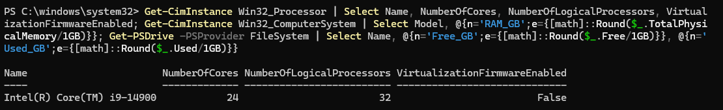
Figure 9
Lab PC Model, Memory and Free Disk Space
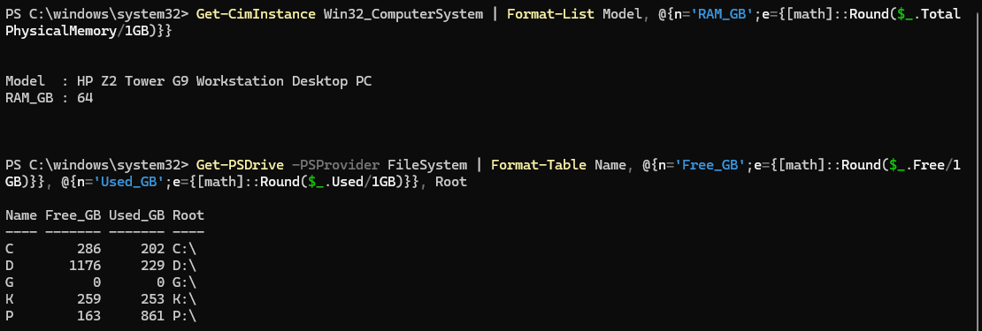
The lab PC is well above the minimum (Figures 8 and 9). One student VM uses about 12% of its RAM.

8. Recommendation
Student VM: Option B, 4 vCPU, 8 GB RAM, a 20 GB system disk and a 40 GB Docker disk. It covers the measured peak with room for the browser, and it is the setup I already tested on a fresh college VM (Thukral, 2026c).
Lab PC: at least 16 GB RAM, 4 cores with virtualisation and 70 GB free disk. The HP Z2 G9 meets this easily, but it still needs confirming that every DSYS601 lab PC is the same model.

9. Limitations
- Idle and peak were each measured once, and Prometheus only keeps 2 days of history.
- Firefox was not open during the measurements.
- Options A and C were not tested, and only one lab PC was checked.

References
Kubernetes. (n.d.). Resource metrics pipeline. Kubernetes Documentation. Retrieved October 14, 2026, from https://kubernetes.io/docs/tasks/debug/debug-cluster/resource-metrics-pipeline/
Rancher. (n.d.). Monitoring V2 configuration: Helm chart options. Rancher Manager Documentation. Retrieved September 26, 2026, from https://ranchermanager.docs.rancher.com/reference-guides/monitoring-v2-configuration/helm-chart-options
Thukral, K. S. (2026a). DSYS601 Kubernetes observability lab [Computer software]. GitHub. https://github.com/kat0870/dsys601-k8s-observability-lab
Thukral, K. S. (2026b). Task 11: Persistence and storage options research and recommendation [Unpublished industry project report]. Ara Institute of Canterbury.
Thukral, K. S. (2026c). Task 14: Standing lab environment handover [Unpublished industry project report]. Ara Institute of Canterbury.
Thukral, K. S. (2026d). Task 4 evidence report: Multi-node Kubernetes cluster build (Kind) and reproducibility via GitHub [Unpublished industry project report]. Ara Institute of Canterbury.
Thukral, K. S. (2026e). Task 9 evidence report: Failure-injection testing [Unpublished industry project report]. Ara Institute of Canterbury.

