Task 6 – Evidence Report
Metrics Pipeline: Prometheus, kube-state-metrics, node-exporter
Student | Kabir Singh Thukrai
Course | DSYS601 – DevOps / BCIS309 Industry Project
Task | Task 6 – Metrics pipeline build: Prometheus, kube-state-metrics and node-exporter scraping cluster and workload metrics
Deployment method | kube-prometheus-stack Helm chart, version 91.5.3 (pinned)
Repository | https://github.com/kat0870/dsys601-k8s-observability-lab
Date | 26 September 2026

1. Objective
Deploy Prometheus, kube-state-metrics, and node-exporter onto the multi-node Kind cluster, and verify that Prometheus is correctly scraping metrics from both the cluster's workload state and each node's host metrics. Grafana dashboard-building (Task 7) and Alertmanager rule-writing (Task 8) are separate tasks and are not covered here, even though both components were installed as part of the same Helm chart.

2. Installation
Helm was installed on the lab VM, and the official prometheus-community Helm chart repository was added:
curl https://raw.githubusercontent.com/helm/helm/main/scripts/get-helm-3 | bash
helm version
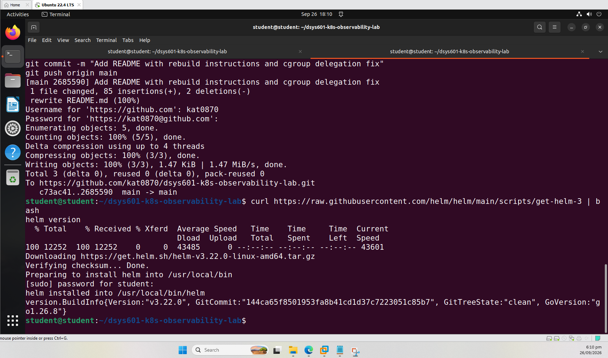
Figure 1 – Helm installed successfully (v3.22.0)
helm repo add prometheus-community https://prometheus-community.github.io/helm-charts
helm repo update
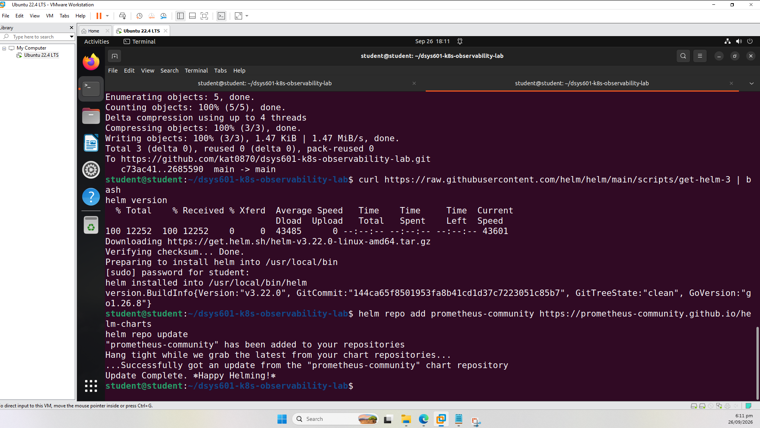
Figure 2 – prometheus-community chart repository added and updated
The kube-prometheus-stack chart was then installed into a dedicated 'monitoring' namespace, with a short 2-day retention (appropriate for a teaching lab) and a known Grafana admin password for lab use:
kubectl create namespace monitoring
helm install kube-prometheus-stack prometheus-community/kube-prometheus-stack \
--namespace monitoring \
--set prometheus.prometheusSpec.retention=2d \
--set grafana.adminPassword=admin123
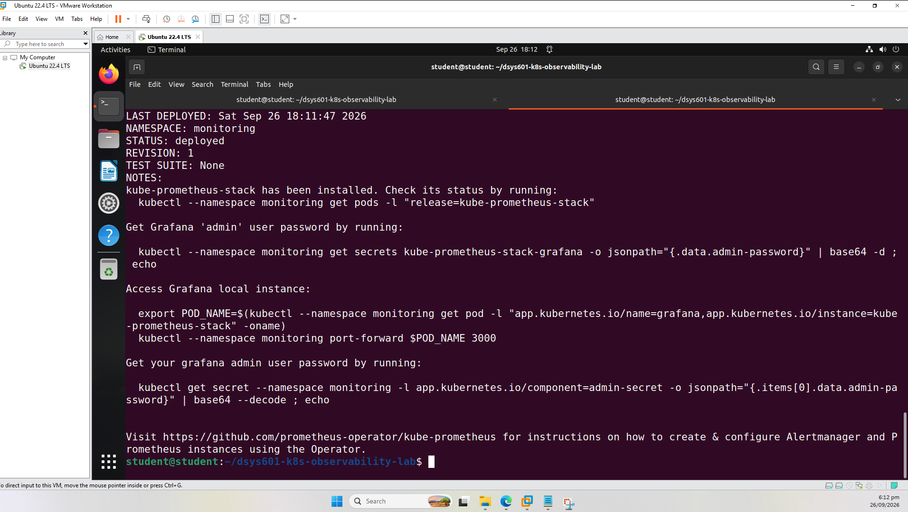
Figure 3 – Helm install completed: STATUS: deployed

3. Deployment Verification
All pods in the monitoring namespace were confirmed Running, including Prometheus, Alertmanager, Grafana, kube-state-metrics, the Prometheus Operator, and one node-exporter pod per cluster node (3 total, matching the 3-node cluster):
kubectl get pods -n monitoring
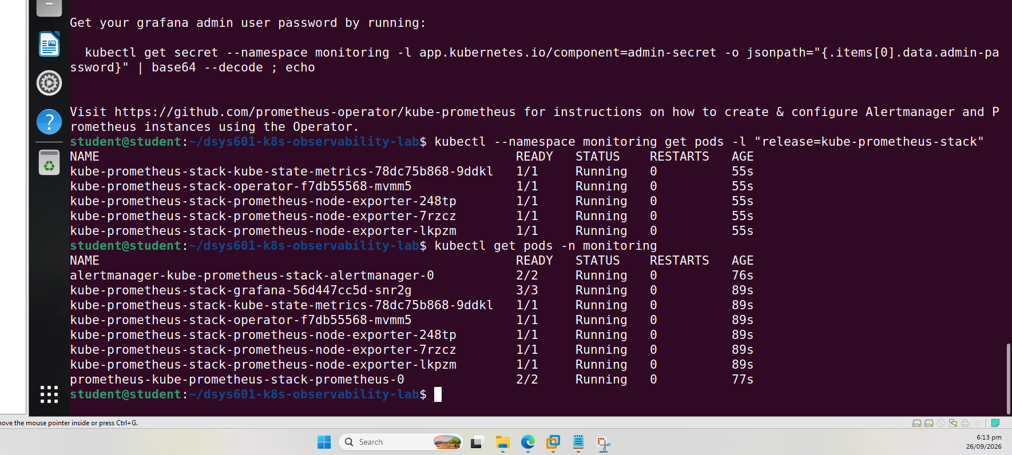
Figure 4 – All 8 monitoring pods Running, including 3 node-exporter instances (one per node)

4. Scrape Verification (Task 6 core requirement)
Installing the pods is not sufficient evidence on its own; Prometheus's own Targets page was used to confirm it is actually scraping metrics from both required sources, via kubectl port-forward to the Prometheus UI on localhost:9090/targets.
4.1 node-exporter
All 3 node-exporter instances (one per cluster node) show as UP and being actively scraped:
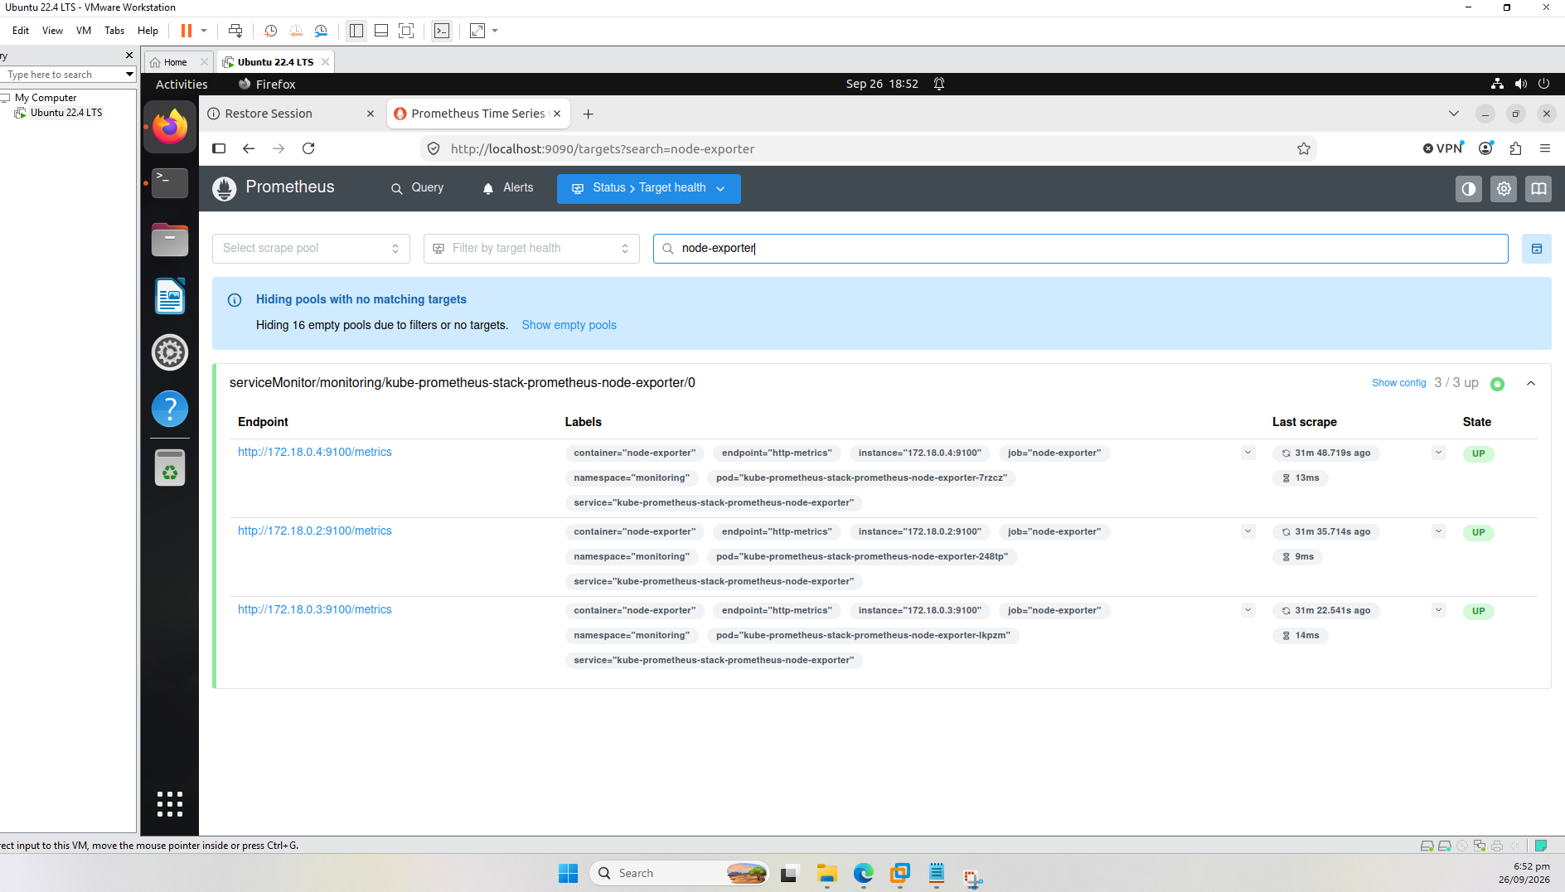
Figure 5 – node-exporter targets: 3/3 up
4.2 kube-state-metrics
kube-state-metrics is confirmed UP and being scraped:
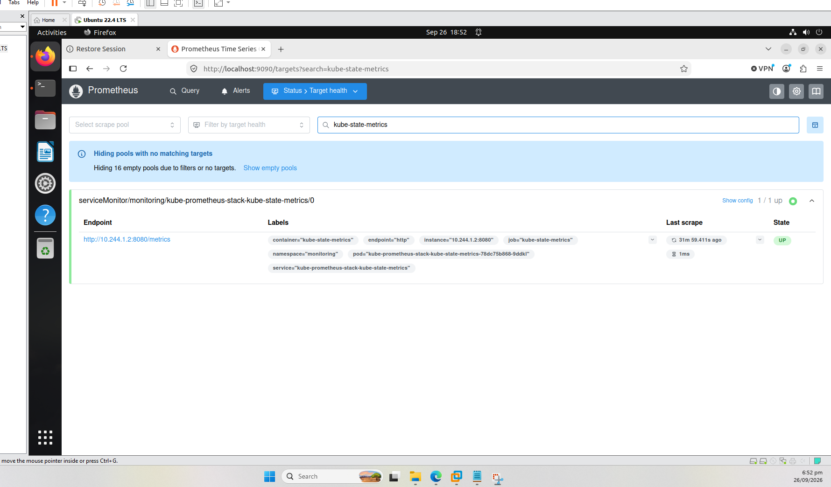
Figure 6 – kube-state-metrics target: 1/1 up

5. Reproducibility
Following the same version-pinning and incremental-commit practice established in Task 4/5, the exact chart version used was recorded, and the Helm values plus a setup script were committed to the project's GitHub repository.
helm list -n monitoring
# CHART: kube-prometheus-stack-91.5.3 APP VERSION: v0.94.1
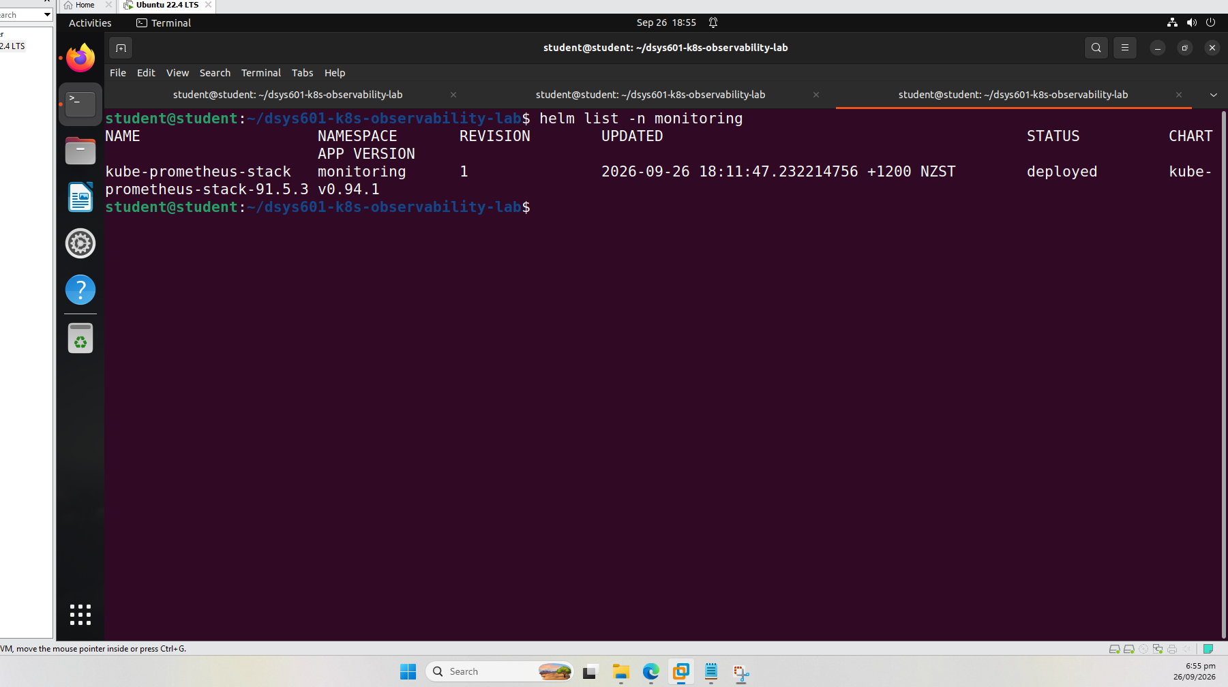
Figure 7 – Installed chart version confirmed via helm list (91.5.3, pinned in setup script)
A monitoring/ folder was added to the repository containing:
monitoring/values.yaml # retention and Grafana password settings used
monitoring/setup-monitoring.sh # adds the Helm repo and installs the pinned chart version
git add monitoring/
git commit -m "Add pinned kube-prometheus-stack Helm values and setup script (Task 6)"
git push origin main
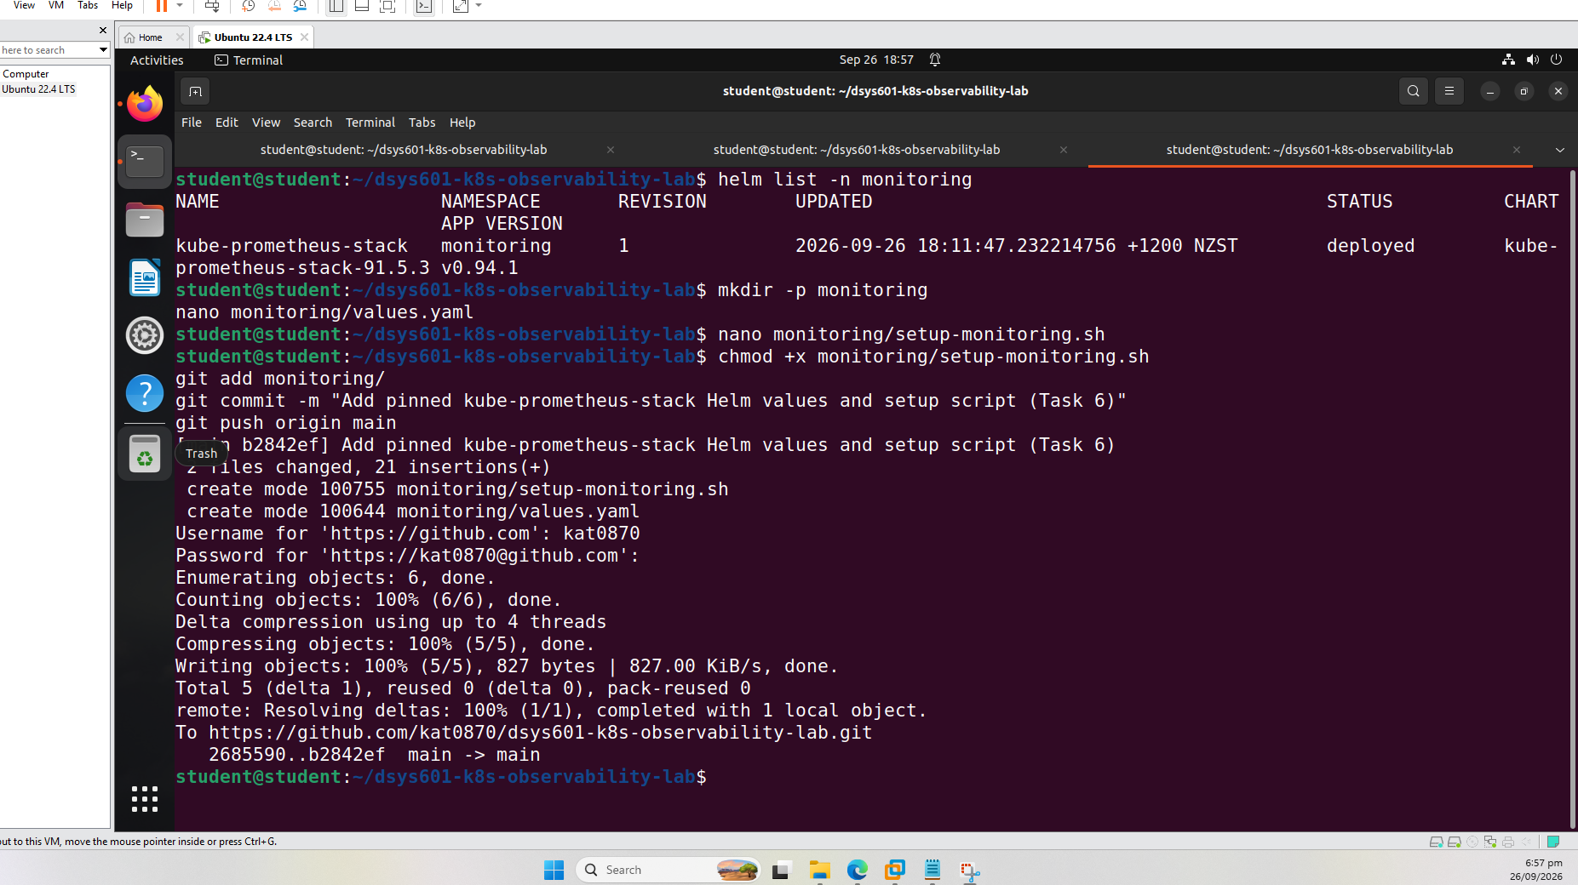
Figure 8 – monitoring/ folder committed and pushed to GitHub

6. Summary
Prometheus, kube-state-metrics, and node-exporter are deployed and verified as working correctly on the multi-node cluster: all pods are Running, and Prometheus's own Targets page confirms both kube-state-metrics and all three node-exporter instances are being actively and successfully scraped. The installation is reproducible from a version-controlled, pinned Helm chart version and values file, consistent with the approach already established for the cluster build (Task 4) and demo application (Task 5).
Repository: https://github.com/kat0870/dsys601-k8s-observability-lab

