

**BLAZO**

**Software Design Specification**

**Version: 1.2**

Prepare by:

Le Thai An (HE181137)

Tran Minh Tien(HE182319)

**– Hanoi, July 2024 –**

**Record of changeS**

| **Date** | **A* M, D** | **In charge** | **Change Description** |
| --- | --- | --- | --- |
| 19/05 | A | TienTM,  AnLT | Add overview and code design |
| 12/07 | M | TienTM,  AnLT | Edit code design for some feature |
|  |  |  |  |
|  |  |  |  |
|  |  |  |  |
|  |  |  |  |
|  |  |  |  |
|  |  |  |  |
|  |  |  |  |
|  |  |  |  |
|  |  |  |  |
|  |  |  |  |
|  |  |  |  |

*A - Added M - Modified D - Deleted

**Table of Contents**

**I. Overview** 4

1. Code Packages 4

2. Database Design 5

a. Database Schema 5

b. Table Description 6

**II. Code Designs** 10

1. <Visit Store/ Add product to cart> 10

2. <Checkout/Manage Order> 12

3. <Add product/ Delete product/ Edit product> 14

4. <Authentication/Login/Forgot password/Log out> 16

5. <Register> 19

6. <Web Blog> 21

# **I. Overview**

## **1. Code Packages**

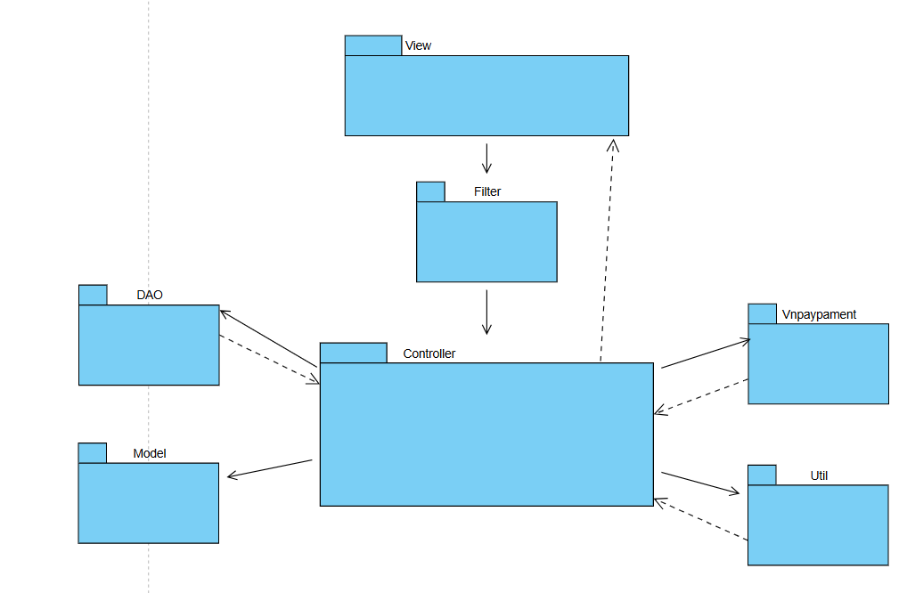

***Package descriptions***

| **No** | **Package** | **Description** |
| --- | --- | --- |
| 1 | Util | The "Util" package contains utility classes and helper methods used to perform common tasks and facilitate reusability within the application. Classes in this package typically include functions such as string manipulation, date formatting, encoding and decoding, and other utility functions. |
| 2 | DAO | The "DAO" package contains classes used to access and interact with the database. Classes in this package typically include methods to perform operations such as adding, updating, deleting, and querying data from the database. The "dal" package often serves as an intermediary layer between the application and the database, helping to separate application logic from data access logic. |
| 3 | Model | The "Model" package contains classes representing data entities within the application. Classes in this package are designed to represent objects in the application but do not contain any business logic. Instead, they simply model the data and are often used to transfer data between different layers and components of the application. |
| 4 | Vnpaypayment | The "Vnpaypaymentl" package contains vnpay payment api |
| 5 | Controller | The "Controller" package contains classes and method to control, process data and connect each other package |
| 6 | Filter | The "Filter" package contains classes to verifies the identity of users and determines whether they have permission to access certain resources or perform specific actions within the application |
| 7 | View | The "Model" package contains jsp file to display user interface |

## **2. Database Design**

### ***a. Database Schema***

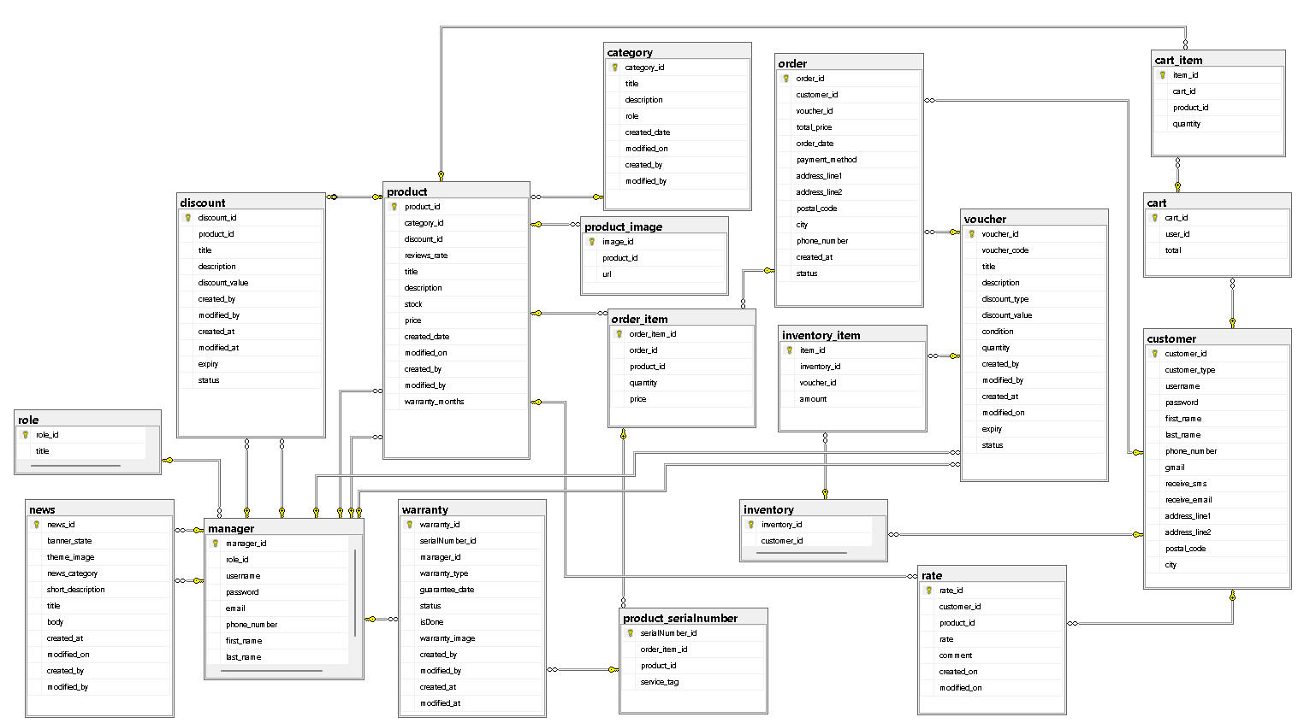

### ***b. Table Description***

#### 

| **No** | **Table** | **Description** |
| --- | --- | --- |
| **01** | customer | customer_id INT PRIMARY KEY IDENTITY,  customer_type INT,  customer_img NVARCHAR(max),  username NVARCHAR(255),  [password] NVARCHAR(255),  first_name NVARCHAR(255),  last_name NVARCHAR(255),  phone_number NVARCHAR(255),  gmail NVARCHAR(255),  receive_sms BIT,  receive_email BIT,  address_line1 NVARCHAR(255),  address_line2 NVARCHAR(255),  postal_code NVARCHAR(255),  city NVARCHAR(255) |
| **02** | inventory | inventory_id INT PRIMARY KEY IDENTITY,  customer_id INT |
| **03** | inventory_item | item_id INT PRIMARY KEY IDENTITY,  inventory_id INT,  voucher_id INT,  amount INT |
| **04** | manager | manager_id INT PRIMARY KEY IDENTITY,  role_id INT,  username NVARCHAR(255),  password NVARCHAR(255),  email NVARCHAR(255),  phone_number NVARCHAR(255),  first_name NVARCHAR(255),  last_name NVARCHAR(255) |
| **05** | role | role_id INT PRIMARY KEY IDENTITY,  title NVARCHAR(255) |
| **06** | product | product_id INT PRIMARY KEY IDENTITY,  category_id INT,  discount_id INT,  reviews_rate INT,  title NVARCHAR(255),  description NVARCHAR(MAX),  stock INT,  price FLOAT,  created_date DATE,  modified_on DATE,  created_by INT,  modified_by INT,  warranty_months INT |
| **07** | rate | rate_id INT PRIMARY KEY IDENTITY,  customer_id INT,  product_id INT,  rate INT,  comment NVARCHAR(MAX),  created_on DATETIME,  modified_on DATETIME |
| **08** | category | category_id INT PRIMARY KEY IDENTITY,  title NVARCHAR(255),  description NVARCHAR(max),  role INT,  created_date DATE,  modified_on DATE,  created_by INT,  modified_by INT |
| **09** | order | order_id INT PRIMARY KEY IDENTITY,  customer_id INT,  voucher_id INT,  total_price FLOAT,  order_date DATE,  payment_method INT,  address_line1 NVARCHAR(255),  address_line2 NVARCHAR(255),  postal_code NVARCHAR(255),  city NVARCHAR(255),  phone_number NVARCHAR(255),  created_at DATE,  status tinyint |
| **10** | order_item | order_item_id INT PRIMARY KEY IDENTITY,  order_id INT,  product_id INT,  quantity INT,  price FLOAT |
| **11** | discount | discount_id INT PRIMARY KEY IDENTITY,  product_id INT,  title NVARCHAR(255),  description NVARCHAR(MAX),  discount_value FLOAT,  created_by INT,  modified_by INT,  created_at DATE,  modified_at DATE,  expiry datetime,  status bit |
| **12** | voucher | voucher_id INT PRIMARY KEY IDENTITY,  voucher_code NVARCHAR(MAX),  title NVARCHAR(MAX),  description NVARCHAR(MAX),  discount_type INT,  discount_value FLOAT,  condition float,  quantity INT,  created_by INT,  modified_by INT,  created_at DATE,  modified_on DATE,  expiry DATE,  statusBIT |
| **13** | product_image | image_id INT PRIMARY KEY IDENTITY,  product_id INT,  url NVARCHAR(255) |
| **14** | news | news_id INT PRIMARY KEY IDENTITY,  banner_state INT,  theme_image NVARCHAR(MAX),  news_category NVARCHAR(255),  short_description NVARCHAR(MAX),  title NVARCHAR(255),  body NVARCHAR(MAX),  created_at DATE,  modified_on DATE,  created_by INT,  modified_by INT |
| **15** | cart | cart_id INT PRIMARY KEY IDENTITY,  user_id INT,  total FLOAT |
| **16** | cart_item | item_id INT PRIMARY KEY IDENTITY,  cart_id INT,  product_id INT,  quantity INT |
| **17** | product_serialnumber | serialNumber_id INT PRIMARY KEY IDENTITY,  order_item_id INT,  product_id int,  service_tag NVARCHAR(MAX), |
| **18** | warranty | warranty_id INT PRIMARY KEY IDENTITY,  serialNumber_id int,  manager_id int,  warranty_type int,  guarantee_date DATE,  status NVARCHAR(255),  isDone BIT,  warranty_image NVARCHAR(MAX),  created_by INT,  modified_by INT,  created_at DATE,  modified_at DATE, |

# **II. Code Designs**

## **1. <Visit Store/ Add product to cart>**

### **a. Class Diagram**

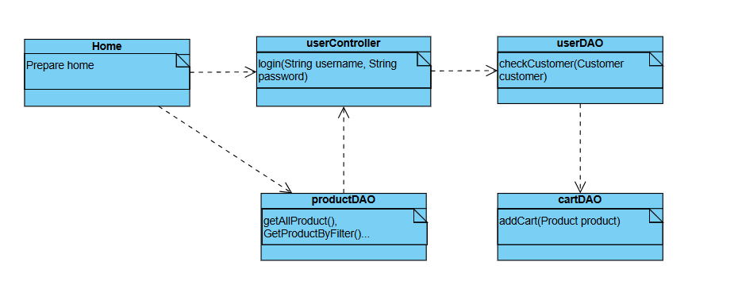

### **b. Sequence Diagram**

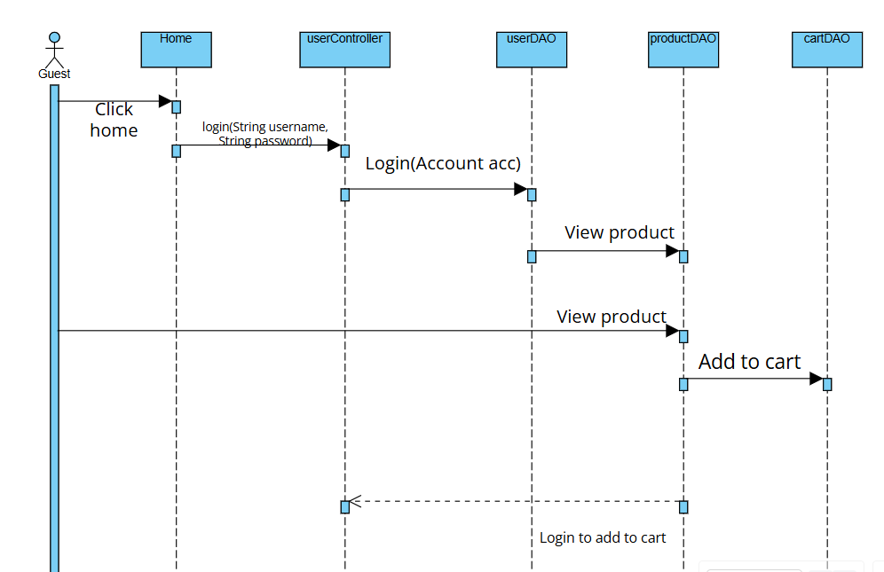

### **c. Class Specifications**

***Guest***

| **No** | **Method** | **Description** |
| --- | --- | --- |
| *01* | *get()* | *Returns the current value of the property* |
| *02* | *set()* | Set new value of the property |

***Product***

| **No** | **Method** | **Description** |
| --- | --- | --- |
| *01* | *get()* | *Returns the current value of the property* |
| *02* | *set()* | Set new value of the property |

***Cart***

| **No** | **Method** | **Description** |
| --- | --- | --- |
| *01* | *get()* | *Returns the current value of the property* |
| *02* | *set()* | Set new value of the property |

***UserDAO***

| **No** | **Method** | **Description** |
| --- | --- | --- |
| *01* | *checkSignIn*() | Parameter: User object. This function check username and password is correct or not. |
| *02* | *checkUsernameEmailIsDuplicated()* | Parameter: User object. This function check if username and email is correct to reset password. |

***UserControll***

| **No** | **Method** | **Description** |
| --- | --- | --- |
| *01* | signIn() | *Parameter: HttpServletRequest, HttpServletResponse. This funtion help user sign in to the system.* |
| *02* | logOut() | *Parameter: HttpServletRequest, HttpServletResponse. This function in order to log out the system.* |

### **d. Database queries**

Select * from product

Select * from cart where user_id=?

Insert into cart(productID,quantity) values (?,?) where user_id=?

"SELECT * FROM users WHERE username = ? AND email = ?" **resetPassword**

"UPDATE users SET users.password = ? WHERE username = ?"

## **2. <Checkout/Manage Order>**

### **a. Class Diagram**

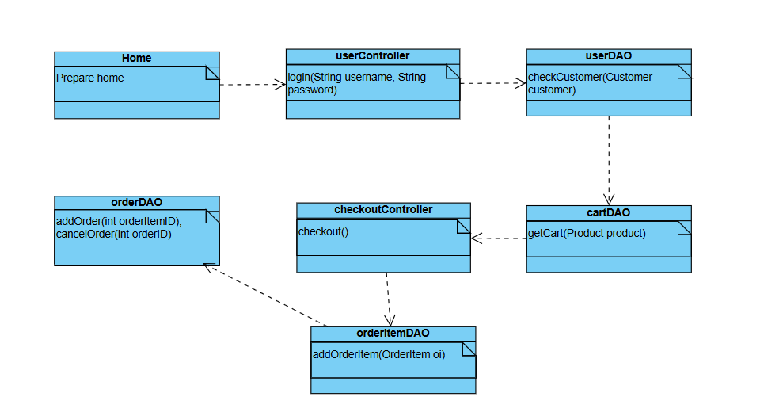

### **b. Sequence Diagram**

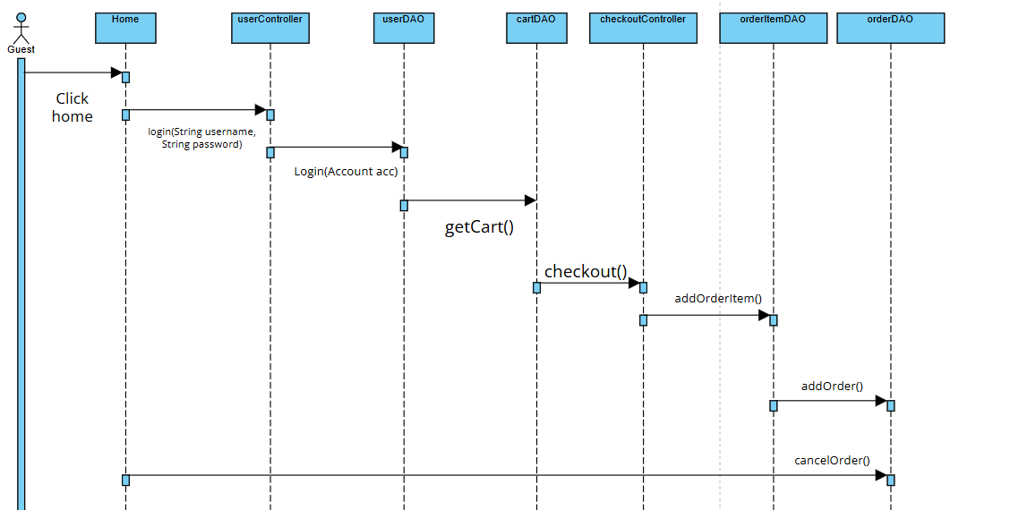

### **c. Class Specifications**

***Guest***

| **No** | **Method** | **Description** |
| --- | --- | --- |
| *01* | *get()* | *Returns the current value of the property* |
| *02* | *set()* | Set new value of the property |

***Cart***

| **No** | **Method** | **Description** |
| --- | --- | --- |
| *01* | *get()* | *Returns the current value of the property* |
| *02* | *set()* | Set new value of the property |

***OrderItem***

| **No** | **Method** | **Description** |
| --- | --- | --- |
| *01* | *get()* | *Returns the current value of the property* |
| *02* | *set()* | Set new value of the property |

***Order***

| **No** | **Method** | **Description** |
| --- | --- | --- |
| *01* | *get()* | *Returns the current value of the property* |
| *02* | *set()* | Set new value of the property |

***UserDAO***

| **No** | **Method** | **Description** |
| --- | --- | --- |
| *01* | *checkSignIn*() | Parameter: User object. This function check username and password is correct or not. |
| *02* | *checkUsernameEmailIsDuplicated()* | Parameter: User object. This function check if username and email is correct to reset password. |

***UserControll***

| **No** | **Method** | **Description** |
| --- | --- | --- |
| *01* | signIn() | *Parameter: HttpServletRequest, HttpServletResponse. This funtion help user sign in to the system.* |
| *02* | logOut() | *Parameter: HttpServletRequest, HttpServletResponse. This function in order to log out the system.* |

### 

### **d. Database queries**

Select * from orderItem where order_id=?

Select * from order where id=?

Delete from order where id=?

"SELECT * FROM users WHERE username = ? AND email = ?" **resetPassword**

"UPDATE users SET users.password = ? WHERE username = ?"

## **3. <Add product/ Delete product/ Edit product>**

### **a. Class Diagram**

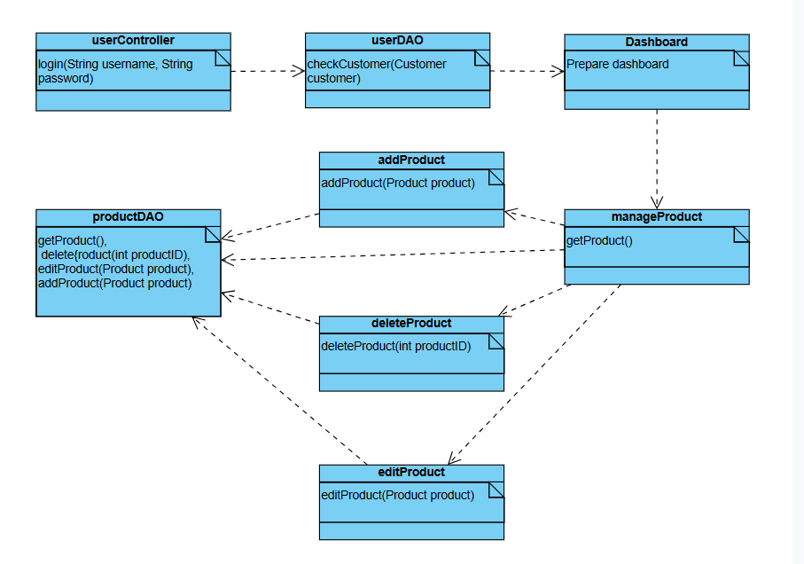

### **b. Sequence Diagram**

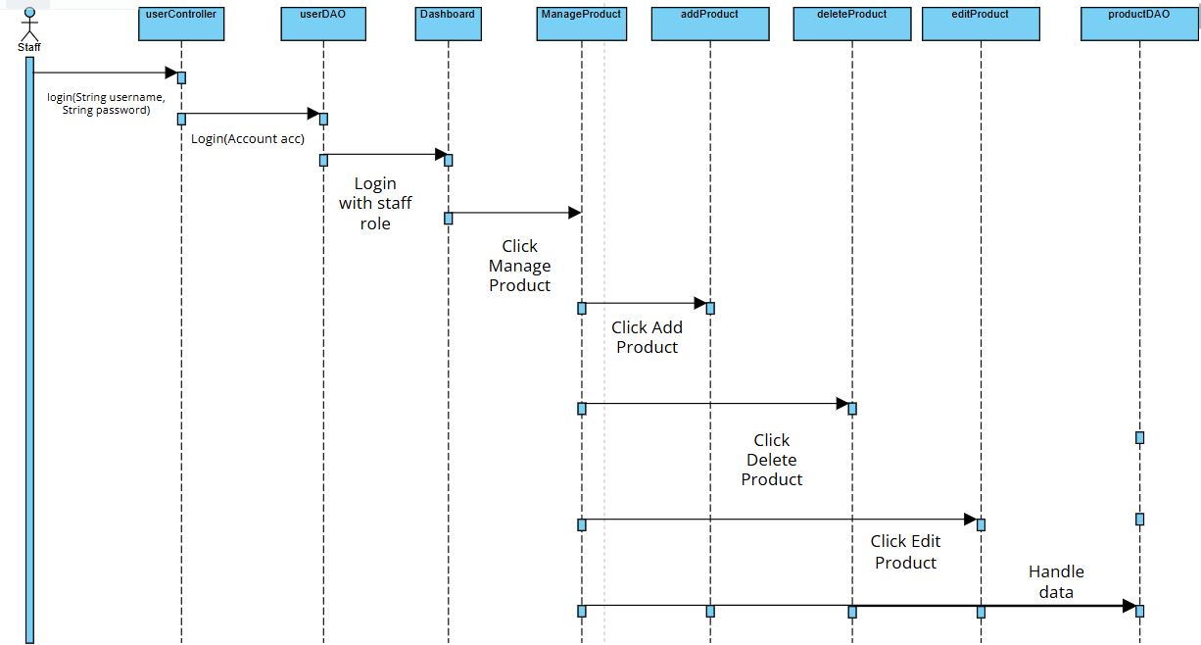

### **c. Class Specifications**

***Guest***

| **No** | **Method** | **Description** |
| --- | --- | --- |
| *01* | *get()* | *Returns the current value of the property* |
| *02* | *set()* | Set new value of the property |

***Product***

| **No** | **Method** | **Description** |
| --- | --- | --- |
| *01* | *get()* | *Returns the current value of the property* |
| *02* | *set()* | Set new value of the property |
| *03* | *addProduct(Product p)* | Add new Product |
| *04* | *deleteProduct(int id)* | Delete Product |
| *05* | *editProduct(Product p)* | Update Product |

***UserDAO***

| **No** | **Method** | **Description** |
| --- | --- | --- |
| *01* | *checkSignIn*() | Parameter: User object. This function check username and password is correct or not. |
| *02* | *checkUsernameEmailIsDuplicated()* | Parameter: User object. This function check if username and email is correct to reset password. |

***UserControll***

| **No** | **Method** | **Description** |
| --- | --- | --- |
| *01* | signIn() | *Parameter: HttpServletRequest, HttpServletResponse. This funtion help user sign in to the system.* |
| *02* | logOut() | *Parameter: HttpServletRequest, HttpServletResponse. This function in order to log out the system.* |

### 

### **d. Database queries**

Select * from product where user_id=?

Select * from product where id=?

Delete from product where id=?

"SELECT * FROM users WHERE username = ? AND email = ?" **resetPassword**

"UPDATE users SET users.password = ? WHERE username = ?"

## 

## **4. <Authentication/Login/Forgot password/Log out>**

### **a. Class Diagram**

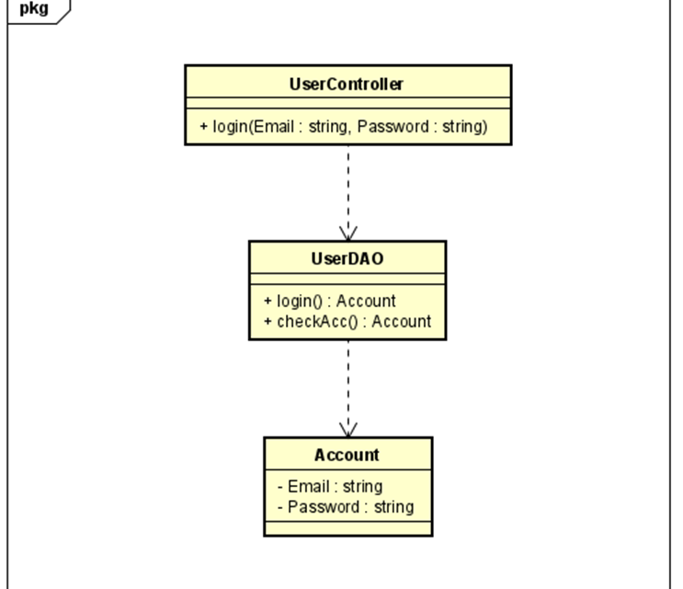

### **b. Sequence Diagram**

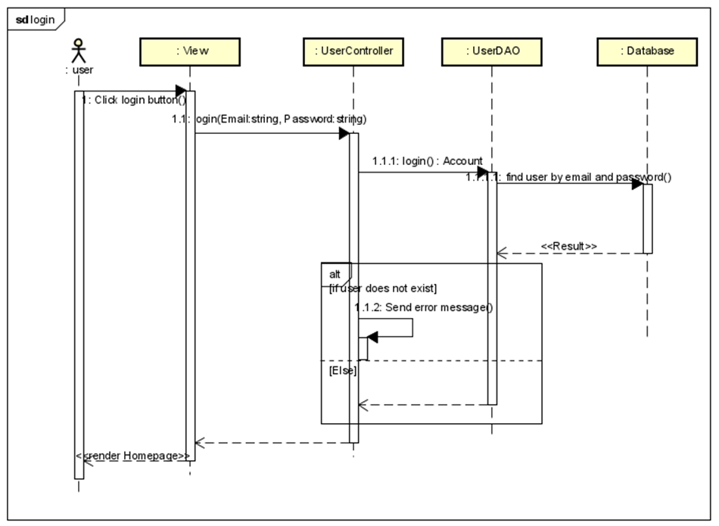

### **c. Class Specifications**

***User***

| **No** | **Method** | **Description** |
| --- | --- | --- |
| *01* | *get()* | *Returns the current value of the property* |
| *02* | *set()* | Set new value of the property |

***Employee***

| **No** | **Method** | **Description** |
| --- | --- | --- |
| *01* | *get()* | *Returns the current value of the property* |
| *02* | *set()* | Set new value of the property |

***UserDAO***

| **No** | **Method** | **Description** |
| --- | --- | --- |
| *01* | *checkSignIn*() | Parameter: User object. This function check username and password is correct or not. |
| *02* | *resetPassword()* | Parameter: User object. This function will reset new password |
| *03* | *checkUsernameEmailIsDuplicated()* | Parameter: User object. This function check if username and email is correct to reset password. |

***UserControll***

| **No** | **Method** | **Description** |
| --- | --- | --- |
| *01* | signIn() | *Parameter: HttpServletRequest, HttpServletResponse. This funtion help user sign in to the system.* |
| *02* | logOut() | *Parameter: HttpServletRequest, HttpServletResponse. This function in order to log out the system.* |
| *03* | resetPassword(  ) | *Parameter: HttpServletRequest, HttpServletResponse. This function to reset password if user forgot password.* |
| *04* | validateEmail() | *Parameter: HttpServletRequest, HttpServletResponse. This function check check if email is correct or not* |

### **d. Database queries**

checkUsernameEmailIsDuplicated

"SELECT * FROM users WHERE username = ? AND email = ?" **resetPassword**

"UPDATE users SET users.password = ? WHERE username = ?"

## **5. <Register>**

### **a. Class Diagram**

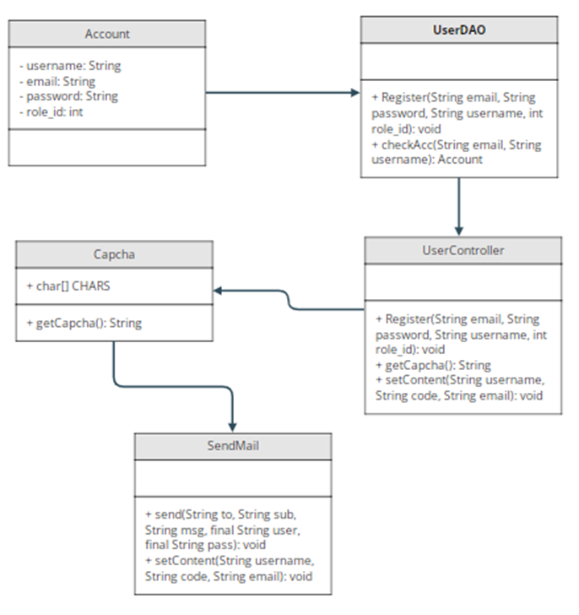

### **b. Sequence Diagram**

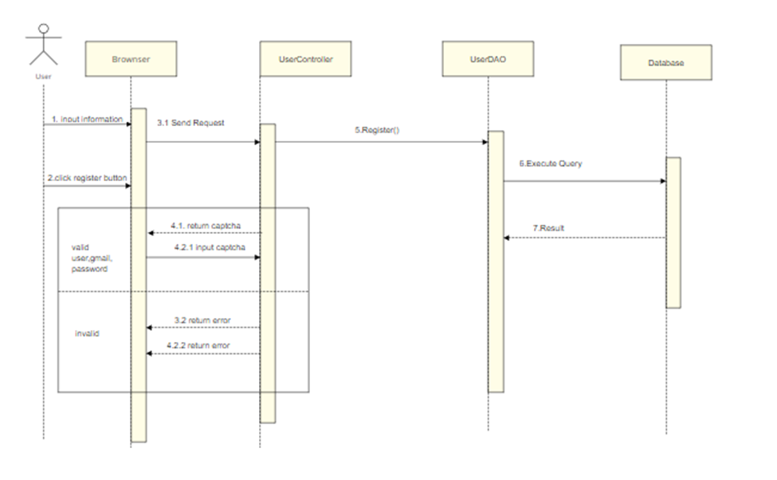

### **c. Class Specifications**

| No | Method | Description |
| --- | --- | --- |
| 1 | Register | use to create new user |
| 2 | checkAcc | use to check username or email exist |
| 3 | getCapcha | get a random string |
| 4 | send | send mail to user |
| 5 | setContent | set email and username that user use to register to send |

### **d. Database queries**

SELECT * FROM users WHERE email=? OR username=?

INSERT INTO `doctris_system`.`users` (`username`, `password`, `email`, `role_id`) VALUES (?, ?, ?, ?)

## **6. <Web Blog>**

### **a. Class Diagram**

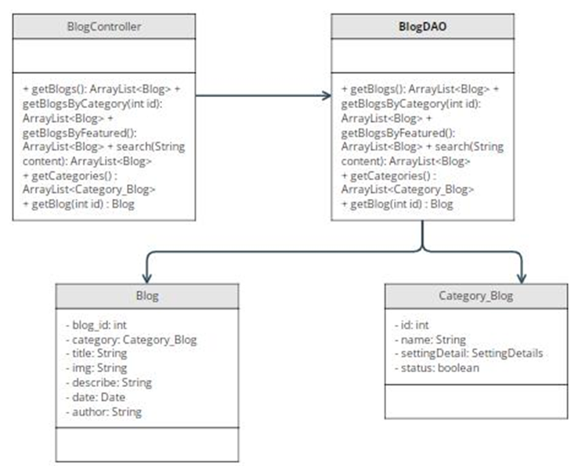

### **b. Sequence Diagram**

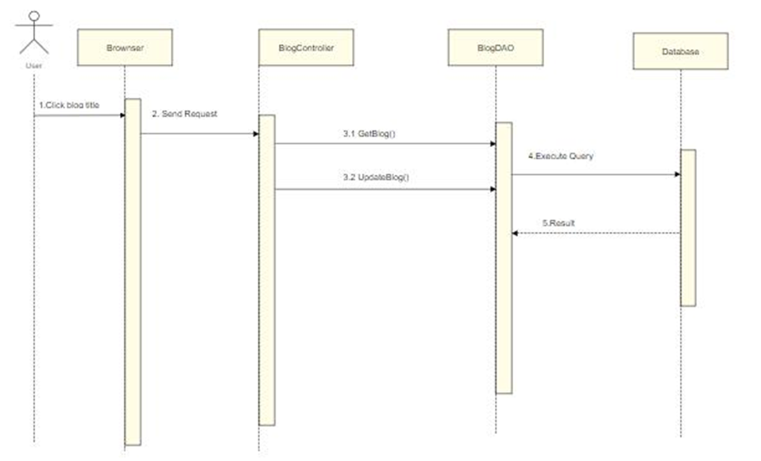

### **c. Class Specifications**

| No | Method | Description |
| --- | --- | --- |
| 1 | getBlogs | get all blog in database order by date |
| 2 | getCategories | get all categories in database |
| 3 | getBlog | get blog by blog id |
| 4 | getBlogBy Featured | get blog which featured |
| 5 | search | get blog that having or contain keyword in its title |
| 6 | getBlogByCategory | get blog in the same category |

### **d. Database queries**

- SELECT news.*, category_news.name FROM blog

inner join category_news

on blog.category_id = category_news.id

order by date desc

* SELECT * FROM category_news;
* SELECT * FROM news WHERE title LIKE ? ORDER BY date desc