

PORMS - PORT OPERATION RISK MANAGEMENT SYSTEM
Software Requirement Specification

– Danang, July 2026 –
TABLE OF CONTENTS
I. Record of Changes 3
II. Software Requirement Specification 4
1. Product Overview 4
2. User Requirements 4
2.1 Actors 4
2.2 Use Cases 5
2.2.1 Diagram(s) 5
2.2.2 Use Case Descriptions 8
3. Functional Requirements 11
3.1 System Functional Overview 11
3.1.1 Screens Flow 11
3.1.2 Screen Descriptions 12
3.1.3 Screen Authorization 14
3.1.4 Non-Screen Functions 14
3.1.5 Entity Relationship Diagram 15
3.2 Authentication & User Management 19
3.2.1 - Sign In 19
3.2.2 - Change Password 20
3.2.3 - View Profile 21
3.2.4 - View User List 22
3.2.5 - Add User 23
3.3 Port & Zone Management 26
3.3.1 - View Port List 26
3.3.2 - View Port Detail 27
3.3.3 - Add / Edit Zone 28
3.4 Dashboard & Real-time Monitoring 30
3.4.1 - Main Dashboard 30
3.4.2 - Override Operation Mode (Modal) 32
3.5 Alert Management 34
3.5.1 - Alert Panel 34
3.6 Risk Configuration 36
3.6.1 - Risk Threshold Configuration 36
3.7 SOP Configuration 38
3.7.1 - SOP Rules List 38
3.7.2 - Add / Edit SOP Rule (Modal) 39
3.8 Task Log 42
3.8.1 - Task Log 42
3.9 Operation Log & Audit Trail 43
3.9.1 - Operation Log 43
3.10 Simulation Mode 46
3.10.1 - Simulation Control 46
3.10.2 - Simulation Results 47
3.11 Analytics Dashboard 50
3.11.1 - Analytics 50
4. Non-Functional Requirements 52
4.1 External Interfaces 52
4.1.1 User Interface 52
4.1.2 Software Interface 52
4.1.3 Hardware Interface 52
4.2 Quality Attributes 52
4.2.1 Availability 52
4.2.2 Usability 52
4.2.3 Reliability 52
4.2.4 Performance 53
4.2.5 Security 53
4.2.6 Maintainability and Extensibility 53
5. Requirement Appendix 54
5.1 Business Rules 54
5.2 Common Requirements 55
5.3 Application Messages List 55

I. Record of Changes
Date | A/M/D | In Charge | Change Description
04/05/2026 | A | Nguyễn Phan Anh Minh | Initial draft — Product Overview, Actors, Use Cases, System Overview
05/05/2026 | A | Nguyễn Phan Anh Minh | Add Functional Requirements: Auth, Port/Zone, Dashboard, Alert modules
06/05/2026 | A | Nguyễn Phan Anh Minh | Add Risk Config, SOP Config, Operation Log, Simulation modules. Add Non-Functional Requirements and Appendix
29/05/2026 | A | Nguyễn Anh Kiệt | Add Figure 2 Actor Inheritance Diagram, Figure 3 Authentication Use Case Diagram, Figure 4 User Management Use Case Diagram, Figure 5 Port & Zone Management Use Case Diagram
30/05/2026 | M | Nguyễn Anh Kiệt | Change actor name: COMPANY_ADMIN to PORT MANAGER
31/05/2026 | M, A | Nguyễn Anh Kiệt | Modify Figure 2 Actor Inheritance Diagram, Figure 5 Port & Zone Management Use Case Diagram, Add Figure 6 Dashboard & Alert Management Use Case Diagram
31/05/2026 | M | Đinh Hải Quân | Modify Figure 7 Risk & SOP Configuration Use Case Diagram, Figure 8 Simulation & Analytics Use Case Diagram
01/06/2026 | M,A | Nguyễn Anh Kiệt | Modify Figure 3 Authentication Use Case Diagram, Figure 4 User Management Use Case Diagram, Add Figure 12 ERD Diagram
02/06/2026 | A | Trần Quang Dũng | Add Figure 1 Context Diagram, Figure 9 ADMIN Screen Flow Diagram, Figure 10 PORT MANAGER Screen Flow Diagram, Figure 11 OPERATOR Screen Flow Diagram
05/06/2026 | M, A | Nguyễn Anh Kiệt | Modify report title , Figure 3 Authentication Use Case Diagram, Add Table of Contents
31/07/2026 | M, A | Đinh Hải Quân | Update SRS to the implemented July 2026 baseline: role/port-scoped alerts, task assignment lifecycle, SMTP email, Vietnamese voice alerts, operational forecast, AI long-range forecast, forecast evaluation, notification settings and Excel/PDF reports.
Table 1. Record of Changes

II. Software Requirement Specification

1. Product Overview
PORMS (Port Operation Risk Management System) is a decision-support and risk alert system for seaport operations based on real-time weather data. The system is designed and developed as a Capstone Project (CP_SEP490) at FPT University Da Nang, targeting Tien Sa Port, Da Nang as the demonstration environment.
Traditional port operations rely heavily on individual supervisor experience to assess weather risk and issue safety directives. This leads to inconsistent responses between shifts, delayed reactions to rapidly changing conditions, and a lack of audit trail for compliance. PORMS eliminates these weaknesses by automating the full pipeline: weather data collection → risk evaluation → SOP execution → alert delivery → analytics.
The system continuously ingests weather data from the OpenWeather API every 15 minutes via a Prefect ETL pipeline and an ASP.NET BackgroundService. A rule-based Risk Engine evaluates risk levels (LOW / MEDIUM / HIGH / CRITICAL) using the internationally standardized Beaufort WMO scale and configurable rainfall/visibility thresholds. When risk level changes, the SOP Engine automatically executes pre-configured Standard Operating Procedure rules, transitioning the port's operation mode (NORMAL → LIMITED → STOP), generating operator tasks, and dispatching prioritized alerts. All actions are recorded in an append-only operation event log to support compliance audits and post-incident analysis. A Metabase BI module, fed by an hourly ETL pipeline, provides management with historical risk trend dashboards and KPI monitoring. A Simulation Mode allows authorized users to replay historical storm datasets at accelerated speed for training and demonstration purposes.
The current implementation uses ASP.NET Core 10, PostgreSQL 16, Prefect 2.x, Metabase 0.50, Docker Compose, and a React 18/TypeScript frontend. Operational and analytics schemas remain separated in PostgreSQL.

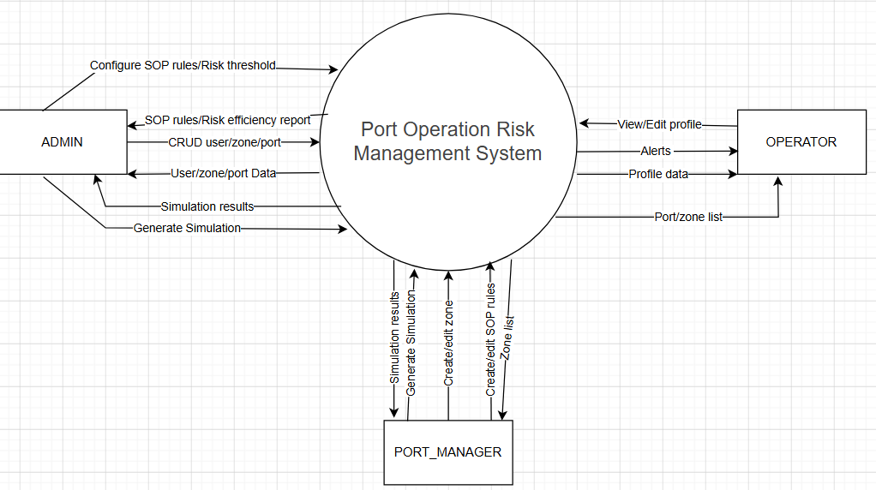
Figure 1. Context Diagram

2. User Requirements

2.1 Actors
# | Actor | Description
1 | ADMIN (System Administrator) | The System Administrator has system-wide access. Responsibilities include managing user accounts, ports and zones; viewing all accessible alerts and tasks; configuring risk thresholds and SOP rules; running simulations; using forecasting, evaluation, reporting and audit functions. ADMIN is not bound to a specific port.
2 | PORT MANAGER (Port Operations Manager) | The Port Manager is assigned to one port. The manager monitors that port, receives HIGH/CRITICAL alerts, acknowledges alerts, assigns NEW response tasks only to active Operators at the same port, supervises task progress and exports reports for the assigned port. The role cannot manage user accounts.
3 | OPERATOR (Port Operations Supervisor) | The Operator is assigned to one port and works within a personal task scope. The Operator sees alerts only when a related task is assigned personally, receives an assignment email, and processes the task through ACKNOWLEDGED, IN_PROGRESS and COMPLETED with a mandatory completion note.
Table 2. All Actors in the System

2.2 Use Cases

2.2.1 Diagram(s)
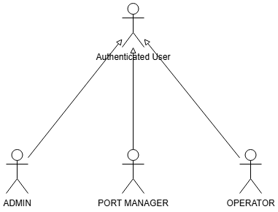
Figure 2. Actor Inheritance Diagram
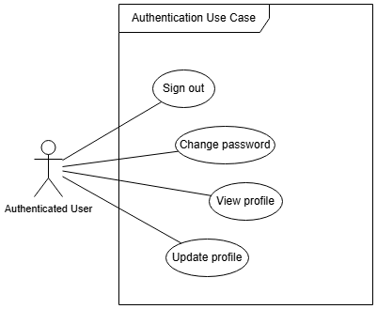
Figure 3. Authentication Use Case Diagram
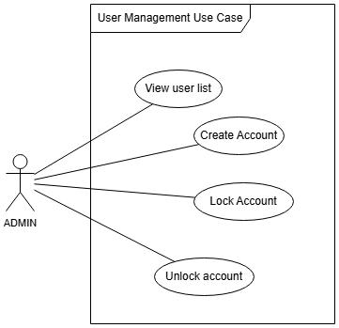
Figure 4. User Management Use Case Diagram
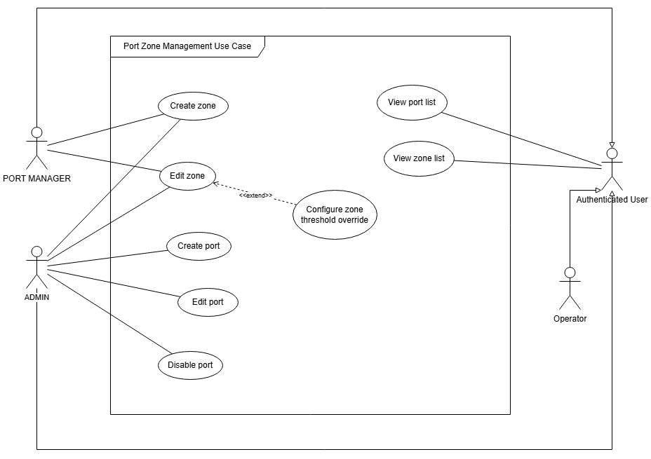
Figure 5. Port & Zone Management Use Case Diagram
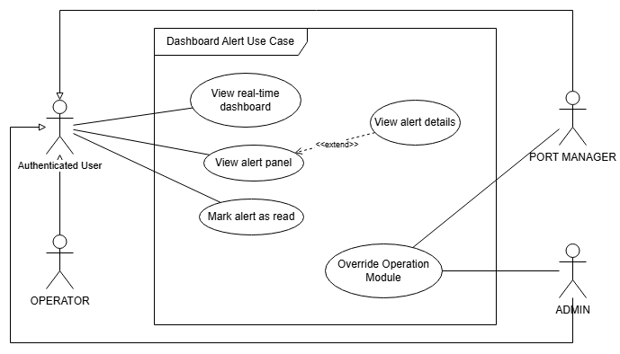
Figure 6. Dashboard & Alert Management Use Case Diagram
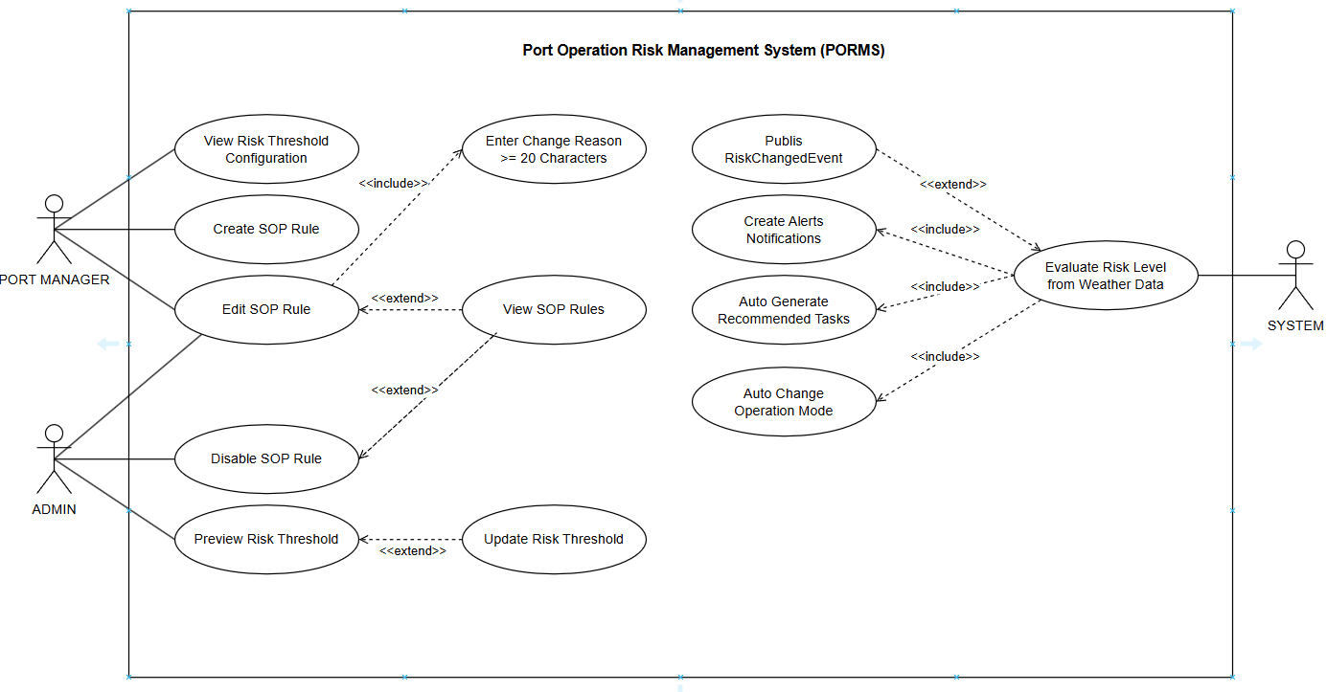
Figure 7. Risk & SOP Configuration Use Case Diagram
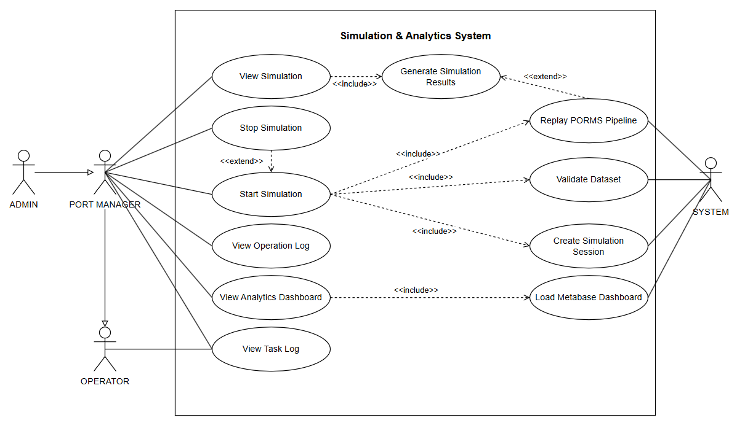
Figure 8. Simulation & Analytics Use Case Diagram

2.2.2 Use Case Descriptions
ID | Use Case | Actors | Description
UC-01 | Sign In | All Actors | Users can sign into the system using their registered email and password.
UC-02 | Sign Out | All Actors | Users can sign out from their current session. Refresh token is revoked.
UC-03 | Refresh Session | All Actors | The system automatically renews the access token using a valid refresh token stored in an httpOnly cookie without requiring the user to log in again.
UC-04 | Change Password | All Actors | Authenticated users can change their password by verifying the current password and entering a new one.
UC-06 | View Profile | All Actors | Authenticated users can view their personal profile information.
UC-07 | Update Profile | All Actors | Authenticated users can update their full name and phone number.
UC-08 | View User List | ADMIN | Admin can view the full list of all users with filtering by role and status.
UC-09 | Create User | ADMIN | Admin can create a new user account with a specified role and assigned port.
UC-10 | Edit User | ADMIN | Admin can update user information including role, status, and assigned port.
UC-11 | Unlock Account | ADMIN | Admin can unlock a user account that has been temporarily locked after too many failed login attempts.
UC-12 | View Port List | All Actors | All users can view the list of ports. ADMIN sees all ports; PORT MANAGER and OPERATOR see only their assigned port.
UC-13 | Create Port | ADMIN | Admin can register a new port with geographic coordinates and weather source.
UC-14 | Edit Port | ADMIN | Admin can update port information. Port code is immutable after creation.
UC-15 | Disable Port | ADMIN | Admin can disable a port, which stops automated weather fetching while preserving all historical data.
UC-16 | View Zone List | All Actors | Users can view the list of zones within their assigned port.
UC-17 | Create Zone | ADMIN, PORT MANAGER | Authorized users can create a new operational zone within a port.
UC-18 | Edit Zone | ADMIN, PORT MANAGER | Authorized users can update zone information including display order and capacity.
UC-19 | Configure Zone Threshold Override | ADMIN, PORT MANAGER | Authorized users can set zone-specific risk thresholds that override the global risk threshold configuration.
UC-20 | View Real-time Dashboard | All Actors | Users can view the main operational dashboard showing current weather, risk level, operation mode, alert bell, zone status grid, risk trend chart, and recent task log.
UC-21 | Override Operation Mode | ADMIN, PORT MANAGER | Authorized users can manually change the operation mode to any target state, bypassing the automatic state machine, with a mandatory explanation reason of at least 20 characters.
UC-22 | View Alert Panel | All Actors | ADMIN views all alerts; PORT MANAGER views alerts from the assigned port; OPERATOR views only alerts related to personally assigned tasks. HIGH/CRITICAL alerts can trigger popup and Vietnamese speech.
UC-23 | Mark Alert as Read | All Actors | Users can mark individual alerts or all alerts as read.
UC-24 | View Alert Detail | All Actors | Users can view the full detail of an alert including metadata context.
UC-25 | View Risk Threshold Configuration | ADMIN, PORT MANAGER | Authorized users can view the current risk evaluation thresholds for WIND, RAIN, and VISIBILITY factors.
UC-26 | Update Risk Threshold | ADMIN | Admin can modify risk evaluation thresholds. Changes take effect within 5 minutes via cache expiry.
UC-27 | Preview Risk Threshold | ADMIN | Admin can preview how threshold changes would affect risk evaluation for given test values without saving.
UC-28 | View SOP Rules | ADMIN, PORT MANAGER | Authorized users can view all SOP rules with execution statistics.
UC-29 | Create SOP Rule | ADMIN, PORT MANAGER | Authorized users can create new SOP rules defining automated responses to risk level changes.
UC-30 | Edit SOP Rule | ADMIN, PORT MANAGER | Authorized users can modify SOP rules. A mandatory change reason of at least 20 characters is required.
UC-31 | Disable SOP Rule | ADMIN | Admin can disable a SOP rule. Historical execution records are preserved.
UC-32 | View and Process Tasks | All Actors | Users view tasks within role scope. Admin/Port Manager assigns a NEW task to an eligible same-port Operator; the assigned Operator acknowledges, starts and completes it with a result note.
UC-33 | View Operation Log | ADMIN, PORT MANAGER | Authorized users can view the append-only audit trail of all system events. Filtering by event type, actor, and date range is supported.
UC-34 | View Analytics Dashboard | ADMIN, PORT MANAGER | Authorized users can access embedded Metabase BI dashboards showing risk trends, SOP effectiveness, and KPIs.
UC-35 | Start Simulation | ADMIN | Admin creates/selects a simulation dataset and replays historical or prepared weather snapshots through the operational pipeline.
UC-36 | Stop Simulation | ADMIN, PORT MANAGER | Authorized users can cancel an in-progress simulation session.
UC-37 | View Simulation Results | ADMIN, PORT MANAGER | After a simulation completes, authorized users can view a summary of simulation outcomes including peak risk level and SOP execution counts.
UC-38 | Configure Notification Preference | All Actors | Users enable/disable in-app popup and Vietnamese voice and select HIGH+CRITICAL or CRITICAL-only popup threshold on the current device.
UC-39 | Assign Response Task | ADMIN, PORT MANAGER | Authorized manager assigns a NEW task only to an active Operator belonging to the task's port.
UC-40 | Process Assigned Task | OPERATOR | Assigned Operator acknowledges, starts and completes a task with a completion result.
UC-41 | View Operational Forecast | ADMIN, PORT MANAGER | View five-day weather-based risk and operating recommendations for an accessible port.
UC-42 | View AI Long-range Forecast | ADMIN, PORT MANAGER | Analyze 7/14/30/60/90-day planning trends with PCA/K-Means risk analysis.
UC-43 | Evaluate Forecast | ADMIN, PORT MANAGER | Compare forecast values with actual weather readings when actual data is available.
UC-44 | Preview and Export Report | ADMIN, PORT MANAGER | Filter alerts, tasks or operation events, preview the result, then export Excel or PDF within access scope.
Table 3. Use Case Descriptions

3. Functional Requirements

3.1 System Functional Overview

3.1.1 Screens Flow
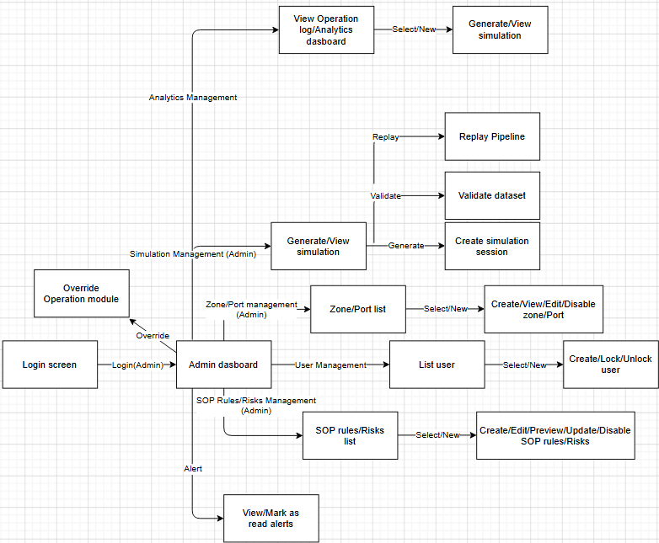
Figure 9. ADMIN Screen Flow Diagram
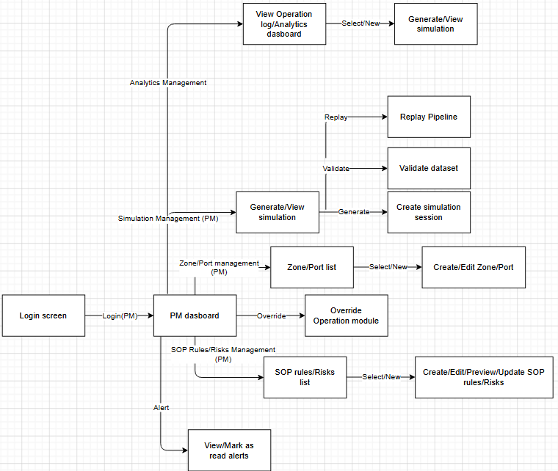
Figure 10. PORT MANAGER Screen Flow Diagram
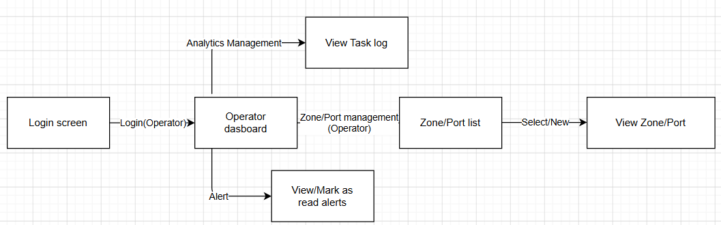
Figure 11. OPERATOR Screen Flow Diagram

3.1.2 Screen Descriptions
# | Feature | Screen | Description
1 | Authentication & User Management | Sign In Screen | Allows all users to authenticate with email and password.
2 |  | Change Password Screen | Allows authenticated users to change their password.
3 |  | Forgot Password Screen | Allows unauthenticated users to request a password reset link via email.
4 |  | View Profile Screen | Displays the authenticated user's personal information.
5 |  | Update Profile Screen | Allows users to update their full name and phone number.
6 |  | User List Screen | Allows Admin to view, search, and filter all registered users.
7 |  | Add User Screen | Allows Admin to create a new user account with role and port assignment.
8 |  | Edit User Screen | Allows Admin to update user information and account status.
9 | Port & Zone Management | Port List Screen | Shows all ports with real-time mode and risk badges. ADMIN sees all; CA/OP see assigned port only.
10 |  | Port Detail Screen | Displays port information and the list of zones within the port.
11 |  | Add Port Screen | Allows Admin to register a new port with geographic coordinates.
12 |  | Add/Edit Zone Screen | Allows Admin and CA to create or update a zone within a port.
13 |  | Zone Threshold Override Screen | Allows Admin and CA to configure zone-specific risk thresholds.
14 | Dashboard & Real-time Monitoring | Main Dashboard Screen | Displays the real-time operational status of the port: weather, risk level, operation mode, alert bell, zone grid, risk trend chart, and recent tasks.
15 |  | Override Mode Modal | A modal dialog that allows Admin and CA to manually change the operation mode with a mandatory reason.
16 | Alert Management | Alert Panel Screen | Shows the full list of alerts for the assigned port with severity filtering and read/unread status.
17 |  | Alert Detail Screen | Displays full details of a single alert including metadata context.
18 | Risk Configuration | Risk Threshold Configuration Screen | Displays and allows editing of risk evaluation thresholds (WIND, RAIN, VISIBILITY) with a live preview panel.
19 | SOP Configuration | SOP Rules List Screen | Displays all SOP rules with execution statistics and allows management actions.
20 |  | Add/Edit SOP Rule Modal | A modal form for creating or updating a SOP rule.
21 | Task Log | Task Log Screen | Displays a chronological list of auto-generated task recommendations from SOP executions.
22 | Operation Log | Operation Log Screen | Displays the append-only audit trail timeline with event filtering.
23 | Analytics | Analytics Screen | Displays embedded Metabase BI dashboards via signed iframes.
24 | Simulation Mode | Simulation Control Screen | Allows authorized users to start, monitor, and stop weather data simulations.
25 |  | Simulation Results Screen | Displays the outcome summary of a completed simulation session.
26 | Task Workflow | Task Detail Screen | Allows assignment by Admin/Port Manager and acknowledgement, start and completion by the personally assigned Operator.
27 | Notification | Notification Settings Screen | Configures website popup, Vietnamese voice and minimum automatic-notification severity for the current browser/device.
28 | Forecast | Operational Forecast Screen | Shows five-day weather risk, recommended operating mode and human-readable response actions.
29 | Forecast | AI Long-range Forecast Screen | Shows planning trends from 7 days to 3 months, risk score, cluster, confidence and recommendation.
30 | Forecast | Forecast Evaluation Screen | Compares forecast and actual wind/rain/visibility/risk and explains missing actual data.
31 | Reporting | Operational Report Screen | Previews and exports filtered Alerts, Tasks or Operation Events to Excel/PDF.
Table 4. Screen Descriptions

3.1.3 Screen Authorization
Screen | ADMIN | PORT MANAGER | OPERATOR
Sign In Screen | X | X | X
Change Password Screen | X | X | X
View Profile Screen | X | X | X
Update Profile Screen | X | X | X
User List Screen | X
Add User Screen | X
Edit User Screen | X
Port List Screen | X | X (own port only) | X (own port only)
Port Detail Screen | X | X (own port) | X (own port)
Add Port Screen | X
Add/Edit Zone Screen | X | X
Zone Threshold Override Screen | X | X
Main Dashboard Screen | X | X | X
Override Mode Modal | X | X
Alert Panel Screen | X | X | X
Alert Detail Screen | X | X | X
Risk Threshold Configuration Screen | X (read+write) | X (read only)
SOP Rules List Screen | X | X
Add/Edit SOP Rule Modal | X | X
Task Log Screen | X (all accessible) | X (own port) | X (assigned only)
Operation Log Screen | X | X
Analytics Screen | X | X
Simulation Control Screen | X
Simulation Results Screen | X
Task Detail Screen | X | X (own port) | X (assigned only)
Notification Settings Screen | X | X | X
Operational Forecast Screen | X | X (own port)
AI Long-range Forecast Screen | X | X (own port)
Forecast Evaluation Screen | X | X (own port)
Operational Report Screen | X (all ports) | X (own port)
Table 5. Screen Authorization

3.1.4 Non-Screen Functions
# | Feature | System Function | Description
1 | Authentication | Forgot Password Email | When a user requests a password reset, the system sends a one-time link with a 15-minute TTL to the registered email.
2 | Weather Ingestion | Automated Weather Fetch | The ASP.NET BackgroundService (IHostedService) automatically calls the OpenWeather API every 15 minutes for all active ports and saves normalized readings to the database.
3 | Weather Ingestion | Prefect ETL Collector | Prefect's weather_collector flow runs on a 15-minute interval schedule, fetches weather data, normalizes it, and triggers the Risk Engine via internal API call.
4 | Risk Engine | Automatic Risk Evaluation | After each successful weather fetch, the Risk Engine automatically evaluates risk level using Beaufort WMO thresholds. If the risk level changes, a RiskChangedEvent is published via MediatR.
5 | SOP Engine | Automatic SOP Execution | When a RiskChangedEvent is received, the SOP Engine queries matching rules and executes them in execution_order sequence, creating task logs, mode changes, and alerts.
6 | Alert System | Anti-spam Alert Suppression | Duplicate alerts of the same type for the same port are suppressed within a 10-minute window. CRITICAL severity alerts bypass this suppression.
7 | ETL Pipeline | DW Hourly Load | Prefect's dw_loader flow runs every hour to load new operational data into the analytics schema for Metabase BI dashboards.
8 | Simulation | Weather Snapshot Replay | The simulation engine replays a JSON dataset of weather snapshots through the full pipeline (Risk → SOP → Mode → Alert) at an accelerated speed multiplier.
9 | Alert System | Port-scoped Alert Delivery | HIGH/CRITICAL alerts are visible to Admin and the assigned Port Manager. An Operator gains access only after a related task is assigned personally.
10 | Notification | Vietnamese Voice Alert | Accessible HIGH/CRITICAL alerts provide audio/mpeg Vietnamese speech; visual popup remains available if browser audio is blocked.
11 | Notification | Manager Alert Email | After simulation creates a HIGH/CRITICAL alert, SMTP email is sent to active Port Manager accounts at that port. Mail failure does not roll back the simulation.
12 | Task | Assignment Email | After a task is assigned, SMTP email is sent only to the selected Operator.
13 | Forecast | Risk Trend Analysis | PCA score and K-Means cluster support long-range operational planning; output is not an official meteorological forecast.
14 | Reporting | Excel/PDF Generation | The API generates an export that matches preview filters and records the export in operation history.
Table 6. Non-Screen Functions

3.1.5 Entity Relationship Diagram
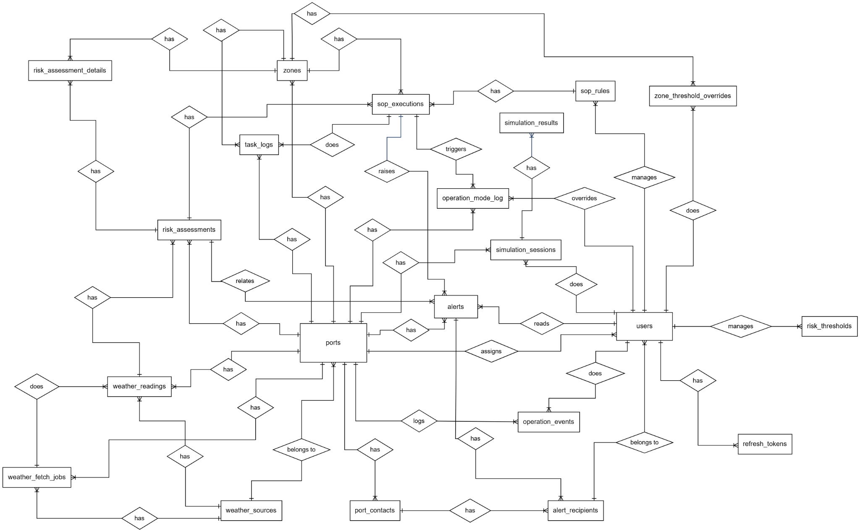
Figure 12. ERD Diagram
Entities Description
# | Entity | Description
1 | users | Stores user accounts: email, BCrypt password_hash, full_name, role (ADMIN|PORT_MANAGER|OPERATOR), status (ACTIVE|INACTIVE|LOCKED), assigned_port_id, last_login_at, deleted_at and timestamps.
2 | refresh_tokens | Stores hashed refresh tokens for session management. Properties: id (PK), user_id (FK), token_hash (SHA-256), device_info (JSONB), expires_at, revoked_at, revoked_reason, created_at.
3 | ports | Represents a monitored port. Properties: id (PK), name, code (unique, immutable), address, latitude, longitude, timezone, current_mode (enum), current_risk_level (enum), default_weather_source_id (FK), ow_station_id, is_active, created_at, updated_at.
4 | zones | Represents an operational zone within a port. Properties: id (PK), port_id (FK), name, zone_type (DOCK|YARD|GATE|WAREHOUSE), description, capacity, latitude, longitude, current_risk_level (enum), display_order, config (JSONB), is_active, created_at, updated_at.
5 | weather_sources | Represents a weather data provider. Properties: id (PK), source_name (unique), source_type (REST_JSON|MANUAL_INPUT), api_base_url, description, recommended_fetch_interval_min, is_active.
6 | weather_readings | Stores normalized weather readings. Properties: id (PK), port_id (FK), source_id (FK), fetch_job_id (FK), wind_speed_ms, beaufort_number, wind_direction_deg, wind_gust_ms, rainfall_1h_mm, rainfall_3h_mm, temperature_c, humidity_pct, visibility_km, pressure_hpa, ow_weather_code, ow_weather_desc, ow_weather_icon, observed_at, recorded_at, raw_payload (JSONB), data_source, is_simulation. UNIQUE(port_id, observed_at).
7 | weather_fetch_jobs | Tracks each weather fetch attempt. Properties: id (PK), port_id (FK), source_id (FK), status (PENDING|RUNNING|SUCCESS|FAILED|SKIPPED), started_at, completed_at, response_time_ms, http_status_code, error_message, created_reading_id (FK), prefect_flow_run_id.
8 | risk_thresholds | Configurable risk evaluation thresholds. Properties: id (PK), factor (WIND|RAIN|VISIBILITY|WAVE), risk_level (enum), min_value, max_value, unit, description, is_active, updated_by_user_id (FK), updated_at. UNIQUE(factor, risk_level).
9 | zone_threshold_overrides | Zone-specific overrides for risk thresholds. Properties: id (PK), zone_id (FK), factor (enum), risk_level (enum), min_value, max_value, unit, reason, is_active, updated_by_user_id (FK), updated_at.
10 | risk_assessments | Stores each risk evaluation result. Properties: id (PK), port_id (FK), weather_reading_id (FK), final_risk_level (enum), previous_risk_level (enum), level_changed (bool), beaufort_number, rainfall_1h_mm, visibility_km, assessment_summary, evaluated_at, is_simulation.
11 | risk_assessment_details | Per-factor detail for each assessment. Properties: id (PK), assessment_id (FK), factor (enum), measured_value, unit, factor_risk_level (enum), threshold_min, threshold_max, used_zone_override (bool), zone_id (FK nullable).
12 | sop_rules | Defines automated response rules. Properties: id (PK), rule_name, trigger_risk_level (enum), applies_to_zone_type (enum, nullable), action_type (enum), action_description, target_operation_mode (enum, nullable), execution_order, alert_message, alert_severity (enum), requires_confirmation (bool), is_active, updated_by_user_id (FK), updated_at.
13 | sop_executions | Records each SOP rule execution. Properties: id (PK), sop_rule_id (FK), assessment_id (FK), port_id (FK), zone_id (FK, nullable), status (TRIGGERED|COMPLETED|FAILED|SKIPPED), skip_reason, execution_result (JSONB), triggered_at, completed_at, is_simulation.
14 | operation_mode_log | Append-only log of all mode changes. Properties: id (PK), port_id (FK), previous_mode (enum), new_mode (enum), triggered_by_risk_level (enum, nullable), triggered_by_execution_id (FK, nullable), overridden_by_user_id (FK, nullable), override_reason, change_type (AUTOMATIC|MANUAL), changed_at, is_simulation.
15 | tasks | Stores task_code, alert/port/zone/session references, title, description, priority, status, assigned_user_id, acknowledgement/start/completion timestamps, completion_note, due_at and audit timestamps.
16 | alerts | Stores port/zone/risk/session references, alert_type, severity, title, message, context JSONB, expiry and timestamps. Per-user state is stored separately in alert_receipts.
17 | alert_receipts | Stores one alert-user receipt with delivered_at, read_at and acknowledged_at. Access scope is enforced by role, assigned port and related task assignment.
18 | port_contacts | Emergency contacts for a port. Properties: id (PK), port_id (FK), contact_role (enum), full_name, title, phone_primary, phone_secondary, email, receive_alerts (bool), alert_threshold (enum), is_active.
19 | operation_events | Append-only audit trail. Properties: id (PK), port_id (FK, nullable), event_type (enum), actor_user_id (FK, nullable), payload (JSONB), summary, occurred_at, is_simulation.
20 | simulation_sessions | Records a replay run linked to simulation_dataset_id and port_id, with starter, status, progress/current step, generated counts and start/completion timestamps.
21 | simulation_datasets / simulation_snapshots | Stores reusable scenario metadata and ordered weather snapshots. Run results are resolved from session-linked risk, alert, task and event records.
Table 7. Entities Description

3.2 Authentication & User Management

3.2.1 - Sign In
Function trigger: The user navigates to the Sign In page directly or is redirected when attempting to access a protected route without an active session.
Function description: Allows ADMIN, PORT MANAGER, and OPERATOR to authenticate into the PORMS system using their registered email and password. Upon successful authentication, the system issues a JWT access token (15-minute TTL) returned in the response body, and a refresh token (7-day TTL) set as an httpOnly cookie.
Screen layout:
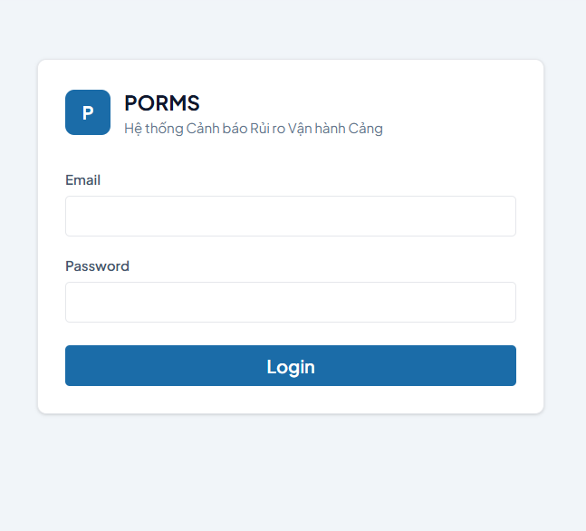
Function detail:
Data Validation:
- Email: Required, must follow standard email format.
- Password: Required, must match the BCrypt-hashed password stored for the account.
Functionality:
In Normal Cases:
- If both email and password are valid and the account is active: the system authenticates the user, issues access token and refresh token, logs USER_LOGIN event, and redirects to the Dashboard page.
- The sidebar navigation menu is rendered based on the authenticated user's role (ADMIN, PORT MANAGER, OPERATOR).
In Abnormal Cases:
- If email or password is incorrect: system displays a generic error message (MSG-02). The specific incorrect field is not revealed.
- After 5 consecutive failed attempts: account is locked for 15 minutes (MSG-03). Failed login count is recorded per user.
- If the account is locked (locked_until > NOW()): system returns 423 status with remaining lockout duration (MSG-03).
- If the server is unreachable: system displays a connectivity error (MSG-30).
Business rule: BR-01, BR-02, BR-03, BR-04, BR-05

# | Component | Comp. Type | Editable | Mandatory | Default Value | Description
Header Section
1 | Page Title | Label (Text) | No | Yes | "Đăng nhập PORMS" | Main heading of the login form.
2 | Subtitle | Label (Text) | No | Yes | "Hệ thống quản lý rủi ro vận hành cảng biển" | Descriptive subtitle below the main heading.
Form Section
3 | Email Label | Label (Text) | No | Yes | "Địa chỉ email" | Label for the email input field.
4 | Email Input | Input (Email) | Yes | Yes | Placeholder: "name@porms.vn" | Accepts the user's registered email address.
5 | Password Label | Label (Text) | No | Yes | "Mật khẩu" | Label for the password input field.
6 | Password Input | Input (Password) | Yes | Yes | Placeholder: "••••••••" | Characters masked by default. Includes visibility toggle icon.
7 | Password Visibility Icon | Icon Button | Yes | No | Eye-off icon | Toggles password character visibility (mask/unmask).
Action Section
8 | Login Button | Button (Primary) | No | Yes | "Đăng nhập" | Submits the credentials for authentication. Shows loading spinner during request.
Error Section
9 | Error Message | Label (Error) | No | No | N/A | Displays generic authentication error (MSG-02) or account locked message (MSG-03).

––––––––––––––––––––––––––––––––––––––––––––––––––––––––––––––––––––––––––––––––––

3.2.2 - Change Password
Function trigger: Triggered when an authenticated user navigates to the Change Password page via the account settings menu.
Function description: Allows authenticated users of all roles to update their account password by verifying the current password first.
Screen layout:
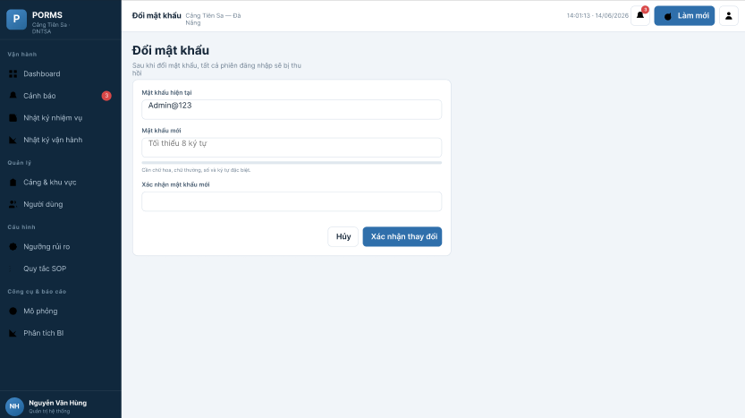
Function detail:
Data Validation:
- Current Password: Required, must match the stored BCrypt hash.
- New Password: Required, minimum 8 characters, must include uppercase, lowercase, number, and special character.
- Confirm Password: Required, must exactly match the New Password field.
Functionality:
In Normal Cases:
- If current password is valid and new password meets requirements: system updates the BCrypt hash, revokes all existing refresh tokens (forcing re-authentication on all devices), and displays success toast (MSG-05).
- User is redirected to the login page after successful password change.
In Abnormal Cases:
- If current password is incorrect: inline validation error is shown.
- If new password does not meet complexity requirements: inline validation error (MSG-29 with field details).
- If new password and confirm password do not match: inline error shown under confirm field.
Business rule: BR-01, BR-02, BR-03

# | Component | Comp. Type | Editable | Mandatory | Default Value | Description
Form Section
1 | Current Password Label | Label (Text) | No | Yes | "Mật khẩu hiện tại" | Label for current password field.
2 | Current Password Input | Input (Password) | Yes | Yes | Placeholder: "••••••••" | Input for the user's current password. Includes visibility toggle.
3 | New Password Label | Label (Text) | No | Yes | "Mật khẩu mới" | Label for new password field.
4 | New Password Input | Input (Password) | Yes | Yes | Placeholder: "Mật khẩu mới" | Input for the new password. Includes strength indicator.
5 | Confirm Password Label | Label (Text) | No | Yes | "Xác nhận mật khẩu mới" | Label for confirm password field.
6 | Confirm Password Input | Input (Password) | Yes | Yes | Placeholder: "Nhập lại mật khẩu mới" | Must match New Password. Shows inline error if mismatch.
Action Section
7 | Confirm Button | Button (Primary) | No | Yes | "Xác nhận thay đổi" | Submits the password change request.
8 | Cancel Button | Button (Secondary) | No | No | "Hủy" | Returns to previous page without saving changes.

––––––––––––––––––––––––––––––––––––––––––––––––––––––––––––––––––––––––––––––––––

3.2.3 - View Profile
Function trigger: Triggered when an authenticated user selects the "Profile" option from the user avatar dropdown menu in the top navigation bar.
Function description: Allows any authenticated user to view their personal account information retrieved from the database. Displays read-only identity fields and editable contact fields.
Screen layout:
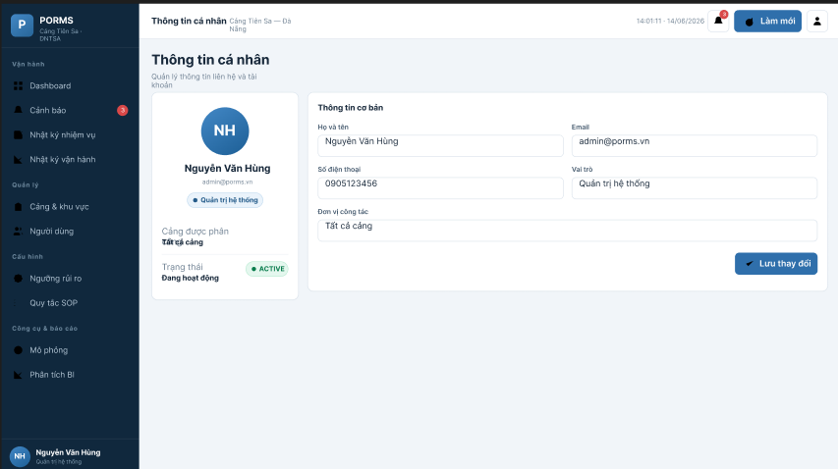
Function detail:
Data Validation:
- The system must successfully retrieve user data matching the authenticated user's ID from the database.
Functionality:
In Normal Cases:
- User profile information is displayed correctly including full name, email (read-only), role, assigned port (if applicable), phone number, and account status.
In Abnormal Cases:
- If the session has expired, the system redirects to the Sign In page.
Business rule: N/A

# | Component | Comp. Type | Editable | Mandatory | Default Value | Description
Personal Information Section
1 | Screen Title | Label (Text) | No | Yes | "Thông tin cá nhân" | Main title of the profile page.
2 | Full Name | Input (Text) | Yes | Yes | [User's full name] | Editable. Must be at least 2 characters.
3 | Email | Input (Text) | No | Yes | [User's email] | Read-only. Cannot be changed by user.
4 | Phone Number | Input (Text) | Yes | No | [User's phone] | Editable. Must be 10–11 digits.
Account Information Section
5 | Role | Label (Text) | No | Yes | [User's role] | Read-only. Shows ADMIN / PORT MANAGER / OPERATOR.
6 | Assigned Port | Label (Text) | No | Conditional | [Port name or "—"] | Read-only. Shows assigned port for CA/OP; empty for ADMIN.
7 | Account Status | Label (Badge) | No | Yes | ACTIVE | Color-coded status badge (ACTIVE=green, INACTIVE=gray).
Action Section
8 | Save Button | Button (Primary) | No | No | "Lưu thay đổi" | Visible only when editable fields have been modified.

––––––––––––––––––––––––––––––––––––––––––––––––––––––––––––––––––––––––––––––––––

3.2.4 - View User List
Function trigger: Triggered when Admin navigates to the User Management section from the sidebar.
Function description: Allows ADMIN to view, search, and filter the list of all registered users in the system. Each user entry displays email, full name, role, assigned port, status, and last login timestamp.
Screen layout:
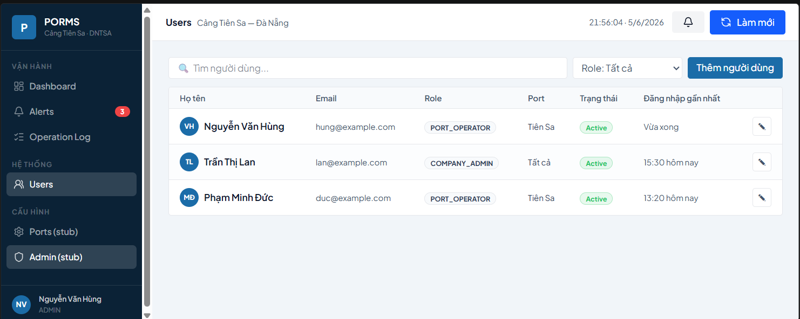
Function detail:
Data Validation:
- Filter inputs are optional. The list defaults to showing all active users paginated at 20 per page.
Functionality:
In Normal Cases:
- System retrieves and displays the paginated list of all users (excluding soft-deleted) with real-time search by email or full name.
- Clicking on a user row navigates to the Edit User page.
- Admin can filter by role (ADMIN / PORT MANAGER / OPERATOR), status (ACTIVE / INACTIVE / SUSPENDED), and assigned port.
- Locked accounts display a "LOCKED" badge and an Unlock button.
In Abnormal Cases:
- If data fails to load, system shows error message (MSG-30). The list shows "No data" (MSG-28) if no users match the filter criteria.
Business rule: BR-06, BR-07

# | Component | Comp. Type | Editable | Mandatory | Default Value | Description
Filter Section
1 | Search Input | Input (Text) | Yes | No | Placeholder: "Tìm theo email hoặc họ tên" | Real-time search filter for email and full name.
2 | Role Filter | Dropdown (Select) | Yes | No | Tất cả | Filters list by role.
3 | Status Filter | Dropdown (Select) | Yes | No | Tất cả | Filters list by account status.
Data Table Section
4 | Table Header | Table Row | No | Yes | Email | Họ tên | Vai trò | Cảng | Trạng thái | Đăng nhập cuối | Column headers for the user data table.
5 | User Row | Table Row | No | Yes | N/A | Each row represents one user. Click to navigate to edit page.
6 | Status Badge | Badge | No | Yes | ACTIVE | Color-coded: ACTIVE=green, INACTIVE=gray, SUSPENDED=red, LOCKED=orange.
7 | Unlock Button | Button | No | Conditional | "Mở khóa" | Visible only for LOCKED accounts. Opens confirmation dialog.
Action Section
8 | Add User Button | Button (Primary) | No | Yes | "+ Thêm người dùng" | Navigates to the Add User screen.
9 | Pagination | Pagination Control | Yes | Yes | Page 1 / 20 per page | Navigates between pages of results.

––––––––––––––––––––––––––––––––––––––––––––––––––––––––––––––––––––––––––––––––––

3.2.5 - Add User
Function trigger: Triggered when Admin clicks the "+ Thêm người dùng" button from the User List screen.
Function description: Allows ADMIN to create a new user account with a specified role, assigned port (mandatory for PORT MANAGER and OPERATOR), and initial password.
Screen layout:
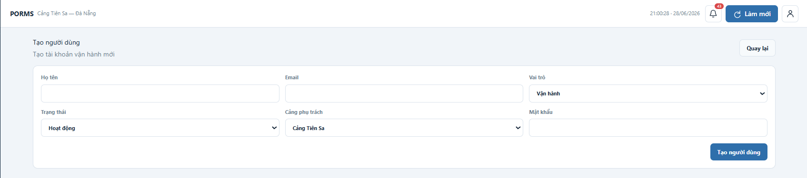
Function detail:
Data Validation:
- Email: Required, must follow standard email format, must be unique in the system.
- Full Name: Required, minimum 2 characters, cannot begin with a digit.
- Role: Required, must be one of ADMIN / PORT MANAGER / OPERATOR.
- Assigned Port: Required for PORT MANAGER and OPERATOR; must not be set for ADMIN.
- Password: Required, minimum 8 characters with at least 1 uppercase, 1 lowercase, 1 number, 1 special character.
- Phone Number: Optional, must be 10–11 digits if provided.
Functionality:
In Normal Cases:
- Upon successful submission: system creates the user account, BCrypt-hashes the password, logs USER_CREATED event, shows success toast (MSG-09), and returns to User List screen.
- The system validates all fields before submission; the Create button is enabled only when all required fields are valid.
In Abnormal Cases:
- If email already exists: system shows conflict error (MSG-10) and highlights the email field.
- If PORT MANAGER / OPERATOR is created without Assigned Port: system shows validation error (MSG-29).
- If ADMIN is created with an Assigned Port: field is automatically cleared.
Business rule: BR-01, BR-02, BR-03, BR-06

# | Component | Comp. Type | Editable | Mandatory | Default Value | Description
Form Section
1 | Email Input | Input (Email) | Yes | Yes | Placeholder: "email@domain.com" | Accepts the new user's email. Real-time uniqueness validation.
2 | Full Name Input | Input (Text) | Yes | Yes | Placeholder: "Họ và tên đầy đủ" | Full name of the new user.
3 | Role Dropdown | Dropdown (Select) | Yes | Yes | OPERATOR | Selects the role. Changing role affects visibility of Assigned Port field.
4 | Assigned Port Dropdown | Dropdown (Select) | Yes | Conditional | "Chọn cảng" | Required for CA/OP. Hidden for ADMIN. Populated from active ports list.
5 | Phone Number Input | Input (Text) | Yes | No | Placeholder: "0xxxxxxxxx" | Optional contact phone number.
6 | Password Input | Input (Password) | Yes | Yes | Placeholder: "••••••••" | Initial password. Strength indicator shown. Eye toggle included.
Action Section
7 | Create Button | Button (Primary) | No | Yes | "Tạo tài khoản" | Submits the form. Disabled until all required fields are valid.
8 | Cancel Button | Button (Secondary) | No | No | "Hủy" | Returns to User List without creating.

––––––––––––––––––––––––––––––––––––––––––––––––––––––––––––––––––––––––––––––––––

3.3 Port & Zone Management

3.3.1 - View Port List
Function trigger: Triggered when any authenticated user navigates to the Ports section from the sidebar.
Function description: Displays all ports accessible to the authenticated user. ADMIN sees all ports; PORT MANAGER and OPERATOR see only their assigned port. Each port card displays name, code, current operation mode (NORMAL/LIMITED/STOP with color coding), current risk level, and unread alert count.
Screen layout:
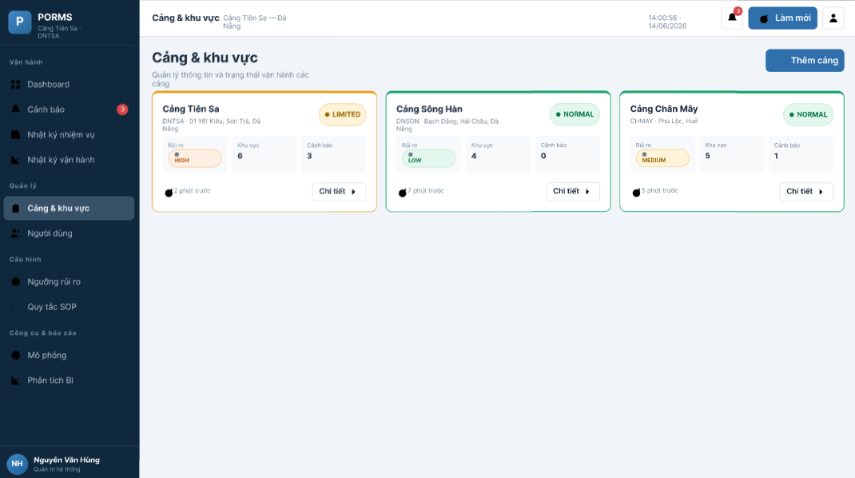
Function detail:
Data Validation:
- No mandatory inputs; the page loads automatically with applicable port data.
Functionality:
In Normal Cases:
- System retrieves port status data from the view v_port_current_state and renders port cards.
- Port cards are color-coded: NORMAL=green border, LIMITED=amber, STOP=red.
- Clicking a port card navigates to the Port Detail screen.
- ADMIN sees an "+ Thêm cảng" button.
In Abnormal Cases:
- If data fails to load, error message MSG-30 is shown. If no active ports exist, "No data" (MSG-28) is shown.
Business rule: BR-06

# | Component | Comp. Type | Editable | Mandatory | Default Value | Description
Port Card Section (per port)
1 | Port Name & Code | Label (Text) | No | Yes | N/A | Displays port full name and code (e.g., "Cảng Tiên Sa — DNTSA").
2 | Operation Mode Badge | Badge | No | Yes | NORMAL | Color-coded: NORMAL=green, LIMITED=amber, STOP=red. Updated every 30 seconds via polling.
3 | Risk Level Badge | Badge | No | Yes | LOW | Color-coded: LOW=#27AE60, MEDIUM=#F39C12, HIGH=#E67E22, CRITICAL=#C0392B.
4 | Unread Alert Count | Badge (Number) | No | No | 0 | Red badge showing number of unread alerts. Hidden when 0.
5 | Last Weather Time | Label (Text) | No | No | N/A | Shows relative time of last weather update (e.g., "2 phút trước").
Action Section
6 | Add Port Button | Button (Primary) | No | Conditional | "+ Thêm cảng" | Visible for ADMIN only. Navigates to Add Port form.

––––––––––––––––––––––––––––––––––––––––––––––––––––––––––––––––––––––––––––––––––

3.3.2 - View Port Detail
Function trigger: Triggered when any authenticated user clicks on a port card from the Port List screen.
Function description: Displays complete port information including geographic coordinates, weather source, and the list of all zones within the port. PORT MANAGER and OPERATOR can only access their assigned port.
Screen layout:
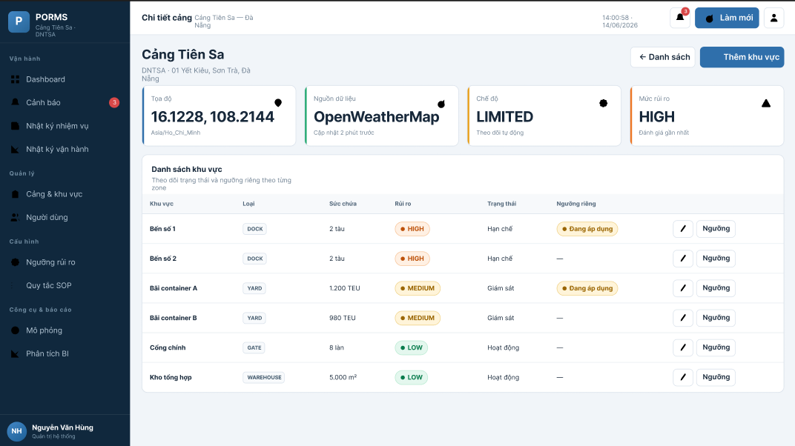
Function detail:
Data Validation:
- portId parameter in URL must correspond to the user's assigned port (for CA/OP) or any existing port (for ADMIN).
Functionality:
In Normal Cases:
- Port header section displays: name, code, address, coordinates, timezone, weather source, and fetch status (last successful fetch time with status indicator).
- Zone table lists all zones with: name, zone type chip, current risk level badge, capacity, and threshold override indicator.
- ADMIN and PORT MANAGER see "Add Zone" and edit buttons. OPERATOR sees read-only view.
In Abnormal Cases:
- If portId does not match assigned port for CA/OP: system returns 403 and redirects to unauthorized page.
Business rule: BR-06, BR-08, BR-09

# | Component | Comp. Type | Editable | Mandatory | Default Value | Description
Port Information Card
1 | Port Name | Label (Text) | No | Yes | [Port name] | Displays the port full name.
2 | Port Code | Label (Badge) | No | Yes | [Port code] | Immutable code displayed as a badge.
3 | Coordinates | Label (Text) | No | Yes | [lat, lon] | Displays latitude and longitude to 4 decimal places.
4 | Timezone | Label (Text) | No | Yes | Asia/Ho_Chi_Minh | Configured timezone for the port.
5 | Weather Source | Label (Text) | No | Yes | OpenWeatherMap | Active weather data source.
6 | Fetch Status | Label (Badge) | No | Yes | ✓ 2 min ago | Green if last fetch < 20 minutes; amber if 20–60 min; red if > 60 min.
7 | Edit Button | Button | No | Conditional | "Chỉnh sửa" | Visible for ADMIN only.
Zone Table Section
8 | Zone Name | Table Cell | No | Yes | [zone name] | Name of the operational zone.
9 | Zone Type Chip | Chip | No | Yes | [DOCK|YARD|GATE|WAREHOUSE] | Zone type displayed as a styled chip.
10 | Risk Level Badge | Badge | No | Yes | LOW | Current risk level of the zone, color-coded.
11 | Threshold Override Indicator | Label (Text) | No | No | "—" | Shows "Override active" if zone-specific thresholds are configured.
12 | Edit Zone Button | Icon Button | No | Conditional | Edit icon | Visible for ADMIN and PORT MANAGER.
Action Section
13 | Add Zone Button | Button (Primary) | No | Conditional | "+ Thêm khu vực" | Visible for ADMIN and PORT MANAGER. Opens Add Zone form.

––––––––––––––––––––––––––––––––––––––––––––––––––––––––––––––––––––––––––––––––––

3.3.3 - Add / Edit Zone
Function trigger: Add Zone: triggered when ADMIN or PORT MANAGER clicks "+ Thêm khu vực" from Port Detail screen. Edit Zone: triggered when clicking the edit icon on a zone row.
Function description: Allows ADMIN and PORT MANAGER to create a new zone or update an existing zone within their assigned port. Zone type, display order, and optional capacity can be configured.
Screen layout:
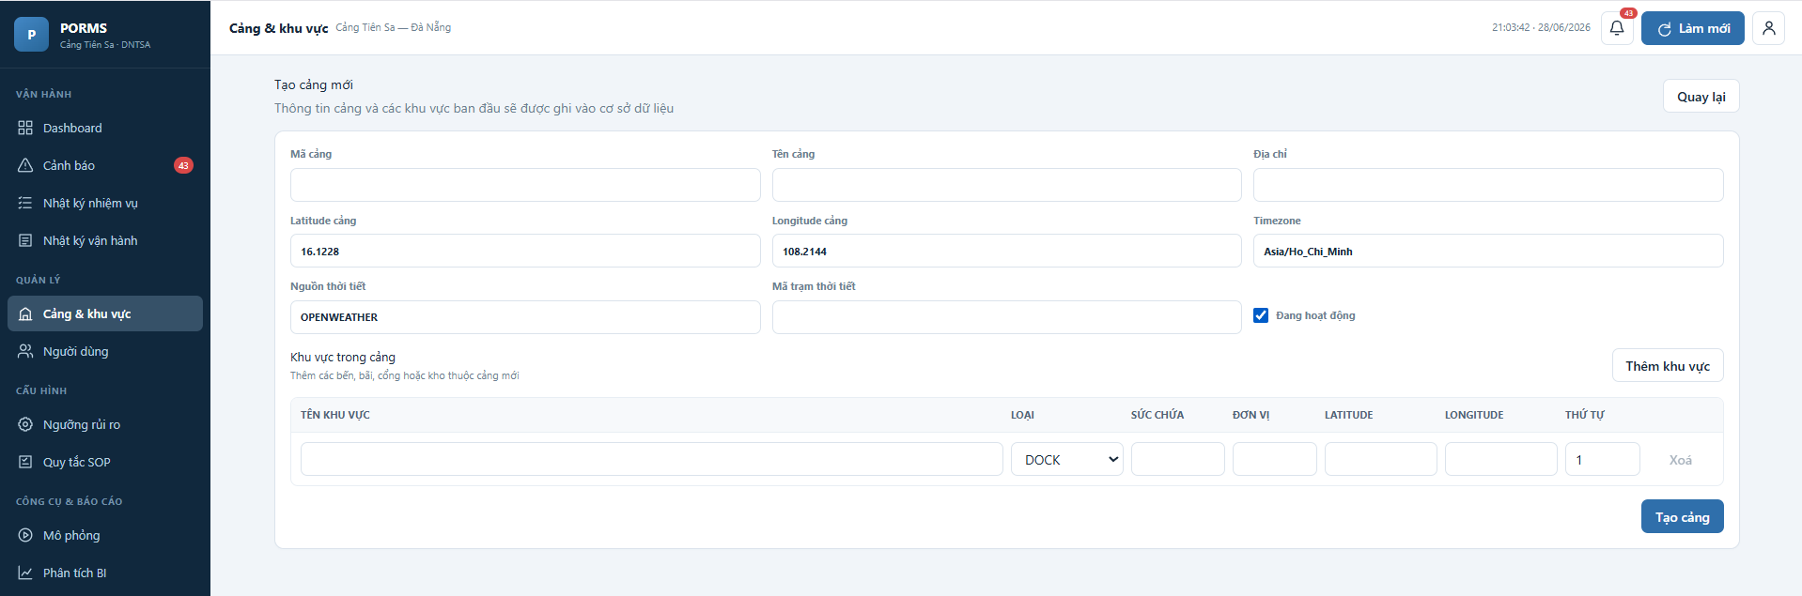
Function detail:
Data Validation:
- Zone Name: Required, unique within the port, maximum 255 characters.
- Zone Type: Required, must be one of DOCK / YARD / GATE / WAREHOUSE.
- Display Order: Optional integer, defaults to 0.
- Capacity: Optional positive integer.
Functionality:
In Normal Cases:
- On successful create: zone is added to the port, MSG-14 toast is shown, page returns to Port Detail.
- On successful edit: zone is updated, MSG-15 toast is shown.
- Display order controls the sequence of zones in the dashboard zone grid.
In Abnormal Cases:
- If zone name is duplicate within the port: inline validation error shown.
Business rule: N/A

# | Component | Comp. Type | Editable | Mandatory | Default Value | Description
Form Section
1 | Zone Name Input | Input (Text) | Yes | Yes | Placeholder: "Tên khu vực" | Unique name for the zone within the port.
2 | Zone Type Dropdown | Dropdown (Select) | Yes | Yes | "Chọn loại khu vực" | Must be DOCK, YARD, GATE, or WAREHOUSE.
3 | Description Textarea | Textarea | Yes | No | Placeholder: "Mô tả khu vực..." | Optional description of the zone.
4 | Capacity Input | Input (Number) | Yes | No | N/A | Optional TEU or slot capacity. Must be positive integer if provided.
5 | Display Order Input | Input (Number) | Yes | No | 0 | Controls display sequence on dashboard. Lower = earlier.
Action Section
6 | Save Button | Button (Primary) | No | Yes | "Lưu" | Creates or updates the zone.
7 | Cancel Button | Button (Secondary) | No | No | "Hủy" | Returns to Port Detail without saving.

––––––––––––––––––––––––––––––––––––––––––––––––––––––––––––––––––––––––––––––––––

3.4 Dashboard & Real-time Monitoring

3.4.1 - Main Dashboard
Function trigger: Triggered automatically on successful login or when the user navigates to the Dashboard from the sidebar.
Function description: The main operational screen for all roles. Displays the real-time status of the assigned port including current weather conditions, risk level, operation mode, unread alert count, zone status grid, 24-hour risk trend chart, and recent task log. Data refreshes automatically every 30 seconds via polling of GET /api/ports/{id}/status.
Screen layout:
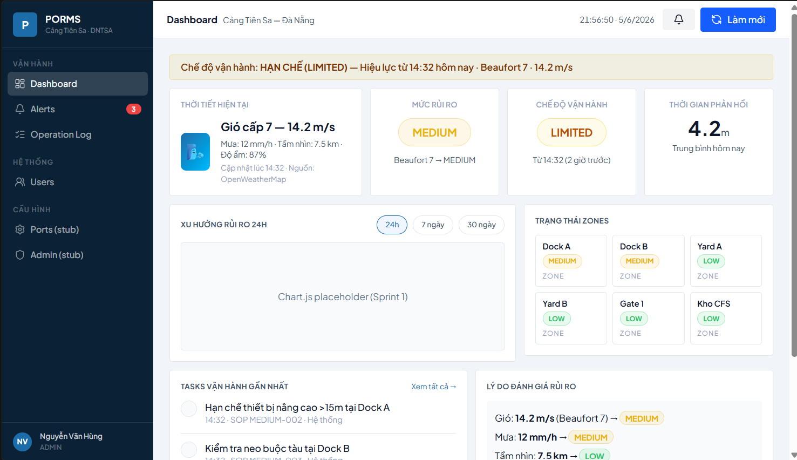
Function detail:
Data Validation:
- User must be authenticated and have an assigned port (for CA/OP) or select a port (for ADMIN via dropdown).
Functionality:
In Normal Cases:
- Weather Card displays: Beaufort number, wind speed (m/s), rainfall (mm/h), temperature (°C), visibility (km), weather icon from OpenWeather, and "last updated" timestamp.
- Risk Level Badge: color-coded (LOW=green, MEDIUM=amber, HIGH=orange, CRITICAL=red) with Vietnamese label and assessment summary text.
- Operation Mode Indicator: color-coded badge (NORMAL=green, LIMITED=amber, STOP=red) with elapsed time in current mode.
- Alert Bell: shows unread alert count; click opens notification dropdown with top 5 most recent alerts.
- Zone Status Grid: 2×3 grid (for DNTSA) showing each zone with name, type, and risk badge.
- Risk Trend Chart: Chart.js line chart showing risk score (1–4) over past 24 hours.
- Recent Tasks: chronological list of the 5 most recent auto-generated task recommendations.
- Assessment Summary: text summary from the latest risk assessment (e.g., "Gió: Beaufort 8 → CAO; Mưa: 35mm/h → CAO | Kết quả: CAO").
- If weather data is older than 20 minutes: a yellow warning badge appears on the Weather Card.
In Abnormal Cases:
- If API polling fails: previous data remains displayed with a warning indicator.
- If no weather readings exist: Weather Card shows "Chưa có dữ liệu thời tiết".
Business rule: BR-10, BR-11, BR-13

# | Component | Comp. Type | Editable | Mandatory | Default Value | Description
Weather Card
1 | Weather Icon | Image | No | Yes | [OW icon URL] | Weather icon from OpenWeather CDN based on ow_weather_icon code.
2 | Wind Speed | Label (Text) | No | Yes | N/A | Displays "{beaufort_number} cấp ({wind_speed_ms} m/s)".
3 | Rainfall | Label (Text) | No | Yes | 0 mm/h | Displays rainfall in mm/h. Shows "Không có mưa" if 0.
4 | Visibility | Label (Text) | No | No | N/A | Displays visibility in km. Shows "—" if unavailable.
5 | Observed At | Label (Text) | No | Yes | N/A | Relative timestamp (e.g., "2 phút trước"). Amber if > 20 min.
Risk Level Badge
6 | Risk Level Badge | Badge (Color) | No | Yes | LOW | Color-coded. Pulse animation for CRITICAL. Text in Vietnamese.
7 | Assessment Summary | Label (Text) | No | No | N/A | Factor-by-factor summary from latest assessment.
Operation Mode Indicator
8 | Mode Badge | Badge (Color) | No | Yes | NORMAL | NORMAL=green, LIMITED=amber, STOP=red. Shows mode name in Vietnamese.
9 | Mode Duration | Label (Text) | No | No | N/A | Shows time elapsed in current mode (e.g., "LIMITED từ 14:32").
10 | Override Button | Button | No | Conditional | "Override" | Visible for ADMIN and PORT MANAGER only. Opens Override Mode modal.
Alert Bell
11 | Bell Icon | Icon Button | No | Yes | Bell icon | Opens alert dropdown. Unread count badge shown in red.
12 | Alert Dropdown | Dropdown Panel | No | No | N/A | Shows top 5 unread alerts with severity, title, and time.
Zone Status Grid
13 | Zone Card | Card | No | Yes | N/A | Per zone: name, zone type, risk level badge. Click navigates to zone detail.
Risk Trend Chart (Chart.js)
14 | Line Chart | Chart (Line) | No | Yes | N/A | X-axis: 24 hours; Y-axis: 1=LOW, 2=MEDIUM, 3=HIGH, 4=CRITICAL. Data from GET /api/risk/history.
Recent Task Log
15 | Task Item | List Item | No | No | N/A | Shows action type icon, action description, zone name, risk level badge, and time. Max 5 items.

––––––––––––––––––––––––––––––––––––––––––––––––––––––––––––––––––––––––––––––––––

3.4.2 - Override Operation Mode (Modal)
Function trigger: Triggered when ADMIN or PORT MANAGER clicks the "Override" button on the Mode Indicator component on the Dashboard.
Function description: A modal dialog that allows ADMIN and PORT MANAGER to manually change the port's operation mode to any target state (NORMAL, LIMITED, STOP), bypassing the automatic state machine. A mandatory override reason of at least 20 characters is required. The override is logged as a MANUAL change in operation_mode_log with the user's identity and reason.
Screen layout:
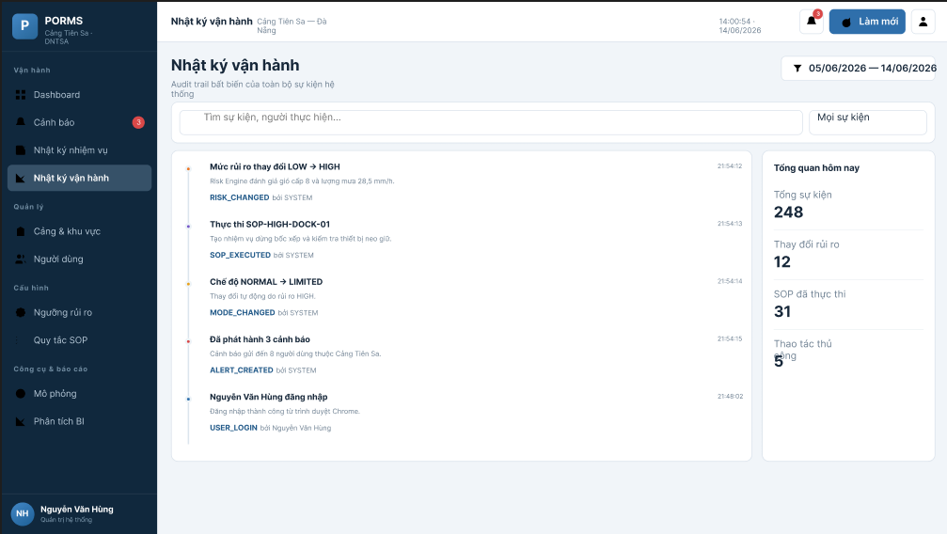
Function detail:
Data Validation:
- Target Mode: Required. Must be different from the current mode.
- Override Reason: Required, minimum 20 characters. Cannot be whitespace only.
Functionality:
In Normal Cases:
- Upon valid submission: system calls POST /api/ports/{id}/mode/override, inserts operation_mode_log record (change_type=MANUAL), updates ports.current_mode via DB trigger, creates an INFO alert notifying all port users of the manual change, logs MODE_OVERRIDDEN event, shows success toast (MSG-21), and refreshes the Dashboard mode indicator.
- Manual override allows any transition including STOP → NORMAL (which is not possible via automatic state machine).
In Abnormal Cases:
- If override reason is less than 20 characters: inline error shown (MSG-22). The Submit button remains disabled.
- If the user's role is OPERATOR: the Override button is not rendered. Direct API call returns 403.
Business rule: BR-13, BR-14

# | Component | Comp. Type | Editable | Mandatory | Default Value | Description
Modal Header
1 | Modal Title | Label (Text) | No | Yes | "Override Chế độ Vận hành" | Main heading of the modal.
2 | Current Mode Display | Label (Badge) | No | Yes | [Current mode] | Shows the current mode with color coding.
Form Section
3 | Target Mode Dropdown | Dropdown (Select) | Yes | Yes | "Chọn chế độ mới" | Options: NORMAL / LIMITED / STOP. Current mode is disabled/excluded.
4 | Override Reason Textarea | Textarea | Yes | Yes | Placeholder: "Nhập lý do override (tối thiểu 20 ký tự)..." | Character counter shown below. Red if < 20 chars.
5 | Character Counter | Label (Text) | No | Yes | "0/20 ký tự tối thiểu" | Real-time character count. Turns green at 20+ characters.
Warning Section
6 | Warning Message | Alert (Warning) | No | Conditional | N/A | Shown when target=NORMAL while risk is still HIGH/CRITICAL: "Cảnh báo: Risk level hiện tại vẫn ở mức {level}."
Action Section
7 | Submit Button | Button (Primary) | No | Yes | "Xác nhận Override" | Disabled until target mode selected and reason ≥ 20 chars.
8 | Cancel Button | Button (Secondary) | No | No | "Hủy" | Closes modal without making changes.

––––––––––––––––––––––––––––––––––––––––––––––––––––––––––––––––––––––––––––––––––

3.5 Alert Management

3.5.1 - Alert Panel
Function trigger: Triggered when the user navigates to the Alerts section from the sidebar or clicks "Xem tất cả" from the notification dropdown.
Function description: Displays alerts within the authenticated user's server-enforced scope. ADMIN sees all ports; PORT MANAGER sees only the assigned port; OPERATOR sees only alerts connected to tasks assigned personally. Filters include port, zone, severity and date. Accessible HIGH/CRITICAL alerts can trigger popup, sound and Vietnamese speech according to local notification preferences.
Screen layout:
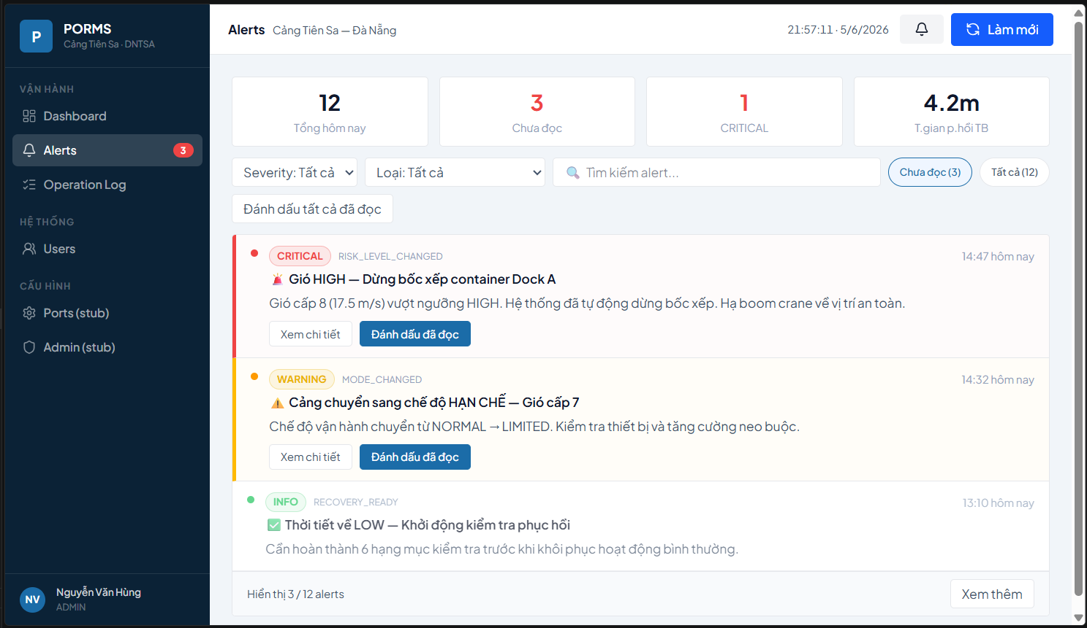
Function detail:
Data Validation:
- portId must match the user's assigned port. ADMIN may access any port.
Functionality:
In Normal Cases:
- Unread alerts are displayed with a red dot indicator and slightly highlighted background.
- CRITICAL severity alerts are displayed with red styling and bold title.
- Clicking acknowledge calls PATCH /api/alerts/{id}/acknowledge and stores a per-user alert_receipts record. An inaccessible alert is not returned to the caller.
- The alert detail screen shows weather context, recommended action and related tasks. Admin/Port Manager may assign a NEW task within their permitted port scope.
- Statistics cards show waiting, CRITICAL, HIGH and acknowledged counts for the current access scope.
- Simulation alerts are shown separately with a "SIM" badge when the simulation data toggle is enabled.
In Abnormal Cases:
- If data fails to load: MSG-30. If no alerts match filter: MSG-28.
Business rule: BR-17, BR-22

# | Component | Comp. Type | Editable | Mandatory | Default Value | Description
Stats Strip
1 | Total Alerts Today | KPI Card | No | Yes | 0 | Count of all alerts created today for this port.
2 | Unread Count | KPI Card | No | Yes | 0 | Count of unread alerts. Shown in red if > 0.
3 | Critical Count | KPI Card | No | Yes | 0 | Count of CRITICAL severity alerts today.
4 | Avg Response Time | KPI Card | No | Yes | — | Average minutes from alert creation to first read today.
Filter Section
5 | Severity Filter | Dropdown (Select) | Yes | No | Tất cả | Filter by INFO / WARNING / CRITICAL.
6 | Status Toggle | Chip Toggle | Yes | No | Tất cả | "Chưa đọc" / "Tất cả" toggle.
7 | Search Input | Input (Text) | Yes | No | Placeholder: "Tìm theo tiêu đề..." | Filters by alert title text.
8 | Mark All Read Button | Button | No | No | "Đánh dấu tất cả đã đọc" | Marks all currently visible unread alerts as read.
Alert List Section
9 | Unread Indicator Dot | Badge (Dot) | No | Conditional | N/A | Red dot on the left side of unread alert rows.
10 | Severity Badge | Badge | No | Yes | N/A | INFO=blue, WARNING=amber, CRITICAL=red.
11 | Alert Title | Label (Text) | No | Yes | N/A | Short descriptive title of the alert.
12 | Alert Message | Label (Text) | No | Yes | N/A | Full alert message (truncated at 120 chars with "Xem thêm" link).
13 | Alert Timestamp | Label (Text) | No | Yes | N/A | Relative time (e.g., "14 phút trước").
14 | Mark Read Button | Button | No | Conditional | "Đánh dấu đã đọc" | Visible on unread alerts for the authenticated user.
15 | View Details Button | Button | No | No | "Xem chi tiết" | Navigates to Alert Detail screen.
Pagination Section
16 | Pagination Control | Pagination | Yes | Yes | Page 1 / 20 per page | Standard pagination for alert list.

––––––––––––––––––––––––––––––––––––––––––––––––––––––––––––––––––––––––––––––––––

3.6 Risk Configuration

3.6.1 - Risk Threshold Configuration
Function trigger: Triggered when ADMIN or PORT MANAGER navigates to Risk Config from the sidebar.
Function description: Allows ADMIN to view and edit risk evaluation thresholds for WIND (m/s), RAIN (mm/h), and VISIBILITY (km) factors. PORT MANAGER can view only. A live preview panel at the top allows testing threshold changes with custom input values before saving. Includes a Beaufort reference card. Changes take effect within 5 minutes via cache expiry.
Screen layout:
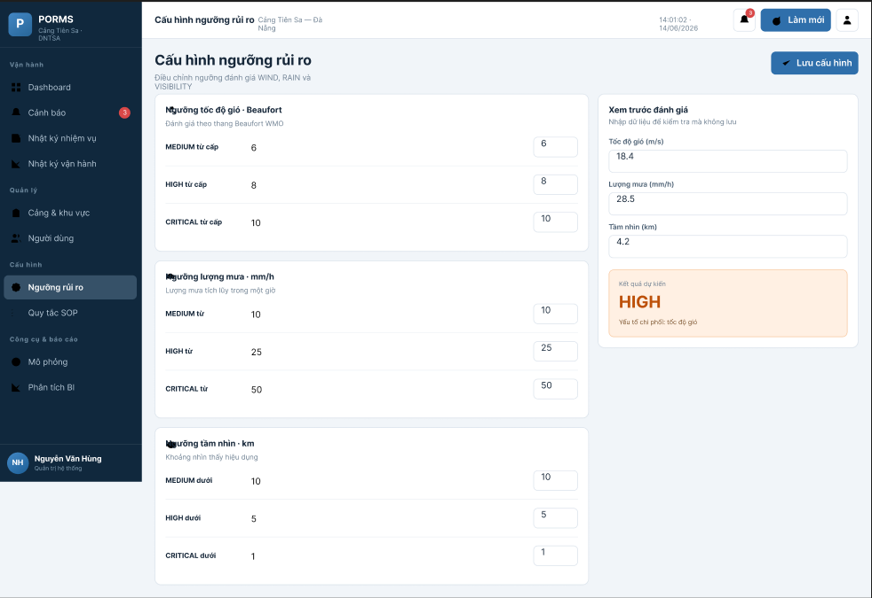
Function detail:
Data Validation:
- ADMIN only: minValue and maxValue inputs must satisfy: minValue < maxValue (except CRITICAL which has no maxValue), no overlapping ranges within the same factor.
- Preview inputs (optional): any non-negative numeric value for wind, rain, and visibility.
Functionality:
In Normal Cases:
- PORT MANAGER sees the threshold table in read-only mode. No edit buttons are displayed.
- ADMIN can click the edit (pencil) icon on any threshold row to unlock inline editing. The row is highlighted in amber when being edited.
- Clicking "Preview": the system calculates risk evaluation results using both current and draft thresholds and shows the side-by-side comparison in the preview panel.
- Clicking "Lưu thay đổi": calls PUT /api/risk/thresholds/{id}, clears the server-side 5-minute cache, logs THRESHOLD_UPDATED event with old/new values, shows MSG-16 toast.
- A Beaufort reference card beside the WIND table shows B0–B12 color-coded ranges for quick reference.
In Abnormal Cases:
- If updated range overlaps an adjacent threshold: MSG-17 inline error; save button disabled.
- If minValue ≥ maxValue: inline validation error.
Business rule: BR-10, BR-21

# | Component | Comp. Type | Editable | Mandatory | Default Value | Description
Preview Panel Section
1 | Wind Test Input | Input (Number) | Yes | No | Placeholder: "m/s" | Test wind speed value for preview.
2 | Rain Test Input | Input (Number) | Yes | No | Placeholder: "mm/h" | Test rainfall value for preview.
3 | Visibility Test Input | Input (Number) | Yes | No | Placeholder: "km" | Test visibility value for preview.
4 | Preview Button | Button | No | No | "Preview" | Calculates and shows result side-by-side (current vs draft).
5 | Preview Result — Current | Label (Badge) | No | No | N/A | Shows risk per factor and final risk with current thresholds.
6 | Preview Result — Draft | Label (Badge) | No | No | N/A | Shows risk per factor and final risk with pending changes.
WIND Threshold Table
7 | Risk Level Label | Badge | No | Yes | N/A | LOW / MEDIUM / HIGH / CRITICAL color-coded.
8 | Min Value Input | Input (Number) | Conditional | Yes | [current value] | Editable by ADMIN when row is unlocked. Locked/read-only for CA.
9 | Max Value Input | Input (Number) | Conditional | Conditional | [current value] | CRITICAL row has "∞" instead of an input.
10 | Beaufort Range Label | Label (Text) | No | Yes | N/A | Shows corresponding Beaufort range (e.g., "B6–7").
11 | Edit Button | Icon Button | No | Conditional | Pencil icon | ADMIN only. Unlocks row for inline editing.
12 | Save Row Button | Button (Primary) | No | Conditional | "Lưu" | Shown when row is in edit mode. Saves changes and clears cache.
RAIN & VISIBILITY Threshold Tables
13 | RAIN Table | Table | Conditional | Yes | N/A | Same structure as WIND table but with mm/h unit and rain classifications.
14 | VISIBILITY Table | Table | Conditional | Yes | N/A | Same structure. Note: visibility has inverse relationship — lower value = higher risk.
Beaufort Reference Card
15 | Beaufort Reference | Table (read-only) | No | Yes | N/A | Shows B0–B12 with m/s ranges and corresponding PORMS risk level.

––––––––––––––––––––––––––––––––––––––––––––––––––––––––––––––––––––––––––––––––––

3.7 SOP Configuration

3.7.1 - SOP Rules List
Function trigger: Triggered when ADMIN or PORT MANAGER navigates to SOP Config from the sidebar.
Function description: Displays all SOP rules for the system with execution statistics (total executions, completed, skipped, last triggered time). Provides filtering by risk level, zone type, and active status. Import/Export JSON functionality is available. Clicking the edit icon on a rule opens the Add/Edit SOP Rule modal.
Screen layout:
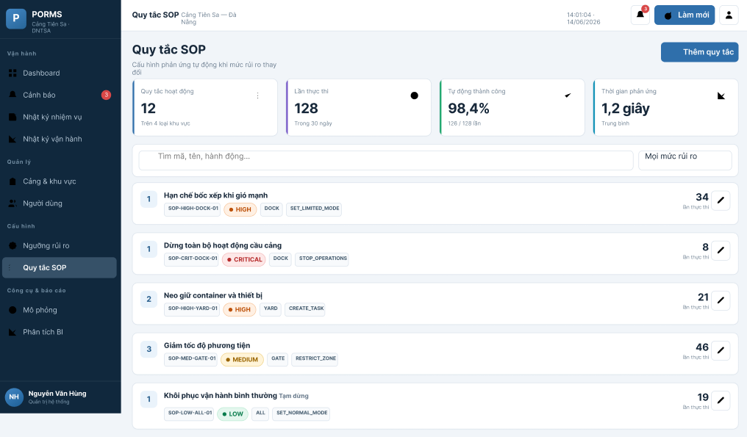
Function detail:
Data Validation:
- Filter inputs are optional. List defaults to showing all active rules ordered by trigger_risk_level then execution_order.
Functionality:
In Normal Cases:
- Statistics columns show total_executions, completed_count, and skipped_count for each rule.
- "Vô hiệu hóa" (disable) sets is_active=FALSE. Historical execution records are preserved.
- RECOVERY-001 rule displays a "NORMAL*" badge with tooltip explaining that manual confirmation is required.
- Import JSON opens a file upload dialog; valid rules are previewed before import.
- Export JSON downloads a JSON file of all current rules for the port.
In Abnormal Cases:
- If data fails to load: MSG-30.
Business rule: BR-12, BR-15

# | Component | Comp. Type | Editable | Mandatory | Default Value | Description
Filter Section
1 | Risk Level Filter | Dropdown (Select) | Yes | No | Tất cả | Filter by LOW / MEDIUM / HIGH / CRITICAL.
2 | Zone Type Filter | Dropdown (Select) | Yes | No | Tất cả | Filter by DOCK / YARD / GATE / WAREHOUSE / All Zones.
3 | Status Filter | Chip Toggle | Yes | No | Active (N) | "Active" / "All" toggle.
SOP Rules Table
4 | Rule Name | Label (Text) | No | Yes | N/A | Rule name (e.g., "HIGH-001: Dừng bốc xếp container tại Dock").
5 | Risk Level Badge | Badge | No | Yes | N/A | Trigger risk level, color-coded.
6 | Zone Type Chip | Chip | No | No | "Tất cả" | Target zone type. "Tất cả" if applies_to_zone_type = NULL.
7 | Action Type Chip | Chip | No | Yes | N/A | Action type (STOP_LOADING, EVACUATE_EQUIPMENT, etc.).
8 | Target Mode Badge | Badge | No | No | "—" | Shows target mode if set (e.g., "STOP" in red). "—" if none.
9 | Execution Order | Label (Number) | No | Yes | N/A | Integer execution priority. Lower = runs first.
10 | Total Executions | Label (Text) | No | Yes | 0 | Shows "N (M✓/K⊘)" format for total/completed/skipped.
11 | Last Triggered | Label (Text) | No | No | "—" | Relative time of most recent execution.
12 | Edit Button | Icon Button | No | Yes | Pencil icon | Opens Add/Edit SOP Rule modal.
Action Section
13 | Add Rule Button | Button (Primary) | No | Yes | "+ Thêm rule" | Opens Add SOP Rule modal.
14 | Import JSON Button | Button | No | Yes | "Import JSON" | Opens file upload for bulk rule import.
15 | Export JSON Button | Button | No | Yes | "Export" | Downloads all rules as JSON file.

––––––––––––––––––––––––––––––––––––––––––––––––––––––––––––––––––––––––––––––––––

3.7.2 - Add / Edit SOP Rule (Modal)
Function trigger: Add: triggered by "+ Thêm rule" button. Edit: triggered by the pencil icon on a rule row in the SOP Rules List.
Function description: A modal form for creating or updating a SOP rule. When editing an existing rule, all current values are pre-populated. A mandatory change reason (minimum 20 characters) is required for edit operations.
Screen layout:
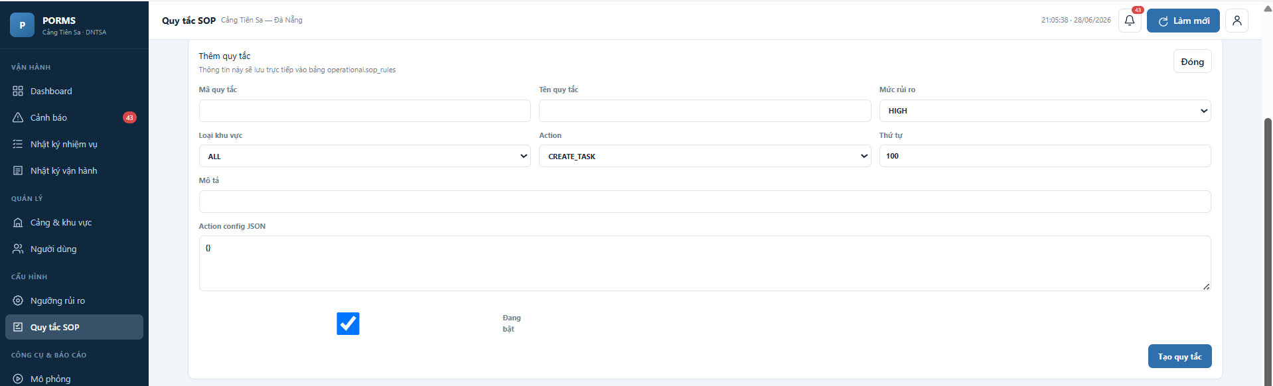
Function detail:
Data Validation:
- Rule Name: Required, maximum 255 characters, unique within the port.
- Trigger Risk Level: Required, must be LOW / MEDIUM / HIGH / CRITICAL.
- Action Type: Required, must be a valid SopActionType enum value.
- Action Description: Required, detailed instruction text for operators.
- Execution Order: Required, positive integer.
- Change Reason (edit mode only): Required, minimum 20 characters.
Functionality:
In Normal Cases:
- On successful create: rule is added, MSG-18 toast, modal closes, SOP Rules List refreshes.
- On successful edit: rule is updated, RULE_UPDATED event logged with payload {old_value, new_value}, MSG-19 toast.
- If Target Operation Mode is set to NORMAL and Trigger Risk Level is not LOW: inline warning shown ("Recovery rules should typically have trigger_risk_level = LOW").
In Abnormal Cases:
- If change reason is less than 20 characters in edit mode: MSG-20 inline error; save button disabled.
- If rule name is duplicate: inline validation error.
Business rule: BR-12, BR-15

# | Component | Comp. Type | Editable | Mandatory | Default Value | Description
Form Section
1 | Rule Name Input | Input (Text) | Yes | Yes | Placeholder: "Tên quy tắc SOP" | Unique, descriptive name (e.g., "HIGH-001: Dừng bốc xếp Dock").
2 | Trigger Risk Level Dropdown | Dropdown (Select) | Yes | Yes | "Chọn mức rủi ro" | LOW / MEDIUM / HIGH / CRITICAL.
3 | Applies to Zone Type Dropdown | Dropdown (Select) | Yes | No | "Tất cả zones" | DOCK / YARD / GATE / WAREHOUSE / Tất cả. "Tất cả" = NULL in DB.
4 | Action Type Dropdown | Dropdown (Select) | Yes | Yes | "Chọn loại hành động" | STOP_LOADING / LIMIT_VESSEL_ENTRY / EVACUATE_EQUIPMENT / CLOSE_GATE / EMERGENCY_SHUTDOWN / NOTIFY_AUTHORITY / CUSTOM.
5 | Action Description Textarea | Textarea | Yes | Yes | Placeholder: "Mô tả chi tiết hành động..." | Detailed instructions shown in task log and alert.
6 | Target Mode Dropdown | Dropdown (Select) | Yes | No | "Không đổi mode" | NORMAL / LIMITED / STOP / (none). If set, mode will change when rule executes.
7 | Alert Message Input | Input (Text) | Yes | No | Placeholder: "Tiêu đề cảnh báo..." | Short alert title (max 255 chars). Leave empty for no alert.
8 | Alert Severity Dropdown | Dropdown (Select) | Yes | Conditional | WARNING | INFO / WARNING / CRITICAL. Required if Alert Message is set.
9 | Execution Order Input | Input (Number) | Yes | Yes | 100 | Positive integer. Lower = executes first within same risk level.
Change Reason Section (Edit Mode Only)
10 | Change Reason Textarea | Textarea | Yes | Conditional | Placeholder: "Lý do thay đổi (tối thiểu 20 ký tự)..." | Mandatory for edit mode. Character counter shown.
11 | Character Counter | Label (Text) | No | Conditional | "0/20" | Real-time counter. Turns green at ≥ 20 chars.
Action Section
12 | Save Button | Button (Primary) | No | Yes | "Lưu" | Disabled until all required fields valid (and reason ≥ 20 in edit).
13 | Cancel Button | Button (Secondary) | No | No | "Hủy" | Closes modal without saving.

––––––––––––––––––––––––––––––––––––––––––––––––––––––––––––––––––––––––––––––––––

3.8 Task Log

3.8.1 - Task Log
Function trigger: Triggered when any authenticated user navigates to the Task Log from the sidebar.
Function description: Displays role-scoped operational tasks and supports their full lifecycle. ADMIN monitors accessible tasks; PORT MANAGER monitors and assigns tasks at the assigned port; OPERATOR sees only personally assigned tasks and can acknowledge, start and complete them with a result note.
Screen layout:
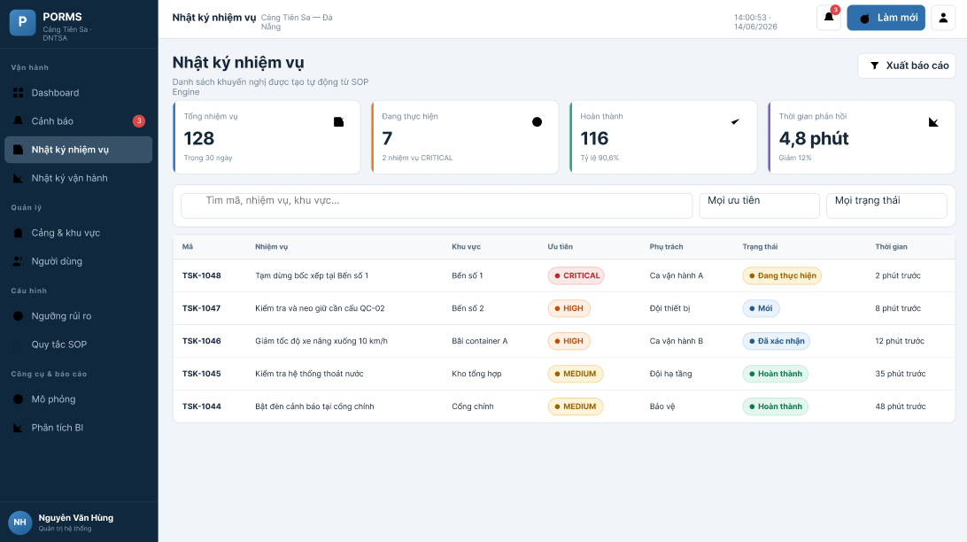
Function detail:
Data Validation:
- No mandatory inputs; list auto-loads for the authenticated user's port.
Functionality:
In Normal Cases:
- Each task item shows: action type icon, action description, zone name (or "Toàn cảng"), risk level badge at creation time, and timestamp.
- Filter by zone: dropdown populated from the port's zones.
- Filter by action type: dropdown of all SopActionType values.
- Simulation tasks are shown with a "SIM" badge when simulation toggle is ON.
- After assignment, only the selected Operator receives the assignment email and access to the related task/alert; other Operators at the port do not receive that personal notification.
In Abnormal Cases:
- If data fails to load: MSG-30.
Business rule: BR-18

# | Component | Comp. Type | Editable | Mandatory | Default Value | Description
Filter Section
1 | Zone Filter | Dropdown (Select) | Yes | No | "Tất cả khu vực" | Filters tasks by zone. Populated from port's active zones.
2 | Action Type Filter | Dropdown (Select) | Yes | No | "Tất cả loại" | Filters by SOP action type.
3 | Date Range Filter | Date Range Picker | Yes | No | Last 7 days | Filters tasks by creation date.
4 | Simulation Toggle | Toggle | Yes | No | OFF | When ON: includes simulation tasks with "SIM" badge.
Task Timeline Section
5 | Task Item | Timeline Item | No | Yes | N/A | Shows: action icon, description (up to 200 chars), zone name, risk badge, timestamp.
6 | Action Type Icon | Icon | No | Yes | N/A | Icon representing action category (e.g., crane for STOP_LOADING).
7 | Risk Level Badge | Badge | No | Yes | N/A | Risk level at the time the task was created.
8 | Zone Label | Chip | No | No | "Toàn cảng" | Zone name chip if zone-specific; "Toàn cảng" if zone_id is NULL.
9 | SIM Badge | Badge | No | Conditional | "SIM" | Shown on simulation-generated tasks when simulation toggle is ON.
Action Section
10 | Export CSV Button | Button | No | No | "Xuất CSV" | Downloads filtered task log as CSV file.
11 | Pagination | Pagination | Yes | Yes | 20 per page | Standard pagination control.

––––––––––––––––––––––––––––––––––––––––––––––––––––––––––––––––––––––––––––––––––

3.9 Operation Log & Audit Trail

3.9.1 - Operation Log
Function trigger: Triggered when any authenticated user navigates to Lịch sử vận hành. Returned events are filtered by the user's role and accessible port/task scope.
Function description: Displays the append-oriented operation event history using friendly Vietnamese labels. Users can switch between actual and simulation history; technical event codes are translated before display. No edit or delete action is provided.
Screen layout:
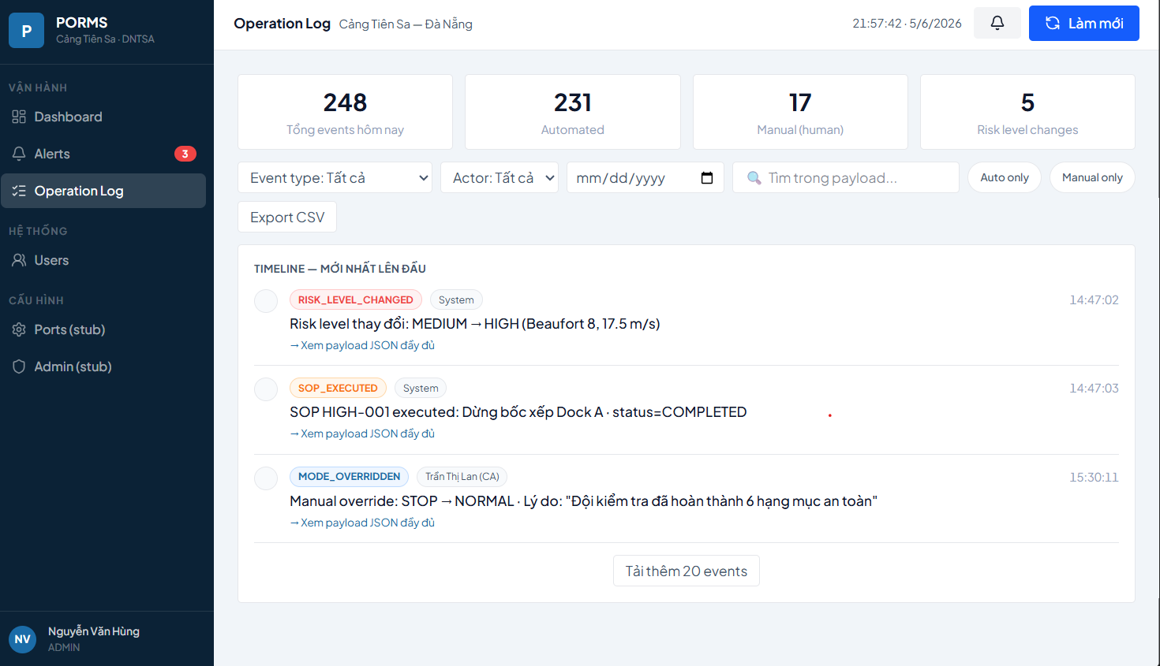
Function detail:
Data Validation:
- No mandatory inputs; list auto-loads for the port.
Functionality:
In Normal Cases:
- Timeline shows: event type icon (color-coded), summary text, actor (user name or "System"), and timestamp.
- Event type color coding: RISK_LEVEL_CHANGED=red, SOP_EXECUTED=orange, MODE_CHANGED=amber, MODE_OVERRIDDEN=blue (manual), WEATHER_FETCHED=gray, ALERT_CREATED=orange, THRESHOLD_UPDATED=blue.
- Filters: event type (multi-select), actor (automated/manual/specific user), date range, simulation toggle.
- Click on any event row: expands to show full JSONB payload formatted as readable key-value pairs.
- Export CSV: downloads filtered events.
- Statistics strip: total events today, automated count, manual count, risk level change count.
In Abnormal Cases:
- DELETE /api/events always returns 405. ADMIN cannot delete events via UI.
Business rule: BR-20

# | Component | Comp. Type | Editable | Mandatory | Default Value | Description
Stats Strip
1 | Total Events Today | KPI Card | No | Yes | N/A | Total event count for the day.
2 | Automated Events | KPI Card | No | Yes | N/A | Events with actor_user_id = NULL (system-generated).
3 | Manual Events | KPI Card | No | Yes | N/A | Events triggered by user actions.
4 | Risk Changes | KPI Card | No | Yes | N/A | Count of RISK_LEVEL_CHANGED events today.
Filter Section
5 | Event Type Filter | Multi-Select Dropdown | Yes | No | Tất cả | Filter by one or more event types.
6 | Actor Filter | Dropdown (Select) | Yes | No | Tất cả | "Automated" / "Manual" / "Tất cả".
7 | Date Range Filter | Date Range Picker | Yes | No | Today | Date range filter.
Timeline Section
8 | Event Icon | Icon | No | Yes | N/A | Color-coded icon representing the event type category.
9 | Event Summary | Label (Text) | No | Yes | N/A | Human-readable summary (e.g., "Risk level changed: MEDIUM → HIGH").
10 | Actor Label | Chip | No | Yes | System | "System" for automated; user full name for manual events.
11 | Timestamp | Label (Text) | No | Yes | N/A | Absolute datetime (HH:mm:ss format).
12 | Expand Payload Button | Icon Button | No | No | Chevron icon | Expands/collapses JSON payload detail section.
13 | Payload Detail | Code Block | No | Conditional | N/A | Shown on expand. Formats JSONB as indented key-value display.
Action Section
14 | Export CSV Button | Button | No | No | "Xuất CSV" | Downloads filtered operation events as CSV.
15 | Pagination | Pagination | Yes | Yes | 50 per page | Standard pagination.

––––––––––––––––––––––––––––––––––––––––––––––––––––––––––––––––––––––––––––––––––

3.10 Simulation Mode

3.10.1 - Simulation Control
Function trigger: Triggered when ADMIN navigates to the Simulation section from the sidebar.
Function description: Allows ADMIN to create/select a reusable simulation dataset and replay ordered historical or prepared weather snapshots through Weather → Risk → Mode → Alert → Task. Generated data is isolated by simulation_session_id and displayed as simulation history.
Screen layout:
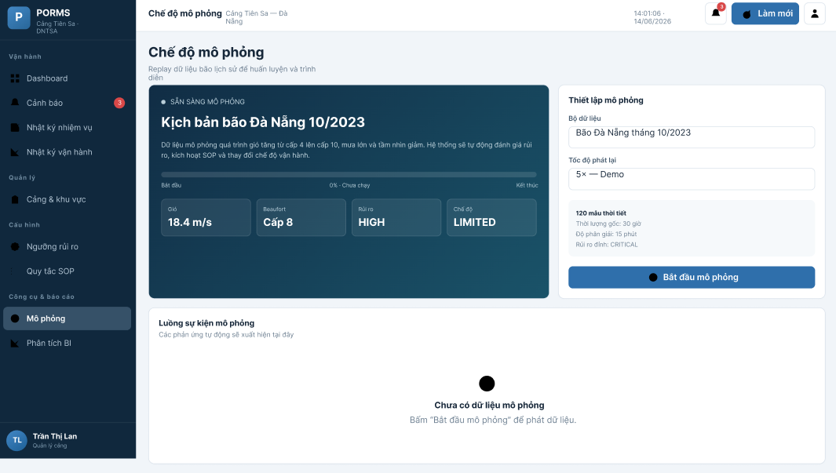
Function detail:
Data Validation:
- Dataset name and port are required. The dataset must contain at least one valid ordered weather snapshot; each snapshot includes wind, rainfall, visibility and optional zone context.
- Dataset snapshots are validated before save/run. The current screen supports saved datasets and a prepared demonstration sequence rather than claiming an implemented drag-and-drop-only workflow.
- The current implementation runs the stored sequence and reports session progress, generated alerts/tasks and final risk. Replay speed controls described in earlier drafts are not treated as completed unless present in the active UI.
- Only one active simulation per port at any given time (BR-19).
Functionality:
In Normal Cases:
- On start: system validates the JSON, creates a simulation_sessions record, and begins replaying snapshots at the configured speed. Progress bar shows current/total snapshots.
- Dashboard shows a "CHẾ ĐỘ MÔ PHỎNG" banner in amber when simulation is active.
- On "Dừng simulation" click: session is cancelled, remaining snapshots are not processed.
- On completion: SESSION_COMPLETED; simulation_results record is created; Simulation Results page becomes accessible.
In Abnormal Cases:
- If a simulation is already running for this port: MSG-25 toast.
- If JSON has fewer than 5 snapshots: MSG-27 inline error.
- If speed_multiplier is out of range [1, 100]: inline validation error.
Business rule: BR-18, BR-19

# | Component | Comp. Type | Editable | Mandatory | Default Value | Description
Configuration Section
1 | Scenario Name Input | Input (Text) | Yes | Yes | Placeholder: "Tên kịch bản" | Descriptive name for the simulation run.
2 | JSON Upload Area | File Upload (Drag & Drop) | Yes | Yes | N/A | Accepts .json files only. Validates format on upload. Shows file name and snapshot count on success.
3 | Speed Multiplier Input | Input (Number) | Yes | Yes | 10 | Integer 1–100. At speed 10: each 15-minute gap becomes 90 seconds.
4 | Speed Hint Label | Label (Text) | No | Yes | N/A | Calculated hint: "Ước tính: N snapshots × 90 giây = X phút tổng."
Action Section
5 | Start Button | Button (Primary) | No | Yes | "Bắt đầu Simulation" | Calls POST /api/simulation/start. Disabled during active simulation.
Progress Section (shown when simulation is RUNNING)
6 | Progress Bar | Progress Bar | No | Yes | 0% | Shows current snapshot / total snapshots and % completion.
7 | Current Weather Display | Card (read-only) | No | Yes | N/A | Shows the weather values currently being simulated.
8 | Current Risk Badge | Badge | No | Yes | N/A | Shows risk level being evaluated for current snapshot.
9 | Estimated Time Remaining | Label (Text) | No | Yes | N/A | Remaining time based on speed and remaining snapshots.
10 | Stop Button | Button (Danger) | No | Yes | "Dừng Simulation" | Calls POST /api/simulation/stop. Shown only when simulation is RUNNING.
History Section
11 | Past Sessions Table | Table | No | No | N/A | Lists previous sessions: scenario name, status, start time, speed, duration.
12 | View Results Button | Button | No | Conditional | "Xem kết quả" | Visible for COMPLETED sessions. Navigates to Simulation Results screen.

––––––––––––––––––––––––––––––––––––––––––––––––––––––––––––––––––––––––––––––––––

3.10.2 - Simulation Results
Function trigger: Triggered when ADMIN or PORT MANAGER clicks "Xem kết quả" from a COMPLETED session in the Simulation Control history table.
Function description: Displays a comprehensive summary of a completed simulation session. Shows key metrics including peak risk level, number of risk changes, total SOP executions, alerts generated, and a breakdown of time spent at each risk level.
Screen layout:
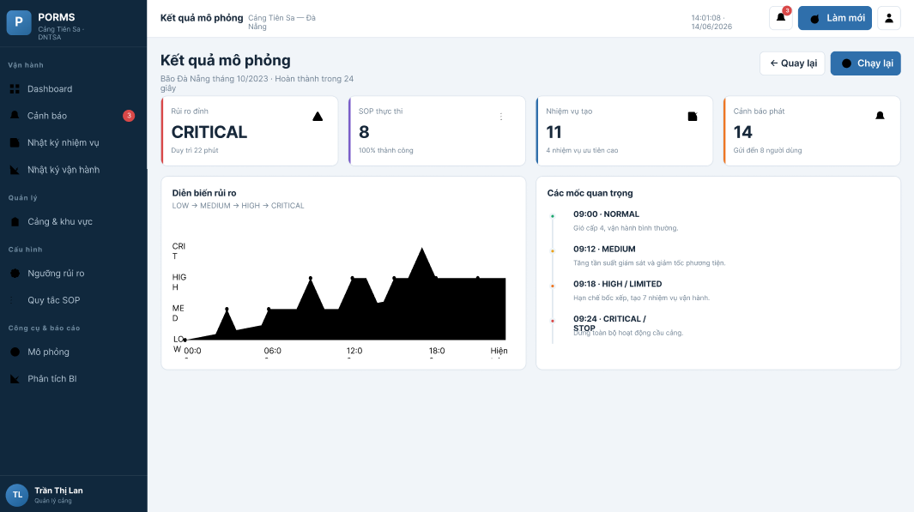
Function detail:
Data Validation:
- sessionId must correspond to a COMPLETED simulation session belonging to the authenticated user's port.
Functionality:
In Normal Cases:
- KPI cards show: peak_risk_level, total_risk_changes, total_sop_executions, total_alerts_generated.
- Risk distribution pie/bar chart shows how many snapshots were at each risk level.
- SOP execution summary table lists rules triggered, counts, and actions taken.
- An "Export PDF" button (scope v2) placeholder is shown.
In Abnormal Cases:
- If session status is not COMPLETED: message "Simulation chưa hoàn thành" shown.
Business rule: N/A

# | Component | Comp. Type | Editable | Mandatory | Default Value | Description
Session Info Header
1 | Scenario Name | Label (Text) | No | Yes | N/A | Name of the completed simulation scenario.
2 | Start Time | Label (Text) | No | Yes | N/A | Date and time the simulation was started.
3 | Duration | Label (Text) | No | Yes | N/A | Total elapsed simulation time.
4 | Speed Multiplier | Label (Text) | No | Yes | N/A | Speed used (e.g., "×10").
KPI Cards Section
5 | Peak Risk Level | KPI Card | No | Yes | N/A | Highest risk level reached. Color-coded.
6 | Total Risk Changes | KPI Card | No | Yes | N/A | Count of risk level transitions during simulation.
7 | SOP Executions | KPI Card | No | Yes | N/A | Total SOP rule executions (completed + skipped).
8 | Alerts Generated | KPI Card | No | Yes | N/A | Total alerts created during simulation.
Risk Distribution Section
9 | Risk Distribution Chart | Bar Chart | No | Yes | N/A | Shows snapshots_at_low / medium / high / critical as a grouped bar.
SOP Summary Section
10 | SOP Summary Table | Table | No | Yes | N/A | Lists triggered rules with execution counts and status breakdown.
Action Section
11 | Back Button | Button | No | Yes | "Quay lại" | Returns to Simulation Control screen.

––––––––––––––––––––––––––––––––––––––––––––––––––––––––––––––––––––––––––––––––––

3.11 Analytics Dashboard

3.11.1 - Analytics
Function trigger: Triggered when ADMIN or PORT MANAGER navigates to the Analytics section from the sidebar.
Function description: Displays three embedded Metabase BI dashboards inside the PORMS portal via signed iframes. Each dashboard connects to the analytics PostgreSQL schema via the read-only porms_metabase role. The embed URLs are generated server-side using JWT signing with the METABASE_SECRET_KEY and include a locked port_code parameter.
Screen layout:
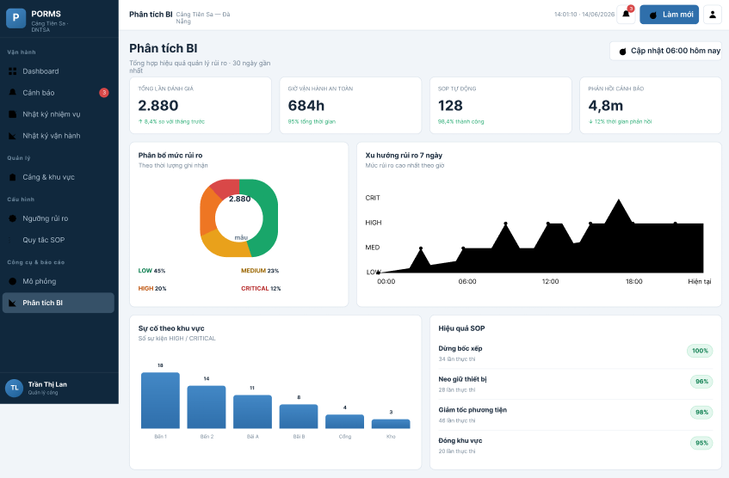
Function detail:
Data Validation:
- User must have ADMIN or PORT MANAGER role. OPERATOR cannot access this screen.
Functionality:
In Normal Cases:
- Tab 1 — Risk Trend Over Time: line chart of risk score (1–4) for 30 days, stacked bar of hours per risk level per week, top 10 peak risk events table, risk heatmap by hour × weekday.
- Tab 2 — Weather vs Operation Impact: scatter plot of wind speed vs SOP trigger count, top SOP rules horizontal bar chart, SOP executions grouped bar by action type × risk level, zone impact analysis.
- Tab 3 — KPI Overview: 4 KPI metric cards (total alerts, SOP runs, avg response time, minutes at CRITICAL), monthly alerts by severity, minutes at CRITICAL per month, SOP effectiveness table, alert response time distribution.
- Port filter parameter is locked to the user's assigned port (cannot be changed by user in iframe).
- Dashboards refresh based on Metabase cache TTL (60 minutes by default).
In Abnormal Cases:
- If Metabase server is unreachable: iframe shows "Không thể tải dashboard" error message. PORMS operational features remain unaffected.
Business rule: N/A

# | Component | Comp. Type | Editable | Mandatory | Default Value | Description
Tab Navigation
1 | Tab 1: Risk Trend | Tab Button | Yes | Yes | Active by default | Switches to Risk Trend Over Time dashboard.
2 | Tab 2: Weather & SOP | Tab Button | Yes | No | N/A | Switches to Weather vs Operation Impact dashboard.
3 | Tab 3: KPI Overview | Tab Button | Yes | No | N/A | Switches to KPI Overview dashboard.
Dashboard Display Section
4 | Metabase iframe | iframe (Embedded) | No | Yes | N/A | Displays the signed Metabase dashboard. Minimum height 700px. Scrollable.
5 | Loading Indicator | Spinner / Skeleton | No | Yes | N/A | Shown while iframe is loading.
6 | Cache Notice | Label (Text) | No | Yes | "Dữ liệu cập nhật mỗi 1 giờ" | Informs user of data refresh cadence.

––––––––––––––––––––––––––––––––––––––––––––––––––––––––––––––––––––––––––––––––––

3.12 Operational Forecast

3.12.1 - Five-Day Operational Forecast
Function trigger: Triggered when ADMIN or PORT MANAGER opens Dự báo vận hành and selects an accessible port.
Function description: Uses OpenWeather five-day forecast and PORMS risk thresholds to show daily risk, recommended operating mode and plain-language actions.
Screen layout:
# | Component | Comp. Type | Editable | Mandatory | Default Value | Description
1 | Port selector | Dropdown | Yes | Yes | Assigned/default port | Selects an accessible port.
2 | Five-day cards | Card grid | No | Yes | N/A | Daily weather, risk and operating guidance.
3 | Action groups | Information panels | No | Yes | N/A | Plain-language recommended and restricted activities.
Function detail:
Functionality:
In Normal Cases:
Display five aligned daily cards with weather/risk summary.
Translate technical risk and weather codes into Vietnamese.
Separate activities that may continue from activities that should be limited.
In Abnormal Cases:
If forecast data is unavailable, show a clear error/empty state and do not present generated values as actual observations.
Business rule: BR-23
––––––––––––––––––––––––––––––––––––––––––––––––––––––––––––––––––––––––––––––––––

3.13 AI Long-range Forecast

3.13.1 - Long-range Operational Trend
Function trigger: Triggered when ADMIN or PORT MANAGER opens Dự báo dài hạn and chooses 7, 14, 30, 60 or 90 days.
Function description: Builds a planning trend from available forecast data and analyzes risk using PCA scoring and K-Means cluster classification.
Screen layout:
# | Component | Comp. Type | Editable | Mandatory | Default Value | Description
1 | Horizon selector | Button group | Yes | Yes | 7 days | Chooses planning horizon.
2 | Trend chart | Line chart | No | Yes | N/A | Risk score and confidence over time.
3 | Analysis table | Table | No | Yes | N/A | Friendly risk, cluster and recommendation labels.
Function detail:
Functionality:
In Normal Cases:
Show risk score, rule risk, cluster explanation, confidence and operating recommendation.
Decrease displayed confidence as the planning horizon grows.
Clearly state that long-range results support planning and do not replace official weather forecasts.
In Abnormal Cases:
If source forecast or ML analysis fails, show a retryable error without retaining misleading stale output.
Business rule: BR-24
––––––––––––––––––––––––––––––––––––––––––––––––––––––––––––––––––––––––––––––––––

3.14 Forecast Evaluation

3.14.1 - Forecast-versus-Actual Evaluation
Function trigger: Triggered when ADMIN or PORT MANAGER opens Đánh giá dự báo.
Function description: Compares forecast wind, rainfall, visibility and risk with actual weather observations after the planned time.
Screen layout:
# | Component | Comp. Type | Editable | Mandatory | Default Value | Description
1 | Evaluation filters | Filter panel | Yes | No | Current scope | Limits port and date range.
2 | Comparison rows | Table | No | Yes | N/A | Forecast, actual and error values.
3 | Export | Button | No | No | Disabled without data | Exports evaluation data.
Function detail:
Functionality:
In Normal Cases:
Show forecast/actual pair and error for every available factor.
Mark a row reconciled only when actual data exists.
Allow export of the evaluation dataset.
In Abnormal Cases:
When the machine or collector was offline and no observation exists, show Chưa có dữ liệu thực tế instead of zero or a false comparison.
Business rule: BR-25
––––––––––––––––––––––––––––––––––––––––––––––––––––––––––––––––––––––––––––––––––

3.15 Operational Reports

3.15.1 - Preview and Export Report
Function trigger: Triggered when ADMIN or PORT MANAGER opens Báo cáo vận hành.
Function description: Previews filtered Alerts, Tasks or Operation Events and exports the same result to Excel or PDF.
Screen layout:
# | Component | Comp. Type | Editable | Mandatory | Default Value | Description
1 | Report type | Tabs | Yes | Yes | Alerts | Alerts, Tasks or Operation Events.
2 | Filters | Filter panel | Yes | Yes | Last 7 days | Port, zone, risk and date range.
3 | Preview | Table | No | Conditional | Empty | Rows matching active filters.
4 | Excel/PDF | Buttons | No | Conditional | Disabled | Enabled only when preview contains data.
Function detail:
Functionality:
In Normal Cases:
Admin can choose all or one port; Port Manager is restricted to the assigned port.
Select report type, port, zone, severity and date range, then preview.
Export only a non-empty preview and record the action in operation history.
In Abnormal Cases:
Invalid scope, date range or empty result produces an explanation and no blank file.
Business rule: BR-26, BR-27
––––––––––––––––––––––––––––––––––––––––––––––––––––––––––––––––––––––––––––––––––

3.16 Notification Settings

3.16.1 - Personal Notification Preference
Function trigger: Triggered when any authenticated user opens Cài đặt thông báo.
Function description: Controls website popup, Vietnamese voice and minimum automatic-popup severity for the current account on the current browser/device.
Screen layout:
# | Component | Comp. Type | Editable | Mandatory | Default Value | Description
1 | Website popup | Switch | Yes | Yes | Enabled | Controls in-app alert popup.
2 | Vietnamese voice | Switch | Yes | No | Enabled | Controls speech playback.
3 | Minimum severity | Radio cards | Yes | Yes | HIGH | HIGH+CRITICAL or CRITICAL-only.
4 | Save | Button | No | Yes | N/A | Stores preference for this user/device.
Function detail:
Functionality:
In Normal Cases:
Enable/disable website popup.
Enable/disable Vietnamese voice when popup is enabled.
Choose HIGH+CRITICAL or CRITICAL-only automatic notification.
In Abnormal Cases:
Browser audio restrictions keep the visual popup available. Clearing browser storage resets this local preference.
Business rule: BR-20, BR-21
––––––––––––––––––––––––––––––––––––––––––––––––––––––––––––––––––––––––––––––––––

4. Non-Functional Requirements

4.1 External Interfaces

4.1.1 User Interface
- UI-01: The system must support web browsers Chrome 90+, Firefox 88+, and Edge 90+.
- UI-02: The minimum supported display resolution is 1024×768 pixels (desktop-first design).
- UI-03: Risk level color conventions must be consistent throughout: LOW=#27AE60, MEDIUM=#F39C12, HIGH=#E67E22, CRITICAL=#C0392B.
- UI-04: Operation mode color conventions: NORMAL=green, LIMITED=amber, STOP=red.
- UI-05: All Vietnamese text must use UTF-8 encoding throughout the application.
- UI-06: Loading states (skeleton screens) must be shown while data is being fetched.
- UI-07: CRITICAL alerts must trigger a pulse animation on the Risk Badge and Alert Bell icon.

4.1.2 Software Interface
- SI-01: The backend REST API must conform to OpenAPI 3.0.3 specification. All endpoints must be documented via Swagger UI at /swagger.
- SI-02: The system integrates with OpenWeather Current Weather API (GET /data/2.5/weather) via HTTPS. API key must be stored as environment variable OW_API_KEY.
- SI-03: All protected API endpoints must require Bearer JWT authentication token in the Authorization header.
- SI-04: Internal trigger endpoint (POST /api/internal/trigger-risk-engine) uses X-Internal-Key header authentication for Prefect ETL integration.
- SI-05: The Metabase embed API must use signed JWT tokens generated with METABASE_SECRET_KEY for secure iframe embedding.
- SI-06: ETL pipeline uses Prefect 2.x as workflow orchestration. Prefect Server must be accessible at http://prefect-server:4200 within Docker network.
- SI-07: Database communication must use parameterized Npgsql queries to prevent SQL injection. The current infrastructure repositories do not rely on Entity Framework Core.

4.1.3 Hardware Interface
- HI-01: The production server must have a minimum of 4GB RAM to support concurrent Docker containers (PostgreSQL, ASP.NET API, React, Prefect, Metabase).
- HI-02: Minimum 20GB persistent storage for PostgreSQL data volume, ETL logs, and Metabase application data.
- HI-03: The server requires an outbound internet connection for OpenWeather API calls on ports 443 (HTTPS).

4.2 Quality Attributes

4.2.1 Availability
The PORMS demonstration environment uses Docker Compose restart policies and health checks for PostgreSQL, backend and Metabase. Weather collection is orchestrated by Prefect; service failure must be visible and must not erase the latest valid operational data.

4.2.2 Usability
A port operator with no prior PORMS training must be able to identify the current risk level and operation mode within 30 seconds of viewing the dashboard. Risk level and mode color coding must be immediately recognizable. Alert notifications must be visually prominent with red badges and animation for CRITICAL severity. Vietnamese language must be used throughout the operator-facing interface.

4.2.3 Reliability
The system must maintain data integrity across all concurrent operations. Risk assessments must be idempotent: re-evaluating the same weather reading must produce the same result. SOP Engine executions use idempotency keys (assessmentId + ruleId + zoneId) to prevent duplicate actions on retry. The operation_events table is append-only and cannot be modified or deleted, ensuring a tamper-proof audit trail.

4.2.4 Performance
- REST API response time p95 must be under 500ms for standard read endpoints.
- Risk Engine evaluation for a single port must complete within 200ms (excluding DB write time).
- SOP Engine execution for all rules of a single risk event (13 rules × 6 zones = up to 9 executions for PORMS v1) must complete within 500ms.
- The full pipeline (weather fetch → risk assessment → SOP execution → alert visible in UI) must complete within 60 seconds.
- Database backups are performed automatically on a daily basis.

4.2.5 Security
- All passwords must be stored as BCrypt hashes with cost factor 12. No plain-text passwords are stored or transmitted.
- JWT access tokens expire after 15 minutes. Refresh tokens expire after 7 days and are stored as SHA-256 hashes.
- Role-Based Access Control (RBAC) enforces that PORT MANAGER and OPERATOR can only access data for their assigned port.
- Database credentials and API keys must be stored in environment variables and never committed to source control.
- The system must use three separate PostgreSQL roles: porms_api (operational R/W), porms_etl (operational R, analytics R/W), porms_metabase (analytics read-only).
- Common web vulnerabilities (SQL injection, XSS) must be prevented through parameterized queries and input sanitization.

4.2.6 Maintainability and Extensibility
- The system architecture follows Clean Architecture principles with separate Domain, Application, Infrastructure, and API layers.
- Adding a new port requires only database configuration (no code changes or redeployment).
- Risk thresholds and SOP rules are fully configurable via Admin UI without code modification.
- All API endpoints are documented in an OpenAPI 3.0.3 YAML specification. Frontend TypeScript types can be auto-generated from this spec.
- ETL flows are independently deployable via Prefect deployments.
- Code must follow Conventional Commits format and pass all unit tests before merging to the dev branch.

5. Requirement Appendix

5.1 Business Rules
# | Rule Definition
BR-01 | Password requirements: minimum 8 characters, at least 1 uppercase letter, 1 lowercase letter, 1 number, and 1 special character.
BR-02 | Passwords stored in the database must be hashed using the BCrypt algorithm with cost factor 12.
BR-03 | JWT access tokens expire after 15 minutes. Refresh tokens expire after 7 days.
BR-04 | Refresh tokens are stored as SHA-256 hashes in the database. Raw tokens are only stored in httpOnly cookies.
BR-05 | User accounts are locked for 15 minutes after 5 consecutive failed login attempts.
BR-06 | PORT MANAGER and OPERATOR roles must have an assigned_port_id. ADMIN has no port assignment.
BR-07 | User deletion is soft delete (deleted_at timestamp set). Data is preserved but login is prevented.
BR-08 | Port code is immutable after creation. Maximum 20 characters, uppercase alphanumeric only.
BR-09 | Port latitude must be in range [-90, 90]. Longitude must be in range [-180, 180].
BR-10 | Beaufort scale conversion follows WMO 2023 standard. Boundary: 10.7 m/s → B5 (LOW); 10.8 m/s → B6 (MEDIUM); 17.1 m/s → B7; 17.2 m/s → B8 (HIGH); 24.4 m/s → B9; 24.5 m/s → B10 (CRITICAL).
BR-11 | Risk level aggregation uses worst-case (MAX) of WIND, RAIN, and VISIBILITY risk levels.
BR-12 | SOP Engine triggers only when risk level CHANGES. Same-level assessments do not trigger SOP execution.
BR-13 | Operation mode automatic transitions follow state machine: NORMAL → LIMITED → STOP only. Reverse transitions require manual override.
BR-14 | Manual mode override requires a reason with minimum 20 characters.
BR-15 | SOP Rule updates require a change reason with minimum 20 characters, which is logged in operation_events.
BR-16 | RECOVERY-001 SOP rule triggers an INFO alert and checklist task when risk returns to LOW, but does NOT automatically change operation mode from STOP. Manual override by PORT MANAGER is required after physical safety inspection.
BR-17 | Alert anti-spam: duplicate alerts of the same (port_id, alert_type) are suppressed within a 10-minute window. CRITICAL severity bypasses this suppression.
BR-18 | Simulation data is flagged with is_simulation = TRUE and does not affect ports.current_mode or real operational dashboards.
BR-19 | A simulation requires a minimum of 5 weather snapshots. Speed multiplier must be between 1 and 100.
BR-20 | Operation events table is append-only. DELETE and UPDATE operations are rejected (405 Method Not Allowed).
BR-21 | Risk thresholds are cached in-memory for 5 minutes. Threshold updates take effect within 5 minutes maximum.
BR-22 | All alerts generated during simulation are flagged is_simulation = TRUE and are not shown in the real-time alert panel by default.
BR-23 | The five-day operational forecast shall use available OpenWeather forecast data and the configured PORMS risk thresholds.
BR-24 | Long-range forecast output is planning support based on PCA and K-Means analysis. Confidence shall decrease as the selected horizon increases, and the output shall not be presented as an official meteorological forecast.
BR-25 | A forecast evaluation record shall be marked as reconciled only when an actual weather observation exists. Missing actual data shall be stated clearly and shall not be replaced with zero values.
BR-26 | ADMIN may preview and export reports across accessible ports. PORT MANAGER may preview and export data only for the assigned port.
BR-27 | Excel and PDF exports shall contain the same data scope and filters shown in the report preview. The system shall not create an unexplained empty report.
BR-28 | A response task may be assigned only to an ACTIVE OPERATOR belonging to the same port as the alert. Only the assigned OPERATOR may process that task.
BR-29 | The task workflow shall follow NEW -> ACKNOWLEDGED -> IN_PROGRESS -> COMPLETED. Completion requires a result note of at least 10 characters.
BR-30 | Alert access shall be enforced by the server: ADMIN sees all accessible alerts, PORT MANAGER sees alerts of the assigned port, and OPERATOR sees only alerts linked to personally assigned tasks.
BR-31 | Automatic popup and Vietnamese voice notifications shall be triggered only for HIGH and CRITICAL alerts within the authenticated user's access scope.
BR-32 | A HIGH or CRITICAL alert shall notify active PORT MANAGER accounts of the affected port. Task-assignment email shall be sent only to the selected OPERATOR.
BR-33 | An email or speech-delivery failure shall be logged and shall not roll back the alert, simulation session, or task assignment.
BR-34 | Each successful report export shall record the actor, report type, active filters, scope, format, and export time in the operation history.
Table 8. Business Rules

5.2 Common Requirements
# | Requirement | Description
1 | Functionality | PORMS is a real-time port safety decision-support platform that automates risk assessment from weather data, triggers standardized operating procedures, manages operational mode transitions, and provides comprehensive audit trail and analytics capabilities.
2 | Security | The system implements JWT authentication with role-based access control (RBAC). Passwords are BCrypt-hashed. Sensitive DB credentials are stored in environment variables and never committed to source control. Three separate PostgreSQL roles (porms_api, porms_etl, porms_metabase) enforce minimal-privilege access.
3 | Performance | API response time p95 must be under 500ms. Risk Engine evaluation per port must complete within 200ms. The full pipeline (weather fetch → risk assessment → SOP execution → alert delivery) must complete within 60 seconds.
4 | Scalability | Adding a new port requires only a database INSERT and does not require code changes or system restarts. SOP rules and risk thresholds are fully configurable via UI without redeployment.
5 | Compatibility | The frontend must function correctly on Chrome 90+, Firefox 88+, and Edge 90+. The dashboard must be usable on screens with minimum resolution of 1024×768 pixels.
6 | Maintainability | All API endpoints are documented via OpenAPI 3.0.3 (Swagger). Each backend module includes a README. The codebase follows Clean Architecture with Domain, Application, Infrastructure, and API layers.
7 | Availability | System uptime target is ≥ 99% during the 10-week development and demo period. All Docker containers use restart policy "always". The BackgroundService weather fetcher operates independently from the Prefect ETL pipeline as a fallback mechanism.
8 | Usability | An operator unfamiliar with PORMS must be able to understand the current risk status of the port within 30 seconds of viewing the dashboard. Risk level colors (LOW=green, MEDIUM=yellow, HIGH=orange, CRITICAL=red) must be consistent throughout the interface.
9 | Role and Port Scope | All alert, task, forecast, evaluation and report APIs shall enforce role and assigned-port scope on the server; hiding an item in the user interface alone is not sufficient authorization.
10 | Alert and Notification | HIGH and CRITICAL alerts shall provide a clear Vietnamese popup and optional Vietnamese voice playback. Visual information shall remain available when browser audio is blocked or unavailable.
11 | Task Workflow | The system shall restrict assignment to active same-port Operators, enforce valid status transitions, record processing timestamps, and require a completion result before a task is completed.
12 | Forecast Transparency | Forecast screens shall identify the data source, distinguish forecast data from actual observations, translate technical risk codes into understandable Vietnamese, and explain the confidence and limitations of AI-assisted output.
13 | Report Integrity | Report preview and exported Excel/PDF files shall use the same filters, access scope and source records. Files shall include report title, scope, selected period and creation time.
14 | Auditability | Alert acknowledgement, task assignment and status changes, simulation runs, notification failures and report exports shall be recorded in operation history with actor and time information.
15 | Localization and Accessibility | Operational labels, risk levels, event names and recommended actions shall be displayed in clear Vietnamese. Important information shall not rely on color or audio alone.
Table 9. Common Requirements

5.3 Application Messages List
# | Code | Type | Context | Content
01 | MSG-01 | Toast | Login success | Đăng nhập thành công.
02 | MSG-02 | Toast | Login failure — wrong credentials | Email hoặc mật khẩu không đúng.
03 | MSG-03 | Toast (Error) | Account locked after 5 failed attempts | Tài khoản bị khóa {X} phút do đăng nhập sai nhiều lần.
04 | MSG-04 | Toast | Logout success | Đăng xuất thành công.
05 | MSG-05 | Toast | Password changed successfully | Mật khẩu đã được thay đổi thành công. Vui lòng đăng nhập lại.
06 | MSG-06 | Toast | Password reset email sent | Nếu email tồn tại, chúng tôi đã gửi hướng dẫn đặt lại mật khẩu.
07 | MSG-07 | Toast (Error) | Reset token expired or used | Liên kết đặt lại không hợp lệ hoặc đã hết hạn.
08 | MSG-08 | Toast | Profile updated successfully | Thông tin cá nhân đã được cập nhật.
09 | MSG-09 | Toast | User created successfully | Tài khoản người dùng đã được tạo thành công.
10 | MSG-10 | Toast (Error) | Email already exists | Email này đã được sử dụng trong hệ thống.
11 | MSG-11 | Toast | User account unlocked | Tài khoản {username} đã được mở khóa thành công.
12 | MSG-12 | Toast | Port created successfully | Cảng {portName} đã được thêm vào hệ thống.
13 | MSG-13 | Toast (Error) | Port code already exists | Mã cảng {code} đã tồn tại trong hệ thống.
14 | MSG-14 | Toast | Zone created successfully | Khu vực {zoneName} đã được tạo thành công.
15 | MSG-15 | Toast | Zone updated successfully | Thông tin khu vực {zoneName} đã được cập nhật.
16 | MSG-16 | Toast | Risk threshold updated | Ngưỡng đánh giá rủi ro đã được cập nhật. Hiệu lực trong ≤ 5 phút.
17 | MSG-17 | Toast (Error) | Threshold overlap validation | Ngưỡng mới bị chồng lấp với ngưỡng hiện tại. Vui lòng kiểm tra lại.
18 | MSG-18 | Toast | SOP rule created | SOP rule {ruleName} đã được tạo thành công.
19 | MSG-19 | Toast | SOP rule updated | SOP rule {ruleName} đã được cập nhật.
20 | MSG-20 | Toast (Error) | SOP rule change reason too short | Lý do thay đổi phải có ít nhất 20 ký tự.
21 | MSG-21 | Toast | Operation mode overridden | Chế độ vận hành đã được chuyển sang {newMode} thủ công.
22 | MSG-22 | Toast (Error) | Override reason too short | Lý do override phải có ít nhất 20 ký tự.
23 | MSG-23 | Toast | All alerts marked as read | Tất cả {N} cảnh báo đã được đánh dấu là đã đọc.
24 | MSG-24 | Toast | Simulation started | Simulation "{scenarioName}" đã bắt đầu.
25 | MSG-25 | Toast (Error) | Simulation already running | Cảng đang có simulation đang chạy. Dừng simulation hiện tại trước khi bắt đầu mới.
26 | MSG-26 | Toast | Simulation stopped | Simulation đã dừng.
27 | MSG-27 | Toast (Error) | Insufficient snapshots | Simulation cần ít nhất 5 weather snapshots.
28 | MSG-28 | Inline | Empty list | Không có dữ liệu để hiển thị.
29 | MSG-29 | Inline | Required field empty | Vui lòng nhập {fieldName}.
30 | MSG-30 | Toast (Error) | API server unreachable | Không thể kết nối đến máy chủ. Vui lòng thử lại sau.
31 | MSG-31 | Toast | Task assigned | Đã phân công nhiệm vụ cho nhân viên vận hành.
32 | MSG-32 | Validation | Invalid assignee | Người được chọn phải đang hoạt động và thuộc cùng cảng với nhiệm vụ.
33 | MSG-33 | Validation | Completion note | Kết quả xử lý phải có ít nhất 10 ký tự.
34 | MSG-34 | Empty state | Missing actual observation | Chưa có dữ liệu thời tiết thực tế để đối chiếu.
35 | MSG-35 | Empty state | Empty report | Không có dữ liệu phù hợp với bộ lọc. Hệ thống không tạo báo cáo trống.
36 | MSG-36 | Toast | Report exported | Đã tạo báo cáo và ghi nhận hoạt động xuất file vào lịch sử vận hành.
37 | MSG-37 | Toast | Alert acknowledged | Đã xác nhận tiếp nhận cảnh báo.
38 | MSG-38 | Error | Access denied by port scope | Bạn không có quyền xem hoặc xử lý dữ liệu của cảng này.
39 | MSG-39 | Toast | Task completed | Đã hoàn tất nhiệm vụ và lưu kết quả xử lý.
40 | MSG-40 | Information | Voice unavailable | Trình duyệt chưa thể phát giọng đọc. Bạn vẫn có thể xem nội dung cảnh báo trên màn hình hoặc bấm Nghe cảnh báo.
41 | MSG-41 | Toast | Notification preference saved | Đã lưu tùy chọn nhận thông báo trên thiết bị này.
42 | MSG-42 | Error | Notification delivery failed | Không thể gửi một kênh thông báo. Cảnh báo và nhiệm vụ vẫn được lưu trong hệ thống.
Table 10. Application Messages List

