電通二甲微處理器實驗 實驗結報

實驗名稱 | Lab01-Blink
組別 | 19 | 組員 | 陳政佑、葉昕語

- 實驗目的
a使用 circuits.io 模擬 Arduino UNO 電路及程式
b繪製電路圖
c觀察 Arduino UNO 之輸出
d學習將程式碼及實驗報告上傳至 Github

- 實驗步驟
a填寫分組表單
b啓動 Arduino IDE, 載入 Blink 程式碼
c至 circuits.io 註冊帳號，啟動 Arduino 模擬器
d接上 LED 電路
e修改程式，將 LED 輸出改為 Pin 9
f觀察 LED 之閃爍間隔
g修改程式, 使 LED 閃爍間隔分別增加為 2 倍及 ½ 倍, 重新量測並截圖
h畫出電路圖

- 程式碼
一
//Pin 13 has an LED connected on most Arduino boards.
//give it a name:
int led =13;

//the setup routine runs once when you press reset:
void setup (){
//initialize the digital pin as an output.
pinMode(led, OUTPUT);
}

//the loop routine runs over and over again forever:
void loop() {
digitalWrite(led, HIGH) ; //turn the LED on(HIGH is the voltage level)
delay(1000); //wait for a second
digitalWrite(led, LOW): //turn the LED off by making the voltage LOW
delay(1000);
}

- 實驗結果及分析
由於我們今天還沒有拿到arduino uno，所以用circuits.io 模擬 Arduino UNO 電路及程式，arduino連線透過麵包板，把腳位13和燈泡負極相接、5V腳位跟正極相接，調整程式碼，觀察燈泡閃爍頻率，並加上電阻，來觀察燈泡的亮度，成功完成本周的作業。

- 心得討論
第一次接觸arduino蠻緊張的，覺得模擬的介面很方便，不需要動手接電路就可以看到實驗結果，而且介面很可愛，而且覺得小小的板子可以有那麼多功用很厲害，希望實際動手接的時候可以如此順利。
- 修正電路圖
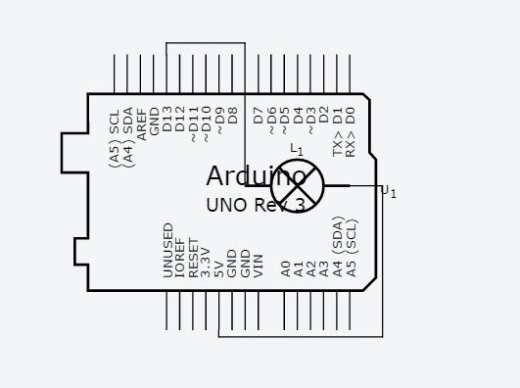
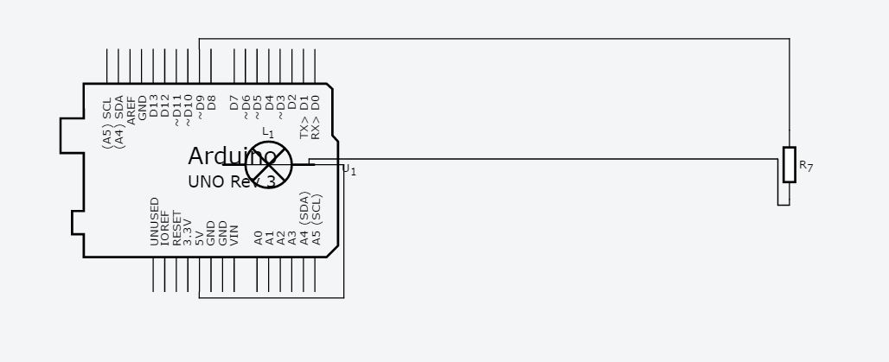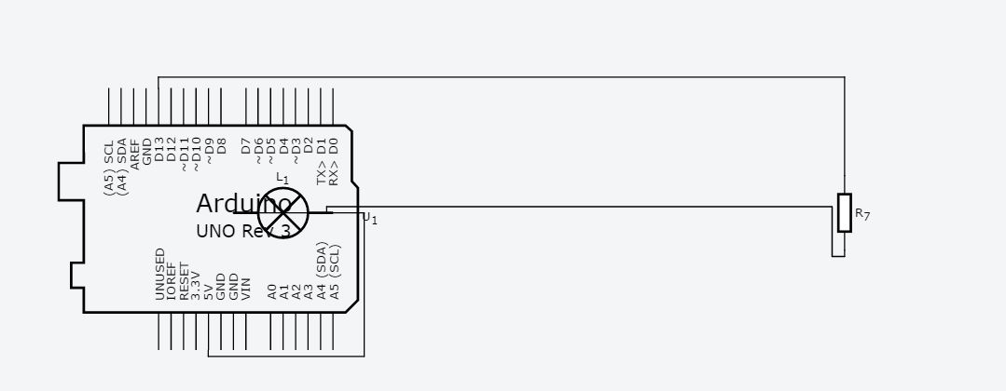
- 修正程式碼
二
//Pin 13 has an LED connected on most Arduino boards.
//give it a name:
int led =13;

//the setup routine runs once when you press reset:
void setup (){
//initialize the digital pin as an output.
pinMode(led, OUTPUT);
}

//the loop routine runs over and over again forever:
void loop() {
digitalWrite(led, HIGH) ; //turn the LED on(HIGH is the voltage level)
delay(500); //wait for a second
digitalWrite(led, LOW): //turn the LED off by making the voltage LOW
delay(500);
}

三
//Pin 13 has an LED connected on most Arduino boards.
//give it a name:
int led =9;

//the setup routine runs once when you press reset:
void setup (){
//initialize the digital pin as an output.
pinMode(led, OUTPUT);
}

//the loop routine runs over and over again forever:
void loop() {
digitalWrite(led, HIGH) ; //turn the LED on(HIGH is the voltage level)
delay(500); //wait for a second
digitalWrite(led, LOW): //turn the LED off by making the voltage LOW
delay(500);
}

