AWS DevOps Setup:-
(AWS DevOps :- All AWS Services Using for CICD)
<====================================>
AWS CodeCommit (Storage and Source Code Management)
AWS CodeBuild (Continuous Integration) (buildspec.yml is mandatory)
AWS CodePipeline (Continuous Delivery)
AWS CodeDeploy. (Continuous Deployment) (appspec.yml is mandatory)
<====================================>

Pre-requisites:-

=> Create a IAM User with Administration Permissions.
=> Generate HTTPS Credentials for CodeCommit ( for IAM User)
=> Create a Two Roles:
EC2-Instance-Role “AmazonS3ReadOnlyAccess” Permissions
AWS-codedeploy-role “AWSCodedeployrole” Permissions
=> Lanch Amazon EC2-Instance (attach EC2-Instance role and install CodeDeploy Agent)

Note Bootup Script for install CodeDeploy Agent

#!/bin/bash
sudo yum update -y
sudo yum install ruby -y
sudo yum install aws-cli -y
cd /home/ec2-user
#wget https://bucket-name.s3.region-identifier.amazonaws.com/latest/install
wget https://aws-codedeploy-us-east-1.s3.us-east-1.amazonaws.com/latest/install
chmod +x ./install
sudo ./install auto

=> Create CodeCommit Repository.
=> Push Code to CodeCommit Repository using HTTPS Credentials.
=> Create a S3 Bucket to store Artifacts.
=> Manually Create a CodeBuild (If build is success can create a AWS CodePipeline).
Note: Creating CodeBuild buildspec.yml file is mandatory with code repository under root Directory.
=> Create a CodeDeploy Application and Application Group using CodeDeploy Console.
=> Create a CodePipeline.(here by defaults create a new s3 bucket if you don’t want or else use existing one)

STEP 1 :- Create a IAM User, With Administration Permissions.

=> Login to AWS root Account=>Select Services=> Select IAM => Left Side Select Users => Click Add User =>

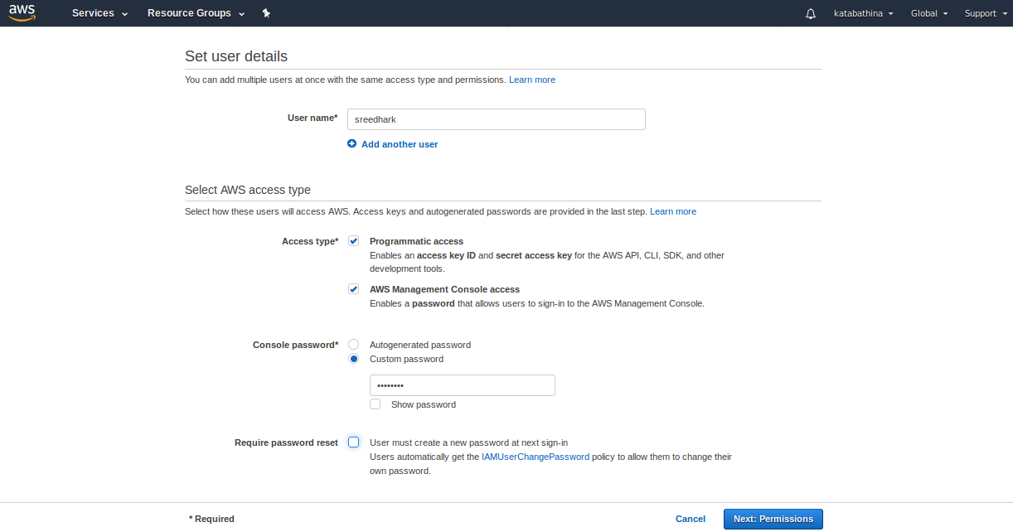
User Name : sreedhark
passwd: XXXXX

=> Select Next:Permissions. => Select Attach existing policies directly and choose Administrator Access => Select Next:Tags.

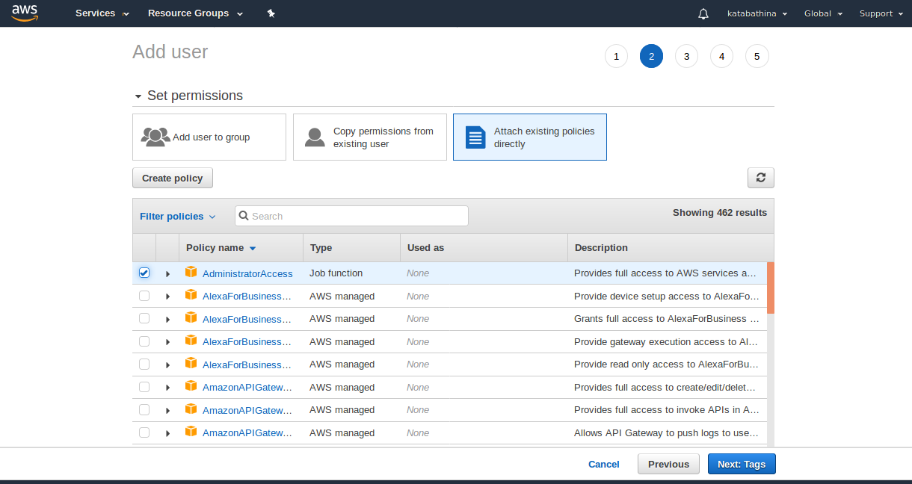

=> Select Review.

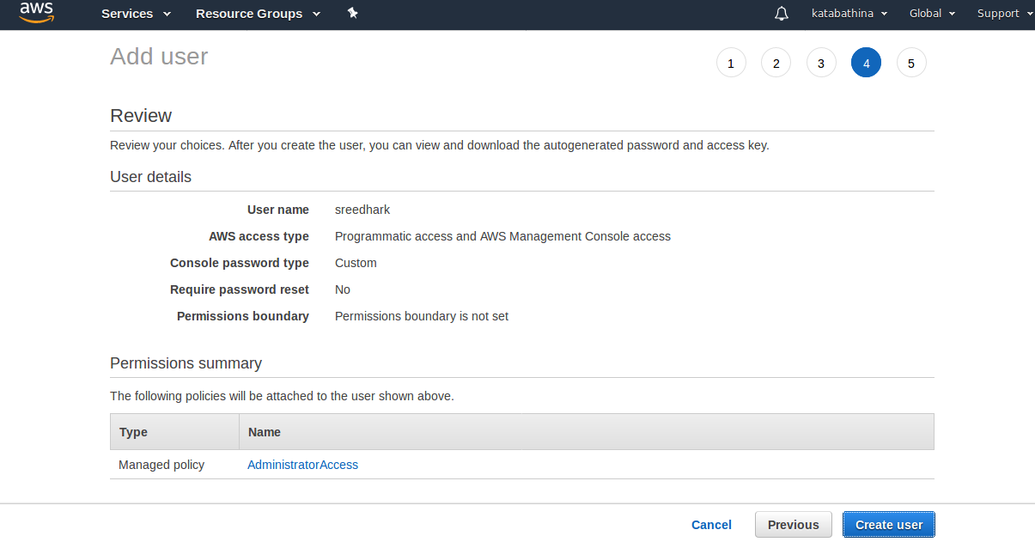
=> Select Create User.

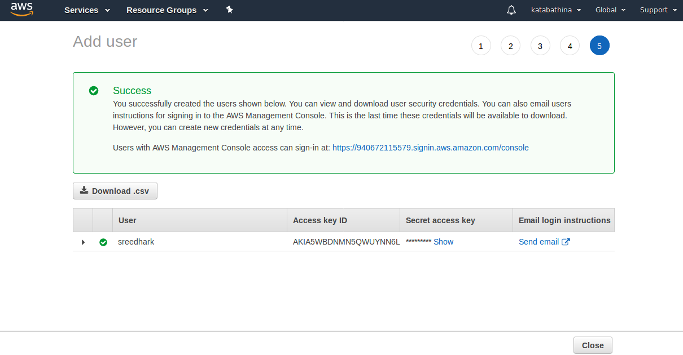
Here it will give IAM User sign in URL: https://940672115579.signin.aws.amazon.com/console

User : sreedhark Access and Secret accesskey generated.

=> Select Close.

STEP 2:- Generate HTTPS Credentials for CodeCommit ( for IAM User):

=> Select Services => Select IAM => Next Select Users from leftside Panel.

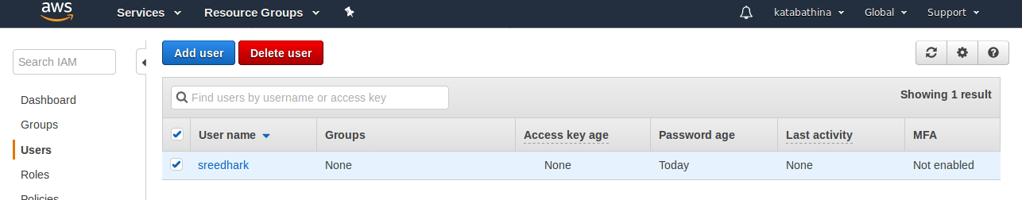
=> Select User “sreedhark”

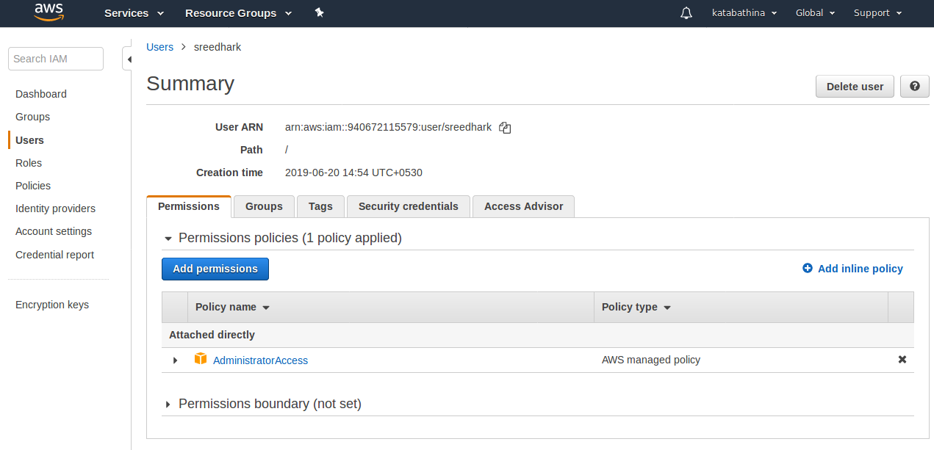
=> Select Security Credentials. => And Scroll down here you will find SSH keys for AWS CodeCommit and HTTPS Git credentials for AWS CodeCommit.

=> Here we are using HTTPS Git credentials for AWS CodeCommit.
=> Select Generate Under HTTPS Git credentials for AWS CodeCommit.

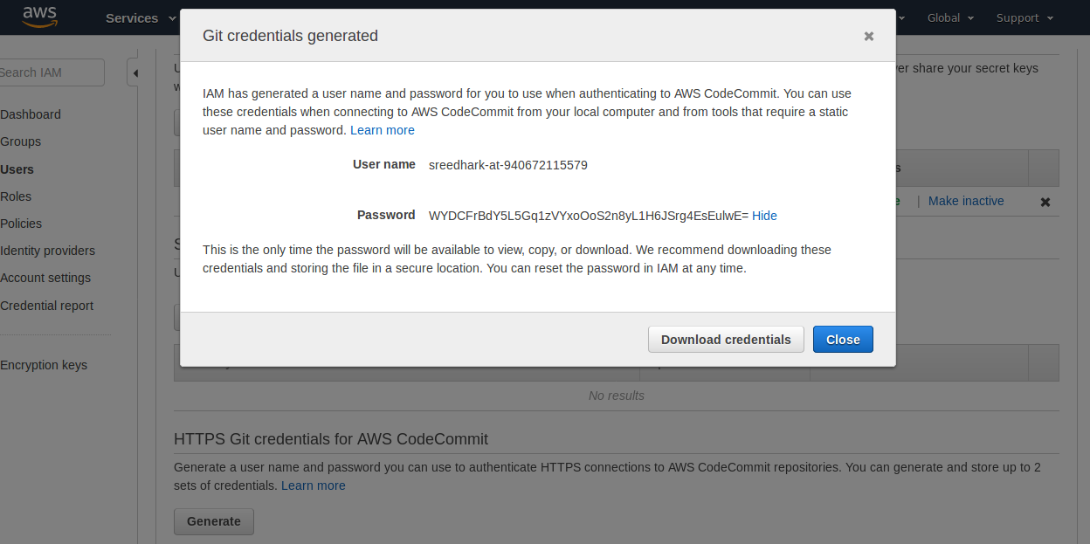

=> Here we got User name and Passwd for AWS CodeCommit.

=> Logout with Root Account .

=> Loing with IAM User Account.

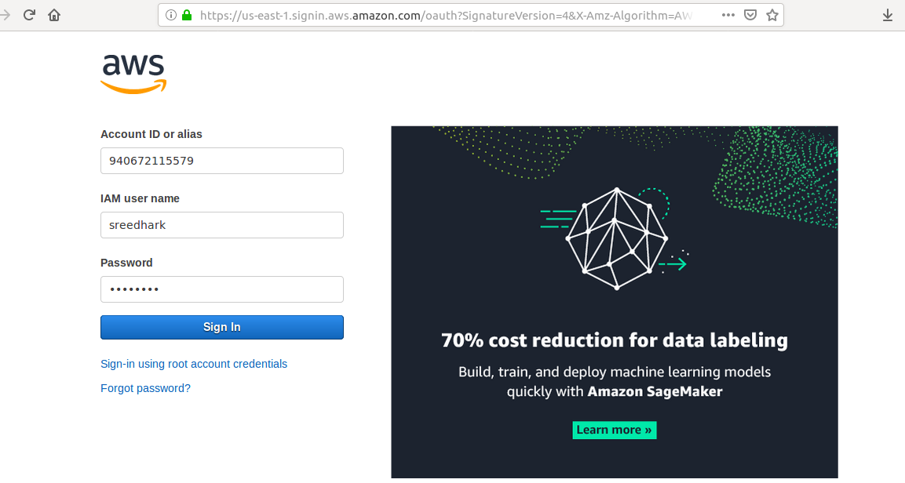
STEP 3:- Create a Two Roles.

{{ EC2-Instance-Role “AmazonS3ReadOnlyAccess” Permissions
AWS-codedeploy-role “AWSCodedeployrole” Permissions }}

=> First Creaing EC2-Instance-Role with “AmazonS3ReadOnlyAccess” permissions.

=> Select Services => Select IAM => Select Roles from Left side panel=> Select Create role.

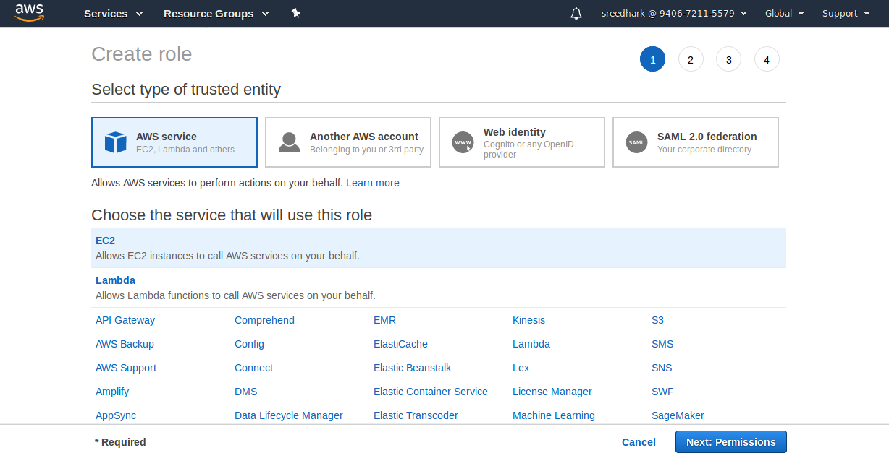
=> Select Permissions.

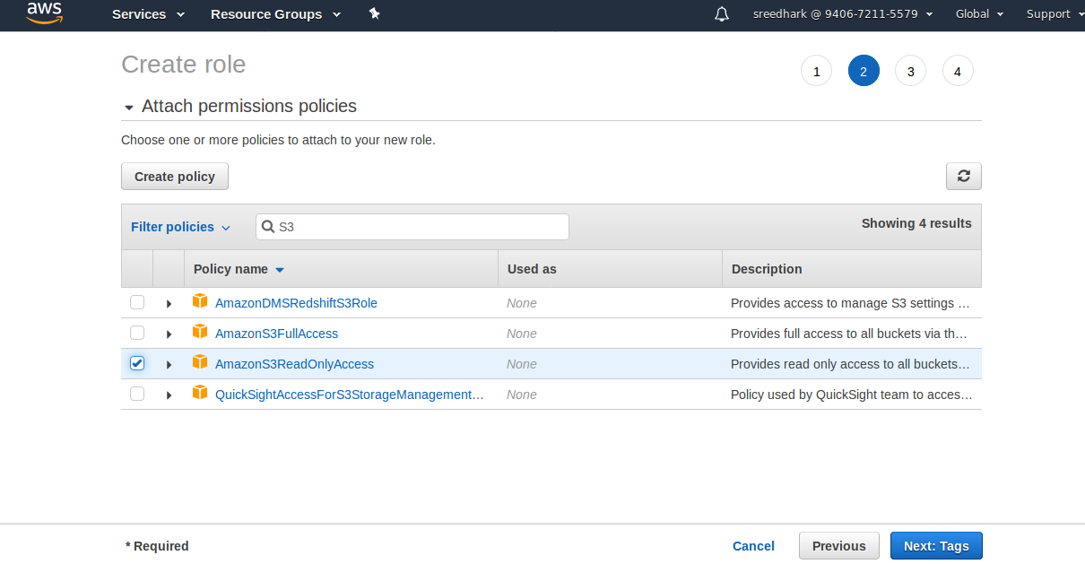

=> Select Next: Tags. => Select Next: Review.

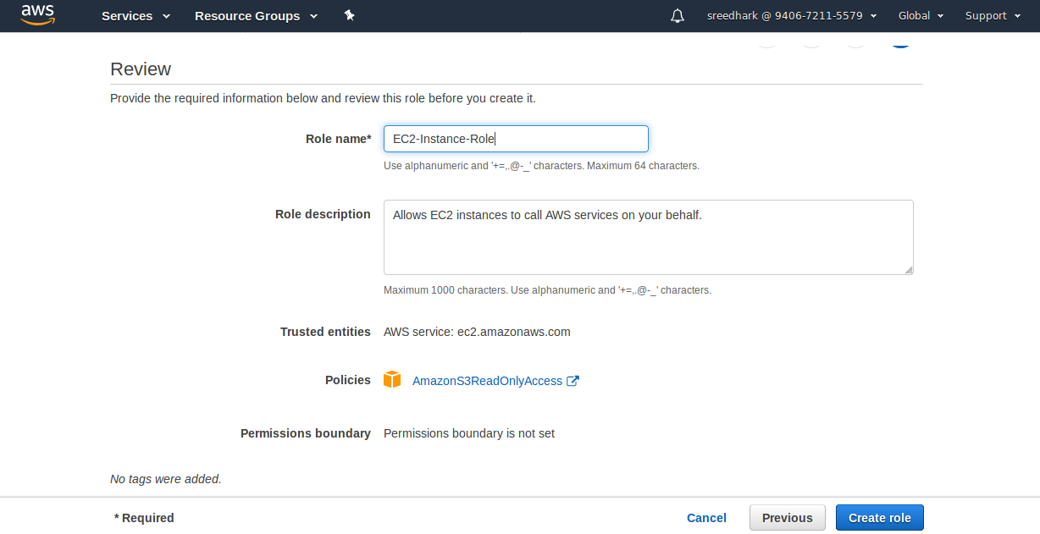
=> Select Create role.

The role EC2-Instance-Role has been created.

=> Creaing AWS-Codedeplo-Role with “AWSCodedeployrole” permissions.

=> Select Services => Select IAM => Select Roles from Left side panel=> Select Create role.

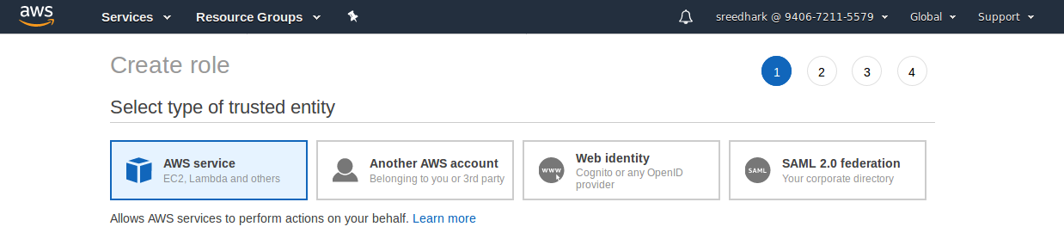

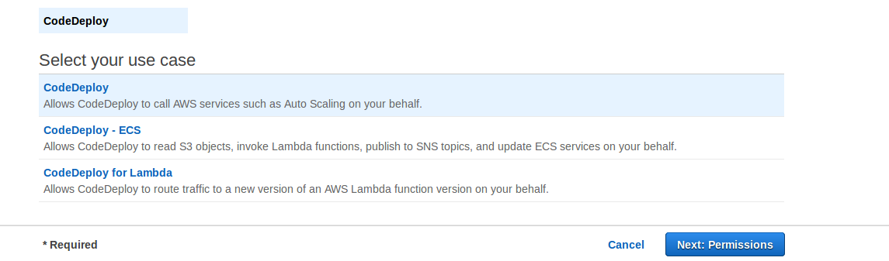
=> Select Next:Permissions.

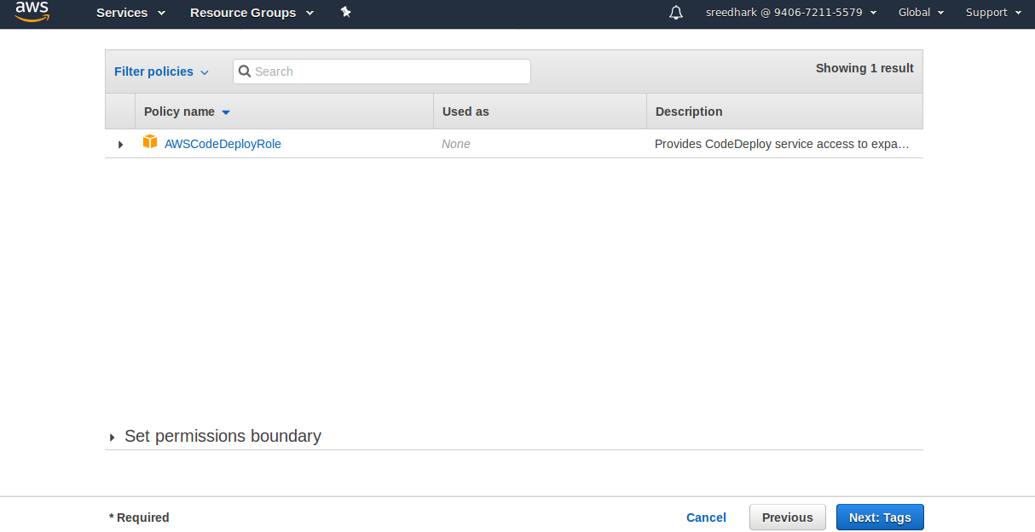
=> Select Next: Tags. => Select Next: Review.

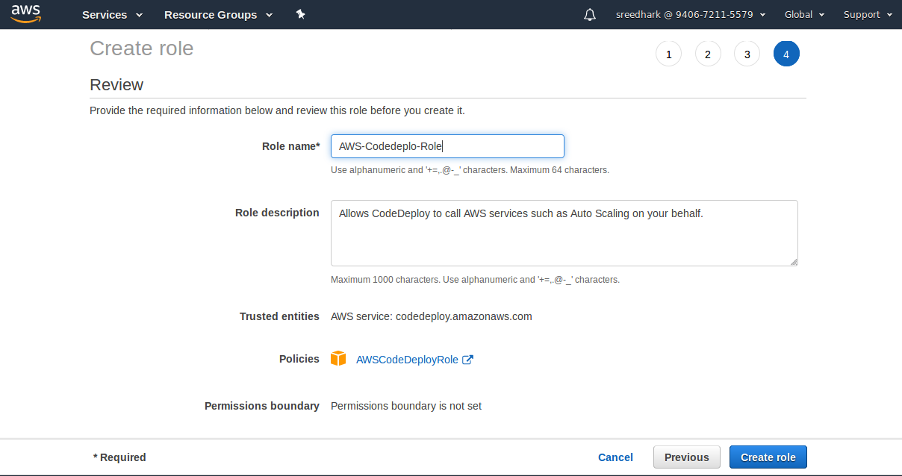

=> Select Create role.

The role AWS-Codedeploy-Role has been created.

STEP 4:- Lanch Amazon EC2-Instance (attach EC2-Instance role and install CodeDeploy Agent)

Note:- Bootup Script for install CodeDeploy Agent.

#!/bin/bash
sudo yum update -y
sudo yum install ruby -y
sudo yum install aws-cli -y
cd /home/ec2-user
#wget https://bucket-name.s3.region-identifier.amazonaws.com/latest/install
wget https://aws-codedeploy-us-east-1.s3.us-east-1.amazonaws.com/latest/install
chmod +x ./install
sudo ./install auto

=> Select Services => Select EC2 => Select Amazon Linux 2 AMI (HVM), SSD Volume Type => Select t2.micro => Select Configure Instance (here will attach EC2-Instance-Role) and advanced details add above script. => Select Storge => Select Add tags. => And add security groups(Opened ports 22,80,8080 anywhere) => and select launch instance.

STEP 5:-Login to EC2-Instance and check CodeDeploy agent is running or not?

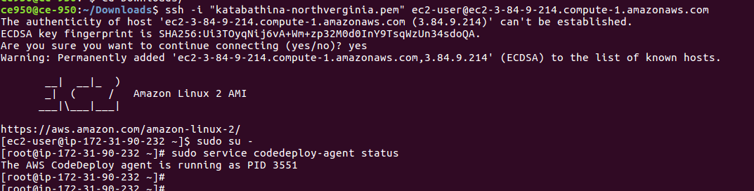

=> Code deploy agent is running state

=> Install java (yum install java -y)

=> verify java installed or not?

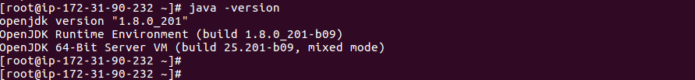
=> Install Tomcat 8 and start.

Goto https://tomcat.apache.org/download-80.cgi

select tomcat 8.

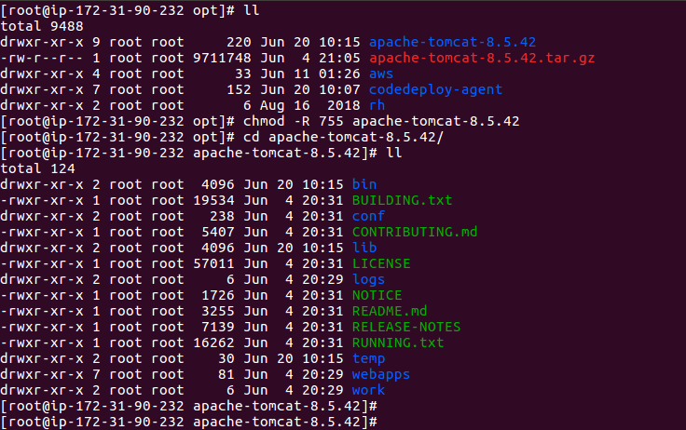

=> Tomcat installed and started.

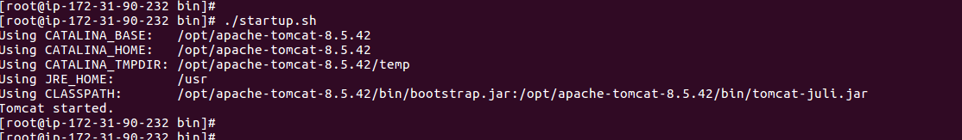

=> check in browser tomcat up and running.(IP:8080)

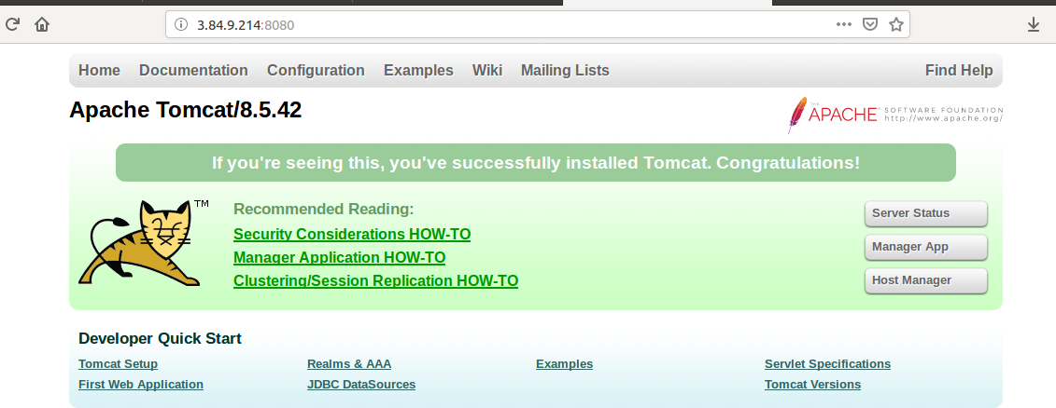

STEP 6:- Create CodeCommit Repository From CodeCommit Console.

=> Goto Services => Select CodeCommit=>

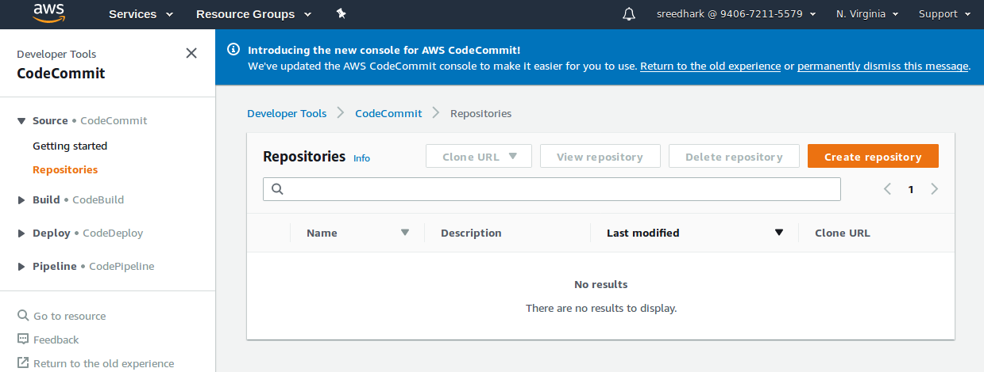

=> Select Create repository.

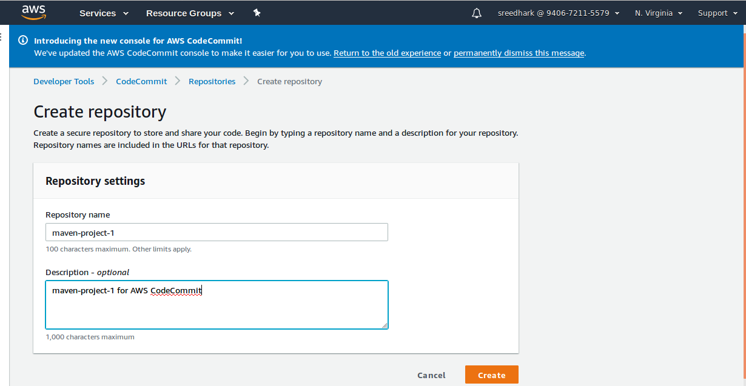
=> Select Create.

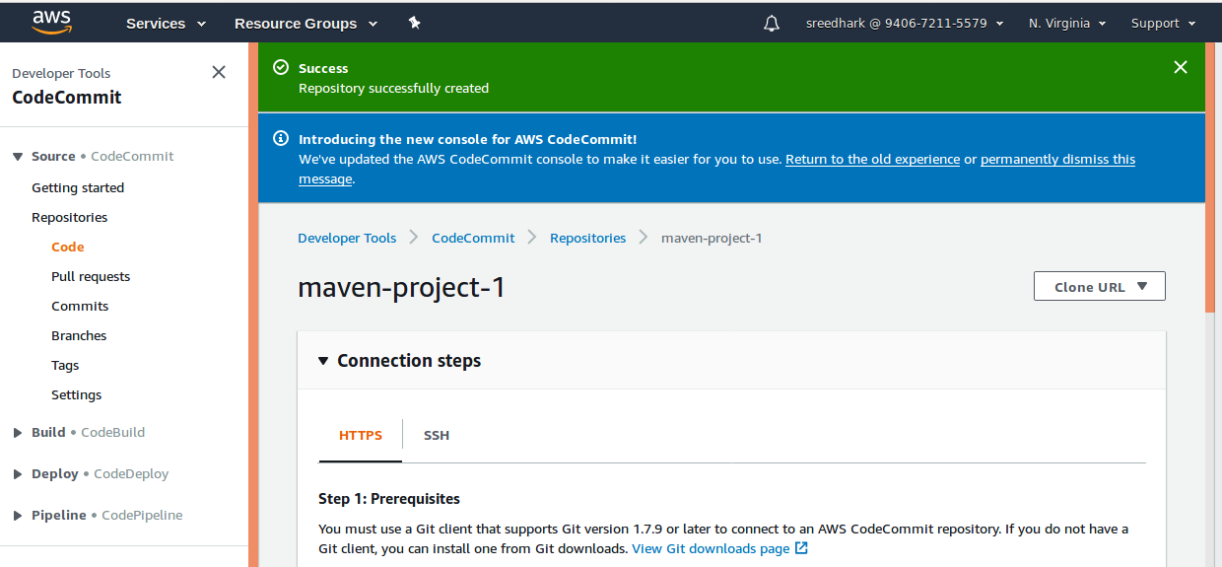
=> Repository Created Successfully, Here using HTTPS to connect CodeCommit repository.

=> Selcect Clone URL (Here will give Clone HTTPS and Clone SSH)
=> Select Clone HTTPS. (Clone that repository to our local machine)

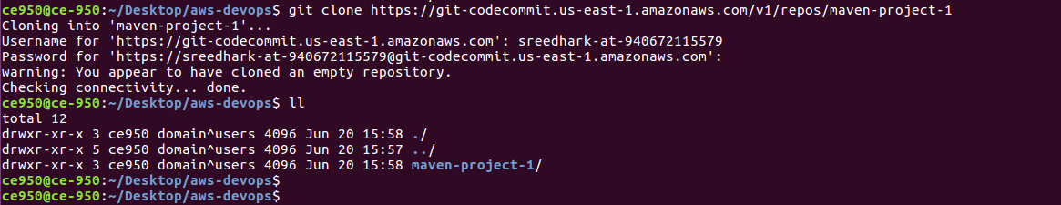

=> While Cloning it will ask HTTPS credentials of IAM User.

=> Clone the empty maven-project-1 repository to local system.

STEP 7: - Push local system Code to CodeCommit Repository using HTTPS Credentials

=> Adding files to Maven-project-1 repository and pushing to CodeCommit.

=> git status
=> git add .
=> git status
=> git commit -m "adding files to maven-project-1 repo"
=> git status

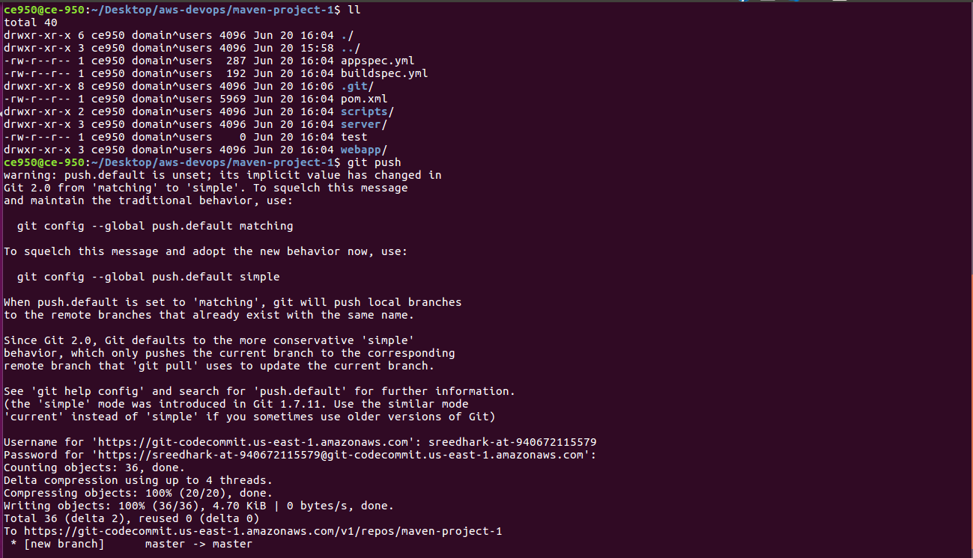

=> From local system Code push to CodeCommit Repository.

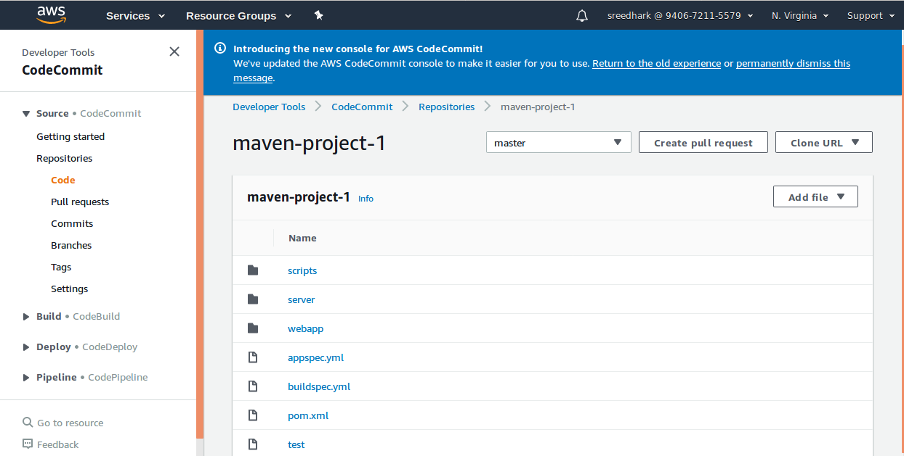

STEP 8: Create a S3 Bucket to store Artifacts from CodeBuild.

=> Select AWS Services => Select S3=> Select Create Bucket=>

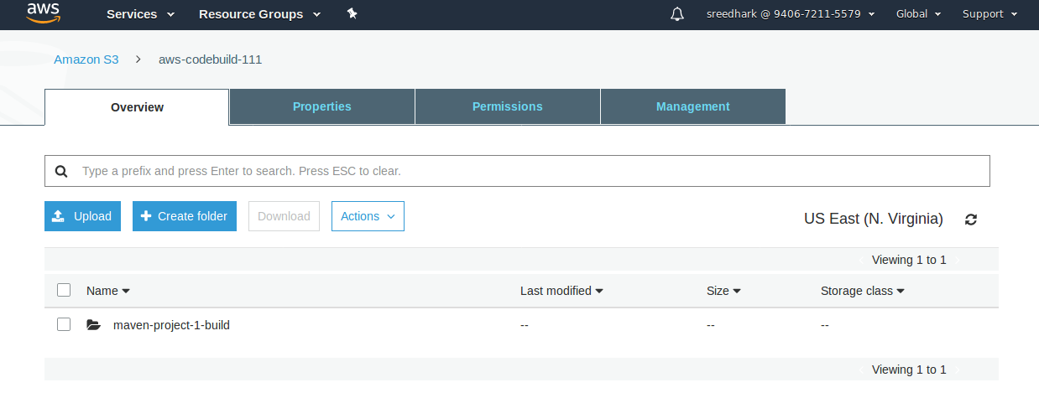

STEP 9: Manually Create a CodeBuild (If build is success can use in a AWS CodePipeline).

Note: Creating CodeBuild buildspec.yml file is mandatory with code repository under root Directory.

=> Select AWS Services => Select CodeBuild =>

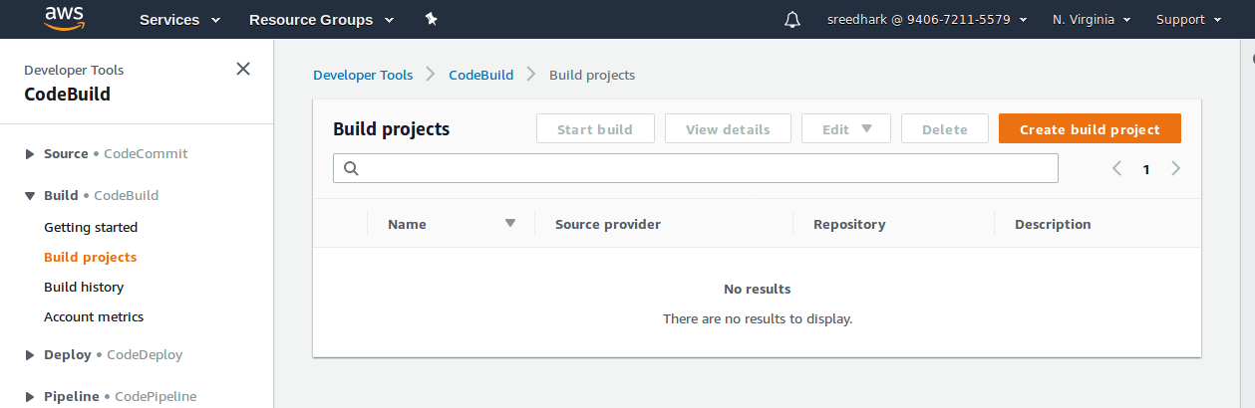
=> Select Create build project.

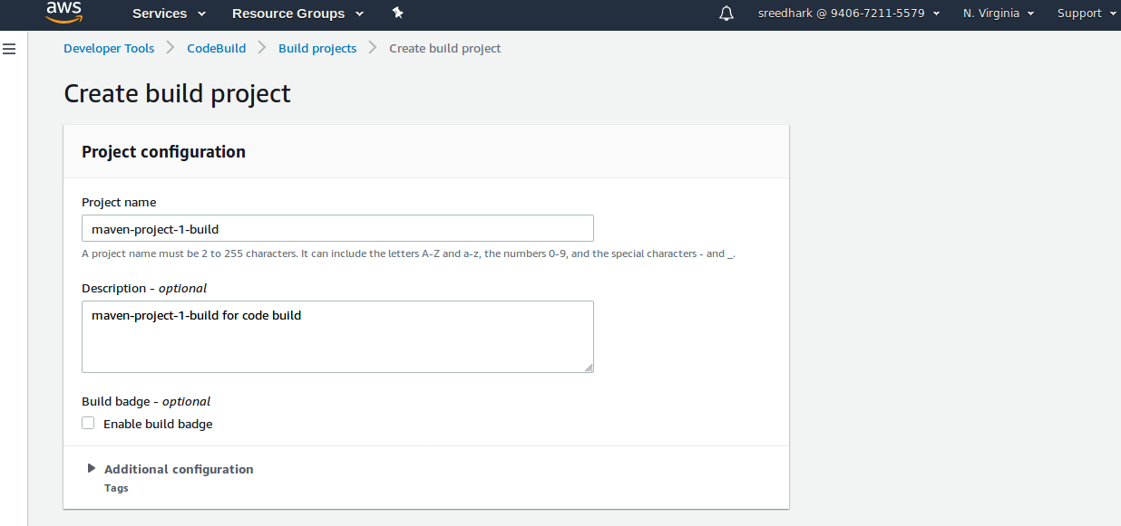
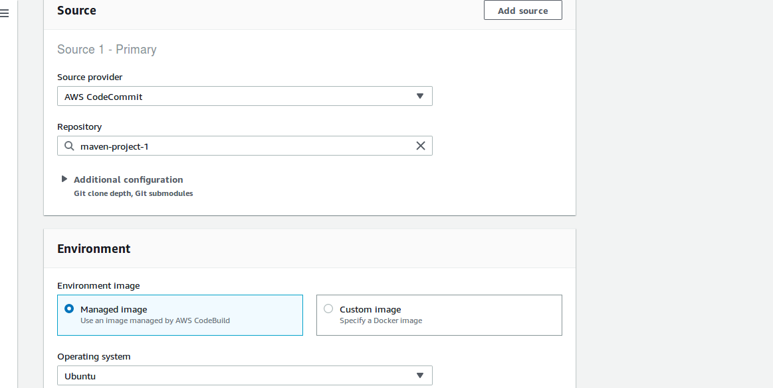

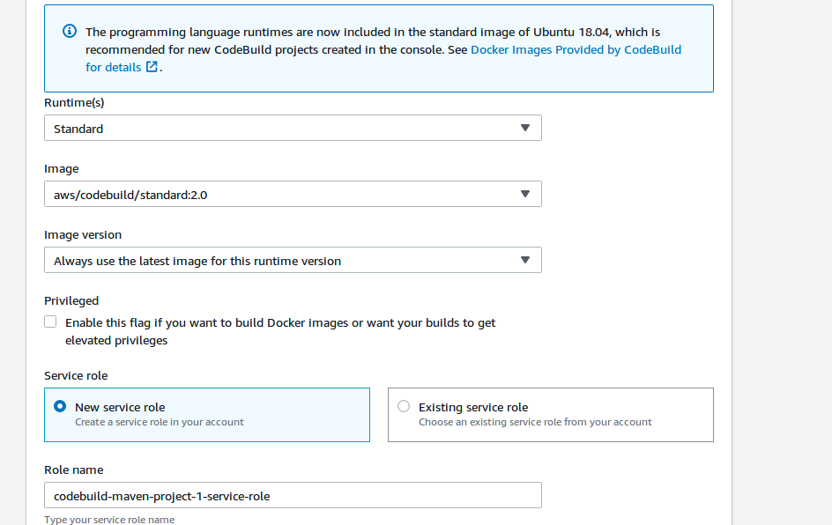

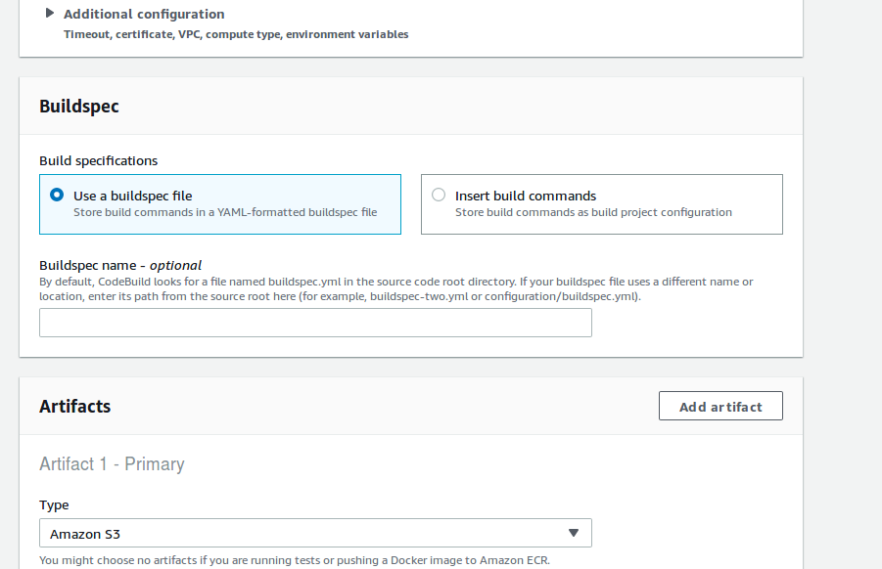

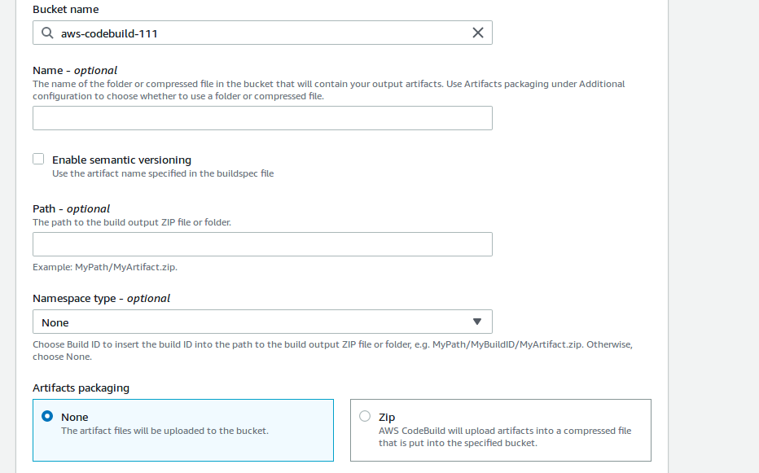
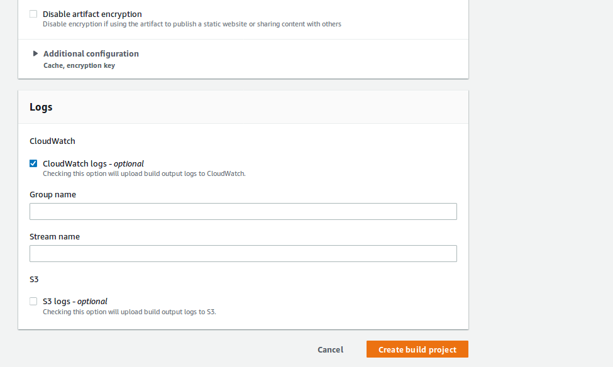

=> Select Create build project.

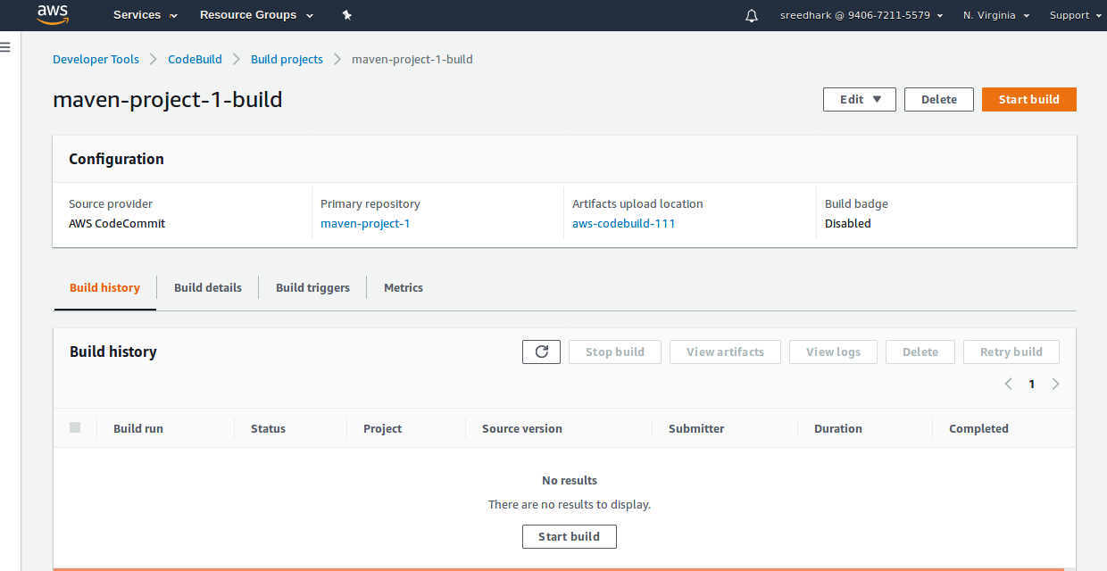
=> Select Start build.

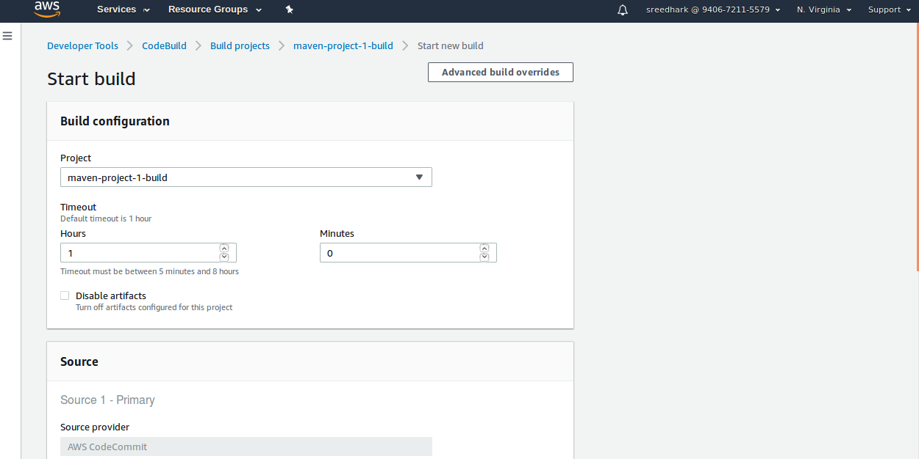

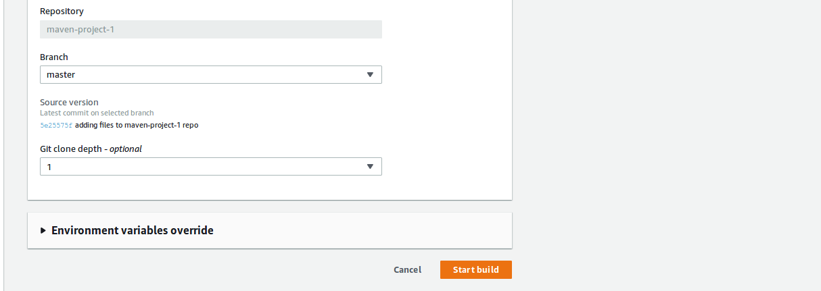
=> Select Start build.

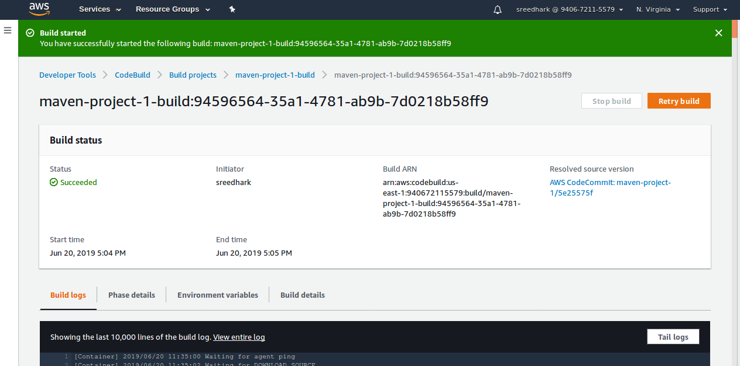
=> Build Success.

=> build is success and Artifacts store in S3 bucket.

STEP 10:- Create a CodeDeploy Application and Application Group using CodeDeploy Console.
Note: For Codedeploy appspec.yml file is mandatory.

=> Select Services => Select CodeDeploy =>

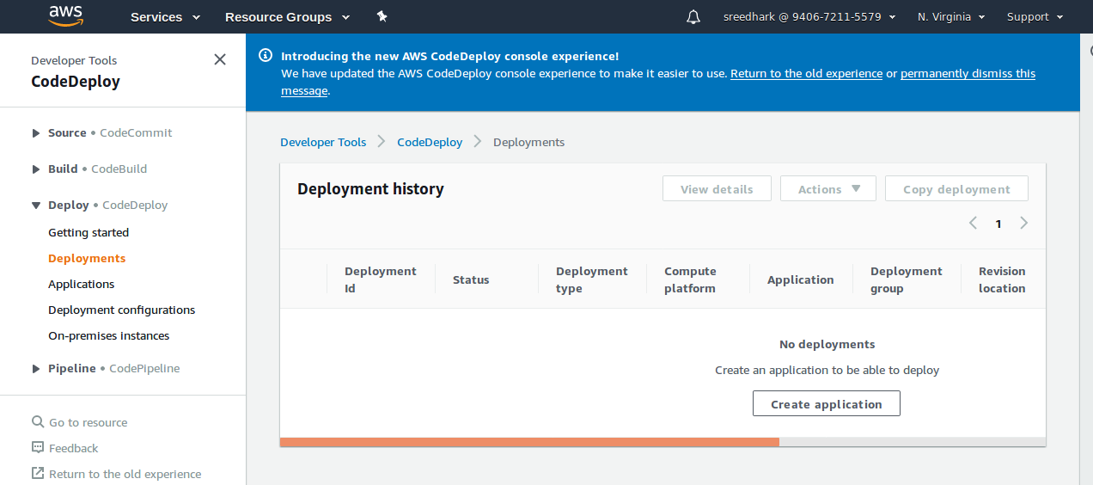
=> Select Create applicaton.

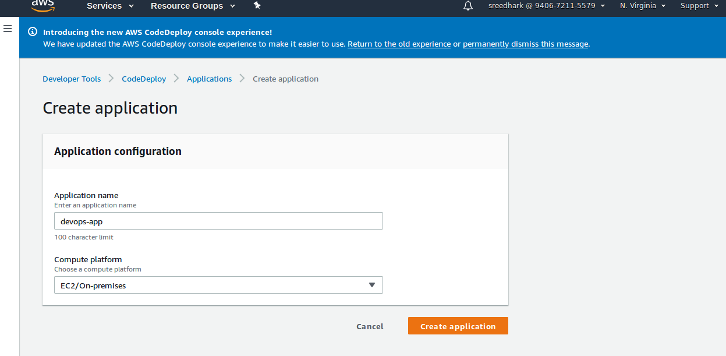
=> Select Create application.

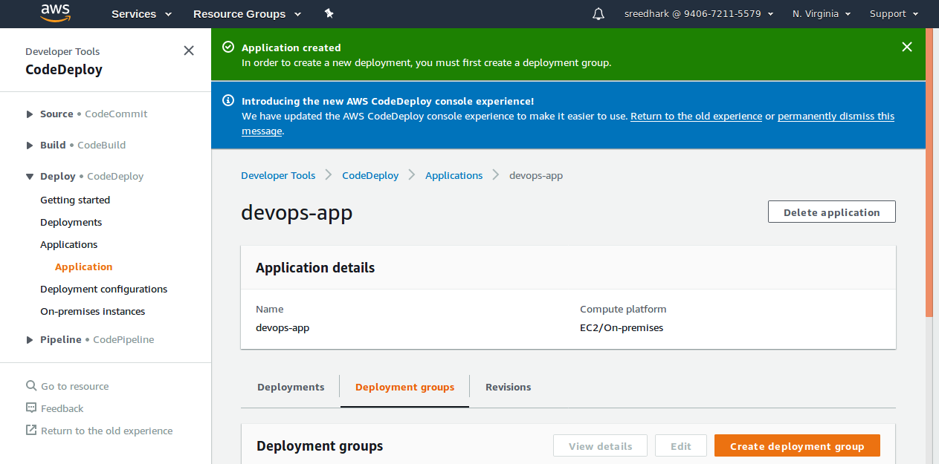
=> Select Create deployment group.

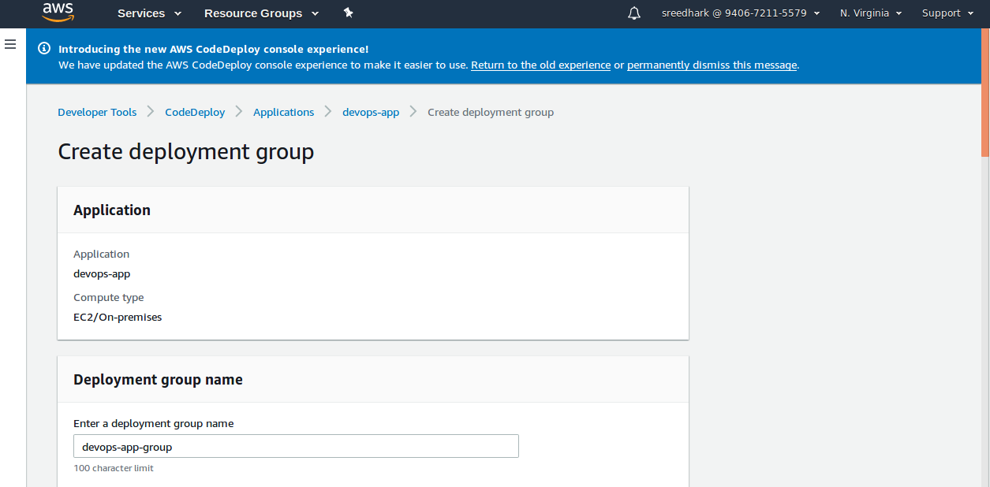
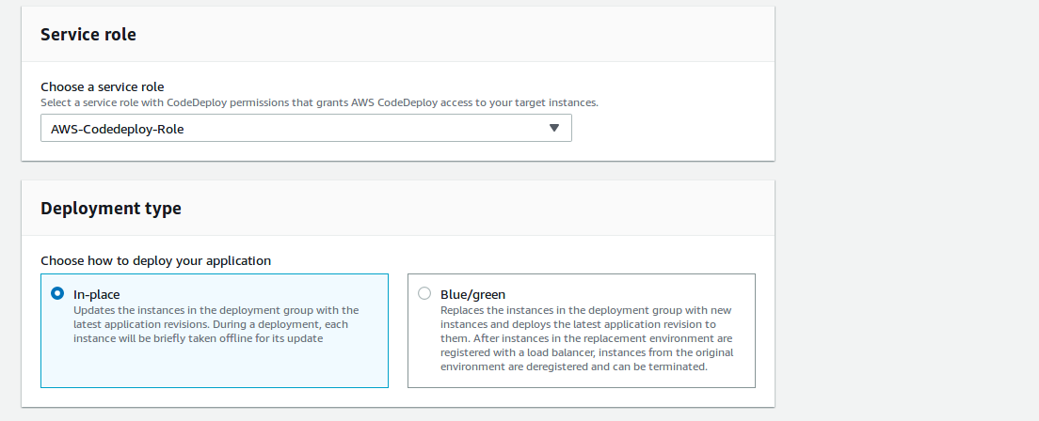
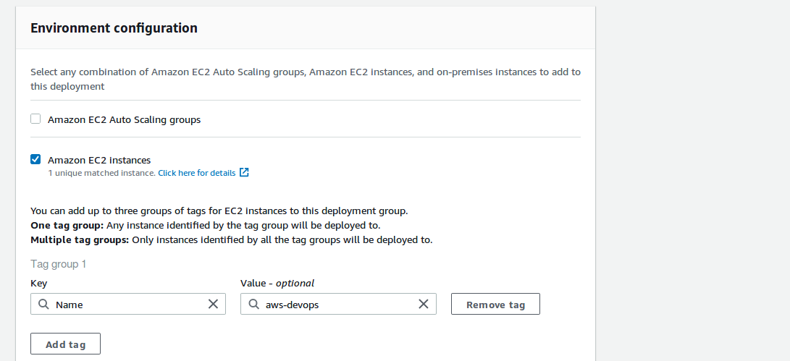

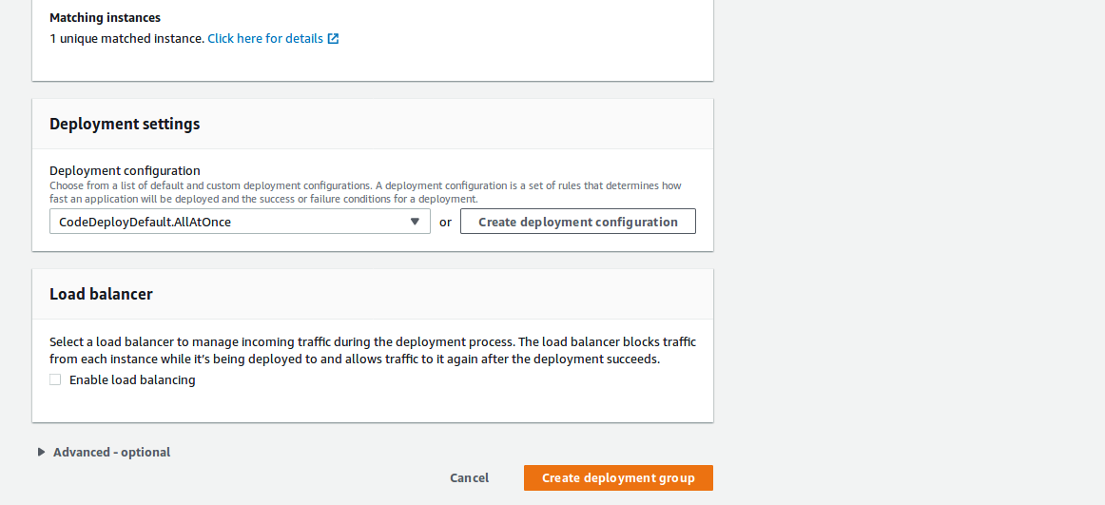
=> Select Create deployment group.

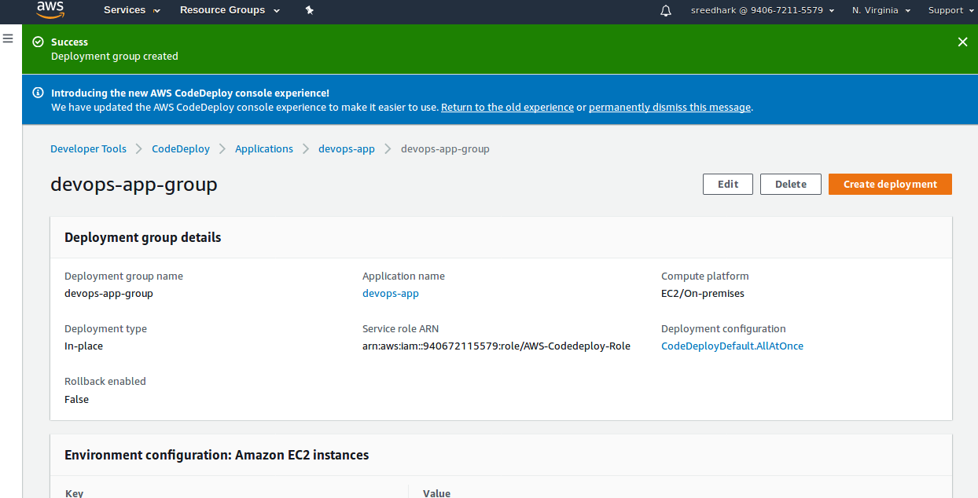
=> Created deployment group.

STEP 11:- Create a CodePipeline.(here by defaults create a new s3 bucket if you don’t want or else use existing one).

=> Select Services => Select CodePipeline =>

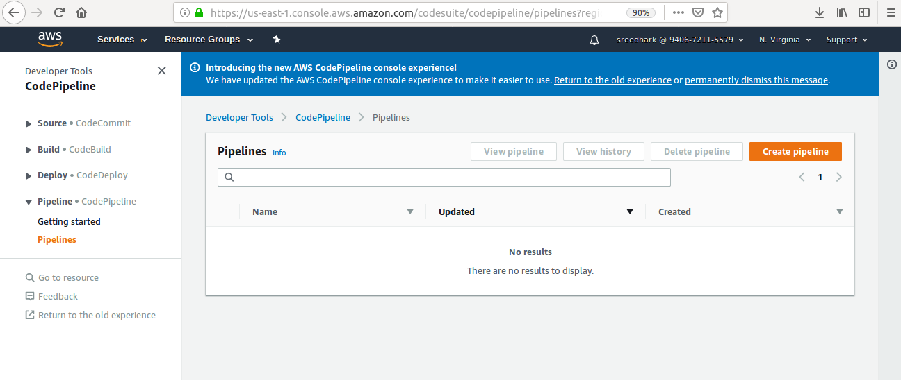
=> Select Create pipeline.

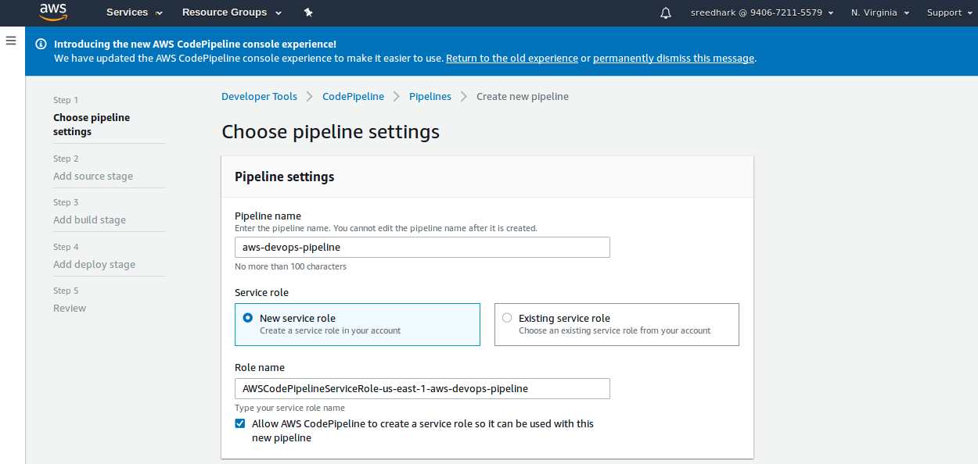
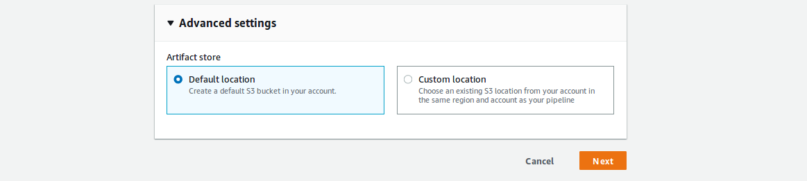
=> Select Next.

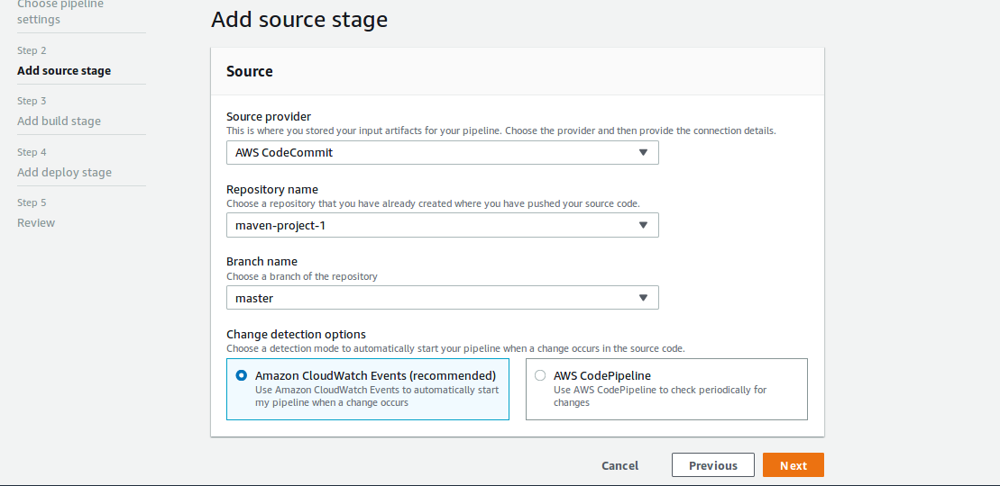
=> Select Next.

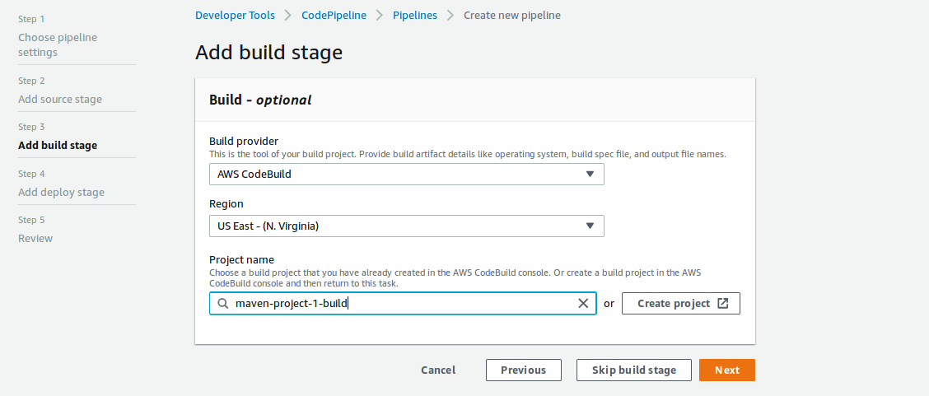
=> Select Next.

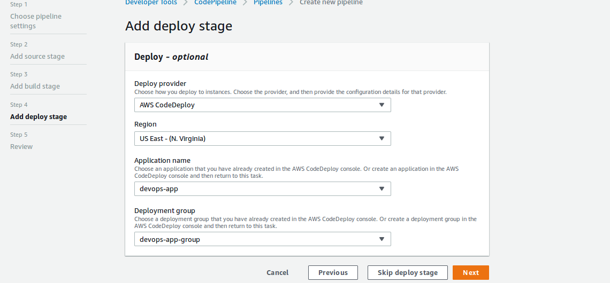
=> Select Next.

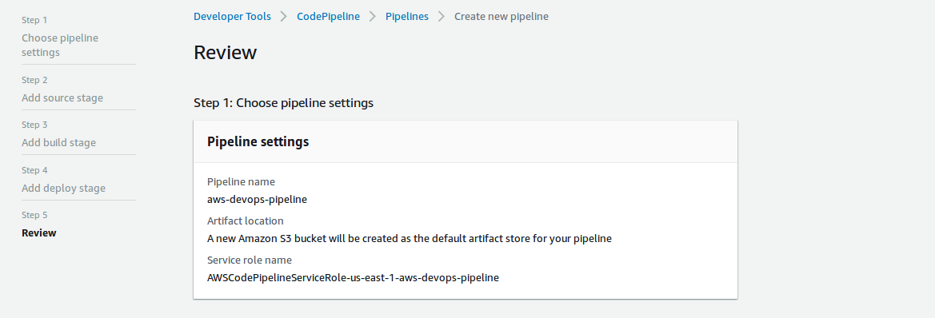

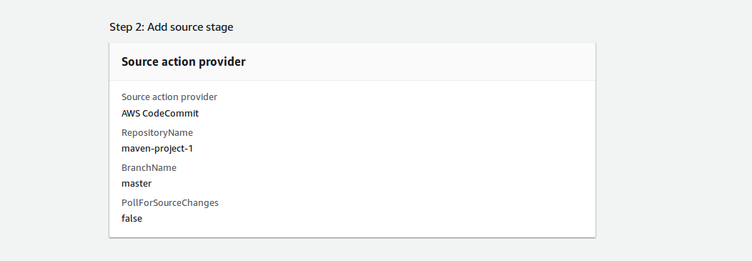
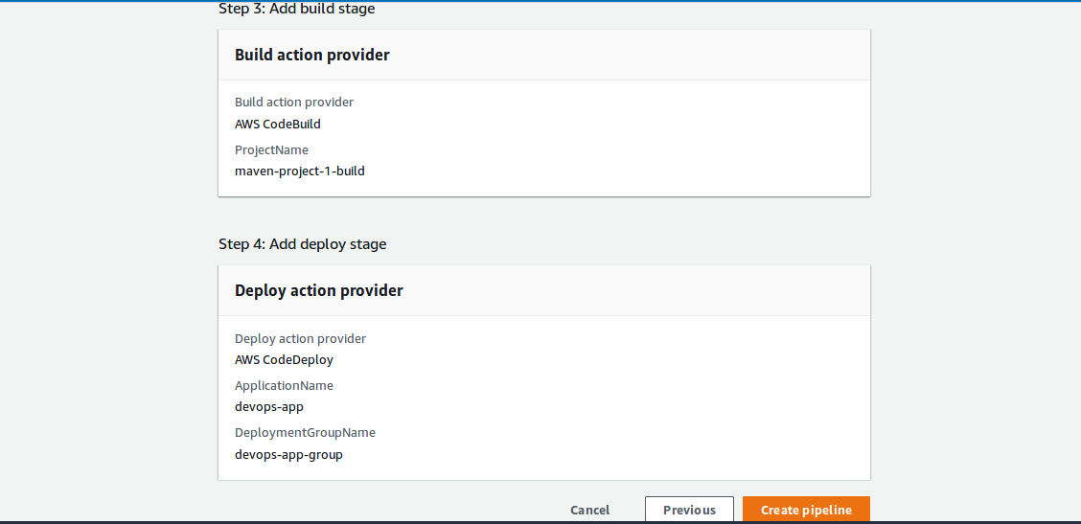
=> Select Create pipeline.

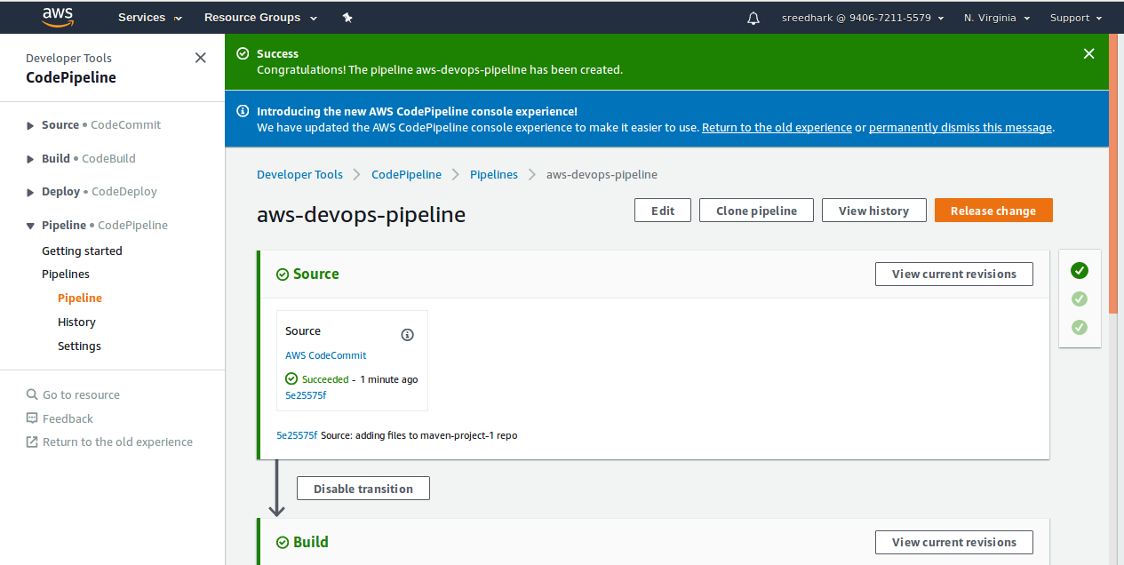

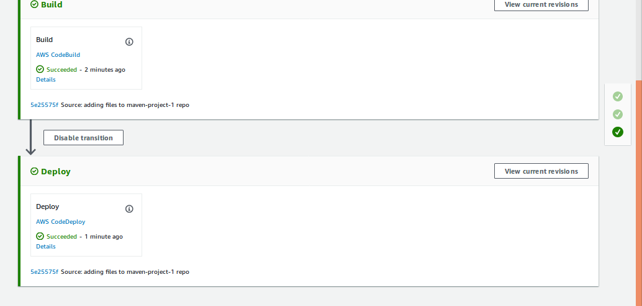

=> CodePiple completed and successfuly build and deploy to target server.

STEP 12:- AWS CodePipeline Created one new S3 bucket
(codepipeline-us-east-1-838089595860) => aws-devops-pipeline folder created and inside its stores sources and build Artifcates)

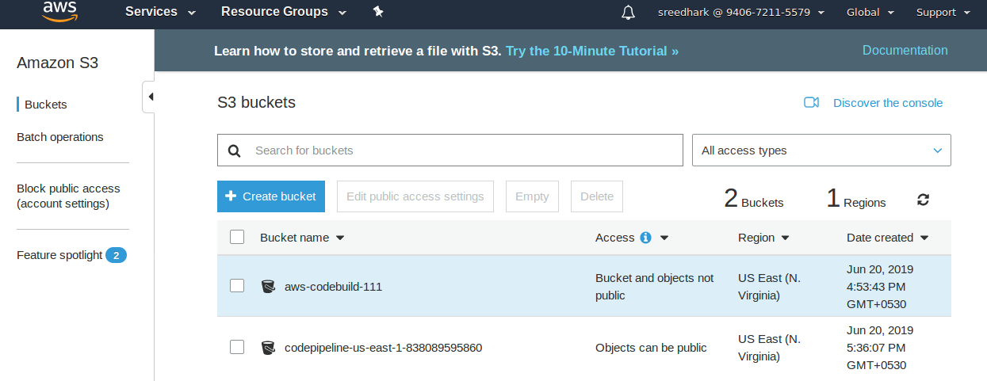

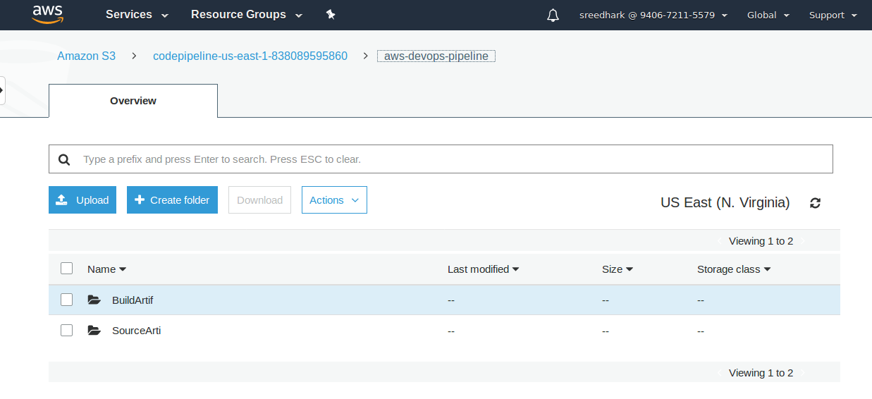

STEP 13: Connect to Server and check tomcat webapps folder and there we deployed webapp.war file.

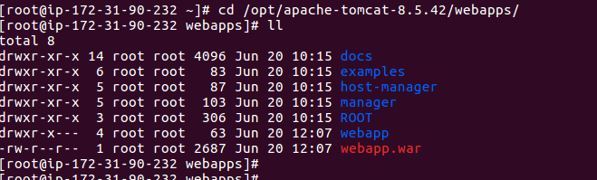

=> Now take ip and check with browser.

IP:8080/webapp

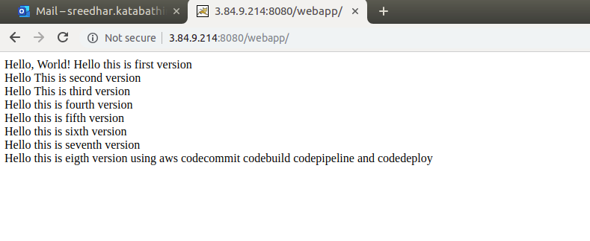
STEP 14:- Checking CICD automation process:

=>I added some changes in my code and push to codecommit and its automatically build and deployed to my server now you see below.

