AWS Backup Service:

AWS Backup

Centrally manages and automates backups across AWS services

Define Backup plans, schedule backups, automate backup retention management, centrally monitor backup activity, and restore backups.

How It works:-

Create
Build Backup plans that define your backup requirements, including backup schedules, backup retention rules and lifecycle rules.

Assign
Assign your AWS resources to Backup plans using resource tags or AWS resource IDs. Resources assigned to Backup plans are then backed up automatically according to the schedule defined in the plan.

Manage
Use AWS Backup to centrally manage backup configurations, monitor backup activity across AWS services, or restore an AWS resource from a backup.

Benefits and features:-

Centrally manage backups
Simplify backup management from a centralized console to protect your storage volumes, databases, and file systems. The AWS Backup console enables you to manage all backup activity with a consolidated view for monitoring and alerts. Use the console, APIs, or CLI as a consistent method to backup, restore, and set retention across AWS services in the cloud and on-premises.

Automate backup processes
Save time and money with automated backup schedules, retention management, and lifecycle management. AWS Backup integrates with tagging to make it easy to organize and protect resources according to defined data classifications. Applying backup policies across tagged resources simplifies your data protection processes and removes the need for costly, custom solutions and manual processes.

Backup Compliance
Organize and refine backup compliance and audits with centralized, monitoring, logging, and alerts. AWS Backup encrypts your data in transit and at rest, and lets you manage your Backup plans, backup access policies, retention, and data protection lifecycles from a single, consolidated place. This helps ensure you’re meeting both internal and regulatory compliance requirements.

Backup activity monitoring
AWS Backup provides a dashboard that makes it simple to audit backup and restore activity across AWS services. AWS Backup integrates with CloudTrail, providing you with a consolidated view of backup activity logs that make it quick and easy to audit what and how your resources are backed up.

Supported Services :-

Amazon EBS
Amazon RDS
Amazon Dynamo DB
Amazon EFS
Amazon Storage Gateway.
<=========================================>

Automating backups through AWS backup Service for EBS Voluems and DynamoDB table:-

Prerequistes:-
We have existing EBS Volumes and Dynamo DB Table.

=>We already have EBS Volumes like below,
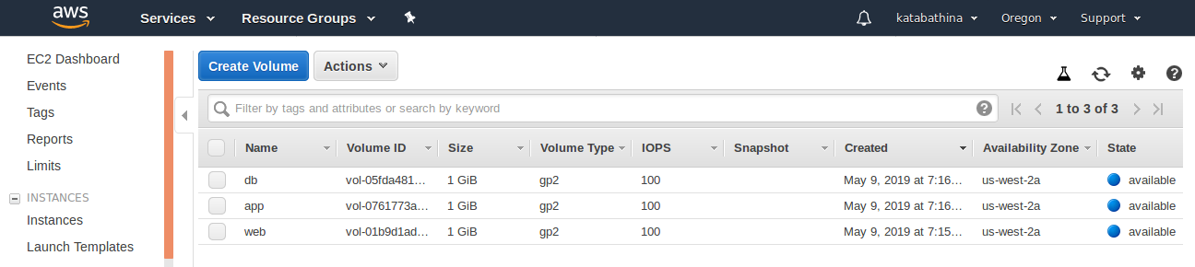
=>Also Dynamo DB Table like below,
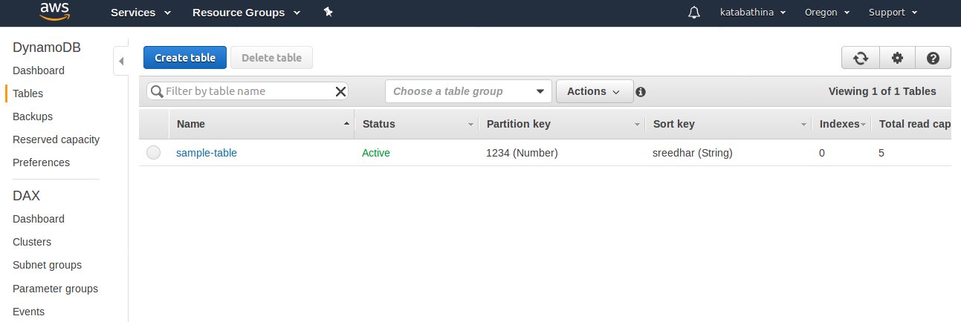
=>Goto AWS Account =>Select Services and Search for AWS Backup=>Select AWS Backup
=>The default page come like below,

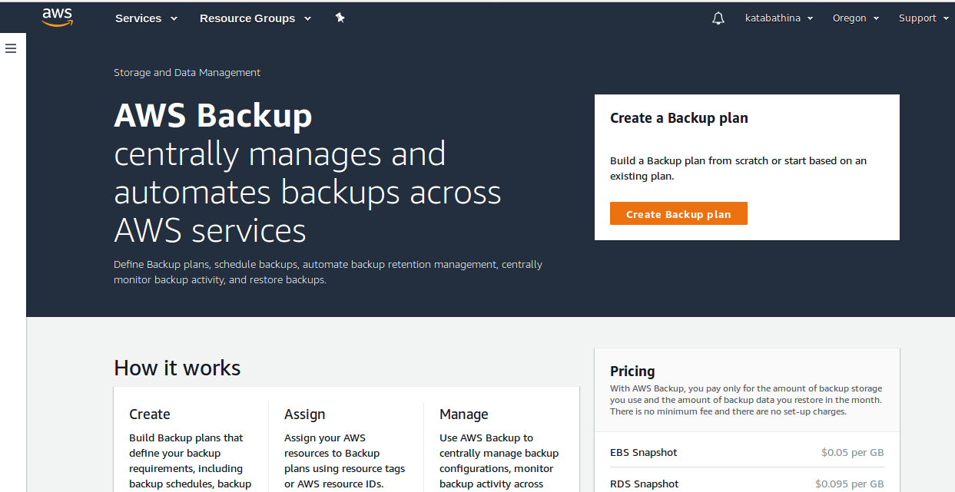
=> Select left side dash bar Icon and it will show the aws backup dashboard console page like below,

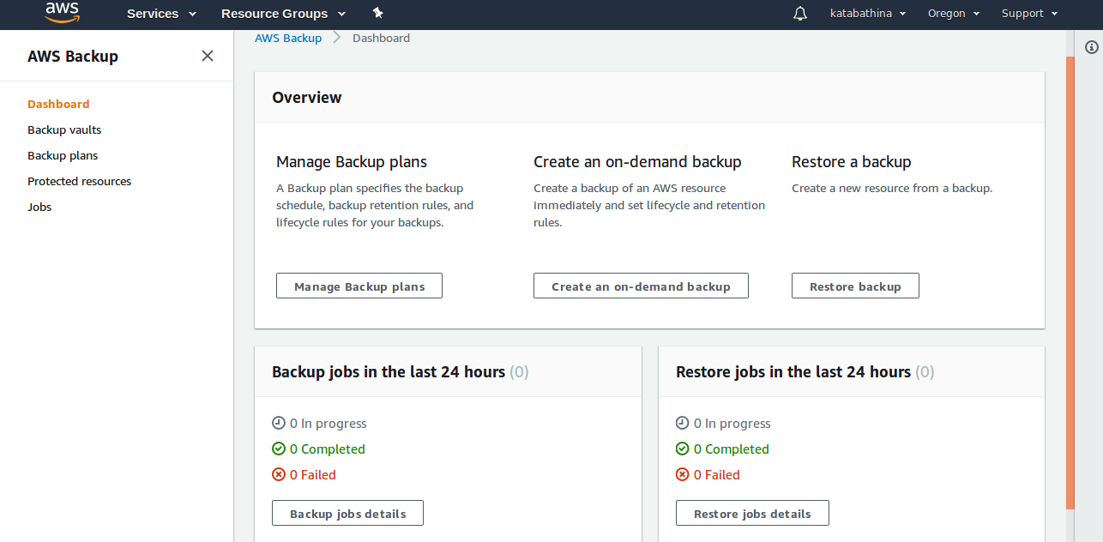
=> First Create a Backup Vaults from AWS backup Dashboard Console.
=> Select Backup valuts and default page come like below,
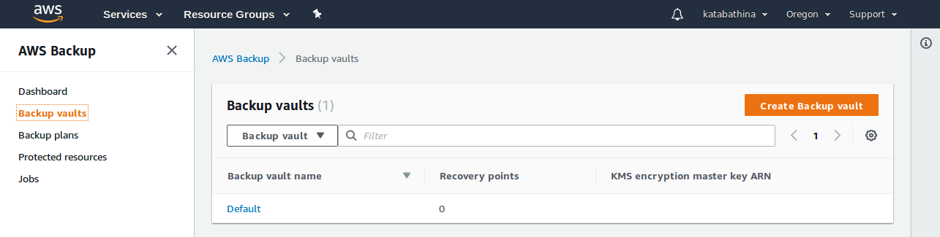
=> Select Create Backup Vault and page will come like below,
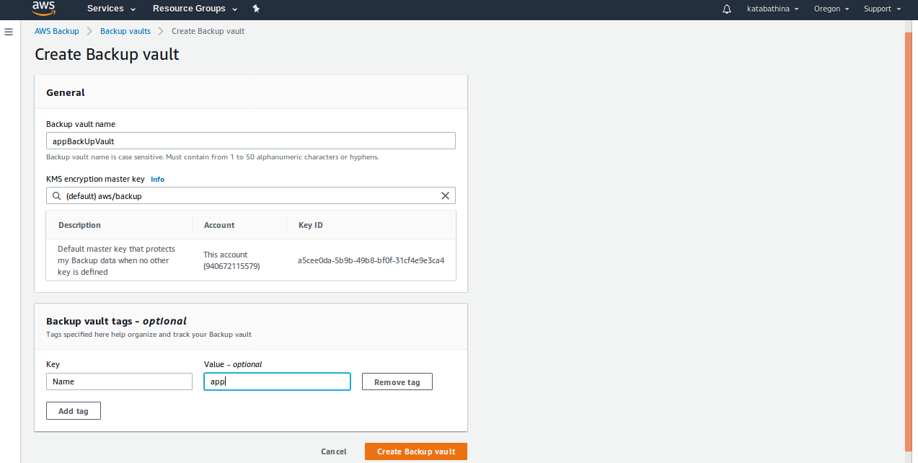
=>Click Create Backup Vault.
=> Successfully Created “appBuckUpVault” like below,
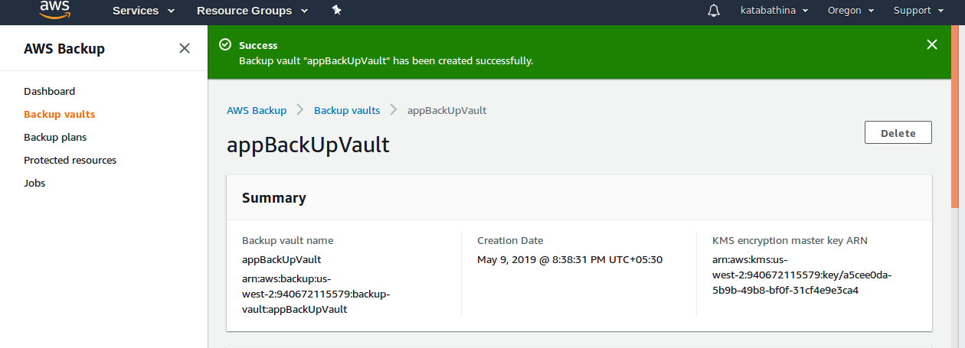

=>Create a One more Seperate Valut for Dynamo DB table, name it like “dbBackUpValult”
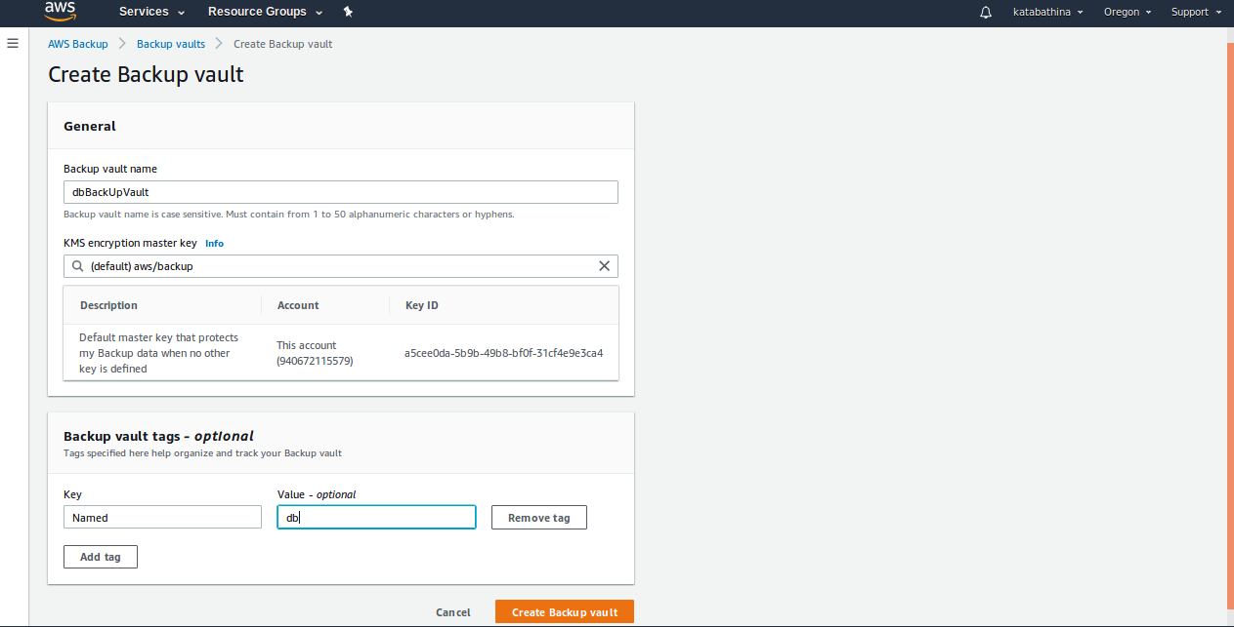
=>Click Create Backup Vault.
=> Successfully Created “dbBuckUpVault” like below,
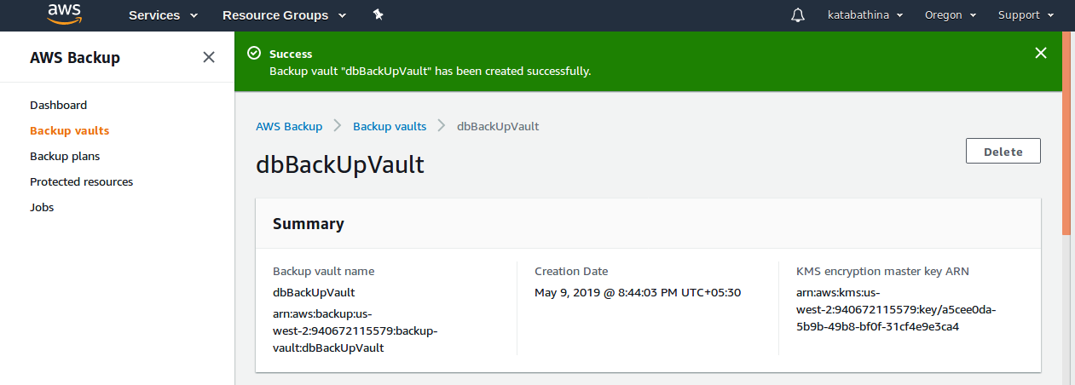
=> Create a Backup Plans for both “appBackUpValult” and “dbBackUpVault” from AWS backup dashboard console.

=> Select Backup plans from left side panel and default its shows like below,
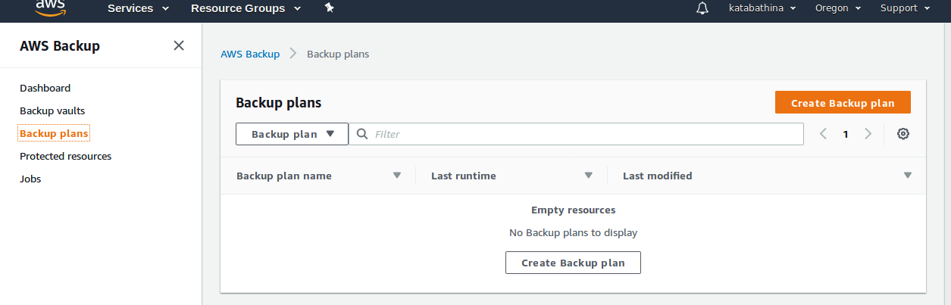
=> Select Create Backup plan and default its shows like below,

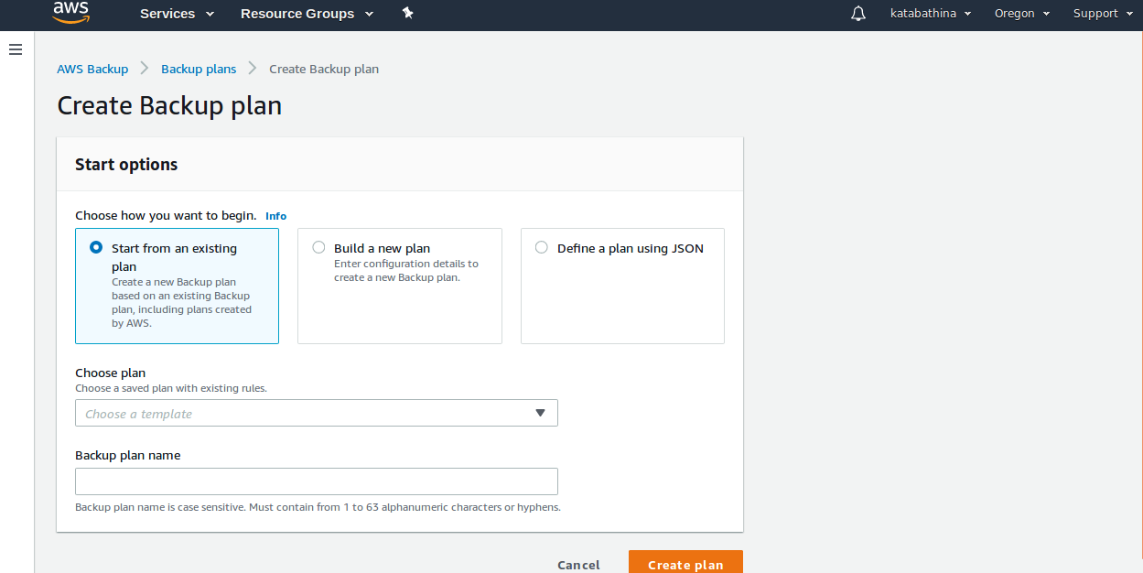

=>Select New build plan and page will come like below,
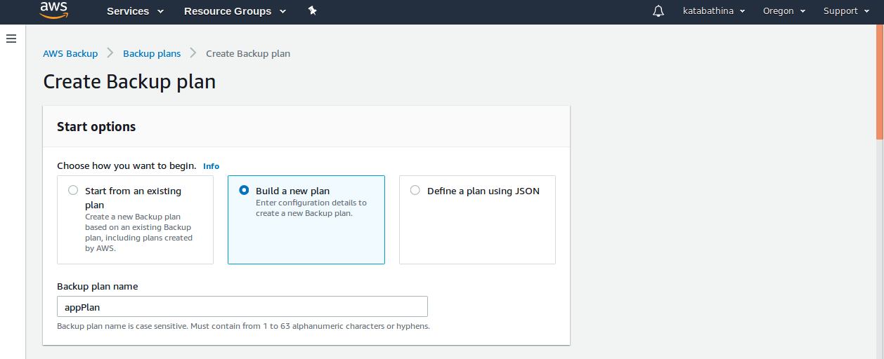
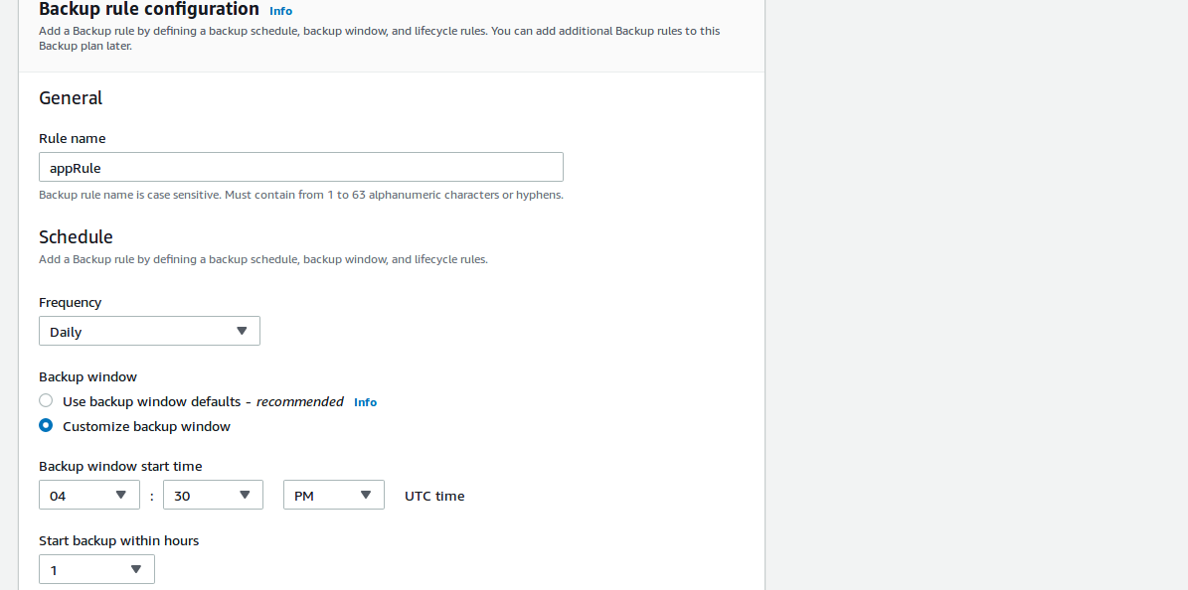
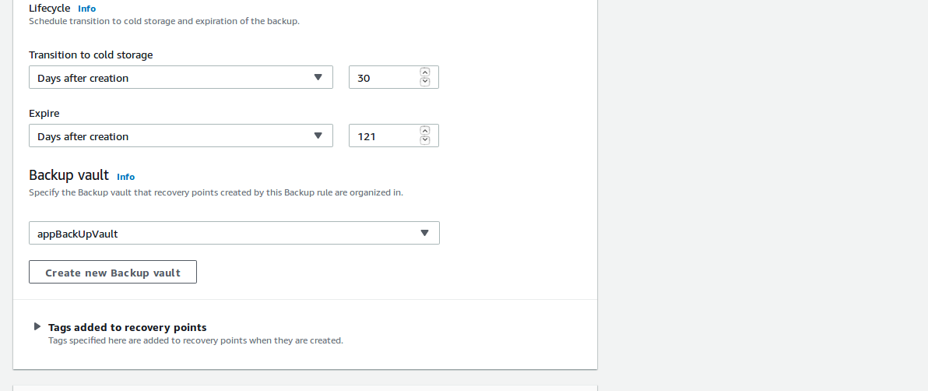
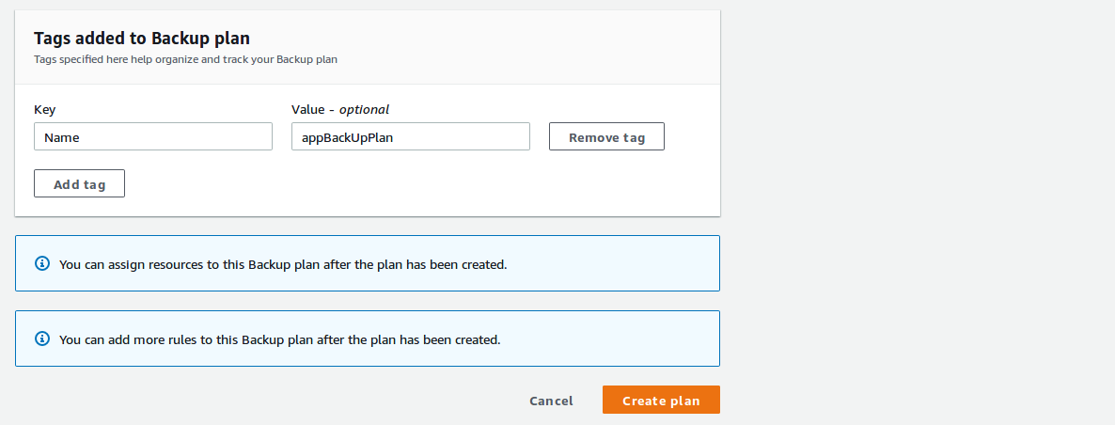

=> Now Click Create plan.
=> Successfully backup plan “appPlan” created.
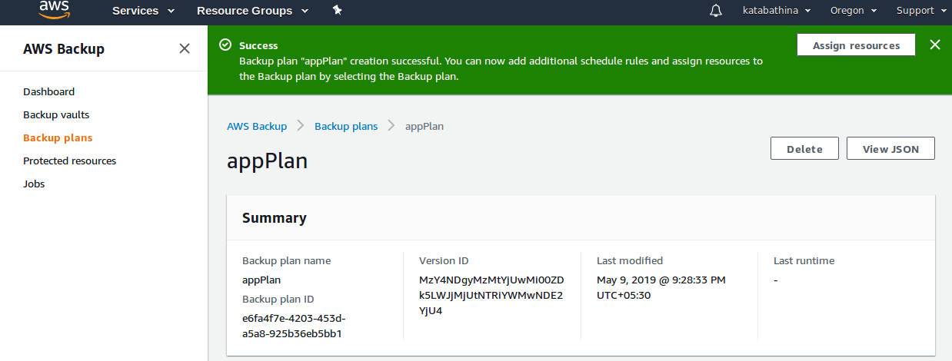
=>Now add resources from same backup plan section.

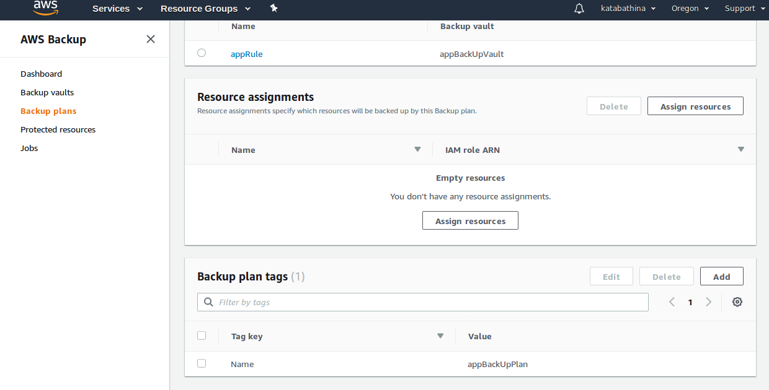
=>Select Assign Resources(resources we can add it two ways like tags and resourced id’s) page come like below,
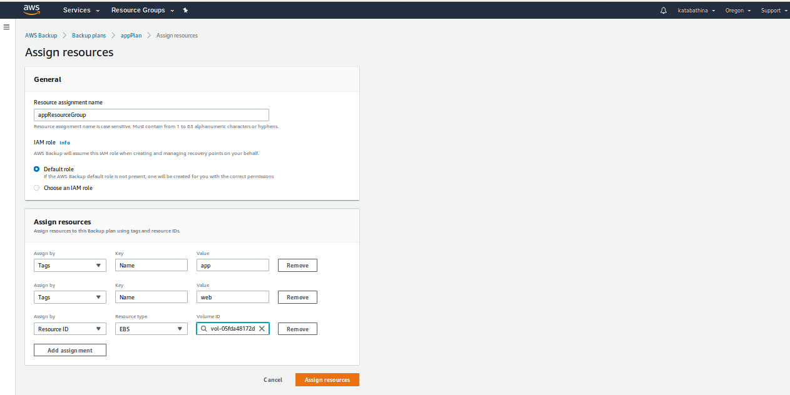
=> Click Assign resources.
=> Resource assignment “appResourceGroup” has been created successfully like below,
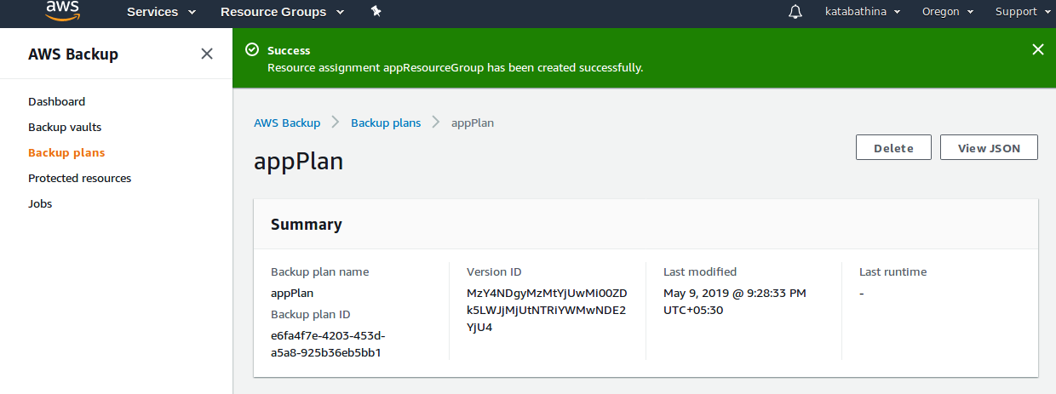

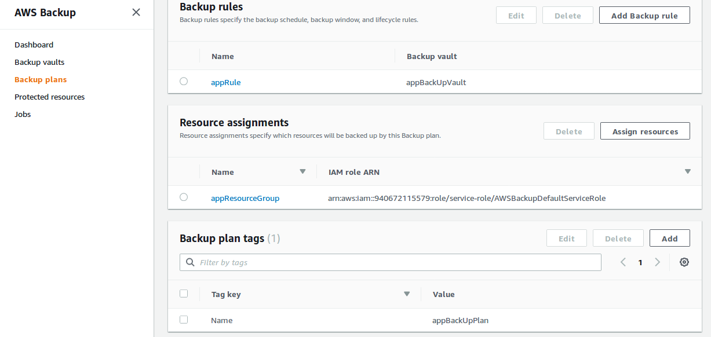

=>Cteate a one more Backup plan for dbBackUpPlan (for Dynamo DB table) .
=>Goto AWS Backup dashboard console and from left side panel select Backup plans ,page come like below,

=> Select Create Backup plan and default page come like below,

=>Select New build plan and page come like below,
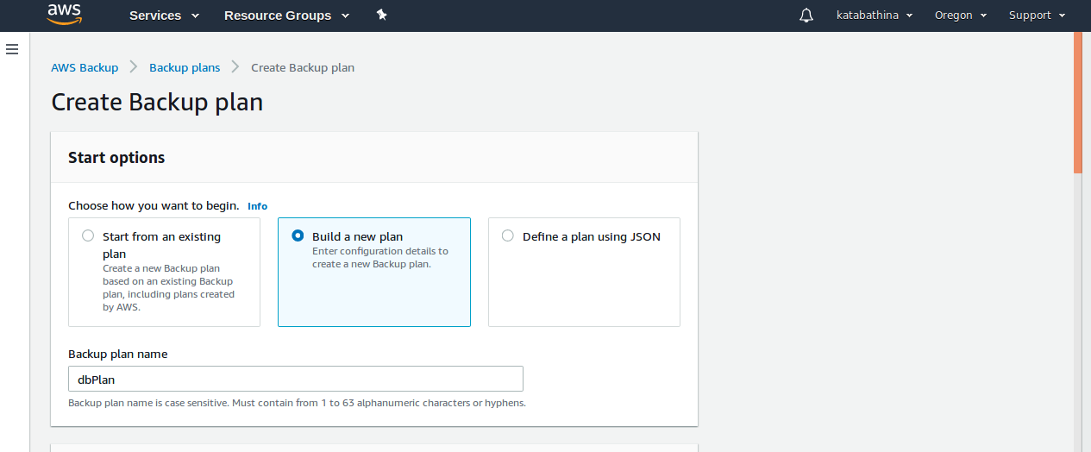
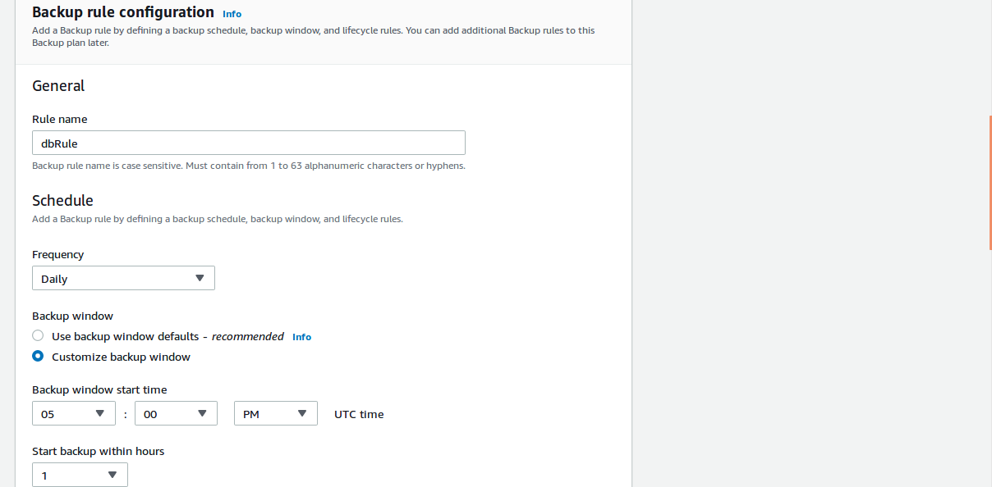

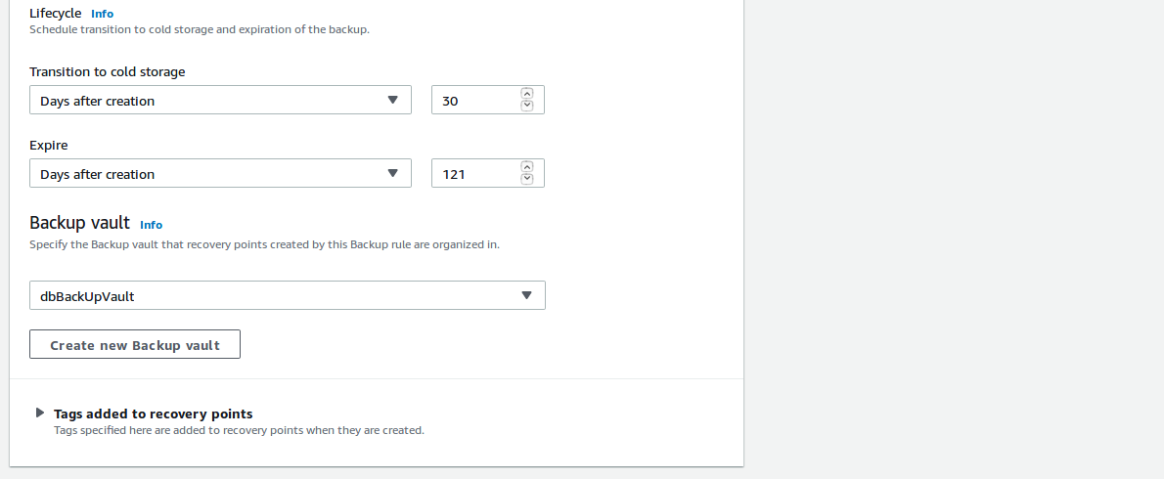
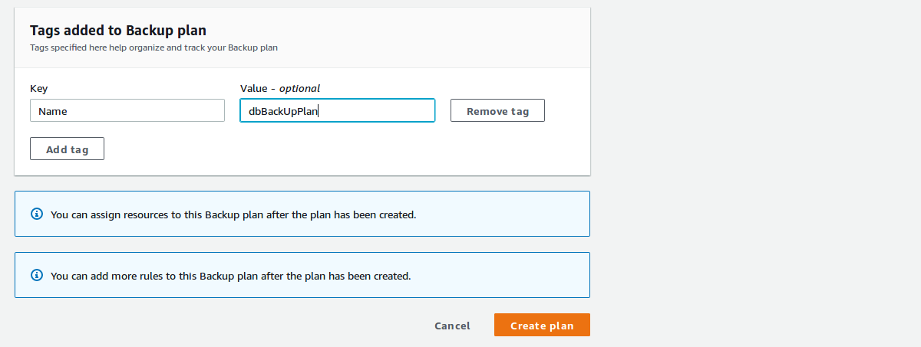
=>Click Create plan.
=>Successfully “dbPlan” backup plan created.

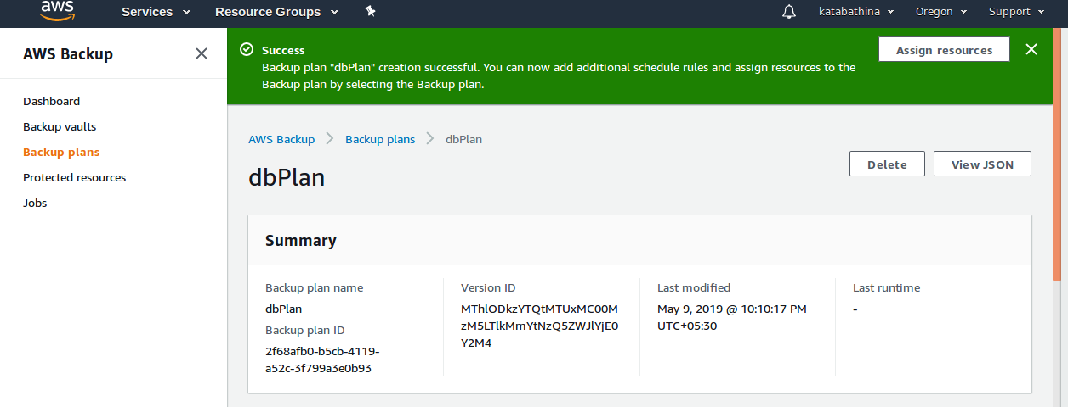
=>Now add resources from same backup plan section.
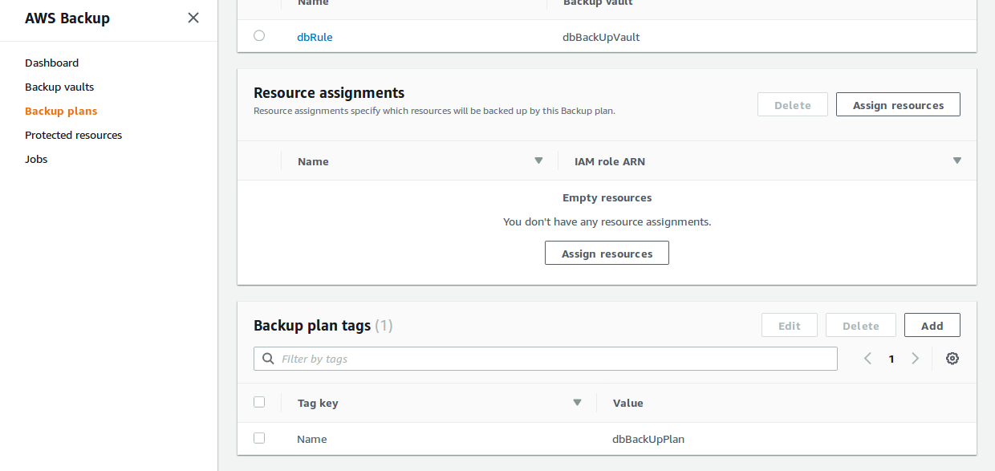
=> Select Assign Resources and page come like below,
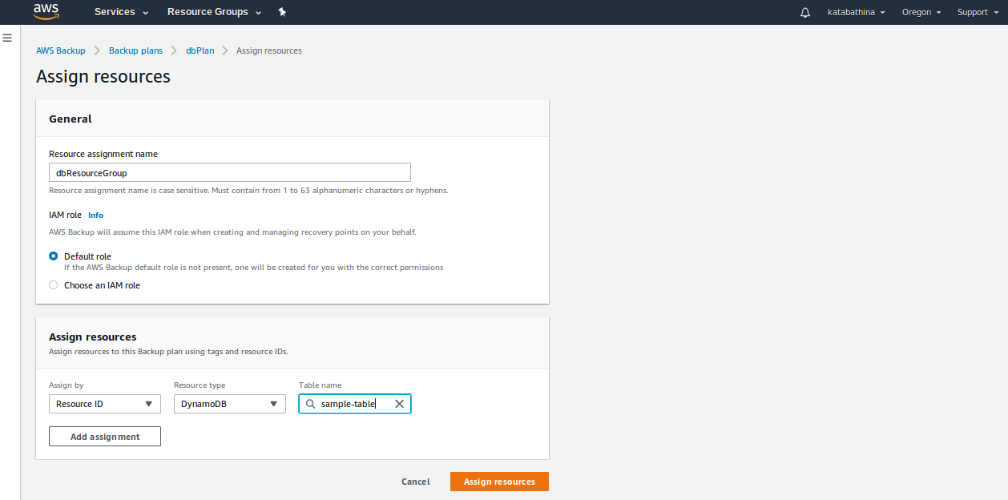
=> Click Assign resources.
=>Resource assignment “dbResourceGroup” has been created successfully like below,

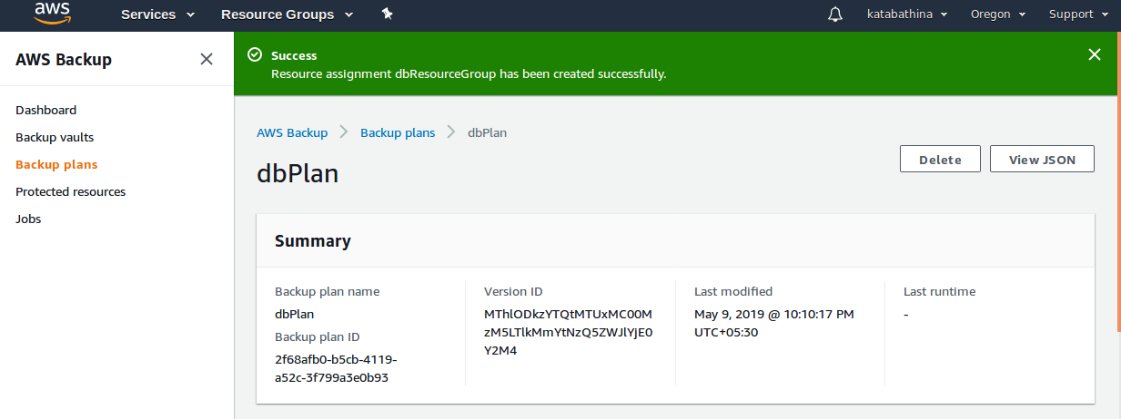
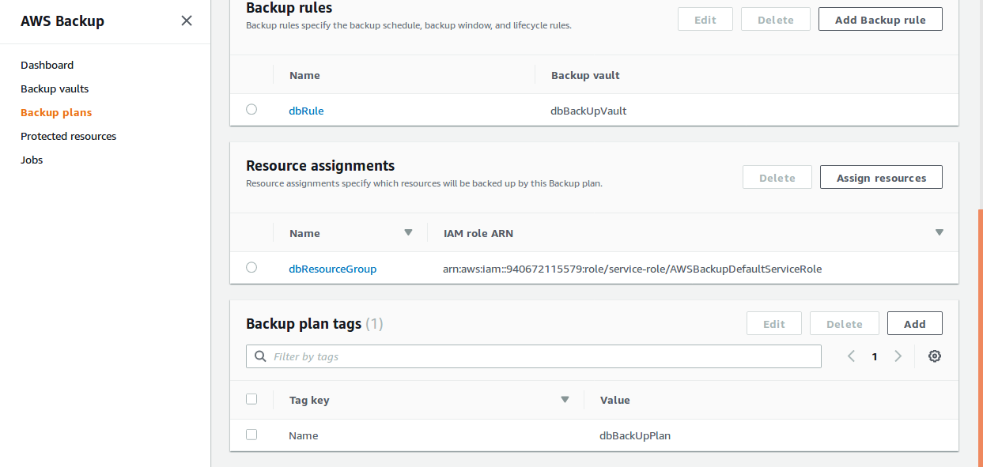
=> Both “appPlan” and “dbPlan” created like below,

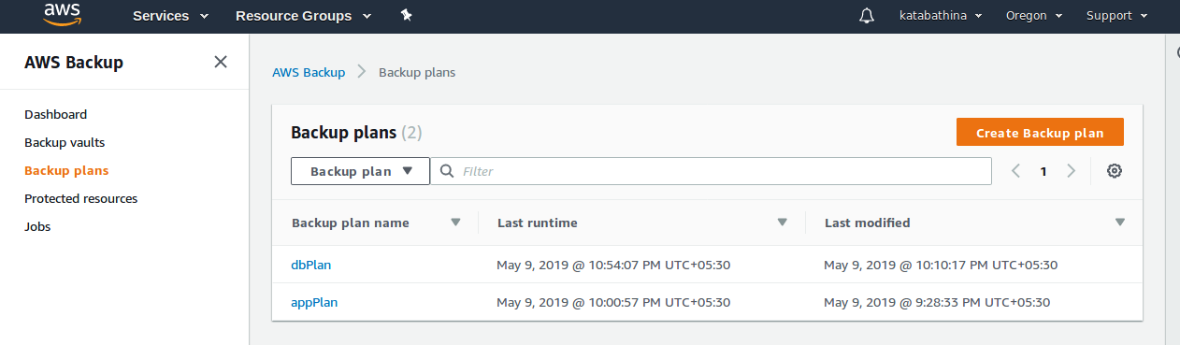
=>Goto AWS backup Dashboard Console and Select Dashboard,

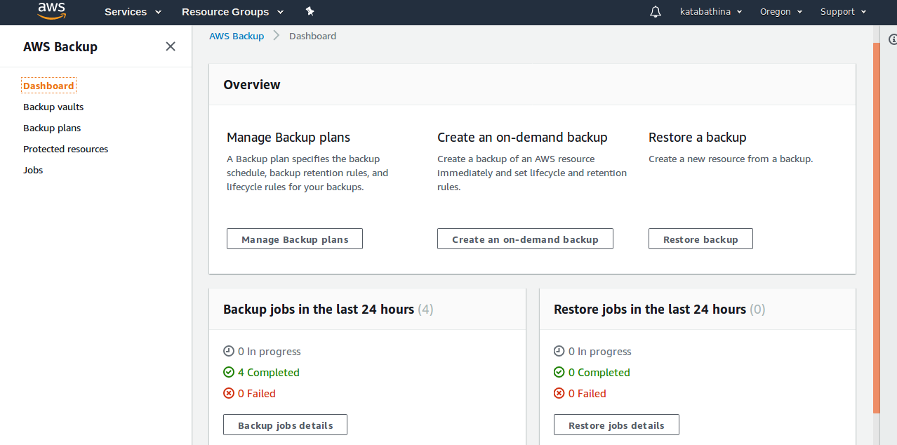
=> 4 jobs executed and completed successfully.
=> From AWS Backup Dashboard Console select Backup vaults it showss like below,
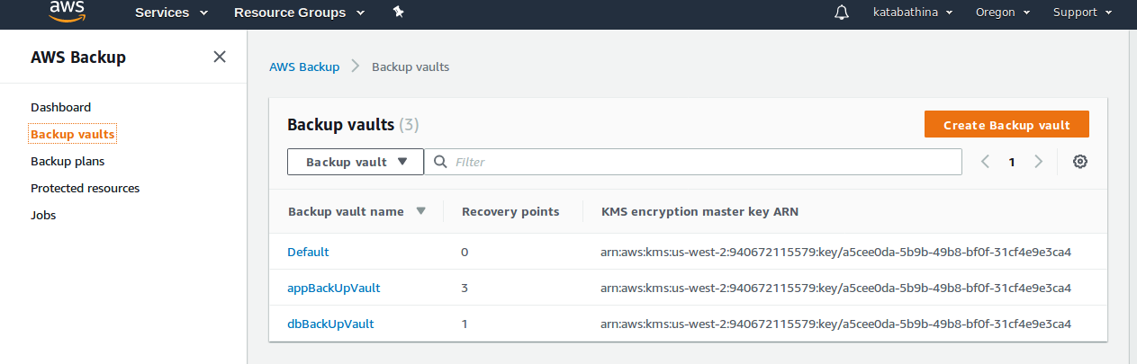
=> From AWS Backup Console select Backup plans it shows last runtime like below,
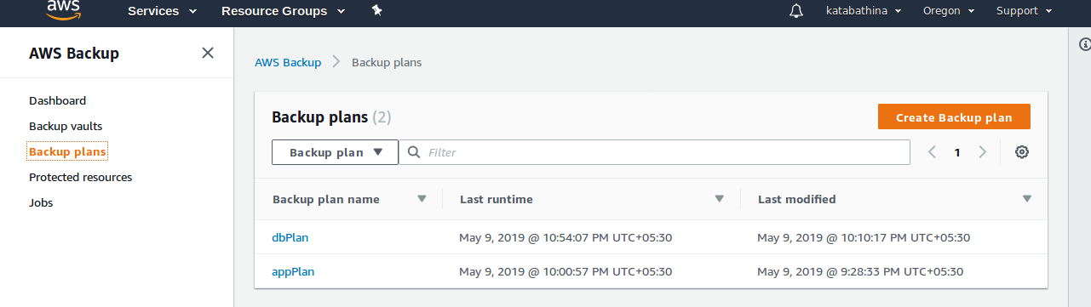

=> From AWS Backup Console select Protected resources it shows resource id and resource type like below,
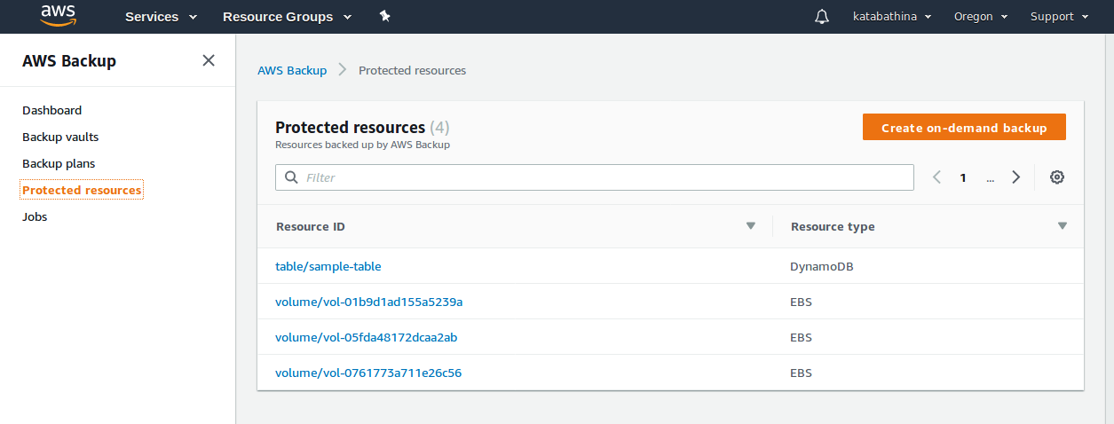
=> From AWS Backup Console select Jobs it shows all backup jobs like below,

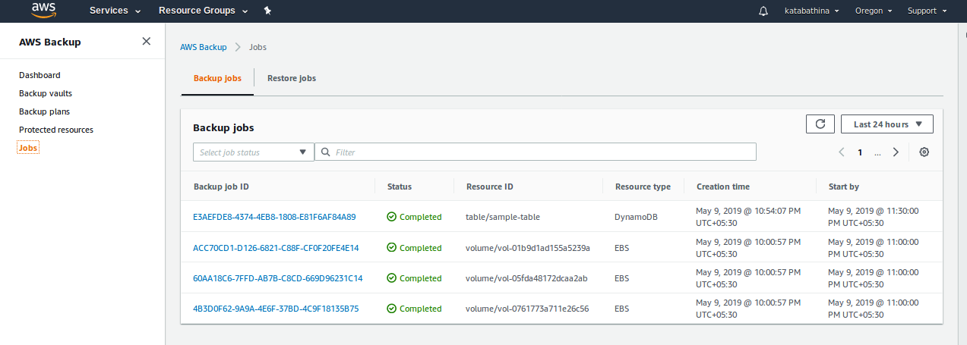
=> The Above over all activity completed and see the snapshots of EBS Volumes like below,

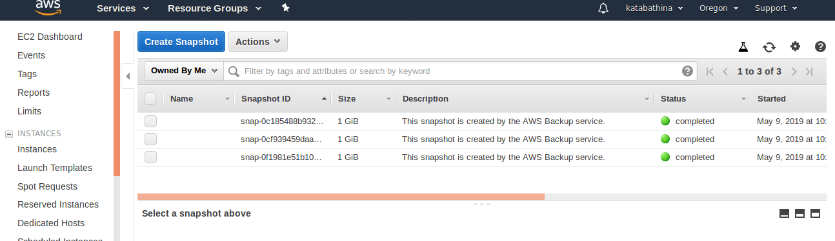
=>Now See the Dynamo DB table snapshot from the Dynamo DB Console.
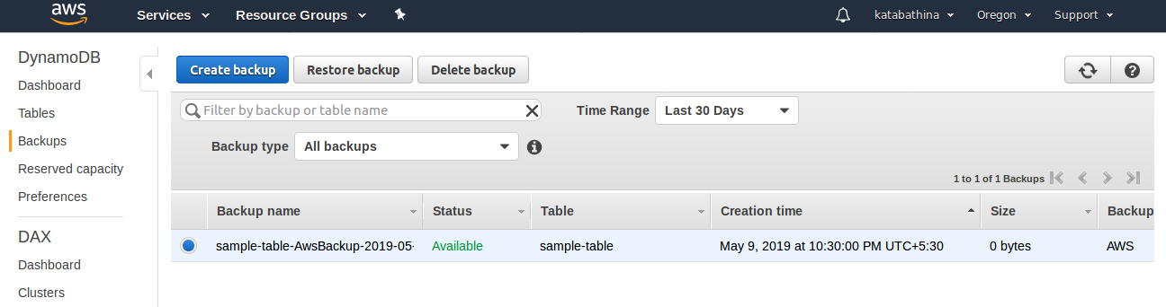
Create a Ondemand Backup and Restore backup:-

=> Goto AWS Backup Dashboard Console,

=> Select Protected resources and page shows like below,
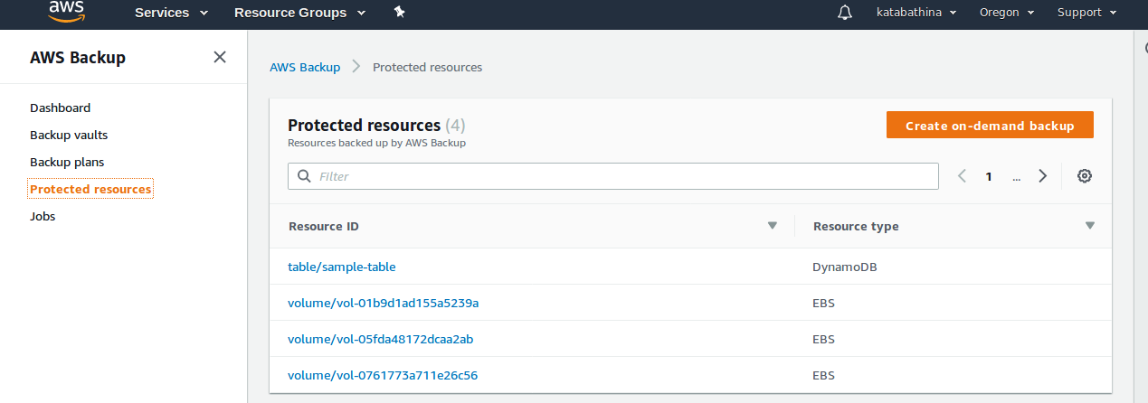
=> Select “Create on-demand backup” and page come like below,
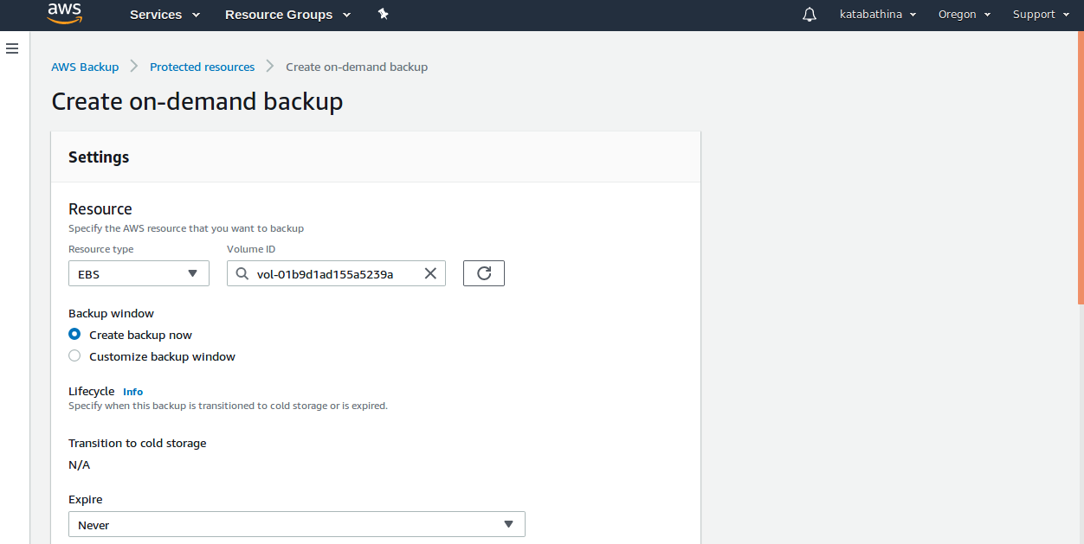
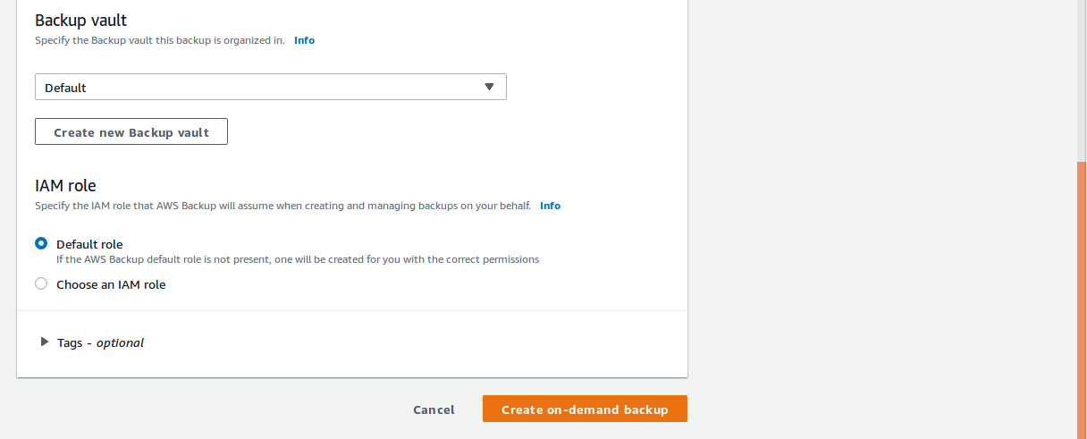
=>Clikc on Create on-demand backup.
=>Backup job has been created successfully like below,
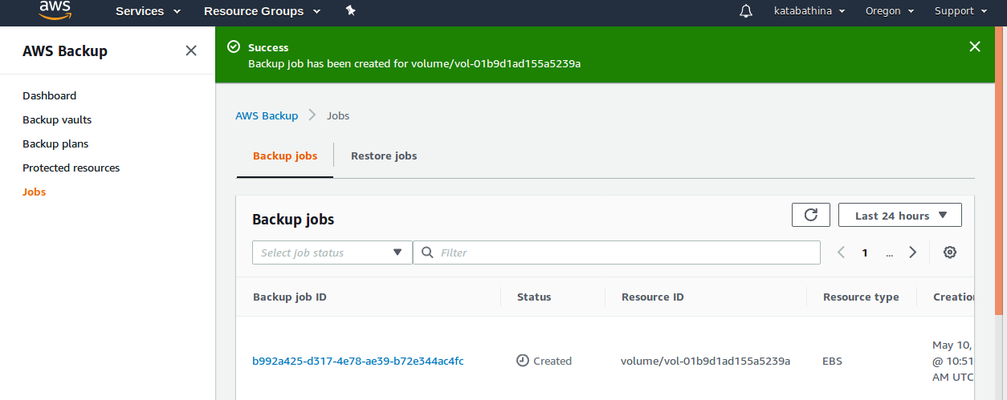
=>Backup job has been created successfully like below,
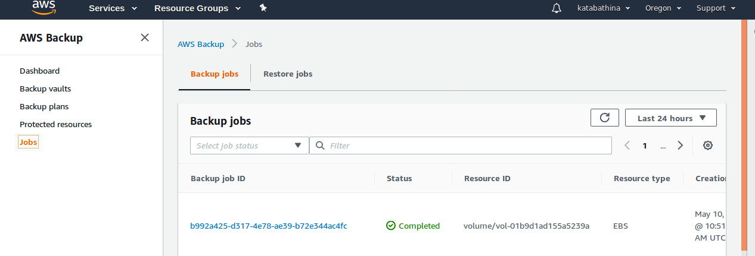

=> Restore a job from backup vaults or protected resources,
=>Goto Protectd resoureces,
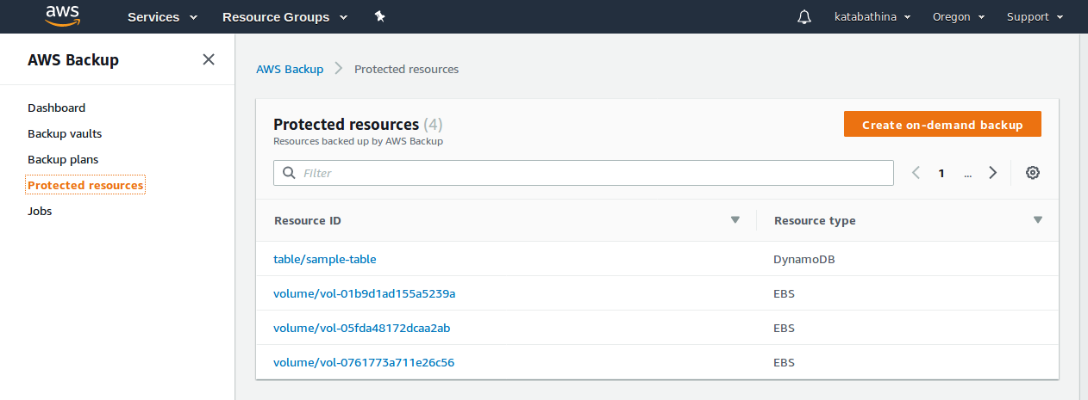
=>Select Resource ID which evere you want restore.
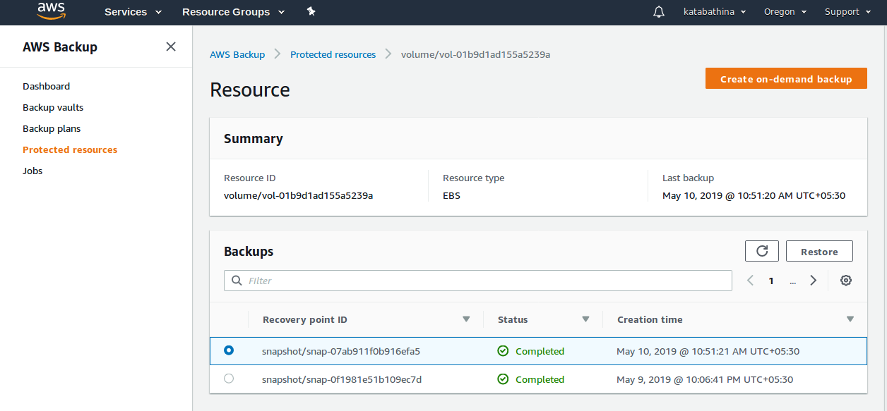
=> Select the Snapshot Recovery point ID which ever you want restore and select restore.
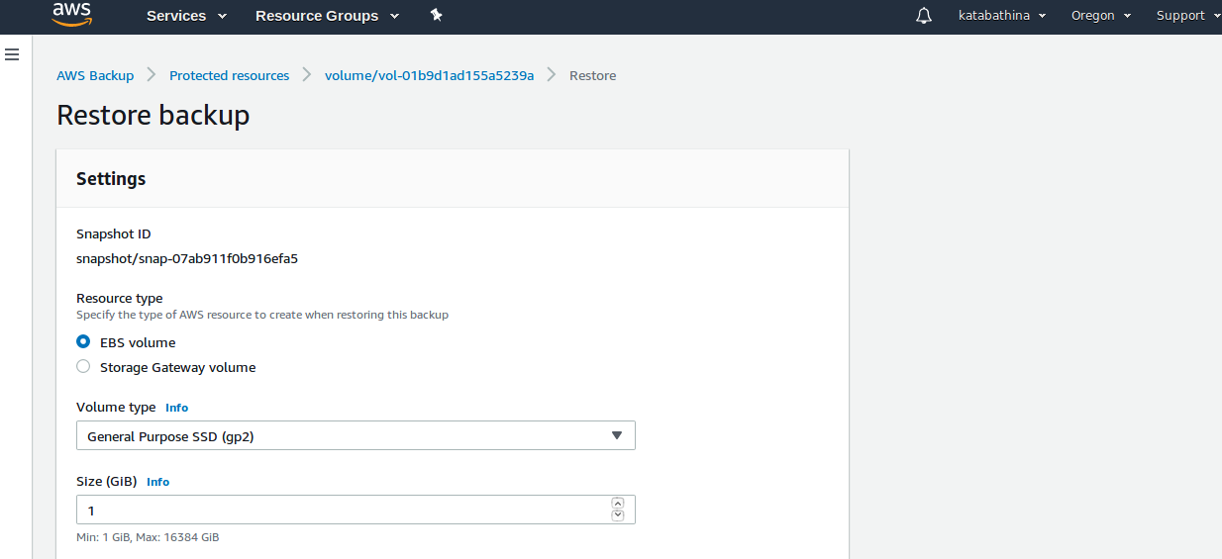
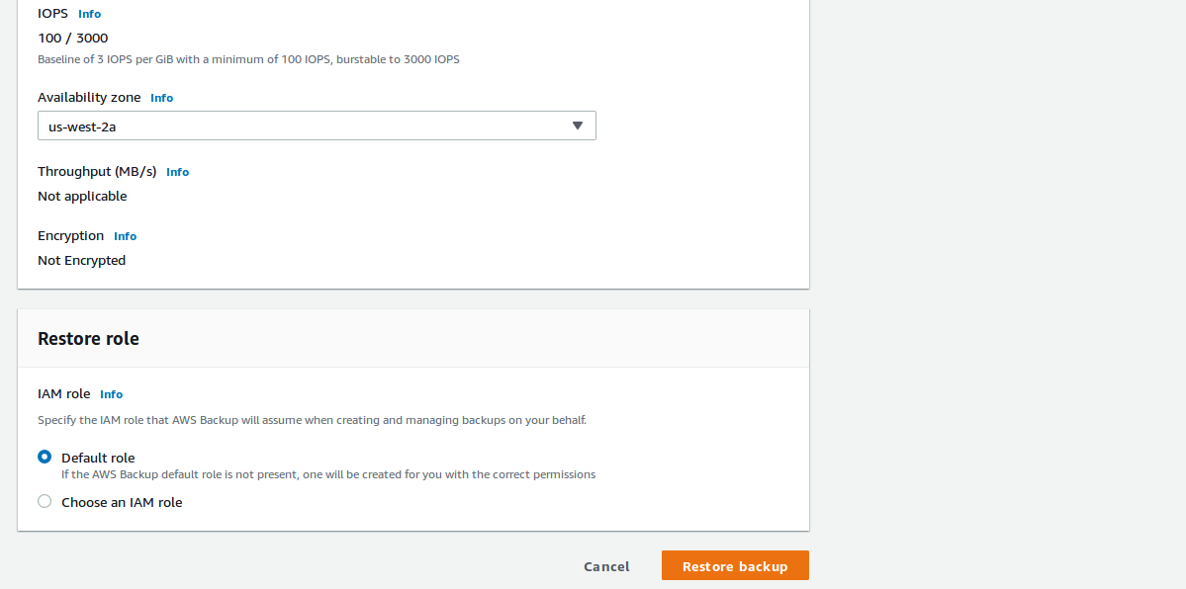
=> Click on Restore backup.
=> The restoring job is in progress and once complete its shows like below,
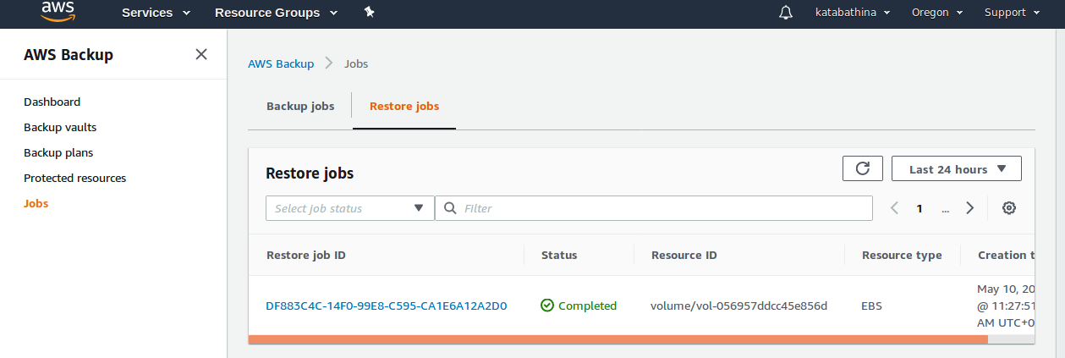
=> Goto AWS backup dashboard console, here it will show all the list of jobs,(backup and restore jobs).

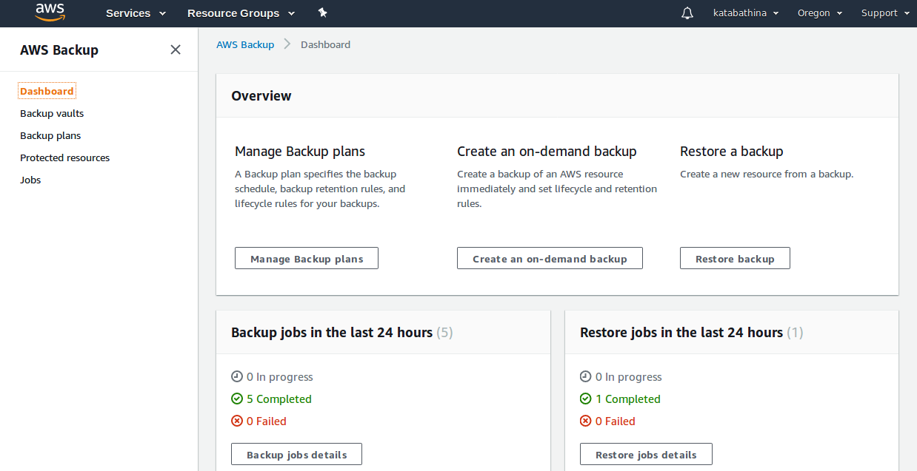
=> Goto EBS Voluems console and shows the restore ebs volume like below,
