Ansible Integration with Jenkins:-(Github->Jenkins->Ansible->Tomcat)

==========================>

------------>
webapp/target/*.war

Jenkins war file build location will give in jenkins below path.

/var/lib/jenkins/workspace/test111/webapp/target/webapp.war

ansible-playbook /opt/play-books/copyfile.yml
---------------->

Ansible Integration with Jenkins:-

Pre-requisites:-

Install jenkins and make it jenkins user as a sudo user.
Install Ansible and create Ansible user and make it as a sudo user and password less authentication setup.
Install Publish over ssh plugin (jenkins and ansible integration)
Configure Pubilish over ssh in Jenkins Configure system(Estabilsh Communication jenkins to ansible)
Create a sample playbook.
Create a jenkins job.

STEP 1: First lanuch 2 Servers.

=>First Server for Ansible and Jenkins and Second Server for Tomcat.

=>Login to first Server , Install java and install jenkins.

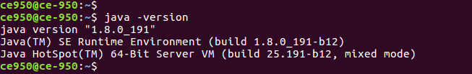
=>Next Install jenkins.

=>Confirm Jenkins is running or not?

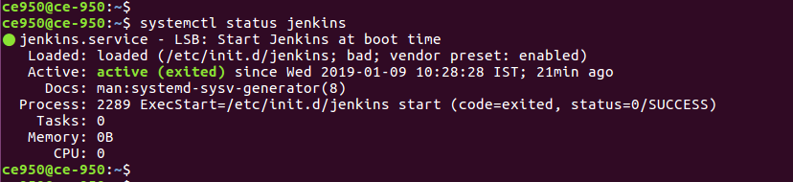
=>Jenkins is up and running and open jenkins console.

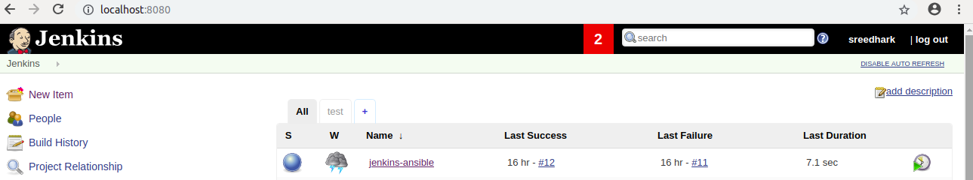
=>Jenkins User make it as Sudo User.

STEP 2:- Install Ansible.

=>Verify Ansible version.

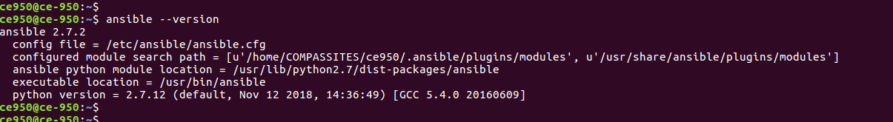
=> Create a Ansible User and make it as Sudo User.

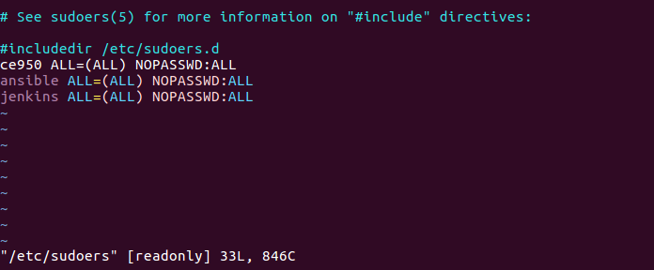
=> Next Generate Public and Private key for Ansible User.

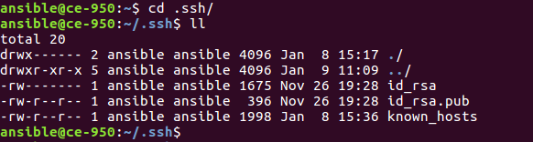
STEP 3:- Login To Second Server.

=>Install Java

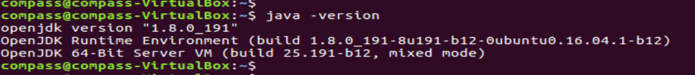
=>Install Tomcat.

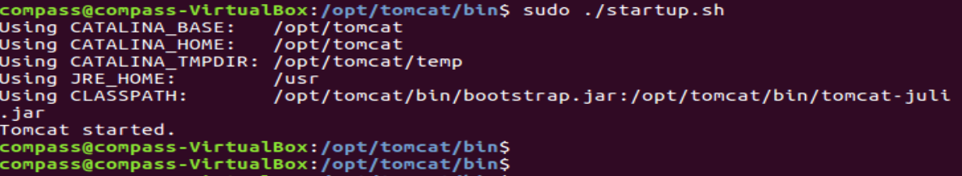
=>Tomcat Started.

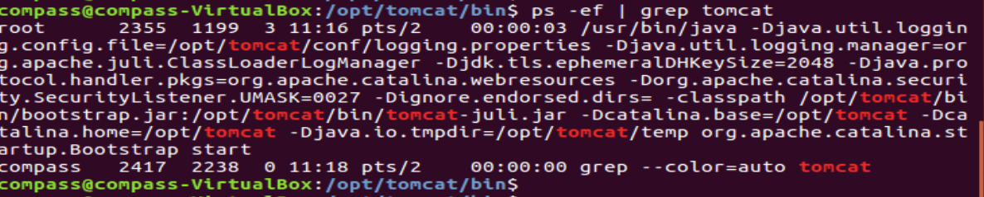
=>Tomcat up and running.

STEP 4 :- Create a ansible User and make it as a Sudo User.

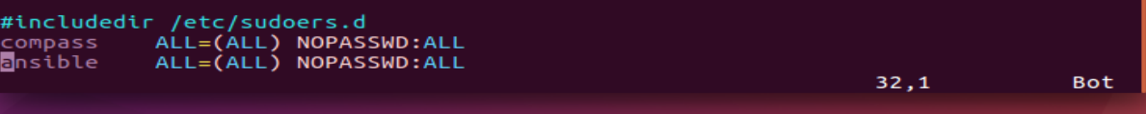
STEP 5:- Connect to First Server.

=>Swith to Ansible User and goto .ssh Foler copy public key to Second server Ansible User.

Ssh-copy-id <ServerIP>

ssh-copy-id 192.168.1.30

=>After that check to verify Passwordless authentication is working or not.

Ssh 192.168.1.30

=>Next add Sercond Server IP In Ansbile Host file.

vi /etc/ansible/hosts
Ex:
[Webserver]
192.168.1.30
:wq!

STEP 6:- Check with Ansible Master Communication host or not?

ansible all -m ping

STEP 7:- Installe the Publish Over SSH Plugin and after that restart jenkins.

=>Ansible integration with Jenkins need “Publish Over SSH” Plugin is mandatory.

=>Install “Publish Over SSH “

Manage Jenkins=>Manage Plugins=>Available=>Publish Over SSH=>

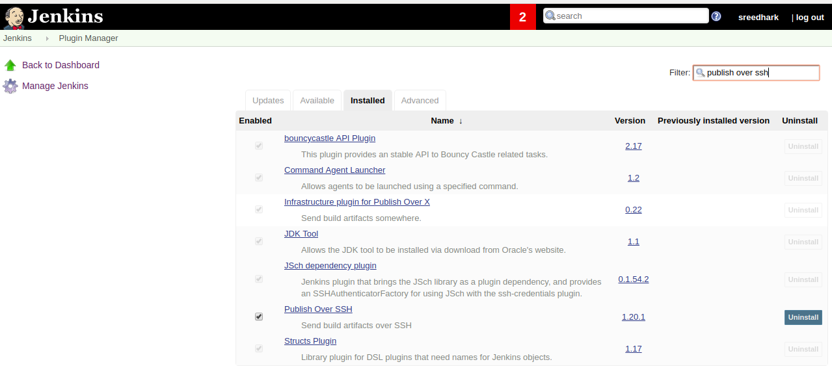

STEP 8:- Enable Connection between Ansible and Jenkins.

=>Manage Jenkins=>Configure System=>Publish Over SSH=> SSH Servers=>

SSH Servers:

->Host Name:<here will ansible server IP>
->User Name:<ansible user name>
->Password: <ansible user passwd>

Test the Connection “Test Connection” <to verify test connection is success or fail>

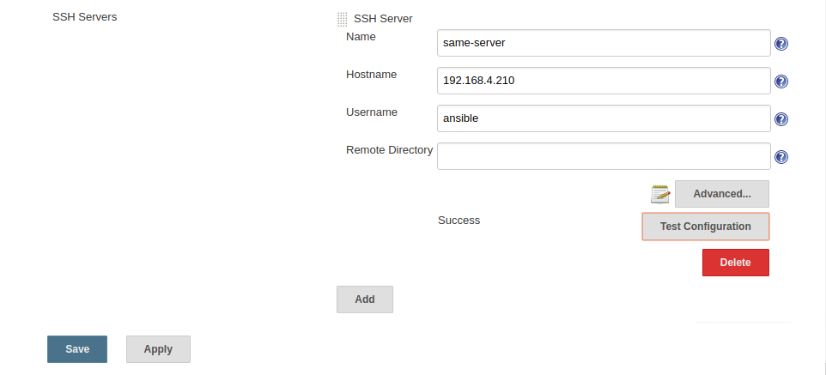

Click Advanced there you will get multiple Options (here you will give ansible user Password)

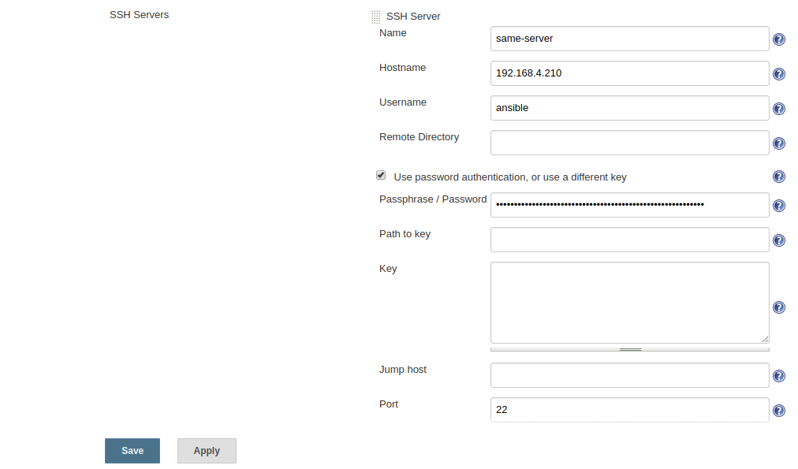
==> Next Select Apply and Save.

STEP 9:- Create a Playbook.

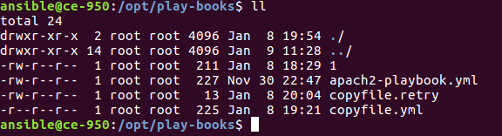
=>Here created a Copyfile.yml playbook.

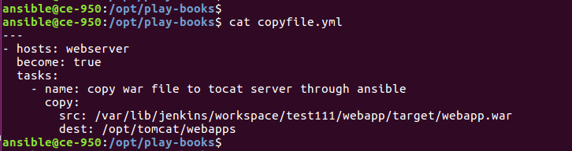
=>Here src is a Jenkins build a war file location, and dest is tomcat server webapps path.

STEP 10:- Create job in Jenkins.

=>Goto Jenkins Console=> Select New Item=>Enter name=test111=>Select Maven

Project=>

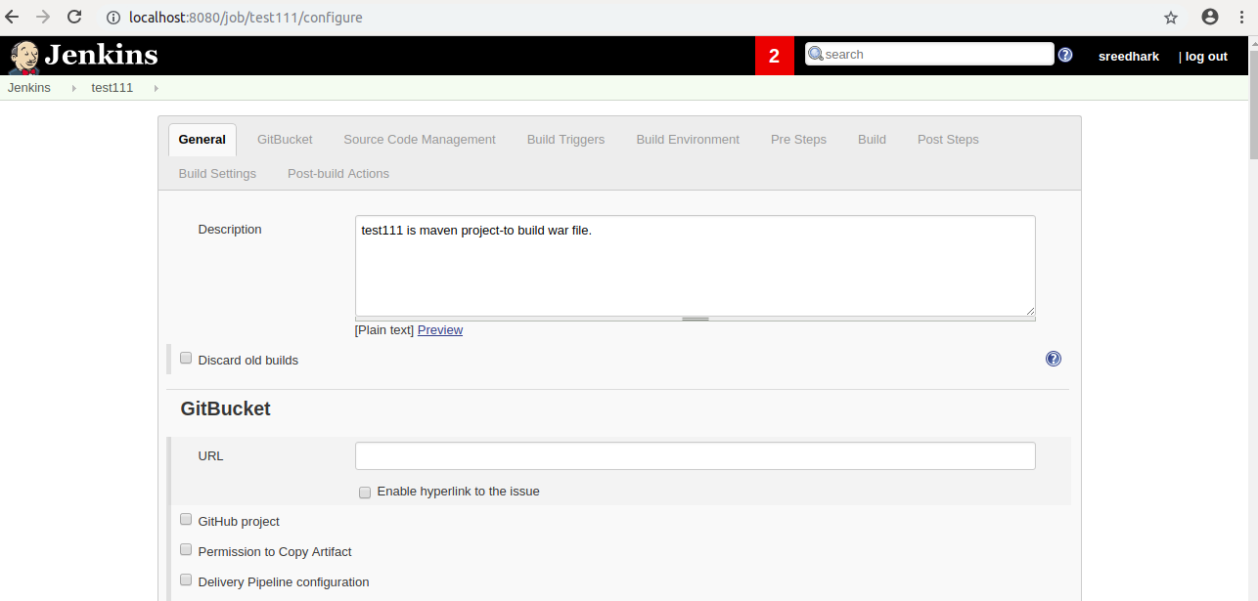

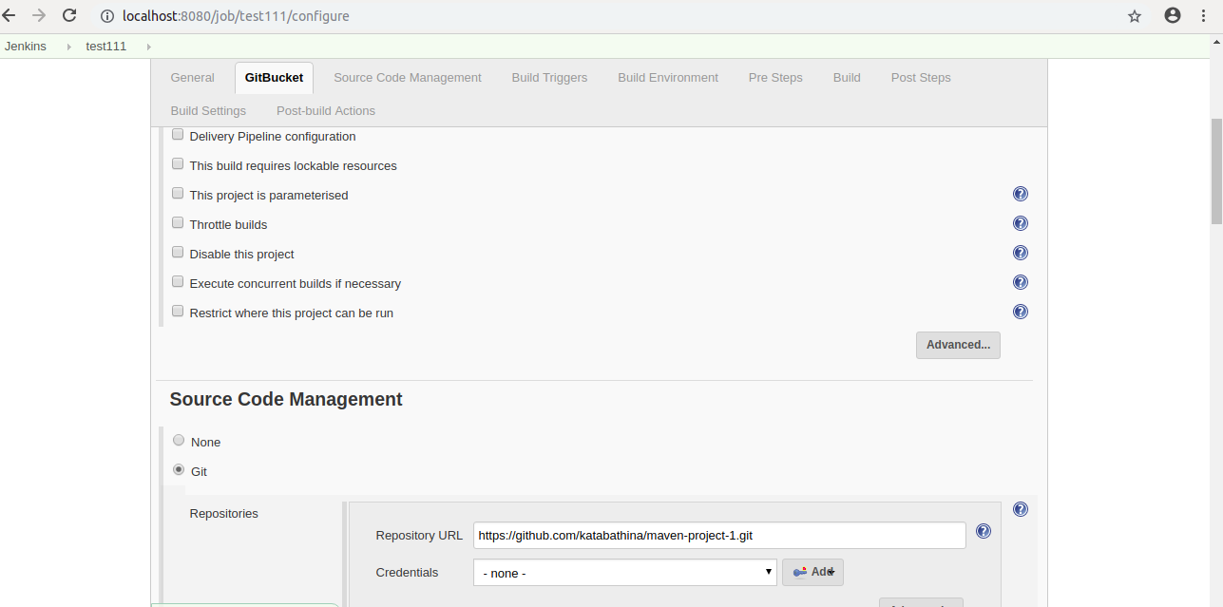
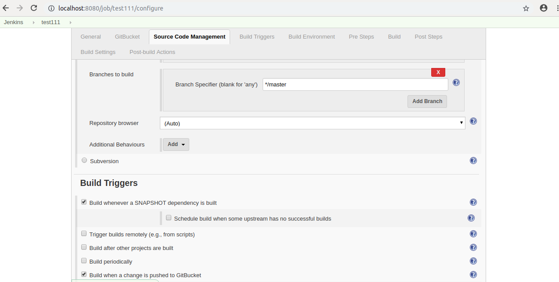
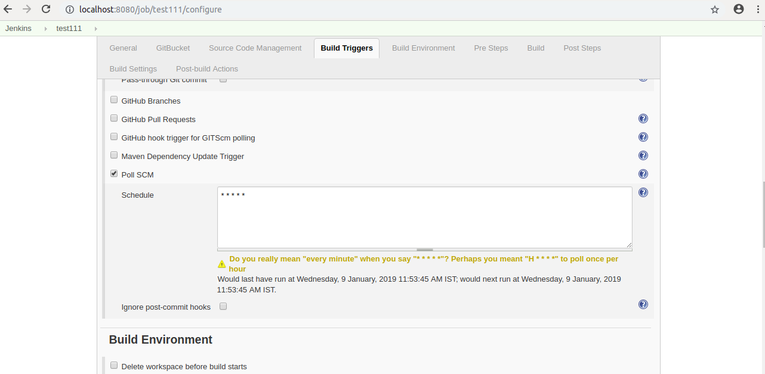

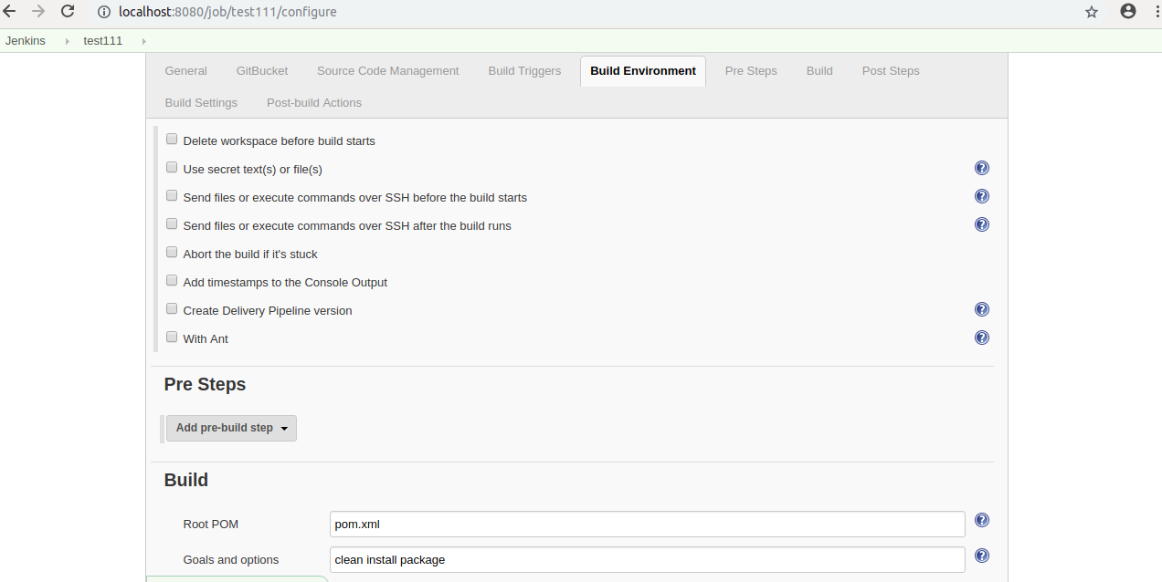

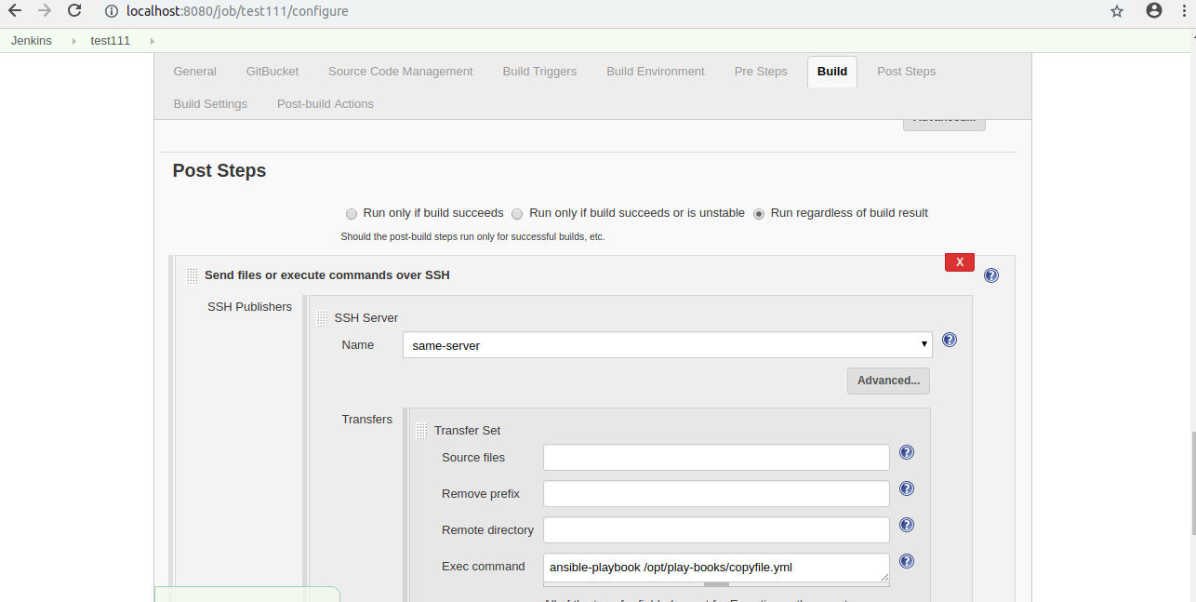

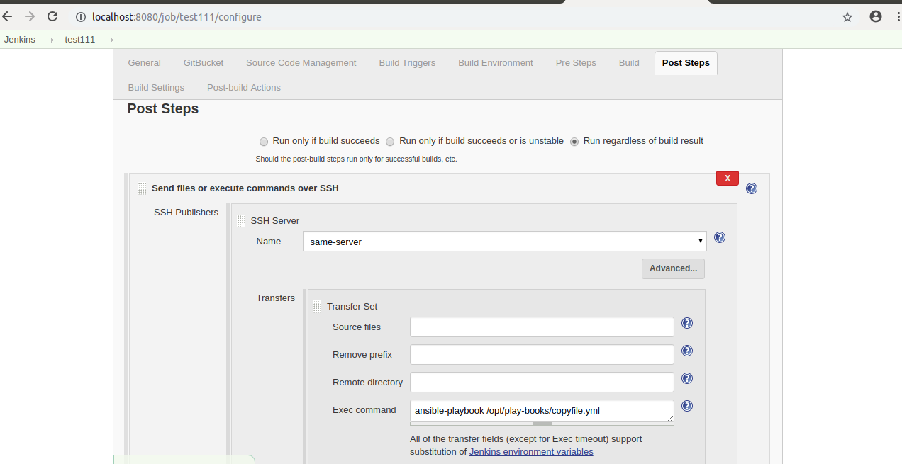
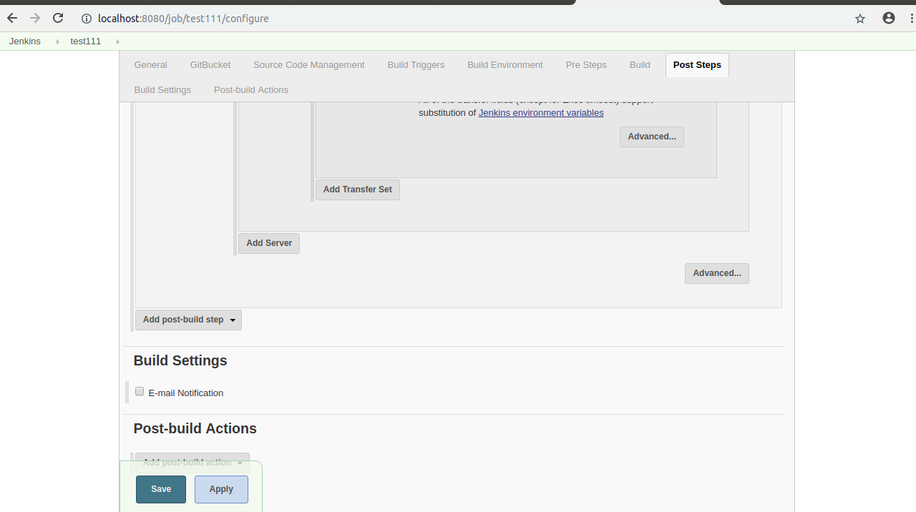
==> Next Select Apply and Save.

STEP 11:- Now build the Job.

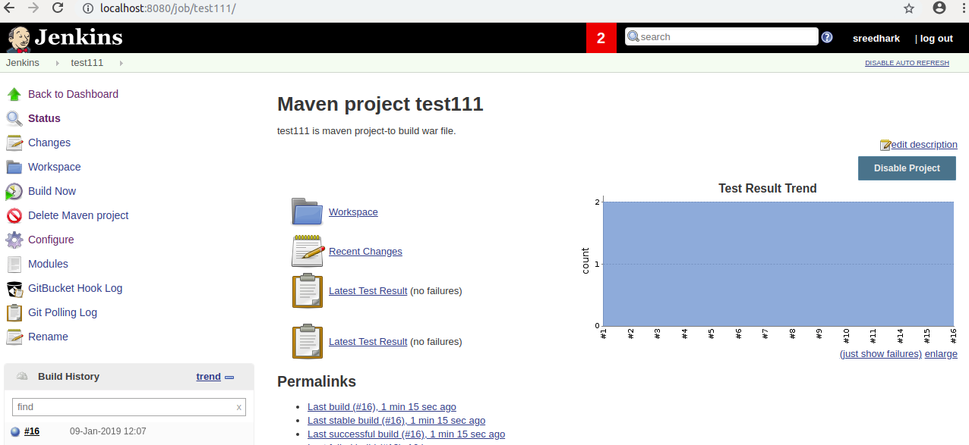
=>Build Success and now see the console output.

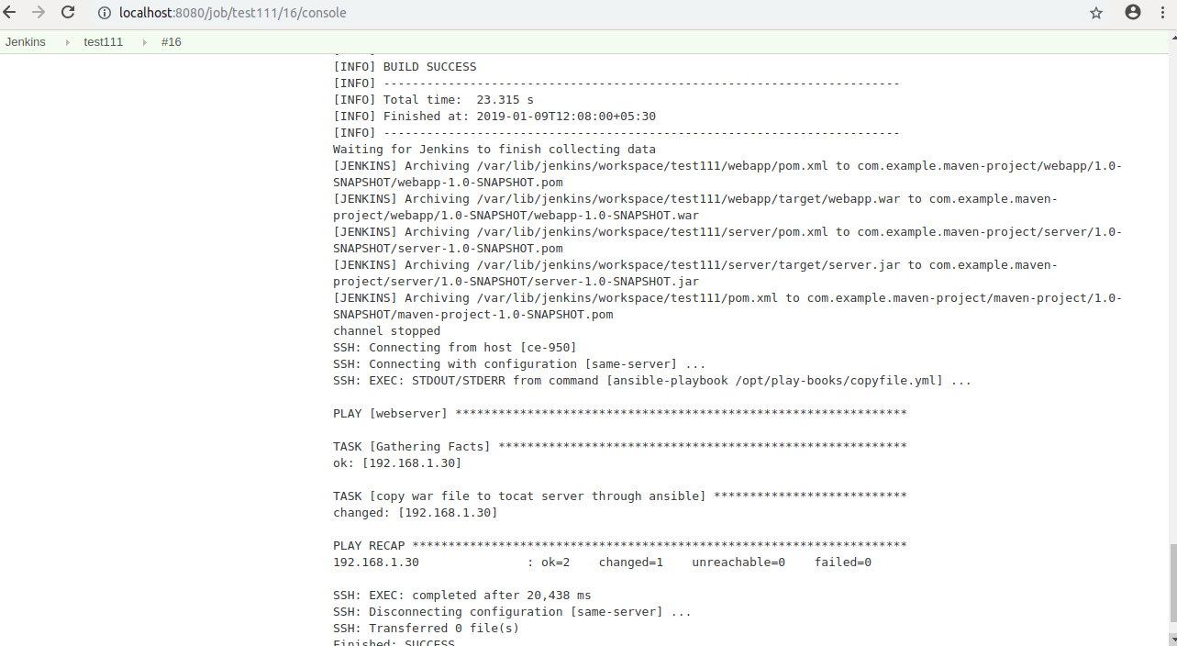
=>Goto Tomcat Server webapps path and broweser output.

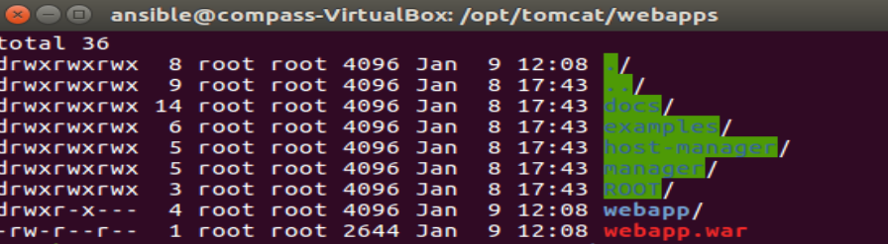

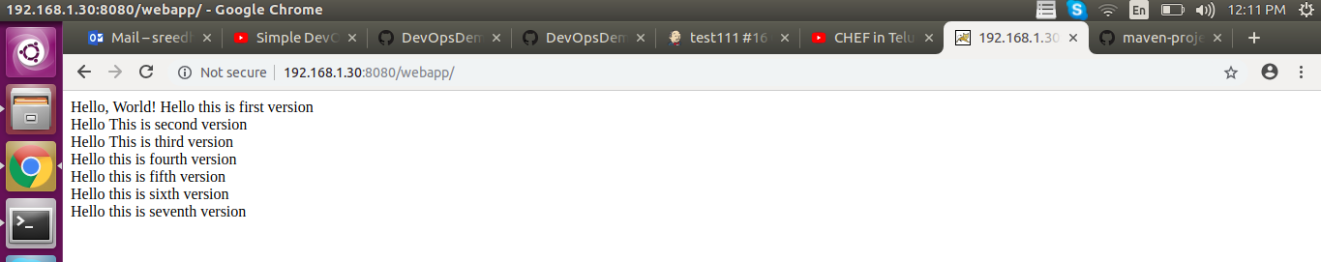

=============================================>

Ref Links:-Velaxy Technology(Devops 2 link)

https://www.youtube.com/watch?v=nE4b9mW2ym0

https://github.com/ValaxyTech/DevOpsDemos/blob/master/Jenkins/Ansible_integration.MD

https://github.com/ValaxyTech/DevOpsDemos/blob/master/SimpeDevOpsProjects/Project-02.MD

