https://www.youtube.com/results?search_query=edureka+gcp+vs+aws

https://www.youtube.com/watch?v=-hFAWk6hyZA

https://www.youtube.com/watch?v=vNic2xziwlY

What Is Autoscaling Group:-

--> Maintain application availability by scaling up/down your Amazon EC2 automatically.

--> Adds more instance during high load.

--> Remove Instances during less load.

--> Run Desired number of Amazon EC2 Instances. (Always 5 Instances)

Ex:-

My Application to be live -- Minimum 1 Server.

My Application to be Perform normal --- Desired 3 Servers

My Application to be Perform during peak Season --- Maximum 20 Servers.

During Peak load-Scale out by --- 2 Servers every 10 Minitues.

AWS Autoscaling Components?

1. Lanuch Configuration (Template).

=> AMI (Ex: Amazon Linux, Redhat Linux)

=>Instance Type (Ex:-t2.micro, m4.large)

=>Storage.

=>Security Group.

=>SSH-Key Pair.

2. Autoscaling Group:-

=> Launch Configuration.

=> Network/Subnets.

=> Scaling Policies for increase.

=>Scaling Policies for decrease.

=> Monitoring & Alaram.

Autoscaling Test Scenario.

---> Build Webserver

--->Create AMI(Image)

--->Create Launch Configuration using webserver AMI.

--->Create Autoscale group with minimum 1 instance, increase by 1 & maximum 4.

--->Run the following Script to increase CPU load Above 50%

vi dd.sh

dd if=/dev/zero of=/dev/null bs=50000 count=100000

dd if=/dev/zero of=/dev/null bs=50000 count=100000

dd if=/dev/zero of=/dev/null bs=50000 count=100000

dd if=/dev/zero of=/dev/null bs=50000 count=100000

dd if=/dev/zero of=/dev/null bs=50000 count=100000

dd if=/dev/zero of=/dev/null bs=50000 count=100000

:wq!

STEP 1:- Spin up EC2-Instance (Sample-WebApplication) With Sample Webapplication.

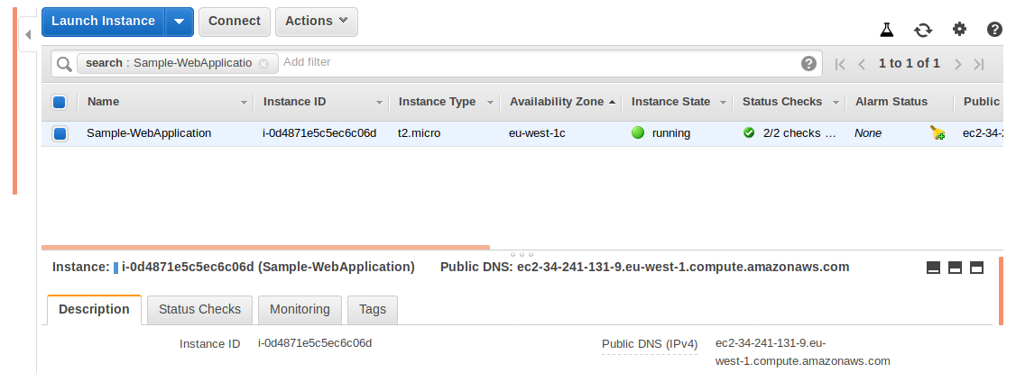
Security Groups allow for Sample Webapplication.

SSH---22---Anywhere

HTTP---80---Anywhere.

---> Connect To EC2 Instance--->

---> Install apache and place a application in document root path.

yum install httpd

systemctl enable httpd

systemctl start httpd

ps -ef | grep httpd

cd /var/www/html/

vi index.html

<!DOCTYPE html>
<html>
<body>

<h1>My This is my Sample Web Application</h1>
<p>My Autoscaling.</p>

</body>
</html>

:wq!

---> Check in browser with Public IP.

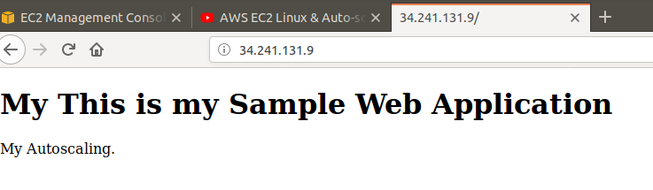
STEP 2:- Create a AMI from Sample Web Application.

--->Goto AWS Console--> Select Services---> Select EC2---> Select---> Sample Web Application

Server--->Goto Actions---> Select Image--> Select Create Image.

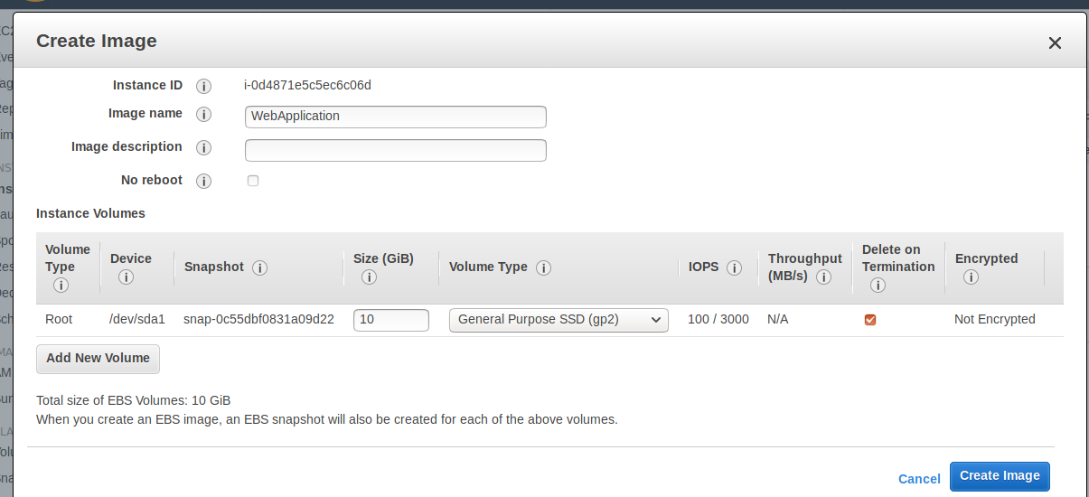
---> Select Create Image.

---> Goto AWS Console---> Select Servcies---> Select EC2--->Lefe Side Panel Select AMIs-->

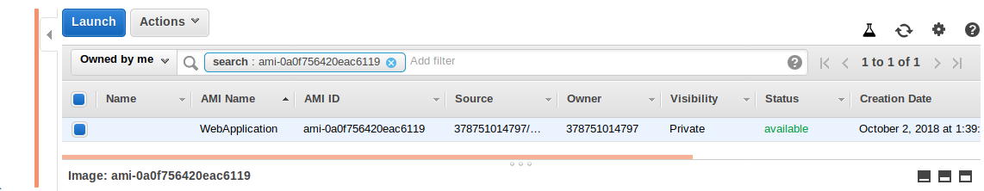

STEP 3:-- Launch Configuration

---> Goto AWS Console---> Select Services---> Select EC2-->Left Side panel Select Launch

Configurations--->

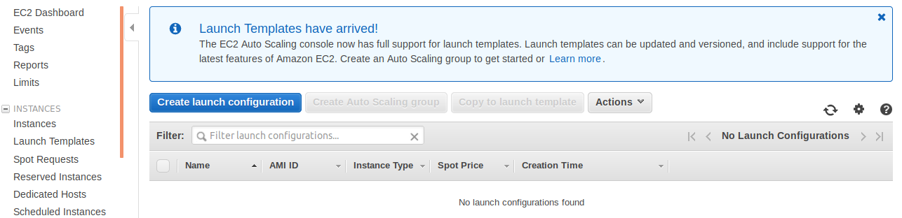
---> Select Create launch Configuration--->

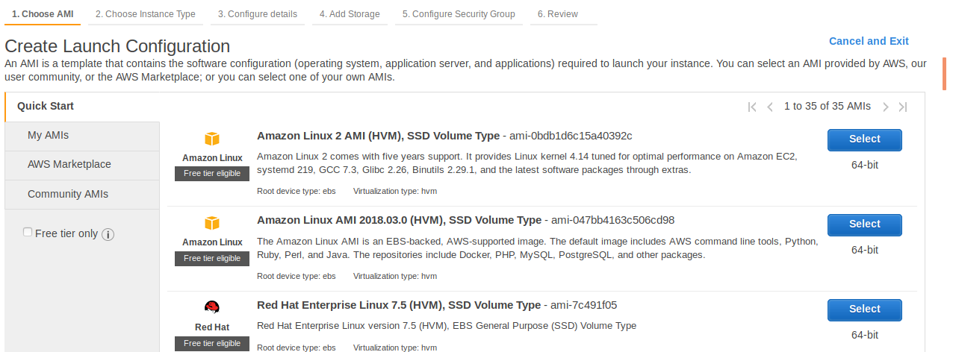
---> Select My AMIs.

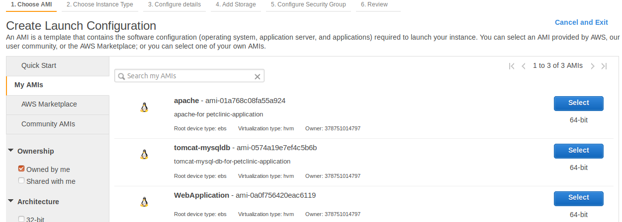
---> Select WebApplication AMI--->

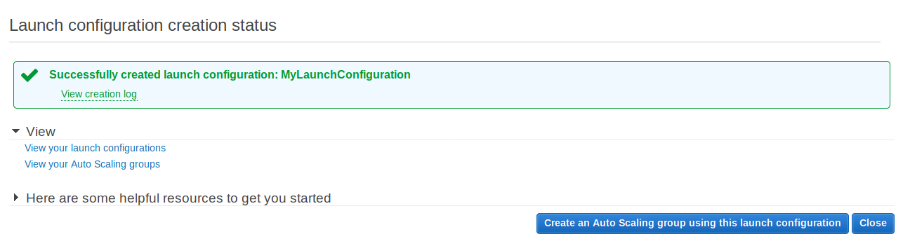

---> Lauch Configuration completed ---> Select Create an Auto Scaling group using this launch

configuration.

STEP 4: Now Creating Autoscaling Group. (Select Create an Auto Scaling group using this

launch configuration.)

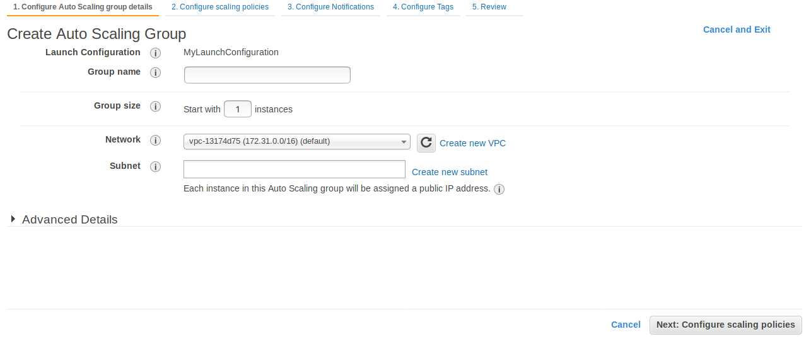

--->

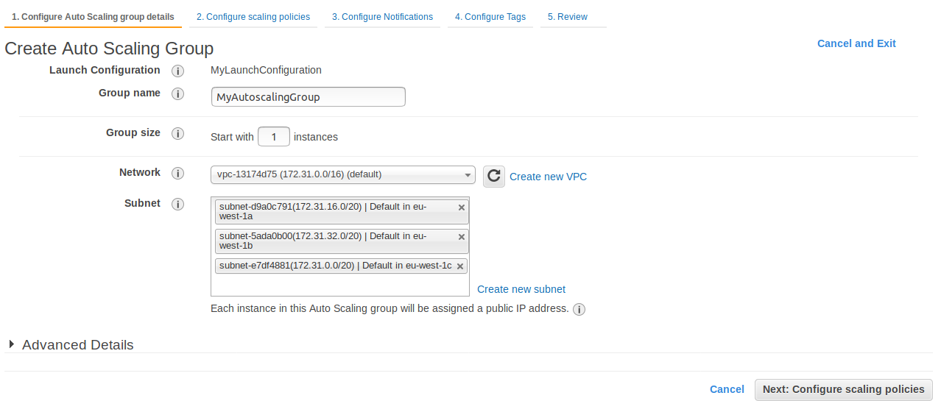
---> Select Configure scaling policies.

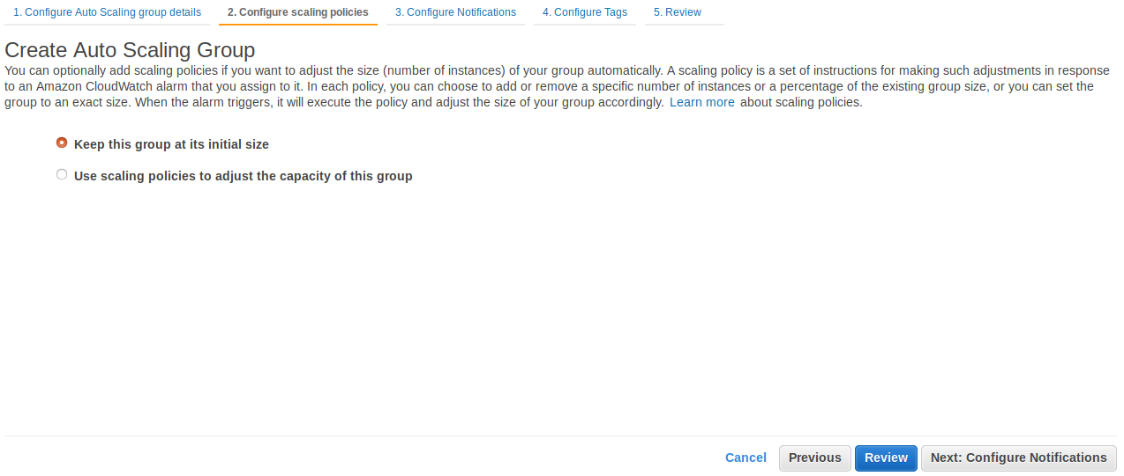

--->Select Use scaling policies to adjust the capacity of this group.

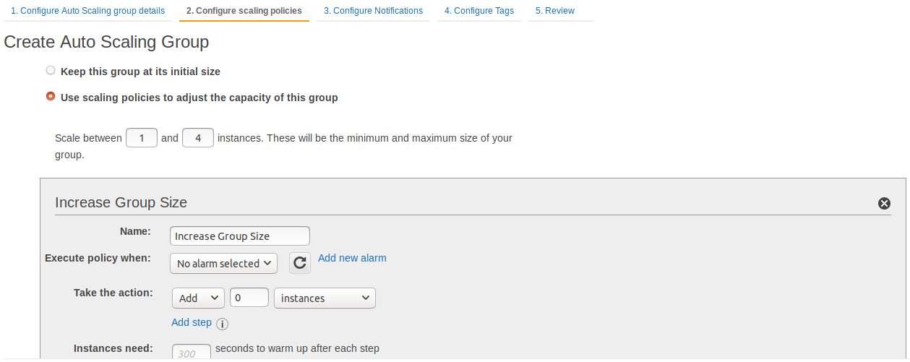
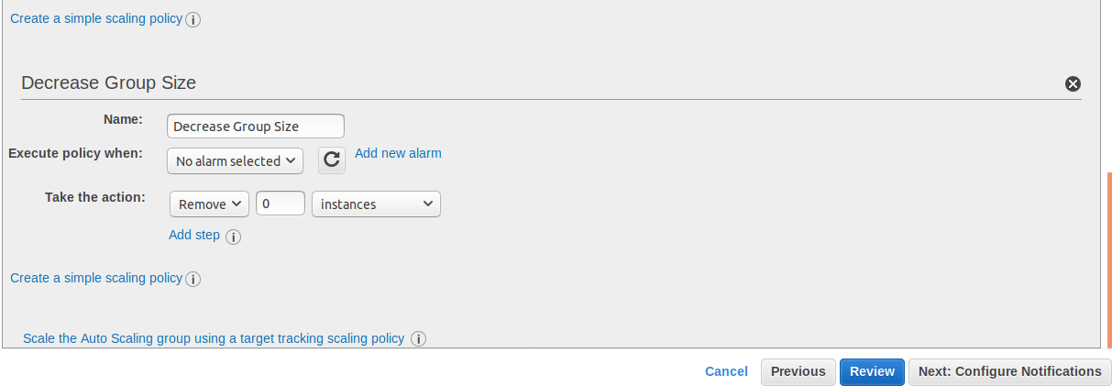
---> here first create a alarm--->Add new Alarm-->

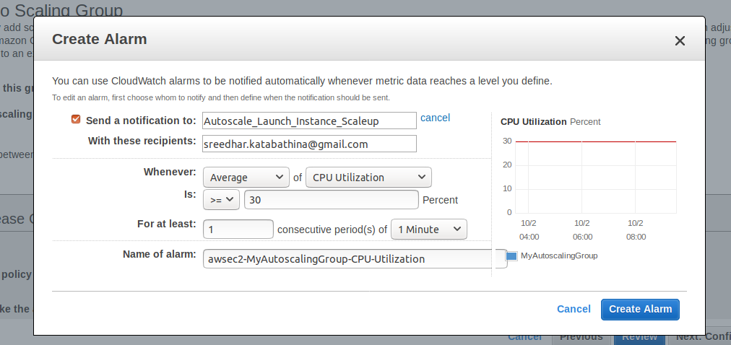
---> Select Create Alarm.

---> here edit alarm--> Reduces Avg CPU utilization to >=20

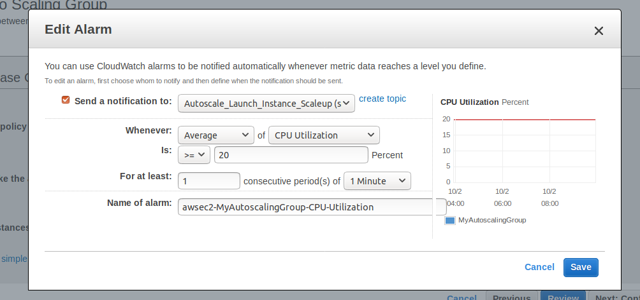
---> Select Save.

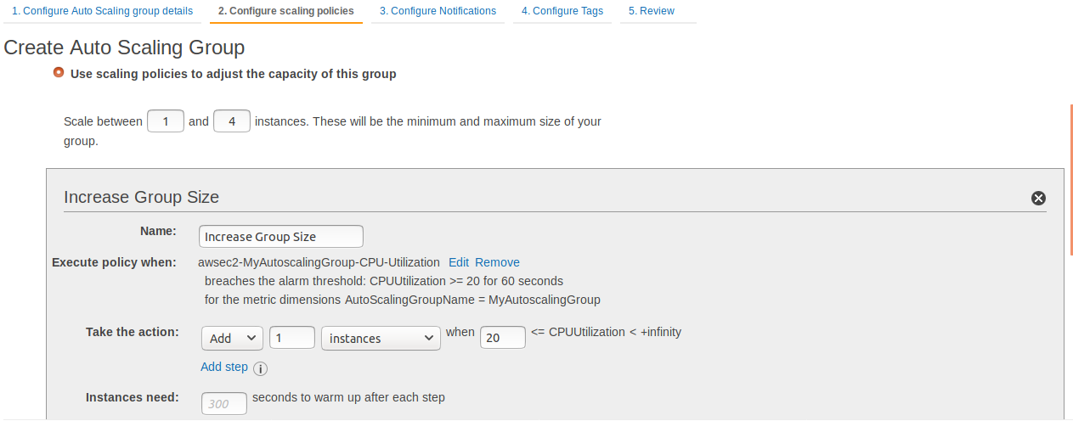

---> here create a alarm for Down Group Size--->Add new Alarm-->

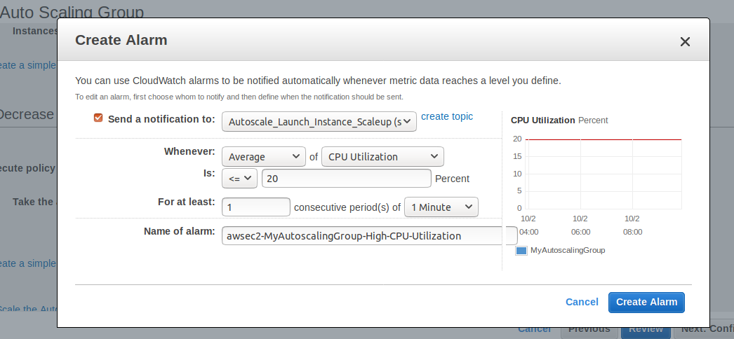
---> Select Create Alarm.

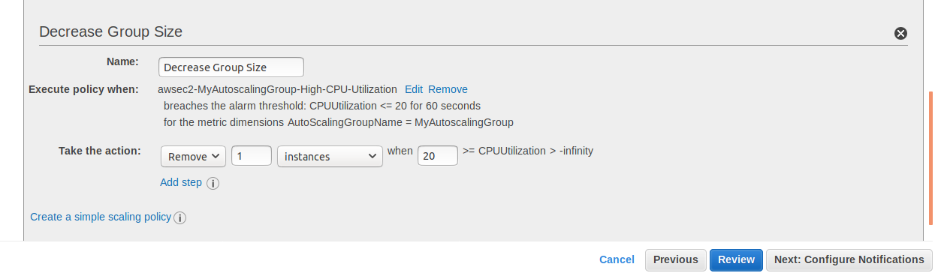
----> Select Configure Notifications.

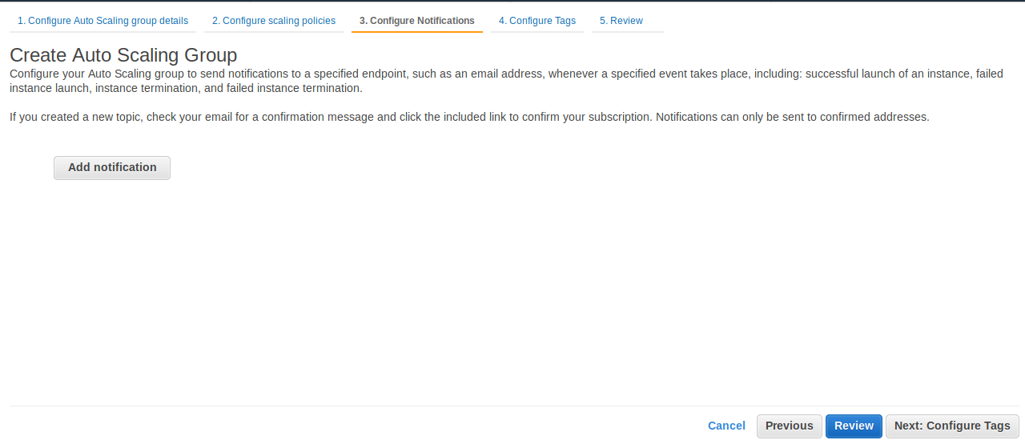
---> Choose Add notifications.

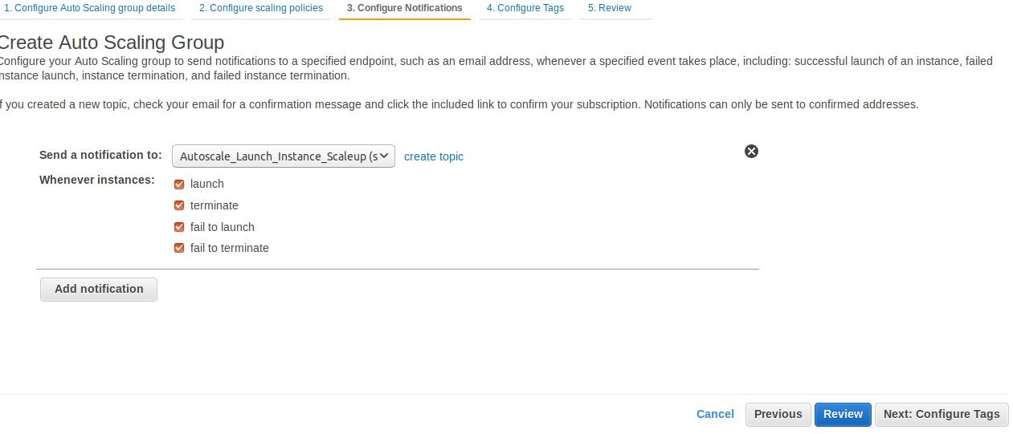
---> Select Configure Tags.

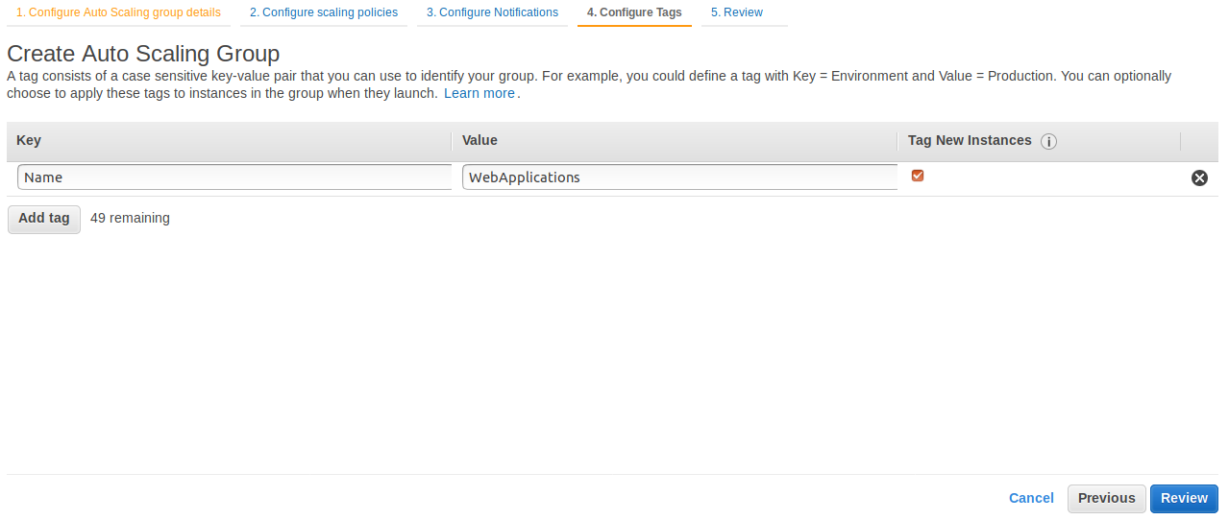
---> Select Review---> Select Create Autoscaling Group.

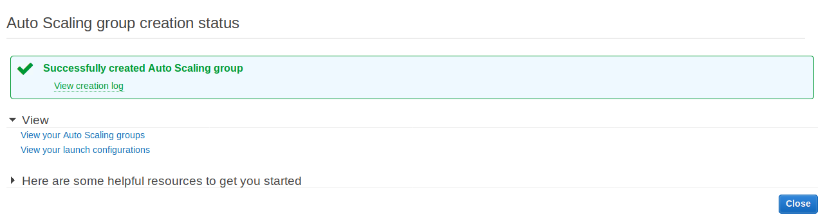
----> Goto AWS Console---> Select Servcies---> Select EC2--->

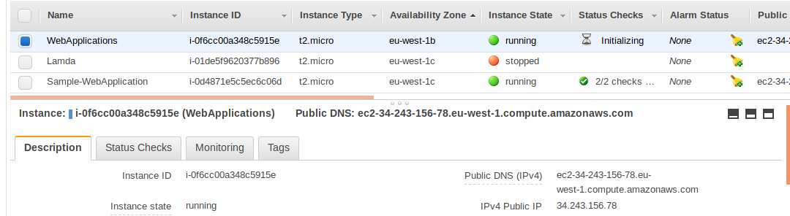
---> Here new server lanuched WebApplications.

---> Take WebApplications Public Ip and seach with browser.

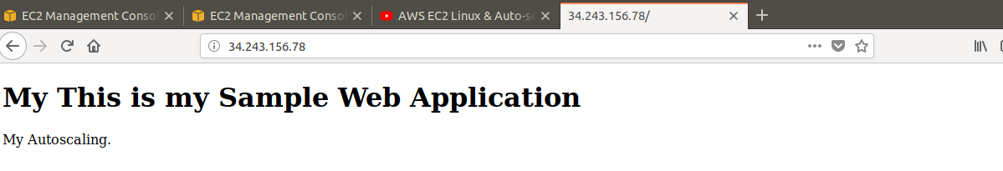

STEP 5:- Connect to WebApplications Server .

---> Now see the CPU utilizaion with Top Command.

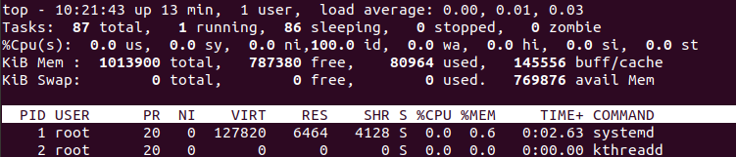
---> now increase the cpu load run below command.

dd if=/dev/zero of=/dev/null bs=50000 count=100000

vi dd.sh

dd if=/dev/zero of=/dev/null bs=50000 count=100000
dd if=/dev/zero of=/dev/null bs=50000 count=100000
dd if=/dev/zero of=/dev/null bs=50000 count=100000
dd if=/dev/zero of=/dev/null bs=50000 count=100000
dd if=/dev/zero of=/dev/null bs=50000 count=100000
dd if=/dev/zero of=/dev/null bs=50000 count=100000
dd if=/dev/zero of=/dev/null bs=50000 count=100000
dd if=/dev/zero of=/dev/null bs=50000 count=100000
dd if=/dev/zero of=/dev/null bs=50000 count=100000
dd if=/dev/zero of=/dev/null bs=50000 count=100000
dd if=/dev/zero of=/dev/null bs=50000 count=100000
dd if=/dev/zero of=/dev/null bs=50000 count=100000

:wq!

---> To increase the cpu load run above script. Mulitple times in back group

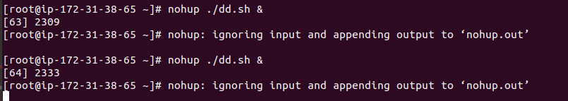
---> Now check CPU load with top command.

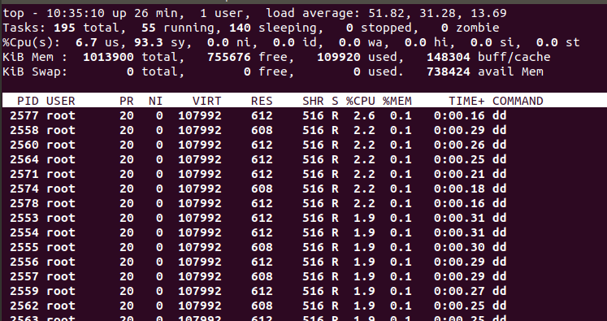
---> Now Goto AWS Console---> Select Services---> Select EC2-->

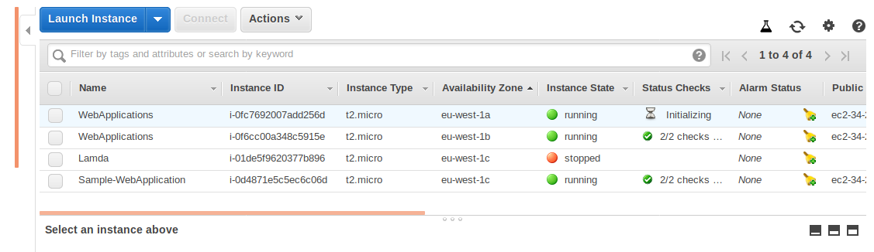
---> See the above one more WebApplications initializing based on CPU load.

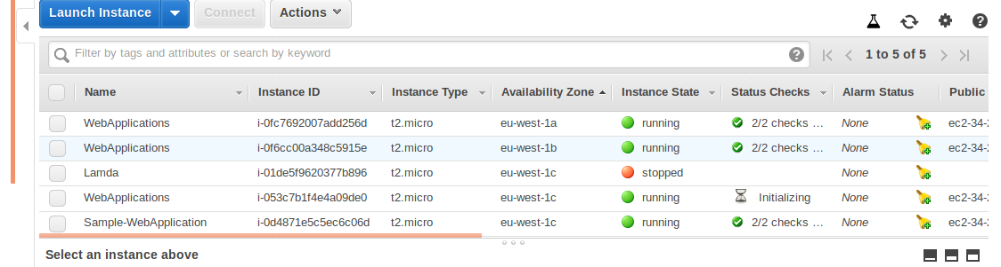

---> See the above one more WebApplications initializing based on CPU load.

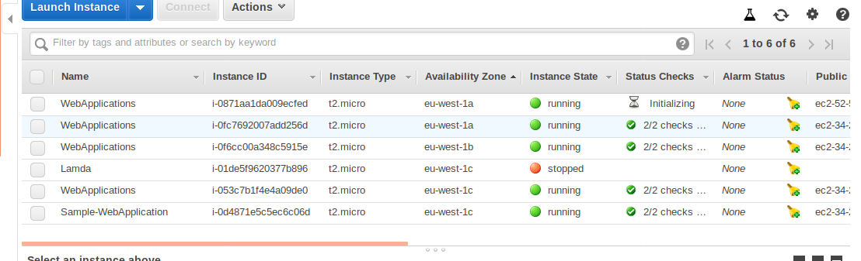
--->Now see the above now One more WebApplications Initializing based on CPU Load.

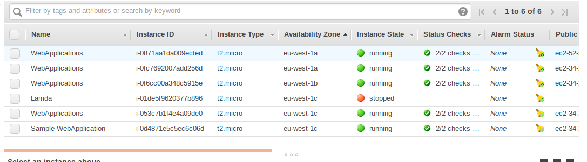

---> Now See the above total 4 WebApplications Servers created.

===> Now see the CPU load with Top command.

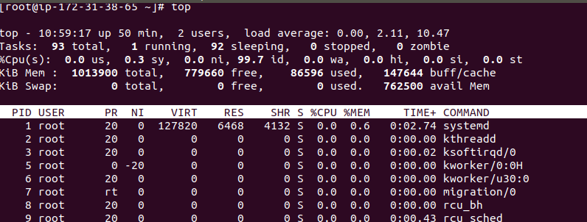

--> Now CPU load is below 20%

--> Now Goto AWS console --> Select Services---> Select EC2-->

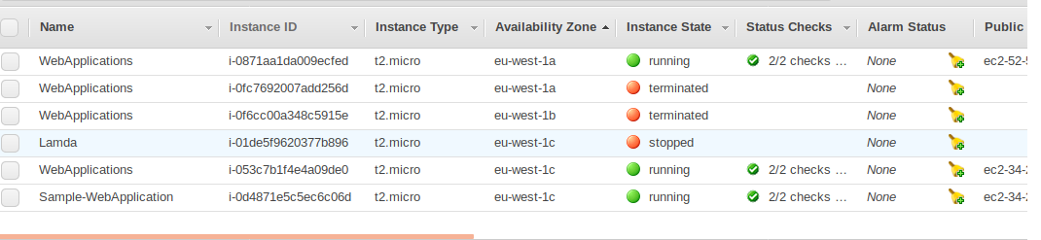
---> Now Webapplications Instances getting terminated based on CPU Load >=20 Now.

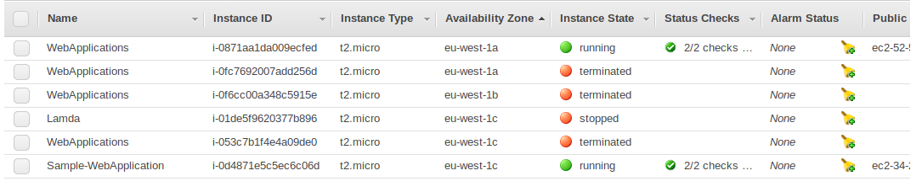
---> The above Screenshot 3 Webapplications Instances getting terminated based on CPU Load

<=20 Now.

---> 3 Terminated, Minimum 1 will be there.

