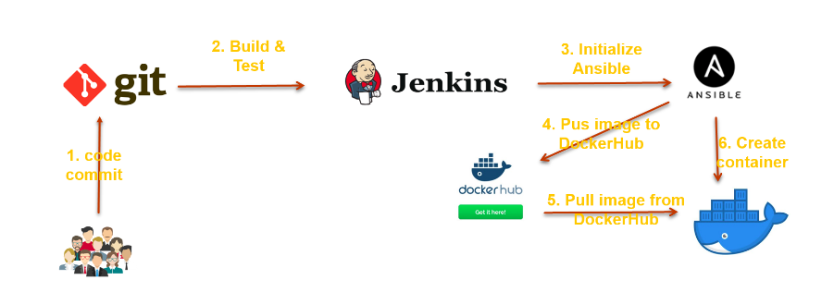
Developer commits the code to github repository-> from there jenkins build the war file and along with that Dockerfile copied to jenkins server-> Again its copied from jenkins server to Ansible server-> Ansible server build the image from Dockerfile and also merge with war file-> from here again Ansible push to dockerhub-> pull the image from docker hub and copied to Docker Client server-> run the image and container will start.

Addtionally version enabled to Dockerhub.

Pre-requisites:-

=> 1. Jenkins

->We are already have set up jenkins server as previous tasks)

2.Ansible
->We alread have ansible server as previous tasks and ansadmin user as well.
->Install docker
->Add ansadmin user add into “docker” group).
-> Start the docker service as a ansadmin user.
-> Check any existing images and any containers are running.
Docker images
docker ps -a

3.New Server (Docker Client)
->Setup this server as ansible client.
-> Create a ansadmin user and make it Password Authentication.
-> install Docker.
-> Add ansadmin user in “docker” group.
-> start docker service as a ansadmin user.
-> Check any existing images and any containers are running.
Docker images
docker ps -a

4.Docker Hub account (create a one public account to store docker images).
5. Github Repository.
->We already have Git hub repository and in this repository add Dockerfile(this file is for build docker image)).
=====>

Part-01 : Create an docker image
In part-01 we create Docker image on ansible server through Jenkins job and pushed it onto DockerHub
=>Login to Jenkins console
- CreateJenkins job, Fill the following details,
  - Source Code Management:
    - Repository :https://github.com/ValaxyTech/hello-world.git
    - Branches to build :*/master
  - Build:
    - Root POM:pom.xml
    - Goals and options :clean install package
  - Post Steps
    - Send files or execute commands over SSH
      - Name:ansible_server
      - Source files :webapp/target/*.war
      - Remove prefix :webapp/target
      - Remote directory ://opt//docker
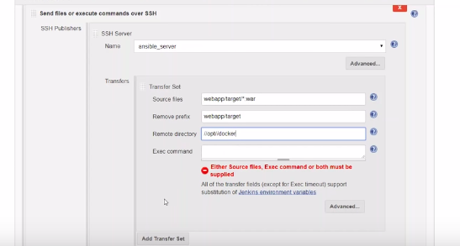
    - Send files or execute commands over SSH
      - Name:ansible_server
      - Source files :Dockerfile
      - Remote directory ://opt//docker
      - Exec Command:
        - cd /opt/docker
        - docker build -t valaxy_demo .
        - docker tag valaxy_demo valaxy/valaxy_demo
        - docker push valaxy/valaxy_demo
        - docker rmi valaxy_demo valaxy/valaxy_demo

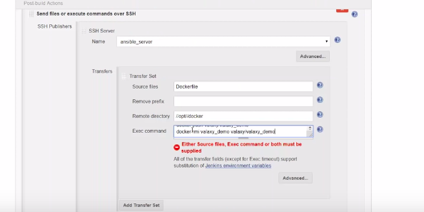

- Login to Docker host and check images and containers. (no images and containers)
- login to docker hub and check. shouldn't find images with for valaxy_demo
- Execute Jenkins job
- check images in Docker hub. Now you could able to see new images pushed to Valaxy Docker_Hub.

Troubleshooting:
- Docker should be installed on ansible server
- Should login to "docker hub" on ansible server
- Docker admin user should be part of docker group

If Trigger the job , job got successed and create a docker image and pushed to Dockerhub.(Part 01 completed successfully)

===>

Part-02 : Deploy Containers:-

((From part 01-> Now we are using that image and create docker container for that we need to create a playbook and add that plabook to jenkins job))

InPart-02 we create create_docker_container.yml playbook. this get intiated by jenkins job, run by ansible and exected on dokcer_host
=> Write a yml file to create a container (file name : create_docker_container.yml)
---
- hosts: web-servers
become: true
tasks:
- name: stop previous version docker
shell: docker stop valaxy_demo
- name: remove stopped container
shell: docker rm -f valaxy_demo
- name: remove docker images
shell: docker image rm -f valaxy/valaxy_demo

- name: create docker image
shell: docker run -d --name valaxy_demo -p 8090:8080 valaxy/valaxy_demo

=>Docker clinet Server Ckeck Whether it is docker login or not?

Docker login

- Add this script to Jenkins job.
  - Choose"configure"to modify your jenkins job.
    - Under post build actions
      - Send files or execute commands over SSH
        - Exec Command:
cd /opt/playbooks
ansible-playbook create_docker_container.yml
2. Execute Jenkins job(Job Got successed).
3.You could see a new container on your docker host. can able access it from browser on port 8090
Troubleshooting: Makesure you have opened required ports on AWS Security group for this server.
->For continuous integration and Deployments add Poll SCM in Existing Job.
Ref Link:-https://www.youtube.com/watch?v=ZwdB1I14vEc

===>

Part-03 :Deploy with Version Control Containers

In Part-03 we try to improvise to store docker images previous versions

So for we used latest docker image to build a container, but what happens if latest version is not working?
One easiest solution is, maintaining version for each build. This can be achieved by using environment variables.
here we use 2 variables
.BUILD_ID- The current build id
- JOB_NAME- Name of the project of this build. This is the name you gave your job when you first set it up.

Lets modify jenkins job which was created in Part-01as below.
- Create Jenkins job
  - Source Code Management:
    - Repository :https://github.com/ValaxyTech/hello-world.git
    - Branches to build :*/master
  - Build:
    - Root POM:pom.xml
    - Goals and options :clean install package
  - Send files or execute commands over SSH
    - Name:ansible_server
    - Source files :webapp/target/*.war
    - Remove prefix :webapp/target
    - Remote directory ://opt//docker
  - Send files or execute commands over SSH
    - Name:ansible_server
    - Source files :Dockerfile
    - Remote directory ://opt//docker
      - cd /opt/docker
      - docker build -t $JOB_NAME:v1.$BUILD_ID .
      - docker tag $JOB_NAME:v1.$BUILD_ID valaxy/$JOB_NAME:v1.$BUILD_ID
      - docker tag $JOB_NAME:v1.$BUILD_ID valaxy/$JOB_NAME:latest
      - docker push valaxy/$JOB_NAME:v1.$BUILD_ID
      - docker push valaxy/$JOB_NAME:latest
      - docker rmi $JOB_NAME:v1.$BUILD_ID valaxy/$JOB_NAME:v1.$BUILD_ID
      - valaxy/$JOB_NAME:latest

Note:- If get any errors please modify ansible playbook.
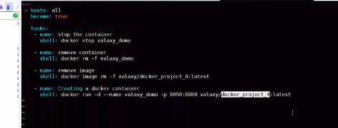

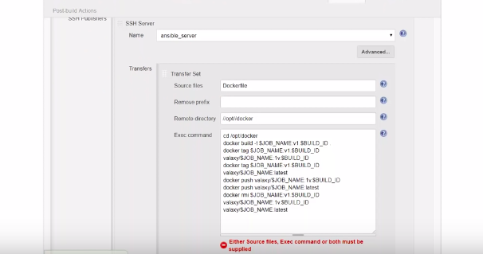

Ref link:-
https://www.youtube.com/watch?v=vU7K94Pt2yQ

https://github.com/katabathina/DevOpsDemos/blob/master/SimpeDevOpsProjects/Project-4.MD

