DevOps CICD by Velaxy Technologies:- ( here completed 1 & 2 diagrams as showing below)

<==============================================>

1.

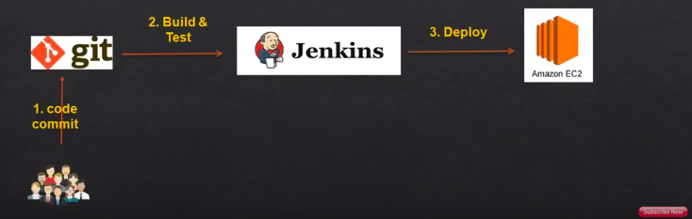

2.

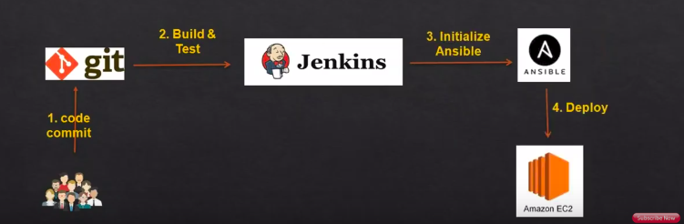

3.

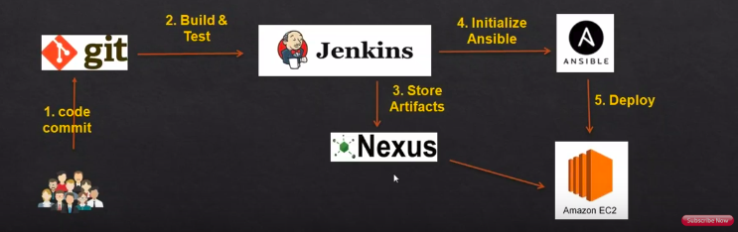

4.

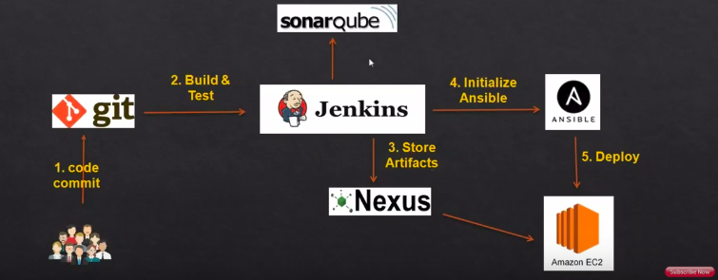
5.

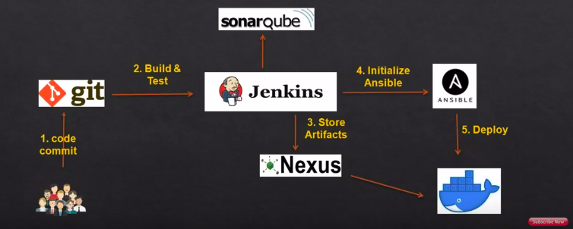

6.

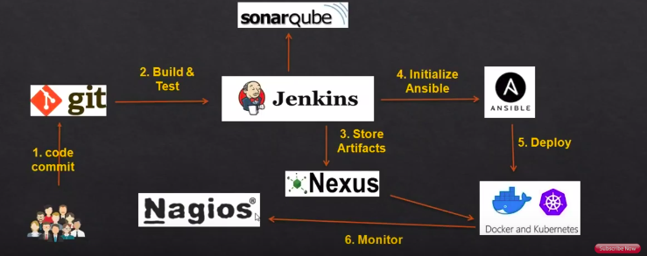

1. Code commit to GIThub--> Jenkins(build)-->Application Server(Deploy).

=> Launch 2 linux EC2 Instances in AWS Account.

=>First Create a Git hub Account.

=>Upload the code into Github Account.

=>1st Instance for jenkins.(Install java and jenkins, Maven)

ref link:-
https://github.com/katabathina/DevOps-Demos/tree/master/setup-jenkins

=> yum install java java-1.8* -y
=> find /usr/lib/jvm/java-1.8* | head -n 3 (to find the java installation location)
=> .bash_profile (Setup environment Variable)

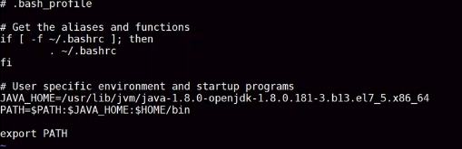
=> source ~/.bash_profile
=> echo $JAVA_HOME

=> Install Jenkins follow below steps:-

=>yum -y install wget
wget -O /etc/yum.repos.d/jenkins.repo https://pkg.jenkins.io/redhat-stable/jenkins.repo
rpm --import https://pkg.jenkins.io/redhat-stable/jenkins.io.key
yum -y install jenkins

=>systemctl start jenkins (Start jenkins service)

=>systemctl enable jenkins (Setup Jenkins to start at boot)

=>http://YOUR-SERVER-PUBLIC-IP:8080 (Accessing Jenkins from Browser)

=>Configure Jenkins
- The default Username is admin
- Grab the default password
  - Password Location:/var/lib/jenkins/secrets/initialAdminPassword
- Plugin Installation; Install Suggested pluggins.

- Create another admin user id

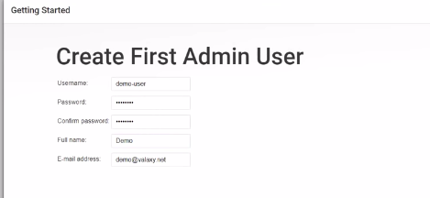

save and continue.
- Change admin password
  - Admin>Configure>Password
- Configure java path
  - Manage Jenkins>Global Tool Configuration>JDK

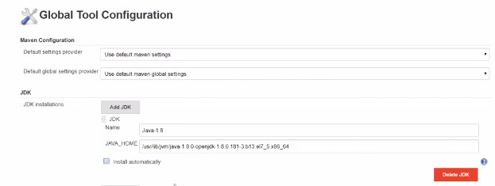
save.

=>Testing sample Jeknkins Job:-
- Create “new item”
- Enter an item name –My-First-Project
  - Chose Freestyle project
- Under Build section Execute shell : echo "Welcome to Jenkins Demo"
- Save your job
- Build job
- Check "console output"
=> Install & Configure Maven On Jenkins Server.
Ref link:https://github.com/katabathina/DevOpsDemos/blob/master/Jenkins/maven_install.MD
=> Install and Configure Maven:-
=>Download maven packages https://maven.apache.org/download.cgi onto Jenkins server. In this case I am using /opt/ as my installation directory - Link : https://maven.apache.org/download.cgi
=>cd /opt
# downloading maven version 3.6.0
wget http://mirrors.fibergrid.in/apache/maven/maven-3/3.6.0/binaries/apache-maven-3.6.0-bin.zip
unzip /opt/maven/apache-maven-3.6.0-bin.zip
=> Setup Environment variable for Maven
cd /etc/profile.d
vi maven.sh
export JAVA_HOME=/usr/lib/jvm/java-8-oracle
export M2_HOME=/opt/apache-maven-3.6.0
export MAVEN_HOME=/opt/apache-maven-3.6.0
export PATH=${M2_HOME}/bin:${PATH}
:wq!
=>source /etc/profile.d/maven.sh
=>to verify maven path:-
echo $M2_HOME
echo $ MAVEN_HOME
echo $ PATH
mvn -version

=>Setup maven on jenkins console
- Install maven plugin without restart
  - Manage Jenkins>Jenkins Plugins>available>Maven Invoker
- Configure Maven path
  - Manage Jenkins>Global Tool Configuration>Maven
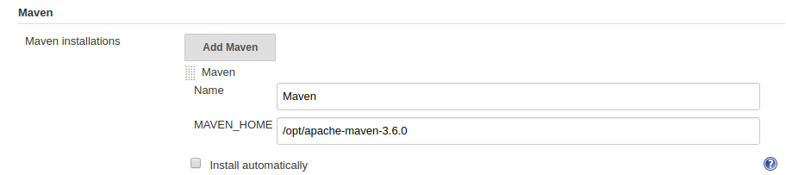
save.
=>Install git on jenkins server.
Yum install git -y
- Install git plugin without restart
  - Manage Jenkins>Jenkins Plugins>available>github
- Configure git path
  - Manage Jenkins>Global Tool Configuration>git
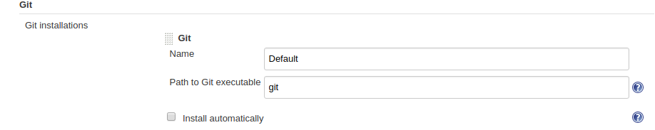
save.

=>2ND Instance for Tomcat (Install java and Tomcat)
ref link:https://github.com/katabathina/DevOpsDemos/blob/master/Tomcat/tomcat_installation.MD
=> Install Java
=> yum install java java-1.8* -y
=> find /usr/lib/jvm/java-1.8* | head -n 3 (to find the java installation location)
=> .bash_profile (Setup environment Variable)

=> source ~/.bash_profile
=> echo $JAVA_HOME

=>Install Apache Tomcat.
cd /opt
wget http://mirrors.fibergrid.in/apache/tomcat/tomcat-8/v8.5.35/bin/apache-tomcat-8.5.35.tar.gz
tar -xvzf /opt/apache-tomcat-8.5.35.tar.gz

=>give executing permissions to startup.sh and shutdown.sh which are under bin.
chmod +x /opt/apache-tomcat-8.5.35/bin/startup.sh shutdown.sh
=>create link files for tomcat startup.sh and shutdown.sh
ln -s /opt/apache-tomcat-8.5.35/bin/startup.sh /usr/local/bin/tomcatup
ln -s /opt/apache-tomcat-8.5.35/bin/shutdown.sh /usr/local/bin/tomcatdown

tomcatup

=>access tomcat application from browser on port 8080.

http://<Public_IP>:8080

=>now application is accessible on port 8080. but tomcat application doesnt allow to login from browser. changing a default parameter in context.xml does address this issue
(search for context.xml)
find / -name context.xml
=>above command gives 3 context.xml files like below . Comment () Value ClassName field on files which are under webapp directory. After that restart tomcat services to effect these changes
/opt/apache-tomcat-8.5.35/conf/context.xml
/opt/apache-tomcat-8.5.35/webapps/host-manager/META-INF/context.xml
/opt/apache-tomcat-8.5.35/webapps/manager/META-INF/context.xml

=>vi /opt/apache-tomcat-8.5.35/webapps/host-manager/META-INF/context.xml

<Valve className="org.apache.catalina.valves.RemoteAddrValve"
allow="127\.\d+\.\d+\.\d+|::1|0:0:0:0:0:0:0:1" />

<!-- <Valve className="org.apache.catalina.valves.RemoteAddrValve"
allow="127\.\d+\.\d+\.\d+|::1|0:0:0:0:0:0:0:1" /> -->

=>vi /opt/apache-tomcat-8.5.35/webapps/manager/META-INF/context.xml

<Valve className="org.apache.catalina.valves.RemoteAddrValve"
allow="127\.\d+\.\d+\.\d+|::1|0:0:0:0:0:0:0:1" />

<!-- <Valve className="org.apache.catalina.valves.RemoteAddrValve"
allow="127\.\d+\.\d+\.\d+|::1|0:0:0:0:0:0:0:1" /> -->

=>tomcatdown
=>tomcatup

=>Update users information in the tomcat-users.xml file goto tomcat home directory and Add below users to conf/tomcat-user.xml file.

vi /opt/apache-tomcat-8.5.35/conf/tomcat-users.xml

<role rolename="manager-gui"/>
<role rolename="manager-script"/>
<role rolename="manager-jmx"/>
<role rolename="manager-status"/>
<user username="admin" password="admin" roles="manager-gui, manager-script, manager-jmx, manager-status"/>
<user username="tomcat" password="s3cret" roles="manager-gui"/>

:wq!

=>tomcatdown
=>tomcatup

http://ip:8080/

Click manager app it will ask username and password.

username="tomcat" password="s3cret"

it will open Tomcat Web Application Manager page.

=> Create a Jenkins Job (CI Job ).

- Login to Jenkins console
- Create Jenkins job, Fill the following details,
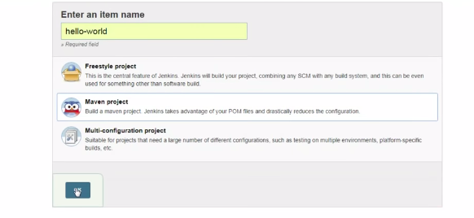
  - Source Code Management:
    - Repository: https://github.com/ValaxyTech/hello-world.git
    - Branches to build :*/master
  - Build:
    - Root POM:pom.xml
    - Goals and options :clean install package
Apply and Save.
Now build job.
Job got Success(CI Job).

=>CD Job (Adding Deployment Steps to CI Job)
We need to add 2 additional steps (Deploy to Container plugin and add tomcat server credentials in jenkins).
=>Install Deploy to Container plugin in jenkins.
we are going to install 'deploy to container' plugin. this is need to deploy on tomcat server which we are using.
- Install deploy to container plugin without restart
  - Manage Jenkins>Manage Plugins>available>deploy to container

=>Add Tomcat Server Credentials in Jenkins Server.

To deploy our build artifacts on tomcat server our Jenkins server need access. For this we should setup credentials. This option is available in Jenkins home page.

setup credentials from jenkins console.
- credentials>jenkins>Global credentials>add credentials
  - Username : admin
  - Password : admin
  - id :Tomcat_user
  - Description:Tomcat user to deploy on tomcat server

ok.

=> Modify the same CI job which created and add deployment steps.
- Post Steps
->Post build actions
  - Deploy war/ear to container
    - WAR/EAR files :**/*.war
    - Containers :Tomcat 8.x
      - Credentials:Tomcat_user(which created in above step)
      - Tomcat URL :http://<PUBLIC_IP>:<PORT_NO>

Save and run the job now.
Job got success.
Check with browser: http://<PUBLIC_IP>:<PORT_NO>/webapps

=>Continuous Integration & Continuous Deployment (CI/CD)
Now job is running fine but to make this as Continuous Integration and Continuous Deployment Tod do that go back and modify job as below.
- Build Triggers
  - Poll SCM
    - schedule * * * * *
Save the job and modify the code in GitHub. Then you could see your job get trigger a build without any manual intervention.

2. Code commit --> Git-->jenkins(Build)--->Ansible(Deployment)--->Tomcat(EC2).
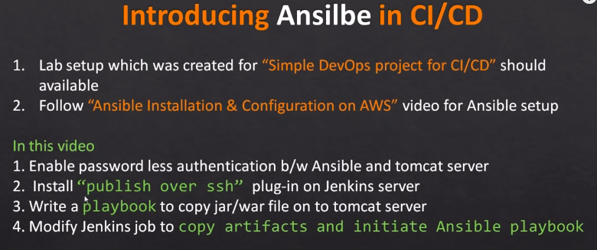
=>Follow the First one that is (Sample DevOps Project 1) and top of it additionally here Ansible.
=>Create New Server that is Ansible Server.

Installation steps:
Add a EPEL (Extra Packages for Enterprise Linux)third party repository to get packages for Ansible
rpm -Uvh https://dl.fedoraproject.org/pub/epel/epel-release-latest-7.noarch.rpm
Install Ansible
yum install ansible -y
Check Ansible version
ansible --version

=>Create a new user for ansible administration & grant admin access to user (Master(Ansible Server) and Slave(Tomcat Server))
useradd ansadmin
passwd ansadmin
# below command addes ansadmin to sudoers file. But strongly recommended to use "visudo" command if you are aware vi or nano editor.
echo "ansadmin ALL=(ALL) ALL" >> /etc/sudoers

Using keybased authentication is advised. If you are still at learning stage use password based authentication (Master(Ansible Server) and Slave(Tomcat Server))
# sed command replaces "PasswordAuthentication no to yes" without editing file
sed -ie 's/PasswordAuthentication no/PasswordAuthentication yes/' /etc/ssh/sshd_config
service sshd restart ----> (to applicatable above changes)
Login as a ansadmin user on master and generate ssh key (Master(Ansible Server)
ssh-keygen
Copy keys onto all ansible client nodes (from Master)
ssh-copy-id <target-server>
Update target servers information on /etc/ansible/hosts file (Master)
echo "<target server IP>" > /etc/ansible/hosts
Run ansible command as ansadmin user it should be successful (Master)
ansible all -m ping

=>Integration for jenkins and ansible server.
=>Install "publish Over SSH"
- Manage Jenkins>Manage Plugins>Available>Publish over SSH
=>Enable connection between Ansible and Jenkins
- Manage Jenkins>Configure System>Publish Over SSH>SSH Servers
  - SSH Servers:
  - Name: Ansible Server
    - Hostname:<ServerIP> (Ansible Server private IP if it is in cloud)
    - username:ansadm
    - password:*******
Test the connection "Test Connection"
Note:- here click advanced then you will get password option.

=>Create a playbook:-
create a copywarfile.yml on Ansible under /opt/playbooks
# copywarfile.yml
---
- hosts: all
become: true
tasks:
- name: copy jar/war onto tomcat servers
copy:
src: /opt/playbooks/wabapp/target/webapp.war
dest: /opt/apache-tomcat-8.5.32/webapps
Add tomcat server details to /etc/ansible/hosts (if you are using other hosts file update server info there)
echo "<server_IP>" >> /etc/ansible/hosts

=>Create a Job for jenkins console.

Create Jenkins job, Fill the following details,
  - Source Code Management:
    - Repository: https://github.com/ValaxyTech/hello-world.git
    - Branches to build :*/master
Build Triggers
  - Poll SCM
    - schedule * * * * *

  - Build:
    - Root POM:pom.xml
    - Goals and options :clean install package

Add post-build steps
  - Send files or execute commands over SSH
    - SSH Server :ansible_server
    - Source fiels:webapp/target/*.war
    - Remote directory://opt//playbooks
- Add post-build steps
  - Send files or execute commands over ssH
    - SSH Server :ansible_server
    - Exec command ansible-playbook /opt/playbooks/copywarfile.yml

Apply and Save.

Execute job and you should be able to seen build has been deployed on Tomcat server.

Ref link:-

https://www.youtube.com/watch?v=nE4b9mW2ym0

https://github.com/katabathina/DevOpsDemos/blob/master/SimpeDevOpsProjects/Project-02.MD

