Created RDS DB Instance and connected from localsystem to RDS Instance.
Automated Snapshot Created.

STEP 1:- Create Security Group for RDS Instance.

---> Goto AWS Console--> Select Services--> Select EC2-->Select Security Groups-->

--> Select Create Security Group-->

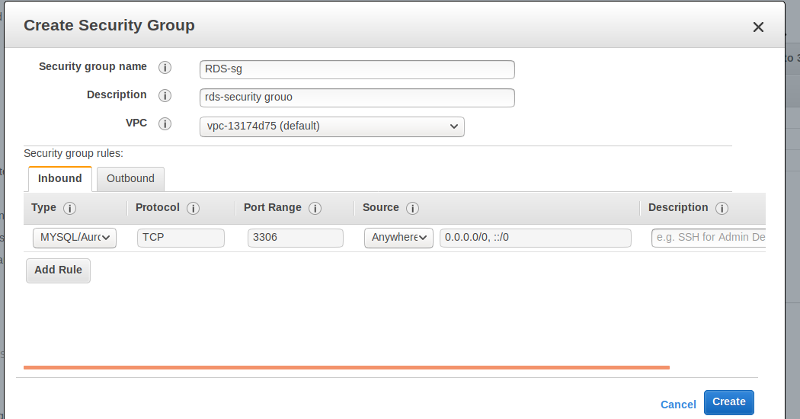
---> Select Create.

---> MYSQL/Aurora -->3306---> To Connect Database.

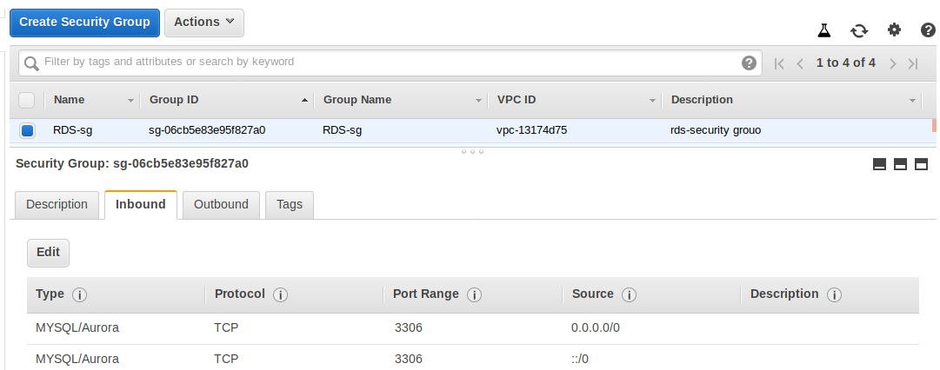

STEP 2: Create RDS Instance.

---> Goto AWS Console --> Select Services---> Select RDS--> Select Instances---> Select Create

Database

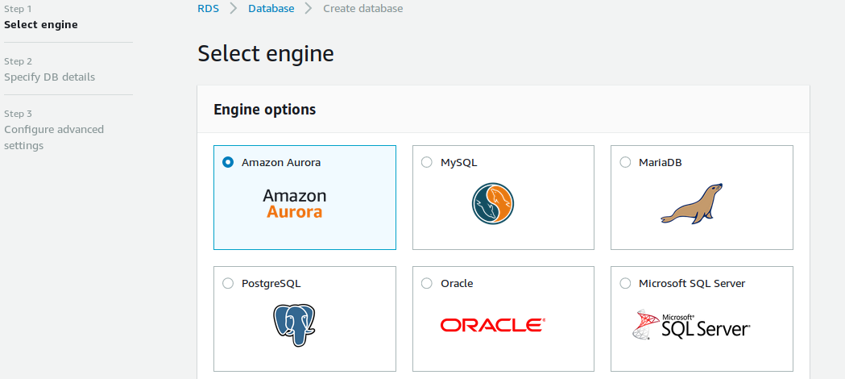
---> Select Which DB you want and--->Select Next.

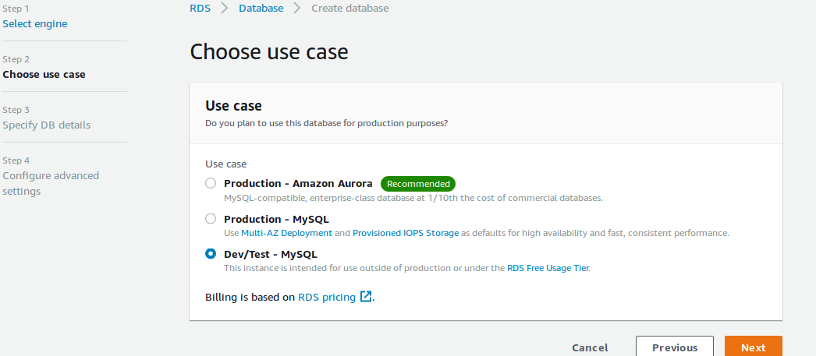

---> here choose use case type--> Select Dev/Test-MySQL--> Select Next.

---> It will goto Specify DB Details,

License model: Use the default value.
- DB engine version: Use the default value. (MySQL 5.7.22)
- DB instance class: db.t2.small
- Multi-AZ deployment: No
- Storage type: General Purpose (SSD)
- Allocated storage: 20 GiB
- DB instance identifier: test-db-instance
- Master username: testuser
- Master password: Choose a password.(testuser123)
- Confirm password: Retype the password.(testuser123)

---> Select Next.
---> It will goto Configure Advanced Settings-->
Virtual Private Cloud (VPC): choose your vpc(here i am choosing default vpc)
The VPC must have subnets in different availability zones.
- Subnet group: default (default vpc no subnets)
- Public accessibility: No
- Availability zone: No Preference
- VPC security groups: Select Existing Security Group(RDS-sg)
- Database name: sample
- Port:3306

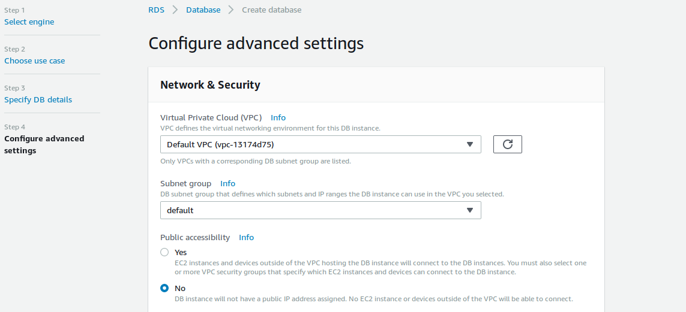
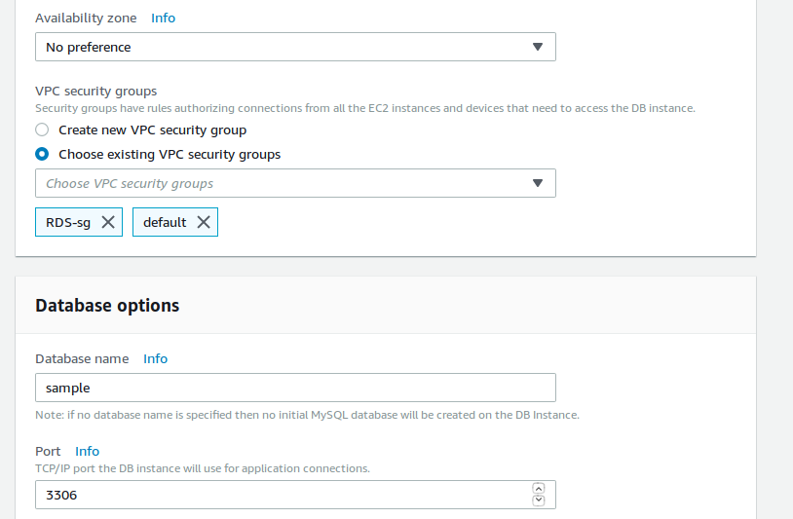

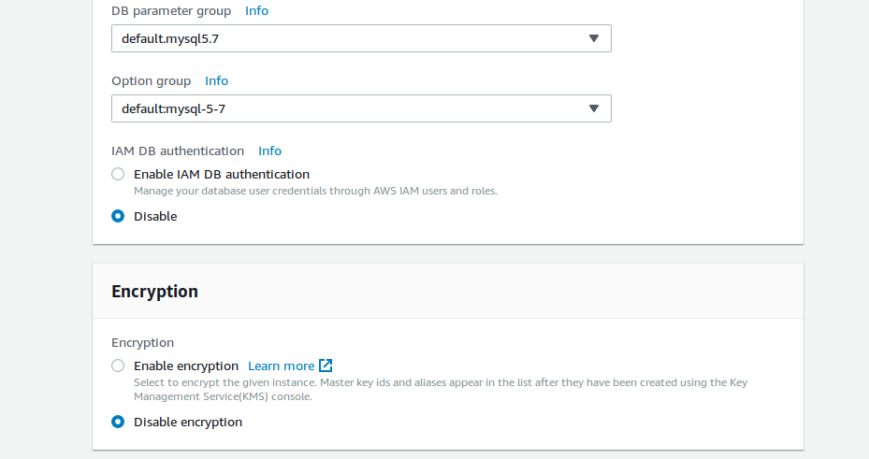

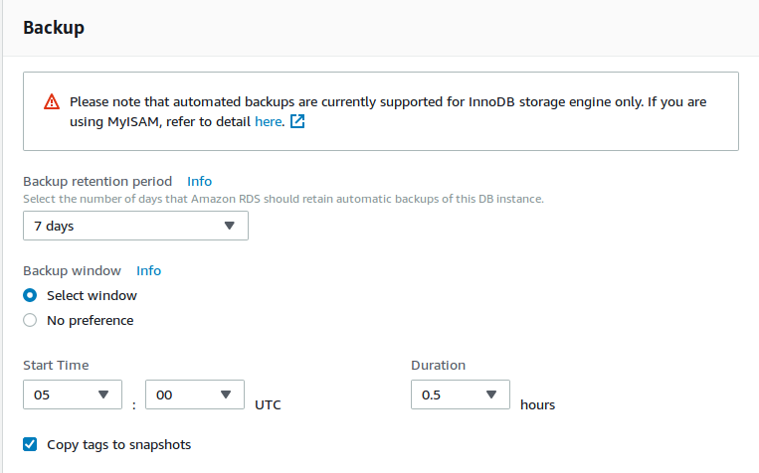
---> The above is Backup--> here Backup retenteion period--> 7 days.

Backup window ---> Backup creation start time.

Create a snapshot with tag name.

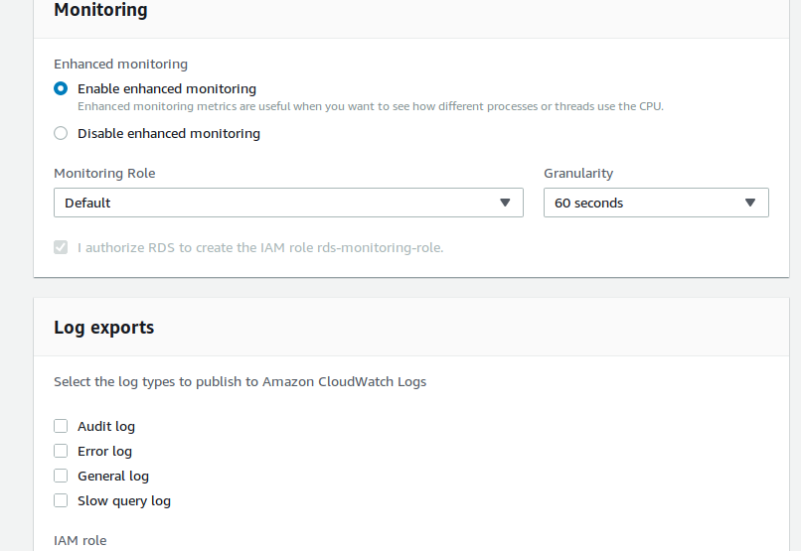
--> Monitoring--> Enable enhaced monitoring.

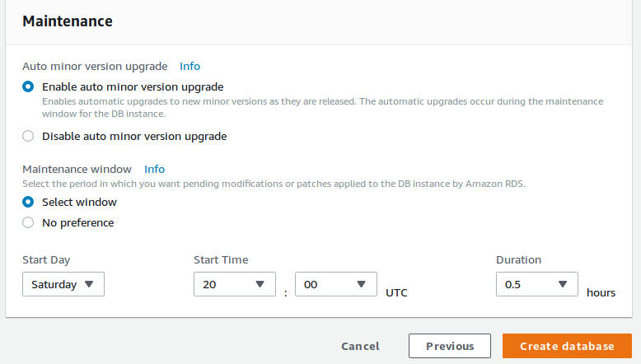

---> Enabled--> Enable auto minor version upgrade(Means if any upgrades comes aws will take

care)--->

---> Maintenance window--> (upgrades activity will do what ever time we specify)

---> Select Create Database.

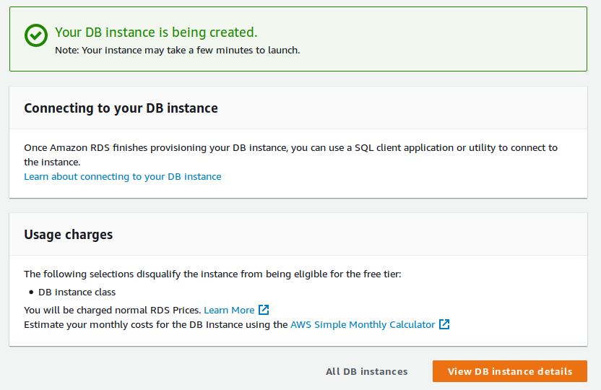
---> Select View DB Instance details.

---> After Created DB Instance it will come like below,

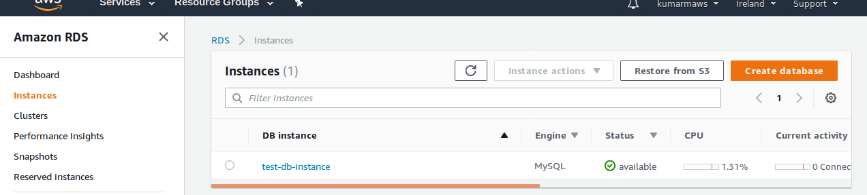

RDS-Instance it will give Endpoint-->

test-db-instance.cbsre0c27wfw.eu-west-1.rds.amazonaws.com.

STEP 3:- Connecting to RDS Instance from my local system-->

mysql -h test-db-instance.cbsre0c27wfw.eu-west-1.rds.amazonaws.com -u testuser -p

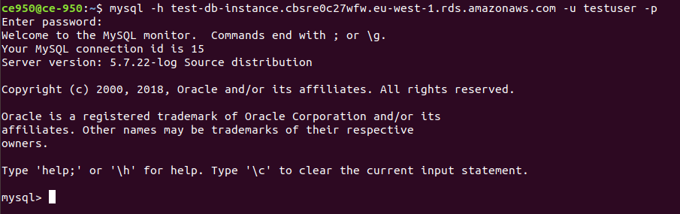
---> See the database which we created while configuring RDS Instance details-->

mysql> show databases;

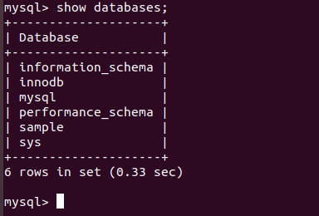

---> Let See Snashot Backup Automatically created, which we set while configuring RDS Instance

at 5.00 PM UTC-->10.30 PM IST.

