Ref Link:-

https://www.linuxbabe.com/ubuntu/nfs-share
192.168.4.210 (NFS-Share)
192.168.1.30 (NFS-Client)
===========================>>>
STEP 1:- Configure the NFS Server (192.164.4.210)
Install nfs-kernal-server packages.
sudo apt install nfs-kernel-server
Create one directory which you want to share.
sudo mkdir katabathina-share
to create a sample files under katabathina-share directory.
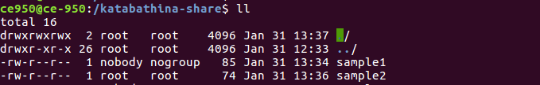
Then edit the exports file with nano text editor. The exports files tell NFS server which directories or file systems will be shared to client.
The syntax is as follows:-
/path/to/directory client-IP address(options)

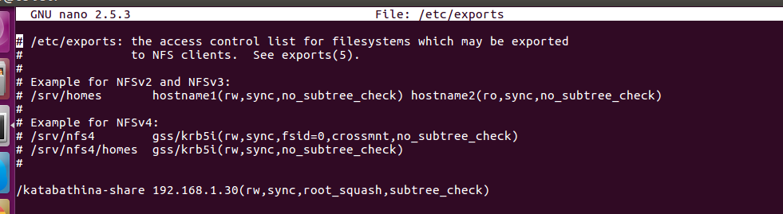
STEP 2:- Configure the Client:
Client Server Install nfs-common package
sudo apt install nfs-common

then edit /etc/fstab file.

sudo nano /etc/fstab

nfs-server-ip:nfs-server-directory /mnt/nfs-share nfs rw,soft,intr,noatime,x-gvfs-
show

The above line will mount the home directory under /mnt/nfs-share directory in read and write mode. X-gvfs-show option will let you see the shared directory in your file manager.

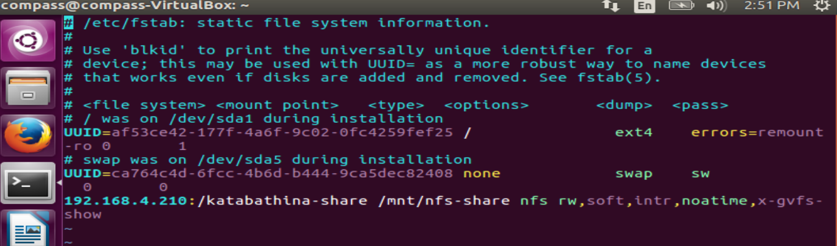
Save and close the file. Then create the mount point.

sudo mkdir /mnt/nfs-share

Next, run the below command

sudo mount -a

If get Any error like below:-

mount.nfs: access denied by server while mounting 192.168.4.210:/katabathina-share.

Check missing any entry on /etc/fstab like / or something.

Then restart nfs server service:-

systemctl status nfs-server.service

systemctl restart nfs-server.service

mount -a

showmount -e 192.168.4.210

Now Check in /mnt/nfs-share

