Nexus Installation:-

Pre-requisites for Nexus Installation:-

Launch EC2-Instance(T2.Medium),Install nexus and JAVA.
Create a Nexus User for start nexus service.
Nexus Default Port:8081

STEP 1:- First Lanuch EC2-Instance.

=>Goto AWS Console-Select Services->Select EC2-> Launch EC2-Instance.

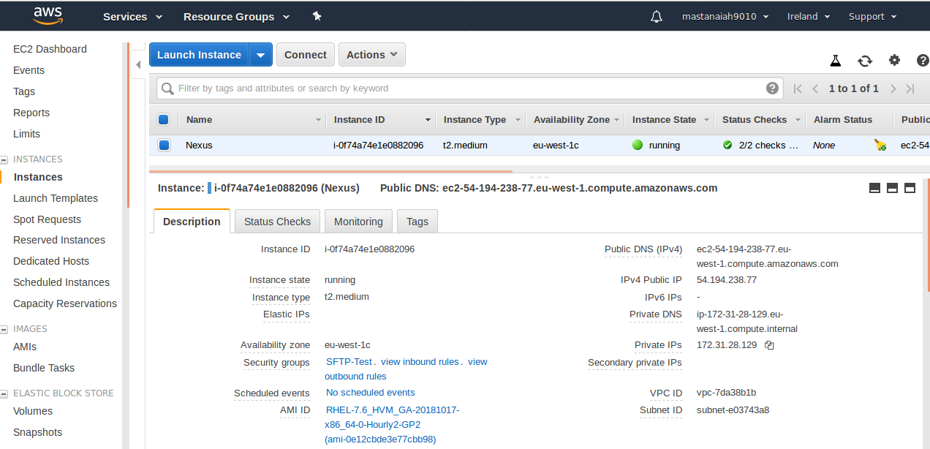

STEP 2:- Connect To EC2-Install.

=> Install Java
# yum install java* -y

STEP 3:- Download and setup nexus stable version.

# cd /opt

# wget https://sonatype-download.global.ssl.fastly.net/nexus/3/nexus-3.0.2-02-unix.tar.gz

# tar -xvzf nexus-3.0.2-02-unix.tar.gz

# mv nexus-3.0.2-02 nexus

STEP 4:- Create a nexus user with sudo permissions.
As a good security practice, it is not advised to run nexus service as root. so create new user called nexus and grant sudo access to manage nexus services.
# adduser nexus
# passwd nexus
making nexus user as a sudo user.
# visudo
nexus ALL=(ALL) NOPASSWD: ALL
:wq!
=> Change ownership to Nexus directory.
# chown -R nexus:nexus nexus
# ls -ld nexus
# drwxr-xr-x. 10 nexus nexus 148 Sep 7 2016 nexus

STEP 5:- Open /opt/nexus/bin/nexus.rc file, uncomment run_as_user parameter and set it as following.
# vi /opt/nexus/bin/nexus.rc
#run_as_user="" (By default line as like this change to below)
run_as_user="nexus"
:wq!

STEP 6:- Add nexus as a service at boot time.
# sudo ln -s /opt/nexus/bin/nexus /etc/init.d/nexus

STEP 7:- Login as a nexus user and start service.
# service nexus start
# service nexus status
nexus is running.

STEP 8:-Login nexus server from browser on port 8081.
http://<Nexus_server IP>:8081
# http://54.194.238.77:8081

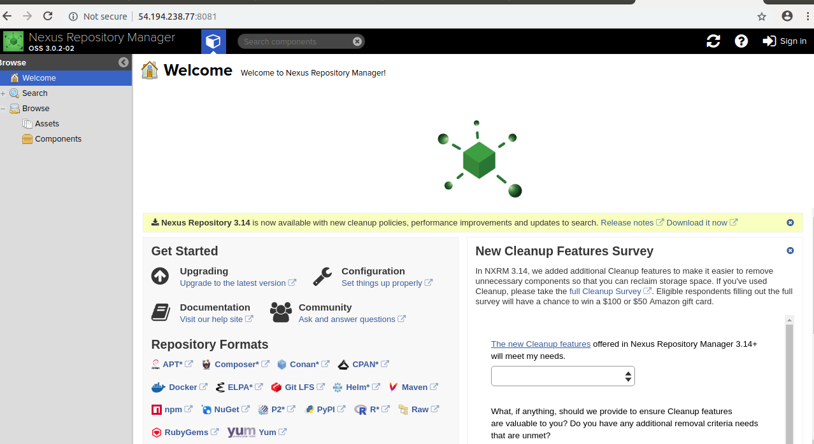
STEP 9:- Use default credentials to login.
username : admin
password : admin123
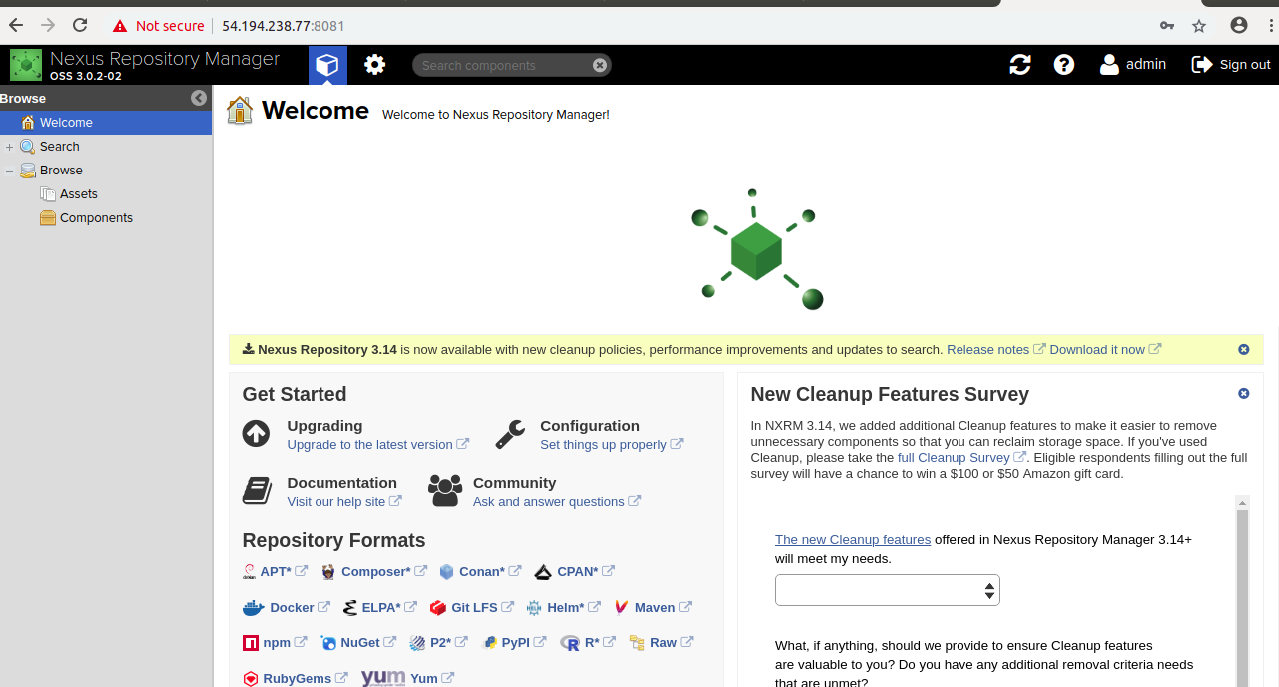

Ref:

https://www.youtube.com/watch?v=k-3krTRuAFA

https://github.com/katabathina/DevOpsDemos/blob/master/Nexus/Nexus_Installation.MD

Nexus Installation Completed.....!!!

