Server to Server PasswordLess Athentication:

PasswordlessAuthentication(MylocalSystem to BastionServer to PrivateServer).

1. My local system (ubuntu)

==>From my local system Generate ssh keys.

# ssh-keygen (next enter enter enter...)

It will generate .ssh directory in user home directory, in side .ssh directory two keys

generated public and private ex: (id_rsa , id_rsa.pub)

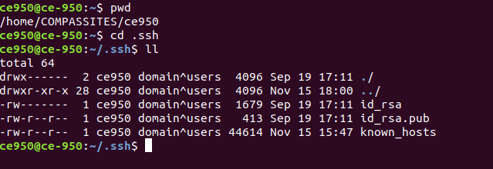

2. Bastion Server

==>Connect to Bastion Server

--->Create a User (ex: sreedhar)

#adduser sreedhar

Next to switch to user(sreedhar) and goto home directory.(ex: home/sreedhar)

Create a .ssh folder.

# mkdir .ssh

Goto inside .ssh directory create a empty file called authorized_keys.

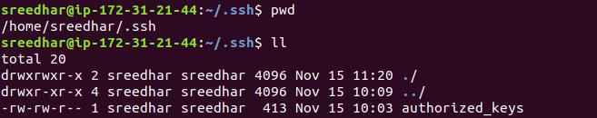

Mylocal System(ubuntu) id_rsa.pub (PublicKey) copy to Bastion Server

authorized_key file.

Mylocal System(ubuntu) id_rsa key (PrivateKey) copy to Bastion Server .ssh

directory.

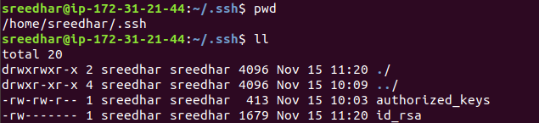
3. Private Server:-

==>Connect to Private Server

--->Create a User (ex: sreedhar)

#adduser sreedhar

Next to switch to user(sreedhar) and goto home directory.(ex: home/sreedhar)

Create a .ssh folder.

# mkdir .ssh

Goto inside .ssh directory create a empty file called authorized_keys.

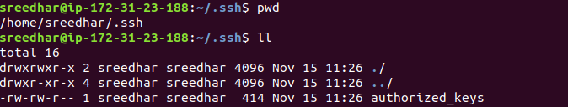
Mylocal System(ubuntu) id_rsa.pub (PublicKey) copy to Private Server

authorized_key file.

4. Goto My local system from there ssh to Bastion Server. (Only first time ask

authentication confirmation).

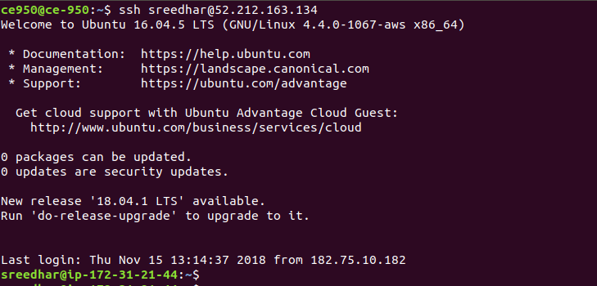

5. From Bastion Server ssh to Private Server.(if its same user no need to give

user name).

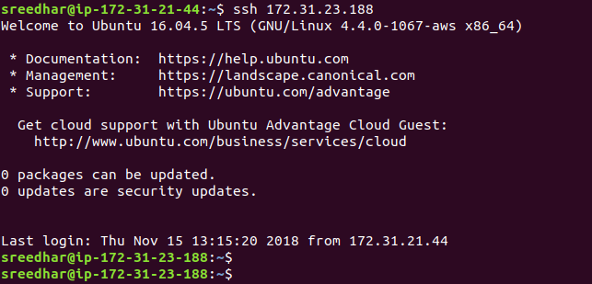

========================================>

This is Onother method:-

1. My local system (ubuntu)

==> From my local system Generate ssh keys.

# ssh-keygen (next enter enter enter...)

It will generate .ssh directory in user home directory, in side .ssh directory two keys

generated public and private ex: (id_rsa , id_rsa.pub)

2. Bastion Server

==>Connect to Bastion Server

--->Create a User (ex: sreedhar)

#adduser sreedhar

Next to switch to user(sreedhar) and goto home directory.(ex: home/sreedhar)

Create a .ssh folder.

# mkdir .ssh

Goto inside .ssh directory create a empty file called authorized_keys.

Mylocal System(ubuntu) id_rsa.pub (PublicKey) copy to Bastion Server

authorized_key file.

In Bastion Server Generate ssh keys.

# ssh-keygen (next enter enter enter...)

here already .ssh directory is there,

generated public and private keys ex: (id_rsa , id_rsa.pub)

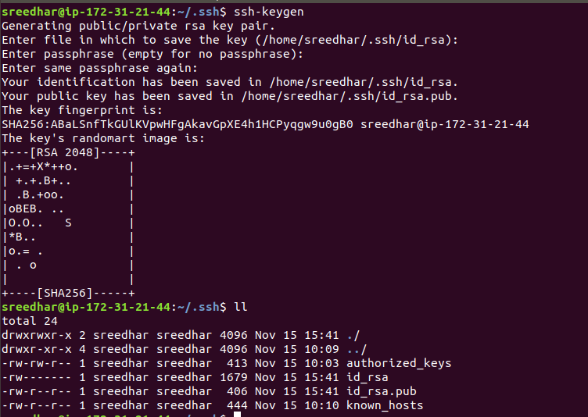
Here open the id_rsa.pub key file.

3. Private Server:-

==>Connect to Private Server

--->Create a User (ex: sreedhar)

#adduser sreedhar

Next to switch to user(sreedhar) and goto home directory.(ex: home/sreedhar)

Create a .ssh folder.

# mkdir .ssh

Goto inside .ssh directory create a empty file called authorized_keys.

Bastion Server id_rsa.pub (PublicKey) copy to Private Server authorized_key file.

4. Goto My local system from there ssh to Bastion Server. (Only first time ask

authentication confirmation).

5. From Bastion Server ssh to Private Server.(if its same user no need to give

user name).

