Install Jenkins on AWS EC2
Jenkins is a self-contained Java-based program, ready to run out-of-the-box, with packages for Windows, Mac OS X and other Unix-like operating systems. As an extensible automation server, Jenkins can be used as a simple CI server or turned into the continuous delivery hub for any project.
Step 1:

Prerequisites
- EC2 Amazon Linux Instance
  - With Internet Access
  - Security Group with Port 8080 open for internet
- Java v1.8.x

Install Java
We will be using open java for our demo, Get latest version from http://openjdk.java.net/install/
yum install java-1.8*
yum -y install java-1.8.0-openjdk

Confirm Java Version:
Lets install java and set the java home
java -version
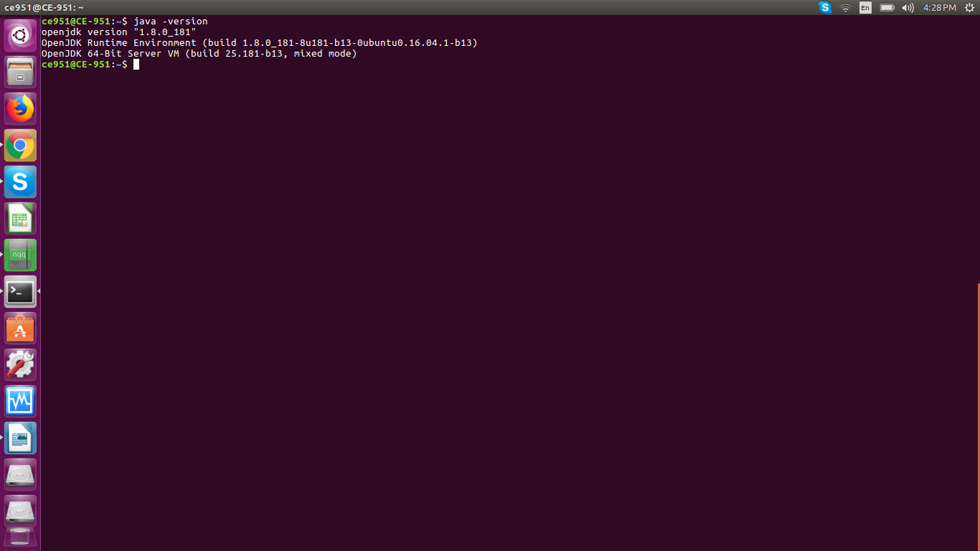

Step 2:

Find the java where its insttalled set permanently /etc/profile configuration file

find /usr/lib/jvm/java-1.8* | head -n 3
JAVA_HOME=
export JAVA_HOME
PATH=$PATH:$JAVA_HOME
To set it permanently update your .bash_profile or /etc/profile
source ~/.bash_profile
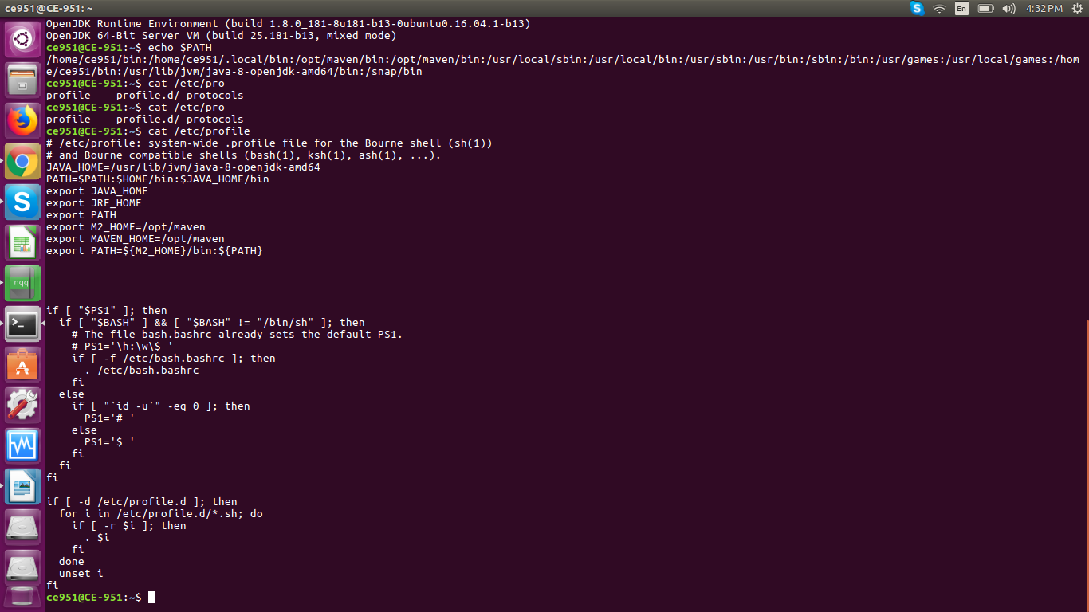
The output should be something like this,
[root@~]# java -version
openjdk version "1.8.0_151"
OpenJDK Runtime Environment (build 1.8.0_151-b12)
OpenJDK 64-Bit Server VM (build 25.151-b12, mixed mode)

Install Jenkins
You can install jenkins using the rpm or by setting up the repo. We will setup the repo so that we can update it easily in future. Get latest version of jenkins from https://pkg.jenkins.io/redhat-stable/t
yum -y install wget
wget -O /etc/yum.repos.d/jenkins.repo https://pkg.jenkins.io/redhat-stable/jenkins.repo
rpm --import https://pkg.jenkins.io/redhat-stable/jenkins.io.key
yum -y install jenkins

Start Jenkins using below command:

Start jenkins service
systemctl start jenkins

Setup Jenkins to start at boot,
systemctl enable jenkins

Accessing Jenkins
By default jenkins runs at port 8080, You can access jenkins at
http:// EC2 instance Ip addr:8080

Configure Jenkins
- The default Username is admin
- Grab the default password
  - Password Location:/var/lib/jenkins/secrets/initialAdminPassword
- Skip Plugin Installation; We can do it later
- Change admin password
  - Admin > Configure > Password
- Configure java path
  - Manage Jenkins > Global Tool Configuration > JDK
- Create another admin user id

